1. From an **operating system designer perspective**, a virtual machine enables protection of the system resources, as each virtual machine is completely isolated not only from other virtual machines, but from the system that it is running on. From a **user perspective**, virtual machines allow for multiple environments of execution to be run simultaneously on the same machine.

2. **UNIX** is a multi-task/multi-user operating system developed by Ken Thompson, Dennis Ritchie, and others at AT&T’s Bell Laboratory in 1970. **LINUX** is an open source, free-to-use operating system developed from the GNU branch of UNIX by Linus Torvalds in 1991. LINUX is the cheaper (free) and more user-friendly of the two, while UNIX is considered to be more feature-rich and complete.

3. **Automatic buffering** allows for a queue of infinite length, ensuring that the sender will never have to block instructions while waiting to copy a message. However, there are no definitions as to how this automatic buffering is used, allowing for wasted memory if too much is reserved. **Explicit buffering** dictates how large the buffer is, which may result in the sender being blocked while waiting for space in the queue. However, it is unlikely that memory will be wasted, as it is determined by the system.

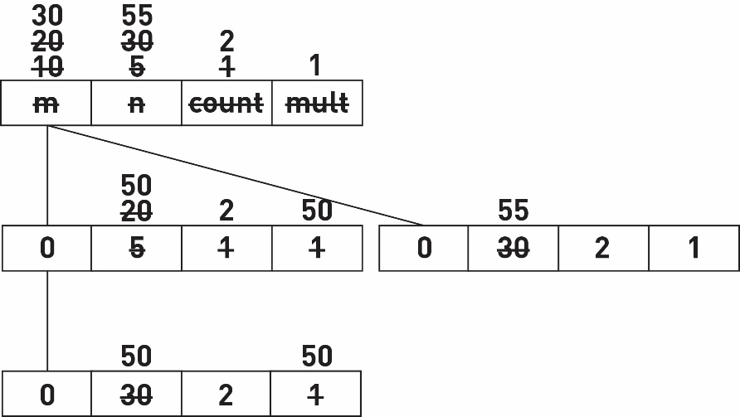4. The total number of processes is **four**, as shown in the diagram below. When the program executes, it will print the following messages (which may appear in a different order, depending on when processes finish):

n = 30 mult = 1

n = 30 mult = 1

n = 55 mult = 1

n = 50 mult = 50

n = 55 mult = 1

n = 50 mult = 50

5.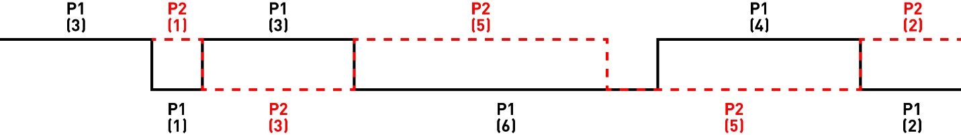 The process is initially new before being admitted to the ready state, prior to the process running. The process then switches to I/O, resulting in a waiting state until it is ready to run again. The states progress as follows: NEW >> READY >> RUNNING >> WAITING >> READY > RUNNING >> WAITING >> READY >> RUNNING >> WAITING.