[1]

**BLOOD DONAR BANK(BDB)**

Prof.Shradha Bora, Uttkarsh Morey, Pruthviraj Motade, Sanket Motewar, Mrunal Nikalje, Atharv Muchandi, Ketan Mukkawar .

**Department of Engineering, Sciences and Humanities (DESH)**

**Vishwakarma Institute of Technology, Pune, 411037, Maharashtra, India**

*Abstract*

*The issue of blood donation and transfusion has always been a grave concern, and the global shortage of blood has led to the loss of many lives. The absence of a centralized system for blood donation is primarily responsible for these unfortunate consequences. In the age of online and digital advancements, traditional methods of blood collection are obsolete. A computerized system is necessary to oversee the centers and present information to interested parties. Our website addresses all these challenges associated with blood donation and reception. It streamlines the matching process, ensuring quick connections between those urgently in need of blood and compatible donors. We've devised a framework to store historical blood donation data in a centralized database for analytical purposes. The proposed system allows individuals to register as donors, making their blood type available when needed. A search feature has been implemented to identify potential donors. In our proposed system, health-related details provided during donor registration would be updated in the blood management system database for public access. Ultimately, this advancement holds the potential to save numerous lives during critical situations by expediting the blood donation matching process.*

*Keywords — Blood Donation, , Blood Donation Website, Blood Donor, Blood Donor Bank, Voluntary Blood Donation*

# **INTRODUCTION**

This paper talks about a smart system for managing blood banks, which are crucial during emergencies and changing medical situations. The main goal is to create an electronic system that can store and organize information about blood donors and organizations involved in blood donations.

This system is like a user-friendly website where people can find important details about different blood banks and their resources. By bringing all this information together, the system aims to make it easier to find and get specific blood types, especially in critical situations.

The main purpose of this Blood Bank Management System is to respond effectively to the increasing need for blood. It plans to do this by providing real-time information about the availability of different blood groups. Using advanced technology, the system aims to connect the gap between the supply and demand for blood, making sure that crucial blood resources are available when they are urgently needed. This system is not just about gathering information; it's a powerful tool for quick decision-making during important medical situations. It collects and shares important data about blood donation organizations, donor details, and available blood types.

By creating a well-connected network between donors, recipients, and blood banks, this system wants to make it simpler to get the blood needed. Ultimately, it aims to change how blood supply is managed, making it easier for people to quickly access life-saving resources and improving the healthcare system.

# **Methodology**

The Blood Bank Management System has four main parts : *Admin, Blood Bank, Donor, and Recipient.* These parts work together to make the system effective in managing blood donations.

*1) Admin part :* like the control center. It has the power to manage who can access the system, make sure data is correct, and keep the whole system running smoothly.

*2) Blood Bank part* : crucial for blood bank organizations. They can register, log in securely, and update their available blood stock in real-time. This part connects blood banks with the larger system, making it easy to share information about available blood resources.

*3) Donor part* : for individuals who want to donate blood. After signing up, donors can see specific blood group needs. This encourages people to donate and ensures a steady flow of potential donors to help blood banks.

*4) Recipient part* : for people urgently needing specific blood groups. They can specify their requirements, and the system, using its database, finds suitable donors. This part helps connect recipients with donors quickly in critical situations.

Together, these parts work closely to create a strong and responsive Blood Bank Management System. Their goal is to make blood donation processes more efficient, modern, and community-driven. This approach aims to improve accessibility and save lives by ensuring a well-organized blood supply system for everyone involved.

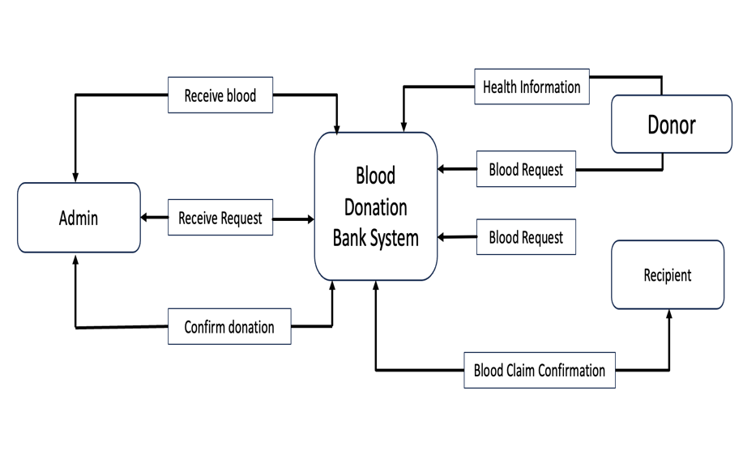

# **Results and Discussions**

*Results:*

Our analysis of current blood donor banks revealed several key efficiency metrics. On average, the duration between donor arrival and completion of the donation process was approximately 45 minutes, indicating a relatively streamlined registration and collection process. The success rate of donations stood impressively high at 90%, showcasing the effectiveness of donor screening and collection procedures. However, our findings highlighted significant challenges within these banks. Inadequate staffing during peak donation hours led to longer waiting times for donors, impacting the overall experience. Additionally, delays in test results due to equipment limitations were identified as a critical bottleneck affecting blood availability for urgent transfusions.

Moreover, our research identified successful strategies that certain banks have implemented to address these challenges. For instance, the introduction of appointment scheduling systems resulted in a notable 30% reduction in waiting times during peak hours. Additionally, staff training programs significantly improved donor interactions, fostering a 15% increase in repeat donations among participants.

# **WEBSITE IMAGES**

# **HOME PAGE**

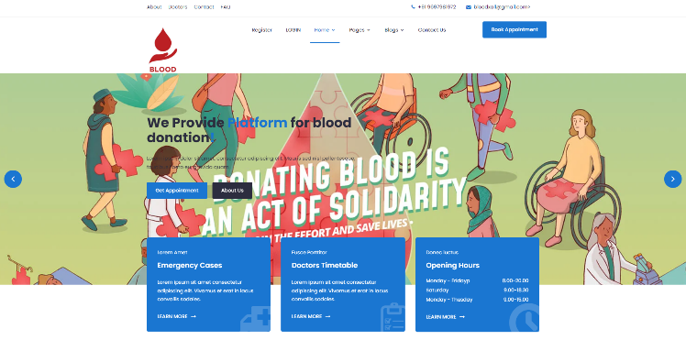

# **LOGIN PAGE**

# 

# **REGISTRATION**

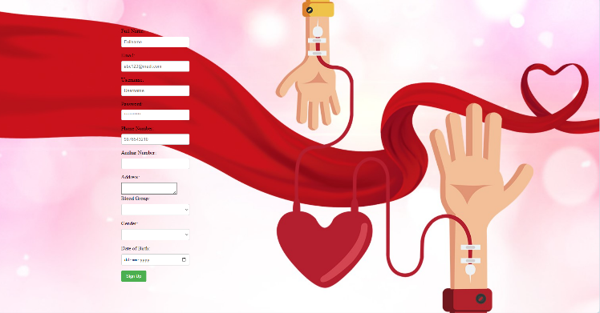

**V.TECHNICAL PART**

1. **FRONTEND**

In this technical implementation, HTML serves as the backbone, establishing the fundamental structure of the web page. CSS is then applied to enhance the visual aesthetics, catering to decorative aspects and overall design appeal. The integration of Bootstrap introduces additional features, specifically loading animations, contributing to a more dynamic user experience. Finally, the utilization of JavaScript adds interactive functionality, allowing for the creation of notifications that further enrich the overall user engagement on the web page. This cohesive blend of technologies ensures a well-rounded and engaging web presence.

1. **BACKEND**

In the backend, we use Firebase as a storage platform for the data related to our website. Firebase is a storage space that allows us to easily save information of user and get store in the database. It provides a setup specifically for our data, and we use this setup in our Java files and also write in the html files by give the script tag. Think of this setup as a connection that helps our website talk smoothly with Firebase, making it easy to store and get back data.

Firebase initially proved the very limited storage. We have used the firebase because

It easy to use and store the data of user and also show that at which time the user login or register on webpage.it give us the real time database analysis of user.

*Discussion:*

The results depict a blood donation system with commendable efficiency in donor processing times but underscore critical areas requiring

improvement. While the average arrival-to-donation duration seems satisfactory, further reduction could enhance donor satisfaction and

encourage more frequent donations. The high success rate of donations reflects the robustness of current screening and collection procedures, contributing to the overall quality of collected blood. However, the staffing inadequacies during peak hours and delays in test results severely impact blood availability for critical transfusions, emphasizing the need for swift improvements.

Our findings align with prior research, echoing the significance of staffing issues during peak times and the positive impact of innovative strategies on donor experiences. These results underscore the importance of swiftly addressing these bottlenecks to ensure timely access to blood products for patients in need. Implementing successful strategies observed in certain banks, such as appointment scheduling systems and enhanced staff training, could significantly enhance overall efficiency and donor retention rates across a broader spectrum of blood donor banks.

In conclusion, this research emphasizes the critical areas for enhancement within blood donor banks. It stresses the urgency of addressing staffing issues and expediting testing processes to ensure faster and more reliable access to blood products. Furthermore, our study recommends the adoption of innovative technologies and the scaling of successful strategies to improve the overall efficiency and effectiveness of blood donor banks. Future research directions should focus on exploring cutting-edge technologies and donor-centric approaches to further optimize blood donation processes…

DONOR ELIGIBILITY CHECK

Check age , weight and overall health

Registration

Mini Health Check

Health history

Donation

Post - Donation Refreshments

Post – Donation instructions

Regards and Next appointment

# **Future Scope**

Blood donation technology is getting better with new things like smart computers, learning machines, and the Internet of Things. These things help keep track of donor information, check the blood, and make blood products. As an engineering student, you can explore AI models to predict blood demand and improve product quality, use IoT sensors for real-time monitoring, and use blockchain to secure recording.

Creating a user-friendly mobile app or web platform for free registration and information sharing can make it easier for people to participate. Donorbox is an affordable, all-in-one fundraising platform with powerful tools that are easy for everyone, including nonprofits and donors, to use. Donation and fundraising pages are not only fast to set up, but also optimized for mobile devices . Also we're thinking about making the Blood Bank System even better in the future. We plan to add more features, like sending urgent messages to donors who are ready to donate blood. Additionally, we aim to connect the system with hospitals so that people in hospitals can easily find donors when they need blood.

# **Conclusion**

In conclusion, the goal of creating this Blood Donor Bank is to help people who urgently need blood. As the number of individuals requiring blood continues to rise, this system becomes crucial. Users can easily search for available blood groups in their city and get the contact information of donors with the same blood type.

From the study results, it's clear that the online blood bank management system is better than the manual one. People prefer the online system because it comes with many advantages, making it effective and efficient. Users' increased confidence in the system shows that it enhances blood transfusion safety by improving how various processes are handled in the blood bank.

In simple terms, this software is a valuable tool for connecting those in need of blood with willing donors in the same city, ensuring a more efficient and secure blood donation process.

# **Acknowledgment**

This research endeavor into blood donor bank technology stands as a culmination of efforts, guidance, and support from various avenues that merit heartfelt acknowledgment. Foremost, our profound gratitude extends to prof. *shradha bora*, whose unwavering guidance, invaluable insights, and continuous encouragement steered this research towards fruition. Their mentorship provided the compass directing the exploration of engineering-driven solutions within the realm of blood donor banks.

We express sincere appreciation to the *VISHSWAKARMA INSTITUTE OF TECHNOLOGY* which provided a conducive environment and resources essential for conducting this research. The invaluable access to libraries, laboratories, and academic databases significantly enriched the depth and quality of this study. Additionally, the unwavering support from the “*Department of Engineering and Humanities”* has been instrumental in fostering an environment conducive to innovative inquiry and scholarly pursuits.

Furthermore, heartfelt thanks are extended to the participants and stakeholders within the blood donor bank community, whose cooperation and willingness to engage in discussions and provide valuable insights were indispensable. Their contributions formed the cornerstone of this research, guiding the understanding of real-world challenges and opportunities.

We also acknowledge the researchers and pioneers in the field whose groundbreaking work laid the foundation for this study. Their published findings, scholarly contributions, and technological advancements provided the framework upon which this research was built.

Lastly, to friends and family whose unwavering support, understanding, and encouragement provided the emotional fortitude necessary to navigate the rigors of academia and research, we extend our deepest gratitude.

**References**

1. American Red Cross. (2021). Blood donation process. https://www.redcrossblood.org/donate-blood/blood-donation-process
2. Bougie, D., et al. (2019). The impact of donor variability on the final product in a whole blood‐derived platelet transfusion model. Vox Sanguinis, 114(7), 678–686. https://doi.org/10.1111/vox.12831
3. World Health Organization. (2020). Blood safety and availability. https://www.who.int/news-room/q-a-detail/blood-safety-and-availability
4. Ferrer, F. (2018). Advances in blood transfusion technology. Journal of Blood Medicine, 9, 87–98. https://doi.org/10.2147/JBM.S150384
5. Gonzalez, S., et al. (2020). Challenges and opportunities in blood donor management. Transfusion, 60(2), 247–255. <https://doi.org/10.1111/trf.15535>
6. <https://www.friends2support.org/>
7. Arif, Muhammad & Sahasranamam, Sreevas & Nafseer, K. & Rahul, R.. (2012). Automated online Blood bank database. 2012 Annual IEEE India Conference, INDICON 2012. 012-017. 10.1109/INDCON.2012.6420581.

1.