IRIS_DSP 设计文档

- IRIS_DSP模块结构图
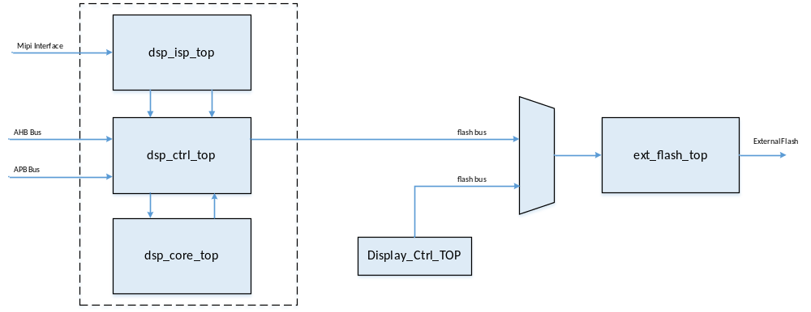
Figure 1 IRIS_DSP模块结构图（虚线部分 ）

- DSP时钟，复位信号
  - 时钟信号
    - 输入时钟
- iris_dsp_wclk
DSP主工作时钟，用于内部状态机和内部逻辑的控制

- iris_dsp_hclk
AHB/APB Bus读、写时钟。当进行AHB/APB Bus读、写操作时，需通过门控信号关闭时钟iris_dsp_wclk

- apb_csi_clk_data
Mipi图像数据输入时钟

    - 输出时钟
- ext_flash_clk
外部Flash读、写时钟，由DSP内部分频产生

  - 复位信号
    - 输入复位
- iris_dsp_wrstn
用于DSP内部状态机和内部逻辑的复位，同iris_dsp_wclk同步

- iris_dsp_hrstn
用于AHB/APB Bus的读、写逻辑复位，同iris_dsp_hclk同步

    - 输出复位
无

    - 内部复位
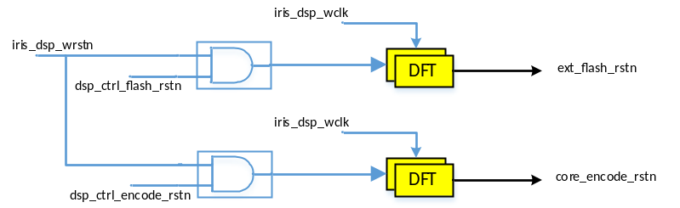
Figure 2 DSP内部复位信号

- DSP_TOP输入输出信号
Table 1 hs_iris_dsp_top 输入输出信号
No | Name | Width | I/O | Source/  Destination | Description
1 | iris_dsp_wclk | 1 | I | CRM | dsp working clock
2 | iris_dsp_wrstn | 1 | I | CRM | dsp working reset
3 | iris_dsp_hclk | 1 | I | cm0_sys_top | AHB bus clock
4 | iris_dsp_hrstn | 1 | I | cm0_sys_top | AHB bus reset
5 | iris_dsp_en | 1 | I | cm0_sys_top | dsp enable
6 | iris_dsp_int2cpu | 2 | O | cm0_sys_top | interrupts to cpu. Bit 0: DSP Status Interrupt
7 | iris_dsp_int2pad | 1 | O | IO | interrupt to pad
8 | iris_dsp_mhaddr | 32 | I | cm0_sys_top | ahb address
9 | iris_dsp_mhsel | 1 | I | cm0_sys_top | ahb select line
10 | iris_dsp_mhwrite | 1 | I | cm0_sys_top | ahb write/read
11 | iris_dsp_mhwdata | 32 | I | cm0_sys_top | ahb write data
12 | iris_dsp_mhrdata | 32 | O | cm0_sys_top | ahb read data
13 | iris_dsp_mhtrans | 2 | I | cm0_sys_top | ahb trans type
14 | iris_dsp_mhburst | 3 | I | cm0_sys_top | ahb burst type
15 | iris_dsp_mhsize | 3 | I | cm0_sys_top | ahb size tupe
16 | iris_dsp_mhresp | 2 | O | cm0_sys_top | ahb response
17 | iris_dsp_mhready | 1 | I | cm0_sys_top | ahb ready feedback
18 | iris_dsp_mhreadyout | 1 | O | cm0_sys_top | ahb slave ready state
19 | iris_dsp_paddr | 10 | I | cm0_sys_top | apb address
20 | iris_dsp_psel | 1 | I | cm0_sys_top | apb select line
21 | iris_dsp_penable | 1 | I | cm0_sys_top | apb enable
22 | iris_dsp_pwrite | 1 | I | cm0_sys_top | apb write/read
23 | iris_dsp_prdata | 32 | I | cm0_sys_top | apb write data
24 | iris_dsp_pwdata | 32 | O | cm0_sys_top | apb read data
25 | iris_dsp_pready | 1 | O | cm0_sys_top | apb ready
26 | iris_dsp_pslverr | 1 | O | cm0_sys_top | apb error
27 | ext_flash_spi_clk | 1 | O | IO | Flash Clock
28 | ext_flash_spi_csn | 1 | O | IO | Flash Chip Select. Low Active
29 | ext_flash_spi_di | 4 | I | IO | Flash Data In
30 | ext_flash_spi_do | 4 | O | IO | Flash Data Out
31 | ext_flash_spi_do_oen | 4 | O | IO | Flash Data In / Out Control
32 | api_csi_rstn | 1 | I | CSI
33 | apb_csi_clk_data | 1 | I | CSI | csi idi clk
34 | apb_csi_csi_data | 32 | I | CSI | csi idi data
35 | apb_csi_bytes_en | 2 | I | CSI | csi idi byte enable
36 | apb_csi_data_en | 1 | I | CSI | csi idi data enable
37 | apb_csi_data_type | 6 | I | CSI | csi idi DT
38 | apb_csi_dvalid | 4 | I | CSI | csi idi data valid
39 | apb_csi_ecc | 8 | I | CSI | csi idi data ECC
40 | apb_csi_header_en | 1 | I | CSI | csi idi header enable
41 | apb_csi_hvalid | 4 | I | CSI | csi idi data line sync
42 | apb_csi_virtual_channel | 2 | I | CSI | csi idi VC
43 | apb_csi_vvalid | 4 | I | CSI | csi idi frame sync
44 | apb_csi_word_count | 16 | I | CSI | csi idi word_count
45 | para_image_clk | 1 | I |  | Parallel Image Clock
46 | para_image_frv | 1 | I |  | Parallel Image Frame Valid
47 | para_image_liv | 1 | I |  | Parallel Image Line Valid
48 | para_image_data | 10 | I |  | Parallel Image Data
49 | isp_video_clk_o | 1 | O |  | Image Video Output --- Clock
50 | isp_video_f_o | 1 | O |  | Image Video Output --- Frame Valid
51 | isp_video_l_o | 1 | O |  | Image Video Output --- Line Valid
52 | isp_video_data_o | 8 | O |  | Image Video Output --- Image Data

- hs_iris_dsp_top内部寄存器定义
CPU通过APB Bus读、写DSP内部寄存器，从而获取DSP的工作状态。DSP内部寄存器位宽均为32 Bit。
DSP内部寄存器中包含部分特殊寄存器。一般情况下，此类寄存器不允许APB Bus进行读、写操作，只有在APB Bus Write/Read Enable情况下，才能对其进行操作。本章中，此类寄存器将添加标识---^{[Special]}。

  - Template Flag: [0x4000_9000] ~ [0x4000_90FC]
Bit | R/W | Default value | Description
[31:0] | RO | 32’h0 | Template Flag

  - Template Encrypt Key: [0x4000_9100] ~ [0x4000_911C]
Bit | R/W | Default value | Description
[31:0] | R/W | 32’h0 | Template Encrypt Key

  - Template Encrypt Enable: [0x4000_9120]
Bit | R/W | Default value | Description
[31:1] | R/W | 31’h0 | Not Used
[0] | R/W | 1’b0 | Template Encrypt Enable. High Active

  - Device User Code Size^{[Special]}: [0x4000_9124]
Bit | R/W | Default value | Description
[31:24] | R/W | 8’h0 | Not Used
[23:0] | R/W | 24’h0 | Device User Code Size. By Byte

  - Template Index Max Threshold^{[Special]}: [0x4000_9128]
Bit | R/W | Default value | Description
[31:16] | R/W | 16’h0 | Not Used
[15:0] | R/W | 16’h0 | Template Index Max Threshold.

  - ISP Image Width & Height: [0x4000_912C]
Bit | R/W | Default value | Description
[31:16] | R/W | 16’h0 | ISP Image Height
[15:0] | R/W | 16’h0 | ISP Image Width

  - ISP Image Output Video Width & Height: [0x4000_9130]
Bit | R/W | Default value | Description
[31:16] | R/W | 16’h0 | ISP Image Output Video Height
[15:0] | R/W | 16’h0 | ISP Image Output Video Width

  - ISP Image Left Eye Clip Window (For Encode) Point: [0x4000_9134]
Bit | R/W | Default value | Description
[31:28] | R/W | 4’h0 | Not Used
[27:16] | R/W | 12’h0 | ISP Image Left Eye Clip Window --- Left Point
[15:12] | R/W | 4’h0 | Not Used
[11:0] | R/W | 16’h0 | ISP Image Left Eye Clip Window --- Top Point

  - ISP Image Left Eye Clip Window (For Encode) Point: [0x4000_9138]
Bit | R/W | Default value | Description
[31:28] | R/W | 4’h0 | Not Used
[27:16] | R/W | 12’h0 | ISP Image Left Eye Clip Window --- Bottom Point
[15:12] | R/W | 4’h0 | Not Used
[11:0] | R/W | 16’h0 | ISP Image Left Eye Clip Window --- Right Point

  - ISP Image Right Eye Clip Window (For Encode) Point: [0x4000_913C]
Bit | R/W | Default value | Description
[31:28] | R/W | 4’h0 | Not Used
[27:16] | R/W | 12’h0 | ISP Image Right Eye Clip Window --- Left Point
[15:12] | R/W | 4’h0 | Not Used
[11:0] | R/W | 16’h0 | ISP Image Right Eye Clip Window --- Top Point

  - ISP Image Right Eye Clip Window (For Encode) Point: [0x4000_9140]
Bit | R/W | Default value | Description
[31:28] | R/W | 4’h0 | Not Used
[27:16] | R/W | 12’h0 | ISP Image Right Eye Clip Window --- Bottom Point
[15:12] | R/W | 4’h0 | Not Used
[11:0] | R/W | 16’h0 | ISP Image Right Eye Clip Window --- Right Point

  - ISP Image Left Eye Clip Window (For Shutter Control) : [0x4000_9144]
Bit | R/W | Default value | Description
[31:28] | R/W | 4’h0 | Not Used
[27:16] | R/W | 12’h0 | ISP Image Left Eye Clip Window --- Left Point
[15:12] | R/W | 4’h0 | Not Used
[11:0] | R/W | 16’h0 | ISP Image Left Eye Clip Window --- Top Point

  - ISP Image Left Eye Clip Window (For Shutter Control) : [0x4000_9148]
Bit | R/W | Default value | Description
[31:28] | R/W | 4’h0 | Not Used
[27:16] | R/W | 12’h0 | ISP Image Left Eye Clip Window --- Bottom Point
[15:12] | R/W | 4’h0 | Not Used
[11:0] | R/W | 16’h0 | ISP Image Left Eye Clip Window --- Right Point

  - ISP Image Right Eye Clip Window (For Shutter Control): [0x4000_914C]
Bit | R/W | Default value | Description
[31:28] | R/W | 4’h0 | Not Used
[27:16] | R/W | 12’h0 | ISP Image Right Eye Clip Window --- Left Point
[15:12] | R/W | 4’h0 | Not Used
[11:0] | R/W | 16’h0 | ISP Image Right Eye Clip Window --- Top Point

  - ISP Image Right Eye Clip Window (For Shutter Control): [0x4000_9150]
Bit | R/W | Default value | Description
[31:28] | R/W | 4’h0 | Not Used
[27:16] | R/W | 12’h0 | ISP Image Right Eye Clip Window --- Bottom Point
[15:12] | R/W | 4’h0 | Not Used
[11:0] | R/W | 16’h0 | ISP Image Right Eye Clip Window --- Right Point

  - ISP Rx Parameters: [0x4000_9154]
Bit | R/W | Default value | Description
[31:16] | R/W | 16’h0 | rx_encode_k
[15:0] | R/W | 16’h0 | rx_k

  - ISP Rx Gray Parameters: [0x4000_9158]
Bit | R/W | Default value | Description
[31:16] | R/W | 16’h0 | Not Used
[15:8] | R/W | 8’h0 | rx set gray
[7:0] | R/W | 8’h0 | rx set gray range

  - ISP Rx Statistial Parameters --- High: [0x4000_915C]
Bit | R/W | Default value | Description
[31:19] | R/W | 13’h0 | Not Used
[18:0] | R/W | 19’h0 | ISP Rx Statistial High

  - ISP Rx Statistial Parameters --- Low : [0x4000_9160]
Bit | R/W | Default value | Description
[31:19] | R/W | 13’h0 | Not Used
[18:0] | R/W | 19’h0 | ISP Rx Statistial Low

  - ISP Rx Statistial Parameters --- Mid: [0x4000_9164]
Bit | R/W | Default value | Description
[31:19] | R/W | 13’h0 | Not Used
[18:0] | R/W | 19’h0 | ISP Rx Statistial Low

  - ISP Rx Sample Factor Bit : [0x4000_9168]
Bit | R/W | Default value | Description
[31:2] | R/W | 30’h0 | Not Used
[ 1:0] | R/W | 2’h0 | ISP Rx Sample Factor Bit

  - ISP Rx Max Ratio: [0x4000_916C]
Bit | R/W | Default value | Description
[31:12] | R/W | 20’h0 | Not Used
[11:0] | R/W | 12’h0 | ISP Rx Max Ratio

  - ISP Rx Sensor Select : [0x4000_9170]
Bit | R/W | Default value | Description
[31:5] | R/W | 28’h0 | Not Used
[3:0] | R/W | 4’h0 | ISP Rx Sensor Select

  - Template Encode Rx Parameters of Pupil Radius Range: [0x4000_9190]
Bit | R/W | Default value | Description
[31:16] | R/W | 16’h0 | Not Used
[15:8] | R/W | 8’h0 | pupil radius range, max  Set to 8’d92
[7:0] | R/W | 8’h0 | pupil radius range, min  Set to 8’d10

  - Template Encode Rx Parameters of Iris Radius Range: [0x4000_9194]
Bit | R/W | Default value | Description
[31:16] | R/W | 16’h0 | Not Used
[15:8] | R/W | 8’h0 | iris radius range, max. Name as ‘iris_r_max’  Set to 8’d120
[7:0] | R/W | 8’h0 | iris radius range, min. Name as ‘iris_r_min’  Set to 8’d80

  - Template Encode Rx Parameters of Median^{[Special_01]}: [0x4000_9198]
Bit | R/W | Default value | Description
[31:8] | R/W | 16’h0 | Not Used
[7:0] | R/W | 8’h0 | median threshold for eyelash check  Set to 8’d24

  - Template Encode Rx Parameters of Median^{[Special_01]}: [0x4000_919C]
Bit | R/W | Default value | Description
[31:10] | R/W | 22’h0 | Not Used
[9:8] | R/W | 2’h0 | down sample size  2’b00: 3x3  2’b01: 5x5  2’b10: 7x7  2’b11: 9x9  Set to 2’b00
[7:0] | R/W | 8’h0 | down sample hi-light threshold  Set to 8’d192

  - Template Encode Rx Parameters of Median^{[Special_01]}: [0x4000_91A0]
Bit | R/W | Default value | Description
[31:10] | R/W | 22’h0 | Not Used
[9:8] | R/W | 2’h0 | full sample size  2’b00: 3x3  2’b01: 5x5  2’b10: 7x7  2’b11: 9x9  Set to 2’b10
[7:0] | R/W | 8’h0 | full sample hi-light threshold  Set to 8’d240

  - Template Encode Rx Parameters of Fake Check^{[Special_01]}: [0x4000_91A4]
Bit | R/W | Default value | Description
[31:26] | R/W | 6’h0 | Not Used
[25:16] | R/W | 10’h0 | fack_score, UFIX_2_8, [0.0, 4.0). max  Set to 10’d400
[15:10] | R/W | 6’h0 | Not Used
[9:0] | R/W | 10’h0 | fack_score, UFIX_2_8, [0.0, 4.0). min  Set to 10’d250

  - Template Encode Rx Parameters of Integrator^{[Special_01]}: [0x4000_91A8]
Bit | R/W | Default value | Description
[31:3] | R/W | 29’h0 | Not Used
[2] | R/W | 1’b0 | window size for gaze  1’b0: 5x5  1’b1: 9x9  Set to 1’b0
[1] | R/W | 1’b0 | window size for iris  1’b0: 5x5  1’b1: 9x9  Set to 1’b1
[0] | R/W | 1’b0 | window size for eyelid  1’b0: 5x5  1’b1: 9x9  Set to 1’b0

  - Template Encode Rx Parameters of Pupil Feature^{[Special_01]}: [0x4000_91AC]
Bit | R/W | Default value | Description
[31:12] | R/W | 20’h0 | Not Used
[11:8] | R/W | 4’h0 | gm coefficient  Set to 4’d4
[7:4] | R/W | 4’h0 | Not Used
[3:0] | R/W | 4’h0 | min eyelash number  Set to 4’d4

  - Template Encode Rx Parameters of Pupil Feature^{[Special_01]}: [0x4000_91B0]
Bit | R/W | Default value | Description
[31:30] | R/W | 2’h0 | Not Used
[29:16] | R/W | 14’h0 | down sample gm range, UFIX_9_5. max  Set to 14’d4096 (128.0)
[15:14] | R/W | 2’h0 | Not Used
[13:0] | R/W | 14’h0 | down sample gm range, UFIX_9_5. min  Set to 14’d512 (16.0)

  - Template Encode Rx Parameters of Pupil Feature^{[Special_01]}: [0x4000_91B4]
Bit | R/W | Default value | Description
[31:8] | R/W | 24’h0 | Not Used
[7:0] | R/W | 8’h0 | down sample margin  Set to (iris_r_min / 3)

  - Template Encode Rx Parameters of Pupil Feature: [0x4000_91B8]
Bit | R/W | Default value | Description
[31:16] | R/W | 16’h0 | Not Used
[15:8] | R/W | 8’h0 | down sample radius range. max  Set to (pupil_r_max / 3)
[7:0] | R/W | 8’h0 | down sample radius range. min  Set to (pupil_r_min / 3）

  - Template Encode Rx Parameters of Pupil Feature^{[Special_01]}: [0x4000_91BC]
Bit | R/W | Default value | Description
[31:30] | R/W | 2’h0 | Not Used
[29:16] | R/W | 14’h0 | full sample gm range, UFIX_9_5. max  Set to 14’d3072 (96.0)
[15:14] | R/W | 2’h0 | Not Used
[13:0] | R/W | 14’h0 | down sample gm range, UFIX_9_5. min  Set to 14’d384 (12.0)

  - Template Encode Rx Parameters of Pupil Feature^{[Special_01]}: [0x4000_91C0]
Bit | R/W | Default value | Description
[31:8] | R/W | 24’h0 | Not Used
[7:0] | R/W | 8’h0 | full sample margin  Set to (iris_r_min)

  - Template Encode Rx Parameters of Pupil Feature: [0x4000_91C4]
Bit | R/W | Default value | Description
[31:16] | R/W | 16’h0 | Not Used
[15:8] | R/W | 8’h0 | full sample radius range. max  Set to (pupil_r_max + 1)
[7:0] | R/W | 8’h0 | full sample radius range. min  Set to (pupil_r_min – 1)

  - Template Encode Rx Parameters of Iris Feature^{[Special_01]}: [0x4000_91C8]
Bit | R/W | Default value | Description
[31:20] | R/W | 12’h0 | Not Used
[19:16] | R/W | 4’h0 | for dm_ex  Set to 4’d5
[15:12] | R/W | 4’h0 | Not Used
[11:8] | R/W | 4’h0 | for sm_max  Set to 4’d9
[7:4] | R/W | 4’h0 | Not Used
[3:0] | R/W | 4’h0 | for sm_min  Set to 4’d3

  - Template Encode Rx Parameters of Iris Feature^{[Special_01]}: [0x4000_91CC]
Bit | R/W | Default value | Description
[31:3] | R/W | 29’h0 | Not Used
[2:0] | R/W | 3’h0 | eyelash pix number threshold  Set to 3’d3

  - Template Encode Rx Parameters of Iris Feature^{[Special_01]}: [0x4000_91D0]
Bit | R/W | Default value | Description
[31:24] | R/W | 8’h0 | Not Used
[23:16] | R/W | 8’h0 | gray range, max  Set to 8’d224
[15:8] | R/W | 8’h0 | Not Used
[7:0] | R/W | 8’h0 | gray range, min  Set to 8’d16

  - Template Encode Rx Parameters of Iris Feature^{[Special_01]}: [0x4000_91D4]
Bit | R/W | Default value | Description
[31:25] | R/W | 7’h0 | Not Used
[24:16] | R/W | 9’h0 | dif range, max  Set to 9’d96
[15:9] | R/W | 7’h0 | Not Used
[8:0] | R/W | 9’h0 | dif range, min  Set to 9’d10

  - Template Encode Rx Parameters of Eyelid Feature^{[Special_01]}: [0x4000_91D8]
Bit | R/W | Default value | Description
[31:16] | R/W | 16’h0 | Not Used
[15:8] | R/W | 8’h0 | r range shift. max  Set to 8’d8
[7:0] | R/W | 8’h0 | r range shift. min  Set to 8’d4

  - Template Encode Rx Parameters of Find Arc^{[Special_01]}: [0x4000_91DC]
Bit | R/W | Default value | Description
[31:20] | R/W | 12’h0 | Not Used
[19:16] | R/W | 4’h0 | a range. increase  Set to 4’d1
[15:12] | R/W | 4’h0 | Not Used
[11:8] | R/W | 4’h0 | a range. max  Set to 4’d15
[7:4] | R/W | 4’h0 | Not Used
[3:0] | R/W | 4’h0 | a range. min  Set to 4’d0

  - Template Encode Rx Parameters of Find Arc^{[Special_01]}: [0x4000_91E0]
Bit | R/W | Default value | Description
[31:24] | R/W | 8’h0 | Not Used
[23:16] | R/W | 8’h0 | b range. increase  Set to 8’d4
[15:8] | R/W | 8’h0 | b range shift. max  Set to 8’d240
[7:0] | R/W | 8’h0 | b range shift. min  Set to 8’d16

  - Template Encode Rx Parameters of Find Arc^{[Special_01]}: [0x4000_91E4]
Bit | R/W | Default value | Description
[31:24] | R/W | 8’h0 | Not Used
[23:16] | R/W | 8’h0 | c range. increase  Set to 8’d4
[15:8] | R/W | 8’h0 | c range shift. max  Set to 8’d136
[7:0] | R/W | 8’h0 | c range shift. min  Set to 8’d16

  - Template Encode Rx Parameters of Find Arc^{[Special_01]}: [0x4000_91E8]
Bit | R/W | Default value | Description
[31:20] | R/W | 12’h0 | Not Used
[19:8] | R/W | 12’h0 | min energy  Set to 12’d51
[7:0] | R/W | 8’h0 | x step  Set to 8’d4

  - Template Encode Rx Parameters of Find Circle^{[Special_01]}: [0x4000_91EC]
Bit | R/W | Default value | Description
[31:14] | R/W | 18’h0 | Not Used
[13:8] | R/W | 6’h0 | pupil circle, for feature & total  Set to 6’d6
[7:6] | R/W | 2’h0 | Not Used
[5:0] | R/W | 6’h0 | pupil circle, for feature_l | r & total  Set to 6’d16

  - Template Encode Rx Parameters of Find Circle^{[Special_01]}: [0x4000_91F0]
Bit | R/W | Default value | Description
[31:14] | R/W | 18’h0 | Not Used
[13:8] | R/W | 6’h0 | pupil circle, for feature & count  Set to 6’d4
[7:6] | R/W | 2’h0 | Not Used
[5:0] | R/W | 6’h0 | pupil circle, for feature_l | r & count_l | r  Set to 6’d3

  - Template Encode Rx Parameters of Find Circle^{[Special_01]}: [0x4000_91F4]
Bit | R/W | Default value | Description
[31:12] | R/W | 20’h0 | Not Used
[11:8] | R/W | 4’h0 | pupil center scan step when raw search  Set to 4’d2
[7:0] | R/W | 8’h0 | min dif of gray  Set to 8’d18

  - Template Encode Rx Parameters of Find Circle^{[Special_01]}: [0x4000_91F8]
Bit | R/W | Default value | Description
[31:24] | R/W | 8’h0 | Not Used
[23:16] | R/W | 8’h0 | pupil radius scan range when acu search  Set to 8’d4
[15:8] | R/W | 8’h0 | pupil center scan range when raw search. dy  Set to 8’d6
[7:0] | R/W | 8’h0 | pupil center scan range when raw search. dx  Set to 8’d6

  - Template Encode Rx Parameters of Find Circle^{[Special_01]}: [0x4000_91FC]
Bit | R/W | Default value | Description
[31:14] | R/W | 18’h0 | Not Used
[13:8] | R/W | 6’h0 | iris circle, for feature & total  Set to 6’d6
[7:6] | R/W | 2’h0 | Not Used
[5:0] | R/W | 6’h0 | iris circle, for feature_l | r & total  Set to 6’d16

  - Template Encode Rx Parameters of Find Circle^{[Special_01]}: [0x4000_9200]
Bit | R/W | Default value | Description
[31:14] | R/W | 18’h0 | Not Used
[13:8] | R/W | 6’h0 | iris circle, for feature & count  Set to 6’d4
[7:6] | R/W | 2’h0 | Not Used
[5:0] | R/W | 6’h0 | iris circle, for feature_l | r & count_l | r  Set to 6’d3

  - Template Encode Rx Parameters of Find Circle^{[Special_01]}: [0x4000_9204]
Bit | R/W | Default value | Description
[31:12] | R/W | 20’h0 | Not Used
[11:8] | R/W | 4’h0 | iris center scan step when raw search  Set to 4’d2
[7:0] | R/W | 8’h0 | min dif of gray  Set to 8’d6

  - Template Encode Rx Parameters of Find Circle^{[Special_01]}: [0x4000_9208]
Bit | R/W | Default value | Description
[31:24] | R/W | 8’h0 | Not Used
[23:16] | R/W | 8’h0 | iris radius scan range when acu search  Set to 8’d3
[15:8] | R/W | 8’h0 | iris center scan range when raw search. dy  Set to 8’d9
[7:0] | R/W | 8’h0 | iris center scan range when raw search. dx  Set to 8’d9

  - Template Encode Rx Parameters of Rect Trans^{[Special_01]}: [0x4000_920C]
Bit | R/W | Default value | Description
[31:24] | R/W | 8’h0 | hi-light threshold  Set to 8’d240
[23:20] | R/W | 4’h0 | Not Used
[19:16] | R/W | 4’h0 | mean value * (1.0 – this) = boundary of eyelash  Set to 4’d11
[15:12] | R/W | 4’h0 | Not Used
[11:8] | R/W | 4’h0 | mean value * (1.0 + this) = boundary of reflection  Set to 4’d11
[7:0] | R/W | 8’h0 | mean value + this = boundary of reflection  Set to 8’d40

  - Template Encode Rx Parameters of Rect Trans^{[Special_01]}: [0x4000_9210]
Bit | R/W | Default value | Description
[31:24] | R/W | 8’h0 | Not Used
[23:16] | R/W | 8’h0 | y shift for check eyelash lower  Set to 8’d4
[15:8] | R/W | 8’h0 | y shift for check eyelash upper  Set to 8’d48
[7:0] | R/W | 8’h0 | y shift for check eyelid  Set to 8’d4

  - Template Encode Rx Parameters of CLAHE^{[Special_01]}: [0x4000_9214]
Bit | R/W | Default value | Description
[31:4] | R/W | 28’h0 | Not Used
[3:0] | R/W | 4’h0 | clahe clip limitation, (0, 7]  Set to 4’d2

  - Template Encode Rx Parameters of Check Pupil Center^{[Special_01]}: [0x4000_9218]
Bit | R/W | Default value | Description
[31:16] | R/W | 16’h0 | Not Used
[15:8] | R/W | 8’h0 | full sample  Set to 8’d32
[7:0] | R/W | 8’h0 | down sample  Set to 8’d16

  - Template Encode Rx Parameters of Check Circle^{[Special_01]}: [0x4000_921C]
Bit | R/W | Default value | Description
[31:11] | R/W | 21’h0 | Not Used
[10:8] | R/W | 3’h0 | iris, [1, 7]  Set to 3’d1
[7:3] | R/W | 5’h0 | Not Used
[2:0] | R/W | 3’h0 | pupil, [1, 7]  Set to 3’d1

  - Template Encode Rx Parameters of Check Focus: [0x4000_9220]
Bit | R/W | Default value | Description
[31:16] | R/W | 16’h0 | min, mi quality, UFIX_1_15, [0.0, 1.0]  Set to 16’d7864 (0.24)
[15:0 | R/W | 16’h0 | min, lo quality, UFIX_1_15, [0.0, 1.0]  Set to 16’d5243 (0.16)

  - Template Encode Rx Parameters of Check Focus: [0x4000_9224]
Bit | R/W | Default value | Description
[31:16] | R/W | 16’h0 | Not Used
[15:0 | R/W | 16’h0 | min, hi quality, UFIX_1_15, [0.0, 1.0]  Set to 16’d9830 (0.30)

  - Template Encode Rx Parameters of Check Focus: [0x4000_9228]
Bit | R/W | Default value | Description
[31:16] | R/W | 16’h0 | Not Used
[15:0 | R/W | 16’h0 | max, UFIX_1_15, [0.0, 1.0]  Set to 16’d16384 (0.50)

  - Template Encode Rx Parameters of Correct Focus^{[Special_01]}: [0x4000_922C]
Bit | R/W | Default value | Description
[31:16] | R/W | 16’h0 | UFIX_1_15, 0.441400  Set to 16’d14464
[15:0 | R/W | 16’h0 | UFIX_1_15, 0.729600  Set to 16’d23908

  - Template Encode Rx Parameters of Check Valid Pix Number: [0x4000_9230]
Bit | R/W | Default value | Description
[31] | R/W | 1’b0 | Not Used
[30:16] | R/W | 15’h0 | mi quality  Set to 15’d6554 (0.4)
[15] | R/W | 1’b0 | Not Used
[14:0] | R/W | 15’h0 | lo quality  Set to 15’d4915 (0.3)

  - Template Encode Rx Parameters of Check Valid Pix Number: [0x4000_9234]
Bit | R/W | Default value | Description
[31:15] | R/W | 17’h0 | Not Used
[14:0] | R/W | 15’h0 | hi quality  Set to 15’d9830 (0.6)

  - Template Encode Rx Parameters of Check Segmentation^{[Special_01]}: [0x4000_9238]
Bit | R/W | Default value | Description
[31:9] | R/W | 23’h0 | Not Used
[8:0] | R/W | 9’h0 | max (pupil iris center distance) / (iris_r – pupil_r), UFIX_1_8, [0, 1]  Set to 9’d128 (0.5)

  - Template Encode Rx Parameters of Check Segmentation: [0x4000_923C]
Bit | R/W | Default value | Description
[31:25] | R/W | 7’h0 | Not Used
[24:16] | R/W | 9’h0 | dialoation range, UFIX_1_8, [0, 1]. lo quality, max  Set to 9’d205 (0.800)
[15:9] | R/W | 7’h0 | Not Used
[8:0] | R/W | 9’h0 | dialoation range, UFIX_1_8, [0, 1]. lo quality, min  Set to 9’d32 (0.125)

  - Template Encode Rx Parameters of Check Segmentation: [0x4000_9240]
Bit | R/W | Default value | Description
[31:25] | R/W | 7’h0 | Not Used
[24:16] | R/W | 9’h0 | dialoation range, UFIX_1_8, [0, 1]. md quality, max  Set to 9’d180 (0.700)
[15:9] | R/W | 7’h0 | Not Used
[8:0] | R/W | 9’h0 | dialoation range, UFIX_1_8, [0, 1]. md quality, min  Set to 9’d38 (0.150)

  - Template Encode Rx Parameters of Check Segmentation: [0x4000_9244]
Bit | R/W | Default value | Description
[31:25] | R/W | 7’h0 | Not Used
[24:16] | R/W | 9’h0 | dialoation range, UFIX_1_8, [0, 1]. hi quality, max  Set to 9’d154 (0.600)
[15:9] | R/W | 7’h0 | Not Used
[8:0] | R/W | 9’h0 | dialoation range, UFIX_1_8, [0, 1]. hi quality, min  Set to 9’d51 (0.200)

  - Template Encode Rx Parameters of Check Segmentation: [0x4000_9248]
Bit | R/W | Default value | Description
[31:26] | R/W | 6’h0 | Not Used
[25:16] | R/W | 10’h0 | min margin, UFIX_2_8, [0.004, 2.0], Right  Set to 10’d2 (0.004)
[15:10] | R/W | 6’h0 | Not Used
[9:0] | R/W | 10’h0 | min margin, UFIX_2_8, [0.004, 2.0], Left  Set to 10’d1 (0.004)

  - Template Encode Rx Parameters of Check Segmentation: [0x4000_924C]
Bit | R/W | Default value | Description
[31:26] | R/W | 6’h0 | Not Used
[25:16] | R/W | 10’h0 | min margin, UFIX_2_8, [0.004, 2.0], Bottom  Set to 10’d4 (0.004)
[15:10] | R/W | 6’h0 | Not Used
[9:0] | R/W | 10’h0 | min margin, UFIX_2_8, [0.004, 2.0], Top  Set to 10’d3 (0.004)

  - Template Encode Rx Parameters of Check Gaze: [0x4000_9250]
Bit | R/W | Default value | Description
[31:8] | R/W | 24’h0 | Not Used
[7:0] | R/W | 8’h0 | hi-light threshold  Set to 8’d220

  - Template Encode Rx Parameters of Check Gaze^{[Special_01]}: [0x4000_9254]
Bit | R/W | Default value | Description
[31:12] | R/W | 20’h0 | Not Used
[11:8] | R/W | 4’h0 | threshold of center gray rate, UFIX_2_2, [0.0, 4.0)  Set to 4’d8 (2.00)
[7:4] | R/W | 4’h0 | Not Used
[3:0] | R/W | 4’h0 | threshold of foreground rate, UFIX_2_2, [0.0, 4.0)  Set to 4’d5 (1.25)

  - Template Encode Rx Parameters of Check Gaze: [0x4000_9258]
Bit | R/W | Default value | Description
[31:24] | R/W | 8’h0 | win a range, relative to pupil center, FIX_7_0. Bottom  Set to 8’d0
[23:16] | R/W | 8’h0 | win a range, relative to pupil center, FIX_7_0. Top  Set to 8’d0
[15:8] | R/W | 8’h0 | win a range, relative to pupil center, FIX_7_0. Right  Set to 8’d0
[7:0] | R/W | 8’h0 | win a range, relative to pupil center, FIX_7_0. Left  Set to 8’d0

  - Template Encode Rx Parameters of Check Gaze: [0x4000_925C]
Bit | R/W | Default value | Description
[31:24] | R/W | 8’h0 | win b range, relative to pupil center, FIX_7_0. Bottom  Set to 8’d0
[23:16] | R/W | 8’h0 | win b range, relative to pupil center, FIX_7_0. Top  Set to 8’d0
[15:8] | R/W | 8’h0 | win b range, relative to pupil center, FIX_7_0. Right  Set to 8’d0
[7:0] | R/W | 8’h0 | win b range, relative to pupil center, FIX_7_0. Left  Set to 8’d0

  - Template Encode Rx Parameters of Check Gaze: [0x4000_9260]
Bit | R/W | Default value | Description
[31:20] | R/W | 12’h0 | Not Used
[19:16] | R/W | 4’h0 | win e rate  Set to 4’d4
[15:8] | R/W | 8’h0 | win e extending vertical pix  Set to 8’d0
[7:0] | R/W | 8’h0 | win e extending horizontal pix  Set to 8’d0

  - Template Encode Rx Parameters of Check Gaze: [0x4000_9264]
Bit | R/W | Default value | Description
[31] | R/W | 1’b0 | Not Used
[30:16] | R/W | 15’h0 | reflect pix threshold. max_nma  Set to 15’d0
[15] | R/W | 1’b0 | Not Used
[14:0] | R/W | 15’h0 | reflect pix threshold. min_nma  Set to 15’d0

  - Template Encode Rx Parameters of Check Gaze: [0x4000_9268]
Bit | R/W | Default value | Description
[31] | R/W | 1’b0 | Not Used
[30:16] | R/W | 15’h0 | reflect pix threshold. max_nmb  Set to 15’d0
[15] | R/W | 1’b0 | Not Used
[14:0] | R/W | 15’h0 | reflect pix threshold. min_nmb  Set to 15’d0

  - Template Encode Rx Parameters of Check Open: [0x4000_926C]
Bit | R/W | Default value | Description
[31:16] | R/W | 16’h0 | Not Used
[15:8] | R/W | 8’h0 | lo quality: min right or left eyelid uncovered angle / 360 * 256  Set to 8’d16 (22.5)
[7:0] | R/W | 8’h0 | lo quality: max upper or lower eyelid covered angle / 360 * 256  Set to 8’d128 (168.0)

  - Template Encode Rx Parameters of Check Open: [0x4000_9270]
Bit | R/W | Default value | Description
[31:16] | R/W | 16’h0 | Not Used
[15:8] | R/W | 8’h0 | hi quality: min right or left eyelid uncovered angle / 360 * 256  Set to 8’d21 (29.5)
[7:0] | R/W | 8’h0 | hi quality: max upper or lower eyelid covered angle / 360 * 256  Set to 8’d106 (150.0)

  - Template Encode Rx Parameters of Check Iris Gray: [0x4000_9274]
Bit | R/W | Default value | Description
[31:16] | R/W | 16’h0 | Not Used
[15:8] | R/W | 8’h0 | max  Set to 8’d192
[7:0] | R/W | 8’h0 | min  Set to 8’d16

  - Template Match Rx Parameters^{[Special_02]}: [0x4000_9280]
Bit | R/W | Default value | Description
[31:7] | R/W | 25’h0 | Not Used
[6:0] | R/W | 7’h0 | mask in win check, [0, 81]  Set to 7’d64

  - Template Match Rx Parameters^{[Special_02]}: [0x4000_9284]
Bit | R/W | Default value | Description
[31:15] | R/W | 17’h0 | Not Used
[14:0] | R/W | 15’h0 | match valid pix threshold  Set to 15’d6554

  - Template Match Rx Parameters^{[Special_02]}: [0x4000_9288]
Bit | R/W | Default value | Description
[31:15] | R/W | 17’h0 | Not Used
[14:0] | R/W | 15’h0 | match score threshold  Set to 15’’d64

  - Device ID Rx Parameters^{[Special_04]}: [0x4000_92A8] ~ [0x4000_92B4]
Bit | R/W | Default value | Description
[31:0] | R/W | 32’h0 | Device ID. USB Used

  - Device ID Rx Parameters^{[Special_04]}: [0x4000_92B8]
Bit | R/W | Default value | Description
[31:0] | R/W | 32’h0 | USB Used

  - Device ID Rx Parameters^{[Special_04]}: [0x4000_92BC]
Bit | R/W | Default value | Description
[31:0] | R/W | 32’h0 | Device Status. USB Used

  - DSP Receive Command (One Cycle): [0x4000_9300]
Bit | R/W | Default value | Description
[31:8] | R/W | 24’h0 | Not Used
[7:0] | W | 8’h0 | Receive Command. One Cycle  8’h01: Device Info Configure  8’h02: Device User Code Configure  8’h07: Template Encode Start  8’h04: Template Encode Stop  8’h0D: Template Match Start  8’h0E: One Template Remove  8’h0B: All Template Erase  8’h08: One Template Write To Flash  8’h19: One Template Read From Flash  8’h1A: Display Image Configure  8’’h1F: Display Image Start  8’h1C: Display Image Stop

  - DSP Current Status: [0x4000_9304]
Bit | R/W | Default value | Description
[31:8] | RO | 24’h0 | Not Used
[7] | RO | 1’b0 | DSP Initial Finish. Hold
[6:4] | RO | 3’h0 | Not Used
[3:0] | RO | 4’h0 | DSP Current Status.  4’h1: Idle Status  4’h2: Device Info Configure Status  4’h3: Device User Code Configure Status  4’h4: Template Encode Status  4’h5: Template Encode Stop Status  4’h6: Template Match Status  4’h7: Template Remove Status  4’h8: All Template Erase Status  4’h9: Template Write To Flash Status  4’hA: Template Read From Flash Status  4’hB: Display Image Configure Mode

  - DSP Command Status: [0x4000_9308]
Bit | R/W | Default value | Description
[31:9] | RO | 23’h0 | Not Used
[8] | RO | 1’b0 | Template Write To/Read From Flash Finish
[7] | RO | 1’b0 | Template Remove/Erase Finish
[6] | RO | 1’b0 | All Template Match Finish. Not Accept
[5] | RO | 1’b0 | Template Match Accept
[4] | RO | 1’b0 | Template Encode Finish & Not Valid / Stop Finish
[3] | RO | 1’b0 | Template Encode Valid
[2] | RO | 1’b0 | Display Image Configure Finish
[1] | RO | 1’b0 | Device User Code Configure Finish
[0] | RO | 1’b0 | Device Info Configure Finish
DSP Command Status寄存器中，状态值将持续，直至DSP收到新指令

  - DSP Error Status: [0x4000_930C]
Bit | R/W | Default value | Description
[31:5] | RO | 27’h0 | Not Used
[4] | RO | 1’b0 | Template Match Time Out
[3] | RO | 1’b0 | Template Encode Time Out
[2] | RO | 1’b0 | Template Index Overflow
[1] | RO | 1’b0 | Flash Write & Read Check Error
[0] | RO | 1’b0 | Flash Write & Read Time Out
DSP Error Status寄存器中，状态值将持续，直至DSP收到新指令

  - DSP Receive Control: [0x4000_9310]
Bit | R/W | Default value | Description
[31:10] | R/W | 22’h0 | Not Used
[9:8] | R/W | 2’h0 | Display Image Select.  2’b01: Logo  2’b10: Image A  2’b11: Image B
[7:6] | R/W | 2’h0 | Not Used
[5:4] | R/W | 2’h0 | Write(Configure) Display Image Select  2’b01: Logo  2’b10: Image A  2’b11: Image B
[3:1] | R/W | 3’h0 | Not Used
[0] | R/W | 1’b0 | Template Clear Enable (When Remove/Erase)  1’b1: Clear Enable  1’b0: Clear Disable

  - DSP Receive Template Index: [0x4000_9314]
Bit | R/W | Default value | Description
[31:17] | R/W | 15’h0 | Not Used
[16] | R/W | 1’b0 | Template Transfer BRAM A/B Select. 1’b0: Template BRAM A
[15:0] | R/W | 16’h0 | DSP Receive Template Index

  - DSP Template Encode Control Register[0x4000_9318]
Bit | R/W | Default value | Description
[31:14] | R/W | 18’h0 | Not Used
[13:8] | R/W | 6’h0 | Template Encode Error Mask
[7:6] | R/W | 2’h0 | Not Used
[5:4] | R/W | 2’h0 | Template Encode Quality Threshold.
[3:2] | R/W | 2’h0 | Template Encode Mode.  Bit 0: Load Image Enable, High Active  1’b0: Load Image; 1’b1: Not Load Image (AHB Download Image)  Bit 1: Template Encode Enable. High Active  1’b0: Location Only, 1’b1: Location & Encode
[1:0] | R/W | 2’h0 | ISP Image Clip Select. 2’b01: Left Eye; 2’b10: Right Eye

  - DSP Template Match Control Register: [0x4000_931C]
Bit | R/W | Default value | Description
[31:20] | R/W | 12’h0 | Not Used
[19:4] | R/W | 16’h0 | Download Mode. Template B Threshold
[3:2] | R/W | 2’h0 | Not Used
[1:0] | R/W | 2’h0 | Template Match Mode  2’b01: Normal Mode. Template B Read From Flash  2’b10: Download Mode. Template B Download By Server

  - DSP Special Register APB Bus Write/Read Enable: [0x4000_9320]
Bit | R/W | Default value | Description
[31:0] | R/W | 32’h0 | Special Register(Part 00) Write Enable
只有在该寄存器值为32‘h22C3时，APB Bus才能对DSP Special Register(Part 00)进行写操作

  - DSP Special Register APB Bus Write/Read Enable: [0x4000_9324]
Bit | R/W | Default value | Description
[31:0] | R/W | 32’h0 | Special Register(Part 01) Write Enable
只有在该寄存器值为32‘h22C3时，APB Bus才能对DSP Special Register(Part 01)进行写操做

  - DSP Special Register APB Bus Write/Read Enable: [0x4000_9328]
Bit | R/W | Default value | Description
[31:0] | R/W | 32’h0 | Special Register(Part 02) Write Enable
只有在该寄存器值为32‘h22C3时，APB Bus才能对DSP Special Register(Part 02)进行写操作

  - DSP Special Register APB Bus Write/Read Enable: [0x4000_932C]
Bit | R/W | Default value | Description
[31:0] | R/W | 32’h0 | Special Register(Part 03) Read Enable
只有在该寄存器值为32‘h22C3时，APB Bus才能对DSP Special Register(Part 03)进行读操作

  - DSP Special Register APB Bus Write/Read Enable: [0x4000_9330]
Bit | R/W | Default value | Description
[31:0] | R/W | 32’h0 | Special Register(Part 04) Write Enable
只有在该寄存器值为32‘h22C3时，APB Bus才能对DSP Special Register(Part 04)进行写操作

  - Template Encode Result Register: [0x4000_9348]
Bit | R/W | Default value | Description
[31:16] | R | 16’h0 | Not Used
[15:8] | R | 8’h0 | down sample pupil estimate center, UFIX_8_0. cy
[7:0] | R | 8’h0 | down sample pupil estimate center, UFIX_8_0. cx

  - Template Encode Result Register^{[Special_03]}: [0x4000_934C]
Bit | R/W | Default value | Description
[31:16] | R | 16’h0 | Not Used
[15:8] | R | 8’h0 | full sample pupil estimate center, UFIX_8_0. cy
[7:0] | R | 8’h0 | full sample pupil estimate center, UFIX_8_0. cx

  - Template Encode Result Register: [0x4000_9350]
Bit | R/W | Default value | Description
[31:28] | R | 4’h0 | Not Used
[27:16] | R | 12’h0 | pupil circle. UFIX_8_4. cy
[15:12] | R | 4’h0 | Not Used
[11:0] | R | 12’h0 | pupil circle, UFIX_8_4. cx

  - Template Encode Result Register: [0x4000_9354]
Bit | R/W | Default value | Description
[31:12] | R | 20’h0 | Not Used
[11:0] | R | 12’h0 | pupil circle, UFIX_8_4. r

  - Template Encode Result Register^{[Special_03]}: [0x4000_9358]
Bit | R/W | Default value | Description
[31:4] | R | 29’h0 | Not Used
[2:0] | R | 3’h0 | pupil circle, UFIX_8_4. (pupil_q_o)

  - Template Encode Result Register: [0x4000_935C]
Bit | R/W | Default value | Description
[31:28] | R | 4’h0 | Not Used
[27:16] | R | 12’h0 | iris circle. UFIX_8_4. cy
[15:12] | R | 4’h0 | Not Used
[11:0] | R | 12’h0 | iris circle, UFIX_8_4. cx

  - Template Encode Result Register: [0x4000_9360]
Bit | R/W | Default value | Description
[31:12] | R | 20’h0 | Not Used
[11:0] | R | 12’h0 | iris circle, UFIX_8_4. r

  - Template Encode Result Register^{[Special_03]}: [0x4000_9364]
Bit | R/W | Default value | Description
[31:4] | R | 29’h0 | Not Used
[2:0] | R | 3’h0 | iris circle, UFIX_8_4. (iris_q_o)

  - Template Encode Result Register: [0x4000_9368]
Bit | R/W | Default value | Description
[31:24] | R | 8’h0 | Not Used
[23:16] | R | 8’h0 | eyelid upper. (eyelid_u_c_o)
[15:8] | R | 8’h0 | eyelid upper. (eyelid_u_b_o)
[7:4] | R | 4’h0 | Not Used
[3:0] | R | 4’h0 | eyelid upper. (eyelid_u_a_o)

  - Template Encode Result Register^{[Special_03]}: [0x4000_936C]
Bit | R/W | Default value | Description
[31:12] | R | 20’h0 | Not Used
[11:0] | R | 12’h0 | eyelid upper. (eyelid_u_e_o)

  - Template Encode Result: [0x4000_9370]
Bit | R/W | Default value | Description
[31:24] | R | 8’h0 | Not Used
[23:16] | R | 8’h0 | eyelid lower. (eyelid_l_c_o)
[15:8] | R | 8’h0 | eyelid lower. (eyelid_l_b_o)
[7:4] | R | 4’h0 | Not Used
[3:0] | R | 4’h0 | eyelid lower. (eyelid_l_a_o)

  - Template Encode Result Register^{[Special_03]}: [0x4000_9374]
Bit | R/W | Default value | Description
[31:12] | R | 20’h0 | Not Used
[11:0] | R | 12’h0 | eyelid lower. (eyelid_l_e_o)

  - Template Encode Result Register: [0x4000_9378]
Bit | R/W | Default value | Description
[31:16] | R | 16’h0 | Not Used
[15:8] | R | 8’h0 | upper eyelid covered angle
[7:0] | R | 8’h0 | lower eyelid covered angle

  - Template Encode Result Register: [0x4000_937C]
Bit | R/W | Default value | Description
[31:16] | R | 16’h0 | Not Used
[15:8] | R | 8’h0 | uncover left angle
[7:0] | R | 8’h0 | uncover right angle

  - Template Encode Result: [0x4000_9380]
Bit | R/W | Default value | Description
[31:8] | R | 24’h0 | Not Used
[7:0] | R | 8’h0 | mean value of iris gray

  - Template Encode Result: [0x4000_9384]
Bit | R/W | Default value | Description
[31:17] | R | 15’h0 | Not Used
[16:8] | R | 9’h0 | distance / (iris_r – pupil_r), UFIX_1_8, [0, 1]
[7:0] | R | 8’h0 | distance between pupil center and iris center

  - Template Encode Result: [0x4000_9388]
Bit | R/W | Default value | Description
[31:9] | R | 23’h0 | Not Used
[8:0] | R | 9’h0 | dialoation, UFIX_1_8, [0, 1]

  - Template Encode Result: [0x4000_938C]
Bit | R/W | Default value | Description
[31:26] | R | 6’h0 | Not Used
[25:16] | R | 10’h0 | margin, UFIX_2_8, [0, 2]. Right
[15:10] | R | 6’h0 | Not Used
[9:0] | R | 10’h0 | margin, UFIX_2_8, [0, 2]. Left

  - Template Encode Result Register: [0x4000_9390]
Bit | R/W | Default value | Description
[31:26] | R | 6’h0 | Not Used
[25:16] | R | 10’h0 | margin, UFIX_2_8, [0, 2]. Bottom
[15:10] | R | 6’h0 | Not Used
[9:0] | R | 10’h0 | margin, UFIX_2_8, [0, 2]. Top

  - Template Encode Result Register: [0x4000_9394]
Bit | R/W | Default value | Description
[31:16] | R | 16’h | Not Used
[15:0] | R | 16’h0 | corrected focus: UFIX_1_15, [0.0, 1.0]

  - Template Encode Result Register: [0x4000_9398]
Bit | R/W | Default value | Description
[31:15] | R | 17’h0 | Not Used
[14:0] | R | 15’h0 | valid pix number

  - Template Encode Result Register: [0x4000_939C]
Bit | R/W | Default value | Description
[31:6] | R | 26’h0 | Not Used
[5:0] | R | 6’h0 | error flag, can not generate template

  - Template Encode Result Register: [0x4000_93A0]
Bit | R/W | Default value | Description
[31:2] | R | 30’h0 | Not Used
[1:0] | R | 2’h0 | template quality

  - Template Encode Result Register: [0x4000_93A4]
Bit | R/W | Default value | Description
[31:14] | R | 18’h0 | Not Used
[13:0] | R | 14’h0 | reason of score != 1

  - Template Encode Result Register: [0x4000_93A8]
Bit | R/W | Default value | Description
[31:14] | R | 18’h0 | Not Used
[13:0] | R | 14’h0 | reason of score != 2

  - Template Encode Result Register: [0x4000_93AC]
Bit | R/W | Default value | Description
[31:14] | R | 18’h0 | Not Used
[13:0] | R | 14’h0 | reason of score != 3

  - Template Match Result Register: [0x4000_93C0]
Bit | R/W | Default value | Description
[31:8] | R | 24’h0 | Not Used
[7:0] | R | 8’h0 | match accept angle

  - Template Match Result Register: [0x4000_93C4]
Bit | R/W | Default value | Description
[31:14] | R | 18‘h0 | Not Used
[13:0] | R | 14’h0 | match accept unmasked pixel number

  - Template Match Result Register: [0x4000_93C8]
Bit | R/W | Default value | Description
[31:16] | R | 16’h0 | Not Used
[15:0] | R | 16’h0 | match accept template index

  - Template Match Result Register: [0x4000_93D0]
Bit | R/W | Default value | Description
[31:9] | R | 23’h0 | Not Used
[8:0] | R | 9’h0 | match accept template score

  - ISP Gain Control: [0x4000_93E8]
Bit | R/W | Default value | Description
[31:16] | R/W | 16’h0 | Not Used
[15:0] | RO | 16’h0 | ISP Gain Control

  - ISP Shutter Control: [0x4000_93EC]
Bit | R/W | Default value | Description
[31:16] | R/W | 16’h0 | Not Used
[15:0] | RO | 16’h0 | Template Shutter Control

- DSP各指令操作流程
本节中，DSP内部寄存器地址，仅列出低16位(Bit[0] ~ [15])，其地址高16位均为0x4000

  - DSP Initial Sequence
虹膜锁上电启动或硬复位时，DSP将自动进行初始化操作，其流程图所示：
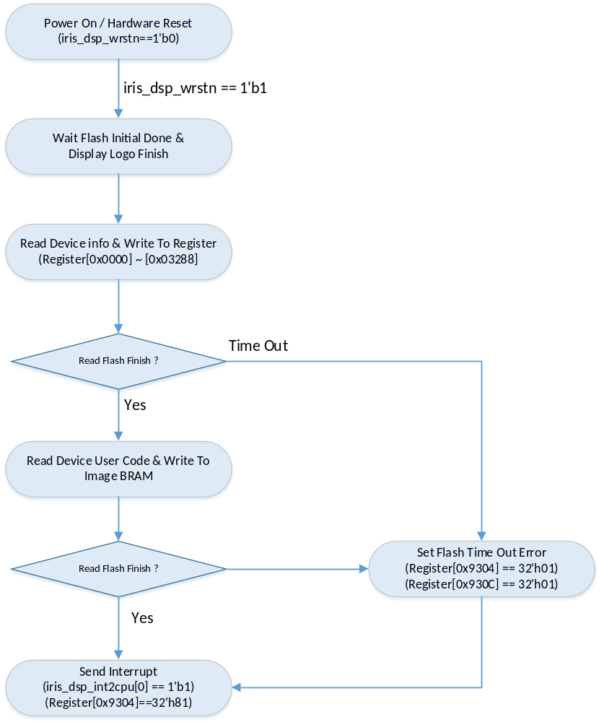
Figure 3 DSP Initial Sequence

  - DSP Configure Sequence
    - Device Info Configure Sequence
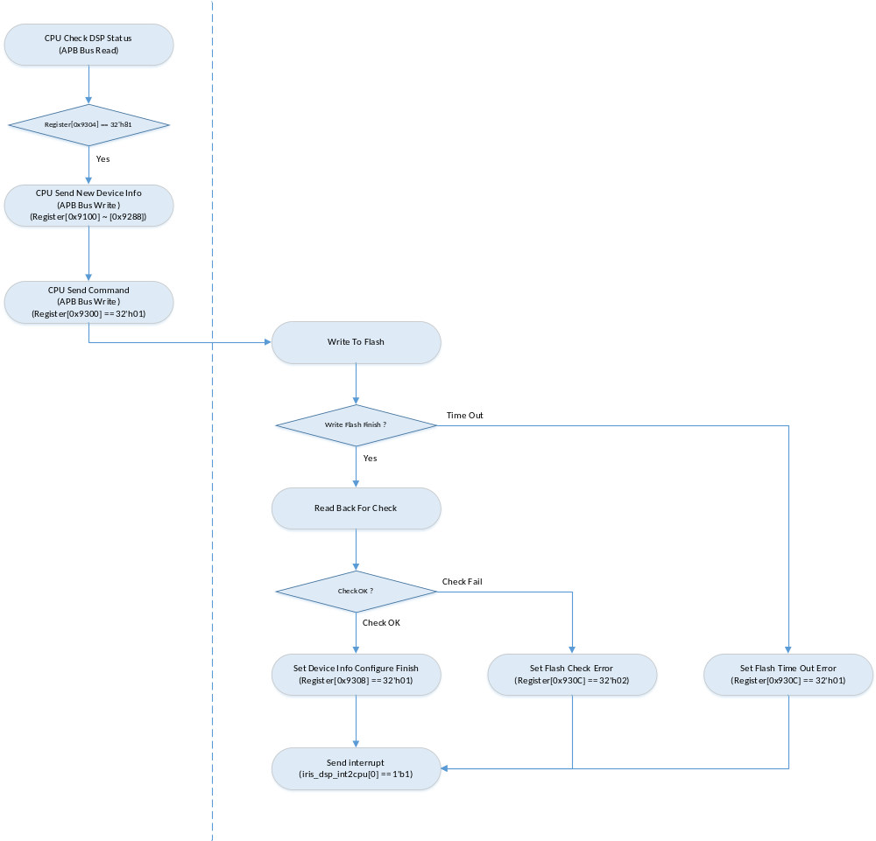
Figure 4 Device Info Configure Sequence

    - Device User Code Configure Sequence (Test Only)
Device User Code共64K Byte，在指令发送前，CPU通过AHB Bus写入DSP内Image BRAM.
AHB Bus Address: 32’h3000_0000 ~ 32’h3008_FFFF
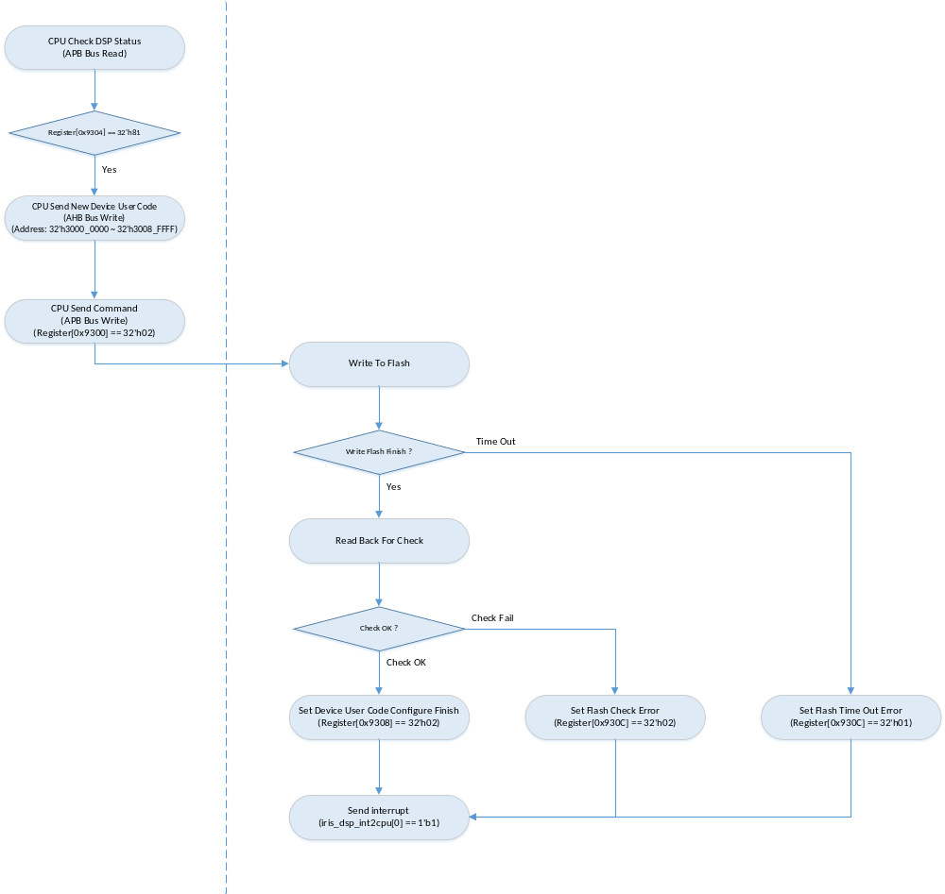
Figure 5 Device User Code Configure Sequence

    - Display Image Configure Sequence
Display Image Configure用于修改开机画面等功能显示图片.CPU在发生Display Image Configure指令前，需先设置Register[0x9310]，以指定当前需要修改的具体图片

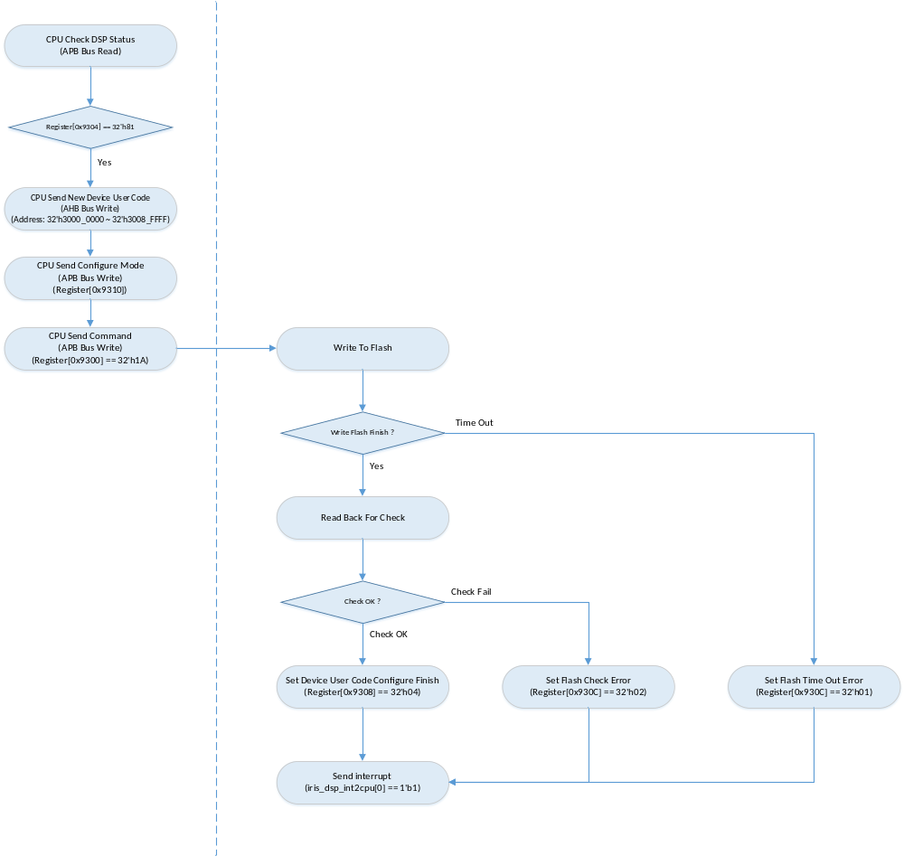
Figure 6 Display Image Configure Sequence

  - Template Encode Sequence
CPU在发送模板编码指令前，必须先设置Register[0x9318]，以指定DSP的编码模式，若不设置该Register，DSP将以上次M0的设置进行编码操作
DSP图像编码完成后，将模板的参数信息(分数等)写入Register[0x9348] ~ [0x93AC]，CPU可在收到中断信息后，读取参数信息，以判断模板是否有效
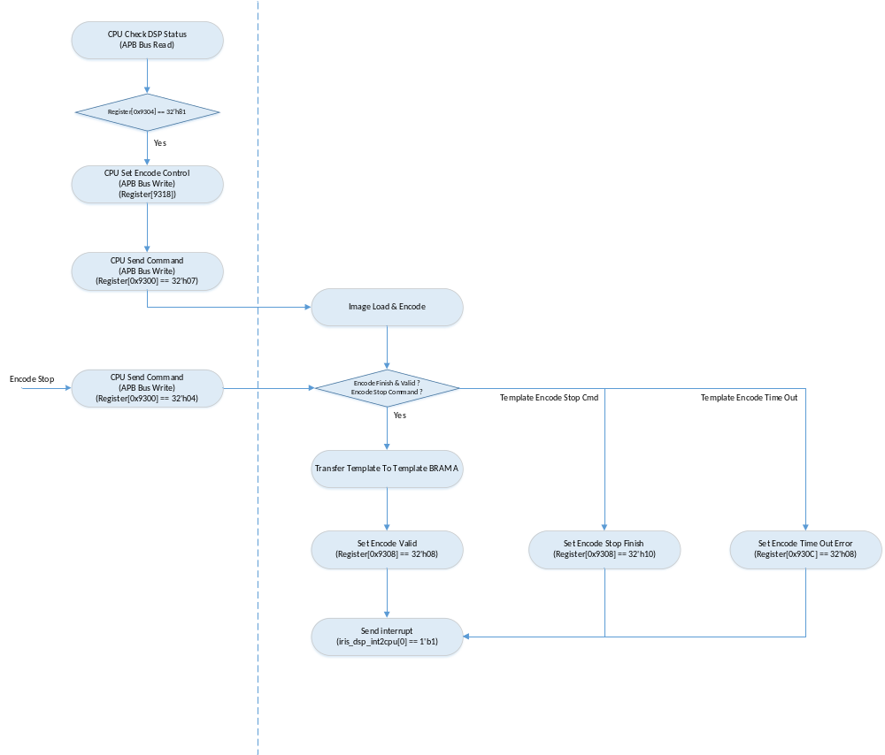
Figure 6 Template Encode Sequence

  - Template Match Sequence
Template Match分为Normal Mode和Download Mode，其中，Normal Mode从Flash中读取Template用于识别，适用于虹膜锁操作；Download Mode则通过AHB Bus下载Template进行识别操作，适用于USB操作。
CPU发送识别指令前，需先设置Register[0x931C]，以指定识别模式。若使用Download Mode，需同时指定AHB Bus下载的Template总数(最大限制为64，0 ~ 63)，同时，下载Template B(比对模板)时，需从地址32‘h3009_2000开始。

Normal Mode下，CPU检测到DSP模板识别成功后，读取Register[0x93C0] ~ [0x93CC]，以确定识别成功模板的Index和分数等信息
Download Mode下，CPU通过AHB Bus读取每次模板比对后的结果。AHB Bus Address: 32’h3009_4000 ~ 32’h3009_4040

Note: Template Match Download Mode, 仅适用于FPGA，ASIC无需进行测试
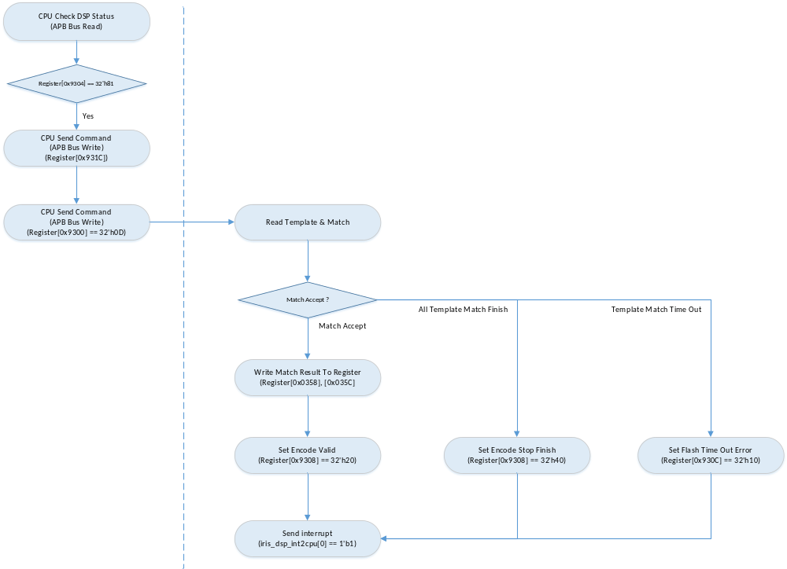
Figure 7 Template Match Sequence

  - Template Remove/Erase Sequence
Template Remove分为两种模式，由CPU在发送Template Remove/Erase指令前，通过Register[0x9310]进行设置。若CPU写入32‘h01，DSP在执行指令时，将同时删除Template Flag和Template Data；若CPU写入32‘h00，DSP在执行指令时，仅删除Template Flag；若CPU不设置该寄存器，DSP将延用上次CPU的设置。

CPU发送Template Remove指令前，需通过Register[0x9314]指定需要删除的Template Index，该值不能超出DSP所支持的最大模板范围。

DSP Template Remove Command: 32’h0E
DSP Template Erase Command: 32’h0B
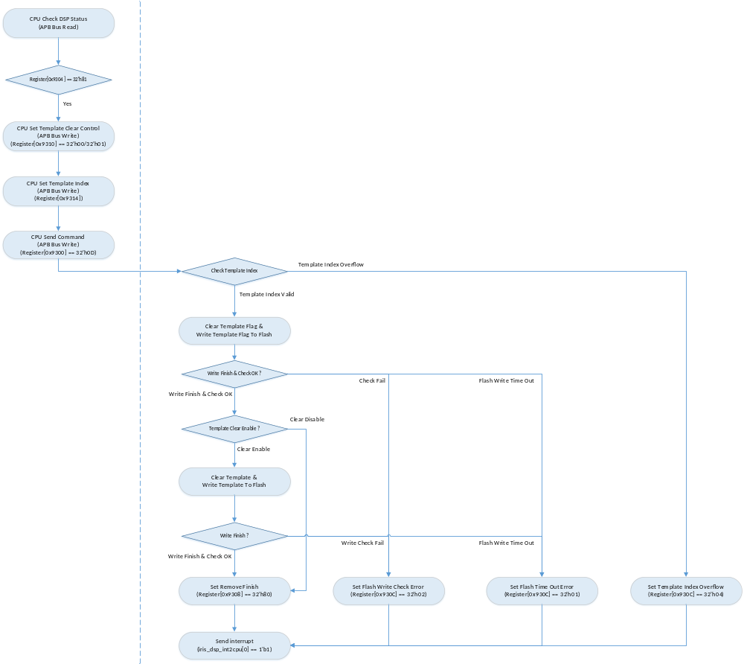
Figure 8 Template Remove / Erase Sequence

  - Template Write/Read Sequence
    - Template Write
Template Write指令用于将DSP编码得到的模板数据或CPU下发的模板数据写入Flash中。CPU在发送指令前，需通过Register[0x9314]，指定模板写入的地址(Template Index)，以及读取的Template BRAM。

CPU通过AHB Bus向DSP下发模板数据
Template BRAM A: 32’h3009_0000 ~ 32’h3009_1FFF
Template BRAM B: 32’h3009_2000 ~ 32’h3000_3FFF
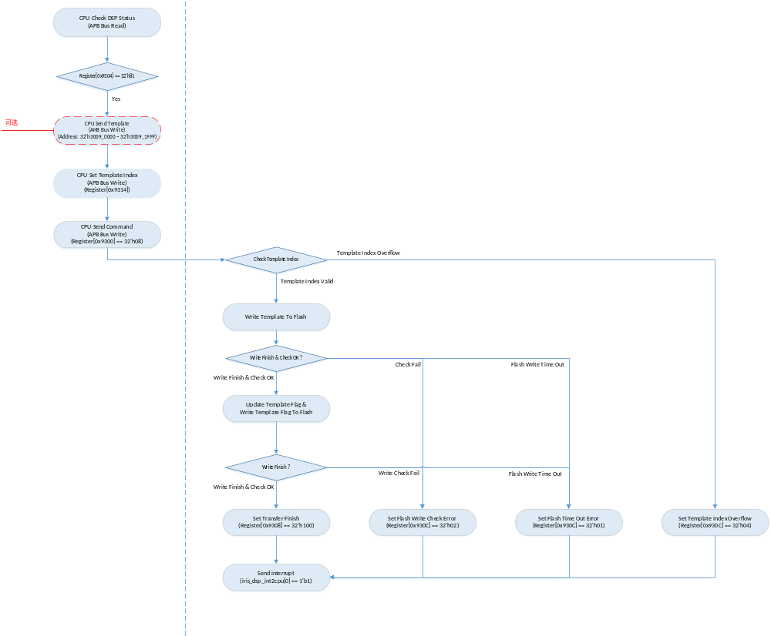
Figure 9 Template Write Sequence

    - Template Read Sequence
Template Read指令，用于从Flash中读取指定的模板数据。在DSP完成Template Read指令后，CPU可以通过AHB Bus读取Template BRAM，从而得到模板数据。
CPU通过AHB Bus从DSP读取模板数据
Template BRAM A: 32’h3009_0000 ~ 32’h3009_1FFF
Template BRAM B: 32’h3009_2000 ~ 32’h3000_3FFF
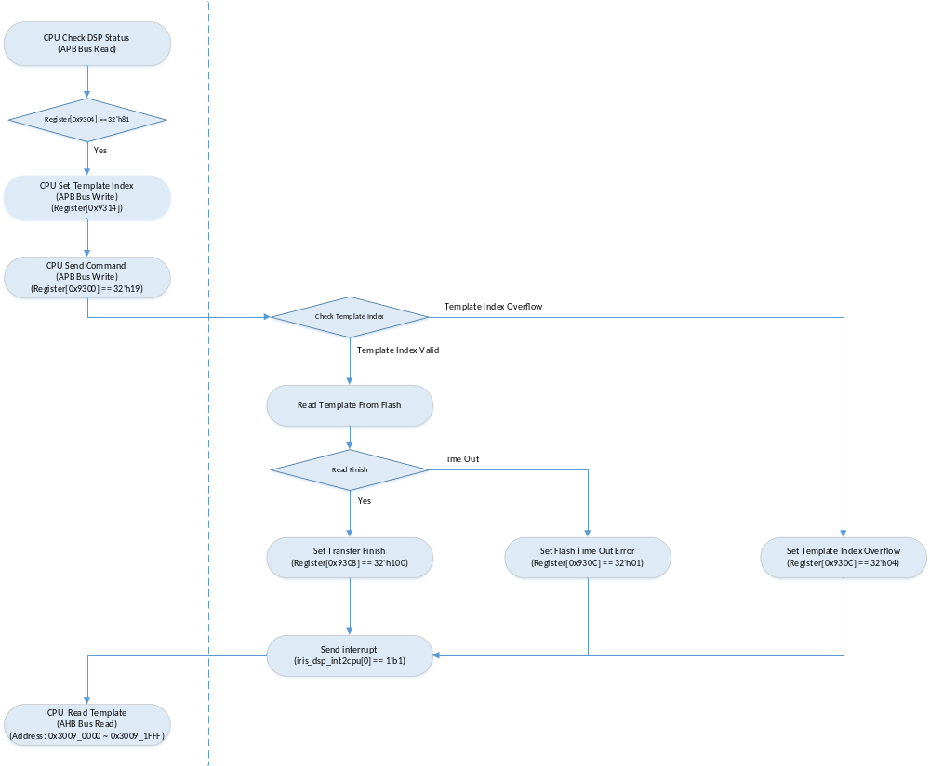

Figure 10 Template Read Sequence

- DSP_CTRL_TOP模块
dsp_ctrl_top模块用于AHB/APB Bus读、写操作，执行CPU发送的各指令。

  - DSP_CTRL_TOP模块结构图
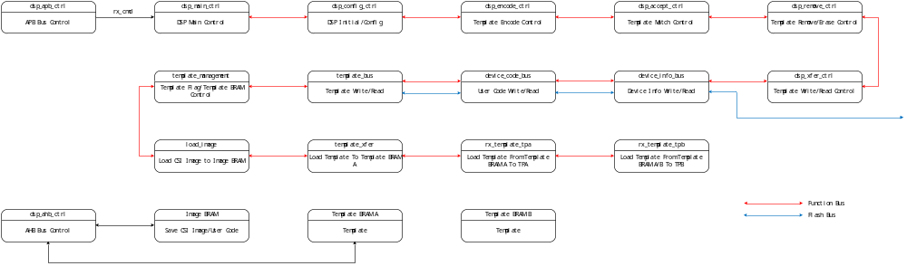
Figure 11 dsp_ctrl_top模块结构图

  - DSP_CTRL_TOP模块输入输出信号
Table 2 dsp_ctrl_top模块输入输出信号
No | Name | Width | I/O | Source/  Destination | Description
1 | wclk | 1 | I | CRM | dsp working clock
2 | wrstn | 1 | I | CRM | dsp working reset
3 | hclk | 1 | I | cm0_sys_top | AHB bus clock
4 | hrstn | 1 | I | cm0_sys_top | AHB bus reset
5 | dsp_status_intr | 1 | O | cm0_sys_top | DSP Status Interrupt. High Active
6 | hsel | 1 | I | cm0_sys_top | AHB Bus Select
7 | htrans | 2 | I | cm0_sys_top | AHB Bus Transfer Type
8 | hsize | 3 | I | cm0_sys_top | AHB Bus Data Size Type
9 | hwrite | 1 | I | cm0_sys_top | AHB Bus Write Enable. High Active
10 | haddr | 32 | I | cm0_sys_top | AHB Bus Write/Read Address
11 | hwdata | 32 | I | cm0_sys_top | AHB Bus Write Data
12 | hrdata | 32 | O | cm0_sys_top | AHB Bus Read Data
13 | hready | 1 | I | cm0_sys_top | AHB Bus Ready Feedback
14 | hresp | 2 | O | cm0_sys_top | AHB Bus Response. Set to 2’h0
15 | hreadyout | 1 | O | cm0_sys_top | AHB Bus Ready
16 | penable | 1 | I | cm0_sys_top | APB Bus Enable
17 | psel | 1 | I | cm0_sys_top | APB Bus Select
18 | pwrite | 1 | I | cm0_sys_top | APB Bus Write Enable. High Active
19 | paddr | 10 | I | cm0_sys_top | APB Bus Write/Read Address
20 | pwdata | 32 | I | cm0_sys_top | APB Bus Write Data
21 | prdata | 32 | O | cm0_sys_top | APB Bus Read Data
22 | pready | 1 | O | cm0_sys_top | APB Bus Ready
23 | pslverr | 1 | O | cm0_sys_top | APB Bus Slave Error. Set to 1’b0
24 | isp_rx_image_width | 16 | O | dsp_isp_top | ISP Image Width Threshold
25 | isp_rx_image_height | 16 | O | dsp_isp_top | ISP Image Height Threshold
26 | isp_rx_video_o_width | 16 | O | dsp_isp_top | ISP Output Video Width
27 | isp_rx_video_o_height | 16 | O | dsp_isp_top | ISP Output Video Height
28 | isp_rx_clip_win_select | 2 | O | dsp_isp_top | ISP Image Clip Window Select.  2’b01: Left Eye
29 | isp_rx_clip_win_l_t | 12 | O | dsp_isp_top | ISP Left Eye Image Clip Window
30 | isp_rx_clip_win_l_l | 12 | O | dsp_isp_top | ISP Left Eye Image Clip Window
31 | isp_rx_clip_win_l_r | 12 | O | dsp_isp_top | ISP Left Eye Image Clip Window
32 | isp_rx_clip_win_l_b | 12 | O | dsp_isp_top | ISP Left Eye Image Clip Window
33 | isp_rx_clip_win_r_t | 12 | O | dsp_isp_top | ISP Right Eye Image Clip Window
34 | isp_rx_clip_win_r_l | 12 | O | dsp_isp_top | ISP Right Eye Image Clip Window
35 | isp_rx_clip_win_r_r | 12 | O | dsp_isp_top | ISP Right Eye Image Clip Window
36 | isp_rx_clip_win_r_b | 12 | O | dsp_isp_top | ISP Right Eye Image Clip Window
37 | isp_rx_total_num | 17 | O | dsp_isp_top
38 | isp_rx_th_min | 17 | O | dsp_isp_top
39 | isp_rx_th_mid | 17 | O | dsp_isp_top
40 | isp_rx_th_max | 17 | O | dsp_isp_top
41 | isp_rx_set_mid | 8 | O | dsp_isp_top
42 | isp_rx_set_rng | 8 | O | dsp_isp_top
43 | isp_rx_rng_min | 8 | O | dsp_isp_top
44 | isp_rx_gain | 12 | O | dsp_isp_top
45 | isp_rx_shutter_max | 13 | O | dsp_isp_top
46 | isp_rx_shutter_min | 13 | O | dsp_isp_top
47 | isp_rx_hl_max | 16 | O | dsp_isp_top
48 | isp_rx_hl_min | 8 | O | dsp_isp_top
49 | isp_rx_max_ratio | 12 | O | dsp_isp_top
50 | isp_gain_ctrl | 16 | I | dsp_isp_top | ISP Image Gain Control
51 | isp_gain_ctrl_valid | 1 | I | dsp_isp_top | ISP Image Gain Control Valid
52 | isp_shut_ctrl | 16 | I | dsp_isp_top | ISP Image Shutter Control
53 | isp_shut_ctrl | 1 | I | dsp_isp_top | ISP Image Shutter Control Valid
54 | isp_image_sof | 1 | I | dsp_isp_top | ISP Image Frame Start
55 | isp_image_eof | 1 | I | dsp_isp_top | ISP Image Frame End
56 | isp_image_data | 10 | I | dsp_isp_top | ISP Image Frame Data
57 | isp_image_dval | 1 | I | dsp_isp_top | ISP Image Frame Data Valid(768 * 768)
58 | isp_image_accept | 1 | I | dsp_isp_top | ISP Image Frame Accept
59 | flash_init_done | 1 | I | ext_flash_top | Flash Control Initial Finish
60 | flash_finish | 1 | I | ext_flash_top | Flash Write/Read Finish
61 | flash_rstn | 1 | I | ext_flash_top | Flash Software Reset. Low Active
62 | flash_wr | 1 | O | ext_flash_top | Flash Write Start. One Cycle
63 | flash_rd | 1 | O | ext_flash_top | Flash Read Start. One Cycle
64 | flash_addr | 24 | O | ext_flash_top | Flash Write/Read Byte Address
65 | flash_cnt | 16 | O | ext_flash_top | Flash Write/Read Page Count
66 | flash_wr_req | 1 | I | ext_flash_top | Flash Write One Page Request
67 | flash_wr_data | 4 | O | ext_flash_top | Flash Write Data
68 | flash_wr_dval | 1 | O | ext_flash_top | Flash Write Data Valid
69 | flash_rd_data | 4 | I | ext_flash_top | Flash Read Data
70 | flash_rd_dval | 1 | I | ext_flash_top | Flash Read Data Valid
71 | core_encrypt_init_start | 1 | O | dsp_core_top | Template Encrypt Initial Start
72 | core_encrypt_init_finish | 1 | I | dsp_core_top | Template Encrypt Initial Finish
73 | core_encrypt_en | 1 | O | dsp_core_top | Template Encrypt Enable
74 | core_encrypt_key | 256 | O | dsp_core_top | Template Encrypt Key
75 | core_encrypt_key_val | 1 | O | dsp_core_top | Template Encrypt Key Valid
76 | core_encode_rstn | 1 | O | dsp_core_top | Template Encode Software Reset. Low Active
77 | core_encode_start | 1 | O | dsp_core_top | Template Encode Start. One Cycle
78 | core_encode_finish | 1 | I | dsp_core_top | Template Encode Finish
79 | core_encode_valid | 1 | I | dsp_core_top | Template Encode Valid
80 | core_rx_encode_reg00 | 16 | O | dsp_core_top | Template Encode Control
81 | core_rx_encode_reg01 | 16 | O | dsp_core_top | Template Encode Control
82 | core_rx_encode_reg02 | 16 | O | dsp_core_top | Template Encode Control
83 | core_rx_encode_reg03 | 16 | O | dsp_core_top | Template Encode Control
84 | core_rx_encode_reg04 | 16 | O | dsp_core_top | Template Encode Control
85 | core_rx_encode_reg05 | 16 | O | dsp_core_top | Template Encode Control
86 | core_rx_encode_reg06 | 16 | O | dsp_core_top | Template Encode Control
87 | core_rx_encode_reg07 | 16 | O | dsp_core_top | Template Encode Control
88 | core_rx_encode_reg08 | 16 | O | dsp_core_top | Template Encode Control
88 | core_rx_encode_reg09 | 16 | O | dsp_core_top | Template Encode Control
90 | core_rx_encode_reg0A | 16 | O | dsp_core_top | Template Encode Control
91 | core_rx_encode_reg0B | 16 | O | dsp_core_top | Template Encode Control
92 | core_rx_encode_reg0C | 16 | O | dsp_core_top | Template Encode Control
93 | core_rx_encode_reg0D | 16 | O | dsp_core_top | Template Encode Control
94 | core_rx_encode_reg0E | 16 | O | dsp_core_top | Template Encode Control
95 | core_rx_encode_reg0F | 16 | O | dsp_core_top | Template Encode Control
96 | core_encode_reg00 | 16 | I | dsp_core_top | Template Encode Result
97 | core_encode_reg01 | 16 | I | dsp_core_top | Template Encode Result
98 | core_encode_reg02 | 16 | I | dsp_core_top | Template Encode Result
99 | core_encode_reg03 | 16 | I | dsp_core_top | Template Encode Result
100 | core_encode_reg04 | 16 | I | dsp_core_top | Template Encode Result
101 | core_encode_reg05 | 16 | I | dsp_core_top | Template Encode Result
102 | core_encode_reg06 | 16 | I | dsp_core_top | Template Encode Result
103 | core_encode_reg07 | 16 | I | dsp_core_top | Template Encode Result
104 | core_encode_reg08 | 16 | I | dsp_core_top | Template Encode Result
105 | core_encode_reg09 | 16 | I | dsp_core_top | Template Encode Result
106 | core_encode_reg0A | 16 | I | dsp_core_top | Template Encode Result
107 | core_encode_reg0B | 16 | I | dsp_core_top | Template Encode Result
108 | core_encode_reg0C | 16 | I | dsp_core_top | Template Encode Result
109 | core_encode_reg0D | 16 | I | dsp_core_top | Template Encode Result
110 | core_encode_reg0E | 16 | I | dsp_core_top | Template Encode Result
111 | core_encode_reg0F | 16 | I | dsp_core_top | Template Encode Result
112 | core_match_start | 1 | O | dsp_core_top | Template Match Start
113 | core_match_tpb_id | 16 | O | dsp_core_top | Template Match Template Index
114 | core_match_finish | 1 | I | dsp_core_top | Template Match Finish
115 | core_match_accept | 1 | I | dsp_core_top | Template Match Accept
116 | core_rx_match_reg00 | 16 | O | dsp_core_top | Template Match Control
117 | core_rx_match_reg01 | 16 | O | dsp_core_top | Template Match Control
118 | core_match_accept_score | 16 | I | dsp_core_top | Template Match Accept Score
119 | core_match_accept_tpb_id | 16 | I | dsp_core_top | Template Match Accept Template Index
120 | core_match_tpb_empty | 1 | I | dsp_core_top | Template Match Template B Empty
121 | core_image_dow_sample | 1 | I | dsp_core_top | Image Read Sample Down Enable  1’b1: Enable  1’b0: Disable
122 | core_image_original_x | 10 | I | dsp_core_top | Image Read Original Point
123 | core_image_original_y | 10 | I | dsp_core_top | Image Read Original Point
124 | core_image_bram_en | 1 | I | dsp_core_top | Image BRAM Read Enable
125 | core_image_bram_addr | 16 | I | dsp_core_top | Image BRAM Read Address(258 * 258)
126 | core_image_bram_rd_data | 8 | O | dsp_core_top | Image BRAM Read Data. Delay 7 Cycle
127 | core_tmpl_bram_en | 1 | O | dsp_core_top | Template BRAM Read Enable
128 | core_tmpl_bram_addr | 9 | O | dsp_core_top | Template BRAM Read Address
129 | core_tmpl_bram_rd_data | 128 | O | dsp_core_top | Template BRAM Read Data
130 | core_match_tpa_we | 1 | O | dsp_core_top | Match.Template A Write Enable
131 | core_match_tpa_addr | 9 | O | dsp_core_top | Match.Template A Write Address
132 | core_match_tpa_wr_data | 128 | O | dsp_core_top | Match.Template A Write Data
133 | core_match_tpb_we | 1 | O | dsp_core_top | Match.Template B Write Enable
134 | core_match_tpb_addr | 9 | O | dsp_core_top | Match.Template B Write Address
135 | core_match_tpb_wr_data | 128 | O | dsp_core_top | Match.Template B Write Data

  - dsp_ctrl_top模块内部BRAM

    - Image BRAM

Image BRAM用于存储:
- 初始化过程中，由Flash读取的User Code，用于启动CPU；
- 配置过程中，由CPU写入的New User Code；
- 编码过程中，由ISP输入的图像数据，该图像数据由dsp_core_top模块读取，以完成图像编码操作；
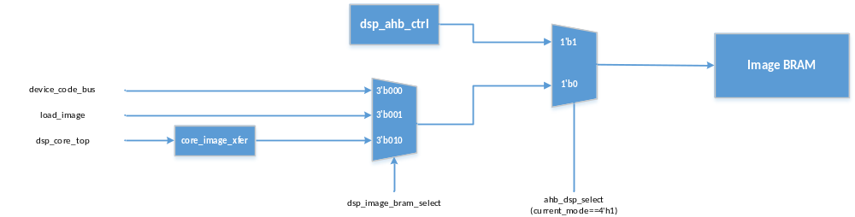
Figure Image_BRAM

Image BRAM的大小为147456 * 32 Bit(576K Byte)，由36个16K Byte的SRAM组成。Image BRAM的读数据延时为3 Cycle。其中，读数据通道(dsp_core_top)的读数据延时为7 Cycle，且该通道读取数据大小为256 * 256 * 8 Bit。

AHB Bus只有在DSP处于Idle Status(Register[0x9304]==32‘h81)时，可以对Image BRAM进行读、写操作。
对于Image BRAM，AHB Bus的读、写地址范围为: 32’h3000_0000 ~ 32’h3008_FFFF

    - Template BRAM
Template BRAM用于存储编码得到的模板数据，Template BRAM A/B组成Ping-Pang结构，以加快DSP进行模板识别的速度。

      - Template BRAM A
Template BRAM A用于存储:
- 图像编码后得到的模板数据
- AHB Bus下发的模板数据
- 模板识别操作时，与Template BRAM B组成Ping-Pang结构，存储从Flash中读取的模板数据
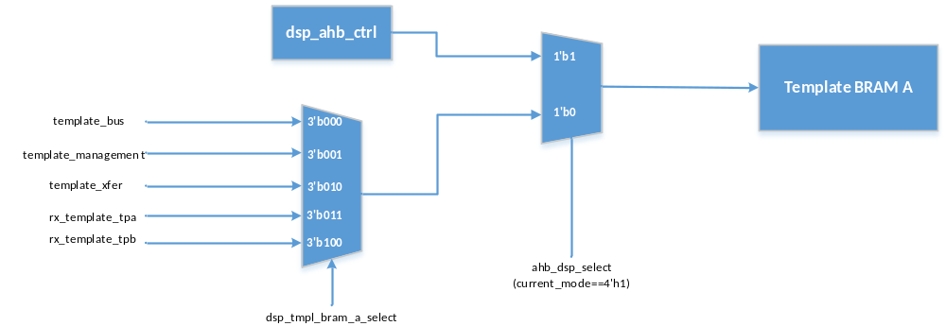
Figure Template BRAM A

Template BRAM的大小为2048 * 32 Bit(8K Byte)，读数据延时为3 Cycle。

AHB Bus只有在DSP处于Idle Status(Register[0x9304]==32‘h81)时，可以对Template BRAM A进行读、写操作.
对于Template BRAM A，AHB Bus的读、写地址范围为: 32’h3009_0000 ~ 32’h3009_1FFF

      - Template BRAM B
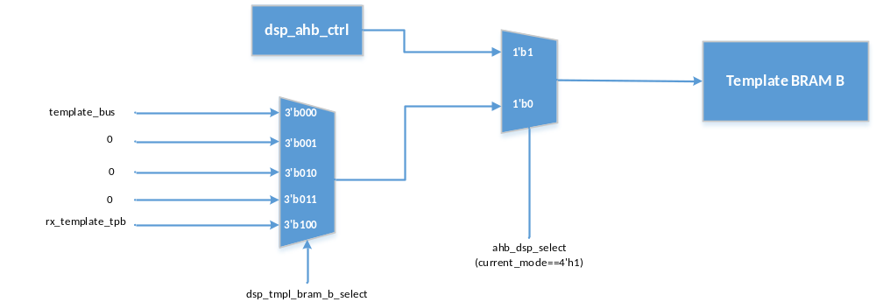
Figure Template BRAM B

AHB Bus只有在DSP处于Idle Status(Register[0x9304]==32‘h81)时，可以对Template BRAM B进行读、写操作.
对于Template BRAM B，AHB Bus的读、写地址范围为: 32’h3009_2000 ~ 32’h3009_3FFF

      - Match Result BRAM
Match Result BRAM用于存储：
- 在Download Mode下，DSP进行模板识别操作时，得到的全部比对结果
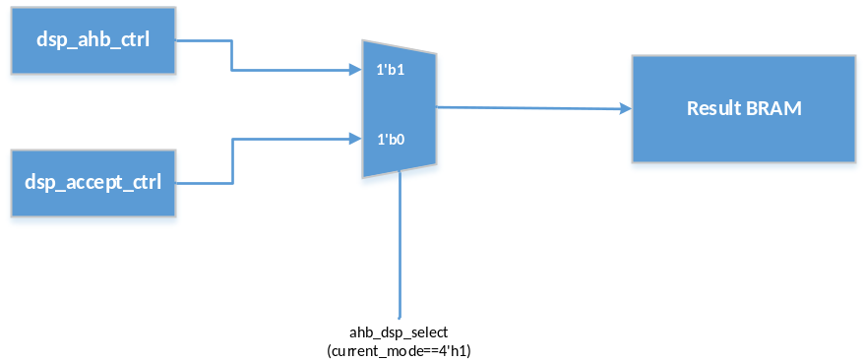
Figure Match Result BRAM

每个模板的比对结果包含Template ID和比对分数，共32 Bit，其中Bit[31:16]为Template ID，Bit[15:0]为比对分数

AHB Bus只有在DSP处于Idle Status(Register[0x9304]==32‘h81)时，可以对Match Result BRAM进行读、写操作.
对于Match Result BRAM，AHB Bus的读、写地址范围为: 32’h3009_4000 ~ 32’h3009_4040

      - DF
  - dsp_apb_ctrl模块
(待续)

  - dsp_ahb_ctrl模块
(待续)

  - dsp_main_ctrl模块
    - dsp_main_ctrl输入输出信号

    - dsp_main_ctrl模块状态图
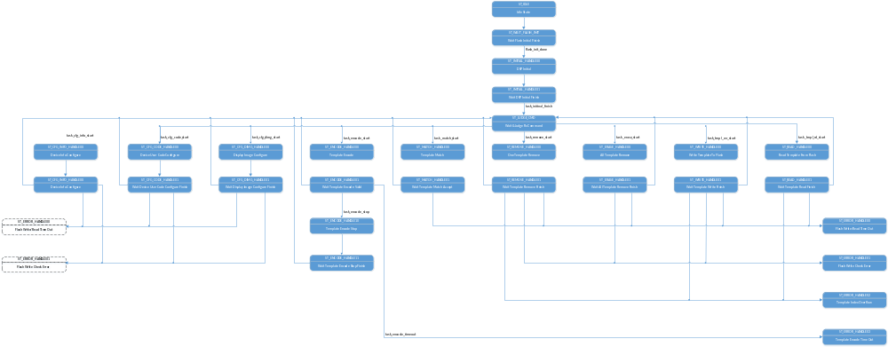
Figure 12 dsp_main_ctrl模块状态图

    - df

  - dsp_config_ctrl模块

dsp_config_ctrl模块用于完成DSP初始化和配置操作。用户可以根据实际需求，选择对Device Info和Device User Code分别进行配置。
在操作过程中，仅通过Function Bus启动device_info_bus, device_code_bus模块。

    - dsp_config_ctrl模块输入输出信号

Table 3 dsp_config_ctrl模块输入输出信号
No | Name | Width | I/O | Source/  Destination | Description
1 | clk | 1 | I | CRM | dsp working clock
2 | rstn | 1 | I | CRM | dsp working reset
3 | fbus_start_addr_i | 8 | I |  | Function Start Bus Address
4 | fbus_start_data_i | 4 | I |  | Function Start Bus Data
5 | fbus_start_addr_o | 8 | O |  | Function Start Bus Address
6 | fbus_start_data_o | 4 | O |  | Function Start Bus Data
7 | fbus_finish_addr_i | 8 | I |  | Function Finish Bus Address
8 | fbus_finish_data_i | 4 | I |  | Function Finish Bus Data
9 | fbus_finish_addr_o | 8 | O |  | Function Finish Bus Address
10 | fbus_finish_data_o | 4 | O |  | Function Finish Bus Data

    - dsp_config_ctrl模块状态图
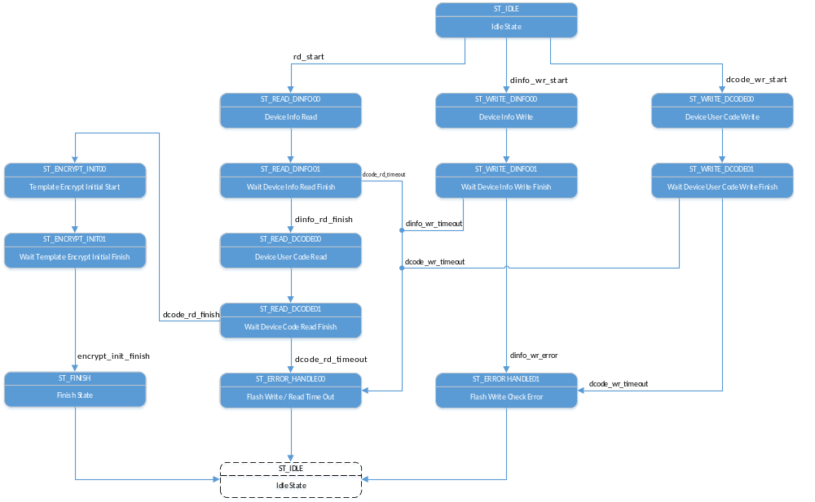
Figure 13 dsp_config_ctrl模块状态图

  - dsp_encode_ctrl模块

dsp_encode_ctrl模块用于采集ISP输入的图像数据并进行编码，在编码成功后，将模板数据存入Template BRAM A中。
在操作过程中，dsp_encode_ctrl模块仅通过Function Bus启动load_image, template_xfer模块。

    - dsp_encode_ctrl模块输入输出信号

Table 3 dsp_encode_ctrl模块输入输出信号
No | Name | Width | I/O | Source/  Destination | Description
1 | clk | 1 | I | CRM | dsp working clock
2 | rstn | 1 | I | CRM | dsp working reset
3 | encrypt_init_start | 1 | O | dsp_core_top | Template Encrypt Initial Start
4 | encrypt_init_finish | 1 | I | dsp_core_top | Template Encrypt Initial Finish
5 | core_encode_rstn | 1 | O | dsp_core_top | Template Encode Software Reset  High Active. Hold 32 Cycle
6 | core_encode_start | 1 | O | dsp_core_top | Template Encode Start
7 | core_encode_finish | 1 | I | dsp_core_top | Template Encode Finish
8 | core_encode_valid | 1 | I | dsp_core_top | Template Encode Valid
9 | fbus_start_addr_i | 8 | I |  | Function Start Bus Address
10 | fbus_start_data_i | 4 | I |  | Function Start Bus Data
11 | fbus_start_addr_o | 8 | O |  | Function Start Bus Address
12 | fbus_start_data_o | 4 | O |  | Function Start Bus Data
13 | fbus_finish_addr_i | 8 | I |  | Function Finish Bus Address
14 | fbus_finish_data_i | 4 | I |  | Function Finish Bus Data
15 | fbus_finish_addr_o | 8 | O |  | Function Finish Bus Address
16 | fbus_finish_data_o | 4 | O |  | Function Finish Bus Data

    - dsp_encode_ctrl模块状态图
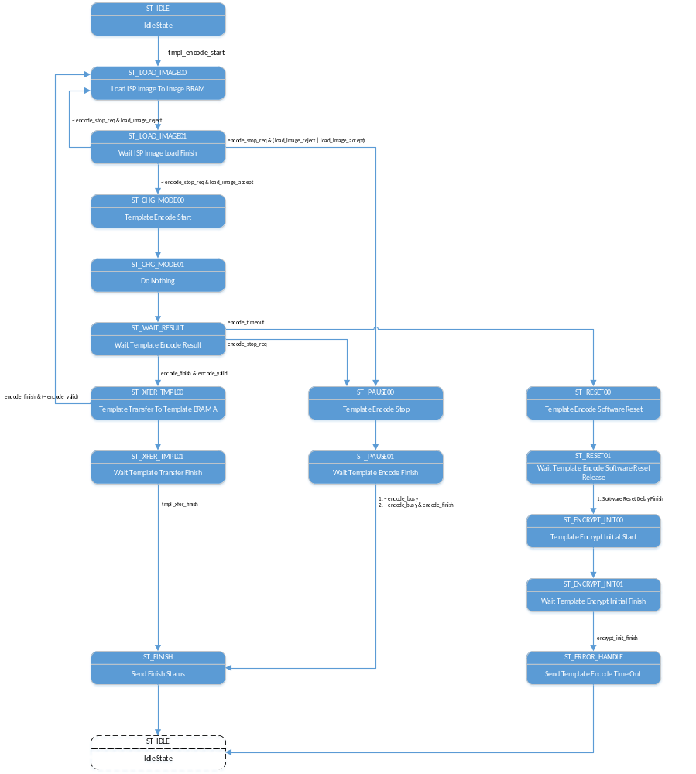
Figure 14 dsp_encode_ctrl模块状态图

    - df

  - dsp_accept_ctrl模块
dsp_accept_ctrl模块用于实现模板识别操作。
在操作过程中，仅通过Function Bus启动rx_template_tpa, rx_template_tpb, template_bus, template_management模块。

    - dsp_accept_ctrl模块输入输出信号

Table dsp_accept_ctrl模块输入输出信号
No | Name | Width | I/O | Source/  Destination | Description
1 | clk | 1 | I | CRM | dsp working clock
2 | rstn | 1 | I | CRM | dsp working reset
3 | flash_rstn | 1 | O | ext_flash_top | Flash Software Reset. Low Active
4 | core_match_tpb_empty | 1 | I | dsp_core_top | Match.Template B Empty
5 | core_match_start | 1 | O | dsp_core_top | Template Match Start
6 | core_match_tpb_id_o | 16 | O | dsp_core_top | Template Match Index
7 | core_match_finish | 1 | I | dsp_core_top | Template Match Finish
8 | core_match_accept | 1 | I | dsp_core_top | Template Match Accept
9 | core_match_tpb_id_i | 16 | I | dsp_core_top | Template Matched Index
10 | fbus_start_addr_i | 8 | I |  | Function Start Bus Address
11 | fbus_start_data_i | 4 | I |  | Function Start Bus Data
12 | fbus_start_addr_o | 8 | O |  | Function Start Bus Address
13 | fbus_start_data_o | 4 | O |  | Function Start Bus Data
14 | fbus_finish_addr_i | 8 | I |  | Function Finish Bus Address
15 | fbus_finish_data_i | 4 | I |  | Function Finish Bus Data
16 | fbus_finish_addr_o | 8 | O |  | Function Finish Bus Address
17 | fbus_finish_data_o | 4 | O |  | Function Finish Bus Data

    - dsp_accept_ctrl模块状态图
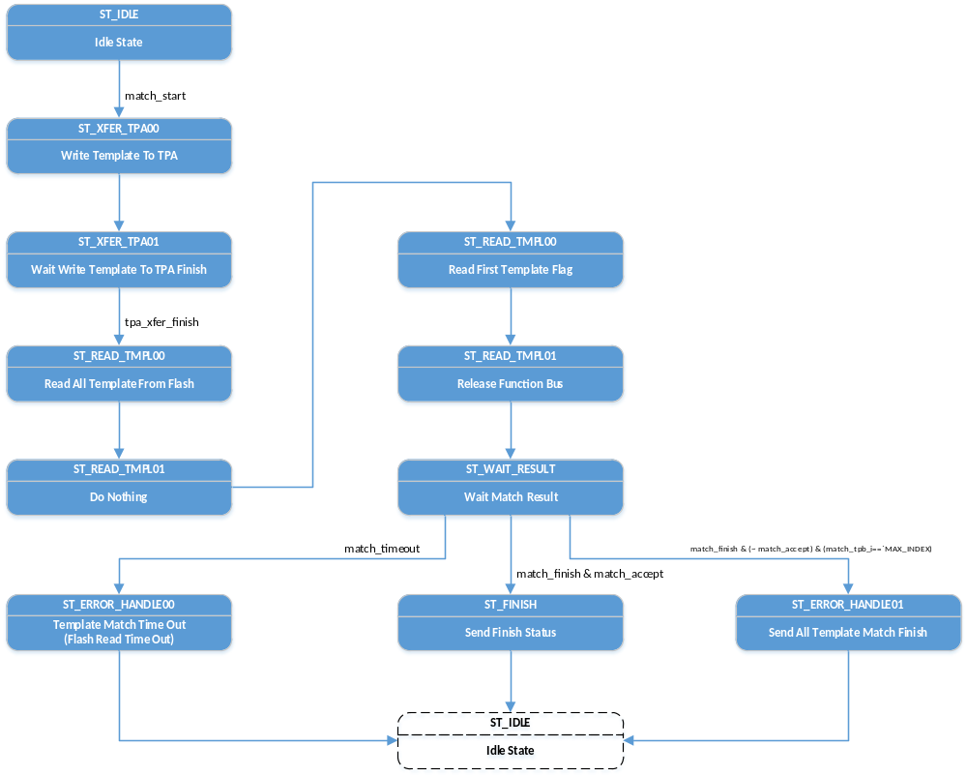
Figure dsp_accept_ctrl模块状态图

    - df

  - dsp_remove_ctrl模块
dsp_remove_ctrl模块用于单个或全部模板删除。
在操作过程中，仅通过Function Bus启动template_management，device_info_bus, template_bus模块。

    - dsp_remove_ctrl模块输入输出信号

Table dsp_remove_ctrl模块输入输出信号
No | Name | Width | I/O | Source/  Destination | Description
1 | clk | 1 | I | CRM | dsp working clock
2 | rstn | 1 | I | CRM | dsp working reset
3 | tmpl_clear_en | 1 | I | dsp_apb_ctrl | Template Clear Enable. High Active
4 | tmpl_index_i | 16 | I | dsp_apb_ctrl | Template Index Input
5 | tmpl_index_o | 16 | O | template_bus | Template Index Output
6 | fbus_start_addr_i | 8 | I |  | Function Start Bus Address
7 | fbus_start_data_i | 4 | I |  | Function Start Bus Data
8 | fbus_start_addr_o | 8 | O |  | Function Start Bus Address
9 | fbus_start_data_o | 4 | O |  | Function Start Bus Data
10 | fbus_finish_addr_i | 8 | I |  | Function Finish Bus Address
11 | fbus_finish_data_i | 4 | I |  | Function Finish Bus Data
12 | fbus_finish_addr_o | 8 | O |  | Function Finish Bus Address
13 | fbus_finish_data_o | 4 | O |  | Function Finish Bus Data

    - dsp_remove_ctrl模块状态图
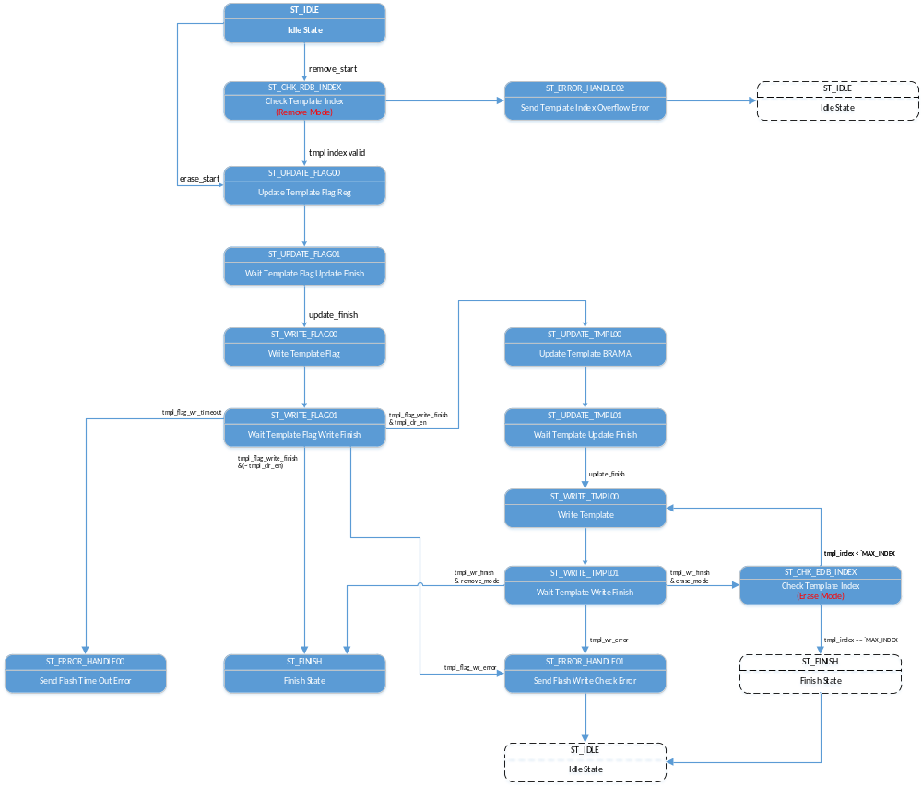
Figure dsp_remove_ctrl模块状态图

    - df

  - dsp_xfer_ctrl模块

dsp_xfer_ctrl模块用于实现模板输出的读、写操作.
在操作过程中，仅通过Function Bus启动template_bus，template_management，device_info_bus模块

    - dsp_xfer_ctrl模块输入输出信号

Table dsp_xfer_ctrl模块输入输出信号
No | Name | Width | I/O | Source/  Destination | Description
1 | clk | 1 | I | CRM | dsp working clock
2 | rstn | 1 | I | CRM | dsp working reset
3 | tmpl_index_i | 16 | I | dsp_apb_ctrl | Template Index Input
4 | tmpl_index_o | 16 | O | template_bus | Template Index Output
5 | fbus_start_addr_i | 8 | I |  | Function Start Bus Address
6 | fbus_start_data_i | 4 | I |  | Function Start Bus Data
7 | fbus_start_addr_o | 8 | O |  | Function Start Bus Address
8 | fbus_start_data_o | 4 | O |  | Function Start Bus Data
9 | fbus_finish_addr_i | 8 | I |  | Function Finish Bus Address
10 | fbus_finish_data_i | 4 | I |  | Function Finish Bus Data
11 | fbus_finish_addr_o | 8 | O |  | Function Finish Bus Address
12 | fbus_finish_data_o | 4 | O |  | Function Finish Bus Data

    - dsp_xfer_ctrl模块状态图
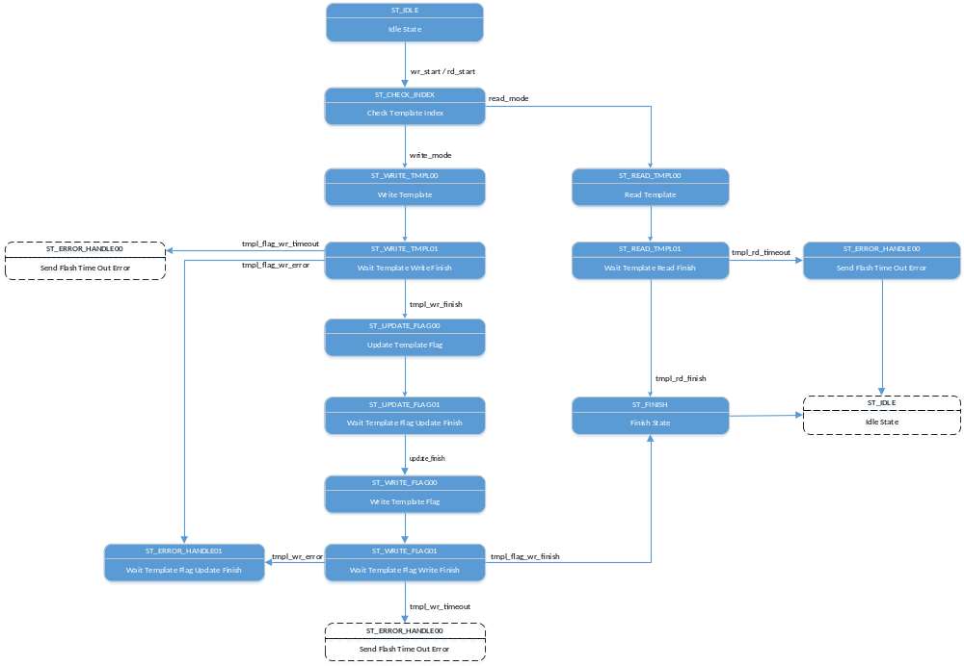
Figure dsp_xfer_ctrl模块状态图

    - df
  - fd

- DF

