_________________________________________________

HALO Design

Language Reference and

Graphical Notations

Draft Version 0.2

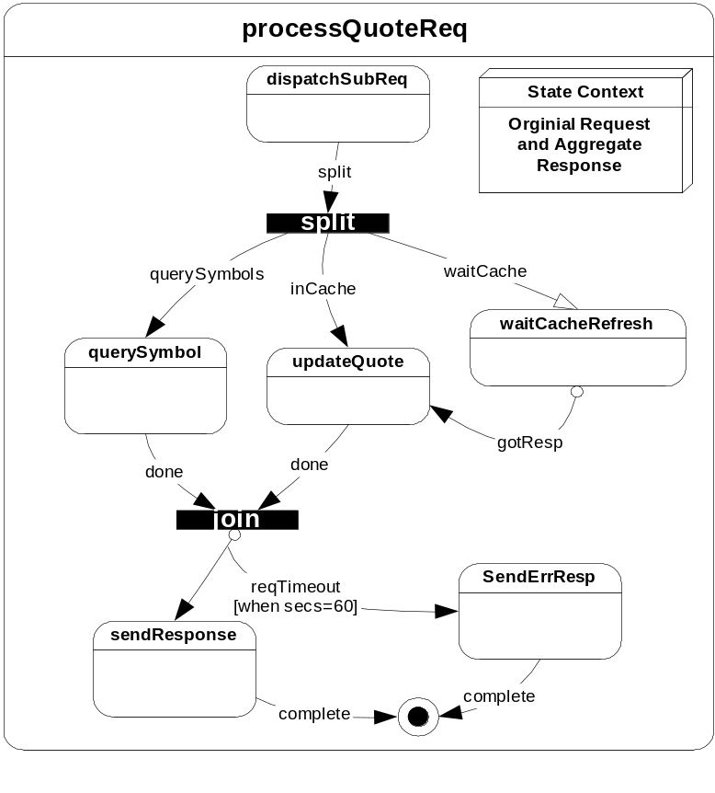

Introduction

HALO is a Application Object and Hierarchical State Machine Framework built on top of the existing SAPI/NTK libraries. HALO is intended to streamline and enhance productivity in SAPI application design, development, maintenance and monitoring. The HALO Framework consists of the following components:

- HALO Workflow Editor (HWE)
- HALO Definition Language (HDL) Specification
- HDL Compiler (HDLC)
- HALO In-Memory Objects (HOME)
- HALO Runtime Kernel (HARK)
- HALO Runtime API (HARP)

Two key objectives of the HALO framework are:

- To better separate SAPI application design from application construction
- To reduce or eliminate the SAPI application developer’s infrastructural coding tasks.

HALO’s HWE and HDL scripts can define and document how the application will process events from the SAPI underlying framework. HALO’s HDLC and HARK components translate this design into objects that drive a running application and automate the following SAPI server infrastructural tasks:

- The SAPI application states and how they occur
- The application linkages to external services
- The application and transactional data the server maintains in memory and when each is allocated and freed.
- The type of transactional messages a SAPI application receives, and how to handle them
- The kinds of errors that are expected and how they are dealt with
- The amount of time the application will wait for a response in various states and what it will do if a timeout occurs
- The outgoing message congestion boundaries to stay within.
- The periodic, automated self-maintenance commands that are scheduled, and the time-of-day or day-of-week they are run.
- The severity, visibility and informational content of KL log messages for each application event.
- The type of HOG stats that will be kept for each state and event
- The available control port commands, their help text and parameter options.
- The VAR_Config TCL variables that are available, their type and usage.

Application designers can architect, diagram and script the application with stakeholders, automating many of the above tasks. Development team-leads can scope and assign state callback coding tasks to team members, and integrate their efforts to build executables and provide integration-tested servers to QA. Application developers can focus primarily on domain-specific callback design and code for each well-defined state, context, timeout and error. HALO’s components are designed to help facilitate this division of responsibility.

The HALO framework can also serve as a point of integration for future scriptable application objects. By making the inclusion of these objects across SAPI servers less code-intensive, barriers to their use can be eliminated and standards of access are enforced. For example, access to databases via EZDB, Tandem Master File and Roster Servers can be scripted into a state’s context definition as a remote object. Application developers can then access these objects in a standardized way via HALO’s context access APIs, and not have to write code for remote messaging and protocols.

It’s important to note that the goal of HALO-based server development isn’t to make everyone’s job necessarily easier, but more productive. Achieving this goal will allow more software to be developed in less time, and reduce time-to-market for a wide variety of SAPI servers. HALO automates many development tasks that are time-consuming, error-prone, or sometimes overlooked. Plus, by making the description, design and scope of an application much more visible and easily found in HWE diagrams and HDL scripts, HALO can make the activities of those that test, monitor, maintain and extend SAPI applications more productive as well.

Fig. 1. HALO Component Interaction Diagram

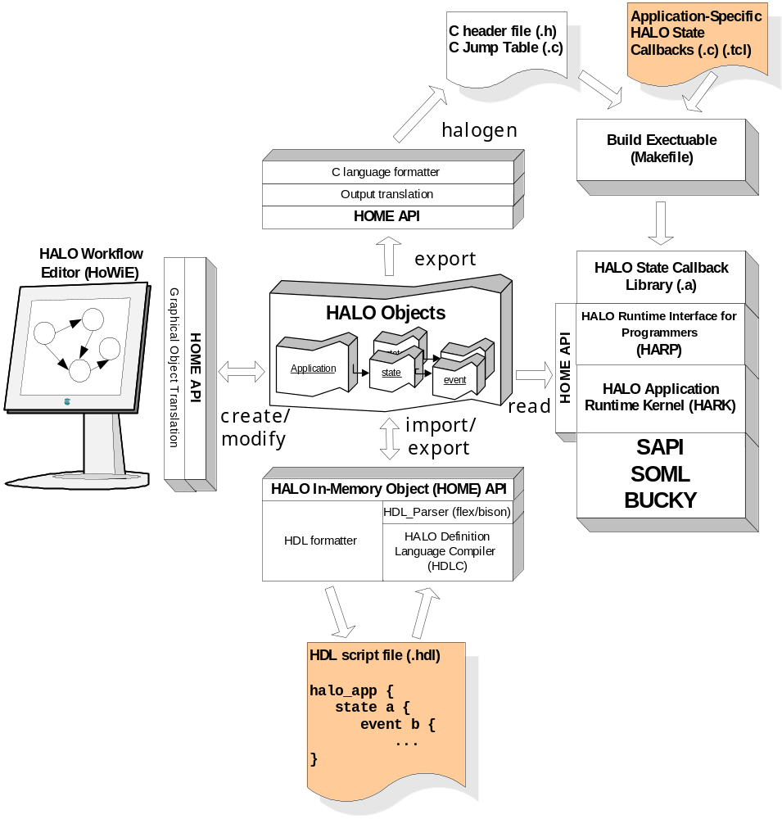

Glossary and Graphical Notations

The following terms define basic HALO objects and concepts, and are accompanied by standard graphical notation used in statecharts.

state A HALO State is a configurable software entity that represents a distinct application processing step or interaction with the underlying framework. The state is represented graphically by a rectangle with rounded corners.

Fig. 2. HALO State
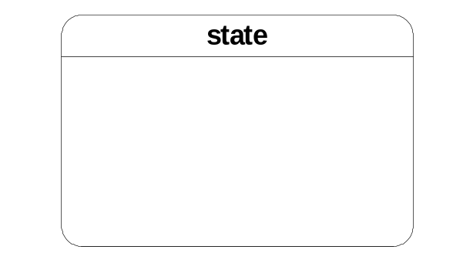

state context A state may contain one or more data context objects. The context objects are automatically allocated and freed as the state is created and destroyed. A state context may contain a key value composed of context fields which distinguishes it from other instances of the same state.

Fig. 3. HALO State with Context
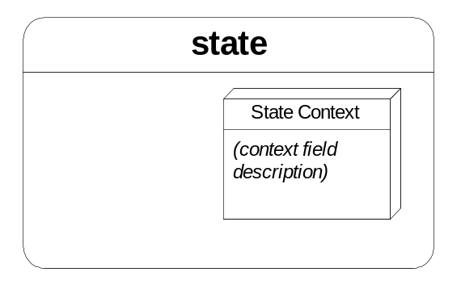

event A named object that represents an action or change occurring in a system. Each event must have a source state and destination state. Source states use events to alter the system by transitioning to destination states.

Fig 4. Standard event transition from source to destination state
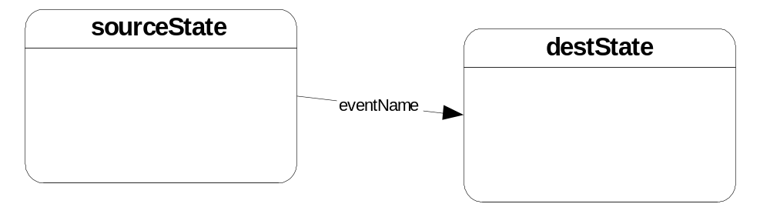

composite state A composite state contains one or more sub-states. The composite state has a parent-child relationship with its sub-states. A child sub-state may also be a composite state, containing another generation of children. There are two classes of composite states: singleton and keyed. A keyed composite state is defined in HDL with a context that has one or more key fields. Singleton composites either have no context or have no context key fields. Each distinct combination of key fields will produce a unique instance of the keyed composite state. Conversely, there will be at most one singleton composite state. In graphical notation, a keyed composite states will contain an ‘*’ after the state name.

Fig. 5. Composite state parent with child sub-states.
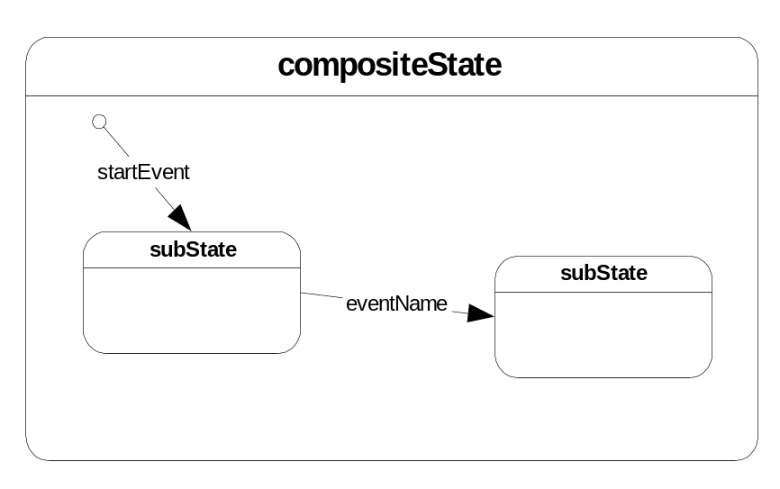

event propagation When a state callback triggers a user event that has no configured transition out of the current state, HALO will propagate the event upwards through the state ancestry in search of a matching event name. As the search for the event propagates upwards, states are exited and resource reclaimed. Event propagation provides application designers a means for centralizing the flow control and handling of errors that may occur at many points within a state hierarchy. Event propagation is also used by HALO to handle the case where a state callback triggers an event completely unknown to the statechart. This will cause propagation of the unknown upward to the application state, where a standard statechart error handler can be invoked. The isolation of this erroneous event can be logged and will not affect the rest of the application.

Fig 6. An error event transition handled higher in the state hierarchy.
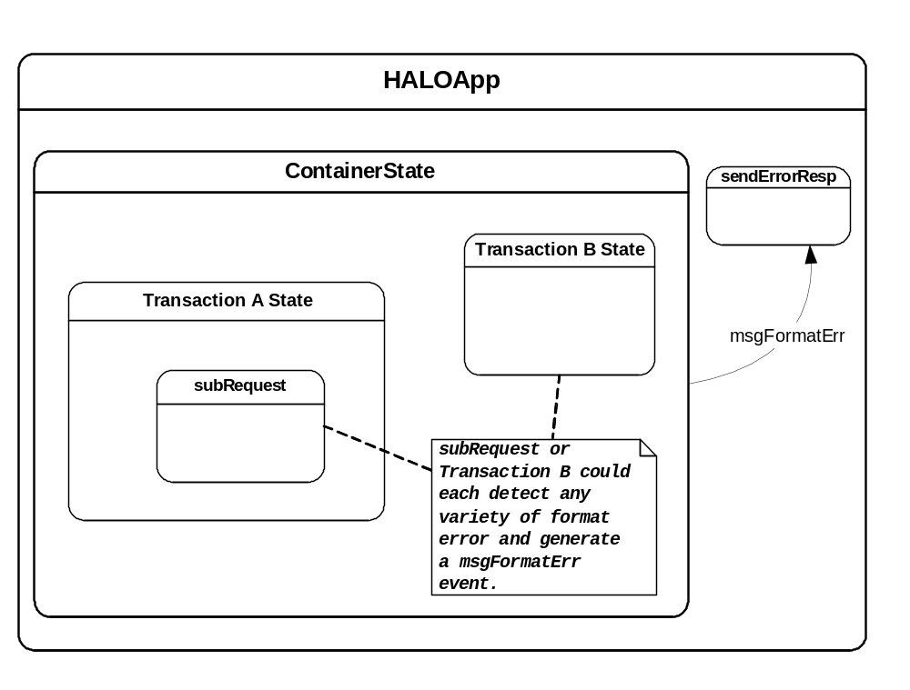

container Another term for a composite state that represents an application-defined entity. Containers contain state context data and one or more sub-states or sub-containers. Containers can be keyed, and therefore uniquely instanced. Containers are often hierarchical and associated with entities such as groups of users, user sessions, active session transactions, and sub-requests within a transaction.

Fig. 7. Container with multiple levels of sub-containers.

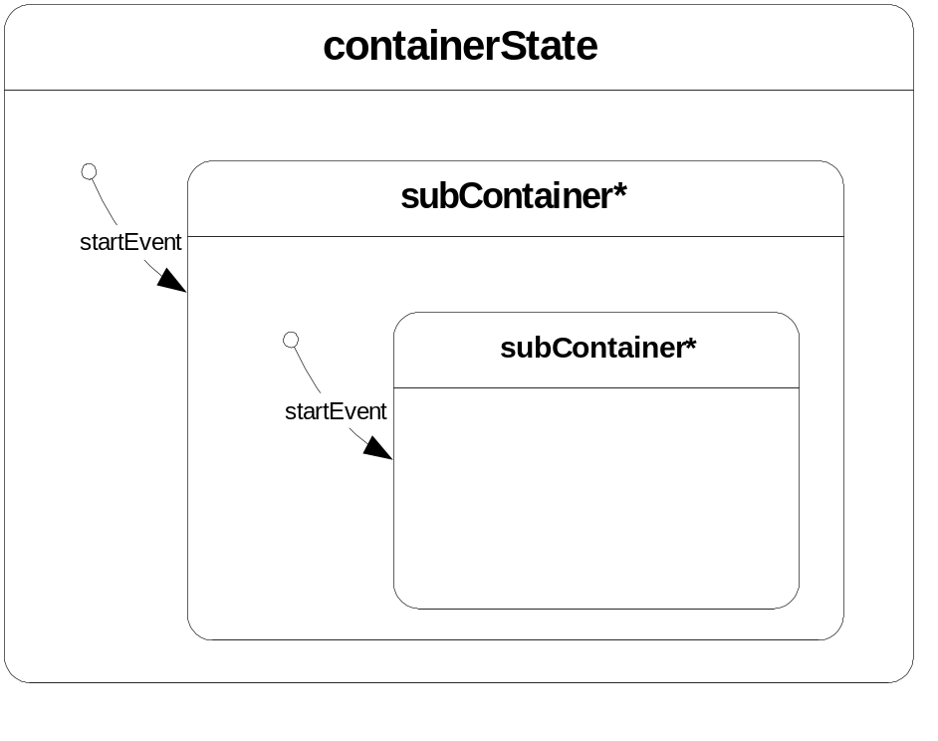

event params Events may contain one or more sets of parameter objects. An event param is data associated with the event instance. Params are defined in HDL for each event, and are created and populated either explicitly in state callbacks or automatically when a portal event arrives.

start event An event that originates inside a composite state, and whose destination indicates the initial sub-state to instance when the composite is created. Start events may be either portal events or user events. There may be more than one start event in a composite, as long as event guards cause one and only one of the events to match.

Fig. 8. Composite states showing both types of start event. 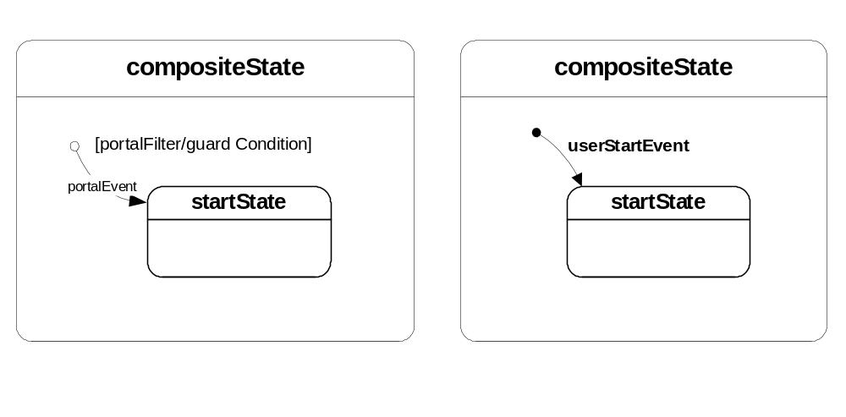
user event An event that is created from within a state callback. A user event typically indicates that a state action is complete or has caused an error. A user event is differentiated from portal and timeout events because they are generated by a state callback function and not from a system timer or message arrival.

Fig. 9. Application Callback generates error or complete user event.
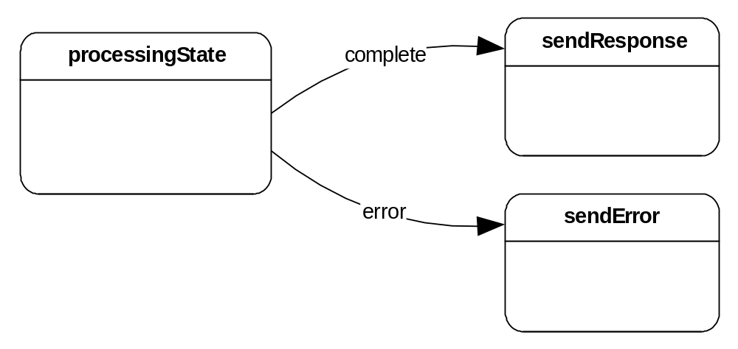

event guard An event accompanied by a boolean expression (guard condition) that controls which instance of an event is chosen when transitioning to a destination state. The guard condition may reference event params or the destination state’s parent context fields. Guard conditions support all C language logical and mathematical operators, precedence rules and parenthesis. Many guarded forms of a named event may exist emanating from a source state. The guards are evaluated in no particular order until one of the guards evaluates to TRUE. Mutual exclusivity of the condition expressions must be enforced by the designer. When accompanying one or more guarded events, the default guard event would be the one that has no guard expression, and would be the event choice when all other guarded forms evaluate to FALSE.

Fig. 10. Mutually exclusive event guards requiring no default

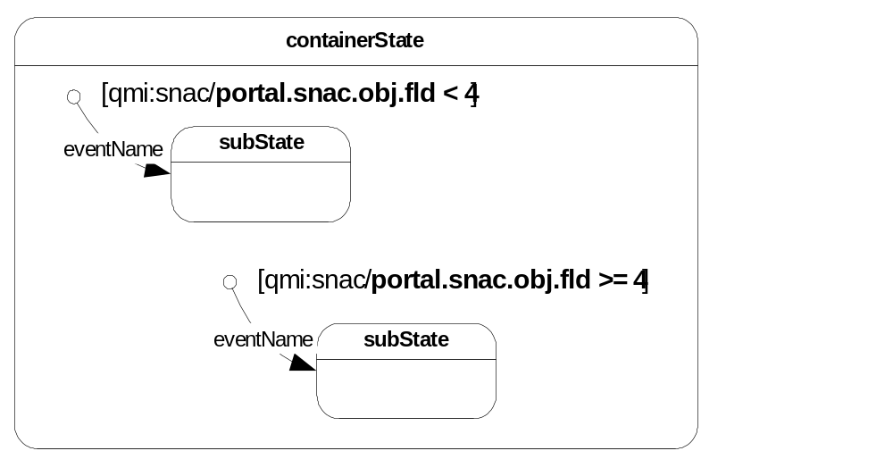

state chart A graphical depiction of a system represented as a sequence of states and the events that route between them.

state callback Each HALO state has three (3) C-function callback hooks available to designers and developers. The callbacks are used to associate application-specific behavior to HALO state transitions. The callbacks are termed: entry, action and exit. It is up to the developer to decide which named callbacks are appropriate for each state, if any. The entry and exit callbacks are used primarily in persistent container states to initialize and destroy container objects. The action callback is generally used for transient states that are created by an incoming event, carry out an action, and then exit. The developer can specify which callback to invoke and the C-function name reference. The halogen command creates jump tables that associates HALO state names with C function entry points. Each entry, action, and exit callback has the following signature. Application callback developers use the HARP API to access state, event, context and params data from the callback arguments.

HALOReturnType
CFunctionName(
HALODesc *halo,
HALOFieldAccess *stateContextFields,
HALOFieldAccess *eventParamFields
);

HSM Hierarchical State Machine. A Finite State Machine that supports nesting of state and events within other states (see composite state.)

HALO A framework for building SAPI services on top of a scripted HSM. HALO is an acronym for Hierarchical Application workfLOw.

HOME A set of parsers and APIs used internally by HALO to define the objects in a hierarchical state machine.

HDL HALO Design Language. The HDL is a script language used to define all HALO object specifications, descriptions and interactions. HDL supports a grammar for describing hierarchical states, events, and interactions with the underlying SAPI framework. The HDL grammar is extensible in that user types and functions may be defined and referenced. While it is possible and sometimes necessary to hand-generate or modify HDL in a text editor, the ideal method is to produce HDL files via a graphical editor for better visual clarity
HARK HALO’s runtime component that instantiates HOME objects as SAPI messages and events are received. HARK executes the HSM defined in HOME.

HARP An API for application’s programmers to interface with the HARK runtime to access HOME object instances. HARP allows developers to access state contexts and create/access events and params.

halogen A program used to create application-specific C #defines, typedefs and jump tables from an HDL file. These modules are used to facilitate invocation of state application-callbacks at runtime. Additionally, they allow application developers to reference HOME object instances in their callbacks.

underlying framework The software system on top of which the HALO system rests and depends upon for delivery of external events. Currently, this implies the SAPI NTK framework.

portal The virtual point of entry and exit into the underlying framework.

portal event Portal events originate from the underlying framework (e.g. SNAC messages over QMI). Portal events are often defined as start events within composite states. These start events are used to guide the event instance through a state hierarchy in search of a state to process it. States may require creation as the navigation occurs if they are not already instanced. Portal events may also transition out of wait states. Wait states are closely associated with portal response events. (see response events.)

Fig. 11. A start portal event and wait state outgoing portal event.
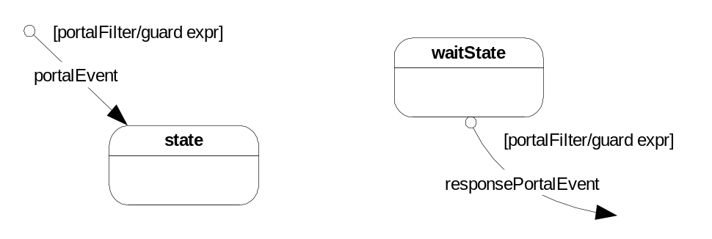

external portal event A class of portal event that is initiated by an external client of the HALO application. External portal events will trigger the search for and/or creation of the state hierarchy that will service them.

response event A class of portal event that is a response to an action initiated by a HALO state. There will always be an explicit wait state that is suspended and awaiting the arrival of a response event. An external portal event is distinguished from a response event in that external portal events are initiated by an outside client of the SAPI application and there may be no instantiated states available to service it when it arrives. A response event must always have a wait state ready to service it when it arrives. An example of a response event is a result from a query request initiated by a HALO state.

Fig. 12. A response event and the wait state that will process it.
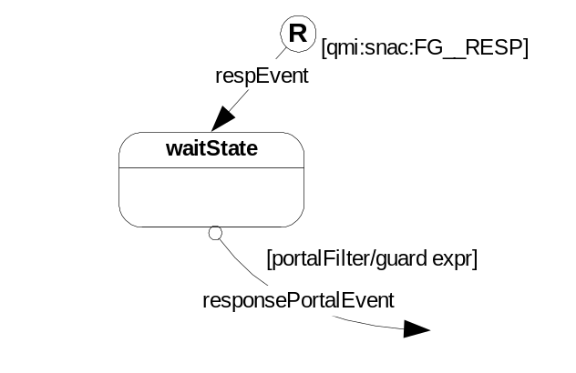

timeout event A timeout event is clock-based event associated with a target event. There are two types of timeout events: idle and absolute. Each timeout type has a time interval (days to milliseconds) and a destination state. Idle timers expire if its target event is not matched in an event transition within the time interval. Otherwise, idle timers are disabled and reset each time the target transition occurs. Absolute timers will expire after the exact time interval irregardless of target event activity. An idle timeout example is one that is targeted at a response event. If the response doesn’t arrive within n seconds, the timeout event destination state can send an error response. An absolute timeout example would expire every m hours to perform container maintenance.

Fig. 13. A timeout event and its target portal event.
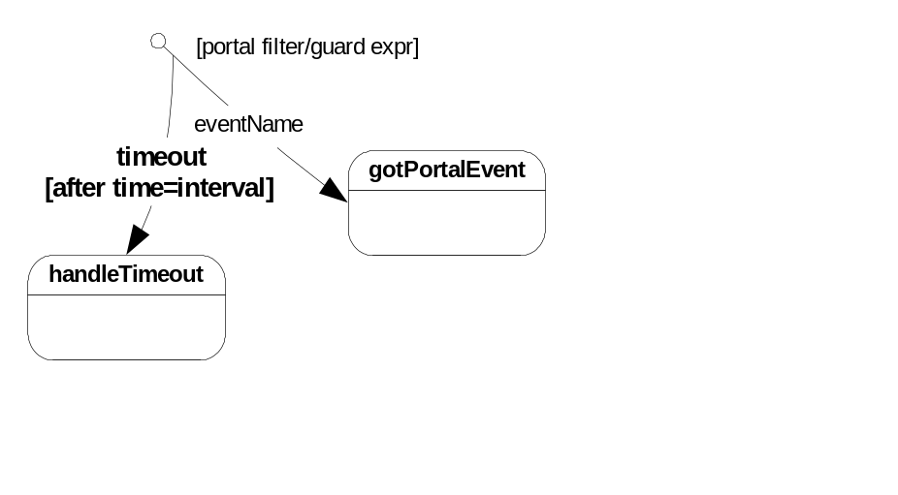

portal params Portal params that are extracted from messages originating from the underlying framework. (e.g. SOML qc, SNAC header fields such as fg, type, ver and reqid, and the snac object itself). Portal params can be referenced in event guard conditions to control event destinations within HDL.

portal filter Similar in nature to an event guard, the portal filter will accompany portal events and control which like-named events will be chosen when routing to destination states. The portal filter uses the underlying transport, message format, API, and message specific details to build the filter expression. Portal filters may be also be accompanied by event guard expressions, which can further qualify the event. A filter example would be ‘qmi:snac:PF__’, which will match any event that has the QMI transport, SNAC message format, and has any SNAC type from the PF__ foodgroup. Another example is ‘flap:snac:kraft:PF__QUOTE_RESP,2’, which will match only version 2 PF__ SNACS of type QUOTE_RESP that arrive via the FLAP transport. The example also specifies that the KRAFT API will be used for decoding and access to the message payload.

Fig. 14. Portal filter examples
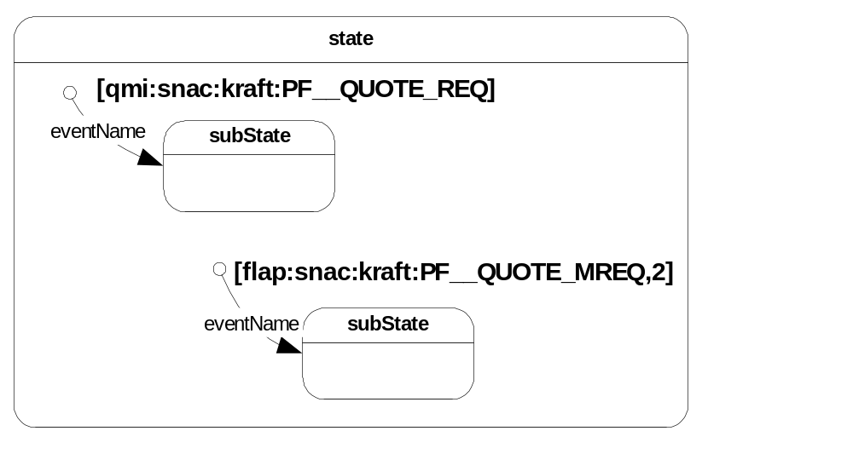

return to portal An event that indicates that HALO state processing is complete (or requires additional external events to complete), returning control to the underlying framework. A return to portal is achieved by transitioning to a wait state, or to the portal virtual state.

Fig. 15. Two ways to return to the underlying portal.
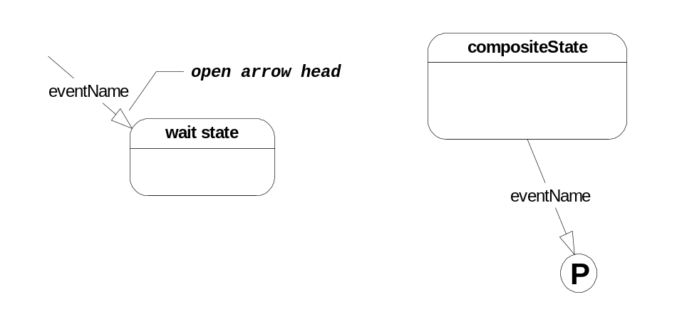
wait state A state that is the created by a return to portal event and will service a future response event. The wait state is created, but control is immediately returned to the underlying portal. The wait state is used to suspend state processing until the arrival of another external event or internal timeout (see response event).

Fig. 16. The wait state, and their role in handling response events.
waitResponse
respEvent
[qmi:snac:FG__RESP]
R
procResponse
sendReq

final state A built-in (virtual) state that indicates the current composite state should be exited and reclaimed. A composite state automatically terminates and reclaims all resources in its active child states. The composite state will terminate and transition to its parent via the same event name. If a transition by that event name does not exist, then the transition will attempt to occur via the generic final event. (see final event).

Fig. 17. A transition to the final virtual state.
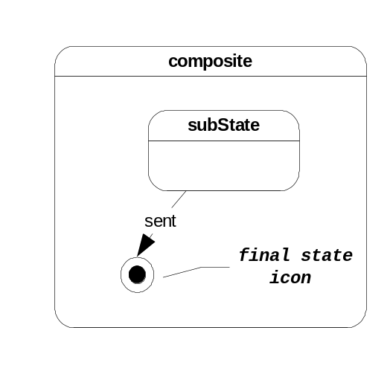

final event The default event transition out of a composite state when one of the composite’s sub-states transitions to the final state and no explicitly matching event is located. A keyed composite state (contains a context key) that use the final event may only transition to a final state in its parent or may return to portal. Singleton composite states may transition to any type of state.

Fig. 18. Use of final event as default transition after final state.
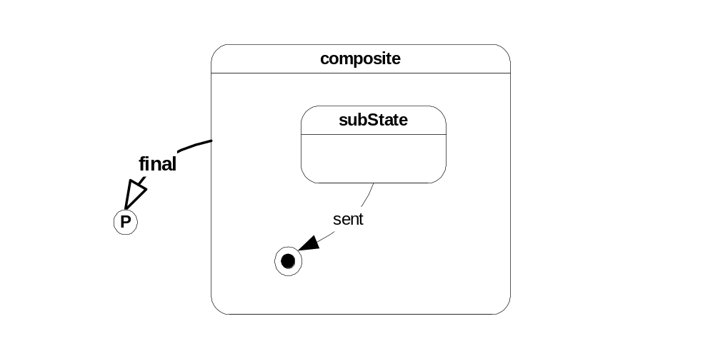

persistent state A state that remains instanced after the HALO layer has returned to portal. Persistent state are either wait states or any type of composite state that hasn’t returned to portal.

split state A event fan-out mechanism in which multiple user events are processed in parallel until they all transition to its paired join state. A state callback author may create many events, each with one of the identities supported by the split (e.g. ev1, ev2, or ev3). It is possible for one or more of the split states to recursively direct new event instances back into the split bar, creating a new generation of split/join processing.

Fig. 19. A split state allowing independent, simultaneous state processing
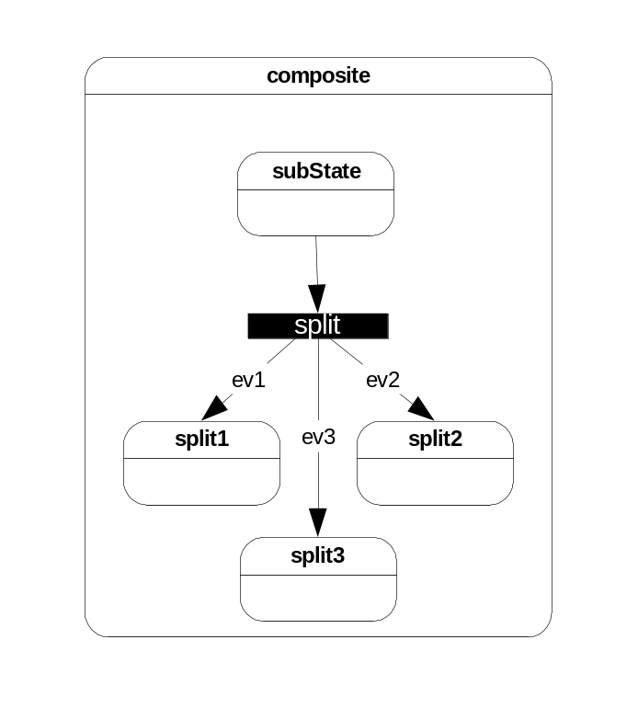

join state A state that will collect split state event instances until all have arrived. Once all are present, the join state will transition to its destination. An example usage of a split/join state pair would be in request processing that triggers multiple sub-requests to external services. The split is used to issue multiple requests, each following its own independent state transitions and terminating at a join state. The join waits for all sub-requests to complete before continuing. A timer event may be associated with the transition out of the join state to timeout all activity associated with the split join.

Fig. 20. A split/join example, where event processing reunites and continues
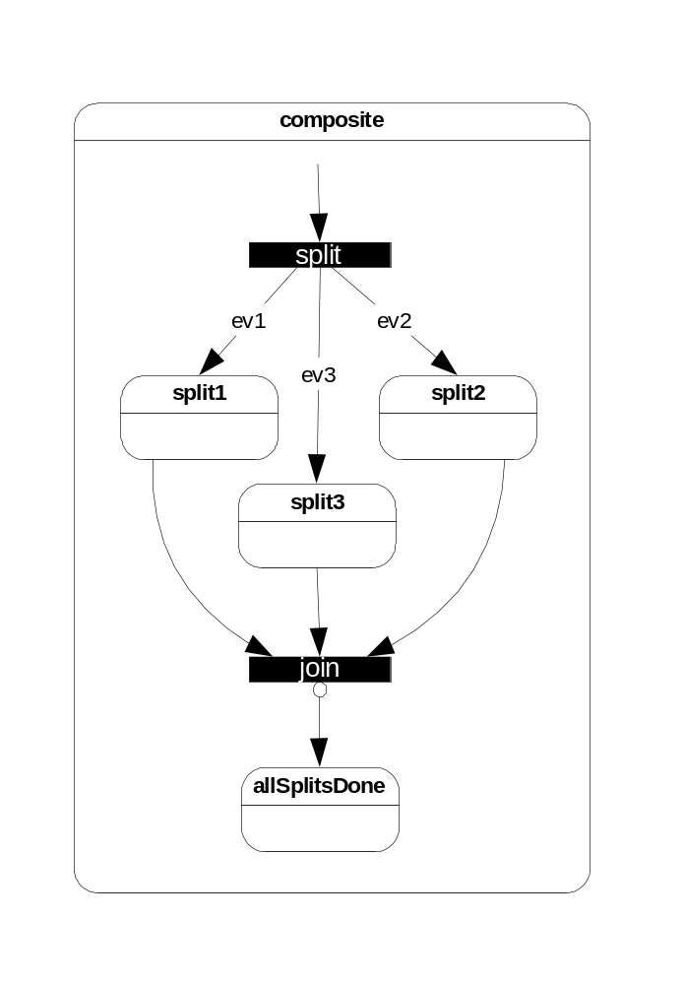

HDL Language Reference

This section describes the HALO Design Language (HDL) syntax. Designers and developers use HDL to define the HALO application states, transitions and data flow. The definitions are stored in a .hdl file to be loaded at runtime to drive the execution of the HALO application.

halo_app

The halo_app statement must appear at the start of every HDL script, and contains all other HDL commands. The halo_app statement defines the HALO application or root state, and is an ancestor of all other HALO states.

halo_app appName appAbbrev baseAppId {

... (halo app sub-statements)

}

where:
appName HALO application state name string
appAbbrev A 2 or 3 character abbreviation for the application, usually uppercase. HALO uses this abbreviation for the following generated code:
1. state and event #define prefix
2. KL Log identifier
3. Default state callback function name prefix
baseAppId A positive integer that serves as the starting value for the incremental #define value generator for states and events. This will help ensure unique constants in the future if HALO applications are merged.

halo_app supported sub-statements:
version assign a version string to the halo app
descr A free-text description of the halo app
typedef Declares a scalar or aggregate type similar to a C language typedef
state Defines a HALO sub-state in the halo app.
event An event that has the root state as the source.
entry entry callback definition
action action callback definition
exit exit callback definition
geom A encoded string used to specify graphical layout
context Declares an object containing fields, links and initializer expression.
Note that only version is specific to the halo_app statement. All other statements above are state sub-statements due to the fact that halo_app defines the root application state. (See state for detailed sub-statement descriptions).

version

The version statement is an optional halo app sub-statement used to embed a version identifier in the HDL script file. The version string can also be retrieved at runtime via the HARP API.

version versionString ;

state

The state statement defines a new HALO sub-state within the containing parent state.

state stateName {

. . . (state sub-statements)

}

state supported sub-statements:
descr A free-text description of the halo state
typedef Declares a scalar or aggregate type similar to a C language typedef
entry entry callback definition
action action callback definition
exit exit callback definition
geom An encoded string used to specify graphical layout
context Declares an object containing fields, links and initializer expression.
key Define a set a key fields for the state from the context fields.
state Defines a HALO sub-state in the current parent state.
event An event that has this state as its source.
stats Triggers the collection of runtime stats for this state, and modifies the stats name and collection style.

descr

The descr statement is on optional halo_app sub-statement used to provide detailed description of the halo app. Note that string syntax supports catenation of “” strings separated by whitespace.

descr descriptionString ;

geom

The geom statement is used by graphical editors to determine layout and sizing of the state object. The string argument is generated, updated and interpreted by the graphical editor as the HDL script is imported, manipulated and exported.

geom “graphicalLayoutEncodedString”

typedef

The typedefs statement provides a means for creating new user types in each state. The type names must be unique within the state, but may override early typedefs of the same name in the state’s ancestry if desired.

typedef existingTypeName newTypeName [nElems] ;

where:
existingTypeName any valid HALO-supported type or a newTypeName from a previous typedef.
newTypeName a unique type name

HALO supported types are:

Type Name | Description | Length in Bytes
s8 | signed 8-bit integer | 1
u8 | unsigned 8-bit integer | 1
s16 | signed 16-bit integer | 2
u16 | unsigned 16-bit integer | 2
s32 | signed 32-bit long integer | 4
u32 | unsigned 32-bit long integer | 4
s64 | signed 64-bit long long int | 8
u64 | unsigned 64-bit long long int | 8
f32 | 32-bit floating point | 4
f64 | 64-bit floating point | 8
Boolean | FALSE == 0, else TRUE | 4
string | variable length, 0 terminated | varying
table(int) | int-keyed hash table | varying
table(string) | string-keyed hash table | varying
list | SDC-backed linked list | varying
struct | named aggregation of types | varying
mem | MEM_Subs backed buffer | 4
ptr | opaque pointer to non-HALO storage. | 4

Examples:

typedef s32 userId;
typedef string userName;
typedef struct ctrl[4] {
s32 i;
string s;
f64 scale;
}

entry

The entry statement activates the entry state callback function for the state. Either an explicit C function name may be provided, or if the default keyword is present, the system generated C function name will be used. The default, system generated name for the entry callback is haloAppAbbrev_stateName_Entry(). The entry callback is an optional callback typically used to initialize a composite state’s context. The context is allocated and initialized immediately prior to the state entry callback invocation. If no entry callback is desired, then this statement is omitted in the state definition.

entry default ;

entry CFunctionName ;

The calling signature for the entry callback is:

HALOReturnType
CFunctionName(
HALODesc *halo,
HALOFieldAccess *stateContextFields,
HALOFieldAccess *eventParamFields
);

action

The action statement activates the action state callback function for the state. Either an explicit C function name may be provided, or if the default keyword is present, the system generated C function name will be used. The default, system generated name for the action callback is haloAppAbbrev_stateName_Action(). The action callback is an optional callback typically used to carry out processing associated with the incoming event. The action callback is invoked immediately after the entry callback is invoked (if defined.) If no action callback is desired, then this statement is omitted in the state definition.

action default ;

action CFunctionName ;

The calling signature for the action callback is:

HALOReturnType
CFunctionName(
HALODesc *halo,
HALOFieldAccess *stateContextFields,
HALOFieldAccess *eventParamFields
);

exit

The exit statement activates the exit state callback function for the state. Either an explicit C function name may be provided, or if the default keyword is present, the system generated C function name will be used. The default, system generated name for the action callback is haloAppAbbrev_stateName_Exit(). The exit callback is an optional callback typically used to free up resource associated with the state context. The exit callback is invoked immediately after action callback is invoked (if defined.) If no exit callback is desired, then this statement is omitted in the state definition.

exit default ;

exit CFunctionName ;

The calling signature for the exit callback is:

HALOReturnType
CFunctionName(
HALODesc *halo,
HALOFieldAccess *stateContextFields,
HALOFieldAccess *eventParamFields
);

context

The context statement defines a data object to be associated with the state. When the state is created, the context objects are allocated and initialized. Initialization can come from init statements in HDL script, or from the entry state callback. When the state is destroyed, the context objects are automatically freed after the exit state callback is invoked. The context contains one or more field declarations, which declare storage in a C language syntax, with the addition of a link statement. The link statement can create pointers to parent state context fields. Links are pointers to context objects upward in the state hierarchy, and provide a convenient way to share and/or access relevant portions of a parent’s instantiated context. There may be any number of context objects created for a state. State callback functions contain a HALOFieldAccess type argument which is used to access the state context objects. The state callback accesses the context directly in C via typedefs generated specifically for the state during halogen. HARP API’s exist to allocate, initialize and/or access aggregate context field types such as tables, lists and strings.

context contextName {

fieldDeclarations

}

context contextName from parentSpec:contextName ;

where:
fieldDeclarations one or more individual or aggregate field type and variable name declarations. A fieldDeclaration has the following format:

fieldType fieldName [ optNumElems ] optInitializer ;

struct structFieldName [ optNumElems ] {

fieldDeclarations

}

table(int|string) tableFieldName {

tableRowFieldDeclarations

}

list listFieldName {

listNodeFieldDeclarations

}

fieldName from parentSpec:contextName.fieldName ;

Field declarations may use any of the HALO fieldTypes supported in the table below, or can use the name of a user-defined type defined in the state or one of the states ancestors.

parentSpec A reference to the parents context or other ancestors context. If the parentSpec : is omitted, the contextName or contextName.fieldName refers to the immediate parent. Otherwise, the following syntax will refer to preceding nth generation of parents:

parent ^ n

optInitializer An optional initializer expression may accompany non-struct field declarations in the form of:

typeName fieldName = expression ;

expression may be any parenthetical C-style math expression. The expression may reference other initialized context fields or constants, but not event parameters (see event copy to find out how to populate a state context from event params).

Type Name | Description | Length in Bytes
s8 | signed 8-bit integer | 1
u8 | unsigned 8-bit integer | 1
s16 | signed 16-bit integer | 2
u16 | unsigned 16-bit integer | 2
s32 | signed 32-bit long integer | 4
u32 | unsigned 32-bit long integer | 4
s64 | signed 64-bit long long int | 8
u64 | unsigned 64-bit long long int | 8
f32 | 32-bit floating point | 4
f64 | 64-bit floating point | 8
Boolean | FALSE == 0, else TRUE | 4
string | variable length, 0 terminated | Varying
table(int) | int-keyed hash table | Varying
table(string) | string-keyed hash table | Varying
list | SDC-backed linked list | Varying
struct | named aggregation of types | Varying
Mem | MEM_Subs backed buffer | 4
Ptr | opaque pointer to non-HALO storage. | 4

Example context:

context appData from parent^3:appContants;

context userData {
loginTime from parent^2:userTable.loginTime;
f64 ratio =((appData.loadFactor-1)/20.25));
s32 uIdent;
string uName;
string uLocation[4];
struct address[2] {
string street;
string state;
string zip;
}
}

key

The key statement is used to declare which context fields are to be combined to create a distinct key value for the current state. The key fields chosen will be used at state creation to generate an ASCII key value. The key value is subsequently used to identify a particular keyed state instance as new events are destined for the state. If a singleton state is desired, then the key statement is omitted, and the state name will be used as the state key value. Context key fields are often the destination of event copy fields, which auto-populate newly created context fields as events transition to the state. An example of key statement usage would be to create a keyed user container state by unique user id.

key contextName.fldName , … ;

Example:

context grpInfo {
string grpName;
string grpPrefs[10];
}

context userCtx {
s32 userId;
uInfoType userInfo;
}

key grpInfo.grpName, userCtx.userId ;

event

The event statement defines a named object that represents an action or change that can occur in a system. The state definition containing the event statement is the event’s source state. The event will transition to a destination state defined in the next statement. The event type will determine if the event is a start event or will return to portal. One or more event guards will conditionally route to a destination state if the guard’s expression returns TRUE. An event may contain a portal filter, which indicates that the event comes from the underlying portal, and will match the characteristics described in the filter. An event may contain event params and copy declarations which define the fields associated with an event and determines which of these fields will be copied into the context of newly created destination states. An event timeout will assign a time interval to the event, and can specify an alternate destination state if the interval should expire before an instance of the event is created.

event eventName {

... (halo event sub-statements)

}

event supported sub-statements:
descr A free-text description of the event
geom An encoded string used to specify graphical layout
type Identifies behavioral characteristics of the event
portal Indicates that the event emanates from the underlying portal and identifies matching characteristics used in filtering.
guard An alternate route this event can take given that an accompanied expression evaluates to TRUE.
params Declares an object containing fields that will accompany instances of this event
next Identifies the destination state of this event
copy Identifies source event param fields and next state context destination fields.
timeout Defines an alternate event route to take in lieu of this event if an event instance doesn’t arrive after a given time interval.
log parameters used for the output of a KL log message each time this event transitions to its destination state.
stats Triggers the collection of runtime stats for this event, and modifies stats name and collection style.

descr

The descr statement is on optional event sub-statement used to provide detailed description of the event. Note that string syntax supports catenation of “” strings separated by whitespace.

descr descriptionString ;

geom

The geom statement is used by graphical editors to determine layout and sizing of the event object. The string argument is generated, updated and interpreted by the graphical editor as the HDL script is imported, manipulated and exported.

geom “graphicalLayoutEncodedString”

type

The type statement is used to give specific behavior to an event. An event may take on one or more of the following event attribute.

type eventAttribute , eventAttribute ;

where:
eventAttribute standard (default). The default event type, which a direct transition from the source state to the destination state. If the type statement is omitted, the event’s type is standard.
start The event’s source state is a composite. The start event is used at composite state creation to determine the first sub-state to instance. The start event is also used when navigating through persistent composites states.
response The event is an implicit start event that represents the arrival of a response message. A response message is an event that is received as a result of a request generated by a HALO state callback. There must be a keyed, persistent state waiting for the receipt of this events response message. (e.g. A query response event keyed by SNAC reqid.)

portal

The portal statement identifies the event as one that has originated from the underlying portal (e.g. A SAPI SNAC over QMI, FLAP or BUCKY). The portal filter portion of the statement will provide message criteria that must be matched in order for this event to be selected as the transition agent for the message. The portal statement typically accompanies start events inside of composite states. These start portal events act as routers to navigate down the state hierarchy searching for a state that will process the event. As portal events navigate down a state hierarchy, the accompanying filters can specify more specific criteria. Each portal event has a built-in params portal object which contains details from the underlying portal message. The portal object has the following hard-coded declaration:

typedef struct AOLQueue {
s32 id;
s32 sub_address;
s32 session;
}

params portal {

struct {
AOLQueue local_aq;
AOLQueue dest_aq;
u8 msgtype;
s32 qc[80];
} soml;

struct {
struct {
u16 fg;
u16 fgVer;
u16 type;
HALOStringField *name;
s32 reqid;
} hdr;
void *obj;
} snac;

struct {
s32 cryptoken;
HALOStringField *tokenSymbol;
} token;
}

The format for the portal statement is as follows:

portal portalFilter ;

The portalFilter has semantics specific to the underlying portal, and in the case of the current SAPI implementation, has the following format:

transport : messageType : optMsgAPI : optMsgParams ;

where:
transport qmi A SAPI message delivered over the QMI transport. SOML is used as the underlying callback mechanism.
flap The flap protocol and transport is the message delivery mechanism.
bucky_bat A BUCKY BAT message.
bucky_app A BUCKY App message.
cp A control port command has been executed and its arguments are in the event parameters.
tc A SAPI TC block of data has arrived.

messageType snac A SNAC message is enclosed in the portal message.
token A SAPI token message.
unplug A SAPI unplug message.
stream An unformatted byte oriented message.

optMsgAPI kraft For SNACs, the KRAFT generated structure will be accessible via the event param field portal.snac.obj. Otherwise, portal.snac.obj will point to the SNAC_Object.
optMsgParams A messageType-specific qualifier:
snac:
foodgroup __
foodgroup __ msgType
foodgroup __ msgType , fgVer
token:
tokenCode , tokenCode , …
cp:
TclProcName

Example portal statements:

portal flap:snac ;

Any SNAC received over flap.

portal qmi:snac:kraft:PF__QUOTE_GIF ;

A SNAC over QMI having foodgroup and type PF__QUOTE_GIF
The KRAFT API is used to present the SNAC contents to the
application callback.

portal qmi:snac:ROSTER2__ ;

Any SNAC having foodgroup ROSTER2__ over QMI. The
SNAC_Object (default) formatting is used to present the SNAC
data to the callback.

portal bucky_bat:snac:kraft:PF_SYMBOL__QUOTE,2 ;

A Bucky Bat msg SNAC having version 2 of foodgroup
PF_SYMBOL__ . The KRAFT API is used to present the SNAC
contents of snac type QUOTE to the application callback

params

The params statement defines a data object to be associated with the event. When the event is created, the params objects are allocated and initialized. If the event is a portal event, the portal params object is implicitly defined and initialized from underlying portal callback information (e.g. SNAC header and/or SOML Context). When an event instance is destroyed, the params objects are automatically freed. The params object contains one or more field declarations, which declare storage in a C language syntax. There may be any number of params objects created for an event. State callback functions contain a HALOFieldAccess type argument which is used to access and/or create the event params. The state callback accesses the context directly in C via typedefs generated specifically for the event during halogen. HARP API’s exist to allocate, initialize and/or access aggregate params field types such as tables, lists and strings.

params paramsName {

fieldDeclarations

}

where:
fieldDeclarations one or more individual or aggregate field type and variable name declarations. A fieldDeclaration has the following format:

fieldType fieldName [ optNumElems ] optInitializer ;

struct structFieldName [ optNumElems ] {

fieldDeclarations

}

table(int|string) tableFieldName {

tableRowFieldDeclarations

}

list listFieldName {

listNodeFieldDeclarations

}

Field declarations may use any of the HALO fieldTypes supported in the table below, or can use the name of a user-defined type defined in the source state or one of the source states ancestors.

optInitializer An optional initializer expression may accompany non-struct field declarations in the form of:

typeName fieldName = expression ;

expression may be any parenthetical C-style math expression. The expression may reference other initialized params fields or constants or source state context fields.

Type Name | Description | Length in Bytes
s8 | signed 8-bit integer | 1
u8 | unsigned 8-bit integer | 1
s16 | signed 16-bit integer | 2
u16 | unsigned 16-bit integer | 2
s32 | signed 32-bit long integer | 4
u32 | unsigned 32-bit long integer | 4
s64 | signed 64-bit long long int | 8
u64 | unsigned 64-bit long long int | 8
f32 | 32-bit floating point | 4
f64 | 64-bit floating point | 8
Boolean | FALSE == 0, else TRUE | 4
string | variable length, 0 terminated | Varying
table(int) | int-keyed hash table | Varying
table(string) | string-keyed hash table | Varying
list | SDC-backed linked list | Varying
struct | named aggregation of types | Varying
mem | MEM_Subs backed buffer | 4
ptr | opaque pointer to non-HALO storage. | 4

Example params:

params eventInfo {
string symbol;
string exchg;
u8 chartType;
s16 width;
s16 height;
list fields {
string fname;
s32 maxLen;
}
}

copy

The copy statement is used to transfer event parameters to new created next state context fields. This is primarily used to populate context key fields at state creation time so that the state key value can be determined. When transitioning to persistent composite states, the copy-to field values are used to generate the key used for state lookup. The copy-to may be used to populate both key and non-key field values in the next state context. The destination fields in the copy statement must be valid references to the next state’s contexts.

copy fromParamField into toNextStateContextField ,
fromParamField into toNextStateContextField , … ;

next

The next statement identifies a state as the destination of this event transition. The next state must be a sub-state within the current composite, or one of the supported virtual states (i.e. final or portal). A transition to the final state will cause the current parent state to exit. A transition to the portal (return to portal) state will cause HALO suspend processing and return to the underlying portal (i.e SAPI NTK event loop).

next nextStateName ;

where:
nextStateName a valid sub-state name in the current composite state
final The final virtual state.
portal The return to portal virtual state.

timeout

The timeout statement is closely associated with portal events or joins, and is used in two ways: an event idle timer, or as an absolute interval timer. Timers are activated when the source state of a portal event is created. A timeout configured as idle, will trigger if an event matching the portal criteria doesn’t arrive within the specified time period. If the event does arrive, the timer is turned off and reset. Idle timers can be used to clean up idle containers, react to missing response events, etc. A timeout configured as absolute only fires after the configured time interval regardless of event activity. These timers are useful to schedule periodic maintenance or activities that must happen regularly. When the state containing the portal event is destroyed, so are the timers.

timeout timeoutName timeoutType {

. . . (timeout sub-statements)

}

where:

timeoutName timeout event name
timeoutType idle The timer will expire when no event matching the parent event’s portal parameters arrives in the time interval specified in the after statement.
absolute The timer always expires when the after interval or next cron time is reached.

timeout supported sub-statements:
after Specifies the time interval that must pass before the timer expires
cron A UNIX cron-style expression that specifies re-occurring points in wall-clock and calendar time when an absolute timer will expire.

The following event sub-statements are also supported:
descr A free-text description of the timeout event
geom An encoded string used to specify graphical layout
copy Copies the portal events source or source’s parent context fields to the destination states context.
log Log a KL message describing the timeout occurrence
stats Enable stats keeping on this timeout event.

after

The after statement is a timeout sub-statement that defines the timeout interval for idle and absolute timeout types. After units and interval type clauses are additive, and support a variety of interval types for maximum clarity. (e.g. instead of specifying 510 secs, use 8 minutes, 30 seconds), It has the following syntax:

after numUnits intervalType , … ;

where:
numUnits and integer number of units > 1.
interval milli[s]
second[s]
minute[s]
hour[s]
day[s]

Example usage:

after 1 minute, 11 seconds ;

after 50000 millis ;

after 9 hours, 7 minutes, 11 seconds ;

cron

The cron statement is a timeout sub-statement that defines the periodic wall-clock or calendar point-in-time in which absolute timeout will expire. The cron statement supports the standard UNIX crontab sytnax:

cron minOfHr hrOfDay dayOfMon monOfYr dayOfWeek ;

where:
minOfHr comma sep list of mins 0 – 59, or range min-max
hrOfDay comma sep list of hours 0 – 23, or range min-max
dayOfMon comma sep list of day 1 – 31, or range min-max
monOfYr comma sep list of months 1 – 12, or range min-max
dayOfWk comma sep list of weekdays 0=Sun – 6, or range min-max

Example usage:

cron 0,15,30,45 8-17

Expire the timer every 5 minutes between the hours of 8 am to 5 pm.

log

The log statement is used to send a formatted message to the underlying portals logging mechanism (i.e. SAPI KL Logging.) Supported features include all KL Log levels, printf-style format specification, and references to event param fields and parent source state context. (Note that the source and destination states of the event do not exist while the event is transitioning, so references to their contexts is not possible).

log level optMsgNum formatSpecString fldRef , … ;

where:

level One of the supported SAPI KL Log levels:
EMERG, ALERT, ABORT, EXIT, CRIT, ERR WARNING,
NOTICE, CONFIG, INFO, DEBUG, DEBUG2, SPECA,
SPECB, SPECC
optMsgNum An optional, unique message number associated with the message.
formatSpec A quoted string context message context and standard printf % specifiers for argument substitutions.
fldRef An event params or parent source context field reference.

Example log statements:

log DEBUG2 6020 “Got %s SNAC: fg = %d_%d”
portal.snac.hdr.name, id.fg, id.snactype;

log NOTICE 1124 “No response received for req %d”
ctx2.reqid;

guard

The guard statement clause is alternate event description associated with the containing event. The guard is qualified with a C-style boolean expression (or guard condition) that when evaluating to TRUE at runtime, will trigger the use of the guard event in lieu of its parent. A guard provides the application designer the means to alter the routing of event based upon the contents of an event parameter or parent source state context field. This is useful when qualifying multiple start events within a composite, or further qualifying user events transitioning out of a processing state.

Each event statement may have one or more guard statement clauses contained within and share the event’s portal and params declarations The evaluation of guard conditions will occur in no particular order, and the first matching guard will be followed. It is the responsibility of the application designer to ensure mutual-exclusivity in the guard conditions. The optional default guard is a guard statement with no qualifying condition and will be the default route if no other guard evaluate to TRUE. The parent event definition may also serve as the default transition if each of its guards has conditions and all evaluate to FALSE.

guard guardCondition {

. . . (guard sub-statements)

}

guardCondition examples:

portal.snac.hdr.reqid >= 1000

!ctx.userIdle && (ctx.numReqs > 1000)

eventData.flag == TRUE && (eventData.sCnt > (ctx.i*2))

guard sub-statements are a subset of event sub-statements.

descr A free-text description of the event
geom An encoded string used to specify graphical layout
type Identifies behavioral characteristics of the event
next Identifies the destination state of this event
copy Identifies source event param fields and next state context destination fields.
log parameters used for the output of a KL log message each time this event transitions to its destination state.

stats

The stats statement will enable statistical data gathering for the state or event. It can also modify what type of measurement will be performed and the display name of the statistic. The HALO stats are currently managed by SAPI HOG, and can be viewed with:

hog_show halo_state

hog_show halo_event

If the stats statement is omitted, no statistics for the state or event will be kept.

Fig. 21. Sample Application Statechart and HDL Script

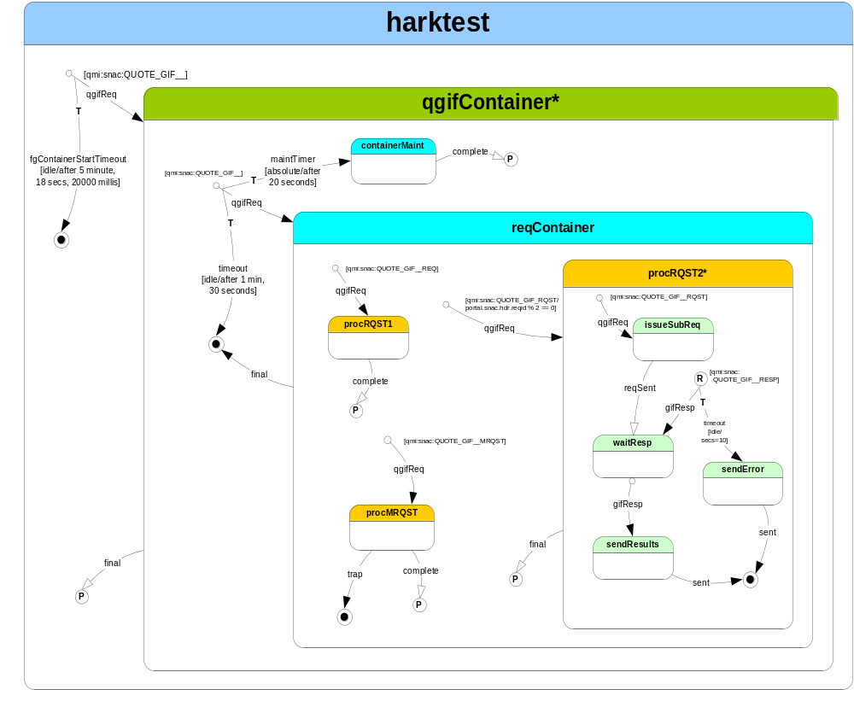

halo_app harktest HKT 10000 {

version "$Revision: 1.23 $";

descr "HARK Test Server";

entry harkTestInit;
exit harkTestExit;

event fgContainterStart {
type start;
portal qmi:snac:QUOTE_GIF__;
next qgifContainer;
copy portal.snac.hdr.fg into id.fg ,
portal.snac.hdr.type into id.snactype,
portal.snac.hdr.reqid into id.reqid;

timeout fgContainerStartTimeout idle {
after 5 minutes, 18 seconds, 20000 millis ;
log NOTICE 100 "QUOTE_GIF__ request timeout";
next final;
}
log DEBUG 5000 "got a QUOTE_GIF__ FG SNAC (%d), reqid: %d"
portal.snac.hdr.fg, portal.snac.hdr.reqid;
}

typedef struct UserRec {
string name;
string location;
string number[3];
}

typedef u16 snacOid;

state qgifContainer {

entry default;
exit default;

descr "a container state keyed by SNAC fg. This has no “
“functional value and only exists for testing keyed “
“ state lookups and copy to ";

event qgifStart {
type start;
portal qmi:snac:QUOTE_GIF__;
timeout qgifStartTimeout idle {
after 1 minute, 30 seconds;
log NOTICE 100 "QUOTE_GIF__ qgifContainer timeout";
next final;
}
timeout maintTimer absolute {
after 20 seconds;
log NOTICE 103 "maintTimer invoked";
next containerMaint;
}
next waitReq;
}

context id {
string name;
UserRec rec[10];
snacOid fg;
s32 i;
snacOid snactype;
string color = "red";
s32 reqid;
s32 nextSubReqid;
}
key id.fg, id.snactype;

state waitReq {

exit procReq;

context wdata {
link cmdLineArgs from parent^2:sapi.argv;
link snacfg from parent:id.fg;
link sntype from parent:id.snactype;
}

event RQST {
portal qmi:snac:QUOTE_GIF__QGIF_RQST;

guard (portal.snac.hdr.reqid % 2 == 0) {
log DEBUG2 6002 "RQST Snac with guard: fg = %d_%d"
id.fg, id.snactype;
copy portal.snac.hdr.reqid into ctx2.reqid;
next procRQST2;
}
next procRQST1;
log DEBUG2 6000 "got %s SNAC: fg = %d_%d, color %s"
portal.snac.hdr.name, id.fg, id.snactype, id.color;
}

event MRQST {
portal qmi:snac:QUOTE_GIF__QGIF_MRQST;
next procMRQST;
log DEBUG2 6001 "got QGIF_MRQST SNAC";
}

}

state containerMaint {
exit default;
event complete {
type return;
next waitReq;
}
}

state procRQST1 {
exit procRQST1 ;
context id from parent:id read-write;
event complete {
type return;
next waitReq;
}
}

state procRQST2 {

entry default;

context ctx2 {
s32 reqid;
mem dynamicFld;
}
key ctx2.reqid;

event req2Start {
type start;
portal qmi:snac:QUOTE_GIF__QGIF_RQST;
next issueSubReq;
}

state issueSubReq {
exit default;
context ctx {
link nextSubReqid from parent^2:id.nextSubReqid;
}
event reqSent {
type return;
params reqParams {
s32 subReqid;
}
copy reqParams.subReqid into resp.subReqid;
next waitResp;

}
}

event qgifResp {
type response;
portal qmi:snac:QUOTE_GIF__QGIF_RESP;
copy portal.snac.hdr.reqid into resp.subReqid;
next waitResp ;
}

state waitResp {

context resp {
s32 subReqid;
}
key resp.subReqid;

event gotResponse {
portal qmi:snac:QUOTE_GIF__QGIF_RESP;
timeout responseTimer idle {
after 10 seconds;
log NOTICE 103 "no resp rcvd for request %d" ctx2.reqid;
next final;
}
next sendResults;
}
}

state sendResults {
entry sendResults;
event complete {
type return;
next final;
}
}
}

state procMRQST {
exit procMRQST;
event complete {
type return;
next waitReq;
}
event trap {
type standard;
next final;
log ALERT 1011 "trapped on event 131" ;
}
}
}

}

