Abstract:

I think that indicating that TSZ+Xray is more compatible with XMM than with Chandra in the abstract is risky. You say in the summary that: “Figure 3 and Table 1 indicate that Chandra temperatures are about 15% higher than those of XMM-Newton, as found by previous work (Mahdavi et al. 2013; Schellenberger et al. 2015), while T ̄gmw and T ̄XMM are in good agreement. We should avoid over-interpretation of this result in terms of absolute calibration. »
This is one of the results of the paper, and we even give uncertainties in the abstract and say that our results are limited. I think the abstract should also summarize the results. We are very far from claiming that XMM is right and CXO is wrong.

Section 3

- You need to indicate what the quoted uncertainties mean: absolute calibration, rms. My point is that when you compare between maps should we consider these uncertainties negligible with respect to the observed differences?
If you mean in the case of X-ray spectroscopy, it is already written “statistical uncertainties”. If you mean something else I don’t see what it is because there are no other uncertainties quoted in this section???
- Define Tgmw when it appears before 3.1, Tgmw = \int Te ne/\int ne
The term “gas mass weighted” is already a definition, but I added the equation where it appears for the first time, in section 3.
- With respect to equation 3 I think that it would clear for the reader if you indicate that you compute an estimate of \int ne from \int ne^2 . You say we have to convert from to, which is a bit confusing
Yes, we convert \int n_e^2 dl to \int n_e dl via l_eff, and this is intrinsically exact. Then we use several approach to estimate l_eff, so the estimate is in l_eff as it is written.
- Model 3b: the sentence “all the subclusters are located at the same line-of-sight coordinate” seems weird to me. I understand your point about subclusters being close but not all at the same position. Furthermore if as you say the model is ruled out: “We even know from the merger scenario that MACSJ0717 is not in the situation described by M3b”, why presenting it?
This model gives an upper limit, so in my opinion it is not useless. If everybody think otherwise, I can remove it.
- I do not understand why you need to define equation (5) when write equation (6). You could simply indicate KbT = Pe /estimate (ne from SX)
We don’t need explicitly equation (5) for equation (6), but we choose to plot the quantity of equation (5), so we define it. Equation 6 is now also expressed in terms of primary quantities.

Section 4

- My point about the contours of Tgmw on the other two is that it is difficult to see from the figure that the maxima at are the same position or not. Furthermore there are visually significant discrepancies in the temperature values at the peak. Is this consistent with the noise in the maps. Typically you indicate later than the zero level of the tSZ+ Xray map is unconstrained.
Again, I will not overplot the contours on the Tx map for 3 main reasons: 1) it is more messy with the contours (the color scale, the range and the frame are the same); 2) as written in the text, the exact morphology and the position of the Tgmw map peak depend on the kSZ and l_eff models, therefore the comparison is not meant to be down to this level of details anyway; 3) the exact morphology of the X-ray spectroscopic maps also depend on statistics (see email discussion for more details).
- You discuss the uncertainties on the tSZ+Xray temperature map and how they affect the results but not for the others.
See the email discussion on Tx error bars.
- Figure 3. I insist. For the left figure the fit seems to be consistent with the data. For the other two this is not the case. For the middle figure (Tgnw –TXMM) the red points look much steeper than the green ones while the best-fit values show an opposite behavior. For right figure the relation does not look linear at all. You need to comment on this on the paper.
It is always possible to have some bug, but I checked again and I could not find anything wrong. I also have two independent ways to do the fit and both give the same answer. If you want to check my code, you are welcome.
The main code is available in Labtools/RA/MACSJ0717/Analysis/macsj0717_pseudo_thermodynamics.pro
Then the fit is done in
Labtools/RA/MACSJ0717/Analysis/macsj0717_thermo_simple_regression.pro
Or Labtools/RA/MACSJ0717/Analysis/macsj0717_thermo_mcmc_regression.pro

Here is an example of the raw Tgmw map and the fit residual with XMM and Chandra: 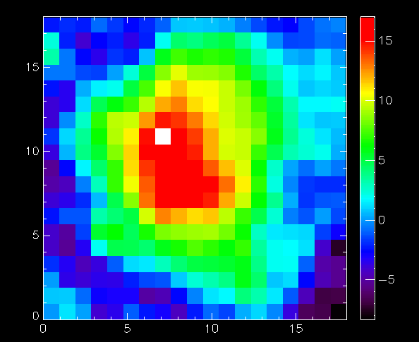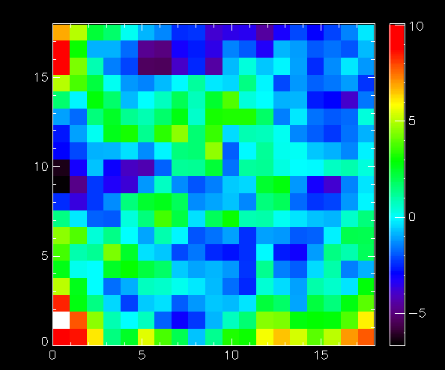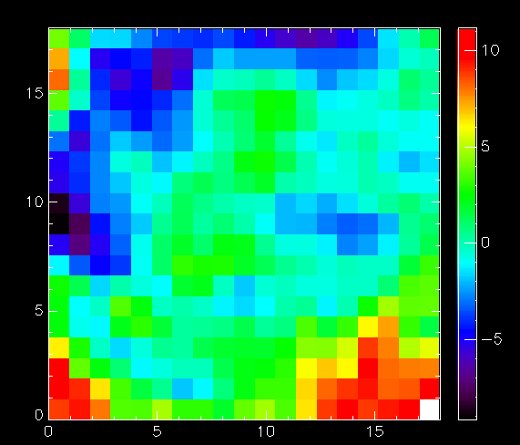
Same thing for the plots in the paper now including the residuals.
Maybe it is me, but I don’t see anything particularly weird. The non-linearities/wavy-pattern (mostly with CXO) could easily be due to model uncertainties and this is why we test several models. The residuals do no show anything special except that the correlations are good and that the scatter is larger than the gmw error bars (see also text for details).

Here is the details about how the fit is done :

