### EXERCISES I – INTRODUCTION AND PROMETHEE

1. Indicate the truth (T) or falsity (F) for the below statements.

| a) in multiple criteria choice, one aims at selecting the most preferred subset of alternatives | T |
| --- | --- |
| b) in classification problems, classes (categories) need to be preference-ordered and pre-defined | F |
| c) the ranking presented in figure w) is complete | F |
| d) the ranking presented in figure x) is complete | T |
| e) non-dominated alternatives are also weakly non-dominated | T |
| f) the preference plot presented in figure y) corresponds to a gain-type criterion | T |
| g) the preference plot presented in figure z) corresponds to a cost-type criterion | F |
| h) one can model incomparability using a preference model in the form of a value function | F T? |
| i) among the three families of preference models, decision rules are the most general one | T |

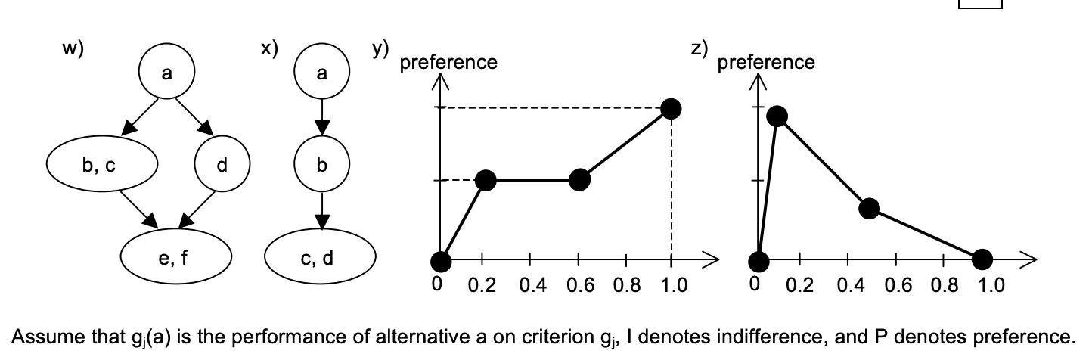

1. Which of the below conditions corresponds to the monotonicity of a consistent family of k criteria of gain-type? .
   1. if then aPb
   2. if aPb, then ⇒ cPb #dobre
   3. if aPb and bPc, then aPc #dobre
   4. if aPb, then ⇒ cPa

What would change in the correct answer if we considered a family of k criteria of cost-type?

#nic by się nie zmieniło ponieważ mamy do czynienia z funkcjami użyteczności

1. Which of the below conditions corresponds to the completeness of a consistent family of k criteria?
   1. ⇒ aPb #źle
   2. if aIb and aIc then bIc
   3. if aIb, then ⇒ aIc #źle
   4. ⇒ aIb #dobre
2. Consider the marginal preference functions for the three criteria: , , and of gain type. Each criterion’s intra- and inter-criteria preference information is provided above the respective plots ( – indifference threshold, – preference threshold, – weight). First, compute the marginal preference indices for two pairs of alternatives: A and B as well as C and D. Then, compute the comprehensive preference indices π.

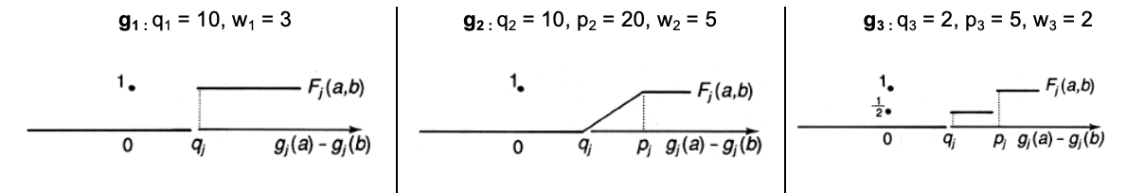

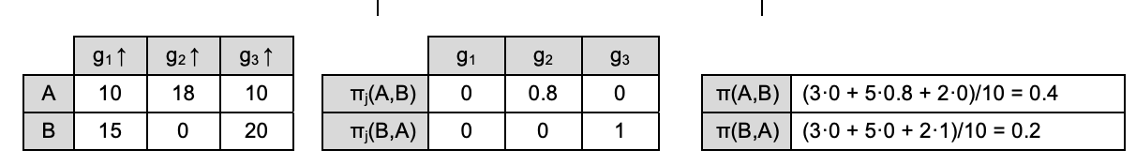

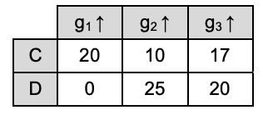

Odejmujemy wartości z kryteriów w porządku (g(C i D) lub g(D i C), w zależności od wariantu i patrzymy na wykresy i wstawiamy w tablice. Jeżeli wartość jest poniżej wartości nierozróżnialności to wstawiamy 0, powyżej lub równe progu preferencji jest 1. Jeżeli pomiędzy to wartość, od 0 do 1.

|  |  |  |  |
| --- | --- | --- | --- |
|  | 1 | 0 | 0 |
|  | 0 | 0.5 | 0.5 |

|  |  |  |  |
| --- | --- | --- | --- |
|  |  |  |  |
|  |  |  |  |

Tu wyliczamy wartość pi względem wartości z poprzedniej tablicy i wag dla każdego z kryteriów, dziejąc to wszystko przez sumę wag.

|  | (1 * 3 + 0 * 5 + 0 * 2)/10 = 0.3 |
| --- | --- |
|  | (3 * 0 + 5 * 0.5 + 2 * 0.5)/10 = 0.35 |

Repeat the computations for pair (A,B), while assuming that all criteria are of cost-type.

1. Indicate the truth (T) or falsity (F) for the below statements.

| a) the PROMETHEE methods use an outranking-based preference model | T |
| --- | --- |
| b) PROMETHEE I provides a partial ranking of alternatives | T |
| c) the sum of comprehensive flows of all alternatives in PROMETHEE II is equal to zero | T |
| d) for alternatives a and b, the sum of marginal preference indices and can be equal to zero | T |
| e) for alternatives a and b, the sum of comprehensive preference indices π(a,b) and π(b,a) is never greater than one | T |
| f) to select the most preferred subset of alternatives, PROMETHEE V requires pre-computed comprehensive flows | T |

1. Using the PROMETHEE method, one derived a matrix of comprehensive preference indices π(a,b) for all pairs of alternatives. Compute the positive , negative , and comprehensive flows Φ(a) for all alternatives. Draw the rankings obtained with PROMETHEE II and PROMETHEE I. Recall that PROMETHEE I admits incomparability.

|  | W | X | Y | Z |  |  |  |
| --- | --- | --- | --- | --- | --- | --- | --- |
| W | 0 | 0 | 0 | 0.3 | 0.3 | 0.9 | -0.6 |
| X | 0 | 0 | 0.2 | 0.7 | 0.9 | 0.1 | 0.8 |
| Y | 0.9 | 0 | 0 | 0.7 | 1.6 | 0.3 | 1.3 |
| Z | 0 | 0.1 | 0.1 | 0 | 0.2 | 1.7 | -1.5 |

PROMETHEE II Y->X->W->Z

PROMETHEE I X->

Y->W->Z

Dla sumujemy wartości w wierszu, dla w kolumnie a to różnica dodatnich odjąć ujemnych.

1. Consider six alternatives (S, V, W, X, Y, Z) with the following comprehensive flows: . Formulate the binary linear program according to the assumptions of PROMETHEE V that would allow selecting a subset of two alternatives that respect the constraints on the maximal budget of 100 and the minimal projected gain of 300. The budgets and gains for all alternatives are provided in the below table. Use the following binary variables: corresponding to the six alternatives.

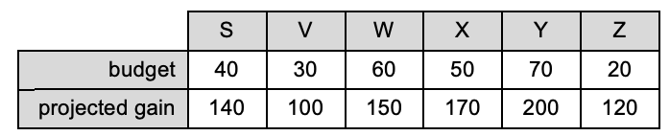

What would be the optimal subset of alternatives selected by PROMETHEE V?

**Funkcja celu:**

max 0.9xs-0.9xv-0.6xw+0.8xx+1.3xy-1.5xz

**Warunki**:

40xs+30xv+60xw+50xx+70xy+20xz<=100

140xs+100xv+150xw+170xx+200xy+120xz>=300

xs,xv,xw,xx,xy,xz={0,1}

xs+xv+xw+xx+xy+xz <= 2

**Wynik:**

xs=0 xv=1 xw=0 xx=0 xy=1 xz=0

### EXERCISES II – ROBUST ORDINAL REGRESSION

1. Indicate the truth (T) or falsity (F) for the below statements.

| a) uses an outranking-based preference model | F |
| --- | --- |
| b) accepts indirect preference information in the form of pairwise comparisons of reference alternatives | T |
| c) The marginal value functions in are general | T |
| d) The marginal value functions in need to be strictly monotonic | T |
| e) If the set is of value functions compatible with the Decision Maker’s comparisons is non-empty, there is always only one compatible value function | F |
| f) The truth of the necessary relation for a given pair of alternatives implies the truth of the possible relation | T |
| g) The possible preference relation is transitive | F |
| h) If alternative a dominates alternative b, then a is necessarily preferred to b | T |
| i) When preference information becomes richer, the necessary relation is impoverished | F |
| j) GRIP admits comparisons regarding the preference intensity | T |

1. Consider the below-presented performance matrix involving three criteria and six alternatives. Write down the ordinal regression problem considered in the method if the decision maker provided the following two pairwise comparisons: AUT > FRA (AUT is preferred to FRA), SWE > GER (SWE is preferred to GER).

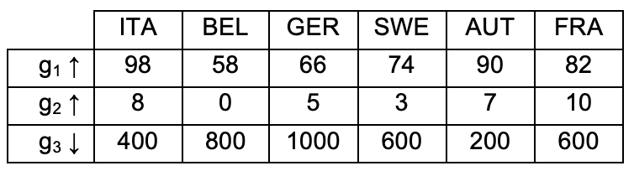

| max ε | objective function |
| --- | --- |
| [C1] U(AUT) ≥ U(FRA) + ε, so (90) + (7) + (200) ≥ (82) + (10) + (600) + ε (as we want U(AUT) > U(FRA)) | pairwise comparisons |
| [C2] U(SWE) ≥ U(GER) + ε, so(74) + (3) + u3(600) ≥ (66) + (5) + (1000) + ε (as we want U(SWE) > U(GER)) | pairwise comparisons |
| [C3] (58) = 0 (g1 of gain type), (0) = 0 ( of gain type), (1000) = 0 ( of cost type) | normalization |
| [C4] (98) + (10) + (200) = 1 | normalization |
| [C5] (98) ≥ (90), (90) ≥ (82), (82) ≥ (74), (74) ≥ (66), (66) ≥ (58) | monotonicity |
| [C6] (10) ≥ (8), u2(8) ≥ (7), (7) ≥ (5), (5) ≥ (3), (3) ≥ (0) | monotonicity |
| [C7] (200) ≥ (400), u3(400) ≥ u3(600), (600) ≥ u3(800), (800) ≥ (1000) | monotonicity |

At least one compatible value function exists if the above constraint set is feasible and max ε > 0. Otherwise, a set of compatible value functions is empty.

1. Let us denote the constraint set from the previous exercise by . Formulate the linear programming models that allow verifying the truth of the necessary relation and the truth of the possible relation .

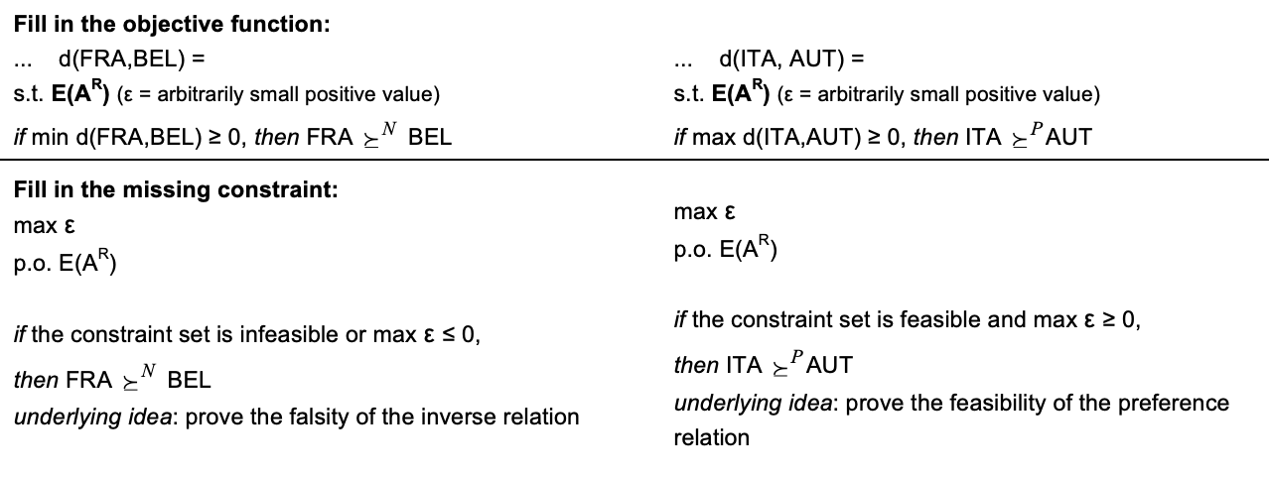

#FRA,BEL NECESSARY

d(FRA,BEL) >= 0 where d(FRA,BEL) = Min [U(FRA)-U(BEL)]

(58) + (0) + (800) >= (82) + (10) + (600) + e

#TU DAJEMY NA ODWRÓT W NECESSARY ZGODNIE ZE SLAJDEM (SPRAWDZAMY ZALEŻNOŚĆ ODWROTNĄ I JĄ OBALAMY)

#ITA, AUT POSSIBLE

d(ITA,AUT) >= 0 where d(ITA,AUT) = Max [U(ITA)-U(AUT)]

(98) + (8) + (400) >= (90) + (7) + (200)

1. Based on the solutions of a series of optimization problems that minimize the differences between comprehensive values for each pair of alternatives, min d(a,b), draw the Hasse diagram for the necessary relation.

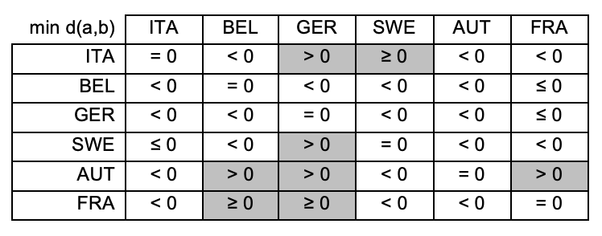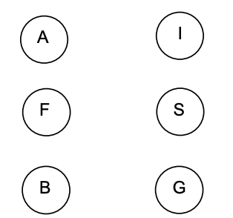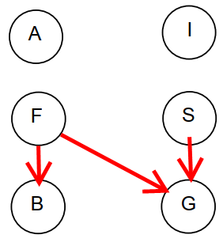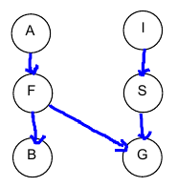

Konieczne relacje to te, które mają ścisłe ograniczenia i patrząc na tą tabele budujemy diagram Hasse, gdzie w wierszach tablicy jest dominacja, a w kolumnach bycie dominowanym.

1. Consider the incremental specification of pairwise comparisons. For the preference information provided in iteration t, the set of compatible value functions is denoted by , and the weak preference relations is denoted by . Fill in the set inclusion relations ( ⊆ or ⊇ ) for the necessary and possible preference relations obtained in the following two iterations. Which relation becomes richer, and which is impoverished?

⊇ ⊆ 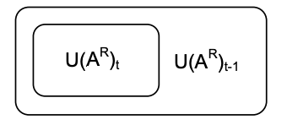

1. Formulate the linear constraints that translate the below-provided preference intensity statements, where means ”intensity strict preference”, ~ * denotes ”intensity indifference”, and means ”intensity weak preference on criterion ”.

(AUT,FRA) (SWE,GER) U( AUT ) – U( FRA ) >= U( SWE ) – U( GER )

(AUT,ITA) ~ * (FRA,SWE) U( AUT ) – U( ITA ) = U( FRA ) – U( SWE )

(AUT,ITA) (FRA,SWE) u1(AUT) - u1(ITA) > u1(FRA) - u1(SWE)

1. The Decision Maker provided the following four pairwise comparisons: . Change the formulation of the below mathematical programming model to identify the minimal subset of pairwise comparisons underlying inconsistency of preference information. Select the preference direction (min or max), write down the objective function, change the below conditions by adding appropriate formulations, denote the binary variables (if you use them), do not change CONSTRAINTS denoting a constraint set modeling the monotonicity, normalization, and non-negativity constraints.

**min**/max

Min -> V = + + +

s.t.

CONSTRAINTS

-

-

-

-

, , , ∈ {0,1}

Assume that the optimal solution of the problem to the left indicated and as the minimal subset of pairwise comparisons underlying inconsistency. Which condition must one add in the next iteration to find another (different) minimal subset underlying inconsistency? Refer to the variables you have previously introduced to the left.

Dla kolejnej iteracji (dać zakaz pojawienia się tego samego rozwiązania)

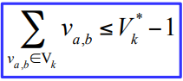

### EXERCISES III – SOLUTION CONCEPTS IN STRATEGIC GAMES

1. Indicate the truth (T) or falsity (F) for the below statements.

| a) In the normal-form strategic games, players take action sequentially | T F |
| --- | --- |
| b) The pure Nash equilibrium is not always Pareto efficient | T |
| c) For a normal-form strategic game involving two players and two actions for each of them, there is always at most one pure Nash equilibrium | F |
| d) For the coordination games, all Nash equilibria are always Pareto efficient | T? |
| e) There is no pure Nash equilibrium for rock-paper-scissors | T |
| f) A mixed strategy is fully mixed if its support contains at least two actions | T |
| g) Every normal-form game has at least one Nash equilibrium | T |
| h) Various orders of eliminating strictly dominated strategies can lead to different reduced games | F |
| i) The equilibrium in dominant strategies is non-empty for all normal-form games | F |
| j) The correlated equilibrium is non-empty for all normal-form games | T |

1. Consider the below normal-form strategic game involving two players, A and B, and solve the following five sub-tasks:
   1. identify dominated/dominating strategies, if any, for players A and B  
      the dominating strategy for player A is B \ is not existing  
      the dominating strategy for player B is … \ is not existing
   2. find all pure Nash equilibria; the pure Nash equilibrium is ( B , R )
   3. justify why (T,L) is not a pure Nash equilibrium (hint: analyze actions of player A)
   4. justify whether (T,L) or (B,R) or (B,L) is a Pareto efficient action profile
   5. change the least number of utilities in the pay-off matrix to transform the normal-form game into a coordination game

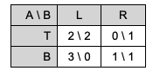

1. Consider the below normal-form strategic game involving two players, A and B, and solve the following four sub-tasks:
   1. find all Nash equilibria (including the mixed ones) by drawing a diagram with the best responses for players A and B

hint: for player A, consider

for player B, consider

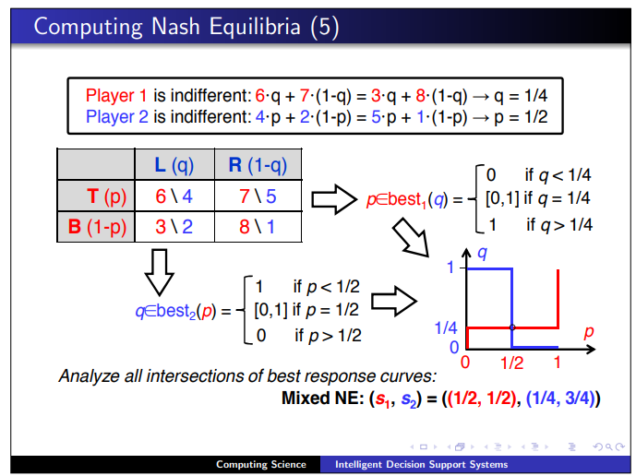

Gracz A jest obojętny czy gra T czy B

=

=

= =

Dla q > 0.8 -> p = 1  
dla q < 0.8 -> p = 0

Gracz B jest obojętny czy gra L czy R

Dla p > 0.9 -> q = 0  
dla p < 0.9 -> q = 1

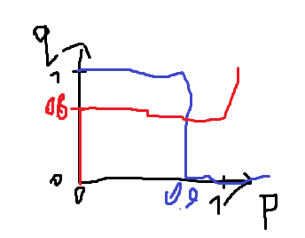

Mamy równowagę nasha tylko dla q = 0.8, p = 0.9 s=((0.9, 0.1),(0.8, 0.2))

* 1. compute an expected utility for player A / B for the following mixed strategy profile s=((0.5, 0.5), (0.1, 0.9))

0 + -4.5 + -0.05 + -2.7 = -7.25

0 + 4.5 + 0 + -40.5 = -36

* 1. justify why the above mixed strategy profile is not a Nash equilibrium

Bo nie przecina się na 0.5, 0.1 (według naszego rysunku)

* 1. change the least number of utilities in the below pay-off matrix to transform the normal-form game into a zero-sum game

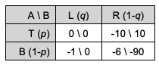

1. Consider the below normal-form strategic game involving two players, A and B, and eliminate the strictly dominated strategies to identify the maximally reduced game.

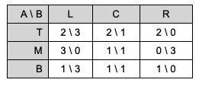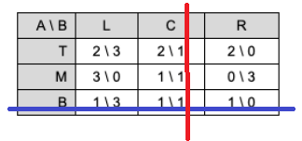

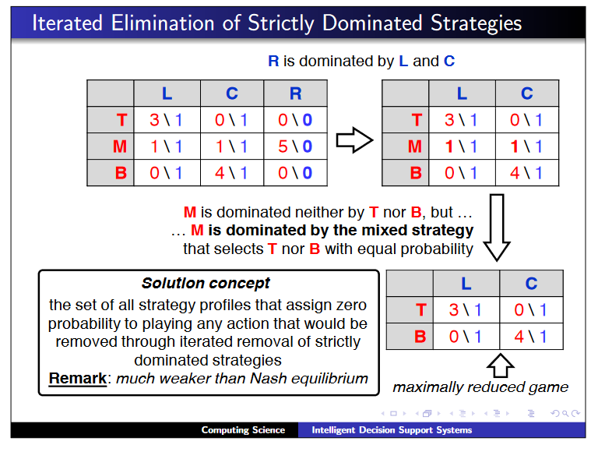

### EXERCISES VI – AHP AND CHOQUET INTEGRAL

1. Indicate the truth (T) or falsity (F) for the below statements.

| a) AHP uses a rule-based preference model | T F |
| --- | --- |
| b) The preference model of AHP is formed by priorities of all elements at all hierarchy levels | T |
| c) The minimal number of hierarchy levels in AHP is three | T |
| d) AHP enforces cardinal consistency condition | F |
| e) The typical Saaty’s scale is between 1 and 5 | F |
| f) AHP requires pairwise comparisons of all pairs of elements with a common predecessor | T |
| g) Pairwise comparisons in AHP are based on the nominal scale | T |
| h) To rank five criteria with the common predecessor, in AHP, it is required to make 10 pairwise comparisons | T |
| i) AHP estimates the priorities by computing the principal eigenvector of a pairwise comparison matrix | T/F |
| j) AHP is vulnerable to the rank reversal phenomenon | T |
| k) AHP maintains the condition of order preservation | F |
| l) When consistency ratio CR is greater than 0.1, the consistency is judged satisfactory | F |

1. Given the below incomplete pairwise comparison matrix, make it complete to satisfy the consistency condition of pairwise comparisons (CCPC) and cardinal consistency condition (CCC).

|  |  |  |  |  |
| --- | --- | --- | --- | --- |
|  | **1** | **3** | 2*3=6 | 1/3 |
|  | 1/3 | **1** | **2** | 1/9 |
|  | ⅓ / 2 = ⅙ | 1/2 | 1 | 1/18 |
|  | **3** | 3*3=9 | 3*6=18 | 1 |

1. Consider the hierarchy consisting of four levels, with two major criteria, each consisting of two sub-criteria, and two alternatives, A and B. Fill in the hierarchy by replacing the question marks (?) so that the hierarchy becomes consistent with the assumptions of AHP. Then, compute the comprehensive scores of A and B. Without computing the exact values, what is the sum of Sc(A) and Sc(B)?

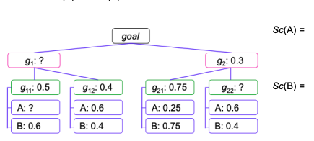

1. Consider the below entirely consistent pairwise comparison matrix. Compute the priorities (w1 – w4) corresponding to the compared alternatives.

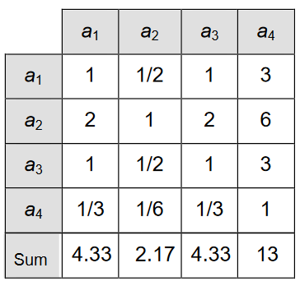

3/13 = odwrotność (3/3 + 6/3 + 3/3 + ⅓)

6/13 = odwrotność (3/6 + 6/6 + 3/6 + ⅙)

3/13 = odwrotność (3/3 + 6/3 + 3/3 + ⅓)

1/13 odwrotność (3/1 + 6/1 + 3/1 + 1/1 )   
Lub

(1/4.33 + 0.5/2.17 + 1/4.33 + 3/13)/4 = 0.23 = 3/13

(2/4.33 + 1/2.17 + 2/4.33 + 6/13)/4= 0.46 = 6/13

(1/4.33 + 0.5/2.17 + 1/4.33 + 3/13)/4 = 0.23 = 3/13

(0.33/4.33 + 0.17/2.17 + 4.33/4.33 + 1/13)/4 = 0.07 = 1/13

1. Consider the below inconsistent pairwise comparison matrix. Compute the priorities (w1 – w4) corresponding to the compared alternatives by approximating the principal eigenvector using the methods based on the arithmetic mean of the normalized matrix.

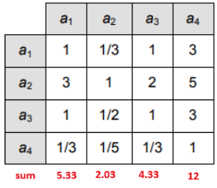

(1/5.33 + 0.33/2.03 + 1/4.33 + 3/12)/4 = 0.21

(3/5.33 + 1/2.03 + 2/4.33 + 5/12)/4 = 0.48

(1/5.33 + 0.5/2.03 + 1/4.33 + 3/12)/4 = 0.23

(0.33/5.33 + 0.2/2.03 + 0.33/4.33 + 0.33/12)/4 = 0.06

1. The maximal eigenvalue of the above matrix is 4.034. Compute the consistency index CI and consistency ratio CR. Is the inconsistency level of this matrix acceptable according to a default rule of AHP?

CI = (Lambda_max - n)/(n - 1)=(4.034 - 1)/(4 - 1)=0,0113

CR = CI/RI = 0,0113/0.9 = 0.0126

RI - Random Index (tabelka)

1. Consider four alternatives X, Y, W, and Z evaluated in terms of three criteria g1, g2, g3 of gain type. For each statement, indicate its truth (T) or falsity (F) (> denotes a preference relation).

| Alternative |  |  |  |  | Relations X > W and Y > Z can be represented using a weighted sum model | T |
| --- | --- | --- | --- | --- | --- | --- |
| X | 8 | 4 | 7 |  | Relations W > X and Z > Y can be represented using a weighted sum model | F |
| Y | 8 | 6 | 5 |  | Relations X > Y and W > Z can be represented using an additive value function | T |
| W | 3 | 4 | 7 |  | Relations X > Y and Z > W can be represented using an additive value function | F |
| Z | 3 | 6 | 5 |  | Relations X > Y and Z > W can be represented using the Choquet integral | T |
|  |  |  |  |  |  |  |

1. Consider the capacities for all subsets of criteria: u(ø) = 0, u({}) = 0.3, u({}) = 0.4, u({}) = 0.5, u({, }) = 0.8, u({, }) = 0.6, u({, }) = 0.7, u({, , }) = 1. Compute the Choquet integral for alternative A = [3, 6, 5].

Ch(A) = (3 - 0) * u({, , }) + (5 - 3) * u({, }) + (6 - 5) * u({}) = 3 + 1.4 + 0.4 = 4.8 = (3 - 0) * 1 + (5 - 3) * 0.7 + (6 - 5) * 0.4 = 3 + 1.4 + 0.4 = 4.8

1. Consider the capacities for various subsets of criteria: u(ø) = 0, u({}) = 0.3, u({}) = 0.4, u({}) = 0.5, u({, , }) = 1. Provide the example capacities for pairs of criteria so that and interact positively, and interact negatively, and there is no interaction between and .

u({, }) = 0.8, bo (0.8 > u({}) + u({}))

u({, }) = 0.6, bo (0.6 < u({}) + u({}))

u({, }) = 0.9, bo (0.9 = u({}) + u({}))

1. Consider the weights for individual criteria and criteria pairs: m(ø) = 0.3, m({}) = 0.3, m({}) = 0.4, m({}) = 0.5, u({, }) = 0.1, u({, }) = -0.1, u({, }) = -0.2. Compute the Choquet integral for alternative A = [3, 6, 5] using the Möbius representation. Verify if these weights satisfy the normalization and monotonicity constraints.

Ch(A) = 3 * m({}) + 6 *m({}) + 5 * m({}) + min(3,6) * u({, }) + min(6,5) * u({, }) + min(3,5) * u({, }) = 3 * 0.3 + 6 * 0.4 + 5 * 0.5 + 3 * 0.1 + 5 * -0.2 + 3 * -0.1 = 0.9 + 2.4 + 2.5 + 0.3 + -1 + -0.3 = 4.8

### EXERCISES V – ELECTRE III AND IV

1. Indicate the truth (T) or falsity (F) for the below statements.

| a) ELECTRE III allows dealing with multiple criteria sorting problems | F |
| --- | --- |
| b) ELECTRE IV requires the Decision Maker to specify the cutting level (credibility threshold) | F |
| c) ELECTRE IV employs a preference model in the form of an additive value function | F |
| d) Weights used in ELECTRE III represent importance coefficients rather than trade-offs between criteria | T |
| e) If alternatives a and b have the same performances on criterion gj, then always cj(a,b)=1 and cj(b,a)=1 | F |
| f) When marginal concordance cj(a,b) is greater than zero, then marginal discordance Dj(a,b) is always equal to 0 | T |
| g) Outranking credibility σ(a,b) cannot be greater than comprehensive concordance C(a,b) | T |
| h) Before the distillation ELECTRE III transforms the valued outranking relation into the crisp one | F? |
| i) The descending and ascending preorders can be different for the same problem | T |
| j) The final preorder in ELECTRE III admits incomparability | T? |
| k) ELECTRE IV does not expect the Decision Maker to specify weights | T |

1. Draw the plots of marginal concordance ci(a,b) and discordance Di(a,b) for criterion gi that is of either gain (to the left) or cost (to the right) type (in this exercise, the thresholds are assumed constant).   
   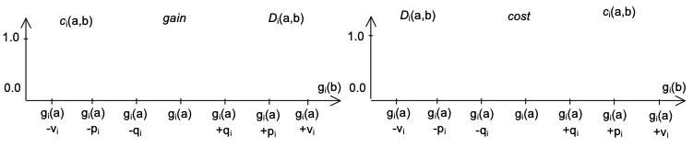

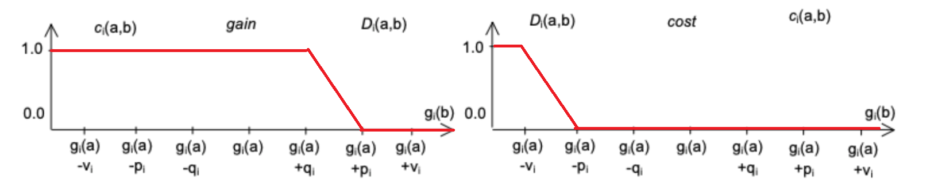

1. Consider three alternatives a, b, and e. They are evaluated on two criteria and (the performances are provided in the below table), with the following specification of preference orders as well as intra- and inter-criteria parameters:
   1. – gain, weight =2, indifference threshold =10, preference threshold =50, and veto threshold =100;
   2. – cost, weight =3, indifference threshold =0, preference threshold =10, and veto threshold =20. For pairs (a,e), (e,a), (b,e), (e,b), compute the marginal concordance and discordance indices, comprehensive concordance indices C, and outranking credibilities σ.

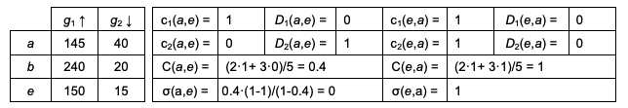

|  | 1 |  | 0 |  | 0 |  | 0.8 |
| --- | --- | --- | --- | --- | --- | --- | --- |
|  | 0.5 |  | 0 |  | 1 |  | 0 |
|  | (2*1+3*0.5)/5=0.7 | | |  | (2*0+3*1)/5=0.6 | | |
|  | 0.7 | | |  | 0.6*(1-0.8)/(1-0.6)=0.3 | | |

1. Assume a is compared with b. The partial results of the concordance and discordance tests are as follows: , , , . Compute the outranking credibility σ(a,b). Recall the meaning of condition when taking into account the reasons against outranking.

σ(a,b) = * ((1 - ) / (1 - )) =0.6 * ((1 - 0.9) / ( 1 - 0.6)) =0.6 * (0.1 / 0.4) = 0.15

1. Conduct the downward and upward distillations for the below credibility matrix.

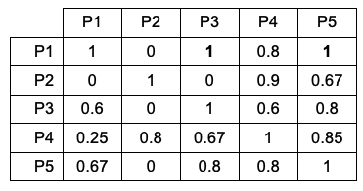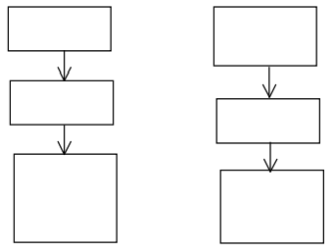

Downward: P1 >> P2 >> {P3, P4, P5}  
Upward: {P1, P2} >> P4 >> {P3, P5}

The first iteration is joint for the downward and upward distillations. Find the maximal credibility (outside the main diagonal): Compute the lower credibility threshold:   
If , add all (currently considered) alternatives to the ranking. No, so preserve only credibilities greater than .

|  | P1 | P2 | P3 | P4 | P5 | Quality |
| --- | --- | --- | --- | --- | --- | --- |
| P1 |  |  | 1 |  | 1 | 2-0=2 |
| P2 |  |  |  | ~~0.9~~ |  | 0-0=0 |
| P3 |  |  |  |  | ~~0.85~~ | 0-1=-1 |
| P4 |  |  |  |  |  | 0-0=0 |
| P5 |  |  |  |  |  | 0-1=-1 |

Maintain only these σ(a,b), which are significantly greater than σ(b,a), i.e., σ(a,b) > σ(b,a) + (-0.15·σ(a,b) + 0.3).   
Cross out the remaining ones   
(e.g., σ(P1,P3) is OK, but σ(P4,P5) needs to be crossed out).  
**Compute strength**: the number of outranked alternatives.

**Compute weakness**: the number of outranking alternatives.   
**Compute quality**: strength – weakness.

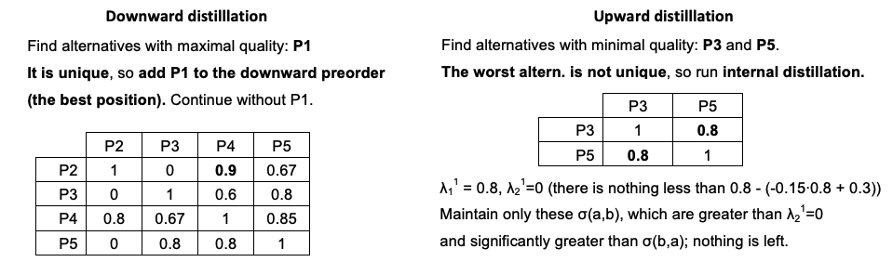

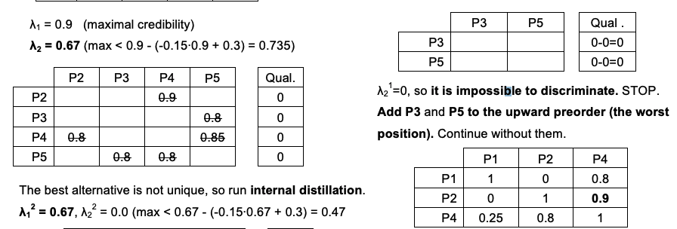

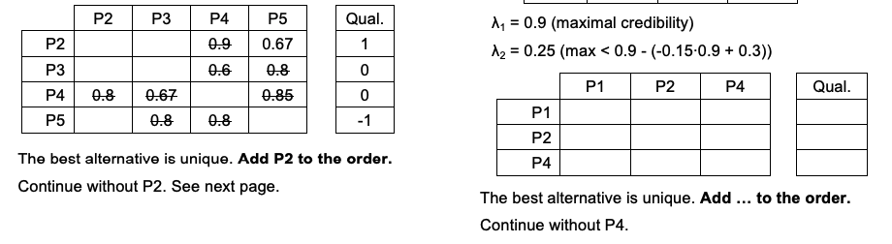

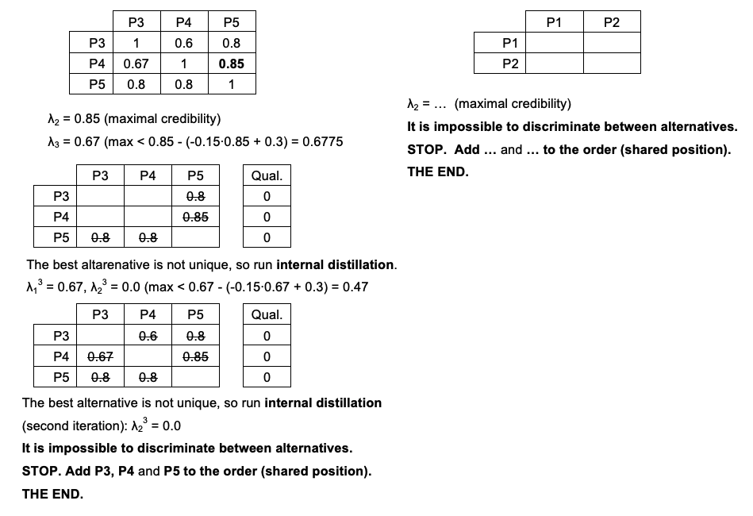

1. Using ELECTRE III, we obtained the following downward c > a > b ~ d ~ e and upward a > d > c > b ~ e preorders, where > is the strict preference and ~ is the indifference. Determine the final preorder admitting incomparability, ranks, and complete median preorder.

Final preorder   
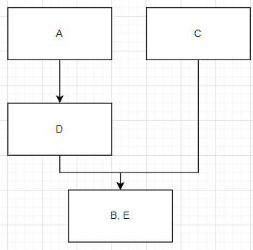  
  
Ranks

1. A,C
2. D
3. B,E

Median preorder

1.A

2. C

3. D

1. B E
2. Identify which outranking relation, if any, holds for pairs of alternatives (a,b) and (b,a) evaluated in terms of four criteria of gain type, according to ELECTRE IV.

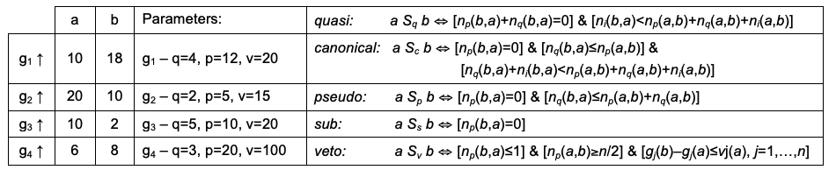

Answer:

for pair (a,b) …. pseudo domination

for pair (b,a) …. no domination

### EXERCISES IV – CONGESTION AND EXTENSIVE GAMES

1. Indicate the truth (T) or falsity (F) for the below statements.

| a) Every congestion game has at least one pure Nash equilibrium | T |
| --- | --- |
| b) The matching pennies games is not a potential game | T |
| c) It is not guaranteed that each potential game has at least one pure Nash equilibrium | F |
| d) Every congestion game is a potential game | T |
| e) An action profile that does not admit a better response is a pure Nash equilibrium | T? |
| f) Every congestion game has the finite improvement property | F |
| g) Every normal-form game has at least one Nash equilibrium | T |
| h) The definition of An extensive-form game involves, e.g., a set of choice nodes, the turn function, and the successor function | T |
| i) Every norm-form game can be translated into an extensive-form game | F |
| j) Every finite extensive-form game has at least one pure Nash equilibrium | T |
| k) The backward induction was originally proposed in the context of tic-tac-toe | F |
| l) Every finite extensive-form game has at least one subgame-perfect equilibrium | T |
| m) The backward induction does not guarantee finding a subgame-perfect equilibrium | F |

1. Consider the below strategic games involving two players, A and B. Are they potential games? If so, define the underlying potential function with P(T,L) = 10.  
   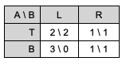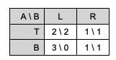

Startujemy w

P(T,L) = 10

P(T,R) = 9 -> dla zmiany decyzji B zmieni się -1

P(B,L) = 11 -> dla zmiany decyzji A zmieni się +1

P(B,R) = ? -> dla zmiany decyzji B zmieni się +1, a dla zmiany decyzji A się nie zmieni +0

P(B,L) + 1 = 12

P(T,R) + 0 = 9

1. Consider the below strategic game involving two players, A and B. Does it have a finite improvement property? If so, identify a pure Nash equilibrium through better response dynamics (mark the path in the table starting in the top-left cell).

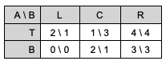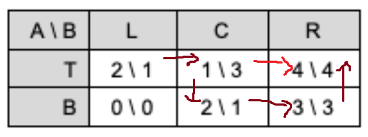

1. Consider the following congestion game: 5 people need to get from A to B. Everyone can choose between the top and the bottom route. Via the top route, the trip takes 5 minutes (in the other scenario, consider – 6 minutes). Via the bottom route, it depends on the number of fellow travelers: it takes as many minutes x as there are people using this route.



* 1. Define the underlying congestion game (players, resources, action space, delay functions).
     1. players N = {1, 2, 3, 4, 5}

resources R = {↑,↓}

action spaces Ai = {{↑},{↓}} representing the two routes

delay functions d↑ = x → 5 and d↓ = x → x

* 1. What are the pure Nash equilibria? Please explain.
     1. Dla 5 minut  
        Równowaga Nasha -> Wszyscy wybierają dolną ścieżkę (mają po 5 min i nikomu nie opłaca się odstąpić od decyzji)  
        Czterech wybiera dolną ścieżkę
     2. Dla 6 minut  
        Rónowaga Nasha -> Wszyscy wybierają dolną ścieżkę
  2. What is the price of anarchy?
     1. Dla 5 minut  
        Optymalne rozwiązanie: sw(x)= -[ x*x+5*(5-x) ] = -[x^2-5x+25] dla x€{0,1,2,3,4,5}  
        znaleźć max - dla 2, 3  
        PoA = sw(5)/sw(2) = -25/-19 = 25/19
     2. Dla 6 minut  
        Optymalne rozwiązanie: sw(x)= -[ x*x+6*(5-x) ] dla x€{0,1,2,3,4,5}  
        znaleźć max - dla 3  
        PoA = sw(5)/sw(3) = -25/-21= 25/7 [tutaj nie jestem pewien czy brać sw(5) skoro to równowaga nasha, ale nie minimum funkcji sw?]

1. Consider the below presented extensive game involving two players, 1 and 2.

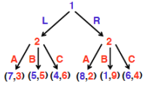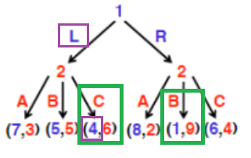

* 1. Find a pure Nash equilibrium using the backward induction.
     1. (L, C-B) można znaleźć tą metodą
  2. Is (L, C-B) the only Nash equilibrium?
     1. chyba tak, nie mogę znaleźć innej
  3. Is (L, C-C) a subgame perfect-equilibrium?
     1. Nie, ponieważ w prawym wierzchołku gracze 2 decyzja nie jest optymalna?
  4. Transform the extensive game to the normal-form game.

1. Consider the below presented centipede game and find a pure Nash equilibrium using a backward induction.

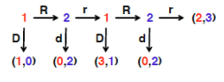

D-d-D-r ? [+1]