**OOAD Semester 2 Project**

**Team members:**

**Maciej Becmer**

**Valerio Farriciello**

**Week 1:**

2/4/2020 : We had an online meeting over Discord where we went over the project and decided on the first steps to take in developing this project. We drew a quick sketch of the use case diagram as well as the class diagram.

4/4/2020 : We began work on the project by creating a visual paradigm online repository and created a domain model class diagram as well as the use case diagram.

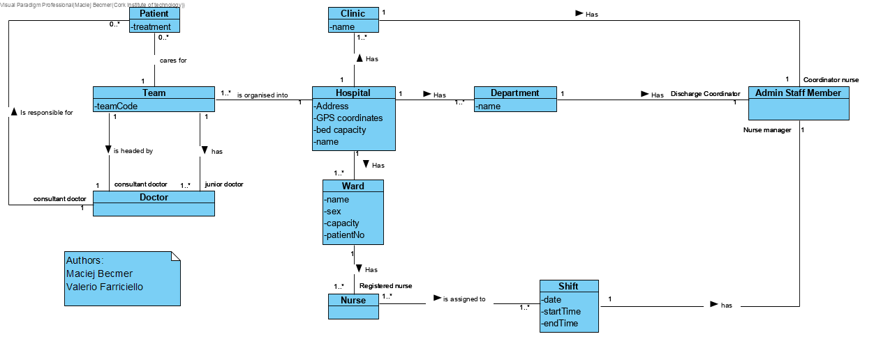

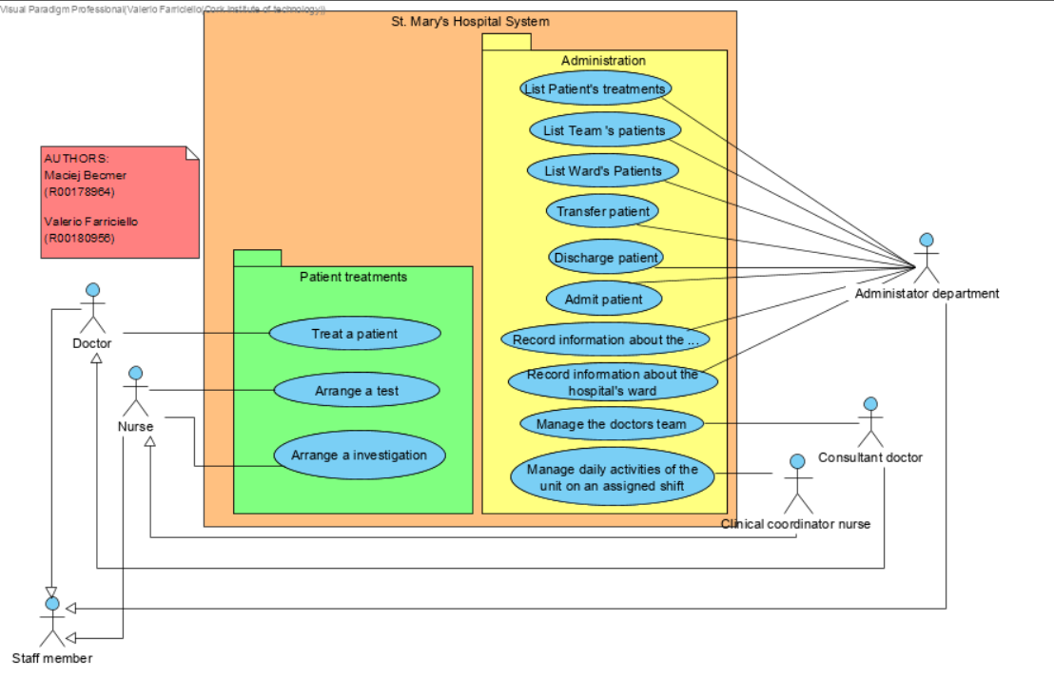

**Week 2:**

8/4/2020 : We decided to change our use case diagram by adding the patient actor and adding a few more use case scenarios.

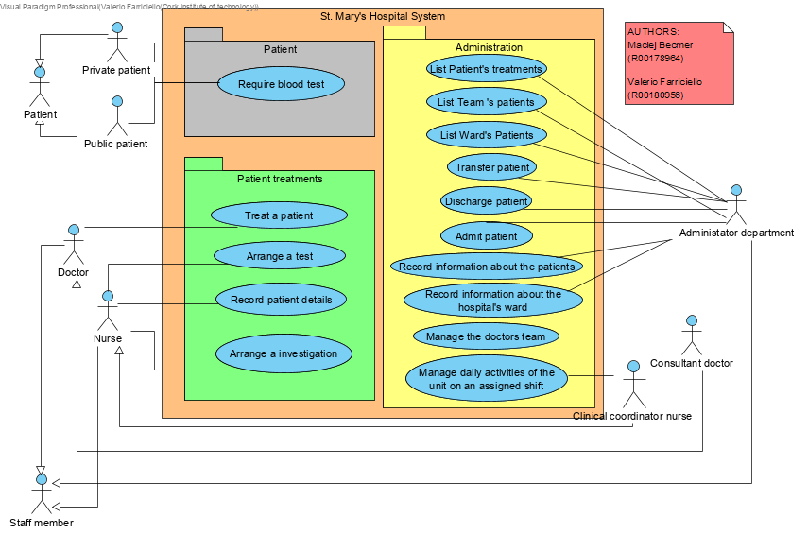

10/04: We tried to import java library in our project but we had issues with VP, so we decided to create our own classes that could be useful for our project like the LinkedList class.

**Week 3:**

8/4/2020 : We decided to change our use case diagram by adding the patient actor and adding a few more use case scenarios.

10/04: We tried to import java library in our project but we had issues with VP, so we decided to create our own classes that could be useful for our project like the LinkedList class.



19/4/2020: We discussed about the way we should implement our sequence diagrams and then we started to work on them.

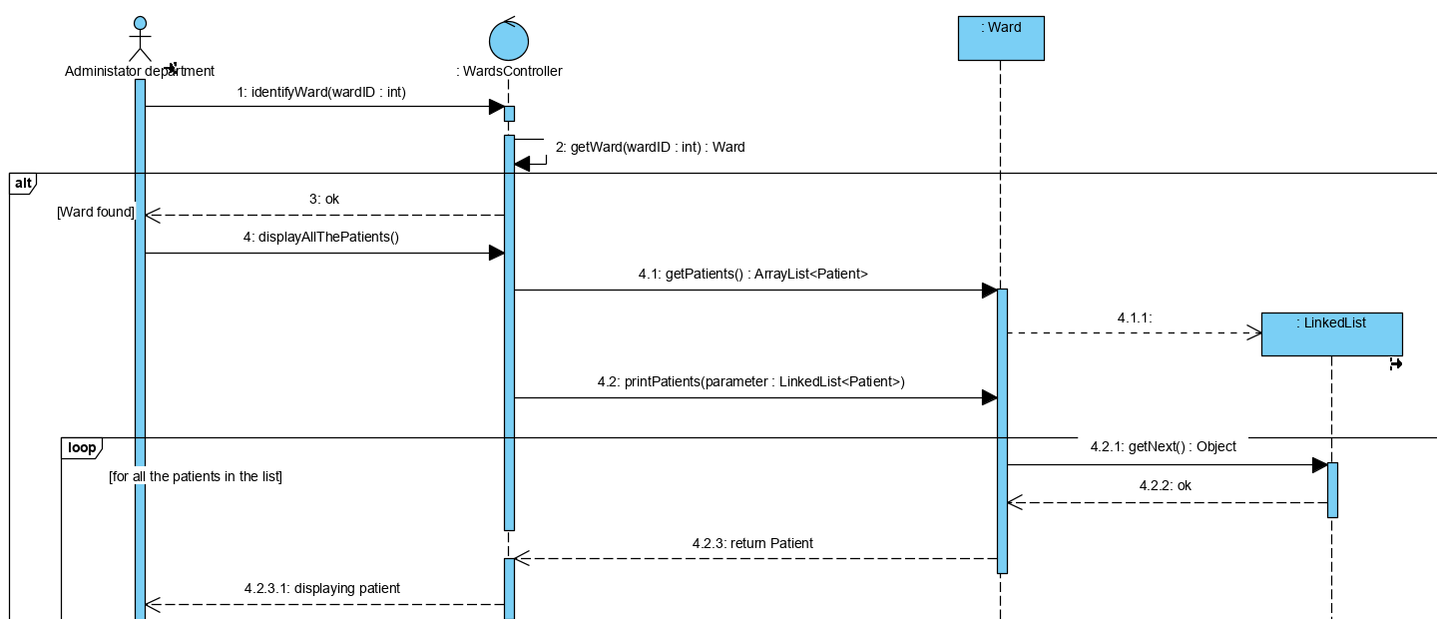

We created the first 2 use cases as system sequence diagrams, usage scenarios, object diagrams and sequence diagrams.

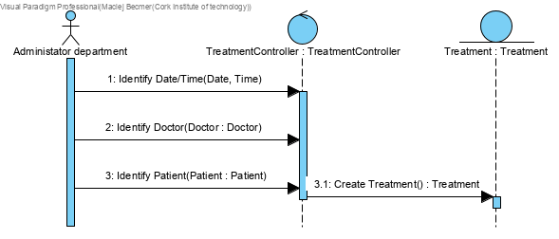

**Week 4:**

21/4/2020: We completed 7 system sequence diagrams and sequence diagrams for the use cases and started working on our objects diagram.

We haven’t decided yet which use case will be used for the remaining one (the 8th).

23/4/2020: As our last use case we picked ‘manage the doctors team’.

The only issue is that this use case is very generic, so we decided to work on it by creating a scenario where the consultant doctor wants to remove a doctor from his/her team.

(We added a note inside our diagrams)

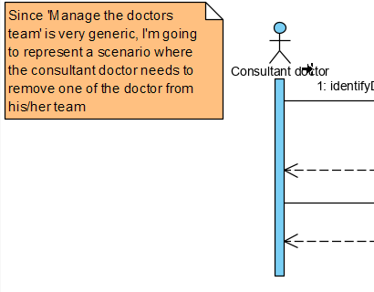

25/4/2020: All our diagrams (except the class diagrams) have been completed with some modifications.

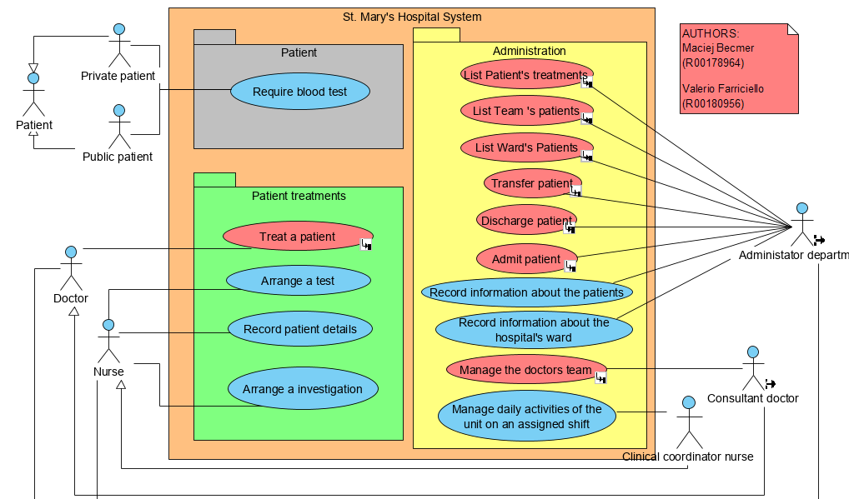

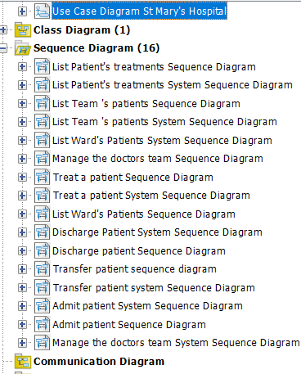

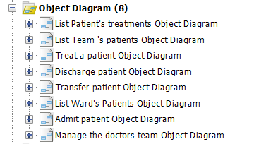

26/4/2020: We noticed a mistake in our ‘treat a patient’ system sequence and sequence diagrams and we fixed it.

1/5/2020: We completed all sequence diagrams and class design diagrams for the project. We have updated the project file with all necessary screenshots and descriptions up to date.

2/5/2020: We finished part 5 of the project by creating new design class diagrams. The question asks to extend the main design class diagram, but since we split the design class diagram into 8 smaller design class diagrams, we decided to create completely new ones in order to fit the question, as we felt that extending one of the smaller ones for the new features will not be sufficient. We also updated the project journal file with all necessary details and screenshots and we consider the project to be finished.

