|  |  |  |
| --- | --- | --- |
| Opis | AX pin | MEGA pin |
| A – step | 28 | 4 |
| A – dir | 27 | 5 |
| B – step | 3 | 6 |
| B – dir | 2 | 7 |
| C – step | 14 | 8 |
| C – dir | 13 | 9 |
| Reset | 26 | 10 |

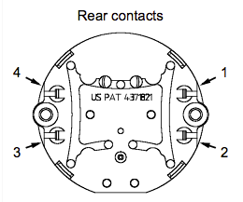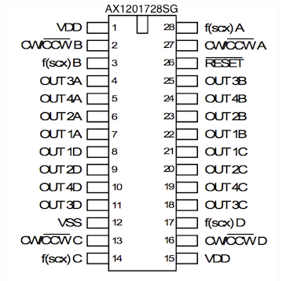

|  |  |  |  |  |  |
| --- | --- | --- | --- | --- | --- |
| **Motor pin** | **AX pin** | **Motor pin** | **AX pin** | **Motor pin** | **AX pin** |
| M1 – 1 | OUT1C – 21 | M2 – 1 | OUT1B – 22 | M3 – 1 | OUT1A – 7 |
| M1 – 2 | OUT2C – 20 | M2 – 2 | OUT2B – 23 | M3 – 2 | OUT2A – 6 |
| M1 – 3 | OUT3C – 18 | M2 – 3 | OUT3B – 25 | M3 – 3 | OUT3A – 4 |
| M1 – 4 | OUT4C – 19 | M2 – 4 | OUT4B – 24 | M3 – 4 | OUT4A – 5 |

Bezpośrednie połączenie do MEGA

Motor 1 – MEGA 22  
Motor 2 – MEGA 23  
Motor 3 – MEGA 25  
Motor 4 – MEGA 24