Laboratorium 7

Liczba kroków | Dokładność MAXIMUM
Liczba kroków | Euler | Runge-Kutta
5 | 6.8508 | 0.7732
10 | 5.9894 | 0.1303
15 | 4.3174 | 0.0173
20 | 3.4366 | 0.0044
25 | 2.8719 | 0.0015
35 | 2.1731 | 0.0003
50 | 1.6045 | 6.006e-05
75 | 1.1121 | 9.475e-06
100 | 0.8550 | 2.618e-06
150 | 0.5832 | 4.412e-07
250 | 0.3569 | 4.922e-08
500 | 0.1812 | 2.700e-09
750 | 0.1214 | 5.088e-10
1000 | 0.0913 | 1.570e-10
5000 | 0.0184 | 3.197e-13
10000 | 0.0092 | 2.851e-12
50000 | 0.0018 | 1.471e-11

Euler 10000 kroków
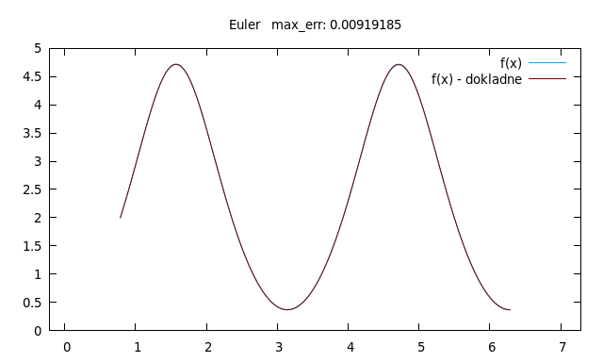
Euler 5
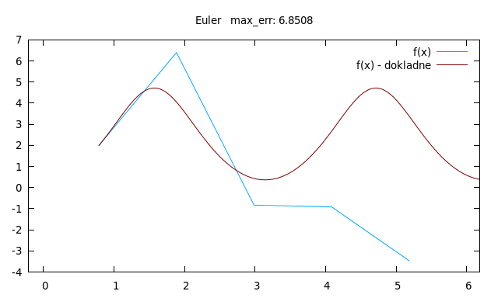
Runge 5 kroków
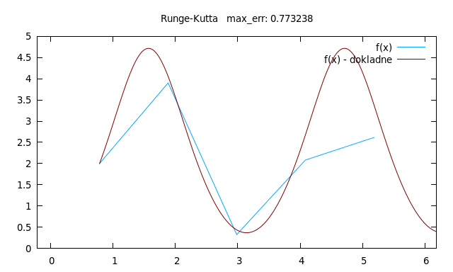

Runge 10000 kroków
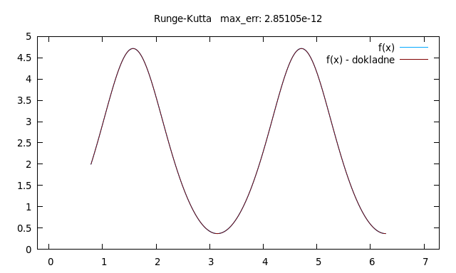
Finite Differences

20000 kroków
