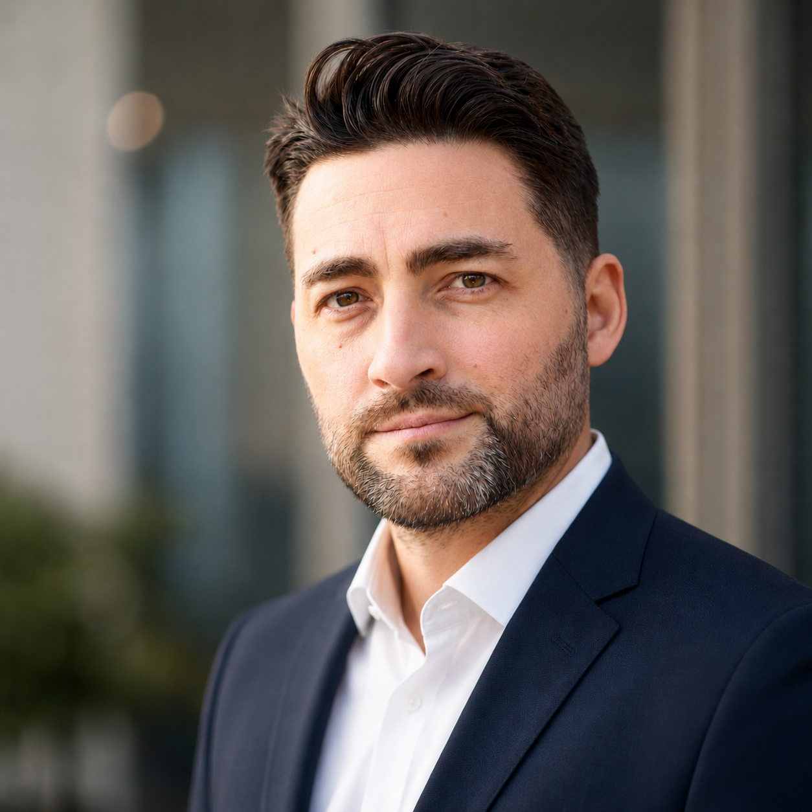  Maciej Sufa  AI Process & Automation Specialist  +48 504 003 019  sufamaciej@gmail.com  maciejvsufa.pl  github.com/maciejvsufa  b. 24 April 1988, Warsaw  Łódź, ul. Milionowa 243, Poland  Employment or B2B · remote PL / EU  Registered sole proprietorship — B2B-ready (often preferred by companies)  Skills  AI & automation  · AI agents  · Prompt engineering  · n8n · ExoVault · MCP · API  · AI audits  · Multi-agent  Development  · React · Next.js · TypeScript  · Python · Tailwind  · No-code + AI  · Docker · Git  Production · soft  · Social media automation  · Video pipeline  · Client communication  · Deployments · training  Languages  · Polish — native  · English — B1/B2 (fluent with technical documentation, conversational spoken) | Professional Profile  I audit and automate business processes with AI — apps, integrations and solutions that remove repetitive work. I design AI-agent systems, automations (n8n, Python, MCP) and social media pipelines. Audit → prototype → deployment. Business background: 3 years in premium customer service (Domoteka showroom) plus stage experience (theatre, film, workshops) help me translate technology into business language. Open to employment or B2B — registered sole proprietorship. Remote · PL/EU.  Experience  Co-founder · Asistel 2026 – present  AI platform for pharmacies and multi-branch companies (asistel.pl) — 3-person experienced team  • Product, AI layer (dialog, tickets) and client communication; team and process management panel  • Asistel PWA: speech-to-text voice notes — one-tap recording, saved as text; pharmacists work hands-free  • Voice agent handling calls — code review and shared approval in the team  Founder & AI Solutions Builder · LEV 2025 – present  Independent practice — AI solutions for business  • Audit → prototype → deployment: automations, apps, websites, API integrations  • ExoVault (exovault.co) as a work tool: encrypted AI agent memory, task organization and team communication  • Social media automation, team training  Selected Projects  Asistel — AI platform for pharmacies and multi-branch companies, co-created in a 3-person team: AI voice agent handling calls, PWA with speech-to-text notes, team & process management panel  Studio AI — End-to-end video production pipeline: script → voiceover (TTS, forced alignment) → illustrations → editing and publishing (Python, ffmpeg, Claude agents, n8n; ExoVault as agent-team memory and task board)  Organizacja Myśląca (Thinking Organization) — Decision-support system based on systems thinking (Senge): ladder of inference, dialogue vs. discussion, system archetypes — prototyping the tool with AI agents  maciejvsufa.pl — Next.js portfolio (PL/EN), Lighthouse 99+  Education · Certificate  Warsaw Film School (WSF) — acting (2008–2010), higher education  AI Skills for Tomorrow — Using AI in Business Development (2025)  Google & SGH (Warsaw School of Economics) — Practical Google & SGH program: AI in productivity, marketing, sales, analytics and AI agents; AI implementation leadership

