1.NYY

2.YNY

3.Configuring SaaS Solution

4. A

5. In the public cloud

6.D,E

7. Pay monthly usage goals

8. Y

9. N

10. Y

11. C

12. B

13. Infrastructure / Platform

14. D

15. N, Y, N

16. D

17. Disaster recovery

18. C

19. Hybrid

20. A

21. tak jak jest

22. YYN

23. NYY

24. A, C

25. NYY

26. B

27. A

28. Hybrid – Provides a choice, Private – Provides capital control, Public – No required capital

30. N, Y, N

31. A

32. N, Y, Y

33. N

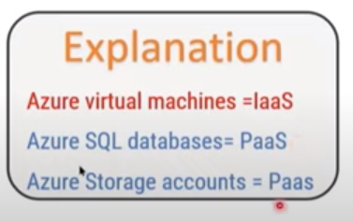

34.C

35. A

36. N, Y, Y

37. C

38. Developer, Standard, Professional, Premier

39. B

40. B

41. B

42. B

43. A

44. B

45. B

46. A

47. B

48. B

49. A

50. B

51. A

52. B\

53. B

54. A

55. b

56. a

57. b

58. Y,Y, Y

59. A

60. N, N, Y

61. N, Y, Y

62. ostatnie dwa

63. Y

64. B

65. A

66. B

67. pay monthly usage costs

68. C

69. B

70. D

71. D

72. C

73. hybrid

74. A

75. B

76. A

78. Paas

79. N,Y, Y

80. PaaS

81. D

82. Agility – Applications can be developed…, Geo-disstribution- Applications and data can…, Scalability – Resources can be provisioned…

83. hybrid

84. configuring Saas

85. A, D

86. D

87. geo-distribution

88. Local Network Gateway

89. B

90. B

91. N, Y, N

92. C

93. A, D

94. Y, N, Y

95. The virtual machines can be moved to the new subscription

96. A, E

97. D

98.N, N, N

99. N, N, N

100. Containers

101. Basic

102. B

103. C

104. D

105. Managing physical server, Replacing failed server hardware

106. Azure AD

107. B

108. B

109. D

110. A

111. D

112. B

113. A

114. B

115. D, E

116. C

117. A

118. B

119. A

120. A

121. A

122. B

123. A

124. A

125. D

126. resource location, resource usage

127. TCO

128. A, B

129. A

130. A

131. B

132. A

133. A, B

134. C

135. A

136. A

137. A

138. B

139. A

140. B

141. C

142. B

143. C, D

144. A, C

145. A

146. A, C

147. A

148. B

149. A

150. B

151. A

152. A

153. B

154. A, D

155. B

156. A

157. D

158. A

159. C

160. A

161. A

162. A, D

163. C

164. A

165. A,B

166. A

167. C, D

168. C

169. B

170.B

171. A