App development

Ideas, diagrams

Microsoft Office User

All topics

1. Clarify & collect requriments 1

1.1. Functional requriments: 1

1.2. Nonfunctional requriments: 1

2. User stories 1

2.1. General: 1

2.2. Epics: 1

3. Use case diagrams 2

4. Identify main entities and realtionships between them (class diagram) 2

5. Model behavior (sequence diagram) 2

6. Represent object states 2

# 

# 1. Clarify & collect requriments

## 1.1. Functional requriments:

* we need to make a shop
* user can go to products page
* user can go to contact page
* user can go to about page(describes product)
* user can go to home page
* user can add products to basket
* user can add amount of products in basket
* user can delete products from basket
* user can make an order by giving his address etc. in form
* user can pay for the product by: card, swift
* user can read order id from email

## 1.2. Nonfunctional requriments:

* The app should be easy to use
* The app must have rating 90< in google
* The app must be sequre (payments)
* The app must have nice animations
* The app need to load fast
* The app must be truthworthy

# 2. User stories

## 2.1. General:

* Placing an order
* Contact with seller
* Reading about the product
* Be trustworthy about the seller

## 2.2. Epics:

* Placing and order
  + As a user I want to add products to basket and if needed change amount and delete them
  + As a user I want to place an order with my home address
  + As a user I want payment to be sequre and easy
* Contact with seller
  + As a user I want to easily contact with the seller if it is necessary (contact page)
* Reading about the product
  + As a user I want to know a lot more about the product (about page)
* Be trustworthy about the seller
  + As a user I want to make sure that this shop is not a scam

# 3. Use case diagrams

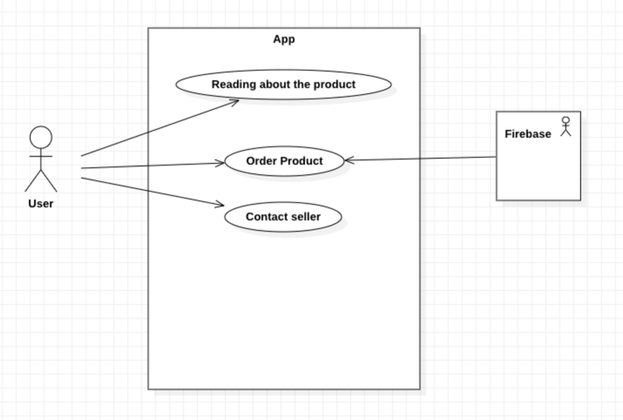

# 4. Identify main entities and realtionships between them (class diagram)

# 5. Model behavior (sequence diagram)

# 6. Represent object states