USA Bank Stress Test DFAST Replication

Final Technical and Pedagogical Manual
A public, reproducible and didactic DFAST-style stress testing project
Generated on: 2026-06-30 08:14:20
Prepared for students, instructors, researchers and interested public readers.

Preface
This manual explains the construction of a public DFAST-style bank stress testing engine using only public data. It is designed primarily for students, but it can also be used by analysts and interested readers who want to understand the mechanics of stress testing, supervisory data, capital ratios and model validation.
The manual is intentionally technical and pedagogical. It does not only present final results; it explains the logic of the project, the role of each script, the meaning of the variables, the structure of the models, the interpretation of validation metrics and the limitations of a public replication exercise.
The central message is that a useful stress testing project must combine data governance, regulatory interpretation, financial accounting, econometric modelling, validation, model risk assessment and transparent communication.

1. Executive Overview
The project builds a reduced-form replication of selected DFAST-style stress testing outputs for large banking organizations in the United States. It uses Federal Reserve public stress test results and public scenario data to estimate models for credit losses, PPNR and CET1 capital depletion.
The final integrated engine predicts stressed minimum CET1 ratios and compares them with Federal Reserve public benchmark outcomes. The model achieves strong validation results, with high correlation, low average error and limited systematic bias.
The results should be interpreted as a public benchmark and teaching tool, not as an official supervisory stress test or bank rating system.

Table 1. Manual executive summary
Metric | Value
Panel observations | 497
Banks | 56
Exercise years | 11
Scenarios | 3
Latest exercise year | 2025
Minimum predicted CET1 ratio | 5.5573
Mean predicted CET1 ratio | 10.6961
Maximum predicted capital depletion | 8.5976
Mean predicted capital depletion | 2.6675
CET1 minimum ratio RMSE | 0.846
CET1 minimum ratio MAE | 0.5873
CET1 minimum ratio bias | 0.0145
CET1 minimum ratio R-squared | 0.9688
CET1 minimum ratio correlation | 0.9843
CET1 4.5 percent classification accuracy | 1
CET1 7.0 percent classification accuracy | 0.9557
High model risk observations | 35
Largest absolute CET1 error | 5.0721

2. Conceptual Foundations of Bank Stress Testing
A bank stress test is a forward-looking exercise. It asks how a bank's balance sheet, income statement and capital ratios would behave under adverse economic and financial conditions.
The essential question is not whether a bank is profitable in normal times. The essential question is whether it can absorb losses and continue to satisfy capital adequacy standards under stress.
In a simplified stress testing framework, macroeconomic stress affects borrower defaults, credit losses, revenue, provisions, trading losses, risk-weighted assets and capital ratios. The final outcome is usually expressed through capital adequacy measures such as the CET1 ratio.

Table 2. Core concepts
Concept | Explanation
Stress test | A forward-looking exercise that evaluates how a bank performs under adverse economic and financial conditions.
DFAST-style replication | A public-data reconstruction of selected stress test outputs, without access to confidential supervisory models.
Scenario | A coherent set of macroeconomic and financial assumptions used to project bank outcomes.
Severely adverse scenario | A severe hypothetical scenario designed to test resilience under material stress.
Credit losses | Losses generated by loan portfolios and credit exposures during the stress horizon.
PPNR | Pre-provision net revenue; a measure of earnings available to absorb losses before provisions.
Provision | Allowance or expense recognized to absorb expected credit losses.
CET1 ratio | Common Equity Tier 1 capital divided by risk-weighted assets.
Capital depletion | Reduction in capital ratio between the starting point and the stressed minimum.
Risk-weighted assets | Assets adjusted by regulatory risk weights to reflect relative riskiness.
Benchmark validation | Comparison of model projections with observed public DFAST benchmark outcomes.
Model risk | Risk that a model produces inaccurate, unstable or misleading results.
Tail error | A large error located in the extreme part of the error distribution.
Threshold classification | Classification of observations as above or below selected capital thresholds.
Vulnerability ranking | Relative ranking of banks according to model-based stress vulnerability indicators.

3. Regulatory and Public Data Scope
The empirical scope is based on public Federal Reserve DFAST outputs. Public DFAST results are useful because they provide observed stress outcomes across banks, years and scenarios.
A public replication has strict boundaries. It can use observed public outcomes and public scenario data, but it cannot reproduce confidential supervisory models, confidential bank submissions, loan-level supervisory data or internal management actions.
This distinction is fundamental for students. A public-data model can be rigorous, transparent and informative, but it remains a benchmark model. It is not the official model used by supervisors.

4. Reproducible Research Pipeline
The project is organized as a sequential R pipeline. Each script performs a defined task, creates outputs and leaves an audit trail.
This structure is pedagogically important because it allows students to understand that empirical modelling begins before estimation. Data availability, source documentation, cleaning, key integrity and sample construction are part of the model-building process.

Table 3. Script-by-script learning map
Script | Title | Student learning point
Script 01 | Data Availability Audit | How to verify whether a project is feasible before modelling.
Script 02 | Regulatory Documentation and Raw Data Ingestion | How to document source provenance and regulatory basis.
Script 02b | Download Regulatory Documentation | How public documentation supports reproducibility.
Script 02c | Fix Missing Regulatory Documentation Downloads | How to handle missing public source links transparently.
Script 03 | Clean Federal Reserve DFAST Results | How to clean raw public supervisory data.
Script 04 | Structure Federal Reserve Macro Scenarios | How macro scenarios are structured for stress testing.
Script 05 | Build DFAST Benchmark Dataset | How to build a bank-year-scenario benchmark panel.
Script 06 | Capital and Losses Transmission Layer | How accounting logic links PPNR, losses and capital.
Script 07 | Exploratory Analysis | How to inspect distributions, outliers and empirical structure.
Script 08 | Build Modelling Sample and Treatment Rules | How to create a clean econometric modelling sample.
Script 09 | Estimate Credit Loss Model | How to estimate stress-period credit loss intensity.
Script 10 | Estimate PPNR Model | How to estimate revenue capacity under stress.
Script 11 | Estimate Capital Depletion Model | How to estimate capital depletion under stress.
Script 12 | Integrated Stress Test Projection Engine | How to combine component models into one engine.
Script 12b | Fix Integrated Projection Join Keys | Why unique join keys are essential in panel data.
Script 13 | Stress Test Results and Bank Vulnerability Ranking | How to rank banks under model-based vulnerability metrics.
Script 14 | Benchmark Validation Against Federal Reserve Public Results | How to validate a model against a public benchmark.
Script 15 | Robustness, Sensitivity and Model Risk Assessment | How to assess tail error, threshold sensitivity and model risk.
Script 16 | Create Final Institutional Report | How to communicate institutional results.
Script 17 | Create Final Technical and Pedagogical Manual | How to convert the project into a teaching manual.

5. Data Structure and Variables
The final dataset is organized at the bank-year-scenario level. Each observation corresponds to one bank, one stress test exercise year and one scenario category.
The most important technical requirement is key uniqueness. The final panel must contain one row per bank-year-scenario key. If duplicated keys remain, joins between model components can create artificial row expansion and distort results.
This project identified and corrected such a problem in Script 12b. That correction is an important teaching example in panel data management.

Table 4. Final key audit
Dataset | Rows | Unique keys | Duplicated keys | Max rows per key
final_results_panel | 497 | 497 | 0 | 1

Table 5. Main variables used in the manual
Variable | Interpretation
actual_credit_loss_ratio | Observed credit loss intensity from public benchmark data.
predicted_credit_loss_ratio | Model-predicted credit loss intensity.
actual_ppnr_ratio | Observed PPNR ratio from public benchmark data.
predicted_ppnr_ratio | Model-predicted PPNR ratio.
actual_capital_depletion | Observed CET1 capital depletion.
predicted_capital_depletion | Model-predicted CET1 capital depletion.
observed_cet1_min_ratio | Observed public DFAST stressed minimum CET1 ratio.
integrated_predicted_cet1_min_ratio | Integrated model-predicted stressed minimum CET1 ratio.
cet1_min_prediction_error | Predicted CET1 minimum ratio minus observed CET1 minimum ratio.
abs_cet1_min_prediction_error | Absolute value of the CET1 prediction error.
model_risk_score | Composite score measuring potential model risk at observation level.
model_risk_bucket | Categorical classification of model risk.

6. Stress Testing Transmission Mechanism
The transmission mechanism links stress conditions to capital outcomes. In simplified form, stress increases losses, affects earnings, changes risk-weighted assets and reduces capital ratios.
PPNR is important because it absorbs losses before capital is depleted. A bank with high loss-absorbing revenue may experience lower capital pressure than a bank with similar losses but weaker earnings.
Capital depletion is the bridge between stressed income and regulatory capital adequacy. The integrated model therefore estimates credit losses, PPNR and capital depletion before computing the predicted stressed CET1 minimum ratio.

Table 6. Simplified model equations and teaching messages
Model block | Simplified equation | Pedagogical message
Credit loss model | Credit loss ratio = f(bank effects, year effects, scenario indicators, balance sheet controls) | Credit losses are not only macro driven; they also depend on bank-specific portfolios.
PPNR model | PPNR ratio = f(bank effects, year effects, scenario indicators, profitability controls) | PPNR is the first buffer against stress losses.
Capital depletion model | CET1 depletion = f(credit losses, PPNR, RWA dynamics, initial CET1, bank effects, year effects) | Capital depletion aggregates multiple channels and is therefore harder to model than a single component.
Integrated CET1 projection | Predicted CET1 minimum ratio = Starting CET1 ratio - Predicted CET1 depletion | The integrated engine converts model components into a capital adequacy outcome.

7. Econometric Modelling Blocks
The project estimates three main reduced-form model blocks: credit losses, PPNR and CET1 capital depletion.
The operational models use bank and year fixed effects. Bank fixed effects capture persistent differences across institutions. Year fixed effects capture common exercise-year conditions and changes in the stress testing environment.
The purpose is not to discover a universal structural law of bank losses. The purpose is to build a transparent, empirically disciplined benchmark that approximates public DFAST outcomes.

7.1. Credit Loss Model
The credit loss model estimates stress-period loss intensity. It reflects the fact that credit losses depend on both macro-financial stress and bank-specific exposure structures.
In teaching terms, this block helps students understand why the same macro scenario can have different effects across banks.

7.2. PPNR Model
The PPNR model estimates the earnings buffer available before provisions and selected losses. It is one of the most important concepts in bank stress testing because earnings can absorb part of the stress before capital is reduced.
For students, PPNR shows that stress testing is not only about losses. It is also about the capacity to generate revenue under adverse conditions.

7.3. Capital Depletion Model
The capital depletion model maps credit losses, PPNR, capital ratios and balance sheet dynamics into the reduction of CET1 capital under stress.
This model is naturally more difficult than the credit loss and PPNR models because it aggregates several channels. Its lower explanatory power relative to the final CET1 ratio is therefore not surprising.

Table 7. Accuracy of the main modelling blocks
Component | Observations | Rmse | Mae | Bias | R squared | Correlation
Credit loss ratio | 497 | 0.0060 | 0.0043 | -0.0001 | 0.9560 | 0.9778
PPNR ratio | 497 | 0.0093 | 0.0065 | 0.0000 | 0.9200 | 0.9592
CET1 capital depletion | 497 | 0.7891 | 0.5698 | 0.0004 | 0.8379 | 0.9153
CET1 minimum ratio | 497 | 0.8460 | 0.5873 | 0.0145 | 0.9688 | 0.9843

8. Integrated Stress Test Engine
The integrated engine combines the component models into a final capital projection. The simplified formula is: predicted CET1 minimum ratio equals starting CET1 ratio minus predicted CET1 depletion.
The first integrated version produced artificial row expansion because of duplicated bank-year-scenario keys. Script 12b corrected this by forcing one row per key before merging the component predictions.
This correction is a central lesson: in panel-data modelling, correct joins are as important as correct equations.

Figure 1. Observed versus predicted CET1 minimum ratio
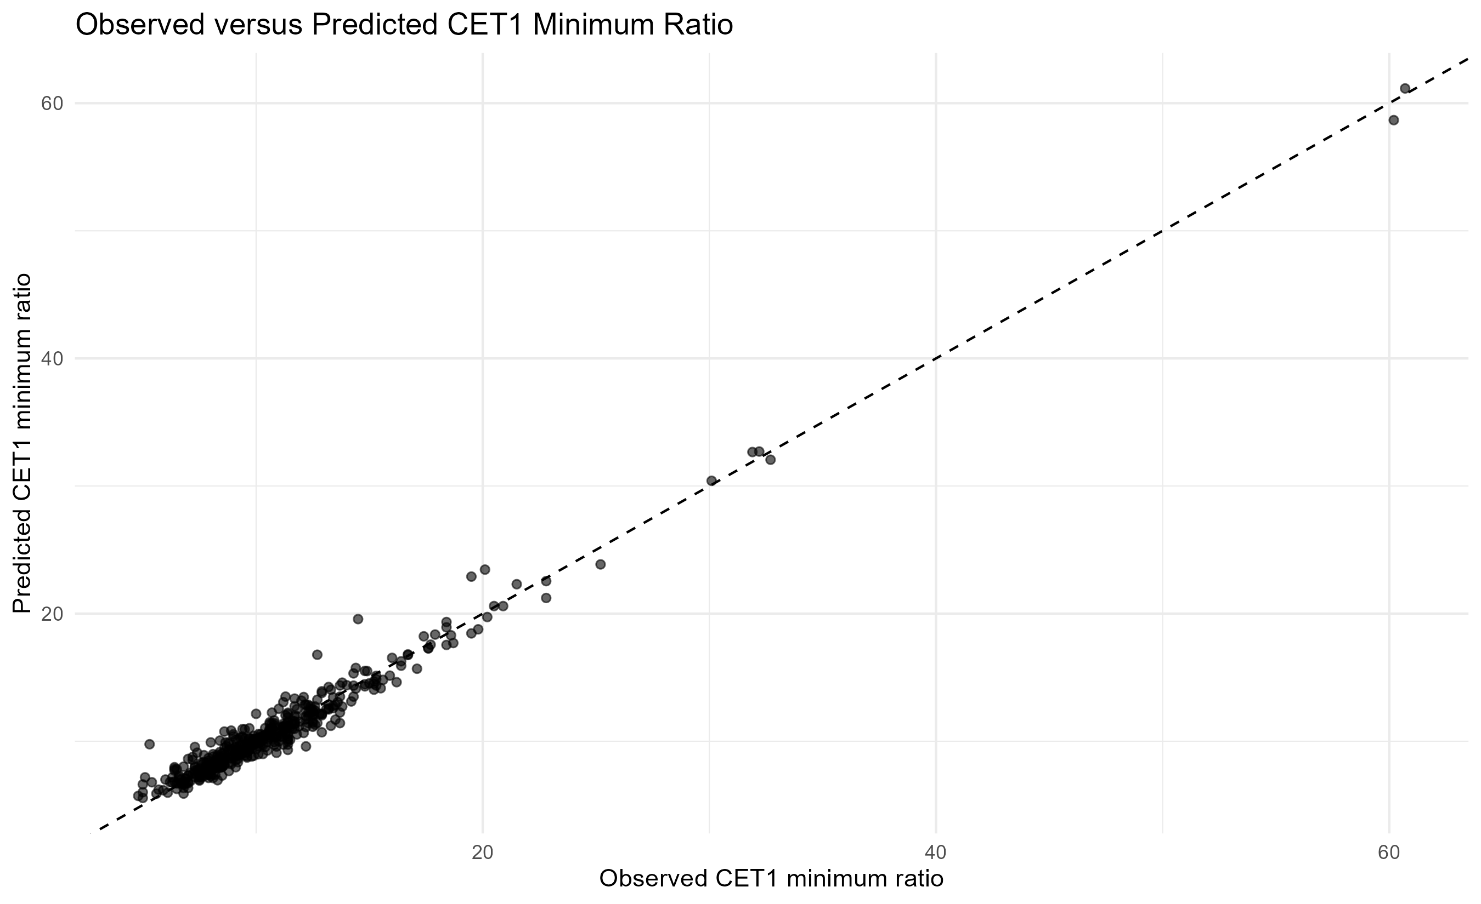

9. Final Stress Test Results and Vulnerability Ranking
The final results identify banks with lower predicted minimum CET1 ratios, larger predicted capital depletion and weaker stress margins.
The ranking is model-based and relative. It is not an official supervisory ranking, not a credit rating and not an investment recommendation.
For students, the ranking is useful because it shows how model outputs can be transformed into analytical summaries. It also creates an opportunity to discuss responsible interpretation.

Figure 2. Latest exercise top 20 banks by minimum predicted CET1
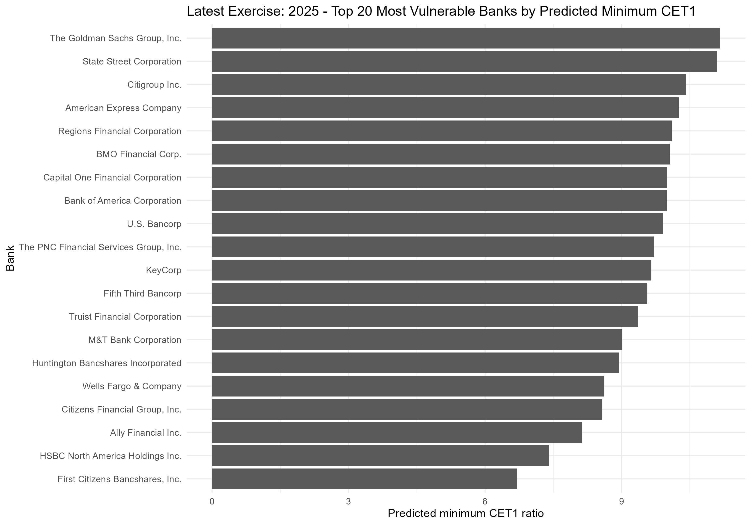

Table 8. Latest exercise vulnerability ranking
Latest year rank composite | Bank name | Min predicted cet1 min ratio | Min observed cet1 min ratio | Max predicted capital depletion | Max predicted credit loss ratio | Min predicted ppnr ratio | Worst scenario by predicted cet1
1 | First Citizens Bancshares, Inc. | 6.7000 | 6.7 | 4.5000 | 0.0698 | 0.0357 | Supervisory Severely Adverse
2 | HSBC North America Holdings Inc. | 7.4094 | 8.1 | 3.8906 | 0.0399 | 0.0026 | Supervisory Severely Adverse
3 | BMO Financial Corp. | 10.0557 | 10.1 | 3.9443 | 0.0518 | 0.0343 | Supervisory Severely Adverse
4 | Ally Financial Inc. | 8.1360 | 7.8 | 2.0640 | 0.0578 | 0.0484 | Supervisory Severely Adverse
5 | Citizens Financial Group, Inc. | 8.5708 | 8.6 | 2.0292 | 0.0555 | 0.0413 | Supervisory Severely Adverse
6 | Capital One Financial Corporation | 9.9949 | 11.0 | 4.3051 | 0.1265 | 0.1170 | Supervisory Severely Adverse
7 | M&T Bank Corporation | 9.0123 | 9.2 | 1.7877 | 0.0652 | 0.0590 | Supervisory Severely Adverse
8 | KeyCorp | 9.6507 | 9.9 | 2.1493 | 0.0484 | 0.0443 | Supervisory Severely Adverse
9 | Wells Fargo & Company | 8.6168 | 9.2 | 1.9832 | 0.0445 | 0.0513 | Supervisory Severely Adverse
10 | Huntington Bancshares Incorporated | 8.9373 | 9.3 | 1.4627 | 0.0546 | 0.0563 | Supervisory Severely Adverse
11 | Fifth Third Bancorp | 9.5643 | 9.7 | 1.2357 | 0.0560 | 0.0522 | Supervisory Severely Adverse
12 | RBC US Group Holdings LLC | 13.4961 | 13.7 | 3.7039 | 0.0484 | 0.0399 | Supervisory Severely Adverse
13 | Truist Financial Corporation | 9.3571 | 9.7 | 1.4429 | 0.0463 | 0.0477 | Supervisory Severely Adverse
14 | Citigroup Inc. | 10.4145 | 10.3 | 2.7855 | 0.0464 | 0.0527 | Supervisory Severely Adverse
15 | DB USA Corporation | 15.7460 | 14.4 | 6.8540 | 0.0174 | 0.0109 | Supervisory Severely Adverse
16 | Regions Financial Corporation | 10.1002 | 10.3 | 0.7998 | 0.0557 | 0.0521 | Supervisory Severely Adverse
17 | U.S. Bancorp | 9.9066 | 9.8 | 0.8934 | 0.0538 | 0.0638 | Supervisory Severely Adverse
18 | Bank of America Corporation | 9.9931 | 9.9 | 1.4069 | 0.0398 | 0.0425 | Supervisory Severely Adverse
19 | The PNC Financial Services Group, Inc. | 9.7127 | 10.3 | 0.8873 | 0.0438 | 0.0506 | Supervisory Severely Adverse
20 | TD Group US Holdings LLC | 14.3904 | 14.0 | 2.1096 | 0.0478 | 0.0425 | Supervisory Severely Adverse

10. Benchmark Validation
Benchmark validation compares the model's predictions with observed public Federal Reserve DFAST outcomes. This step is essential because a stress test engine must be assessed against actual benchmark results.
The key validation variable is the CET1 minimum ratio. The model achieves high explanatory power, low average error and near-zero average bias.
Students should understand that no single validation metric is sufficient. RMSE, MAE, bias, R-squared, correlation and threshold accuracy each answer a different question.

Table 9. Validation metrics and classroom warnings
Metric | Meaning | Classroom warning
RMSE | Root mean squared error; penalizes large errors more heavily. | A low RMSE can hide important tail errors.
MAE | Mean absolute error; average size of the prediction error. | MAE is intuitive but does not penalize large errors as strongly as RMSE.
Bias | Average prediction error; indicates whether predictions are systematically above or below observed values. | A low bias does not mean every prediction is accurate.
R-squared | Share of outcome variation explained by the prediction. | A high R-squared does not eliminate model risk.
Correlation | Linear association between observed and predicted values. | High correlation can coexist with level errors.
Classification accuracy | Share of observations correctly classified relative to a threshold. | Accuracy depends on the chosen threshold.

Table 10. Threshold classification accuracy
Threshold | Observations | Correctly classified | Classification accuracy
CET1 4.5 percent | 497 | 497 | 1.0000
CET1 7.0 percent | 497 | 475 | 0.9557

Figure 3. Distribution of CET1 prediction errors
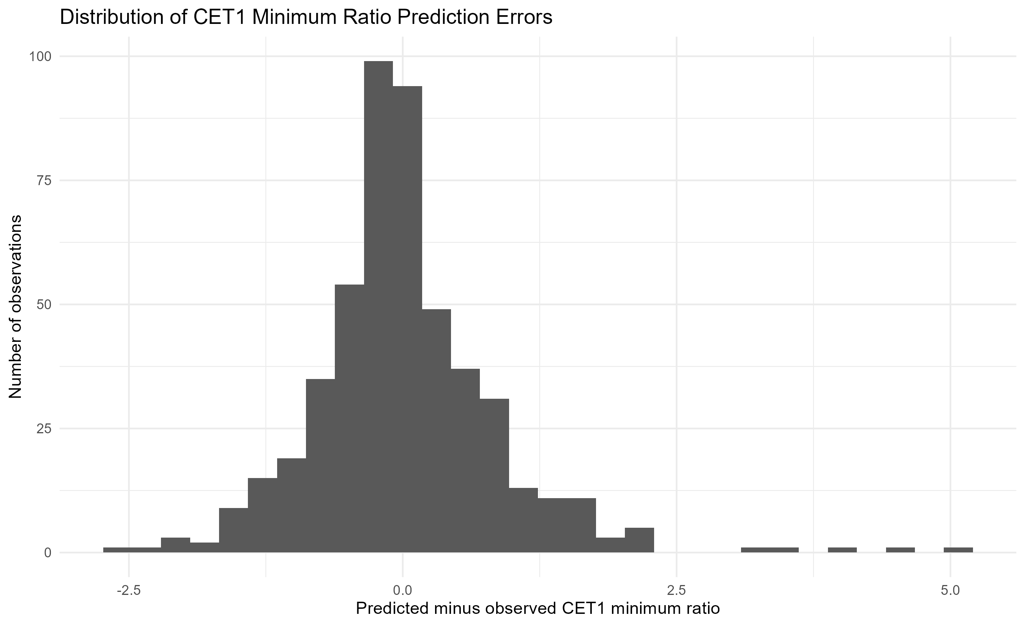

Table 11. Largest CET1 prediction errors
Bank name | Exercise year | Scenario label | Observed cet1 min ratio | Integrated predicted cet1 min ratio | Cet1 min prediction error | Abs cet1 min prediction error | Cet1 min validation flag
DB USA Corporation | 2,023 | Supervisory Severely Adverse | 14.5 | 19.5721 | 5.0721 | 5.0721 | Large deviation
State Street Corporation | 2,017 | Supervisory Severely Adverse | 5.3 | 9.7653 | 4.4653 | 4.4653 | Large deviation
DB USA Corporation | 2,024 | Supervisory Severely Adverse | 12.7 | 16.7789 | 4.0789 | 4.0789 | Large deviation
DB USA Corporation | 2,020 | Supervisory Alternative Severe | 19.5 | 22.9024 | 3.4024 | 3.4024 | Large deviation
Credit Suisse Holdings (USA), Inc. | 2,021 | Supervisory Severely Adverse | 20.1 | 23.4510 | 3.3510 | 3.3510 | Large deviation
DB USA Corporation | 2,017 | Supervisory Severely Adverse | 12.2 | 9.5966 | -2.6034 | 2.6034 | Large deviation
Discover Financial Services | 2,021 | Supervisory Severely Adverse | 13.7 | 11.4220 | -2.2780 | 2.2780 | Large deviation
Morgan Stanley | 2,017 | Supervisory Severely Adverse | 7.3 | 9.5553 | 2.2553 | 2.2553 | Large deviation
Northern Trust Corporation | 2,018 | Supervisory Adverse | 11.3 | 13.4989 | 2.1989 | 2.1989 | Large deviation
HSBC North America Holdings Inc. | 2,016 | Supervisory Severely Adverse | 12.9 | 10.7027 | -2.1973 | 2.1973 | Large deviation
State Street Corporation | 2,016 | Supervisory Adverse | 8.6 | 10.7606 | 2.1606 | 2.1606 | Large deviation
UBS Americas Holding LLC | 2,023 | Supervisory Severely Adverse | 10.0 | 12.1495 | 2.1495 | 2.1495 | Large deviation
DB USA Corporation | 2,017 | Supervisory Adverse | 13.3 | 11.2134 | -2.0866 | 2.0866 | Large deviation
The Goldman Sachs Group, Inc. | 2,015 | Supervisory Adverse | 11.4 | 9.3237 | -2.0763 | 2.0763 | Large deviation
HSBC North America Holdings Inc. | 2,020 | Supervisory Alternative Severe | 5.1 | 7.1739 | 2.0739 | 2.0739 | Large deviation
Morgan Stanley | 2,018 | Supervisory Severely Adverse | 8.9 | 10.8366 | 1.9366 | 1.9366 | Moderate deviation
UBS Americas Holding LLC | 2,022 | Supervisory Severely Adverse | 8.0 | 9.9119 | 1.9119 | 1.9119 | Moderate deviation
TD Group US Holdings LLC | 2,017 | Supervisory Severely Adverse | 11.2 | 13.0666 | 1.8666 | 1.8666 | Moderate deviation
HSBC North America Holdings Inc. | 2,018 | Supervisory Adverse | 10.9 | 9.0918 | -1.8082 | 1.8082 | Moderate deviation
American Express Company | 2,020 | Supervisory Severely Adverse | 13.5 | 11.6951 | -1.8049 | 1.8049 | Moderate deviation

11. Robustness, Sensitivity and Model Risk
Model risk is the possibility that the model produces inaccurate, unstable or misleading outputs for its intended use.
In this project, model risk is assessed through error distributions, tail errors, threshold sensitivity, bank-level error concentration and model-risk buckets.
The overall fit is strong, but there are tail cases. This is a critical lesson: a model can perform well on average and still require caution for specific observations.

Table 12. Model risk bucket summary
Model risk bucket | Observations | Share
Low model risk | 302 | 0.6076
Watchlist | 92 | 0.1851
Moderate model risk | 68 | 0.1368
High model risk | 35 | 0.0704

Figure 4. Model risk buckets
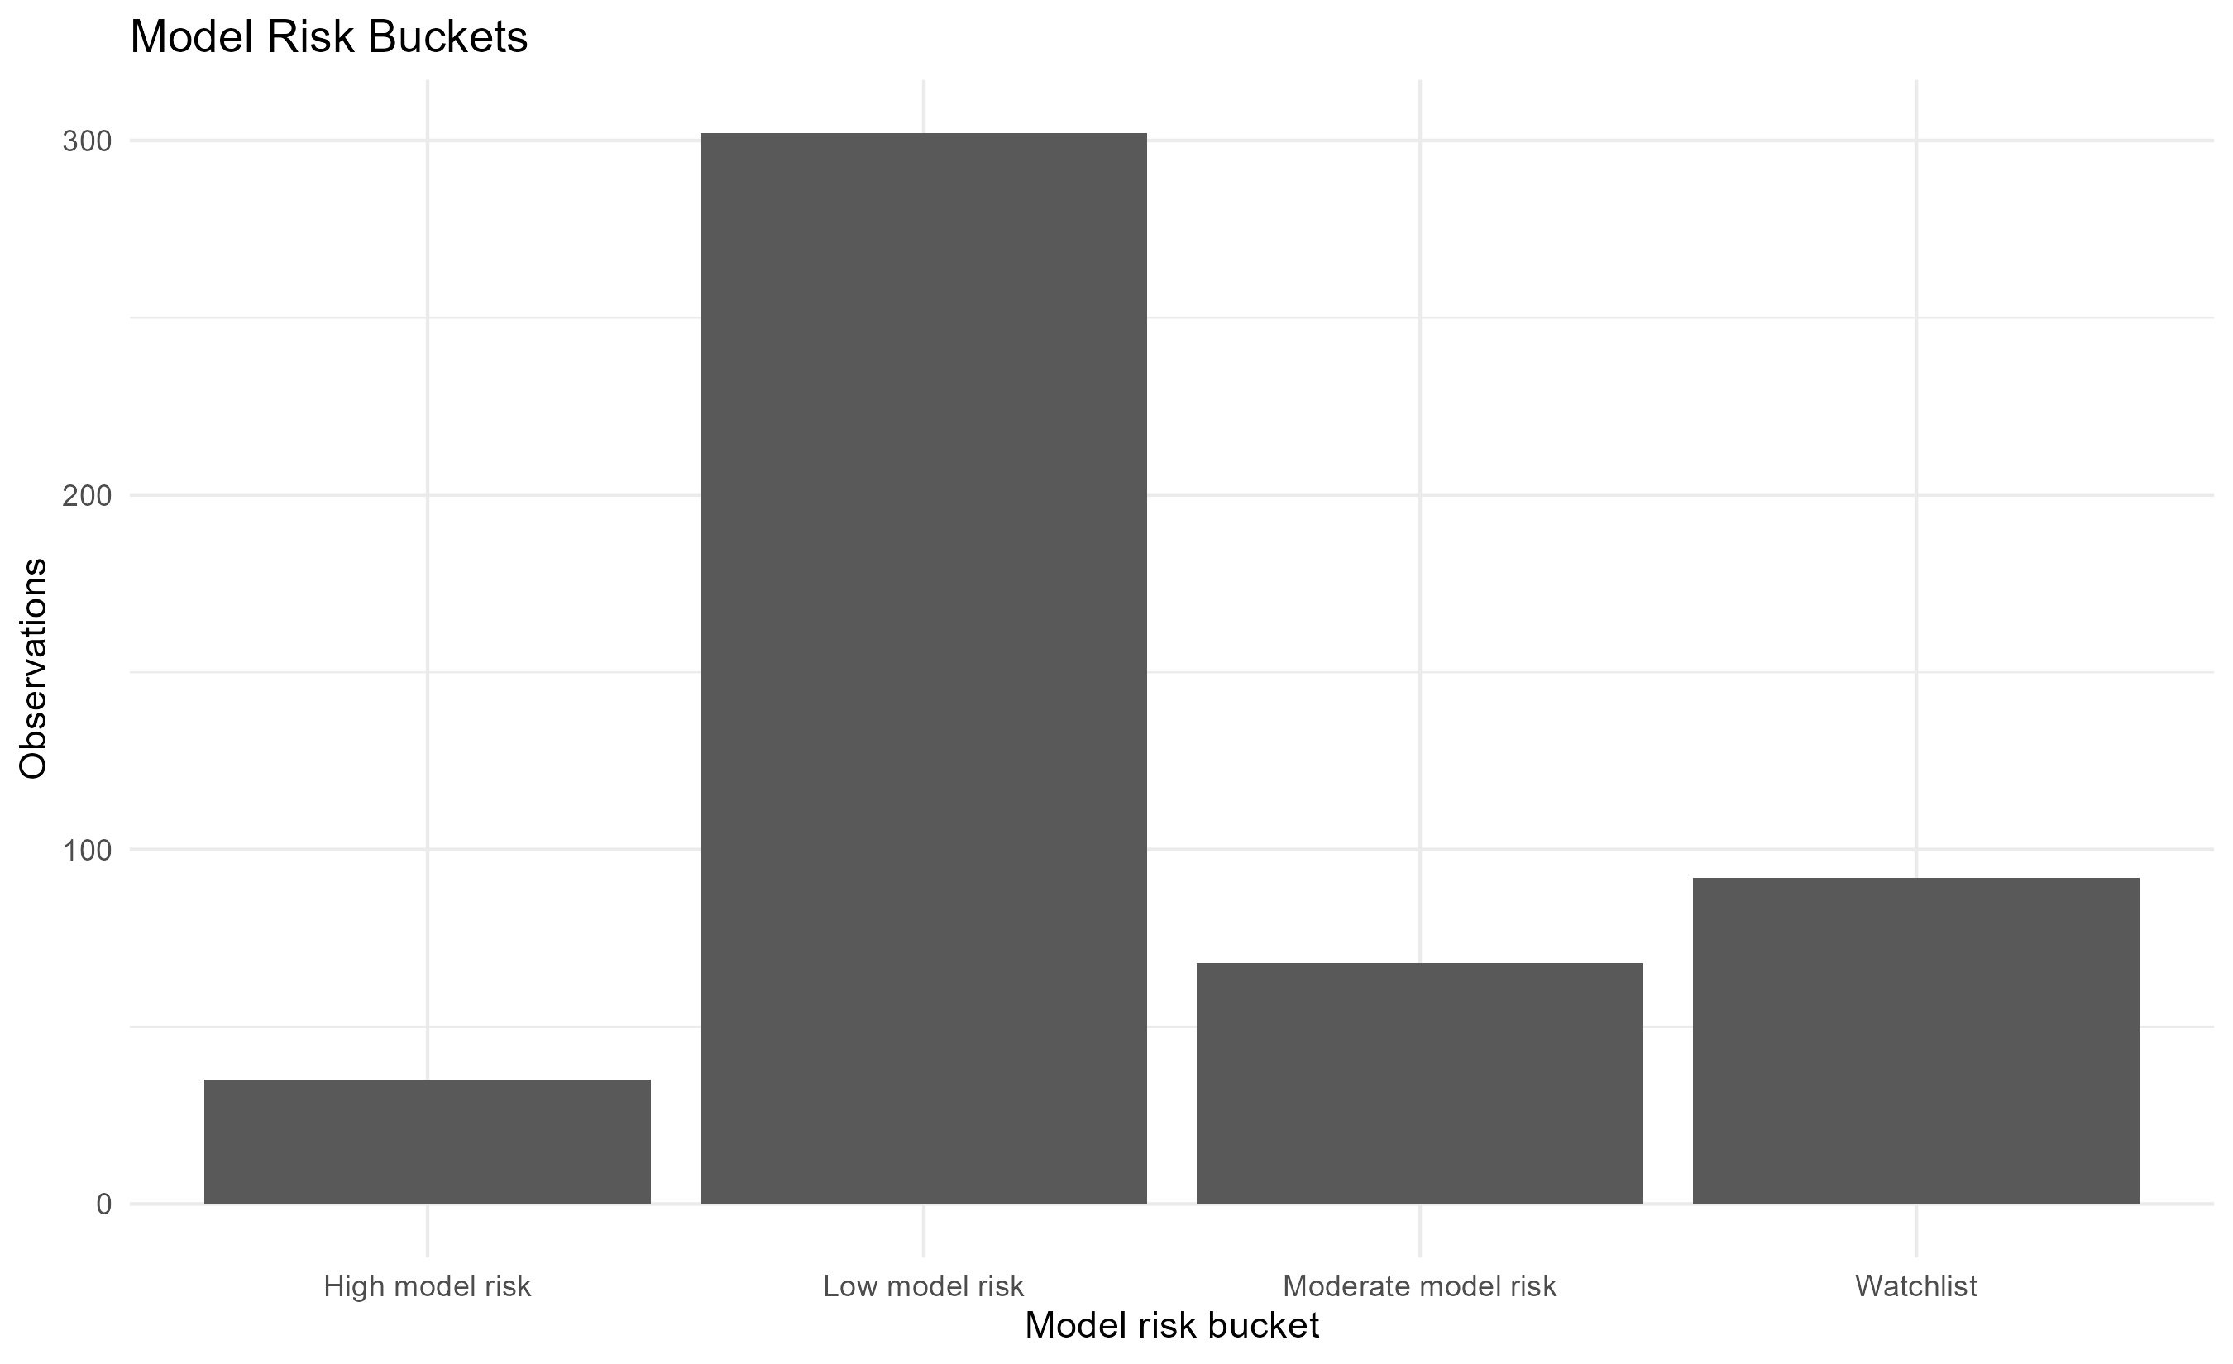

Figure 5. CET1 threshold sensitivity
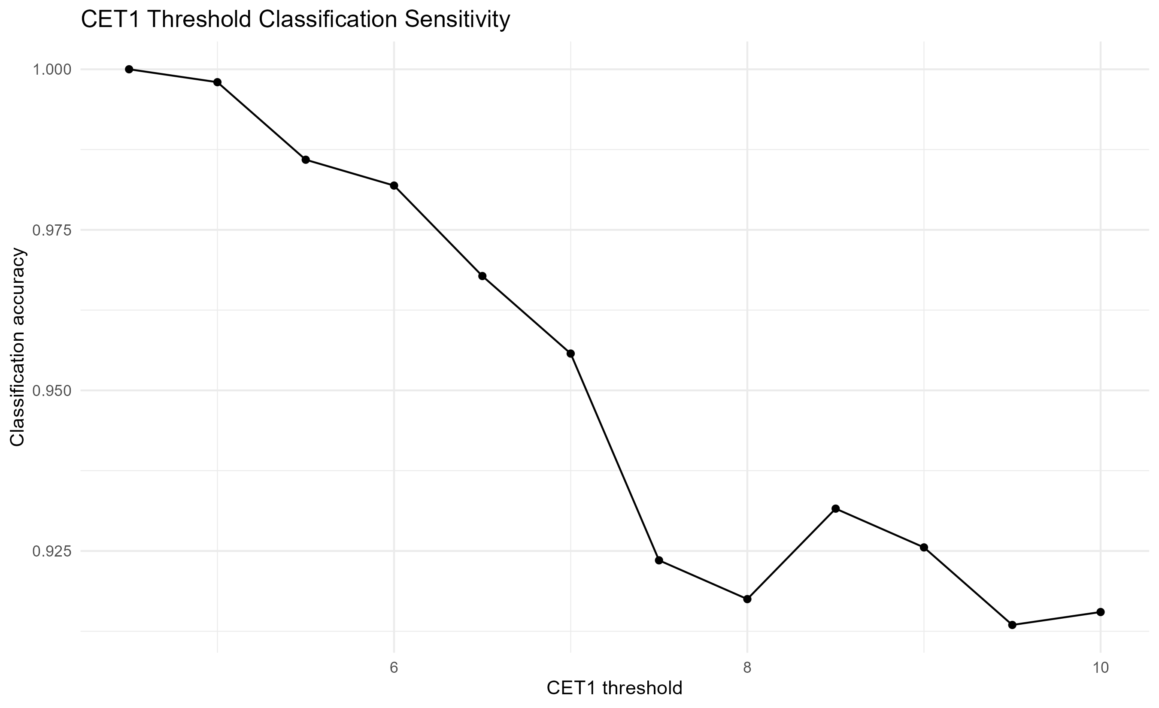

Table 13. Bank-level model risk ranking
Bank model risk rank | Bank name | Observations | Cet1 rmse | Cet1 mae | Max abs cet1 error | High model risk observations | Threshold miss observations | Max model risk score
1 | HSBC North America Holdings Inc. | 14 | 1.1591 | 0.9578 | 2.1973 | 3 | 2 | 0.9324
2 | State Street Corporation | 16 | 1.5694 | 1.2020 | 4.4653 | 2 | 1 | 0.8838
3 | BMO Financial Corp. | 14 | 0.8293 | 0.6987 | 1.3868 | 2 | 2 | 0.8624
4 | UBS Americas Holding LLC | 12 | 1.0229 | 0.7776 | 2.1495 | 1 | 0 | 0.8577
5 | Capital One Financial Corporation | 16 | 0.5985 | 0.4752 | 1.2113 | 3 | 3 | 0.8334
6 | Morgan Stanley | 16 | 1.0446 | 0.8322 | 2.2553 | 1 | 0 | 0.8150
7 | Discover Financial Services | 11 | 0.9281 | 0.6871 | 2.2780 | 1 | 0 | 0.8106
8 | The Bank of New York Mellon Corporation | 16 | 0.9427 | 0.8157 | 1.5518 | 0 | 0 | 0.8028
9 | The Goldman Sachs Group, Inc. | 16 | 1.1003 | 0.9118 | 2.0763 | 1 | 0 | 0.7932
10 | Credit Suisse Holdings (USA), Inc. | 9 | 1.3542 | 0.9602 | 3.3510 | 1 | 0 | 0.7857
11 | The PNC Financial Services Group, Inc. | 16 | 0.6439 | 0.4888 | 1.5668 | 1 | 1 | 0.7780
12 | TD Group US Holdings LLC | 16 | 0.8376 | 0.7173 | 1.8666 | 0 | 0 | 0.7775
13 | DB USA Corporation | 12 | 2.4421 | 1.9455 | 5.0721 | 5 | 0 | 0.7483
14 | KeyCorp | 12 | 0.5887 | 0.4191 | 1.3044 | 1 | 1 | 0.7462
15 | U.S. Bancorp | 16 | 0.4120 | 0.3603 | 0.9009 | 2 | 2 | 0.7455
16 | M&T Bank Corporation | 14 | 0.4077 | 0.3368 | 0.9175 | 0 | 0 | 0.7434
17 | Zions Bancorporation | 4 | 0.4476 | 0.3652 | 0.7304 | 1 | 1 | 0.7362
18 | Huntington Bancshares Incorporated | 12 | 0.6980 | 0.5216 | 1.6203 | 1 | 1 | 0.7280
19 | The Charles Schwab Corporation | 5 | 0.7407 | 0.6407 | 1.3408 | 0 | 0 | 0.7125
20 | Citigroup Inc. | 16 | 0.7422 | 0.6076 | 1.5728 | 0 | 0 | 0.7095

12. Student Exercises
The exercises below are designed to move students from mechanical reproduction to critical interpretation.
Instructors can assign them individually or as group work. Some exercises require only interpretation, while others require students to inspect output files or rerun selected scripts.

Table 14. Recommended student exercises
Exercise number | Exercise | Expected learning outcome
1 | Explain why a public DFAST replication cannot reproduce confidential supervisory models. | Understand the boundary between public replication and official supervision.
2 | Identify the role of PPNR in the stress testing transmission mechanism. | Understand earnings as a loss absorption channel.
3 | Explain why duplicated join keys increased the integrated panel from 520 to 658 rows. | Understand panel-data keys and join mechanics.
4 | Compute RMSE and MAE manually for a small set of observed and predicted CET1 ratios. | Understand forecast error metrics.
5 | Compare the interpretation of R-squared and correlation. | Understand model fit versus association.
6 | Discuss why CET1 classification at 4.5 percent can be perfect while 7.0 percent classification is not. | Understand threshold sensitivity.
7 | Interpret the difference between vulnerability ranking and model risk ranking. | Distinguish bank vulnerability from model uncertainty.
8 | Explain why DB USA Corporation appears as a tail error case in the validation output. | Interpret tail risk.
9 | Discuss why a model can have low average bias but still have severe individual errors. | Understand distributional model risk.
10 | Propose one additional robustness test for the project. | Think critically about robustness.
11 | Write a short policy note explaining the limitations of public-data stress testing. | Communicate limitations clearly.
12 | Replicate one figure and explain its economic interpretation. | Connect graphics with economic interpretation.

13. Limitations and Responsible Interpretation
The limitations of the project must be explicit. Public-data stress testing is valuable because it is transparent and reproducible, but it is necessarily incomplete.
The model does not include confidential supervisory assumptions, internal bank data, confidential management actions or loan-level portfolio information.
The correct interpretation is therefore limited: the project is a public benchmark, educational tool and reproducible research framework.

Table 15. Limitations and recommended responses
Limitation | Consequence | Recommended response
Public-data-only design | The model is reproducible but necessarily incomplete. | Document all sources and keep the workflow reproducible.
Reduced-form specification | The model explains observed outcomes but is not a structural supervisory model. | Explain the model as a benchmark, not as an official engine.
No confidential supervisory assumptions | The project cannot reproduce Federal Reserve confidential modelling layers. | Use explicit disclaimer language.
No internal bank portfolio data | Detailed loan-level, trading, operational and management-action data are not observed. | Avoid overclaiming precision.
Potential bank-specific idiosyncrasies | Some banks may have special features not captured by public variables. | Report largest errors and model risk rankings.
Tail error concentration | A small number of observations can have large errors. | Discuss tail risk separately from average fit.
Ranking sensitivity | Relative rankings may change under alternative specifications. | Use sensitivity checks and alternative thresholds.
Pedagogical simplification | Some technical details are simplified for teaching and transparency. | Provide exercises and technical appendices.

14. Suggested Teaching Plan
A four-session teaching plan can be used for an applied banking or macro-financial econometrics course.
Session 1: introduce DFAST, stress testing, CET1, PPNR, RWAs and public supervisory data.
Session 2: reproduce Scripts 01 to 08 and discuss data governance, cleaning, sample construction and key integrity.
Session 3: reproduce Scripts 09 to 12b and discuss fixed effects, component models and the integrated projection engine.
Session 4: reproduce Scripts 13 to 17 and discuss validation, model risk, rankings, limitations and technical communication.

15. Glossary

Table 16. Glossary
Term | Definition
DFAST | Dodd-Frank Act Stress Test; a U.S. supervisory stress testing framework.
Stress test | Forward-looking assessment of bank resilience under adverse conditions.
Scenario | Set of assumptions used to simulate economic and financial stress.
CET1 | Common Equity Tier 1 capital ratio.
PPNR | Pre-provision net revenue.
RWA | Risk-weighted assets.
Credit loss ratio | Credit losses scaled by a relevant balance sheet or risk-weighted asset measure.
Capital depletion | Reduction in capital ratio under stress.
Fixed effects | Econometric controls for unobserved group or time-specific effects.
RMSE | Root mean squared error.
MAE | Mean absolute error.
Bias | Average prediction error.
R-squared | Share of variation explained by model predictions.
Correlation | Linear association between observed and predicted values.
Benchmark validation | Comparison of model projections with observed public benchmark outcomes.
Model risk | Risk that model outputs are inaccurate or unstable for the intended purpose.
Tail error | Large error in the extreme part of the error distribution.
Threshold sensitivity | Assessment of how classification changes under different capital thresholds.
Vulnerability ranking | Relative ranking of banks based on model outputs.
Public replication | Transparent reconstruction using only public data.

16. Final Disclaimer
This manual is an independent educational and analytical document based on public data. It is not affiliated with, endorsed by or approved by the Federal Reserve, any banking organization or any supervisory authority.
No confidential supervisory information, confidential bank submissions, non-public models or internal bank data are used.
The manual must not be interpreted as an official regulatory assessment, investment recommendation, credit opinion or statement on the safety and soundness of any institution.
All results are produced for teaching, public benchmarking and reproducible research purposes.

