USA Bank Stress Test DFAST Replication

Final Institutional Report
Public reduced-form replication of Federal Reserve DFAST-style stress testing
Generated on: 2026-06-30 07:55:23
Prepared for academic, pedagogical and public benchmarking purposes.

Executive Summary
This report presents a complete public-data replication of a DFAST-style bank stress testing framework for large banking organizations in the United States. The project uses public Federal Reserve DFAST results, public macroeconomic scenario data and reproducible R scripts to build a reduced-form stress test engine.
The purpose is not to reproduce confidential Federal Reserve supervisory models or internal bank stress testing systems. The purpose is to construct a transparent, auditable and pedagogically useful benchmark that links macro-financial stress testing concepts to public data, econometric modelling, capital depletion and model validation.

Table 1. Executive summary of final results
Metric | Value
Panel observations | 497
Banks | 56
Exercise years | 11
Scenarios | 3
Latest exercise year | 2025
Minimum predicted CET1 ratio | 5.5573
Mean predicted CET1 ratio | 10.6961
Maximum predicted capital depletion | 8.5976
Mean predicted capital depletion | 2.6675
CET1 minimum ratio RMSE | 0.846
CET1 minimum ratio MAE | 0.5873
CET1 minimum ratio bias | 0.0145
CET1 minimum ratio R-squared | 0.9688
CET1 minimum ratio correlation | 0.9843
CET1 4.5 percent classification accuracy | 1
CET1 7.0 percent classification accuracy | 0.9557
High model risk observations | 35
Largest absolute CET1 error | 5.0721

1. Scope, Use and Disclaimer
The project is based exclusively on public information. It uses public DFAST results and public scenario data released by the Federal Reserve. It does not access, infer or replicate confidential supervisory models, confidential bank submissions, internal capital planning models or non-public supervisory assumptions.
The results should be interpreted as a public benchmark and educational replication exercise. They should not be interpreted as official supervisory findings, investment advice, bank ratings, capital adequacy opinions or regulatory pass/fail decisions.
The vulnerability rankings are relative outputs of the reduced-form model. They indicate which banks appear more exposed under the model's public-data assumptions, not which banks are officially weak or unsafe.

2. Reproducible Pipeline
The project follows a staged pipeline. Each script creates auditable outputs, diagnostic tables and execution logs. This structure is intentionally suitable for classroom use, replication, peer review and future extension.

Table 2. Script pipeline and analytical role
Stage | Script | Output role
Data availability audit | Script 01 | Defines the public data universe and feasibility of the project.
Regulatory documentation and raw data ingestion | Script 02 / 02b / 02c | Downloads and records public regulatory and DFAST source documents.
Federal Reserve DFAST data cleaning | Script 03 | Cleans Federal Reserve public DFAST result files.
Macro scenario structuring | Script 04 | Structures baseline and severely adverse macroeconomic scenarios.
DFAST benchmark dataset construction | Script 05 | Creates bank-year-scenario public DFAST benchmark data.
Capital and losses transmission layer | Script 06 | Builds the accounting link between PPNR, losses and CET1 depletion.
Exploratory analysis | Script 07 | Describes distributions, outliers and empirical structure.
Modelling sample and treatment rules | Script 08 | Creates clean and winsorized modelling samples.
Credit loss model | Script 09 | Estimates credit loss intensity using public DFAST outcomes.
PPNR model | Script 10 | Estimates PPNR performance using public DFAST outcomes.
Capital depletion model | Script 11 | Estimates CET1 capital depletion.
Integrated projection engine | Script 12 | Combines component projections into an integrated stress test engine.
Join-key correction | Script 12b | Corrects duplicated join keys and produces the valid integrated panel.
Final results and vulnerability ranking | Script 13 | Produces final bank vulnerability rankings.
Benchmark validation | Script 14 | Validates model outputs against Federal Reserve public benchmark results.
Robustness and model risk assessment | Script 15 | Assesses robustness, sensitivity, tail errors and model risk.

3. Data and Regulatory Framework
The empirical base is built from Federal Reserve public DFAST results and macroeconomic scenario releases. The relevant regulatory context includes supervisory stress testing, capital planning, stressed capital ratios and scenario-based loss and revenue projections.
The dataset is organized at the bank-year-scenario level. Each observation contains public outcome variables such as stressed capital ratios, credit losses, PPNR, capital depletion and related balance sheet measures.
A key data quality issue identified during the project was the presence of duplicated bank-year-scenario keys after joining model components. This was corrected in Script 12b. The final panel contains one observation per bank-year-scenario key.

Table 3. Final key audit
Dataset | Rows | Unique keys | Duplicated keys | Max rows per key
final_results_panel | 497 | 497 | 0 | 1

4. Stress Testing Methodology
The analytical framework follows a reduced-form transmission structure. Public DFAST outcomes are used to estimate component models for credit losses, PPNR and CET1 capital depletion. These components are then combined into an integrated stress test engine.
The core transmission logic is: stressed credit losses and revenue dynamics affect pre-tax performance; pre-tax performance and risk-weighted asset dynamics affect capital depletion; capital depletion determines the projected minimum CET1 ratio under stress.

Table 4. Model architecture
Model block | Dependent variable | Operational model | Role in engine
Credit losses | Credit loss ratio | Bank and year fixed effects | Captures stress-period credit loss intensity.
PPNR | PPNR ratio | Bank and year fixed effects | Captures pre-provision earnings capacity under stress.
Capital depletion | CET1 capital depletion | Bank and year fixed effects | Maps losses, earnings and risk-weighted asset effects into CET1 depletion.
Integrated CET1 projection | Predicted CET1 minimum ratio | CET1 actual ratio minus predicted capital depletion | Produces the final stressed capital adequacy measure.

4.1. Credit Loss Model
The credit loss model estimates the intensity of stress-period credit losses using public bank-year-scenario outcomes. The operational specification uses bank and year fixed effects, allowing the model to capture persistent differences across institutions and common exercise-year effects.

4.2. PPNR Model
The PPNR model estimates pre-provision net revenue performance under stress. PPNR is central because it provides loss-absorbing capacity before capital is depleted.

4.3. Capital Depletion Model
The capital depletion model maps losses, PPNR, balance sheet dynamics and scenario effects into CET1 depletion. It is the direct bridge between stress outcomes and the final capital adequacy measure.

4.4. Integrated Projection Engine
The integrated engine combines component projections and computes the predicted CET1 minimum ratio. The corrected engine uses a unique bank-year-scenario key to prevent artificial row expansion.

5. Benchmark Validation Against Federal Reserve Public Results
The benchmark validation compares the model's predicted outcomes with public Federal Reserve DFAST benchmark outcomes. The central validation variable is the CET1 minimum ratio.

Table 5. Model accuracy by component
Component | Observations | Rmse | Mae | Bias | R squared | Correlation
Credit loss ratio | 497 | 0.0060 | 0.0043 | -0.0001 | 0.9560 | 0.9778
PPNR ratio | 497 | 0.0093 | 0.0065 | 0.0000 | 0.9200 | 0.9592
CET1 capital depletion | 497 | 0.7891 | 0.5698 | 0.0004 | 0.8379 | 0.9153
CET1 minimum ratio | 497 | 0.8460 | 0.5873 | 0.0145 | 0.9688 | 0.9843

Table 6. CET1 threshold classification accuracy
Threshold | Observations | Correctly classified | Classification accuracy
CET1 4.5 percent | 497 | 497 | 1.0000
CET1 7.0 percent | 497 | 475 | 0.9557
The CET1 minimum ratio validation shows high explanatory power, low mean absolute error and negligible average bias. The model classifies the 4.5 percent CET1 threshold correctly in the final validation sample and performs strongly at the 7.0 percent reference level.

Figure 1. Observed versus predicted CET1 minimum ratio
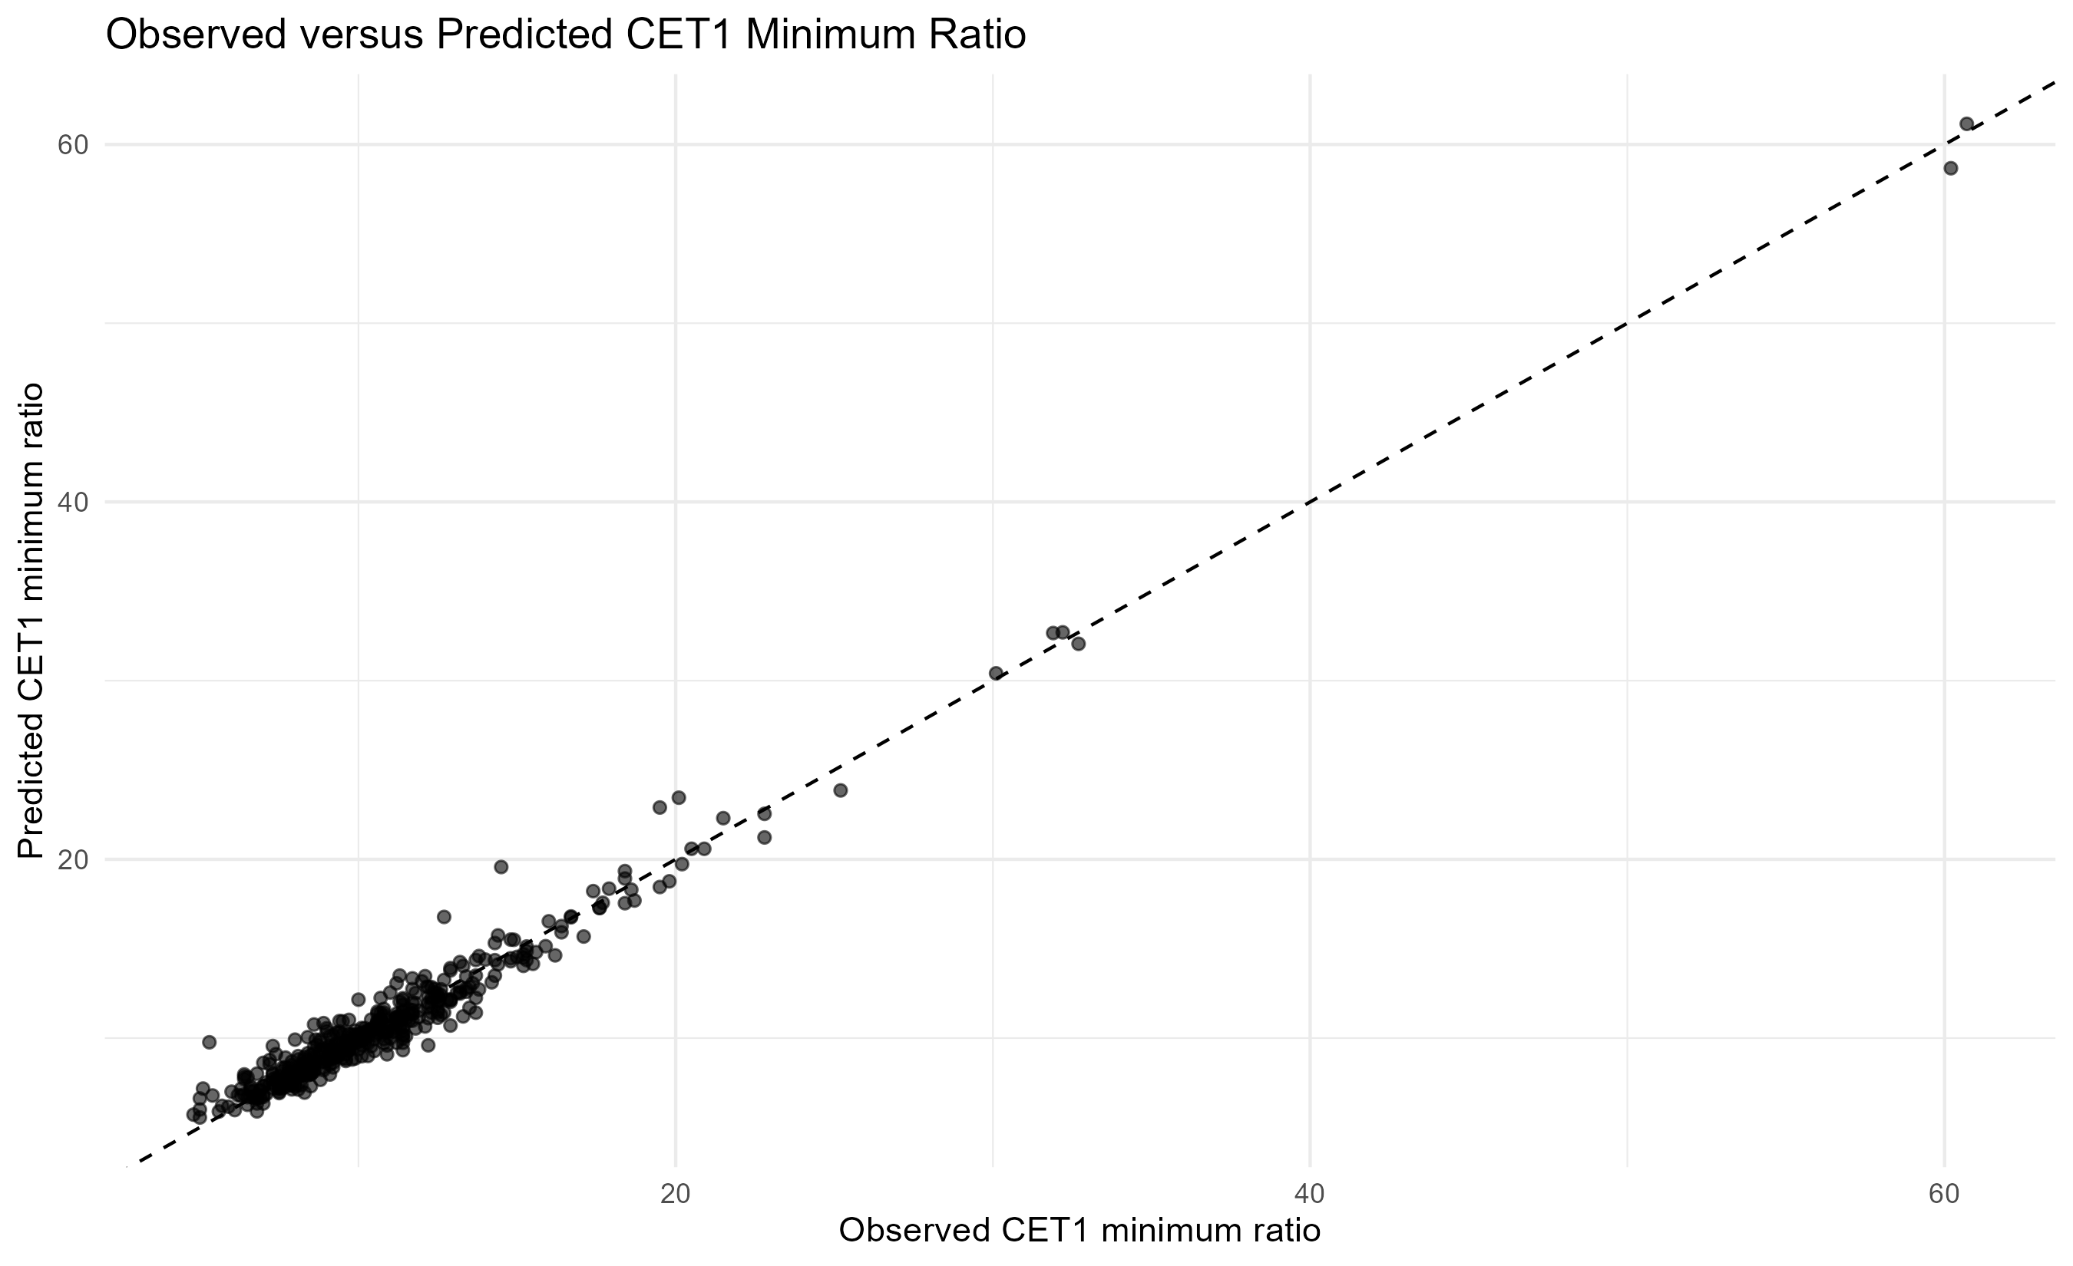

Figure 2. Distribution of CET1 prediction errors
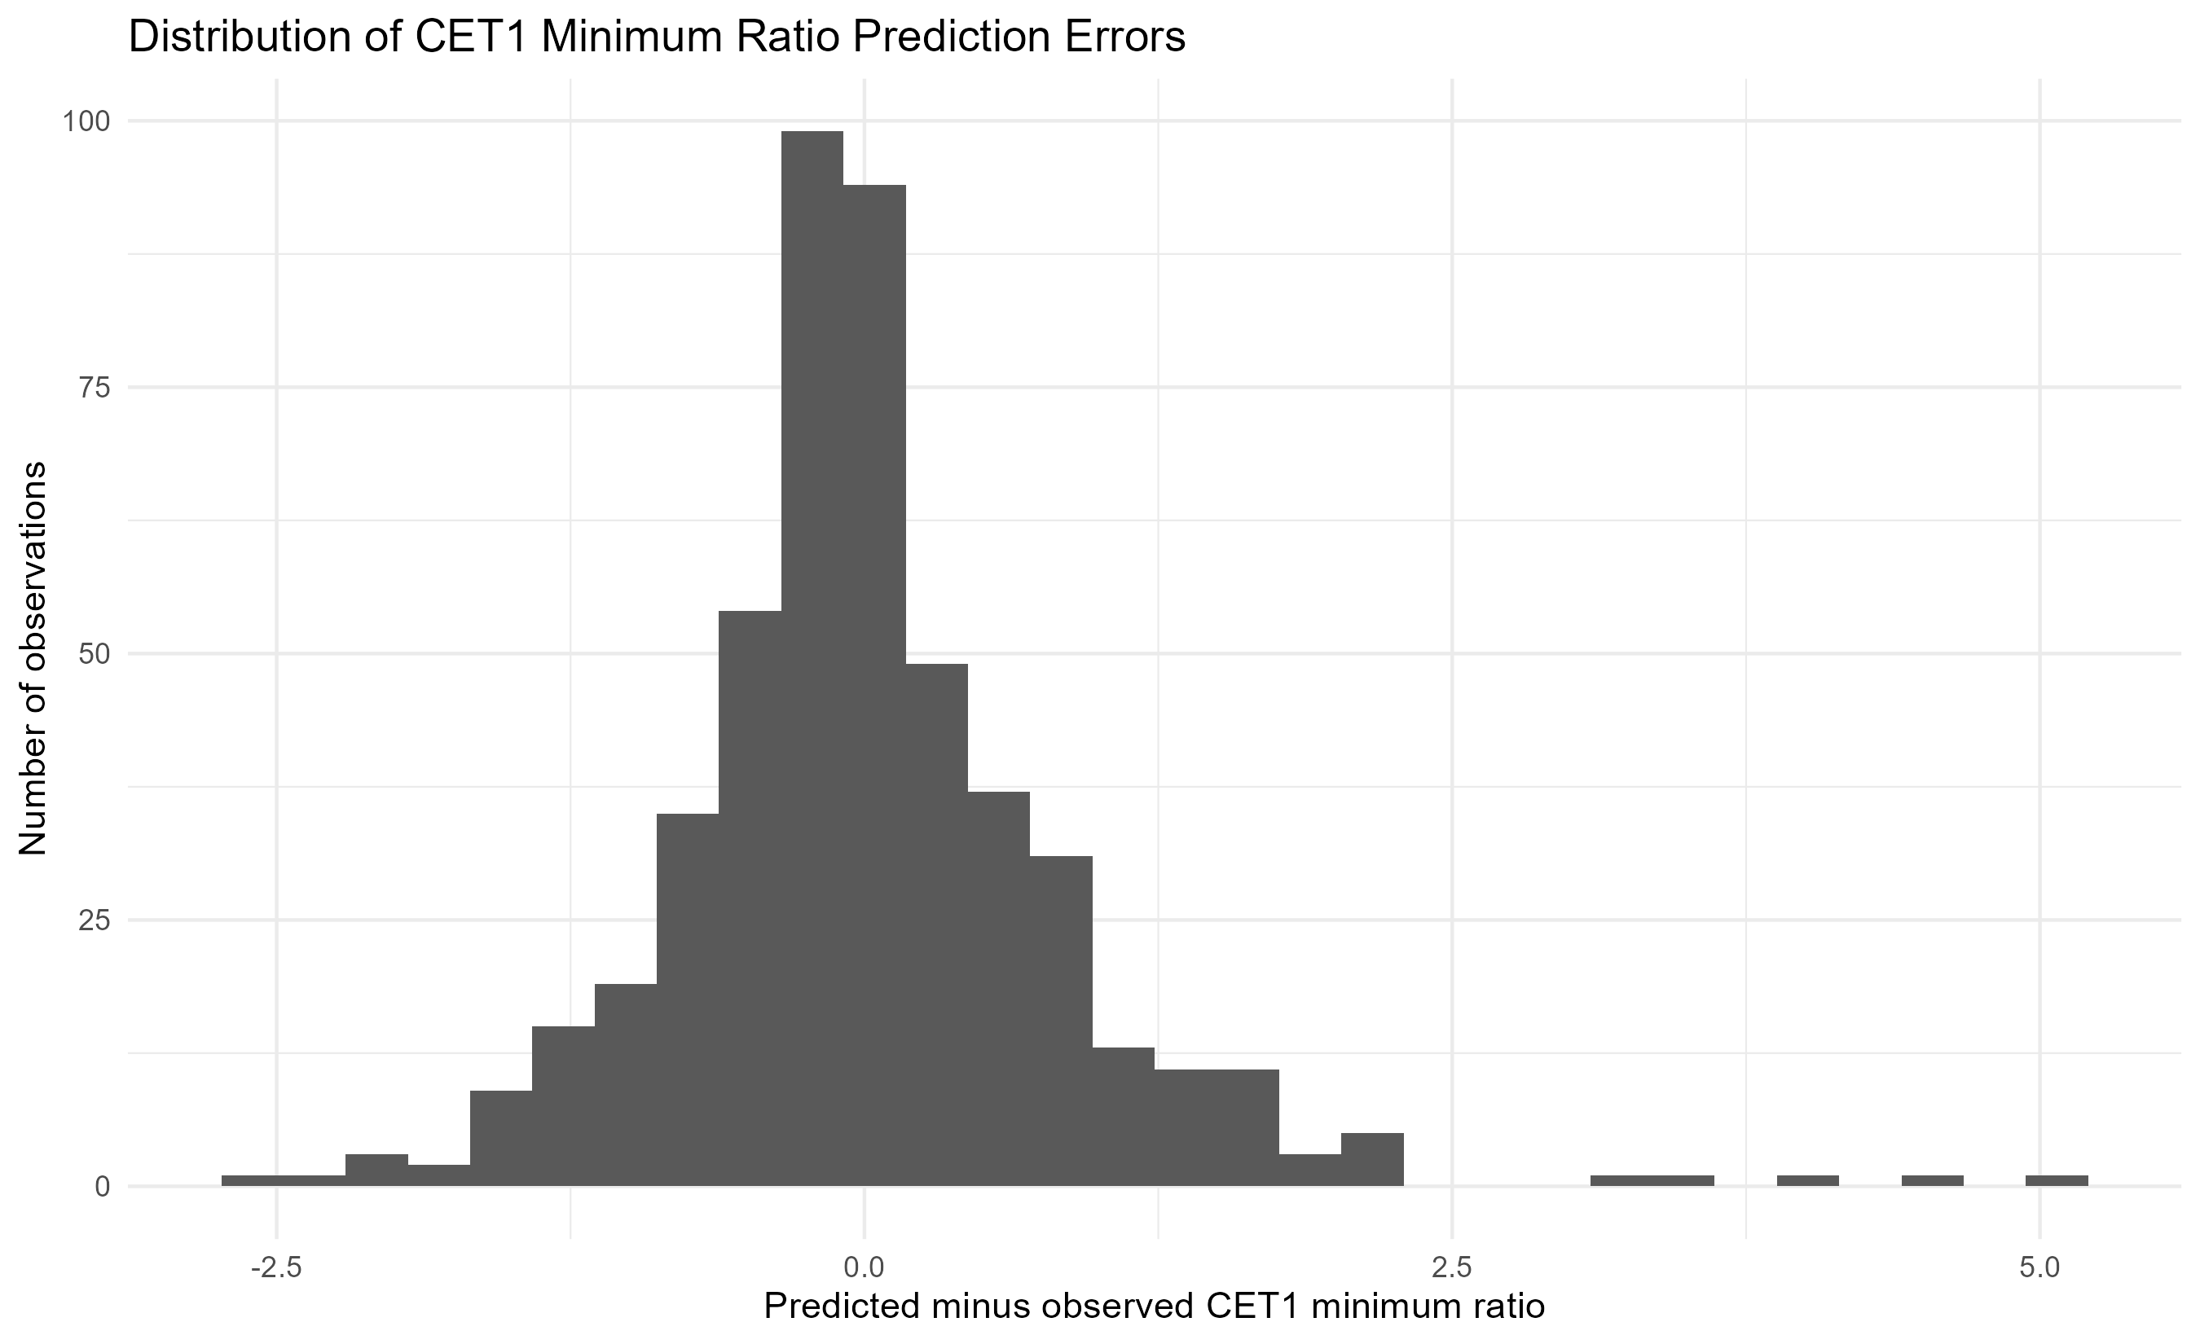

6. Final Stress Test Results
The final results panel contains projected and observed stress outcomes for 497 bank-year-scenario observations, covering 56 banks, 11 exercise years and 3 scenario categories.
The minimum predicted CET1 ratio in the sample is above the 4.5 percent reference threshold. However, several observations fall below the 7.0 percent analytical reference level, indicating capital pressure under stress for selected institutions and scenarios.

Figure 3. Latest exercise top 20 banks by minimum predicted CET1
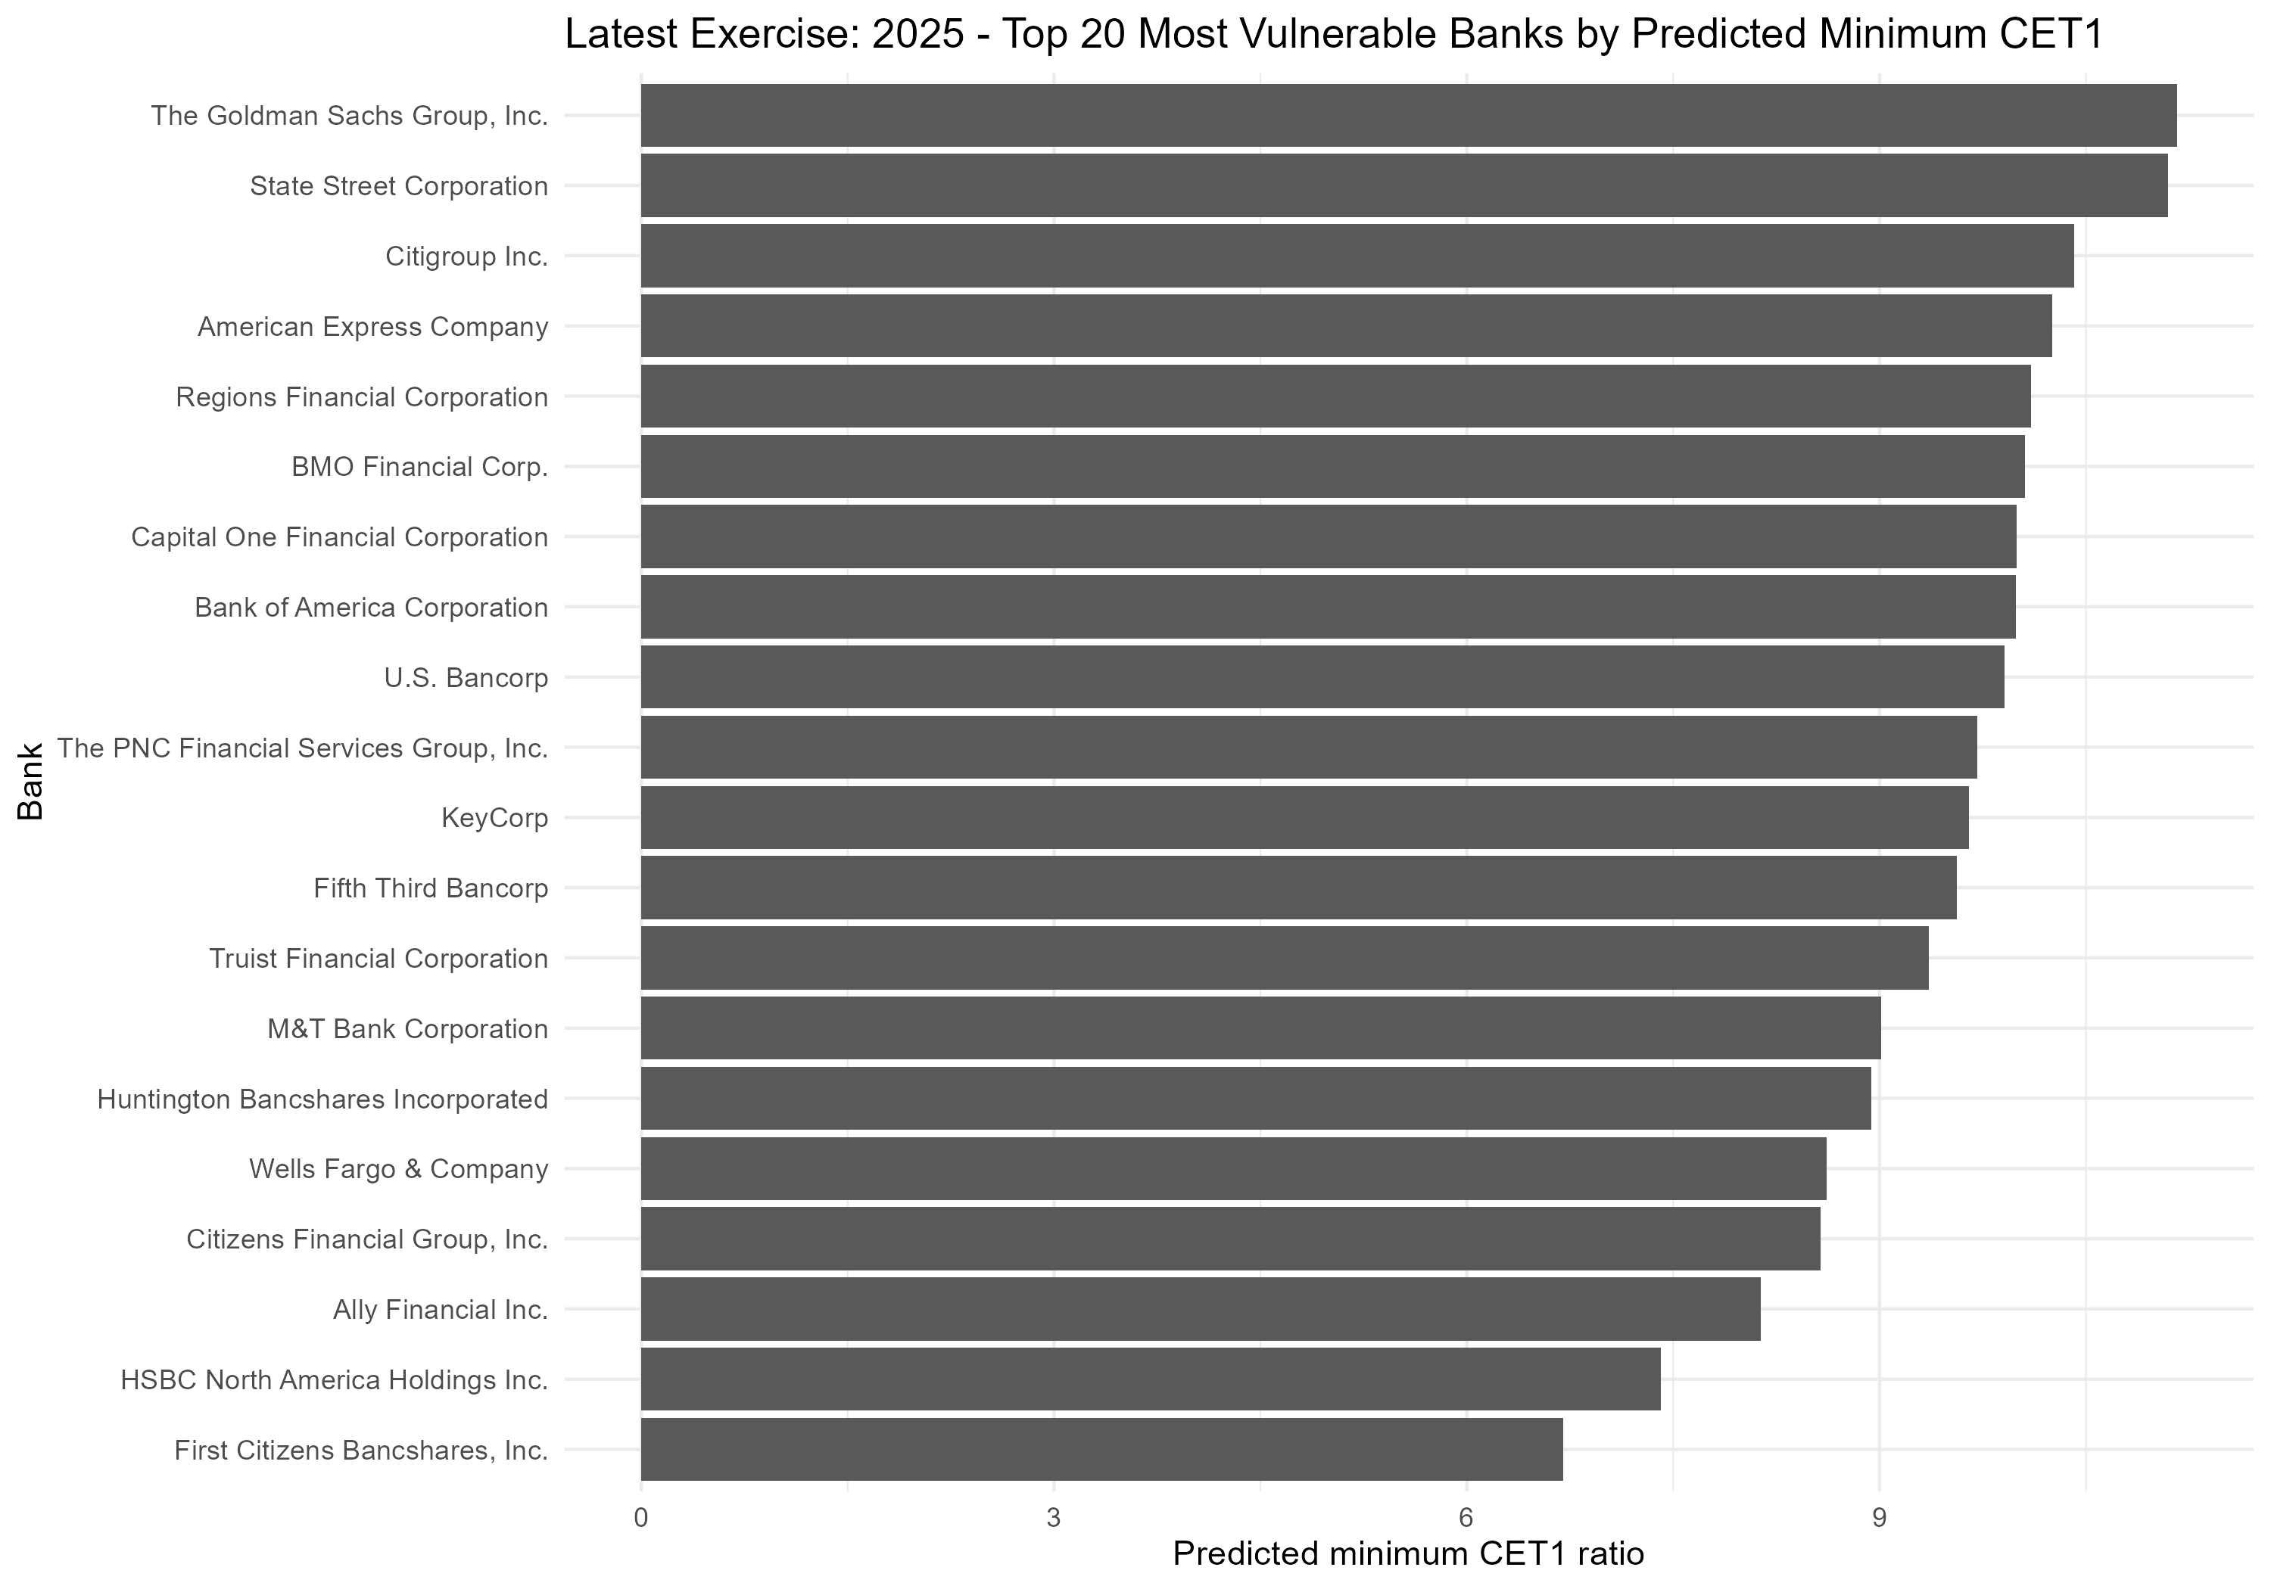

Table 7. Latest exercise vulnerability ranking
Latest year rank composite | Bank name | Min predicted cet1 min ratio | Min observed cet1 min ratio | Max predicted capital depletion | Max predicted credit loss ratio | Min predicted ppnr ratio | Worst scenario by predicted cet1
1 | First Citizens Bancshares, Inc. | 6.7000 | 6.7 | 4.5000 | 0.0698 | 0.0357 | Supervisory Severely Adverse
2 | HSBC North America Holdings Inc. | 7.4094 | 8.1 | 3.8906 | 0.0399 | 0.0026 | Supervisory Severely Adverse
3 | BMO Financial Corp. | 10.0557 | 10.1 | 3.9443 | 0.0518 | 0.0343 | Supervisory Severely Adverse
4 | Ally Financial Inc. | 8.1360 | 7.8 | 2.0640 | 0.0578 | 0.0484 | Supervisory Severely Adverse
5 | Citizens Financial Group, Inc. | 8.5708 | 8.6 | 2.0292 | 0.0555 | 0.0413 | Supervisory Severely Adverse
6 | Capital One Financial Corporation | 9.9949 | 11.0 | 4.3051 | 0.1265 | 0.1170 | Supervisory Severely Adverse
7 | M&T Bank Corporation | 9.0123 | 9.2 | 1.7877 | 0.0652 | 0.0590 | Supervisory Severely Adverse
8 | KeyCorp | 9.6507 | 9.9 | 2.1493 | 0.0484 | 0.0443 | Supervisory Severely Adverse
9 | Wells Fargo & Company | 8.6168 | 9.2 | 1.9832 | 0.0445 | 0.0513 | Supervisory Severely Adverse
10 | Huntington Bancshares Incorporated | 8.9373 | 9.3 | 1.4627 | 0.0546 | 0.0563 | Supervisory Severely Adverse
11 | Fifth Third Bancorp | 9.5643 | 9.7 | 1.2357 | 0.0560 | 0.0522 | Supervisory Severely Adverse
12 | RBC US Group Holdings LLC | 13.4961 | 13.7 | 3.7039 | 0.0484 | 0.0399 | Supervisory Severely Adverse
13 | Truist Financial Corporation | 9.3571 | 9.7 | 1.4429 | 0.0463 | 0.0477 | Supervisory Severely Adverse
14 | Citigroup Inc. | 10.4145 | 10.3 | 2.7855 | 0.0464 | 0.0527 | Supervisory Severely Adverse
15 | DB USA Corporation | 15.7460 | 14.4 | 6.8540 | 0.0174 | 0.0109 | Supervisory Severely Adverse
16 | Regions Financial Corporation | 10.1002 | 10.3 | 0.7998 | 0.0557 | 0.0521 | Supervisory Severely Adverse
17 | U.S. Bancorp | 9.9066 | 9.8 | 0.8934 | 0.0538 | 0.0638 | Supervisory Severely Adverse
18 | Bank of America Corporation | 9.9931 | 9.9 | 1.4069 | 0.0398 | 0.0425 | Supervisory Severely Adverse
19 | The PNC Financial Services Group, Inc. | 9.7127 | 10.3 | 0.8873 | 0.0438 | 0.0506 | Supervisory Severely Adverse
20 | TD Group US Holdings LLC | 14.3904 | 14.0 | 2.1096 | 0.0478 | 0.0425 | Supervisory Severely Adverse

Figure 4. Top 20 banks by composite vulnerability score
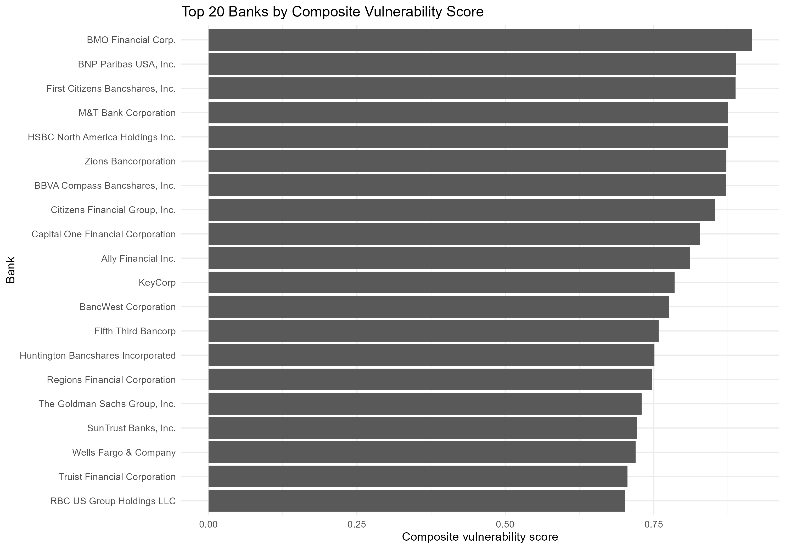

Table 8. Full-sample composite vulnerability ranking
Vulnerability rank composite | Bank name | Min predicted cet1 min ratio | Max predicted capital depletion | Mean predicted credit loss ratio | Mean predicted ppnr ratio | Max composite vulnerability score | Observations below 7
1 | BMO Financial Corp. | 6.0057 | 5.7387 | 0.0433 | 0.0166 | 0.9153 | 4
2 | BNP Paribas USA, Inc. | 7.1301 | 5.2699 | 0.0500 | 0.0149 | 0.8881 | 0
3 | First Citizens Bancshares, Inc. | 6.7000 | 4.5000 | 0.0698 | 0.0357 | 0.8878 | 1
4 | M&T Bank Corporation | 5.5573 | 4.4401 | 0.0562 | 0.0428 | 0.8747 | 3
5 | HSBC North America Holdings Inc. | 6.6566 | 7.1973 | 0.0323 | -0.0004 | 0.8745 | 1
6 | Zions Bancorporation | 7.3304 | 4.8696 | 0.0450 | 0.0292 | 0.8726 | 0
7 | BBVA Compass Bancshares, Inc. | 6.6949 | 4.1261 | 0.0449 | 0.0274 | 0.8717 | 1
8 | Citizens Financial Group, Inc. | 6.7620 | 4.4380 | 0.0472 | 0.0287 | 0.8528 | 4
9 | Capital One Financial Corporation | 6.2083 | 5.1657 | 0.1175 | 0.0991 | 0.8280 | 2
10 | Ally Financial Inc. | 5.9721 | 3.2279 | 0.0495 | 0.0380 | 0.8111 | 4
11 | KeyCorp | 5.8990 | 3.6010 | 0.0408 | 0.0333 | 0.7850 | 2
12 | BancWest Corporation | 8.4572 | 3.8428 | 0.0477 | 0.0323 | 0.7760 | 0
13 | Fifth Third Bancorp | 6.6398 | 3.1602 | 0.0471 | 0.0393 | 0.7582 | 1
14 | Huntington Bancshares Incorporated | 6.6203 | 3.1797 | 0.0453 | 0.0393 | 0.7514 | 3
15 | Regions Financial Corporation | 7.1894 | 3.7106 | 0.0468 | 0.0401 | 0.7477 | 0
16 | The Goldman Sachs Group, Inc. | 5.8928 | 6.2344 | 0.0189 | 0.0332 | 0.7297 | 1
17 | SunTrust Banks, Inc. | 6.7197 | 3.0764 | 0.0320 | 0.0359 | 0.7223 | 3
18 | Wells Fargo & Company | 7.4551 | 3.6449 | 0.0371 | 0.0427 | 0.7193 | 0
19 | Truist Financial Corporation | 7.0281 | 2.2154 | 0.0448 | 0.0324 | 0.7059 | 0
20 | RBC US Group Holdings LLC | 10.3134 | 5.3322 | 0.0466 | 0.0223 | 0.7015 | 0

7. Robustness, Sensitivity and Model Risk
The model risk assessment examines whether the strong average performance hides localized errors, threshold sensitivity or bank-specific deviations. This step is necessary because a stress test model can have good average accuracy but still require caution for specific banks or scenarios.

Table 9. Model risk bucket summary
Model risk bucket | Observations | Share
Low model risk | 302 | 0.6076
Watchlist | 92 | 0.1851
Moderate model risk | 68 | 0.1368
High model risk | 35 | 0.0704

Figure 5. Model risk buckets
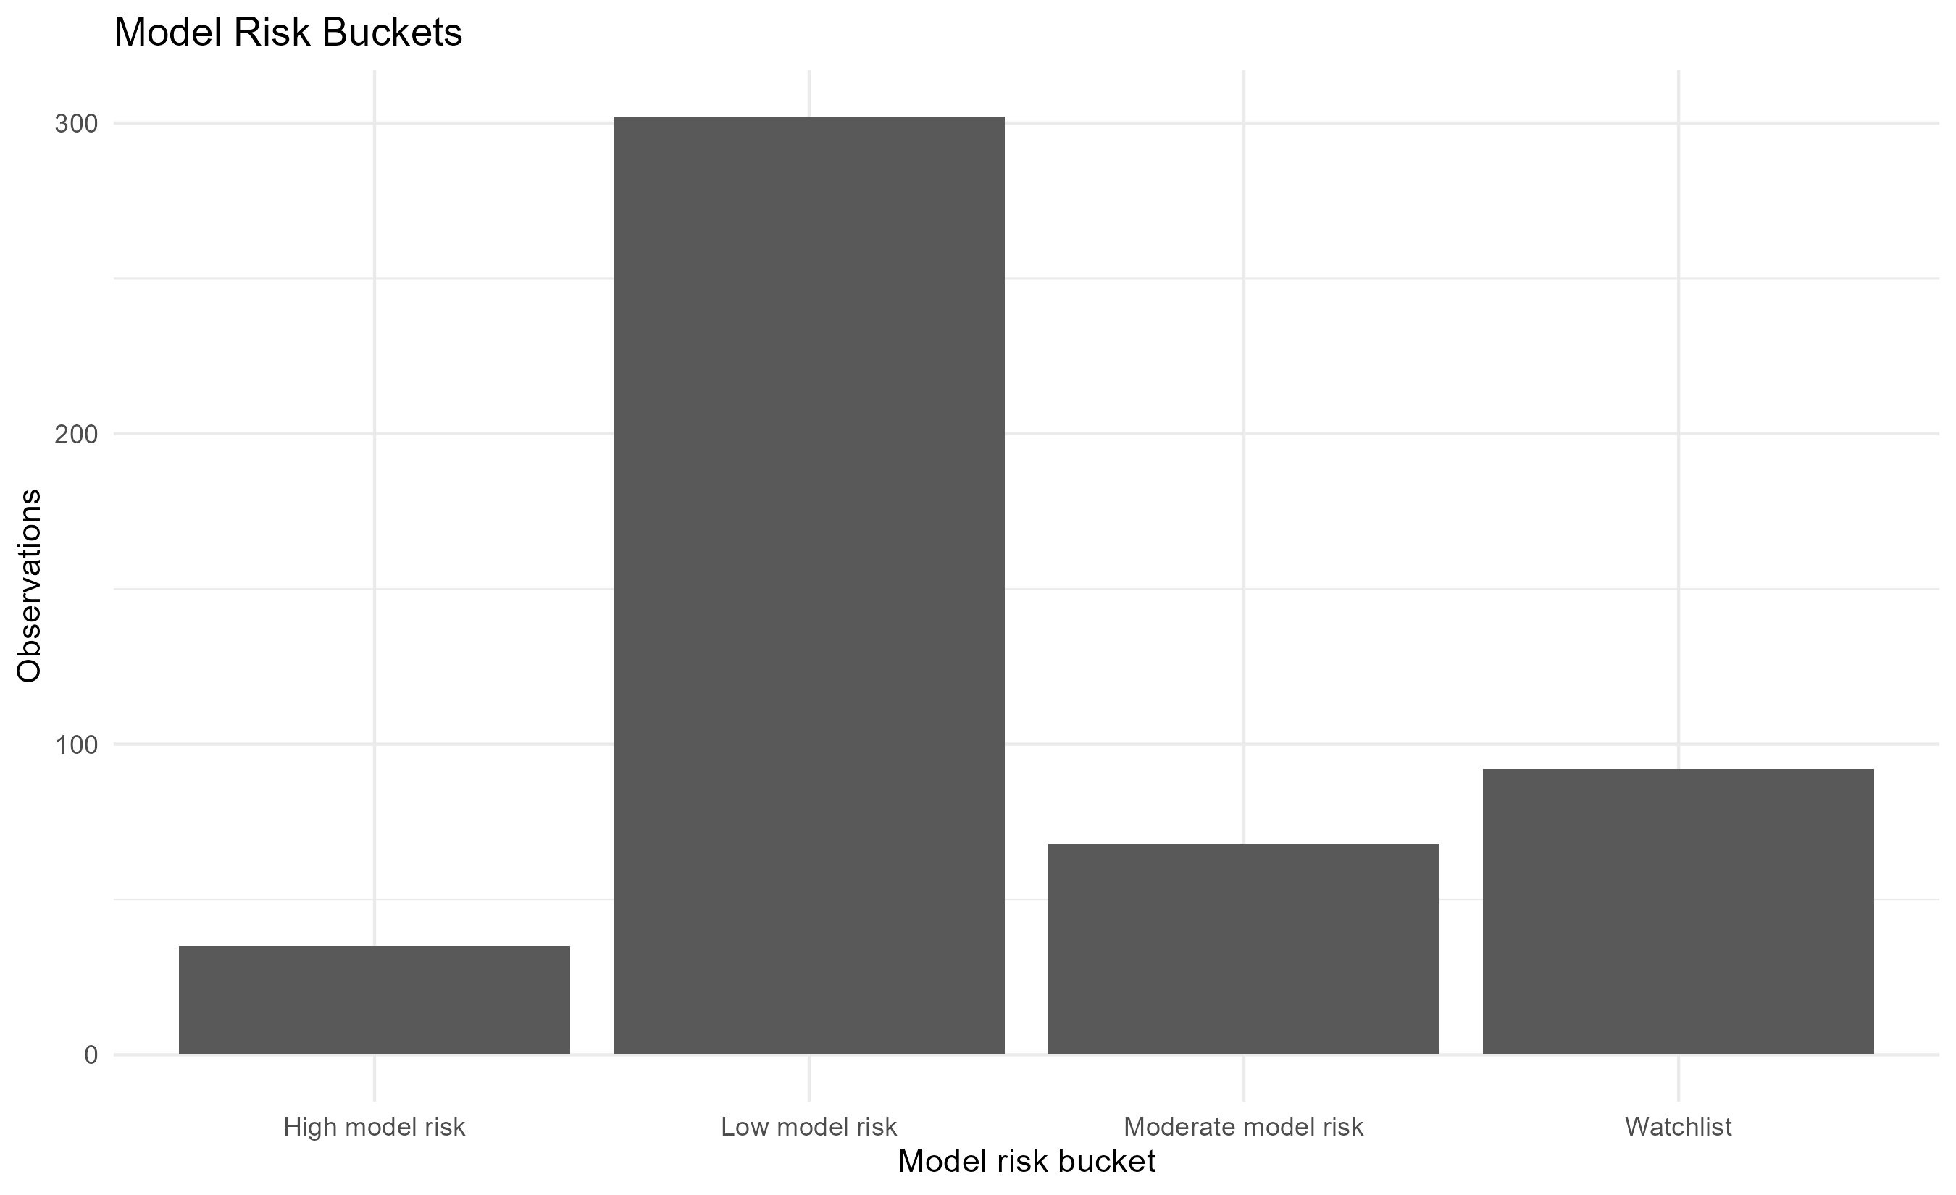

Figure 6. CET1 threshold sensitivity
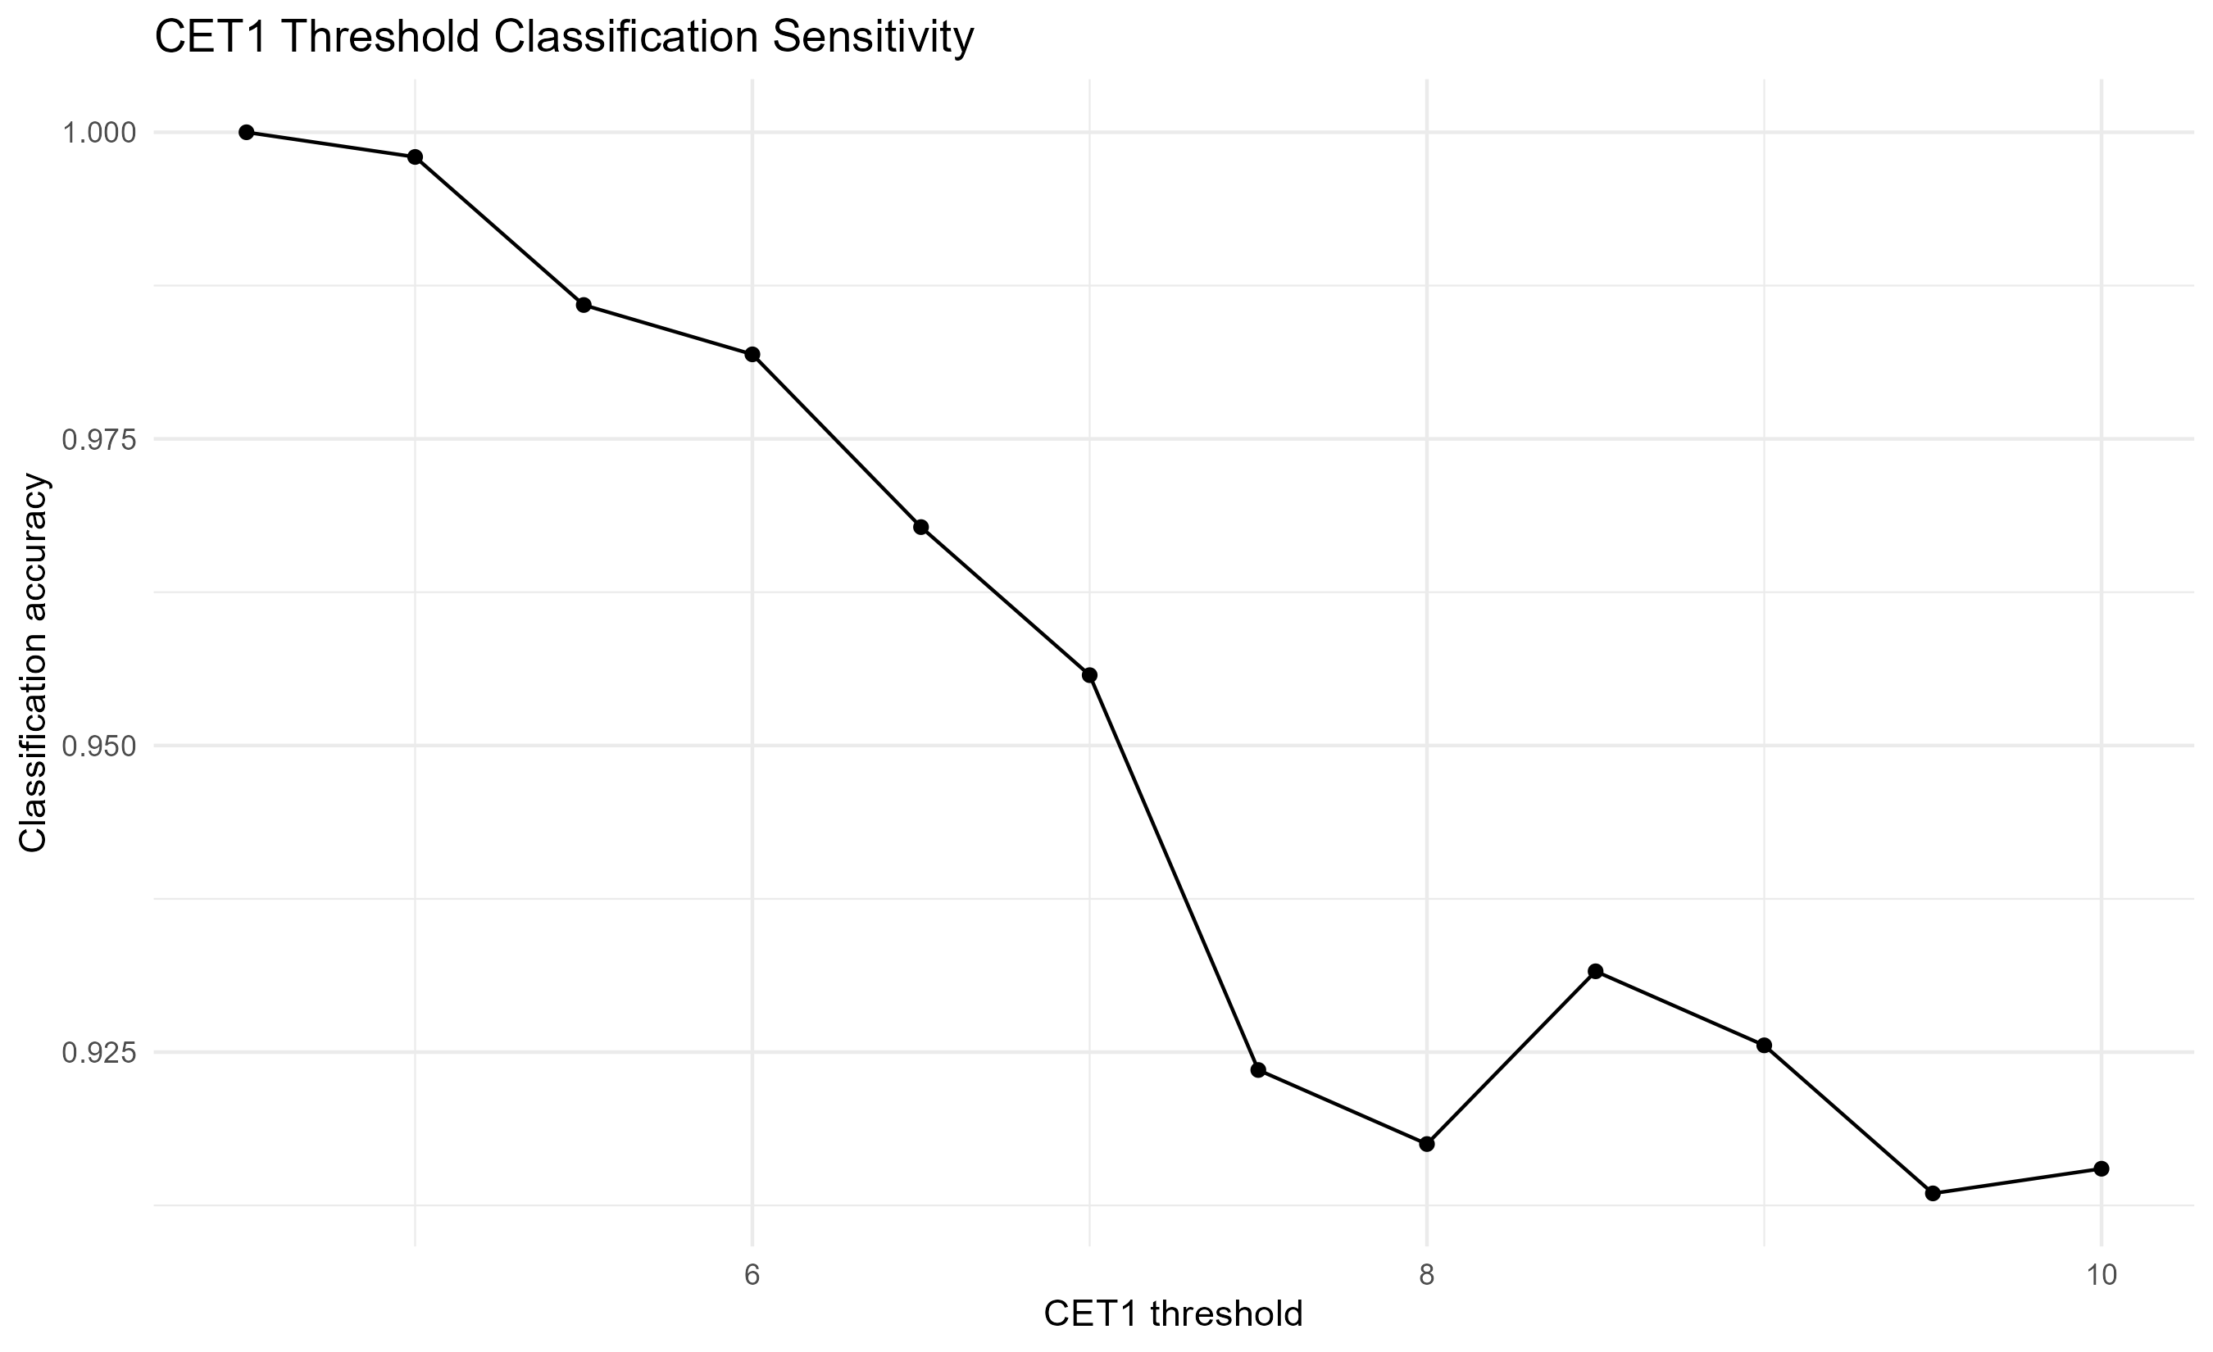

Table 10. Bank-level model risk ranking
Bank model risk rank | Bank name | Observations | Cet1 rmse | Cet1 mae | Max abs cet1 error | High model risk observations | Threshold miss observations | Max model risk score
1 | HSBC North America Holdings Inc. | 14 | 1.1591 | 0.9578 | 2.1973 | 3 | 2 | 0.9324
2 | State Street Corporation | 16 | 1.5694 | 1.2020 | 4.4653 | 2 | 1 | 0.8838
3 | BMO Financial Corp. | 14 | 0.8293 | 0.6987 | 1.3868 | 2 | 2 | 0.8624
4 | UBS Americas Holding LLC | 12 | 1.0229 | 0.7776 | 2.1495 | 1 | 0 | 0.8577
5 | Capital One Financial Corporation | 16 | 0.5985 | 0.4752 | 1.2113 | 3 | 3 | 0.8334
6 | Morgan Stanley | 16 | 1.0446 | 0.8322 | 2.2553 | 1 | 0 | 0.8150
7 | Discover Financial Services | 11 | 0.9281 | 0.6871 | 2.2780 | 1 | 0 | 0.8106
8 | The Bank of New York Mellon Corporation | 16 | 0.9427 | 0.8157 | 1.5518 | 0 | 0 | 0.8028
9 | The Goldman Sachs Group, Inc. | 16 | 1.1003 | 0.9118 | 2.0763 | 1 | 0 | 0.7932
10 | Credit Suisse Holdings (USA), Inc. | 9 | 1.3542 | 0.9602 | 3.3510 | 1 | 0 | 0.7857
11 | The PNC Financial Services Group, Inc. | 16 | 0.6439 | 0.4888 | 1.5668 | 1 | 1 | 0.7780
12 | TD Group US Holdings LLC | 16 | 0.8376 | 0.7173 | 1.8666 | 0 | 0 | 0.7775
13 | DB USA Corporation | 12 | 2.4421 | 1.9455 | 5.0721 | 5 | 0 | 0.7483
14 | KeyCorp | 12 | 0.5887 | 0.4191 | 1.3044 | 1 | 1 | 0.7462
15 | U.S. Bancorp | 16 | 0.4120 | 0.3603 | 0.9009 | 2 | 2 | 0.7455
16 | M&T Bank Corporation | 14 | 0.4077 | 0.3368 | 0.9175 | 0 | 0 | 0.7434
17 | Zions Bancorporation | 4 | 0.4476 | 0.3652 | 0.7304 | 1 | 1 | 0.7362
18 | Huntington Bancshares Incorporated | 12 | 0.6980 | 0.5216 | 1.6203 | 1 | 1 | 0.7280
19 | The Charles Schwab Corporation | 5 | 0.7407 | 0.6407 | 1.3408 | 0 | 0 | 0.7125
20 | Citigroup Inc. | 16 | 0.7422 | 0.6076 | 1.5728 | 0 | 0 | 0.7095

Table 11. Largest CET1 prediction errors
Bank name | Exercise year | Scenario label | Observed cet1 min ratio | Integrated predicted cet1 min ratio | Cet1 min prediction error | Abs cet1 min prediction error | Cet1 min validation flag
DB USA Corporation | 2,023 | Supervisory Severely Adverse | 14.5 | 19.5721 | 5.0721 | 5.0721 | Large deviation
State Street Corporation | 2,017 | Supervisory Severely Adverse | 5.3 | 9.7653 | 4.4653 | 4.4653 | Large deviation
DB USA Corporation | 2,024 | Supervisory Severely Adverse | 12.7 | 16.7789 | 4.0789 | 4.0789 | Large deviation
DB USA Corporation | 2,020 | Supervisory Alternative Severe | 19.5 | 22.9024 | 3.4024 | 3.4024 | Large deviation
Credit Suisse Holdings (USA), Inc. | 2,021 | Supervisory Severely Adverse | 20.1 | 23.4510 | 3.3510 | 3.3510 | Large deviation
DB USA Corporation | 2,017 | Supervisory Severely Adverse | 12.2 | 9.5966 | -2.6034 | 2.6034 | Large deviation
Discover Financial Services | 2,021 | Supervisory Severely Adverse | 13.7 | 11.4220 | -2.2780 | 2.2780 | Large deviation
Morgan Stanley | 2,017 | Supervisory Severely Adverse | 7.3 | 9.5553 | 2.2553 | 2.2553 | Large deviation
Northern Trust Corporation | 2,018 | Supervisory Adverse | 11.3 | 13.4989 | 2.1989 | 2.1989 | Large deviation
HSBC North America Holdings Inc. | 2,016 | Supervisory Severely Adverse | 12.9 | 10.7027 | -2.1973 | 2.1973 | Large deviation
State Street Corporation | 2,016 | Supervisory Adverse | 8.6 | 10.7606 | 2.1606 | 2.1606 | Large deviation
UBS Americas Holding LLC | 2,023 | Supervisory Severely Adverse | 10.0 | 12.1495 | 2.1495 | 2.1495 | Large deviation
DB USA Corporation | 2,017 | Supervisory Adverse | 13.3 | 11.2134 | -2.0866 | 2.0866 | Large deviation
The Goldman Sachs Group, Inc. | 2,015 | Supervisory Adverse | 11.4 | 9.3237 | -2.0763 | 2.0763 | Large deviation
HSBC North America Holdings Inc. | 2,020 | Supervisory Alternative Severe | 5.1 | 7.1739 | 2.0739 | 2.0739 | Large deviation
Morgan Stanley | 2,018 | Supervisory Severely Adverse | 8.9 | 10.8366 | 1.9366 | 1.9366 | Moderate deviation
UBS Americas Holding LLC | 2,022 | Supervisory Severely Adverse | 8.0 | 9.9119 | 1.9119 | 1.9119 | Moderate deviation
TD Group US Holdings LLC | 2,017 | Supervisory Severely Adverse | 11.2 | 13.0666 | 1.8666 | 1.8666 | Moderate deviation
HSBC North America Holdings Inc. | 2,018 | Supervisory Adverse | 10.9 | 9.0918 | -1.8082 | 1.8082 | Moderate deviation
American Express Company | 2,020 | Supervisory Severely Adverse | 13.5 | 11.6951 | -1.8049 | 1.8049 | Moderate deviation
The model risk assessment indicates that most observations are classified as low model risk, but a non-trivial set of observations requires attention. These cases are concentrated in selected bank-year-scenario combinations and should be treated as tail model risk.

8. Pedagogical Use
This project is suitable for teaching applied banking, macro-financial stress testing, financial econometrics, regulatory data analysis and reproducible research. It gives students a complete pipeline from raw public data to final institutional reporting.

Table 12. Pedagogical use of the project
Teaching dimension | Learning objective
Data governance | Understand how public supervisory data are collected, audited and transformed.
Regulatory interpretation | Connect DFAST outputs with capital regulation, scenarios and bank disclosure.
Financial accounting logic | Translate PPNR, losses and RWAs into capital depletion.
Econometric modelling | Estimate reduced-form models and interpret fit, residuals and limitations.
Stress testing mechanics | Build a complete stress test engine from components.
Validation | Compare model outputs with public benchmark outcomes.
Model risk | Identify tail errors, threshold sensitivity and ranking instability.
Communication | Prepare reproducible reports, tables, figures and disclaimers.

8.1. Suggested Classroom Sequence
Step 1: Introduce DFAST, stress testing objectives and capital adequacy concepts.
Step 2: Review the structure of public Federal Reserve DFAST data.
Step 3: Explain the transmission from losses and PPNR to CET1 depletion.
Step 4: Estimate and interpret the credit loss, PPNR and capital depletion models.
Step 5: Build the integrated projection engine.
Step 6: Validate the model against public benchmark outcomes.
Step 7: Discuss model risk, limitations and the difference between public replication and official supervisory modelling.
Step 8: Require students to reproduce selected tables, figures and validation metrics.

8.2. Recommended Student Exercises
Reproduce the key audit and explain why duplicated join keys distort an integrated panel.
Compare the RMSE, MAE and R-squared of the three component models.
Explain why CET1 minimum ratio accuracy can be higher than component-level accuracy.
Identify the banks with the largest CET1 prediction errors and interpret possible reasons.
Evaluate threshold classification at 4.5 percent, 7.0 percent and alternative CET1 thresholds.
Discuss why a model can be useful even when tail errors remain.
Write a short policy note distinguishing official supervisory stress testing from public reduced-form replication.

9. Limitations
The limitations are not weaknesses to hide. They define the valid interpretation of the project. A public reduced-form stress test can be informative and reproducible, but it cannot replace confidential supervisory modelling or bank internal stress testing.

Table 13. Main limitations and implications
Limitation | Implication
Public data only | The engine relies only on public DFAST outputs and public regulatory material.
No confidential supervisory models | The model does not reproduce Federal Reserve confidential supervisory models.
No bank internal capital planning information | Internal bank assumptions, management actions and portfolio details are not observed.
Reduced-form econometric specification | The model is designed for replication and benchmarking, not for official capital decisions.
Bank-specific idiosyncrasies | Some banks have structural features that may not be fully captured by public variables.
Tail errors | Large deviations are concentrated in specific bank-year-scenario observations.
Ranking interpretation | Vulnerability rankings are analytical and relative, not official supervisory rankings.
Threshold interpretation | The 4.5 percent and 7.0 percent thresholds are used as analytical reference points.

10. Institutional Conclusion
The project demonstrates that a transparent public-data stress test replication can approximate Federal Reserve public DFAST outcomes with high accuracy. The integrated engine achieves strong validation results for the CET1 minimum ratio and provides an interpretable framework for bank vulnerability ranking.
The final validation shows low average error, limited systematic bias and high correlation with public benchmark outcomes. At the same time, the model risk assessment identifies tail deviations and bank-specific cases where caution is required.
The appropriate use of the project is therefore as a public benchmark, teaching tool and reproducible research framework. It is not an official supervisory stress test, not a capital planning model and not an investment recommendation.

Final Disclaimer
This report is an independent educational and analytical project based on public data. It is not affiliated with, endorsed by or approved by the Federal Reserve, any banking organization or any supervisory authority. All results are produced for research, teaching and public benchmarking purposes only.
No confidential supervisory information, confidential bank submissions, non-public models or internal bank data are used. The report must not be interpreted as an official regulatory assessment, investment recommendation, credit opinion or statement on the safety and soundness of any institution.

Appendix A. Reproducibility Checklist

Table A1. Reproducibility checklist
Item | Status
Raw public data downloaded | Completed
Regulatory documentation recorded | Completed
Processed DFAST benchmark dataset created | Completed
Transmission layer created | Completed
Modelling sample created | Completed
Credit loss model estimated | Completed
PPNR model estimated | Completed
Capital depletion model estimated | Completed
Integrated engine corrected for join keys | Completed
Final rankings produced | Completed
Benchmark validation completed | Completed
Model risk assessment completed | Completed
Final institutional report generated | Completed

Appendix B. Glossary

Table B1. Glossary of key terms
Term | Definition
DFAST | Dodd-Frank Act Stress Test; a supervisory stress testing framework used in the United States.
CET1 | Common Equity Tier 1 capital ratio; a core regulatory capital adequacy measure.
PPNR | Pre-provision net revenue; earnings before provisions and selected losses.
RWA | Risk-weighted assets; asset measure adjusted for regulatory risk weights.
Capital depletion | Reduction in capital ratio under stress.
Benchmark validation | Comparison of model outputs with observed public benchmark outcomes.
RMSE | Root mean squared error; penalizes larger errors more strongly.
MAE | Mean absolute error; average absolute deviation between prediction and observation.
Model risk | Risk that the model gives inaccurate or unstable outputs for its intended use.
Tail error | Large error in the tail of the error distribution.

