AV Tech Network Router Guide
TP-Link ER605 Router, WireGuard VPN, and PoE Camera Switch
New Hope Lutheran Church - Stream Agent III sd AV System
Prepared May 2026
Internal-use warning: This document includes internal network addresses and the ER605 login. Keep it with the internal AV tech documentation and do not post it publicly.

Contents
- 1. Why the ER605 matters to the AV system
- 2. Why the MikroTik router was replaced
- 3. Network layout and device roles
- 4. Router access and login information
- 5. Current ER605 configuration reference
- 6. PoE switch and camera power design
- 7. WireGuard VPN access overview
- 8. Configuration procedures
- 9. Troubleshooting and recovery
- 10. Screenshots and reference figures

1. Why the ER605 matters to the AV system
The TP-Link ER605 is the router/gateway for the church AV technology network. It is the device that makes the 192.168.88.x AV LAN work as a separate, controlled network behind the main SaskTel/Arris internet gateway.
- It provides the AV LAN gateway at 192.168.88.1.
- It assigns DHCP addresses to AV devices such as BeelinkOBS, the Raspberry Pi WOL helper, tablet clients, and the access point when those devices are not configured with static addresses.
- It routes traffic from the AV LAN out to the church internet connection for YouTube streaming and updates.
- It hosts the WireGuard VPN server used for remote troubleshooting and remote AV support.
- It keeps the camera/control network organized so OBS, Stream Agent III sd, Master Fader, Proclaim, and camera control can work reliably together.
In this design, the ER605 does not power cameras. Power over Ethernet (PoE) is handled by the separate TP-Link TL-SG1005P PoE switch. This separation is deliberate: the router handles routing/VPN/DHCP, while the PoE switch handles camera power and camera data.

2. Why the MikroTik router was replaced
The previous MikroTik PoE router was important in the earlier system because it supplied the camera/control subnet and also powered cameras through PoE. It is no longer trusted for the current AV system.
- The MikroTik power supply was believed to be degraded and no longer able to supply enough current at the correct 48 V level for the cameras.
- Because the same device was also responsible for data switching/routing, the power problem raised concern that transmitting and receiving data could also be compromised.
- The MikroTik system failed during a church service. Troubleshooting during the service was not practical without disrupting the entire streaming setup.
- The replacement design separates routing from PoE power, which makes failures easier to isolate and makes the equipment easier to access in the AV tech cabinet.
Important distinction: This is not a general criticism of MikroTik as a brand. The decision is based on the reliability concerns with the specific church unit and its power/PoE role in the live streaming chain.

3. Network layout and device roles
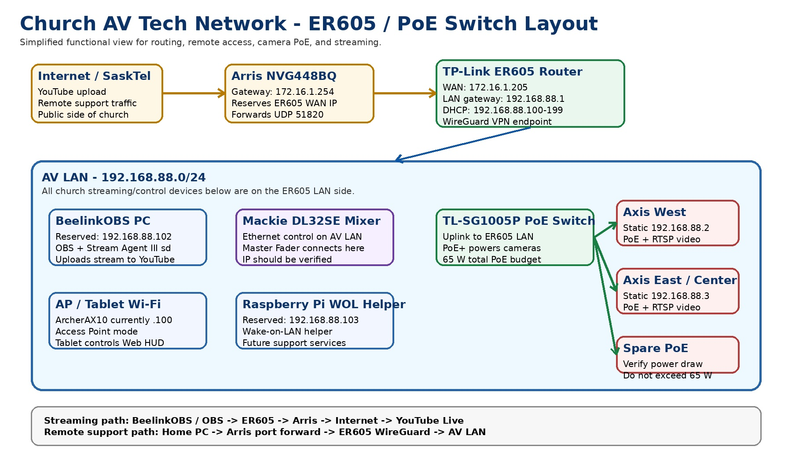
Figure 1 - Current AV network layout showing Arris -> ER605 -> AV LAN and PoE camera switch.

Main network roles
Device | Role in the AV system | Important address / note
Arris NVG448BQ | Main church internet gateway. Upstream router from SaskTel. | Gateway 172.16.1.254. Forwards WireGuard UDP 51820 to ER605 WAN.
TP-Link ER605 | AV LAN router, DHCP server, firewall/NAT, and WireGuard VPN endpoint. | LAN 192.168.88.1. WAN currently 172.16.1.205.
TP-Link TL-SG1005P PoE switch | Powers Axis cameras and carries their Ethernet data. | 4 PoE+ ports, 65 W total PoE budget.
BeelinkOBS PC | Streaming computer running OBS, Stream Agent III sd, Proclaim, Master Fader, and loopMIDI. | Reserved 192.168.88.102.
Axis West camera | West PTZ camera video/control. | Static 192.168.88.2.
Axis East/Center camera | East/Center PTZ camera video/control. | Static 192.168.88.3.
Raspberry Pi WOL helper | Always-on local helper for Wake-on-LAN and future support tasks. | Reserved 192.168.88.103.
Access Point / ArcherAX10 | Wi-Fi access for tablet and mobile controls. | Currently seen at 192.168.88.100; should remain AP mode, not router mode.
Mackie DL32SE mixer | Audio mixer controlled by Master Fader over the AV LAN. | IP should be verified and reserved/static if needed.

4. Router access and login information
Credentials: Protect this section. It contains the ER605 login used for AV support.
Item | Value
ER605 web address from the AV LAN | https://192.168.88.1 or http://192.168.88.1
Router name / ID | NHLC
Router password | pjw3628
Normal access method | Use BeelinkOBS, an AV LAN computer, or WireGuard VPN remote access.
Browser warning | The browser may show Not secure. This is expected for a local router page without a public certificate.

5. Current ER605 configuration reference

5.1 System and WAN status
Setting | Current value / expected value
Hardware version shown in screenshots | ER605 v2.20
Firmware shown in screenshots | 2.2.6 Build 20240718 Rel.82712
WAN connection type | Dynamic IP
WAN status | Link Up / Connected
WAN IP address | 172.16.1.205
WAN subnet mask | 255.255.255.0
WAN MAC address | A8-29-48-9A-C8-CF
WAN default gateway | 172.16.1.254
Primary DNS | 172.16.1.254

5.2 LAN and DHCP
Setting | Current value / expected value
LAN gateway IP | 192.168.88.1
LAN subnet mask | 255.255.255.0
DHCP server | Enabled
DHCP pool | 192.168.88.100 through 192.168.88.199
Lease time | 120 minutes
BeelinkOBS reservation | 192.168.88.102 / MAC 78-55-36-03-3C-2E
Raspberry Pi reservation | 192.168.88.103 / MAC B8-27-EB-EB-A0-FE
Axis camera addresses | 192.168.88.2 and 192.168.88.3 are static camera-side addresses, outside DHCP pool.

5.3 Devices currently visible in DHCP client list
Device | IP address | Notes
BeelinkOBS | 192.168.88.102 | Permanent/reserved. Main streaming PC.
raspberrypi | 192.168.88.103 | Permanent/reserved. WOL helper.
Sound-s-Tab-A9 | 192.168.88.104 | Tablet/client device; lease-based.
ArcherAX10 | 192.168.88.100 | Access point; verify whether it should be static or reserved.

6. PoE switch and camera power design
The TP-Link TL-SG1005P is used because the ER605 does not provide PoE. The switch supplies both Ethernet data and PoE camera power to the Axis cameras, while the ER605 handles routing and VPN functions.

6.1 TL-SG1005P key specifications
Specification | Value
Ports | 5 x 10/100/1000 Mbps RJ45 ports
PoE ports | Ports 1-4 provide PoE+
PoE standards | IEEE 802.3af/at compliant powered devices
Per-port PoE limit | Up to 30 W per PoE port
Total PoE budget | 65 W total for all PoE ports
Switching capacity | 10 Gbps
Packet forwarding rate | 7.44 Mpps
Fan | Fanless
External power adapter | 53.5 V DC / 1.31 A
Configuration | Unmanaged / no configuration required
The Axis M5525-E cameras are suitable for this PoE switch. The Axis datasheet lists PoE as IEEE 802.3af/802.3at Type 1 Class 3, typical 6.6 W and maximum 12.95 W. Two Axis cameras would therefore be under about 26 W maximum, leaving ample margin within the TL-SG1005P 65 W PoE budget. If a FoMaKo or any other PoE camera is reintroduced, verify that camera's PoE draw and keep the total below 65 W.
Comparison with MikroTik: The TL-SG1005P is not a managed router and does not replace the MikroTik feature-for-feature. In this design that is intentional: the ER605 handles router/VPN/DHCP functions, and the TL-SG1005P is a dedicated, standards-based PoE power/data switch for the cameras.

6.2 Why this is better for the current church setup
- Router and PoE power are separated, so a PoE power problem does not necessarily take down routing/VPN functions.
- Both ER605 and TL-SG1005P are compact, low-power, fanless devices that fit well in the AV tech cabinet.
- The equipment is physically accessible for troubleshooting, unlike the earlier higher-shelf router location.
- Shorter Ethernet runs in the AV tech cabinet reduce cable complexity and make visual inspection easier.
- PoE budget is sufficient for the current Axis-only camera setup with significant headroom.

7. WireGuard VPN access overview
WireGuard is the remote access path into the AV LAN. It lets the home/support computer reach BeelinkOBS, the ER605, cameras, and other AV devices without exposing those devices directly to the internet.
Item | Current reference value / note
ER605 WireGuard listen port | UDP 51820
Arris port forward | UDP 51820 -> ER605 WAN 172.16.1.205
Client endpoint | Church public address on port 51820; verify current public IP before relying on it.
ER605 tunnel-side address | 10.6.0.1
Remote client address | 10.6.0.2/32
Client AllowedIPs | 192.168.88.0/24 and 10.6.0.1/32
Client MTU | 1280 has been used successfully in testing.
Keys | Do not publish private keys. This document intentionally does not print private keys.
Key handling: The uploaded ER605 screenshot set did not include a WireGuard key page. If future screenshots include private keys or QR codes, redact them before adding the images to the public/shared documentation set.

8. Configuration procedures

8.1 Physical installation
- Connect the church Arris LAN feed to the ER605 WAN port.
- Connect ER605 LAN ports to the AV LAN devices, access point, and/or the PoE switch uplink.
- Connect Axis cameras to PoE ports 1-4 on the TL-SG1005P. Use port 5 or any non-PoE/uplink arrangement as appropriate for the ER605 uplink.
- Keep the access point in Access Point mode. Do not allow it to run a second DHCP server.
- Place the ER605 and PoE switch in the AV tech cabinet for easier access and shorter cabling.

8.2 Verify ER605 status after power-up
- From BeelinkOBS or another AV LAN computer, browse to https://192.168.88.1.
- Log in using the ER605 credentials in this document.
- Open Status -> System Status.
- Confirm the WAN is Link Up and that the WAN IP is still 172.16.1.205.
- Confirm the LAN gateway remains 192.168.88.1.

8.3 WAN setup
- Open Network -> WAN.
- Confirm WAN Mode is using the WAN port as the active WAN connection.
- Confirm the WAN connection type is Dynamic IP.
- Do not manually set the ER605 WAN IP unless there is a planned change. The Arris DHCP reservation should keep the WAN IP stable.

8.4 LAN and DHCP setup
- Open Network -> LAN.
- Confirm the LAN network is 192.168.88.1 / 255.255.255.0.
- Confirm DHCP Server is enabled.
- Confirm the DHCP range is 192.168.88.100 through 192.168.88.199.
- Use Address Reservation for devices that must stay predictable, especially BeelinkOBS and the Raspberry Pi WOL helper.
- Keep static camera IPs such as 192.168.88.2 and 192.168.88.3 outside the DHCP pool.

8.5 Arris-side requirements
These settings are on the upstream Arris router, not on the ER605. They are included here because WireGuard access depends on them.
- The Arris should reserve the ER605 WAN MAC A8-29-48-9A-C8-CF to 172.16.1.205.
- The Arris should forward UDP 51820 to 172.16.1.205.
- If the ER605 WAN IP changes, remote WireGuard access can fail until the reservation and port forward match again.

8.6 Backup after known-good changes
- After any successful router configuration change, export or back up the ER605 configuration.
- Store the backup with the AV tech documentation, but keep it protected because it can contain sensitive network settings.
- Record the date and what changed so the next support person knows whether the backup is current.

9. Troubleshooting and recovery
Symptom | Most likely checks
Cannot open ER605 page at 192.168.88.1 | Confirm PC is on the AV LAN; ping 192.168.88.1; check cable to ER605 LAN port; verify Wi-Fi is on the AV access point.
WireGuard does not connect from home | Check church internet, Arris port forward UDP 51820, ER605 WAN IP 172.16.1.205, ER605 WireGuard service/listen port, client endpoint, keys, and MTU.
WireGuard connects but pages do not load | Confirm client AllowedIPs include 192.168.88.0/24; verify MTU 1280; ping 192.168.88.1; test browser after ping succeeds.
Camera video or PTZ control fails | Check PoE switch power, camera link LEDs, camera IPs 192.168.88.2/.3, ER605 LAN cabling, and whether the camera web page opens.
BeelinkOBS changes IP | Check ER605 Address Reservation for MAC 78-55-36-03-3C-2E -> 192.168.88.102.
Raspberry Pi WOL helper changes IP | Check ER605 Address Reservation for MAC B8-27-EB-EB-A0-FE -> 192.168.88.103.
Master Fader / mixer unstable | Check mixer Ethernet cable, ER605/AP links, IP addressing, and whether other AV LAN devices remain stable.
Multiple DHCP servers suspected | Confirm the access point is in AP mode and does not run DHCP. ER605 should be the only DHCP server on 192.168.88.x.

10. Screenshots and reference figures
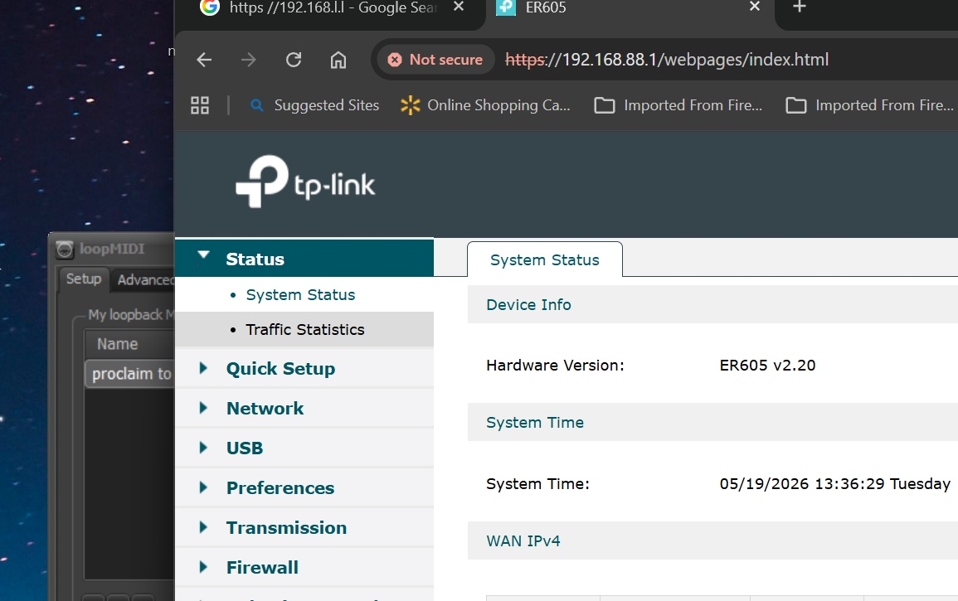
Figure 2 - ER605 Status page showing hardware/firmware and WAN IPv4 status.
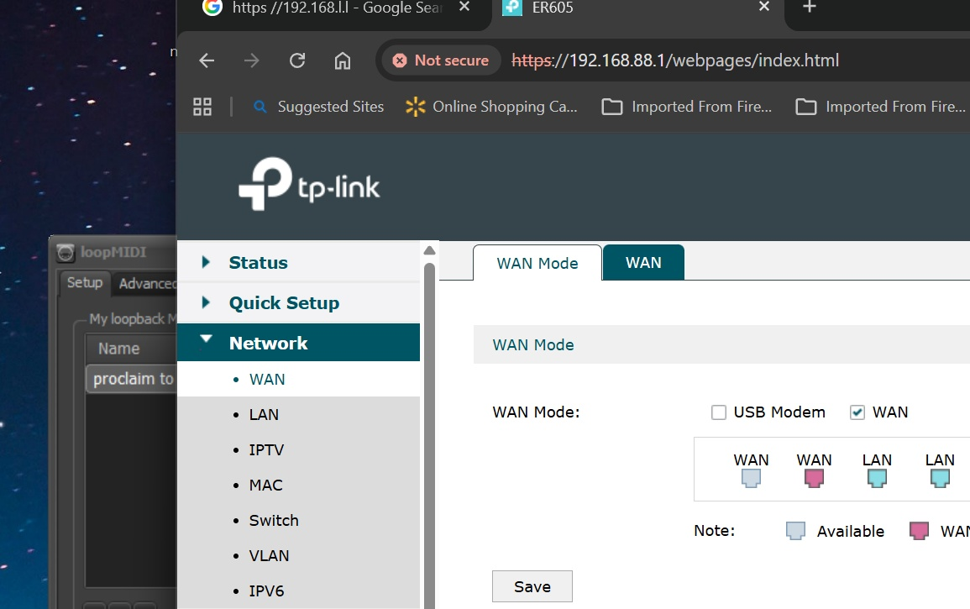
Figure 3 - Network -> WAN Mode page showing the WAN port selected as the WAN connection.
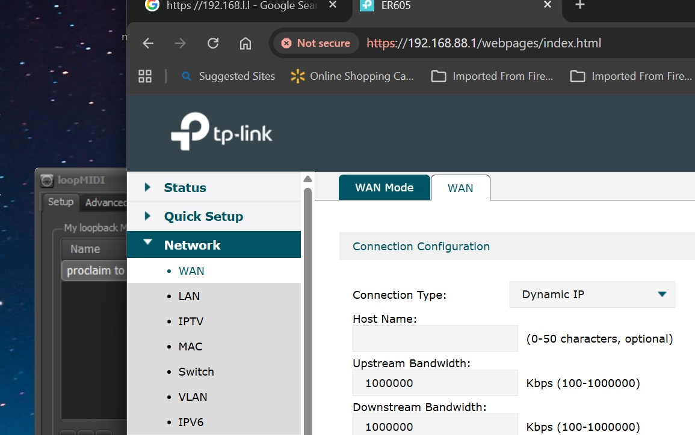
Figure 4 - Network -> WAN page showing Dynamic IP and the current WAN status.
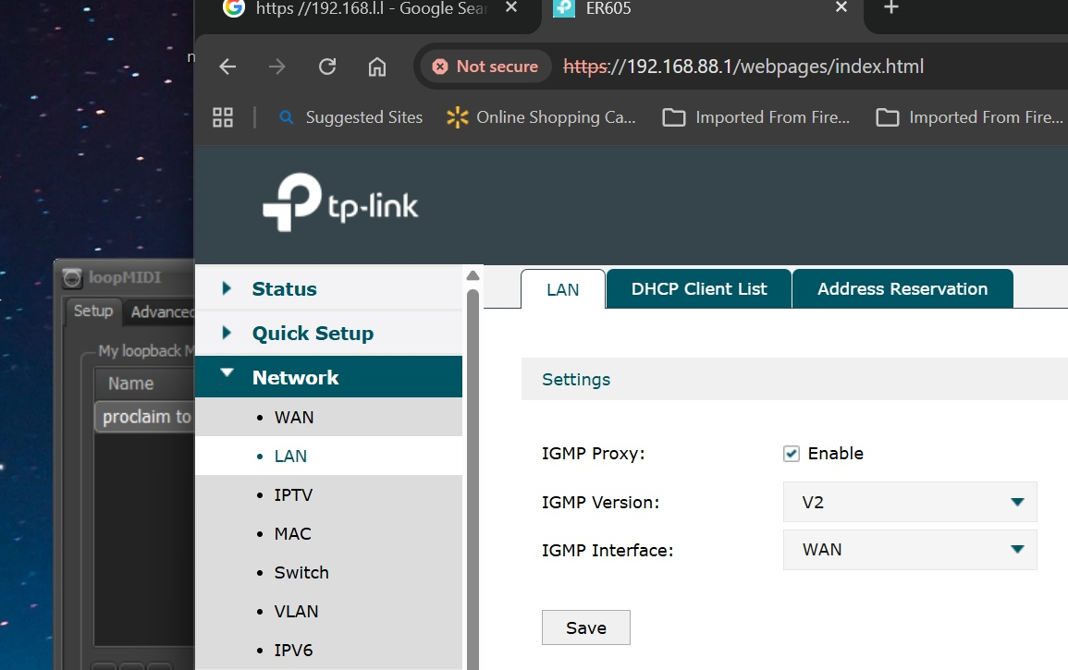
Figure 5 - Network -> LAN summary showing LAN 192.168.88.1/24 and DHCP enabled.
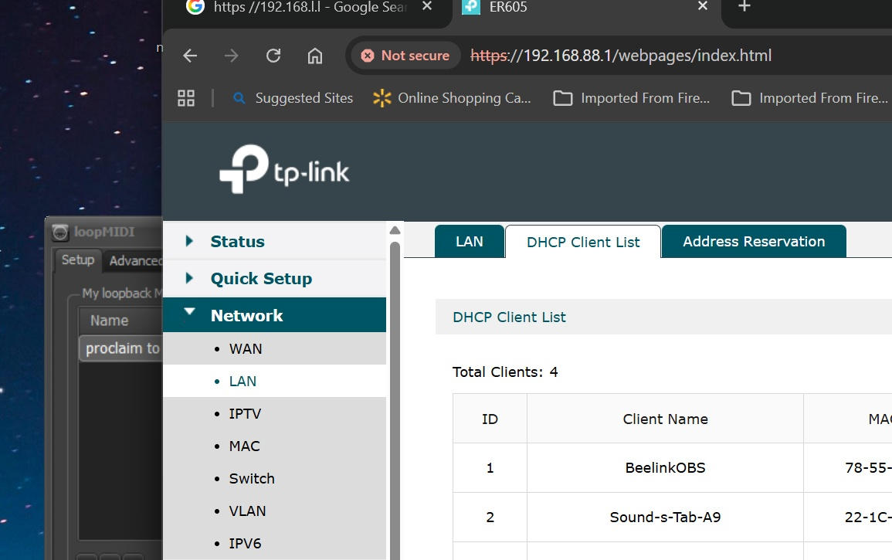
Figure 6 - DHCP Client List showing BeelinkOBS, Raspberry Pi, tablet, and ArcherAX10.
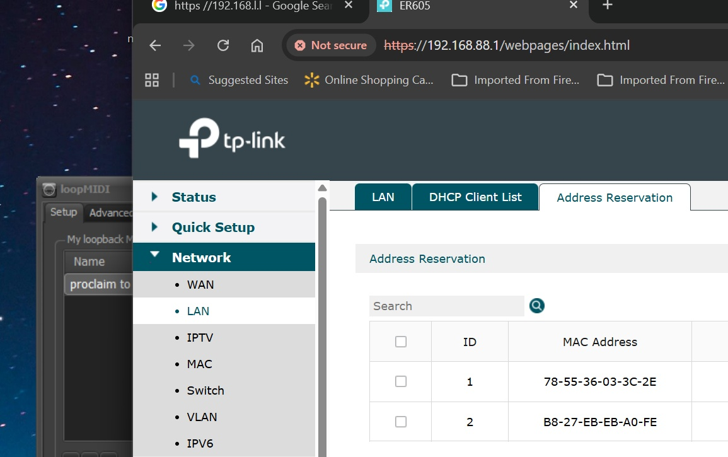
Figure 7 - Address Reservation page showing reserved BeelinkOBS and Raspberry Pi addresses.
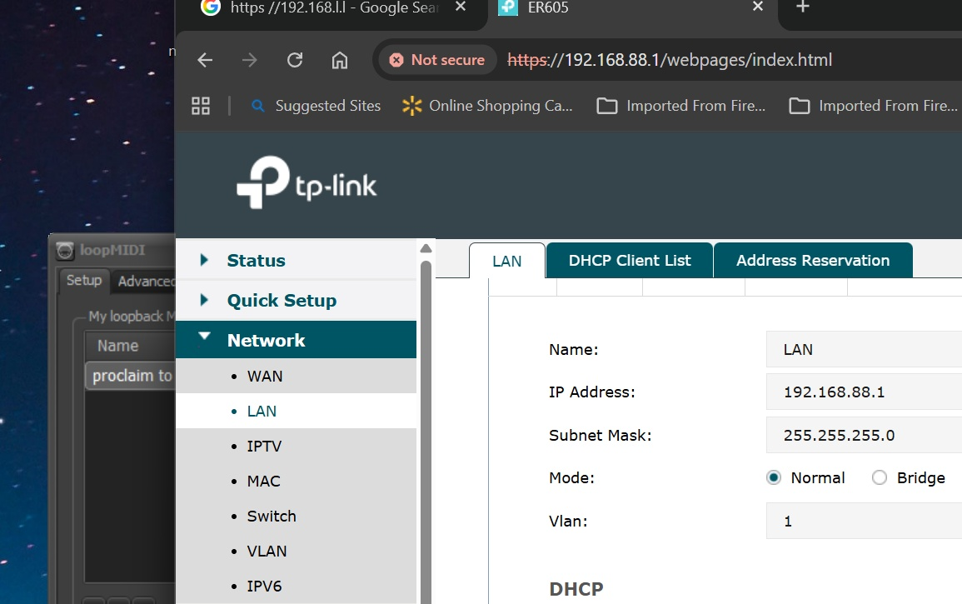
Figure 8 - LAN/DHCP detail page showing DHCP pool 192.168.88.100-199.

11. Source notes for hardware specifications
Hardware specification references used for this guide:
- TP-Link Canada, TL-SG1005P V2 product specifications: 5 gigabit ports, ports 1-4 PoE+, 30 W per PoE port, 65 W total PoE budget, fanless, 10 Gbps switching capacity.
- TP-Link Canada, ER605 V2 product specifications: five gigabit ports, multi-WAN capability, VPN router features, WireGuard VPN throughput listed at 123.4 Mbps, NAT throughput near gigabit class in TP-Link tests.
- Axis M5525-E datasheet: Power over Ethernet IEEE 802.3af/802.3at Type 1 Class 3, typical 6.6 W, maximum 12.95 W.

