New Hope Lutheran Church
AV Tech System
OBS Studio Setup, Operation, and Rebuild Guide
Companion documentation module for Stream Agent III sd
Prepared: May 19, 2026
Status: Working baseline documentation - update with actual OBS screenshots when available

Sensitive information note
This document intentionally does not include the YouTube stream key, OBS WebSocket password, or camera passwords. Record those securely outside any public GitHub repository or printed public manual.

Contents
- Purpose and scope
- What OBS Studio is
- Why New Hope uses OBS
- How OBS connects to Stream Agent III sd
- Current OBS naming requirements
- Software requirements and plugins
- Scene and source design
- Audio design
- YouTube Live interworking
- Normal Sunday operation
- Rebuilding OBS after PC failure
- Backup and maintenance
- Troubleshooting
- Appendices and references

1. Purpose and scope
This document explains the OBS Studio part of the New Hope Lutheran Church AV tech system. It is written so that a new volunteer, or a future maintainer, can understand what OBS does, why it is needed, how Stream Agent III sd controls it, and how to rebuild the OBS configuration if the BeelinkOBS computer has to be replaced.
This is not the final YouTube manual. YouTube scheduling, thumbnails, auto-start, auto-stop, and placeholder management should be documented in a separate YouTube-specific guide. This document covers only the OBS side of that relationship.
- OBS = Open Broadcaster Software. In this document, OBS means OBS Studio.
- NDI = Network Device Interface, used here mainly for Proclaim slide/overlay video reaching OBS over the local network.
- RTSP = Real-Time Streaming Protocol, used by the Axis cameras to send camera video/audio streams to OBS.
- RTMP / RTMPS = Real-Time Messaging Protocol / secure RTMP, used by OBS to send the final live program to YouTube.
- ASIO = Audio Stream Input/Output, an audio-driver method used only if the shared ASIO audio design is selected.
- WebSocket = a network control interface used by Stream Agent III sd to control OBS locally.

2. What OBS Studio is
OBS Studio is the live production and encoder application. It builds the final program picture from scenes and sources, mixes or carries audio sources, encodes the result, and sends it to YouTube Live. OBS is the point where camera video, slide overlays, intro media, and stream audio become one outgoing live program.
OBS scenes and sources are the core of the configuration. A scene is a complete layout; a source is one item inside that layout, such as a camera stream, media file, NDI overlay, browser source, or audio source.
Important mental model
Stream Agent III sd does not stream video to YouTube by itself. It tells OBS what to do. OBS is still the encoder and the program-output engine.

3. Why New Hope uses OBS
New Hope needs a flexible live-production program because the service stream is not a single fixed camera. The system must combine two Axis PTZ cameras, Proclaim slide overlays, an introduction clip, audio, and YouTube output. OBS provides the scene and source structure needed to assemble and encode this final program.
- OBS can receive multiple video sources and layer them in the correct order.
- OBS can stream to YouTube using a persistent church stream key.
- OBS exposes a WebSocket control interface so Stream Agent III sd can automate start/stop, scene switching, media restart, screenshots, and audio controls.
- OBS allows the same scene collection to be backed up and later restored if the PC fails.
- OBS is familiar to many streaming volunteers and has a large support base.

4. How OBS fits into the AV tech system
OBS runs on the BeelinkOBS streaming PC. It sits between the church AV network and YouTube. Cameras, Proclaim, and audio arrive at or are controlled through OBS; OBS then sends the final stream to YouTube.
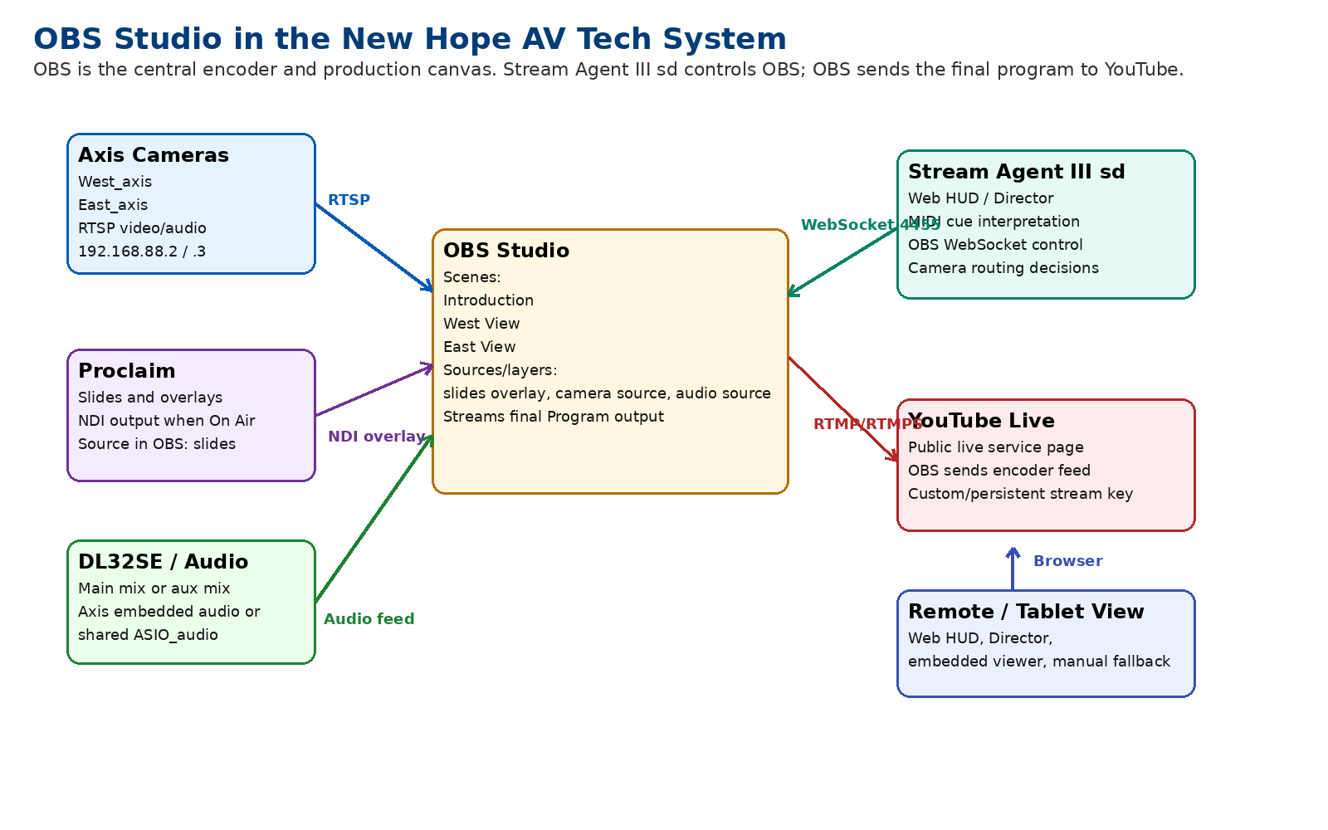
Figure 1 - OBS as the central hub in the New Hope AV tech streaming system.

5. How Stream Agent III sd controls OBS
Stream Agent III sd connects to OBS through the OBS WebSocket interface, normally on the same PC using localhost.
Item | Current/expected value | Purpose
OBS host | 127.0.0.1 | Stream Agent connects locally on the BeelinkOBS PC.
OBS WebSocket port | 4455 | Default OBS WebSocket port used by current app settings.
OBS password | Redacted / configure to match OBS | Required only if OBS WebSocket authentication is enabled.
Expected profile | NHLC live | Used by the app profile safety check when enabled.
Web HUD port | 8765 | Browser interface served by Stream Agent, not by OBS.

Stream Agent uses OBS control for these actions:
- Start stream and stop stream.
- Toggle OBS recording.
- Switch Program scene to Introduction, West View, or East View.
- Set a scene transition, including Cut for intro or app-directed operations when configured.
- Restart the Intro_Video media source and watch for the media-ended state.
- Read OBS screenshot images for the Director preview page.
- Adjust OBS input volume for the configured audio target(s).
- Adjust audio sync offset when shared ASIO mode is active.
Why exact names matter
Stream Agent addresses OBS items by name. If an OBS scene or source is renamed, Stream Agent must be updated or the app will fail to find that scene/source.

6. Current OBS naming requirements
The following names are the key rebuild values. They should be treated as part of the interface contract between OBS and Stream Agent III sd.
OBS item | Required / expected name | Used by
Scene | Introduction | Intro playback sequence
Scene | West View | West camera program scene
Scene | East View | East camera program scene
Media source/input | Intro_Video | Intro media restart and state monitoring
Camera source/input | West_axis | West camera video, Director preview, Axis embedded audio target
Camera source/input | East_axis | East camera video, Director preview, Axis embedded audio target
Proclaim overlay source | slides | Proclaim lower-third/overlay visual layer in live scenes
Shared ASIO audio source | ASIO_audio | Only used when AUDIO_MODE = asio_shared
Expected OBS profile | NHLC live | Profile safety check and correct stream destination

7. Software requirements and plugins
The following software/plugins are part of the OBS side of the system. Versions should be recorded when the system is stable. Do not update OBS or plugins immediately before a service unless there is a verified rollback plan.
Software / plugin | Required for | Notes
OBS Studio 32.x or current stable working version | Main encoder and scene/source host | OBS should be started before Stream Agent or by Task Scheduler before service.
OBS WebSocket | Stream Agent control | Built into OBS Studio 28 and newer; normally no separate install is needed.
DistroAV / NDI plugin | Proclaim overlay source in OBS | Formerly known as OBS-NDI. Needed if Proclaim overlays are captured into OBS by NDI.
NDI runtime/tools | NDI transport support | Install alongside DistroAV if required by the plugin/version.
OBS ASIO plugin | Shared ASIO audio mode only | Needed only if using AUDIO_MODE = asio_shared and an ASIO device/source named ASIO_audio.
Proclaim | Slide/overlay source | Proclaim must be On Air and sending the NDI source expected by OBS.
Stream Agent III sd | Automation and Web HUD | Controls OBS through WebSocket; does not replace OBS.

8. OBS scenes and source design
The scene collection should be simple and predictable. The current Axis-only Stream Agent III sd design expects three main program scenes.
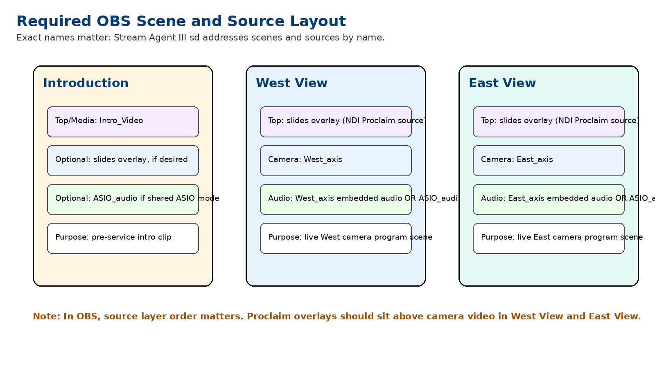
Figure 2 - Required scene/source layout and layer order.

8.1 Introduction scene
Layer / source | Name | Purpose / notes
Media source | Intro_Video | The introduction clip. Stream Agent restarts this source after stream start and waits for it to end.
Audio source | None, embedded, or ASIO_audio depending on design | If the intro video has its own audio, test carefully. A silent intro video plus shared audio path is often simpler for sync.
Optional overlay | slides | Only if a Proclaim overlay is deliberately wanted over the intro. Usually not required.

8.2 West View scene
Layer order | Source name | Purpose / notes
Top overlay | slides | Proclaim NDI overlay. Must be above the camera layer.
Camera video | West_axis | Axis RTSP source for the West camera.
Audio target | West_axis or ASIO_audio | Axis embedded audio mode uses West_axis audio; shared ASIO mode uses ASIO_audio added as existing.

8.3 East View scene
Layer order | Source name | Purpose / notes
Top overlay | slides | Proclaim NDI overlay. Must be above the camera layer.
Camera video | East_axis | Axis RTSP source for the East camera.
Audio target | East_axis or ASIO_audio | Axis embedded audio mode uses East_axis audio; shared ASIO mode uses ASIO_audio added as existing.

9. Camera source setup
The Axis cameras are normally added to OBS as network media sources. The exact RTSP URLs should be recorded securely in the local AV tech setup notes. The app uses the source names West_axis and East_axis to request screenshots and control audio levels in embedded-audio mode.
Camera | IP address | OBS source name | Scene
West Axis M5525-E | 192.168.88.2 | West_axis | West View
East Axis M5525-E | 192.168.88.3 | East_axis | East View

- Use the exact OBS source names shown in this table unless Stream Agent config is also updated.
- Prefer stable wired Ethernet through the ER605/PoE switch AV LAN.
- If RTSP transport options are available, TCP is usually preferred for reliability over the local wired network.
- Do not add extra direct camera preview streams unless needed; too many camera clients can increase load and latency.

10. Proclaim overlay / NDI setup
Proclaim provides the church slides and overlay content. In the current working design, OBS receives the Proclaim overlay through an NDI source and places it above the camera source in each live scene.
OBS source | NDI source seen when Proclaim is On Air | Used in scenes
slides | BEELINKOBS (Proclaim - proclaim overlays) | West View and East View

- The OBS source name should remain slides.
- If the overlay disappears, first confirm Proclaim is open and On Air.
- Confirm DistroAV/NDI is installed and that the Proclaim NDI source is visible to OBS.
- Layer order matters: slides should be above West_axis or East_axis in the scene source stack.

11. Audio design in OBS
The system currently supports two audio models. The selected mode is a Stream Agent setting, but OBS must be built to support the selected mode.
Mode | Stream Agent value | OBS requirement | When to use
Axis embedded audio | AUDIO_MODE = axis_embedded | Audio is carried by West_axis and East_axis media sources. The Web HUD audio fader controls those OBS inputs. | Current Axis-audio test direction; sync page is hidden because audio and video travel together in the camera source.
Shared ASIO audio | AUDIO_MODE = asio_shared | One OBS audio source named ASIO_audio is added as an existing source in all relevant scenes. | Use if a separate audio interface/mixer path feeds OBS directly and audio sync offset needs to be adjusted in OBS.

11.1 ASIO_audio add-existing rule
If shared ASIO mode is used, create one OBS source named ASIO_audio and add it to West View, East View, and usually Introduction using Add Existing. Do not create separate independent ASIO sources with similar names unless the app and documentation are updated.
Why this matters
One shared ASIO_audio source lets the Web HUD master fader and sync control act consistently. Multiple separately named sources are harder to control and troubleshoot.

12. OBS profile, scene collection, and output settings
OBS separates output/stream settings from scene/source layouts. A Profile stores many output-related settings. A Scene Collection stores scenes and sources. Both must be backed up.
Item | Current / expected | Notes
OBS Profile | NHLC live | Used by Stream Agent profile safety. Verify exact capitalization in OBS.
Scene Collection | Verify current church scene collection name | Should contain Introduction, West View, East View. Record final name after confirming.
Output sample rate | 48 kHz expected | Should match the church audio path where practical.
Streaming service | YouTube Live via RTMP/RTMPS | Use the persistent New Hope stream key; never publish the key.
Transition | Fade 400 ms currently reported acceptable; Cut may be forced by app for intro/certain operations | Avoid changing shortly before service without test.

The final confirmed OBS settings should be captured later with screenshots from Settings -> Stream, Output, Audio, Video, Advanced, and WebSocket Server Settings.

13. YouTube Live interworking - OBS side
OBS sends the final program feed to YouTube using the configured stream server and stream key. New Hope uses a recurring/persistent stream-key workflow so the OBS key does not normally change each service. YouTube should have its own detailed document; this section records only the OBS-facing facts.
- The YouTube stream key is sensitive. Treat it like a password.
- The current New Hope approach is to use a persistent/custom stream key in OBS and create/schedule YouTube live placeholders separately.
- YouTube auto-start/auto-stop settings determine whether a scheduled stream starts/stops when OBS begins/stops sending video.
- Stream Agent starts and stops OBS; YouTube must already be prepared to accept the stream.
- The Stream Agent Web HUD includes a View Live button pointing to the New Hope YouTube live page.
New Hope public live URL used by Stream Agent:
https://www.youtube.com/@NewHopeLutheranChurchRegina/live

14. Normal Sunday operating sequence
- Confirm the ER605 AV LAN, PoE switch, Axis cameras, and BeelinkOBS are powered.
- Start or confirm OBS is running. Task Scheduler normally handles this at logon.
- Confirm OBS is on the correct Profile and Scene Collection.
- Confirm the Program scene is safe, typically West View or Introduction before service start.
- Start Proclaim and confirm it is On Air when overlays are needed.
- Start or confirm loopMIDI and Stream Agent III sd are running.
- Open the Stream Agent Web HUD and Director page from the tablet or browser.
- Confirm Director previews show West and East cameras, or troubleshoot before going live.
- Confirm audio meters respond and the Web HUD fader is at the intended level.
- Use timer, Web HUD, or MIDI note 60 to start stream. Stream Agent should start OBS and play Introduction if enabled.
- During the service, let Proclaim MIDI cues drive normal camera changes. Use Director for manual fallback.
- At the end, use Web HUD or MIDI note 61 to start the stop countdown and stop OBS streaming.

15. Rebuilding OBS after a PC failure
This is the core reconstruction procedure. It assumes the replacement PC is already on the AV LAN and can reach the Axis cameras and internet.

15.1 Best case: restore from backup
- Install OBS Studio and the required plugins/NDI/ASIO components.
- Copy the backed-up OBS profile and scene collection into the new user profile, or import them through the OBS menus.
- Copy the Stream Agent III sd folder and config_overrides.json.
- Install Proclaim, Master Fader, loopMIDI, and other required AV software.
- Set up Task Scheduler auto-launch tasks.
- Start OBS and verify the profile, scene collection, source names, and WebSocket settings.
- Run a private YouTube test before relying on the rebuilt system for Sunday service.

15.2 Manual rebuild if no OBS backup exists
- Install OBS Studio.
- Install DistroAV/NDI support if Proclaim overlay is used through NDI.
- Install OBS ASIO plugin only if shared ASIO mode will be used.
- Create or select the OBS Profile named NHLC live.
- Configure Settings -> Stream for YouTube using the New Hope persistent stream key. Do not document the key in public files.
- Create a scene collection for the church service setup.
- Create scenes named Introduction, West View, and East View exactly.
- Add media source Intro_Video to Introduction.
- Add Axis RTSP source West_axis to West View.
- Add Axis RTSP source East_axis to East View.
- Add the Proclaim NDI overlay source as slides to West View and East View above the camera layers.
- If using axis_embedded audio, confirm West_axis and East_axis audio meters appear and the Web HUD fader controls them.
- If using asio_shared audio, create one ASIO_audio source and add it as existing to all relevant scenes.
- Enable/configure OBS WebSocket on port 4455 and match the password in Stream Agent if authentication is used.
- Open Stream Agent Web HUD and verify OBS status is online.
- Use Director to verify previews and issue a safe scene cut test.
- Run a private stream/recording test to confirm video, overlays, audio, and stop/start behavior.

16. OBS backup and maintenance plan
Backups are the difference between a quick restore and a full rebuild. The OBS configuration should be backed up whenever scenes, sources, profile settings, or plugin layout changes are made.
Backup item | How / where | When
OBS Profile | OBS Profile menu export or %APPDATA%\obs-studio\basic\profiles | After stream-key/output/audio setting changes.
OBS Scene Collection | OBS Scene Collection menu export or %APPDATA%\obs-studio\basic\scenes | After scene/source/layout changes.
Stream Agent config | Copy config_overrides.json and current app .py file | After Web HUD config changes.
Intro media | Copy intro video file and source folder | After replacing intro video.
Task Scheduler docs | Keep current DOCX/PDF and screenshots | After app path/name changes.
Plugin installers | Save OBS, DistroAV, ASIO plugin installers or version notes | After stable system verification.

Backup rule
After any successful Sunday with a changed setup, make a backup before experimenting again.

17. Troubleshooting
Symptom | Likely causes | Checks / fixes
Stream Agent says OBS offline | OBS not running; WebSocket disabled; wrong port/password | Open OBS; check Tools/Settings for WebSocket server; verify port 4455 and password.
Director preview blank/stale | Wrong source name; camera offline; OBS screenshot error | Verify West_axis/East_axis exact names; confirm camera feed visible in OBS.
Slides/overlay missing | Proclaim not On Air; NDI source unavailable; source hidden or below camera | Confirm Proclaim On Air; verify slides source in OBS; place above camera layer.
Camera video black | Axis camera offline; RTSP URL wrong; PoE/network issue | Ping camera; open camera web page; check PoE switch; verify source properties.
Audio missing in embedded mode | Camera audio not present; OBS source muted; wrong AUDIO_MODE | Check West_axis/East_axis meters; unmute; confirm Stream Agent Audio / Sync config.
Sync page missing | AUDIO_MODE is axis_embedded | Expected behavior. Switch to asio_shared only if ASIO_audio is in OBS.
Long wait before cut | Preset blind delay applied | Use Director countdown; adjust Preset Delays if delay is too long.
YouTube not live after OBS start | No scheduled placeholder; auto-start off; wrong stream key/profile | Check YouTube Live Control Room and OBS profile NHLC live.
Wrong YouTube destination | Wrong OBS profile or stream key | Use profile safety; verify Settings -> Stream before service.
Multiple OBS copies or odd behavior | Task Scheduler or manual launch started duplicate app | Close duplicates; keep Task Scheduler set to not start a new instance.

18. Items to capture later with screenshots
This document is complete enough to guide a rebuild, but it should later be improved with actual OBS screenshots from the working BeelinkOBS setup. Add the following when available:
- OBS main window showing Scenes and Sources for Introduction, West View, and East View.
- Settings -> Stream page with stream key redacted.
- Settings -> Output page.
- Settings -> Audio page showing 48 kHz sample rate and selected devices.
- Settings -> Video page.
- WebSocket server settings page with password redacted.
- West_axis and East_axis source properties with credentials/URLs redacted where necessary.
- slides NDI source properties.
- Audio Mixer Advanced Audio Properties showing sync offsets if ASIO mode is used.

Appendix A - Configuration record sheet
Configuration item | Expected value / note
OBS version | Record exact working version, currently OBS 32.x family observed.
OBS Profile | NHLC live
Scene Collection | Record exact final name after verification.
Streaming server | YouTube RTMP/RTMPS server configured in OBS; do not publish stream key.
Video base/output resolution | Record exact working values after OBS screenshot capture.
FPS | Record exact working value after OBS screenshot capture.
Audio sample rate | 48 kHz expected.
WebSocket host/port | 127.0.0.1:4455
Scene transition | Fade 400 ms currently acceptable; app may force Cut for selected operations.
West camera source | West_axis
East camera source | East_axis
Proclaim overlay source | slides
Intro media source | Intro_Video
Shared ASIO source | ASIO_audio if AUDIO_MODE = asio_shared

Appendix B - OBS and Stream Agent interface map
Stream Agent function | OBS object touched | Reason
Start Stream | OBS streaming output | Begin sending final program to YouTube.
Stop Stream | OBS streaming output | End encoder output after stop countdown.
Record Toggle | OBS recording output | Optional local recording.
Intro sequence | Introduction scene and Intro_Video media source | Start stream with intro, wait for media end, cut to live scene.
Current view routing | West View / East View scenes | Cut to the scene containing the prepared camera.
Director preview | West_axis / East_axis screenshots | Show camera confidence views in browser.
Audio master fader | West_axis/East_axis or ASIO_audio | Control live audio target(s) from Web HUD.
Sync page | ASIO_audio sync offset | Adjust lip-sync when shared ASIO mode is active.
Profile safety | OBS active profile | Reduce risk of starting with wrong YouTube profile/key.

Appendix C - Glossary
Term | Meaning in this system
OBS | Open Broadcaster Software, the encoder and scene/source production app.
Scene | An OBS layout containing sources. Stream Agent cuts between scenes.
Source | A video, audio, media, browser, or NDI item inside a scene.
Program | The OBS output currently being streamed/recorded.
WebSocket | Local control channel used by Stream Agent to command OBS.
NDI | Network Device Interface, used here to bring Proclaim overlay video into OBS.
RTSP | Real-Time Streaming Protocol, used by Axis cameras to send video/audio to OBS.
RTMP/RTMPS | Streaming protocol used by OBS to send the final feed to YouTube.
ASIO | Audio Stream Input/Output, used only in shared ASIO audio mode.
Blind delay | A wait before cutting to a moved camera so viewers do not see the PTZ motion.

Appendix D - References
These sources were used for general OBS/YouTube/plugin behavior. Local New Hope values come from the Stream Agent III sd app configuration and prior project records.
- OBS Knowledge Base - Sources Guide: https://obsproject.com/kb/sources-guide
- OBS Knowledge Base - Profiles: https://obsproject.com/kb/profiles
- OBS Knowledge Base - Scene Collections: https://obsproject.com/kb/scene-collections
- OBS Knowledge Base - Remote Control Guide: https://obsproject.com/kb/remote-control-guide
- OBS Knowledge Base - Launch Parameters: https://obsproject.com/kb/launch-parameters
- DistroAV / OBS NDI plugin project: https://github.com/DistroAV/DistroAV
- OBS ASIO plugin project: https://github.com/Andersama/obs-asio
- YouTube Help - Manage live stream settings: https://support.google.com/youtube/answer/9854503
- YouTube Help - Encoder settings, bitrates, and resolutions: https://support.google.com/youtube/answer/2853702

