New Hope Lutheran Church
AV Tech System
Proclaim Programming, Operation, and Rebuild Guide
Companion documentation module for Stream Agent III sd, OBS, and YouTube Live
Prepared: May 19, 2026
Status: Working baseline documentation - update with actual Proclaim screenshots when available
Sensitive information note
This document intentionally does not include account passwords, YouTube stream keys, OBS WebSocket passwords, camera passwords, or Proclaim account credentials. Record those securely outside any public repository or printed public manual.

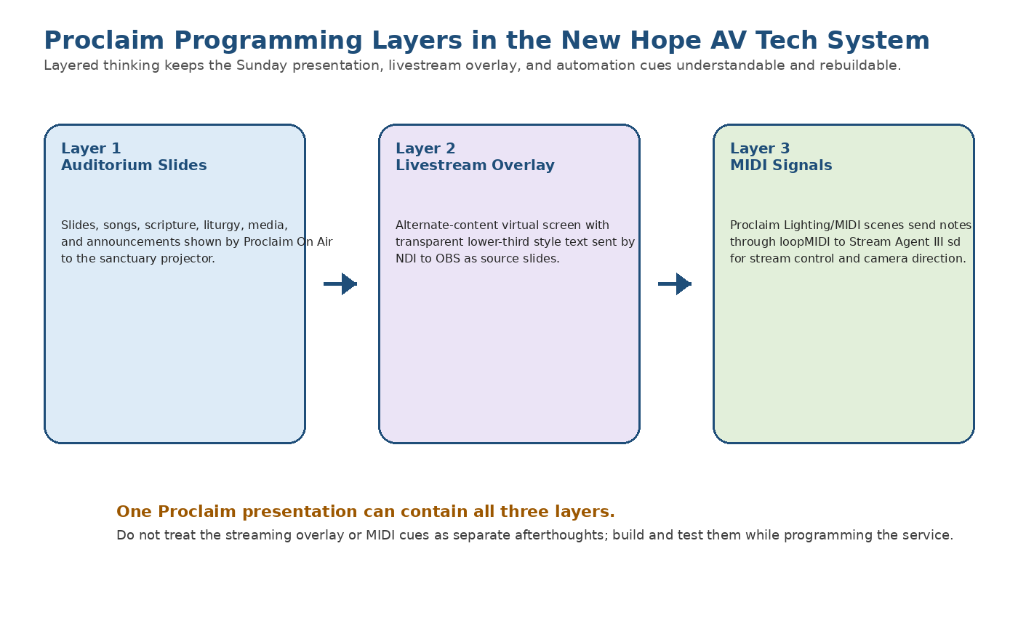
Figure 1 - Three-layer Proclaim programming model for New Hope services.

Contents
- Purpose and scope
- What Proclaim is
- How Proclaim fits into the AV tech system
- Layered programming model
- Presentation naming, dates, and service times
- Layer 1 - auditorium slide programming
- Songs, scripture, media, templates, and reuse
- Projector and display output setup
- Special service programming
- Layer 2 - transparent livestream overlays
- NDI outputs, virtual screens, and OBS interworking
- Layer 3 - MIDI signals and camera direction
- Normal Sunday programming workflow
- Rebuilding Proclaim after PC failure
- Backup and maintenance
- Troubleshooting
- Items to capture later with screenshots
- Appendices and references

1. Purpose and scope
This document explains how New Hope Lutheran Church should program Proclaim presentations for Sunday worship, special services, funeral services, and livestream support. It is written so that a new volunteer or future maintainer can understand not only how to create sanctuary slides, but also how Proclaim feeds OBS and how Proclaim sends MIDI cues to Stream Agent III sd for camera direction.
This guide treats Proclaim programming as three layers:
Layer | What it does | Main output / interface
Layer 1 - Auditorium slides | Full worship slides shown in the church sanctuary: liturgy, hymns, scripture, announcements, media, and service-flow slides. | Projector / sanctuary display from Proclaim On Air
Layer 2 - Livestream transparencies | Transparent overlays or lower-thirds for OBS so online viewers see selected text over the camera image. | Proclaim alternate virtual screen sent to OBS by NDI
Layer 3 - Automation signals | MIDI notes placed at service points to tell Stream Agent III sd what camera view is needed, or to start/stop/record. | Proclaim Lighting/MIDI output -> loopMIDI -> Stream Agent III sd

Important mental model
Proclaim does not stream the service by itself. Proclaim provides slides, overlays, and cue signals. OBS remains the encoder. Stream Agent III sd receives MIDI cues from Proclaim and then controls OBS and the cameras.

2. What Proclaim is
Proclaim is the church presentation program used to assemble and run the worship service order. It manages the Order of Service, service items, slide backgrounds, song lyrics, Bible passages, announcement slides, media items, alternate content screens, and automation signals.
In New Hope terminology, Proclaim is the service-programming tool. OBS is the live-production and encoder tool. Stream Agent III sd is the automation and camera-director tool.
Proclaim concept | Meaning in this system
Presentation | One planned worship service or special service, such as Sunday May 31, 2026. ELW HC Setting 1.
Order of Service | The left-side service structure containing Pre-Service Loop, Warm-Up, Service, and Post-Service Loop sections.
Service item | A single program element such as a song, Bible reading, content slide, video, or signal-bearing cue item.
On Air | The live Proclaim output mode that sends the selected virtual screens to the projector and other outputs.
Virtual screen | A Proclaim output design surface such as Slides, Confidence, Notes, or Alternate Content.
NDI | Network Device Interface, used to send the transparent livestream overlay from Proclaim to OBS.
MIDI | Musical Instrument Digital Interface, used here as a reliable cue-signal system from Proclaim to Stream Agent III sd.

3. How Proclaim fits into the AV tech system
Proclaim runs on the BeelinkOBS Windows PC as part of the Sunday AVTECH system. It serves three different audiences at the same time: the congregation in the sanctuary, the online viewer watching through YouTube, and Stream Agent III sd, which uses Proclaim cues to automate camera selection.
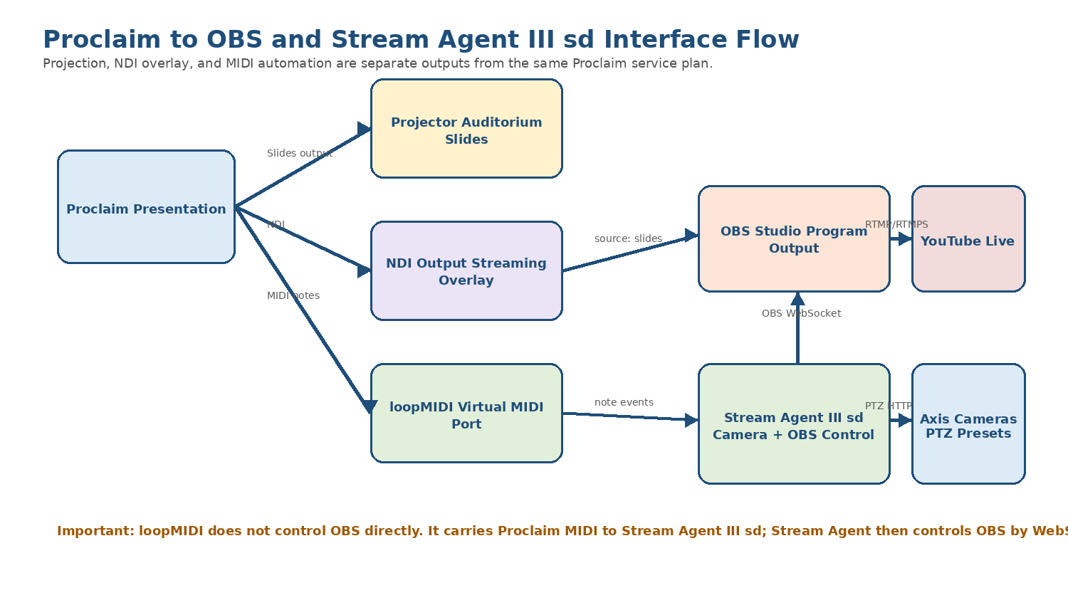
Figure 2 - Proclaim projection, NDI overlay, and MIDI control flow.
Output path | Destination | Purpose
Slides output | Sanctuary projector | Full-screen worship presentation for people in the building.
NDI custom output | OBS source named slides | Transparent Proclaim overlay placed over Axis camera scenes in OBS.
Lighting/MIDI output | loopMIDI virtual port | Note events consumed by Stream Agent III sd for stream control and camera direction.
Service date/time | Proclaim Order of Service | Coordinates Pre-Service Loop, Warm-Up, and transition into the Service section.

4. Layered programming model
Every service should be programmed in the same order: build the worship service first, then add livestream overlays, then add MIDI cue signals. This prevents the control layers from becoming disconnected from the actual service liturgy.
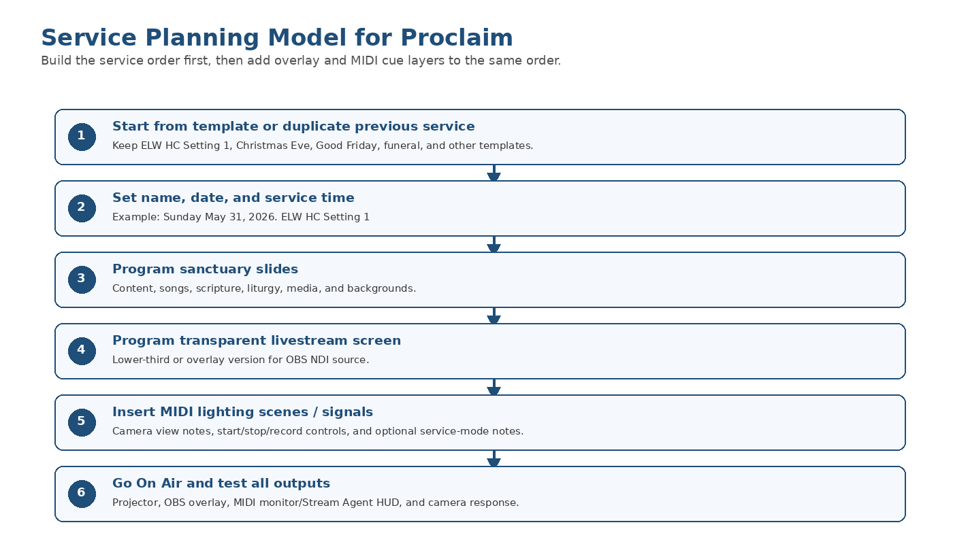
Figure 3 - Recommended Proclaim service programming order.
Programming rule
Do not wait until Sunday morning to add the streaming overlay and camera cues. The overlay and MIDI layers are part of the service plan, especially for services with Communion, choir, Children's Time, processions, special music, or unusual liturgical movement.

5. Presentation naming, dates, and service times
Presentation names should be specific enough that a volunteer can identify the correct service later when duplicating, searching, or recovering material. The name should include the service type, date, and major liturgical setting.
Service type | Recommended name pattern | Example
Regular Sunday with Holy Communion | Sunday Month DD, YYYY. ELW HC Setting # | Sunday May 31, 2026. ELW HC Setting 1
Sunday Service of the Word | Sunday Month DD, YYYY. ELW Service of Word | Sunday June 7, 2026. ELW Service of Word
Maundy Thursday | Maundy Thursday Month DD, YYYY | Maundy Thursday April 2, 2026
Good Friday | Good Friday Month DD, YYYY | Good Friday April 3, 2026
Christmas Eve | Christmas Eve Month DD, YYYY. Candlelight | Christmas Eve December 24, 2026. Candlelight
Funeral / Memorial | Funeral - Name - Month DD, YYYY | Funeral - John Smith - May 15, 2026

Acronym note
ELW = Evangelical Lutheran Worship. HC = Holy Communion. In the example name, ELW HC Setting 1 means the Sunday service uses the Holy Communion Setting 1 liturgy from Evangelical Lutheran Worship.

After duplicating or creating a presentation, set the correct service date and start time. Proclaim uses the service start time to manage the Pre-Service Loop, Warm-Up, and transition to the Service section. The Proclaim support documentation says the date keeps the team organized and the service time affects the pre-service loop and start timing.
Task | How to do it | Reason
Set service date | Use the date dropdown near the presentation date area. | Keeps collaborators and future reuse organized.
Set service start time | Click the blue start time to the right of the Service section title, enter the time, and press Enter. | Allows Proclaim to time the Pre-Service Loop and Warm-Up correctly.
Verify On Air timing | Go On Air early enough for the Pre-Service Loop and Warm-Up to complete before the service begins. | Avoids the Service section appearing too early or too late.

6. Layer 1 - auditorium slide programming
Layer 1 is the normal Proclaim presentation shown to the congregation through the sanctuary projector. This layer should be complete and worship-ready even if streaming automation is turned off.
Service item type | Use at New Hope | Notes
Content | Liturgy, prayers, sermon title, welcome slides, instructions, funeral/memorial text, Christmas Eve candlelight instructions. | Use templates and consistent backgrounds. Keep text large and readable.
Song | Hymns and worship songs. | Use My Songs, Hymnbase, or SongSelect if available. Confirm verse order.
Bible | Scripture readings. | Enter reference, select preferred Bible version, and verify slide breaks.
On-Screen Bible | Occasional scripture display with animation. | Use sparingly; test readability and timing.
Video | Intro clips or service-specific video. | Test audio, start/stop behavior, and whether it belongs in Proclaim or OBS.
Image Slide Show | Announcements, photos, mission trip slides, seasonal pre-service material. | Useful in Pre-Service Loop or Post-Service Loop.
Web Page | Rare; online giving, web content, or embedded web media. | Test before service; web content depends on internet stability.
Cues / stage direction | Leader prompts or internal service directions. | May be useful for confidence monitor; not necessarily shown to congregation.

7. Songs, scripture, media, templates, and reuse

7.1 Add items from the Add Item menu
Most Proclaim programming begins from the Add Item menu. Add the required items into the Service section or into the Pre-Service/Warm-Up/Post-Service sections as appropriate.
- Open the target presentation.
- Select the correct section of the Order of Service.
- Open Add Item.
- Choose the service item type, such as Song, Bible, Content, Video, or Image Slide Show.
- Edit the item content, background, and slide breaks.
- Rename items in the Order of Service when helpful for reuse, but avoid confusing custom names that hide the actual song or Bible title.

7.2 Songs and the song library
For songs, choose Add Item > Song, search the title, and select an existing song from My Songs or a new source such as Hymnbase or SongSelect where available. Confirm the arrangement, verse order, and lyric slide breaks. Proclaim documentation notes that arrangements can preserve customizations for future reuse.
Song task | Operator check
Search song title | Make sure the selected song is the correct hymn/song and version.
Confirm arrangement | Use the correct verses, refrain order, key if needed, and on-screen title.
Check slide breaks | Avoid too many lines per slide. Use readable line breaks.
Apply background or Smart Media | Use the church-approved style for the season or service.
Check overlay layer later | If livestream lower-thirds are used, verify the alternate screen version separately.

7.3 Scripture slides
For scripture, add a Bible service item, enter the reference, choose the preferred Bible version, and check each slide. Proclaim can automatically enter and format Bible verse slides, but the operator should still verify the reading, breaks, and readability.
Scripture item | Check
Reference | Correct book, chapter, and verse range.
Bible version | Use the version approved for the service.
Reader flow | Slide breaks should support the reader, not interrupt mid-thought unnecessarily.
Projection readability | Large enough text; high contrast; no busy backgrounds.
Streaming overlay | Usually blank or simplified unless scripture is intentionally shown online as an overlay.

7.4 Templates, Smart Media, and backgrounds
Use templates and Smart Media to keep the service visually consistent. Proclaim supports customizing existing Smart Media templates or creating new templates. It also allows default media to be set for service item types, including different defaults by virtual screen.
Template / media practice | Reason
Maintain a normal Sunday template | Fast weekly setup and consistent ELW flow.
Maintain special-service templates | Maundy Thursday, Good Friday, Christmas Eve, funeral/memorial, and other special services have different flow and camera needs.
Use seasonal backgrounds deliberately | Advent, Christmas, Lent, Holy Week, Easter, Pentecost, and funerals should not accidentally inherit last Sunday's style.
Create transparent overlay templates | Speeds up Layer 2 overlay programming and prevents one-off formatting mistakes.
Set default media where appropriate | Reduces the need to reuse old items simply to recover a background.

7.5 Reuse previous services and items
The fastest and safest weekly method is usually to duplicate a recent or template presentation, then edit it. Proclaim documentation recommends duplicating prior presentations or templates so the service starts with useful existing items. Individual service items can also be reused from the Add Item menu.
Reuse method | Use when | Caution
File > Duplicate Recent / Duplicate | Starting a new Sunday from last week or from a formal template. | Immediately rename, set date, and set service time.
Add Item > Reuse item | Pulling in a hymn, liturgy block, funeral item, or seasonal slide from older services. | Search by clear item names; avoid importing obsolete cues.
Copy/Paste or Ctrl+D | Duplicating an item within the same presentation. | Move the duplicate to the correct section and update text.
Linked item | Same item needed in Pre-Service and Post-Service loops. | Useful for recurring announcements; be aware edits affect linked copies.

8. Projector and display output setup
The sanctuary projector is the primary Layer 1 output. In Proclaim Display settings, assign the correct virtual screen to the physical projector output. The Proclaim application monitor itself should normally be set as Not Used so the operator screen does not become the congregation display.
Display setting | New Hope purpose | Check
Slides virtual screen | Main sanctuary projected slides. | Assigned to the projector output.
Application display | The PC screen where Proclaim is edited/controlled. | Should normally be Not Used in output assignment.
Identify Displays | Used to confirm which physical display is projector vs. PC monitor. | Run when cabling or Windows display order changes.
Aspect ratio | Usually 16:9 unless the installed projector/screen requires otherwise. | Keep consistent with templates and livestream overlay design.
On Air test | Verifies projection, full-screen behavior, and slide fit. | Always test before the service.

Display test rule
Do not assume the projector output is correct because the presentation looks right on the PC monitor. Click On Air with the projector connected and verify the sanctuary screen.

9. Special service programming
Special services should use their own templates or a duplicated previous service of the same type. The goal is not just to preserve slides, but to preserve the expected service flow, overlays, and MIDI camera cues that match that liturgy.
Service type | Programming notes | Camera / cue notes
Maundy Thursday | Use a Holy Week template. Include confession/absolution, communion, stripping of altar if used, and subdued visual style. | Expect altar, communion, choir, and possibly wide/panorama views.
Good Friday | Use Good Friday template. Text is often longer and more solemn; keep slides simple and readable. | Plan camera changes around readings, cross, choir, and silence; avoid unnecessary movement.
Christmas Eve | Use Christmas Eve/Candlelight template. Include carols, lessons, candlelight instructions, and seasonal backgrounds. | Expect choir, congregation/panorama, pulpit, altar, and possibly piano/band cues.
Funeral / Memorial | Use funeral template. Include name, dates, photo/video if used, hymns, scripture, sermon, commendation, and family-sensitive content. | Keep camera movement conservative; verify permission for streaming/recording and any photos.
Other special services | Duplicate closest matching template and adjust. | Test all MIDI cues because the order may not match Sunday defaults.

10. Layer 2 - transparent livestream overlays
Layer 2 is the alternate screen designed for the online stream. It should not simply mirror the sanctuary projector. For streaming, the desired output is usually transparent lower-third or overlay text so OBS can place Proclaim content over the live camera image.
Overlay item | Recommended approach
Song lyrics | Use lower-third or side/bottom overlay with transparent background. Keep text large enough for online viewers.
Scripture | Use only when helpful; full scripture may be better as projection-only unless online viewers need it.
Liturgy responses | Use short response text, not entire paragraphs, if the overlay would cover too much video.
Sermon title / service title | Good use of lower-third style.
Announcements | Usually projection-only unless intentionally shown to online viewers.
Funeral / memorial name slide | Can be full-screen in OBS or a clean overlay depending on the service plan.

Transparency rule
The livestream overlay should use transparent background wherever the camera image should show through. Proclaim NDI outputs have true transparency by default when configured through its NDI custom output workflow.

11. NDI outputs, virtual screens, and OBS interworking
Proclaim can create virtual screens and assign them to outputs. For New Hope streaming, the important output is an NDI custom output that OBS receives as the Proclaim overlay source. In the current OBS documentation, the OBS source name should be slides and it should sit above the camera sources in West View and East View.
Item | Current / expected value | Purpose
Proclaim alternate virtual screen | Live Stream / Proclaim overlays / confirm exact final name | Design surface for transparent stream overlay.
Proclaim NDI output name | BEELINKOBS (Proclaim - proclaim overlays) / confirm exact final source text | Name OBS sees when Proclaim is On Air.
OBS source name | slides | OBS NDI source placed above West_axis and East_axis.
OBS scenes using overlay | West View and East View | Overlay sits on top of camera video.
OBS plugin support | DistroAV / NDI plugin and NDI runtime as installed | Required for OBS to receive Proclaim NDI source.

11.1 Create or verify the NDI overlay output
- In Proclaim, open Settings > Display.
- Confirm the normal Slides virtual screen is assigned to the sanctuary projector.
- Add or confirm an alternate virtual screen for the livestream overlay.
- In the Output section, choose Add custom output.
- Select NDI as the output type, name the output clearly, and assign the livestream overlay virtual screen.
- Save the output and go On Air so OBS can see the NDI source.
- In OBS, confirm the NDI source named slides receives the Proclaim overlay and is layered above the camera source.

11.2 Build transparent overlay templates
Create one or more custom Smart Media templates for the streaming virtual screen. These should be designed for readability over live video, not just over a plain background.
Template | Use
Stream song lower-third | Default for lyrics over camera video.
Stream scripture lower-third | Short scripture references or brief verse excerpts.
Stream title lower-third | Sermon title, guest speaker, or service title.
Stream blank transparent | Used when no overlay should appear in OBS.
Stream funeral/memorial title | Name/date slide or lower-third for memorial services.

Text visibility
Transparent overlays must be tested over real camera video. White text that looks good on the checkerboard transparency preview may disappear over white robes, bright altar cloths, or projected screens. Use shadow, outline, or a semi-transparent background shape when needed.

12. Layer 3 - MIDI signals and camera direction
Layer 3 is the automation layer. In Proclaim, MIDI is configured through Lighting/MIDI scenes and then attached to service items through the Signals tab. At New Hope, these MIDI notes are not musical commands; they are service cues. Stream Agent III sd reads them and decides which camera should be moved or cut to.
Step | What happens
1. Proclaim service item is reached | The slide or service item carrying a Lighting/MIDI signal becomes active.
2. Proclaim sends MIDI note | The note is sent to the loopMIDI virtual port.
3. Stream Agent III sd receives note | The app listens for a MIDI input port containing Proclaim and maps the note to a view or control action.
4. Stream Agent directs system | The app may move an off-air Axis camera, wait for blind delay, cut OBS to West View or East View, start/stop streaming, or toggle recording.

Important correction
The MIDI notes are not transmitted to OBS directly by loopMIDI. loopMIDI carries Proclaim notes to Stream Agent III sd. Stream Agent then controls OBS by OBS WebSocket and controls Axis cameras by their PTZ control interface.

12.1 New Hope MIDI view-note map
The normal camera view notes are 70 through 79. Channel 1 means the view is required now. In Stream Agent III sd, Channel 2 is intended for the next expected view so the off-air camera can prepare before it is needed.
MIDI note | Logical view | Typical service use | Local note
70 | Pulpit | Readings, sermon, spoken leadership from pulpit/lectern area. | Exact Axis preset name should match app and both cameras.
71 | Panorama | Safe wide view, congregation, general service view, fallback. | Safe fallback view.
72 | Children's Time | Children's message/front area. | May need longer blind delay.
73 | Altar | Prayers, communion table, altar action. | Used often in ELW HC services.
74 | Choir | Choir anthem or choral response. | May need longer blind delay.
75 | Screen | Projected screen / presentation focus. | Use carefully if online viewers also see overlay.
76 | Band | Band or musicians if used. | May be inactive for traditional services.
77 | Piano | Piano or music leadership. | Confirm physical shot.
78 | Communion | Communion distribution or communion table view. | Often requires the longest preparation delay.
79 | Podium / Track | Final name must match current Stream Agent and Axis presets. Earlier builds used Track; recent site troubleshooting used Podium. | Verify and standardize before final release.

12.2 Special control notes
MIDI note | Control action | Use
60 | Start stream | Starts OBS streaming through Stream Agent. Often paired with timer or Sunday start workflow.
61 | Stop stream | Starts the stop countdown and stops OBS streaming. Service-end sequence is only active if deliberately enabled.
62 | Record toggle | Toggles OBS local recording if configured and safe.
10 | Service mode: simple | Context only; No Choir / No Communion.
11 | Service mode: choir only | Context only; Choir / No Communion.
12 | Service mode: communion only | Context only; No Choir / Communion.
13 | Service mode: choir and communion | Context only; Choir / Communion.
14 | Service mode: special / reserved | Context only; special-service pattern.

Service-mode note behavior
Service-mode notes do not switch camera scenes directly. They set service context for the HUD and future predictive logic. The ordinary view notes 70-79 are the main camera direction cues.

12.3 Where to place camera cues in the liturgy
Service moment | Typical cue
Before service / safe holding | 71 Panorama or prepared post-intro view.
Welcome / announcements | 70 Pulpit or 71 Panorama depending on leader position.
Prayer of the Day / spoken liturgy | 70 Pulpit or 73 Altar depending on leadership location.
Scripture readings | 70 Pulpit/Lectern.
Children's Time | 72 Children's Time.
Sermon | 70 Pulpit or Podium if that is the final preset.
Hymn / song | 74 Choir, 77 Piano, 76 Band, or 71 Panorama depending on where the action is.
Communion setup | 73 Altar or 78 Communion.
Distribution | 78 Communion or 71 Panorama depending on privacy and shot quality.
Blessing / sending | 70 Pulpit or 71 Panorama.
Postlude / end | 77 Piano, 76 Band, or 71 Panorama; then stop stream note when appropriate.

13. Normal Sunday programming workflow
- Duplicate the correct Sunday template or previous Sunday presentation.
- Rename the presentation, for example Sunday May 31, 2026. ELW HC Setting 1.
- Set the correct date and service start time.
- Review the Order of Service sections: Pre-Service Loop, Warm-Up, Service, and Post-Service Loop.
- Update sanctuary Layer 1 slides: liturgy, prayers, hymns, scripture, sermon title, announcements, and any media.
- Apply or confirm backgrounds and Smart Media templates.
- Update Layer 2 livestream overlay content on the alternate virtual screen.
- Insert or verify MIDI notes for each camera-relevant service moment.
- Verify service-mode note if used, such as choir and communion.
- Go On Air and test projector output, OBS NDI overlay, and Stream Agent MIDI response.
- Before service, confirm OBS is running, Stream Agent III sd is connected, loopMIDI is running, and Proclaim is On Air.

14. Rebuilding Proclaim after PC failure
This rebuild procedure assumes the replacement BeelinkOBS or equivalent PC is already joined to the AV network and has OBS, Stream Agent III sd, loopMIDI, NDI support, and any required drivers installed or ready to install.

14.1 Best case: restore from existing Proclaim account/sync
- Install Proclaim on the replacement PC.
- Sign in with the authorized New Hope Proclaim account.
- Allow presentations and team media to sync before Sunday service.
- Open the most recent Sunday or template presentation and confirm all media is present.
- Open Settings > Display and verify the projector, virtual screens, and NDI custom output assignments.
- Open Settings > Lighting/MIDI and verify MIDI scenes/outputs still point to the correct loopMIDI port.
- Go On Air and confirm the projector display, NDI overlay in OBS, and MIDI response in Stream Agent III sd.

14.2 Manual rebuild if Proclaim settings must be recreated
- Create or restore the main Slides virtual screen for the sanctuary projector.
- Create the livestream alternate virtual screen used for transparent overlays.
- Create an NDI custom output assigned to the livestream overlay virtual screen.
- Recreate Smart Media templates or import background images for Sunday, Holy Week, Christmas Eve, and funeral services.
- Recreate MIDI Lighting scenes for notes 60, 61, 62, 70-79, and any service-mode notes 10-14.
- Verify loopMIDI starts at logon and exposes the same virtual port name expected by Proclaim and Stream Agent.
- Open OBS and verify the Proclaim overlay source slides sees the NDI output while Proclaim is On Air.
- Open Stream Agent Web HUD and verify MIDI input is detected and camera notes are received.
- Run a private local test or record-only test before relying on the rebuilt system for Sunday service.

15. Backup and maintenance
Backup item | How / where | When
Proclaim presentation templates | Keep named templates in Proclaim: Sunday ELW HC, Service of Word, Maundy Thursday, Good Friday, Christmas Eve, Funeral. | After any major layout or MIDI cue improvement.
Monthly thumbnail/source artwork | Save in the church media folder by month. | Whenever YouTube thumbnails or service graphics are created.
Custom backgrounds and Smart Media | Keep local copies of imported images and template source files where possible. | After adding or changing seasonal templates.
MIDI scene list | Export/screenshot or document note names, note numbers, channel, velocity, and output port. | After any Stream Agent MIDI map change.
Display/NDI settings | Screenshots of Settings > Display and custom output details. | After display, projector, or NDI changes.
Task Scheduler startup docs | Keep Proclaim auto-launch task screenshots with other AVTECH startup tasks. | After changing app paths or startup order.

Backup rule
After a successful Sunday with changed Proclaim templates, NDI settings, or MIDI cues, document and back up the change before experimenting again.

16. Troubleshooting
Symptom | Likely causes | Checks / fixes
Projector shows wrong screen | Windows display order changed; wrong virtual screen assigned; PC monitor not set to Not Used. | Use Settings > Display, Identify Displays, and assign Slides to projector.
Proclaim goes full-screen on PC monitor | Application display assigned incorrectly. | Set the application monitor output to Not Used.
OBS overlay missing | Proclaim not On Air; NDI output not created; OBS source wrong; slides source hidden/below camera. | Go On Air, verify NDI output name, check OBS source slides and layer order.
Overlay has solid background instead of transparency | Wrong virtual screen content; background not removed; mask/output setting wrong. | Edit the alternate screen tab and use transparent/blank background for overlay areas.
Lyrics look good in sanctuary but poor online | Layer 2 overlay not formatted separately; text lacks shadow/outline/background shape. | Edit the livestream virtual screen version and test over real camera video.
MIDI cue does nothing | loopMIDI not running; wrong output port; wrong note/channel; Stream Agent not listening. | Check loopMIDI, Proclaim Lighting/MIDI scene, and Stream Agent MIDI status.
Wrong camera view | Wrong note; preset name mismatch; Axis preset case mismatch; old Track/Podium naming conflict. | Verify note map and exact Axis preset names on both cameras.
Stream starts/stops unexpectedly | Start/stop MIDI note placed on wrong service item or repeated item. | Search service for notes 60/61 and remove accidental duplicates.
Special service misses camera cues | Template duplicated without Layer 3 cues or cues stayed from a different liturgy. | Review the special service order and insert cue notes intentionally.
Reused item has wrong title | Custom Order of Service title broke connection with item fields. | Clear or correct the custom title and update item fields.

17. Items to capture later with screenshots
This document is complete enough for baseline rebuild planning, but it should later be improved with screenshots from the working BeelinkOBS Proclaim setup.
- Proclaim main window showing Order of Service sections.
- Presentation title/date/time area for a normal Sunday service.
- Add Item menu showing Content, Song, Bible, Media, and Reuse item paths.
- Song item edit screen with verse order and arrangement controls.
- Bible item edit screen with reference and Bible version.
- Settings > Display showing projector assignment and custom NDI output.
- Alternate virtual screen editor showing transparent overlay design.
- OBS showing NDI source slides above West_axis and East_axis.
- Settings > Lighting/MIDI showing MIDI scene definitions.
- Service item Signals tab showing camera note assignment.
- loopMIDI window showing the virtual MIDI port.
- Stream Agent Web HUD showing MIDI connected and cue received.

Appendix A - Configuration record sheet
Configuration item | Expected value / note
Proclaim account / team | Record securely; do not publish credentials.
Main sanctuary virtual screen | Slides / confirm exact name.
Projector output | Record Windows display name / HDMI path after screenshot capture.
Livestream virtual screen | Live Stream / Proclaim overlays / confirm exact name.
Proclaim NDI output name | BEELINKOBS (Proclaim - proclaim overlays) / confirm exact final source.
OBS overlay source name | slides.
OBS scenes containing overlay | West View and East View.
loopMIDI port name | Record exact port name used by Proclaim and Stream Agent.
Stream Agent MIDI input filter | Port name contains Proclaim / confirm current config.
Immediate camera channel | MIDI channel 1.
Next expected camera channel | MIDI channel 2 in Stream Agent III sd.
Start / stop / record notes | 60 start, 61 stop, 62 record toggle.
View notes | 70-79 as listed in Appendix B.
Service-mode notes | 10-14 as listed in Appendix B.
Normal Sunday title pattern | Sunday Month DD, YYYY. ELW HC Setting 1.
Normal service time | 10:00 AM if still current; verify.
Stream timer start | Stream Agent timer may start around 9:55 America/Regina; verify current app config.

Appendix B - MIDI note map
Category | Note | Meaning | Destination / effect
Stream control | 60 | Start stream | Stream Agent starts OBS streaming and intro sequence if enabled.
Stream control | 61 | Stop stream | Stream Agent stop countdown and OBS stop stream.
Stream control | 62 | Record toggle | Stream Agent toggles OBS recording.
View | 70 | Pulpit | Camera direction request.
View | 71 | Panorama | Camera direction request and fallback view.
View | 72 | Children's Time | Camera direction request.
View | 73 | Altar | Camera direction request.
View | 74 | Choir | Camera direction request.
View | 75 | Screen | Camera direction request.
View | 76 | Band | Camera direction request.
View | 77 | Piano | Camera direction request.
View | 78 | Communion | Camera direction request.
View | 79 | Podium / Track | Final label must be verified and standardized.
Service mode | 10 | Simple | Context only: No Choir / No Communion.
Service mode | 11 | Choir only | Context only: Choir / No Communion.
Service mode | 12 | Communion only | Context only: No Choir / Communion.
Service mode | 13 | Choir and Communion | Context only: Choir / Communion.
Service mode | 14 | Special / Reserved | Context only: special service pattern.

Appendix C - Suggested service templates
Template name | Purpose | Special notes
Template - Sunday ELW HC Setting 1 | Normal Holy Communion Sunday service. | Include communion camera cues and overlay defaults.
Template - Sunday Service of Word | Sunday without Holy Communion. | No communion cues unless needed.
Template - Sunday Choir and Communion | Choir and Communion Sunday. | Include service-mode note 13 if used.
Template - Maundy Thursday | Holy Week Maundy Thursday. | Communion/altar focus; subdued style.
Template - Good Friday | Good Friday liturgy. | Minimal movement; solemn style.
Template - Christmas Eve Candlelight | Christmas Eve service. | Carols, candlelight instructions, special seasonal slides.
Template - Funeral Memorial | Funeral and memorial services. | Sensitive naming, photo/media checks, conservative camera cues.

Appendix D - Proclaim and Stream Agent interface map
Proclaim item | Stream Agent / OBS object affected | Reason
NDI overlay virtual screen | OBS source slides | Shows Proclaim overlay above camera video.
MIDI note 70-79 | Stream Agent camera routing and Axis presets | Requests service view such as Pulpit or Choir.
MIDI channel 1 | Immediate required view | Camera view needed now.
MIDI channel 2 | Next expected view | Prepare off-air camera for upcoming view.
MIDI note 60 | OBS streaming output through Stream Agent | Start stream workflow.
MIDI note 61 | OBS streaming output through Stream Agent | Stop stream workflow.
MIDI note 62 | OBS recording output through Stream Agent | Record toggle.
Presentation date/time | Proclaim pre-service and warm-up timing | Controls when the Service section begins.

Appendix E - Glossary
Term | Meaning in this system
Proclaim | The worship presentation software used for slides, overlays, and cue signals.
Order of Service | The Proclaim structure containing Pre-Service Loop, Warm-Up, Service, and Post-Service Loop.
Service item | A Proclaim object such as a song, Bible reading, content slide, video, or cue.
On Air | The live Proclaim output state used during service.
Virtual screen | A Proclaim output design surface assigned to a display, NDI, SDI, or other output.
NDI | Network Device Interface, used to send Proclaim overlay video with transparency to OBS.
OBS | Open Broadcaster Software, the live production and YouTube encoder application.
MIDI | Musical Instrument Digital Interface, used here for automation cue notes.
loopMIDI | Windows virtual MIDI cable software that carries Proclaim notes to Stream Agent.
Stream Agent III sd | New Hope automation app that receives Proclaim MIDI cues, controls OBS, and directs Axis cameras.
Blind delay | A wait that allows a PTZ camera to move off-air before OBS cuts to it.
ELW | Evangelical Lutheran Worship, the Lutheran worship/hymn book.
HC | Holy Communion.

Appendix F - References
These sources were used for general Proclaim behavior. Local New Hope values come from the Stream Agent III sd app configuration, OBS setup documentation, and prior project records.
- Proclaim Help - Service Item Overview: https://support.proclaim.logos.com/hc/en-us/articles/20364902144909-Service-Item-Overview
- Proclaim Help - Order Of Service Overview: https://support.proclaim.logos.com/hc/en-us/articles/19863521025293-Order-Of-Service-Overview
- Proclaim Help - Change the Date/Time Of My Service: https://support.proclaim.logos.com/hc/en-us/articles/19864564610189-How-Do-I-Change-the-Date-Time-Of-My-Service
- Proclaim Help - Copy/Duplicate a Presentation: https://support.proclaim.logos.com/hc/en-us/articles/26334250380045-How-Do-I-Copy-Duplicate-a-Presentation
- Proclaim Help - Reuse Items: https://support.proclaim.logos.com/hc/en-us/articles/19863521020941-How-Do-I-Reuse-Items
- Proclaim Help - Add Song Slides: https://support.proclaim.logos.com/hc/en-us/articles/19864381330829-How-Do-I-Add-Song-Slides-To-My-Presentation
- Proclaim Help - Configure Display Outputs: https://support.proclaim.logos.com/hc/en-us/articles/19864180144013-How-Do-I-Configure-My-Display-Outputs
- Proclaim Help - Set Up NDI Outputs: https://support.proclaim.logos.com/hc/en-us/articles/19864216059533-How-To-Set-Up-NDI-Outputs-In-Proclaim
- Proclaim Help - Live Stream with Proclaim: https://support.proclaim.logos.com/hc/en-us/articles/19864456649101-How-To-Live-Stream-with-Proclaim
- Proclaim Help - Alternate Content Virtual Screens: https://support.proclaim.logos.com/hc/en-us/articles/19864188687373-Alternate-Content-Virtual-Screens
- Proclaim Help - Smart Media Templates: https://support.proclaim.logos.com/hc/en-us/articles/19864271011853-How-Do-I-Create-My-Own-Smart-Media-Templates
- Proclaim Help - Lighting Scenes and Outbound MIDI: https://support.proclaim.logos.com/hc/en-us/articles/19863614049293-Lighting-Scenes-and-Outbound-MIDI
- Proclaim Help - Set Up Proclaim Signals: https://support.proclaim.logos.com/hc/en-us/articles/19863591084685-How-Do-I-Set-Up-Proclaim-Signals

