New Hope Lutheran Church
AV Tech System
Proclaim Programming, Operation, and Rebuild Guide
Companion documentation module for Stream Agent III sd, OBS, and YouTube Live
Prepared: May 19, 2026
Status: Working baseline documentation - update with actual Proclaim screenshots when available
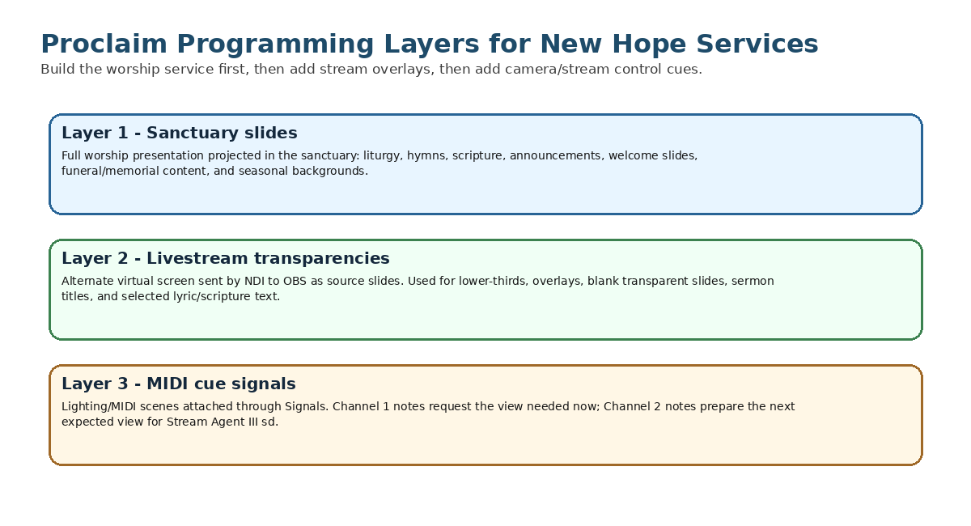
Figure 1 - Three-layer Proclaim programming model for New Hope services.
Sensitive information note
This document intentionally does not include Proclaim account passwords, YouTube stream keys, OBS WebSocket passwords, camera passwords, or other credentials. Record those securely outside any public GitHub repository or printed public manual.

Contents
1. Purpose and scope
2. What Proclaim is
3. How Proclaim fits into the AV tech system
4. Layered programming model
5. Presentation naming, dates, and service times
6. Layer 1 - sanctuary slide programming
7. Songs, scripture, media, templates, and reuse
8. Projector and display output setup
9. Special service programming
10. Layer 2 - transparent livestream overlays
11. NDI outputs, virtual screens, and OBS interworking
12. Layer 3 - MIDI signals and camera direction
13. Programming MIDI notes in Proclaim
14. loopMIDI setup and Proclaim routing
15. Normal Sunday programming workflow
16. Rebuilding Proclaim after PC failure
17. Backup and maintenance
18. Troubleshooting
19. Items to capture later with screenshots
Appendix A - Configuration record sheet
Appendix B - MIDI note map
Appendix C - Suggested service templates
Appendix D - Proclaim and Stream Agent interface map
Appendix E - Glossary
Appendix F - References

1. Purpose and scope
This document explains how New Hope Lutheran Church should program Proclaim presentations for Sunday worship, special services, funeral services, and livestream support. It is written so a new volunteer or future maintainer can understand what Proclaim does, how it is used in the sanctuary, how it feeds OBS for streaming overlays, and how it sends MIDI cue signals to Stream Agent III sd for camera direction and stream control.
This guide treats Proclaim programming as three layers:
Layer | What it does | Main output / interface
Layer 1 - Sanctuary slides | Full worship slides shown in the church sanctuary: liturgy, hymns, scripture, announcements, welcome slides, and service media. | Projector / sanctuary display from Proclaim On Air
Layer 2 - Livestream transparencies | Transparent overlays or lower-thirds for OBS so online viewers see selected text over the camera view. | Proclaim alternate virtual screen sent to OBS by NDI
Layer 3 - Automation signals | MIDI notes placed at service points to tell Stream Agent III sd what camera view is needed now and what camera view is expected next. | Proclaim Lighting/MIDI output -> loopMIDI -> Stream Agent III sd

Important mental model
Proclaim does not stream the service by itself. Proclaim creates slides, overlays, and MIDI cues. OBS streams the final program to YouTube. Stream Agent III sd listens to the MIDI cues and controls OBS and the cameras.

2. What Proclaim is
Proclaim is the church presentation program used to assemble and run the worship service order. It manages the Order of Service, service items, slide backgrounds, song lyrics, Bible passages, announcements, notes, outputs, virtual screens, NDI overlays, and Signals.
In New Hope terminology, Proclaim is the service-programming tool. OBS is the live-production and encoder tool. Stream Agent III sd is the automation and camera-director tool.
Proclaim concept | Meaning in this system
Presentation | One planned worship service or special service, such as Sunday May 31, 2026. ELW HC Setting 1.
Order of Service | The left-side service structure containing Pre-Service Loop, Warm-Up, Service, and Post-Service Loop.
Service item | A single program element such as a song, Bible reading, content slide, video, announcement, or cue.
On Air | The live Proclaim output mode that sends the selected virtual screens to the projector, NDI output, and other assigned outputs.
Virtual screen | A Proclaim output design surface such as Slides, Confidence, Notes, or Alternate Content.
NDI | Network Device Interface, used to send the transparent livestream overlay from Proclaim to OBS.
MIDI | Musical Instrument Digital Interface, used here as a reliable cue-signal system, not as musical performance data.

3. How Proclaim fits into the AV tech system
Proclaim runs on the BeelinkOBS Windows PC as part of the Sunday AVTECH system. It serves three different audiences at the same time: the congregation in the sanctuary, the online viewer watching through YouTube, and Stream Agent III sd, which receives cue signals for camera direction.
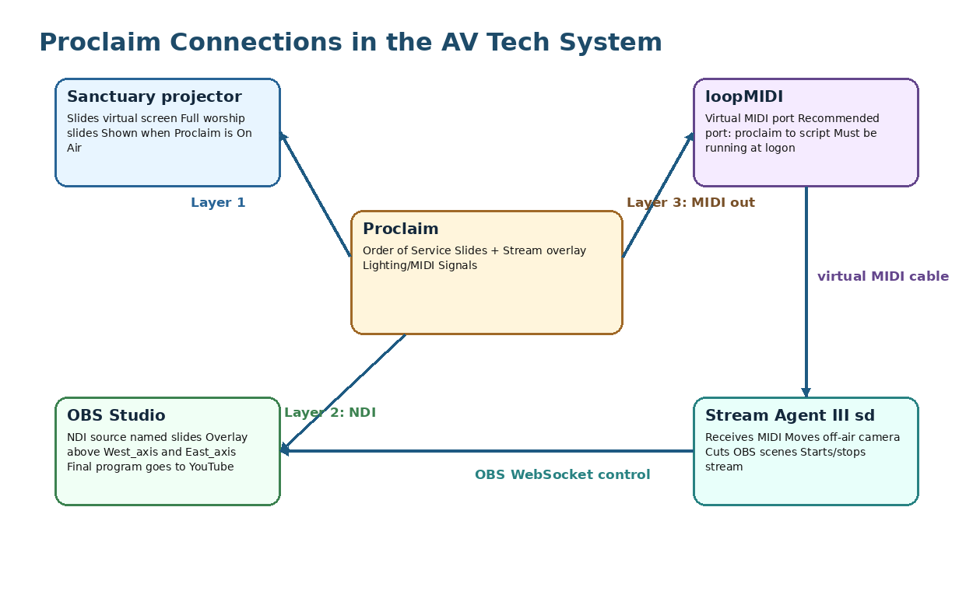
Figure 2 - Proclaim projection, NDI overlay, and MIDI control flow.
Output path | Destination | Purpose
Slides output | Sanctuary projector | Full-screen worship presentation for people in the building.
NDI custom output | OBS source named slides | Transparent Proclaim overlay placed over Axis camera scenes in OBS.
Lighting/MIDI output | loopMIDI virtual port | Note events consumed by Stream Agent III sd for stream control and camera direction.
Service date/time | Proclaim Order of Service | Coordinates Pre-Service Loop, Warm-Up, and transition into the Service section.

4. Layered programming model
Every service should be programmed in the same order: build the sanctuary worship service first, then add livestream overlays, then add MIDI cue signals. This prevents the control layers from becoming disconnected from the actual order of worship.
1. Build Layer 1: sanctuary slides for the congregation.
2. Build Layer 2: livestream overlays and blank transparent states for OBS.
3. Build Layer 3: MIDI Signals for Stream Agent III sd and OBS control.
4. Run a short end-to-end test: projector, NDI overlay in OBS, and MIDI cue reception in Stream Agent.
Programming rule
Do not wait until Sunday morning to add the streaming overlay and MIDI layers. The visible slides may look complete while the livestream and camera automation are still incomplete.

5. Presentation naming, dates, and service times
Presentation names should be specific enough that a volunteer can identify the correct service later when duplicating, searching, or recovering material. Include the service type, date, and liturgy setting when useful.
Service type | Recommended name pattern | Example
Regular Sunday with Holy Communion | Sunday Month DD, YYYY. ELW HC Setting # | Sunday May 31, 2026. ELW HC Setting 1
Sunday Service of the Word | Sunday Month DD, YYYY. ELW Service of Word | Sunday June 7, 2026. ELW Service of Word
Maundy Thursday | Maundy Thursday Month DD, YYYY | Maundy Thursday April 2, 2026
Good Friday | Good Friday Month DD, YYYY | Good Friday April 3, 2026
Christmas Eve | Christmas Eve Month DD, YYYY. Candlelight | Christmas Eve December 24, 2026. Candlelight
Funeral / Memorial | Funeral - Name - Month DD, YYYY | Funeral - John Smith - May 15, 2026

Acronym note
ELW = Evangelical Lutheran Worship. HC = Holy Communion. In the example title, ELW HC Setting 1 means the service is based on Evangelical Lutheran Worship Holy Communion Setting 1.

After duplicating or creating a presentation, set the correct service date and start time. Proclaim uses the service start time to manage the Pre-Service Loop, Warm-Up, and transition to the Service section.
Task | How to do it | Reason
Set service date | Use the date dropdown near the presentation date area. | Keeps collaborators and future reuse organized.
Set service start time | Click the blue start time to the right of the Service section title, enter the time, and press Enter. | Allows Proclaim to time the Pre-Service Loop and Warm-Up correctly.
Verify On Air timing | Go On Air early enough for the Pre-Service Loop and Warm-Up to complete before the service start time. | Avoids the Service section appearing too early or too late.

6. Layer 1 - sanctuary slide programming
Layer 1 is the normal Proclaim presentation shown to the congregation through the sanctuary projector. This layer should be complete and worship-ready even if streaming automation is turned off.
Service item type | Use at New Hope | Notes
Content | Liturgy, prayers, sermon title, welcome slides, instructions, funeral/memorial text. | Use templates and consistent backgrounds. Keep text large and readable.
Song | Hymns and worship songs. | Use My Songs, Hymnbase, or SongSelect if available. Confirm verse order.
Bible | Scripture readings. | Enter reference, select preferred Bible version, and verify slide breaks.
On-Screen Bible | Occasional scripture display with animation. | Use sparingly; test readability and timing.
Video | Intro clips or service-specific video. | Test audio, start/stop behavior, and whether it belongs in Proclaim or OBS.
Image Slide Show | Announcements, photos, mission trip slides, seasonal pre-service material. | Useful in Pre-Service Loop or Post-Service Loop.
Web Page | Rare; online giving, web content, or embedded web media. | Test before service; web content depends on internet stability.
Cues / stage direction | Leader prompts or internal service directions. | May be useful for confidence monitor; not necessarily shown to congregation.

7. Songs, scripture, media, templates, and reuse

7.1 Add items from the Add Item menu
1. Open the target presentation.
2. Select the correct section of the Order of Service.
3. Open Add Item.
4. Choose the service item type, such as Song, Bible, Content, Video, or Image Slide Show.
5. Edit the item content, background, and slide breaks.
6. Rename items in the Order of Service when helpful for reuse, but avoid confusing custom names that hide the actual song or Bible title.

7.2 Songs and the song library
For songs, choose Add Item > Song, search the title, and select an existing song from My Songs or a new source such as Hymnbase or SongSelect where available. Confirm the arrangement, verse order, and slide breaks before the service.
Song task | Operator check
Search song title | Make sure the selected song is the correct hymn/song and version.
Confirm arrangement | Use the correct verses, refrain order, key if needed, and on-screen title.
Check slide breaks | Avoid too many lines per slide. Use readable line breaks.
Apply background or Smart Media | Use the church-approved style for the season or service.
Check overlay layer later | If livestream lower-thirds are used, verify the alternate screen version separately.

7.3 Scripture slides
For scripture, add a Bible service item, enter the reference, choose the preferred Bible version, and check each slide. Proclaim can automatically enter and format Bible verse slides, but the operator should still verify readability and slide breaks.
Scripture item | Check
Reference | Correct book, chapter, and verse range.
Bible version | Use the version approved for the service.
Reader flow | Slide breaks should support the reader, not interrupt mid-thought unnecessarily.
Projection readability | Large enough text; high contrast; no busy backgrounds.
Streaming overlay | Usually blank or simplified unless scripture is intentionally shown online as an overlay.

7.4 Templates, Smart Media, and backgrounds
Use templates and Smart Media to keep the service visually consistent. Create normal Sunday templates and separate templates for Maundy Thursday, Good Friday, Christmas Eve, funeral/memorial services, and other special services. Apply backgrounds deliberately by season and service tone.
Template / media practice | Reason
Maintain a normal Sunday template | Fast weekly setup and consistent ELW flow.
Maintain special-service templates | Maundy Thursday, Good Friday, Christmas Eve, funeral/memorial, and other special services have different tone and flow.
Use seasonal backgrounds deliberately | Advent, Christmas, Lent, Holy Week, Easter, Pentecost, and funerals should not all look the same.
Create transparent overlay templates | Speeds up Layer 2 overlay programming and prevents one-off formatting mistakes.
Set default media where appropriate | Reduces the need to reuse old items simply to recover a background.

7.5 Reuse previous services and items
The fastest and safest weekly method is usually to duplicate a recent or template presentation, then edit it. Reuse individual items only when the whole previous service is not a good starting point.
Reuse method | Use when | Caution
File > Duplicate Recent / Duplicate | Starting a new Sunday from last week or from a formal template. | Immediately rename, set date, and set service time.
Add Item > Reuse item | Pulling in a hymn, liturgy block, funeral item, or seasonal slide from older services. | Search by clear item names; avoid importing obsolete cues.
Copy/Paste or Ctrl+D | Duplicating an item within the same presentation. | Move the duplicate to the correct section and update text.
Linked item | Same item needed in Pre-Service and Post-Service loops. | Useful for recurring announcements; be aware edits affect linked copies.

8. Projector and display output setup
The sanctuary projector is the primary Layer 1 output. In Proclaim Display settings, assign the correct virtual screen to the physical projector output. The Proclaim application monitor itself should normally be set to Not Used, so the control interface stays on the PC screen while the sanctuary sees only the intended slides.
Display setting | New Hope purpose | Check
Slides virtual screen | Main sanctuary projected slides. | Assigned to the projector output.
Application display | The PC screen where Proclaim is edited/controlled. | Should normally be Not Used in output assignment.
Identify Displays | Used to confirm which physical display is projector vs. PC monitor. | Run when cabling or Windows display order changes.
Aspect ratio | Usually 16:9 unless the installed projector/screen requires otherwise. | Keep consistent with templates and livestream overlay design.
On Air test | Verifies projection, full-screen behavior, and slide fit. | Always test before the service.

Display test rule
Do not assume the projector output is correct because the presentation preview looks correct on the PC. Always test by going On Air and looking at the sanctuary screen.

9. Special service programming
Special services should use their own templates or a duplicated previous service of the same type. The goal is not just to preserve slides, but to preserve the expected service flow, overlays, and MIDI cue strategy.
Service type | Programming notes | Camera / cue notes
Maundy Thursday | Use a Holy Week template. Include confession/absolution, communion, stripping of the altar if used, and subdued visual style. | Expect altar, communion, choir, and possibly wide/panorama views.
Good Friday | Use Good Friday template. Text is often longer and more solemn; keep slides simple and movement slow. | Plan camera changes around readings, cross, choir, and silence; avoid unnecessary motion.
Christmas Eve | Use Christmas Eve/Candlelight template. Include carols, lessons, candlelight instructions, and seasonal backgrounds. | Expect choir, congregation/panorama, pulpit, altar, and possibly piano/band cues.
Funeral / Memorial | Use funeral template. Include name, dates, photo/video if used, hymns, scripture, commendation, and family-sensitive material. | Keep camera movement conservative; verify permission for streaming/recording and online archiving.
Other special services | Duplicate the closest matching template and adjust. | Test all MIDI cues because the order may not match Sunday defaults.

10. Layer 2 - transparent livestream overlays
Layer 2 is the alternate screen designed for the online stream. It should not simply mirror the sanctuary projector. For streaming, the desired output is usually transparent lower-third or overlay text over the camera image. OBS receives this as the source named slides.
Overlay item | Recommended approach
Song lyrics | Use lower-third or side/bottom overlay with transparent background. Keep text large and readable over camera video.
Scripture | Use only when helpful; full scripture may be better as projection-only unless online viewers need the text.
Liturgy responses | Use short response text, not entire paragraphs, if the overlay would cover too much video.
Sermon title / service title | Good use of lower-third style.
Announcements | Usually projection-only unless intentionally shown to online viewers.
Funeral / memorial name slide | Can be full-screen in OBS or a clean overlay depending on the service plan.

Transparency rule
The livestream overlay should use transparent background where possible. A black or solid background may cover the camera view in OBS unless deliberately designed that way.

11. NDI outputs, virtual screens, and OBS interworking
Proclaim can create virtual screens and assign them to outputs. For New Hope streaming, the important output is an NDI custom output that OBS receives as the Proclaim overlay source. In the current OBS design, the OBS source name should remain slides and should be layered above the camera source in West View and East View.
Item | Current / expected value | Purpose
Proclaim alternate virtual screen | Live Stream / Proclaim overlays / confirm exact final name | Design surface for transparent stream overlay.
Proclaim NDI output name | BEELINKOBS (Proclaim - proclaim overlays) / confirm exact final source text | Name OBS sees when Proclaim is On Air.
OBS source name | slides | OBS NDI source placed above West_axis and East_axis.
OBS scenes using overlay | West View and East View | Overlay sits on top of camera video.
OBS plugin support | DistroAV / NDI plugin and NDI runtime as installed | Required for OBS to receive Proclaim NDI source.

11.1 Create or verify the NDI overlay output
1. In Proclaim, open Settings > Display.
2. Confirm the normal Slides virtual screen is assigned to the sanctuary projector.
3. Add or confirm an alternate virtual screen for the livestream overlay.
4. In the Output section, choose Add custom output.
5. Select NDI as the output type, name the output clearly, and assign the livestream overlay virtual screen.
6. Save the output and go On Air so OBS can see the NDI source.
7. In OBS, confirm the NDI source named slides receives the Proclaim overlay and is layered above the camera source.

11.2 Build transparent overlay templates
Create one or more custom Smart Media templates for the streaming virtual screen. These should be designed for readability over live video, not just over a plain background. White text with shadow, outline, or a subtle translucent bar is often easier to read over camera video.
Template | Use
Stream song lower-third | Default for lyrics over camera video.
Stream scripture lower-third | Short scripture references or brief verse excerpts.
Stream title lower-third | Sermon title, guest speaker, or service title.
Stream blank transparent | Used when no overlay should appear in OBS.
Stream funeral/memorial title | Name/date slide or lower-third for memorial services.

Text visibility
Transparent overlays must be tested over real camera video. White text that looks good on the Proclaim checkered transparency preview may disappear over a white robe, bright wall, or projected screen.

12. Layer 3 - MIDI signals and camera direction
Layer 3 is the automation layer. In Proclaim, MIDI is configured through Lighting/MIDI scenes and then attached to service items through the Signals tab. At New Hope, these MIDI notes are not musical notes; they are control messages that tell Stream Agent III sd what to do.
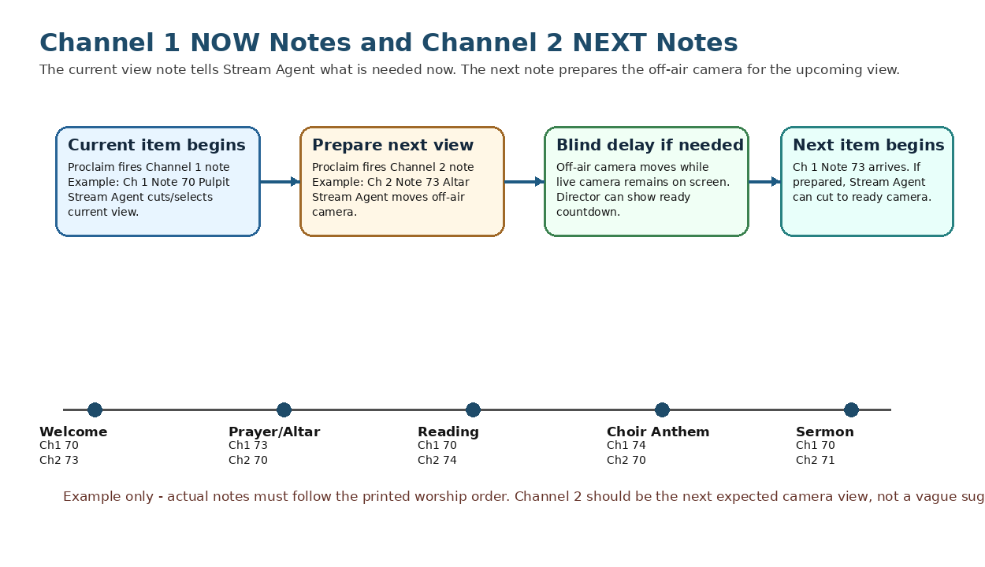
Figure 3 - Channel 1 NOW notes and Channel 2 NEXT notes let Stream Agent prepare a camera before it is needed.

12.1 How Stream Agent III sd interprets NOW and NEXT notes
Cue type | MIDI channel | Meaning | Stream Agent III sd handling
NOW view note | Channel 1 | The view is needed now. | Stream Agent treats the note as the current required view. It selects/cuts to a ready camera when possible, or prepares and applies the configured blind delay if needed.
NEXT view note | Channel 2 | This is the next expected view. | Stream Agent moves/prepares the off-air camera for that view while the current camera stays live. When the matching NOW note arrives later, the cut can be clean and decisive.
Safe fallback | Channel 1 or 2, Note 71 | Panorama / wide view. | Use when the next action is unclear, or when a safe holding view is preferred.

Core camera-steering concept
Channel 2 NEXT notes are now the preferred way to steer camera preparation. Older service-mode notes are no longer part of the current camera steering method and should not be included in current Proclaim templates.

12.2 New Hope MIDI view-note map
MIDI note | Logical view | Typical service use | Local note
70 | Pulpit | Readings, sermon, spoken leadership from pulpit/lectern area. | Exact Axis preset name should match app and both cameras.
71 | Panorama | Safe wide view, congregation, general service view, fallback. | Safe fallback view.
72 | Children's Time | Children’s message/front area. | May need longer blind delay.
73 | Altar | Prayers, communion table, altar action. | Used often in ELW HC services.
74 | Choir | Choir anthem or choral response. | May need longer blind delay.
75 | Screen | Projected screen / presentation focus. | Use carefully if online viewers also see overlay.
76 | Band | Band or musicians if used. | May be inactive for traditional services.
77 | Piano | Piano or music leadership. | Confirm physical shot.
78 | Communion | Communion distribution or communion table view. | Often requires the longest preparation delay.
79 | Podium | Podium/speaker position if different from pulpit. | Older notes may have called this Track. Use the current app/Axis preset name consistently.

12.3 Where to place camera cues in the liturgy
A Channel 1 NOW note should be placed on the service item where the view becomes active. A Channel 2 NEXT note should normally be placed on the current or preceding service item to prepare the next expected view. The examples below are starting points, not fixed rules; always follow the actual printed order of service.
Service moment | Typical NOW note on Channel 1 | Possible NEXT note on Channel 2 | Reason / handling
Before service / safe holding | 71 Panorama | 70 Pulpit or 73 Altar | Start with a safe wide view, then prepare the first leader position.
Welcome / announcements | 70 Pulpit or 71 Panorama | 73 Altar or 74 Choir | Current view follows the leader. Next note prepares prayer/altar or gathering hymn/choir if that is next.
Confession / opening liturgy | 70 Pulpit or 73 Altar | 74 Choir or 71 Panorama | Prepare the next musical or safe wide view before the next service movement.
Gathering hymn / song | 74 Choir, 77 Piano, 76 Band, or 71 Panorama | 70 Pulpit | During the hymn, prepare the pulpit/lectern for the next spoken item.
Prayer of the Day / spoken liturgy | 70 Pulpit or 73 Altar | 70 Pulpit | Prepare the reading location if scripture follows.
Scripture readings | 70 Pulpit | 74 Choir, 75 Screen, or 70 Pulpit | Prepare choir, screen, or next reader depending on the next item.
Psalm / response | 70 Pulpit, 74 Choir, or 75 Screen | 70 Pulpit | Prepare the next reading or Gospel/sermon position.
Children's Time | 72 Children’s Time | 70 Pulpit or 71 Panorama | Prepare sermon/pulpit or a safe wide view while children’s time concludes.
Sermon | 70 Pulpit or 79 Podium | 73 Altar or 71 Panorama | Long segment gives time to prepare the next liturgical action or safe view.
Choir anthem | 74 Choir | 70 Pulpit or 73 Altar | Prepare the next speaker or altar action while choir remains live.
Offering / special music | 77 Piano, 76 Band, 74 Choir, or 71 Panorama | 73 Altar | Prepare altar/prayer view or communion setup if next.
Communion setup | 73 Altar | 78 Communion | Prepare distribution/communion shot before distribution begins.
Communion distribution | 78 Communion or 71 Panorama | 73 Altar or 71 Panorama | Prepare altar return or safe wide view for post-communion prayer.
Sending hymn | 74 Choir, 77 Piano, 76 Band, or 71 Panorama | 71 Panorama | Prepare a safe final/wide view.
Dismissal / end of service | 70 Pulpit or 71 Panorama | 71 Panorama | Keep or prepare safe view before stopping stream.

12.4 Example NOW/NEXT note handling sequence
Step | Proclaim cue | Stream Agent III sd action | Viewer result
1. Welcome starts | Channel 1 note 70 Pulpit | Cuts/selects the current pulpit/lectern view. | Viewers see the leader speaking.
2. Welcome item also carries next cue | Channel 2 note 73 Altar | Moves the off-air camera to Altar and waits/marks it ready. | Viewers still see the pulpit; they do not see camera motion.
3. Prayer item begins | Channel 1 note 73 Altar | If the altar camera is ready, cuts cleanly to the prepared camera. | Viewers see a deliberate cut to altar, not a live PTZ move.
4. Prayer item carries next cue | Channel 2 note 70 Pulpit | Moves the other off-air camera back to Pulpit for the reading. | Reading view is ready before the reader begins.
5. Reading begins | Channel 1 note 70 Pulpit | Cuts to the prepared pulpit/lectern view. | Camera direction follows the liturgy without volunteer camera operation.

Best practice
Do not use Channel 2 as a vague “maybe next” hint. Use it to describe the next expected service view. If the next view is genuinely uncertain, use note 71 Panorama as the safe next cue.

12.5 Special control notes
MIDI note | Control action | Use
60 | Start stream | Starts OBS streaming through Stream Agent. Often paired with timer or Sunday start workflow.
61 | Stop stream | Starts the stop countdown and stops OBS streaming. Service-end sequence is only safe if placed once.
62 | Record toggle | Toggles OBS local recording if configured and safe.

Removed notes
MIDI note 10 and the older service-mode note group are no longer needed with the Channel 2 NEXT-note steering method. Existing templates should be cleaned so they do not include those older cues.

13. Programming MIDI notes in Proclaim
Proclaim calls these cues Lighting/MIDI scenes because the feature was originally designed for lighting systems. At New Hope the same feature is used for camera control and stream control. A Lighting/MIDI scene can send a MIDI note to loopMIDI, and a service item can trigger that scene through the Signals tab.
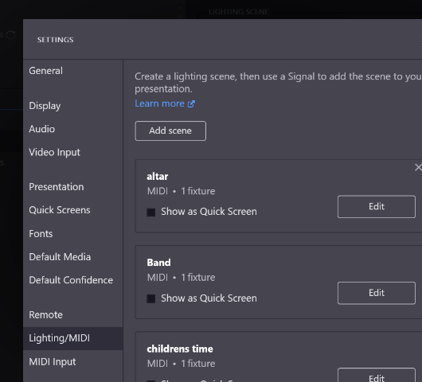
Figure 4 - Proclaim Settings > Lighting/MIDI scene list. The example shows scenes named altar, Band, and childrens time.

13.1 Create a Lighting/MIDI scene
1. Open Proclaim.
2. Open Settings > Lighting/MIDI.
3. Click Add scene.
4. Give the scene a clear name. Recommended examples: Pulpit_NOW_Ch1_70, Pulpit_NEXT_Ch2_70, Choir_NOW_Ch1_74, Choir_NEXT_Ch2_74, Start_Stream_60, Stop_Stream_61.
5. Click Edit for the scene.
6. Choose Add control > MIDI.
7. Select the loopMIDI output port used by Stream Agent. In the screenshot example, the port is named proclaim to script.
8. Click Add note.
9. Set the event type to note on unless the app is deliberately changed to use another event type.
10. Set the note number, velocity, and channel.
11. Use Velocity 100 unless the system is deliberately changed.
12. Use Channel 1 for NOW/current view, Channel 2 for NEXT/prepare view, and Channel 1 for stream control notes 60-62 unless the app configuration says otherwise.
13. Click Save.
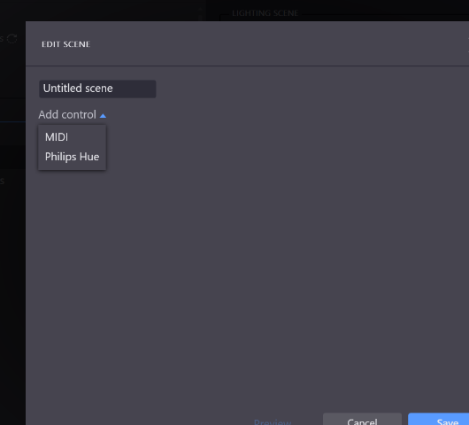
Figure 5 - Editing a scene and choosing MIDI from Add control.
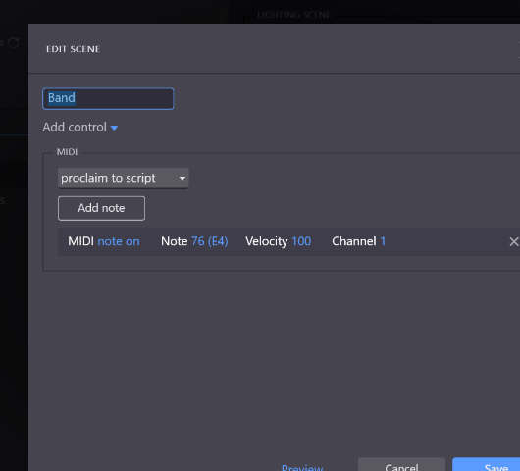
Figure 6 - Example Band scene sending MIDI note on, note 76 (E4), velocity 100, channel 1 to the output named proclaim to script.

13.2 Attach the MIDI scene to a service item
1. Select the service item where the camera or control cue should fire.
2. Make sure Proclaim is in Edit mode.
3. Open the Signals tab for that service item. The tab shows a count, such as Signals (2), when one or more signals are already attached.
4. Click Add Signal.
5. Choose Lighting and then select the Lighting/MIDI scene you created.
6. Save/confirm as needed.
7. When Proclaim is On Air and that service item becomes active, the Signal fires and the MIDI note is sent.
Placement caution
Signals are attached to service items, not to every individual slide inside a multi-slide item. For long hymns or multi-slide liturgy blocks, place the cue on the item where the change should begin, or split the content into separate service items if more precise cue timing is needed.

13.3 Naming recommendation for MIDI scenes
Scene name pattern | Example | Purpose
<View>_NOW_Ch1_<note> | Choir_NOW_Ch1_74 | Immediate current view request.
<View>_NEXT_Ch2_<note> | Choir_NEXT_Ch2_74 | Prepare the off-air camera for the next expected view.
<Control>_<note> | Start_Stream_60 | Stream control cue.
<Special service>_<View>_NEXT_Ch2_<note> | GoodFriday_Altar_NEXT_Ch2_73 | Optional if special-service templates need separate cues or explanations.

14. loopMIDI setup and Proclaim routing
loopMIDI is a Windows virtual MIDI cable. It creates a named MIDI port so one application can send MIDI and another application on the same PC can receive it. At New Hope, Proclaim sends outbound MIDI notes to the loopMIDI port, and Stream Agent III sd listens to that same virtual port as its MIDI input.
Item | Current / expected value | Reason
loopMIDI application | Runs at Windows login | The virtual port exists only while loopMIDI is running.
Recommended port name | proclaim to script / confirm exact current name | This is the port selected in Proclaim and listened to by Stream Agent.
Proclaim role | MIDI output sender | Sends notes when service-item Signals fire.
Stream Agent III sd role | MIDI input listener | Maps notes to camera views and stream controls.
OBS role | Controlled by Stream Agent, not directly by loopMIDI | OBS receives commands through WebSocket after Stream Agent interprets MIDI.

14.1 Create or verify the loopMIDI port
1. Open loopMIDI.
2. Confirm the port list contains the New Hope port. Use the exact recorded name. The screenshot example from Proclaim shows proclaim to script.
3. If the port is missing, type the port name into the New port-name box and click the plus button.
4. Enable loopMIDI autostart or keep the church Task Scheduler startup task active so the port exists after login.
5. Do not close loopMIDI during a service. It may minimize to the tray, but the application must stay running.

14.2 Select the loopMIDI port in Proclaim
1. Open Settings > Lighting/MIDI.
2. Edit a MIDI scene.
3. In the MIDI control area, select the loopMIDI port from the output dropdown.
4. Create the note event and save the scene.
5. Repeat for each NOW, NEXT, and stream-control scene that must output MIDI.

14.3 Verify Stream Agent receives the note
1. Start loopMIDI.
2. Start OBS.
3. Start Stream Agent III sd and open the Web HUD.
4. Open Proclaim and go On Air with a test item carrying a safe cue such as Channel 2 note 71 Panorama.
5. Confirm Stream Agent logs or Web HUD status show MIDI received.
6. Only test start/stop notes 60/61 when a safe record-only or private test plan is in place.
Important correction
The MIDI notes are not transmitted to OBS directly by loopMIDI. loopMIDI only carries the note from Proclaim to Stream Agent. Stream Agent interprets the note, then controls OBS and the cameras through their own interfaces.

15. Normal Sunday programming workflow
1. Duplicate the correct Sunday template or previous Sunday presentation.
2. Rename the presentation, for example Sunday May 31, 2026. ELW HC Setting 1.
3. Set the correct date and service start time.
4. Review the Order of Service sections: Pre-Service Loop, Warm-Up, Service, and Post-Service Loop.
5. Update Layer 1 sanctuary slides: liturgy, prayers, hymns, scripture, sermon title, announcements, and any media.
6. Apply or confirm backgrounds and Smart Media templates.
7. Update Layer 2 livestream overlay content on the alternate virtual screen.
8. Insert or verify Layer 3 MIDI notes for each camera-relevant service moment, using Channel 1 for NOW and Channel 2 for NEXT.
9. Confirm there are no old service-mode notes or unused MIDI note 10 cues in current templates.
10. Go On Air and test projector output, OBS NDI overlay, and Stream Agent MIDI response.
11. Before service, confirm OBS is running, Stream Agent III sd is connected, loopMIDI is running, and Proclaim is On Air.

16. Rebuilding Proclaim after PC failure
This rebuild procedure assumes the replacement BeelinkOBS or equivalent PC is already joined to the AV network and has OBS, Stream Agent III sd, loopMIDI, NDI support, and any required drivers installed or ready to install.

16.1 Best case: restore from existing Proclaim account/sync
1. Install Proclaim on the replacement PC.
2. Sign in with the authorized New Hope Proclaim account.
3. Allow presentations and team media to sync before Sunday service.
4. Open the most recent Sunday or template presentation and confirm all media is present.
5. Open Settings > Display and verify the projector, virtual screens, and NDI custom output assignments.
6. Open Settings > Lighting/MIDI and verify MIDI scenes/outputs still point to the correct loopMIDI port.
7. Go On Air and confirm the projector display, NDI overlay in OBS, and MIDI response in Stream Agent III sd.

16.2 Manual rebuild if Proclaim settings must be recreated
1. Create or restore the main Slides virtual screen for the sanctuary projector.
2. Create the livestream alternate virtual screen used for transparent overlays.
3. Create an NDI custom output assigned to the livestream overlay virtual screen.
4. Recreate Smart Media templates or import background images for Sunday, Holy Week, Christmas Eve, and funeral services.
5. Recreate MIDI Lighting scenes for notes 60, 61, 62, and 70-79.
6. Create both NOW Channel 1 and NEXT Channel 2 versions for camera view notes where practical.
7. Verify loopMIDI starts at logon and exposes the same virtual port name expected by Proclaim and Stream Agent.
8. Open OBS and verify the Proclaim overlay source slides sees the NDI output while Proclaim is On Air.
9. Open Stream Agent Web HUD and verify MIDI input is detected and camera notes are received.
10. Run a private local test or record-only test before relying on the rebuilt system for Sunday service.

17. Backup and maintenance
Backup item | How / where | When
Proclaim presentation templates | Keep named templates in Proclaim: Sunday ELW HC, Service of Word, Maundy Thursday, Good Friday, Christmas Eve, Funeral/Memorial. | After any major layout or MIDI cue improvement.
Monthly thumbnail/source artwork | Save in the church media folder by month. | Whenever YouTube thumbnails or service graphics are created.
Custom backgrounds and Smart Media | Keep local copies of imported images and template source files where possible. | After adding or changing seasonal templates.
MIDI scene list | Screenshot or document note names, note numbers, channels, velocity, and output port. | After any Stream Agent MIDI map change.
Display/NDI settings | Screenshots of Settings > Display and custom output details. | After display, projector, or NDI changes.
Task Scheduler startup docs | Keep Proclaim auto-launch task screenshots with other AVTECH startup tasks. | After changing app paths or startup order.

Backup rule
After a successful Sunday with changed Proclaim templates, NDI settings, or MIDI scenes, update the documentation before experimenting again.

18. Troubleshooting
Symptom | Likely causes | Checks / fixes
Projector shows wrong screen | Windows display order changed; wrong virtual screen assigned; PC monitor not set to Not Used. | Use Settings > Display, Identify Displays, and assign Slides to projector.
Proclaim goes full-screen on PC monitor | Application display assigned incorrectly. | Set the application monitor output to Not Used.
OBS overlay missing | Proclaim not On Air; NDI output not created; OBS source wrong; slides source hidden/below camera. | Go On Air, verify NDI output name, check OBS source slides and layer order.
Overlay has solid background instead of transparency | Wrong virtual screen content; background not removed; mask/output setting wrong. | Edit the alternate screen tab and use transparent/blank background for overlay areas.
Lyrics look good in sanctuary but poor online | Layer 2 overlay not formatted separately; text lacks shadow/outline/background shape. | Edit the livestream virtual screen version and test over real camera video.
MIDI cue does nothing | loopMIDI not running; wrong output port; wrong note/channel; Stream Agent not listening. | Check loopMIDI, Proclaim Lighting/MIDI scene, and Stream Agent MIDI status.
NEXT note does not seem to help | Channel 2 note missing, too late, wrong view, or overwritten by another NEXT cue. | Review the service item before the cut. Confirm Channel 2 note number and view map.
Wrong camera view | Wrong note; preset name mismatch; Axis preset case mismatch; old Track/Podium naming conflict. | Verify note map and exact Axis preset names on both cameras.
Stream starts/stops unexpectedly | Start/stop MIDI note placed on wrong service item or repeated item. | Search service for notes 60/61 and remove accidental duplicates.
Special service misses camera cues | Template duplicated without Layer 3 cues or cues stayed from a different liturgy. | Review the special service order and insert NOW/NEXT cue notes intentionally.

19. Items to capture later with screenshots
This document now includes three MIDI screenshots supplied during editing. It should later be improved with the remaining working BeelinkOBS Proclaim setup screenshots listed below.
- Proclaim main window showing Order of Service sections.
- Presentation title/date/time area for a normal Sunday service.
- Add Item menu showing Content, Song, Bible, Media, and Reuse item paths.
- Song item edit screen with verse order and arrangement controls.
- Bible item edit screen with reference and Bible version.
- Settings > Display showing projector assignment and custom NDI output.
- Alternate virtual screen editor showing transparent overlay design.
- OBS showing NDI source slides above West_axis and East_axis.
- Settings > Lighting/MIDI showing MIDI scene definitions.
- Service item Signals tab showing camera note assignment.
- loopMIDI window showing the virtual MIDI port.
- Stream Agent Web HUD showing MIDI connected and cue received.

Appendix A - Configuration record sheet
Configuration item | Expected value / note
Proclaim account / team | Record securely; do not publish credentials.
Main sanctuary virtual screen | Slides / confirm exact name.
Projector output | Record Windows display name / HDMI path after screenshot capture.
Livestream virtual screen | Live Stream / Proclaim overlays / confirm exact name.
Proclaim NDI output name | BEELINKOBS (Proclaim - proclaim overlays) / confirm exact final source.
OBS overlay source name | slides.
OBS scenes containing overlay | West View and East View.
loopMIDI port name | proclaim to script / confirm exact current name.
Stream Agent MIDI input filter | Port name contains Proclaim or the exact configured value.
NOW view notes | Channel 1 notes 70-79.
NEXT view notes | Channel 2 notes 70-79.
Stream control notes | 60 Start stream, 61 Stop stream, 62 Record toggle.
Removed/obsolete notes | Do not use MIDI note 10 or old service-mode notes in current templates.
Normal Sunday template | Record exact template/presentation name.
Special service templates | Record exact names for Maundy Thursday, Good Friday, Christmas Eve, and Funeral/Memorial.
Proclaim auto-launch task | Record Task Scheduler task name if used.

Appendix B - MIDI note map
Category | Note | Channel | Meaning / effect
Stream control | 60 | 1 | Start stream through Stream Agent.
Stream control | 61 | 1 | Stop stream through Stream Agent stop countdown.
Stream control | 62 | 1 | Record toggle through Stream Agent.
View | 70 | 1 NOW / 2 NEXT | Pulpit. Channel 1 requests it now; Channel 2 prepares it as next.
View | 71 | 1 NOW / 2 NEXT | Panorama / safe wide view.
View | 72 | 1 NOW / 2 NEXT | Children’s Time.
View | 73 | 1 NOW / 2 NEXT | Altar.
View | 74 | 1 NOW / 2 NEXT | Choir.
View | 75 | 1 NOW / 2 NEXT | Screen.
View | 76 | 1 NOW / 2 NEXT | Band.
View | 77 | 1 NOW / 2 NEXT | Piano.
View | 78 | 1 NOW / 2 NEXT | Communion.
View | 79 | 1 NOW / 2 NEXT | Podium; confirm current app and Axis preset naming.

Appendix C - Suggested service templates
Template name | Purpose | Special notes
Template - Sunday ELW HC Setting 1 | Normal Holy Communion Sunday service. | Include communion camera cues and overlay defaults.
Template - Sunday Service of Word | Sunday without Holy Communion. | No communion cues unless needed.
Template - Sunday with Choir | Sunday with choir anthem or choral response. | Use NOW/NEXT choir cues rather than old service-mode notes.
Template - Maundy Thursday | Holy Week Maundy Thursday. | Communion/altar focus; subdued style.
Template - Good Friday | Good Friday liturgy. | Minimal movement; solemn style.
Template - Christmas Eve Candlelight | Christmas Eve service. | Carols, candlelight instructions, special seasonal slides.
Template - Funeral Memorial | Funeral and memorial services. | Sensitive naming, photo/media checks, conservative camera cues.

Appendix D - Proclaim and Stream Agent interface map
Proclaim item | Stream Agent / OBS object affected | Reason
NDI overlay virtual screen | OBS source slides | Shows Proclaim overlay above camera video.
MIDI note 70-79, Channel 1 | Stream Agent current view routing and Axis presets | Requests a view needed now.
MIDI note 70-79, Channel 2 | Stream Agent off-air camera preparation | Prepares the next expected view before it is needed.
MIDI note 60 | OBS streaming output through Stream Agent | Start stream workflow.
MIDI note 61 | OBS streaming output through Stream Agent | Stop stream workflow.
MIDI note 62 | OBS recording output through Stream Agent | Record toggle.
Presentation date/time | Proclaim pre-service and warm-up timing | Controls when the Service section begins.
Service item Signals tab | Proclaim Lighting/MIDI scene trigger | Attaches camera/stream cues to service moments.

Appendix E - Glossary
Term | Meaning in this system
Proclaim | The worship presentation software used for sanctuary slides, stream overlays, and cue signals.
Order of Service | The Proclaim structure containing Pre-Service Loop, Warm-Up, Service, and Post-Service Loop.
Service item | A Proclaim object such as a song, Bible reading, content slide, video, or cue.
On Air | The live Proclaim output state used during service.
Virtual screen | A Proclaim output design surface assigned to a display, NDI, SDI, or other output.
NDI | Network Device Interface, used to send Proclaim overlay video with transparency to OBS.
OBS | Open Broadcaster Software, the live production and YouTube encoder application.
MIDI | Musical Instrument Digital Interface, used here for automation cue notes.
loopMIDI | Windows virtual MIDI cable software that carries Proclaim notes to Stream Agent.
NOW note | A Channel 1 MIDI view note requesting the current required camera view.
NEXT note | A Channel 2 MIDI view note telling Stream Agent to prepare the next expected camera view.
Blind delay | A configured wait that allows a PTZ camera to finish moving before Stream Agent cuts to it.
Stream Agent III sd | The Axis-only automation app that interprets MIDI cues, controls OBS, and steers cameras.

Appendix F - References
These sources were used for general Proclaim and loopMIDI behavior. Local New Hope values come from the Stream Agent III sd app configuration, OBS setup documentation, screenshots supplied by the user, and prior project records.
- Proclaim Help - Service Item Overview: https://support.proclaim.logos.com/hc/en-us/articles/20364902144909-Service-Item-Overview
- Proclaim Help - Order Of Service Overview: https://support.proclaim.logos.com/hc/en-us/articles/19863521025293-Order-Of-Service-Overview
- Proclaim Help - Change the Date/Time Of My Service: https://support.proclaim.logos.com/hc/en-us/articles/19864564610189-How-Do-I-Change-the-Date-Time-Of-My-Service
- Proclaim Help - Copy/Duplicate a Presentation: https://support.proclaim.logos.com/hc/en-us/articles/26334250380045-How-Do-I-Copy-Duplicate-a-Presentation
- Proclaim Help - Reuse Items: https://support.proclaim.logos.com/hc/en-us/articles/19863521020941-How-Do-I-Reuse-Items
- Proclaim Help - Add Song Slides: https://support.proclaim.logos.com/hc/en-us/articles/19864381330829-How-Do-I-Add-Song-Slides-To-My-Presentation
- Proclaim Help - Configure Display Outputs: https://support.proclaim.logos.com/hc/en-us/articles/19864180144013-How-Do-I-Configure-My-Display-Outputs
- Proclaim Help - Set Up NDI Outputs: https://support.proclaim.logos.com/hc/en-us/articles/19864216059533-How-To-Set-Up-NDI-Outputs-In-Proclaim
- Proclaim Help - Live Stream with Proclaim: https://support.proclaim.logos.com/hc/en-us/articles/19864456649101-How-To-Live-Stream-with-Proclaim
- Proclaim Help - Alternate Content Virtual Screens: https://support.proclaim.logos.com/hc/en-us/articles/19864188687373-Alternate-Content-Virtual-Screens
- Proclaim Help - Smart Media Templates: https://support.proclaim.logos.com/hc/en-us/articles/19864271011853-How-Do-I-Create-My-Own-Smart-Media-Templates
- Proclaim Help - Lighting Scenes and Outbound MIDI: https://support.proclaim.logos.com/hc/en-us/articles/19863614049293-Lighting-Scenes-and-Outbound-MIDI
- Proclaim Help - Set Up Proclaim Signals: https://support.proclaim.logos.com/hc/en-us/articles/19863591084685-How-Do-I-Set-Up-Proclaim-Signals
- loopMIDI - Tobias Erichsen: https://www.tobias-erichsen.de/software/loopmidi.html

