New Hope Lutheran Church
AV Tech System
YouTube Live Interface Setup, Operation, and Rebuild Guide
Companion documentation module for Stream Agent III sd
Prepared: May 19, 2026
Status: Working baseline documentation - update with actual YouTube Studio and OBS screenshots when available

Sensitive information note
This document intentionally does not include the YouTube stream key, YouTube account password, OBS WebSocket password, camera passwords, or recovery codes. Record those securely outside any public GitHub repository or printed public manual.

Contents
- Purpose and scope
- What YouTube Live is
- Why New Hope uses YouTube Live
- How YouTube fits into the AV tech system
- How OBS and Stream Agent III sd interface with YouTube
- Current YouTube interface requirements
- Accounts, software, and permissions
- Scheduled placeholder design
- Persistent stream key strategy
- OBS custom streaming settings
- Thumbnail workflow using Proclaim
- Description and public information workflow
- Auto-start and auto-stop
- Church website one-button viewer model
- Normal Sunday operation
- Rebuilding the YouTube interface after failure
- Backup and maintenance
- Troubleshooting
- Items to capture later with screenshots
- Appendices and references

1. Purpose and scope
This document explains the YouTube Live part of the New Hope Lutheran Church AV tech system. It is written so that a new volunteer, or a future maintainer, can understand what YouTube does, why it is needed, how OBS and Stream Agent III sd interact with it, and how to rebuild the YouTube livestream setup if the BeelinkOBS computer or configuration has to be replaced.
This is the YouTube-specific companion to the OBS Studio Setup, Operation, and Rebuild Guide. The OBS document explains the production and encoder side. This document explains the public YouTube destination, the scheduled live placeholder, the persistent/custom stream key, thumbnails, descriptions, auto-start, auto-stop, and viewer access through the church website.
- OBS = Open Broadcaster Software. OBS is the encoder that sends the final program feed to YouTube.
- RTMP / RTMPS = Real-Time Messaging Protocol / secure RTMP. This is the type of transport OBS uses to send the stream to YouTube.
- Stream key = the secret YouTube value that identifies and authorizes the incoming stream from OBS.
- Placeholder = the scheduled YouTube Live event that viewers see before OBS begins sending video.
- Auto-start = YouTube starts the scheduled live event when the OBS data stream arrives.
- Auto-stop = YouTube ends the scheduled live event when the OBS data stream stops.
- Proclaim = church presentation software used for service visuals and for producing thumbnail images.
Important mental model
YouTube does not switch cameras or build the service program. OBS builds the final program picture. Stream Agent III sd controls OBS. YouTube receives the final OBS data stream and presents it to public viewers.

2. What YouTube Live is
YouTube Live is the public delivery platform for the Sunday worship service. It receives an encoded live data stream from OBS, makes it available to viewers, and then stores the completed service as a video under the channel's Live content after the service ends.
In Google's terminology, the church uses an encoder workflow. YouTube Help documents that an encoder stream requires the YouTube Live server URL and stream key to be entered into the encoder. At New Hope, OBS is that encoder.
YouTube role | Meaning in the New Hope system
Public platform | Where online viewers watch the worship service.
Live ingest destination | Receives the audio/video data sent from OBS.
Scheduled event host | Holds the public placeholder page before the live data arrives.
Archive host | Stores the completed worship service after the stream ends.
Viewer access point | The target reached by the church website livestream button.

3. Why New Hope uses YouTube Live
New Hope uses YouTube Live because it is familiar to viewers, works well across phones, tablets, computers, and smart TVs, and provides a public channel page where past services can also be found.
- Viewers do not need special church software to watch the service.
- The church can use a simple website button that points to the YouTube live channel/page.
- The completed service is automatically available later as a past livestream when YouTube archives it.
- The OBS encoder can use a persistent/custom stream key, reducing weekly setup changes.
- YouTube Studio provides a scheduled event placeholder with title, thumbnail, description, and start/stop behavior.

4. How YouTube fits into the AV tech system
YouTube sits at the public end of the AV tech system. Cameras, audio, slides, and automation are handled locally at the church. OBS sends one final program stream to YouTube. YouTube then handles public distribution to viewers.
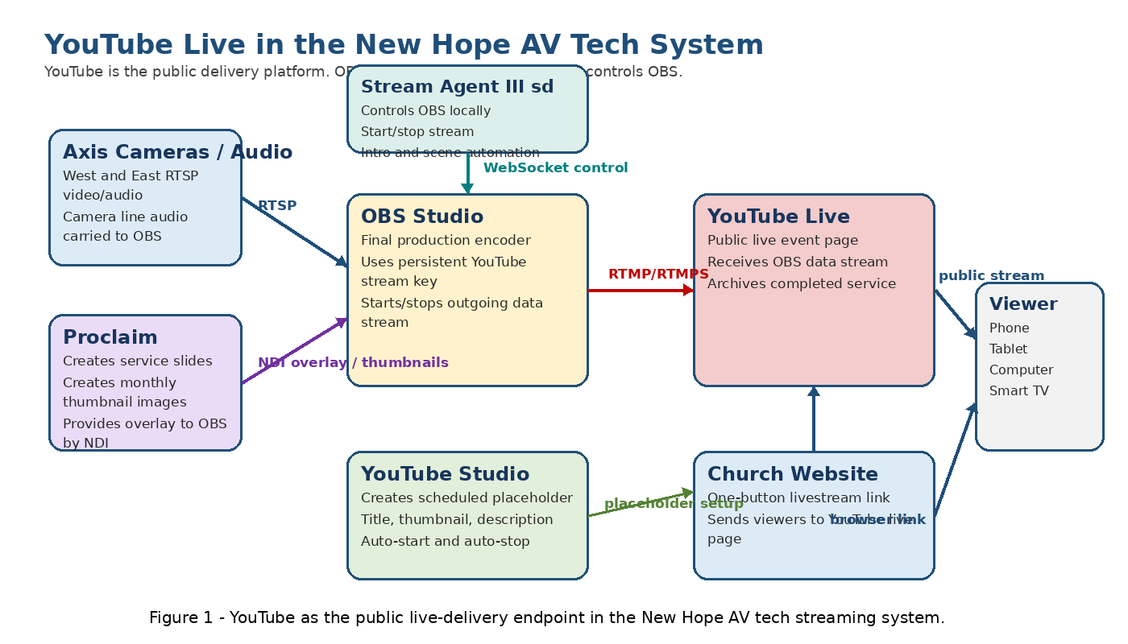
Figure 1 - YouTube as the public live-delivery endpoint in the New Hope AV tech streaming system.

5. How OBS and Stream Agent III sd interface with YouTube
OBS is the direct technical interface to YouTube. Stream Agent III sd controls OBS, but it does not send video to YouTube by itself. The YouTube side must be prepared in advance so that when OBS starts streaming, YouTube recognizes the incoming data stream and attaches it to the correct scheduled event.
Item | Current/expected value | Purpose
OBS streaming service | YouTube Live via custom RTMP/RTMPS setting | Sends the final program feed to YouTube.
YouTube stream key | Persistent/custom New Hope key - redacted | Allows OBS to reach the correct YouTube live destination.
OBS profile | NHLC<space> - confirm exact current profile name | Reduces risk of using the wrong stream destination.
Stream Agent role | Controls OBS start/stop and scene automation | Does not replace OBS as the encoder.
YouTube placeholder | Created separately in YouTube Studio | Public scheduled event seen by viewers before stream start.
Public live URL | https://www.youtube.com/@NewHopeLutheranChurchRegina/live | Used for the church website and Stream Agent View Live button.
Why preparation matters
Stream Agent can start OBS streaming, but YouTube must already have the correct scheduled placeholder, stream key selection, visibility, auto-start, and auto-stop settings. Otherwise OBS may send data, but the public event may not behave as expected.

6. Current YouTube interface requirements
The following values should be treated as part of the interface contract between OBS, Stream Agent III sd, YouTube Studio, and the church website.
YouTube / system item | Required / expected value | Used by
YouTube channel | New Hope Lutheran Church Regina - confirm exact channel name | Public viewers and YouTube Studio.
Public live page | https://www.youtube.com/@NewHopeLutheranChurchRegina/live | Church website button and Stream Agent View Live link.
Stream key type | Persistent/custom stream key | OBS stream settings and scheduled placeholder.
Live stream type | Scheduled encoder livestream | Sunday service placeholder.
Visibility | Public for normal Sunday service | Viewer access.
Auto-start | On | Lets OBS starting the data stream start the public event.
Auto-stop | On | Lets OBS stopping the data stream end the public event.
Live chat | Off / not used | Keeps the stream simple.
Comments | Accepted unless church policy changes | Allows normal post-stream comments.
Thumbnail source | Proclaim-created image in monthly PC folder | Public waiting page.
Description | Service information and welcome text | Public event information.

7. Accounts, software, and permissions
YouTube operation depends on both local software and the church YouTube account. Account credentials and recovery details must be stored securely and not inside this general documentation.
Item | Required for | Notes
Church YouTube account | Creating and managing scheduled live streams | Store login and recovery details securely. Do not print passwords in general volunteer material.
YouTube Studio access | Opening Live Control Room and Manage tab | Used to create and edit the Sunday placeholder.
OBS Studio | Encoding and sending the live stream | OBS stores the stream URL and persistent key.
Stream Agent III sd | Automation and Web HUD start/stop controls | Controls OBS but does not directly manage YouTube Studio.
Proclaim | Thumbnail creation and service visuals | Used to create monthly thumbnail images.
Internet access from BeelinkOBS | Sending stream to YouTube | Confirm before Sunday service.
Secure recovery storage | Stream key, account password, recovery codes | Keep outside public GitHub repositories and printed manuals.

8. Scheduled placeholder design
A scheduled placeholder is the YouTube Live event that exists before the actual live video arrives from OBS. It should contain the title, scheduled date/time, thumbnail, description, visibility, stream key association, and auto-start/auto-stop behavior.
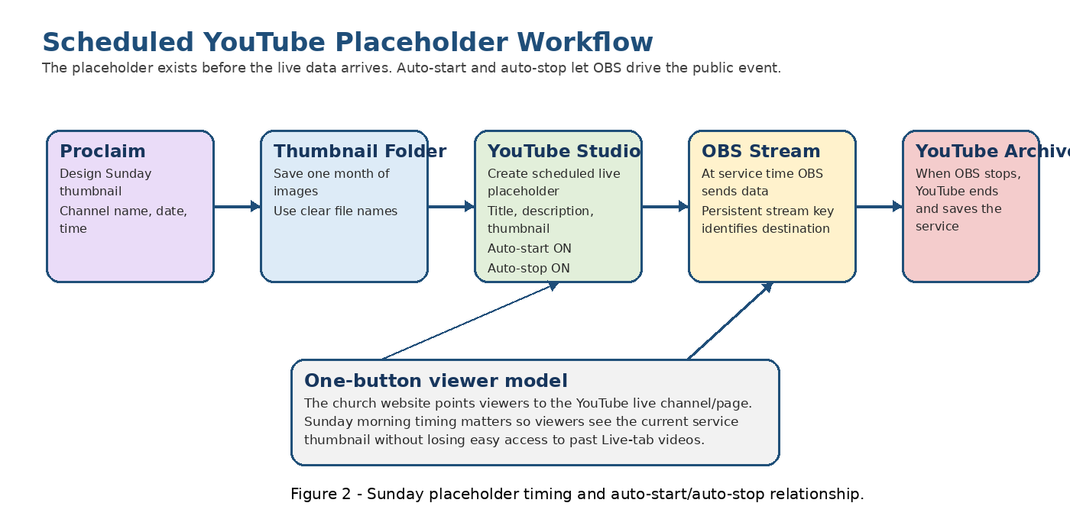
Figure 2 - Sunday placeholder timing and auto-start/auto-stop relationship.

8.1 New Hope placeholder settings
Setting area | New Hope practice | Reason
Title | Sunday service title with date/time | Lets viewers confirm they are in the correct place.
Visibility | Public for normal service | Allows public viewers to watch from the website link.
Thumbnail | Proclaim-produced Sunday image | Creates a clear waiting page.
Description | Brief service information | Explains the service focus and context.
Stream key | Persistent/custom church key | Matches the key stored in OBS.
Auto-start | Enabled | YouTube starts when OBS data arrives.
Auto-stop | Enabled | YouTube ends when OBS stops sending data.
Live chat | Disabled / not used | Keeps the setup simple and avoids chat moderation.
Comments | Allowed unless policy changes | Permits normal post-stream comments.
Extra features | No trailer, no polls, no Q&A, no frills | Keeps Sunday operation predictable.

8.2 Sunday morning timing
New Hope normally creates the scheduled placeholder on Sunday morning. This timing is connected to the church website one-button viewer model. The website points people to the YouTube live page rather than a unique weekly event URL.
Creating the placeholder Sunday morning gives viewers a current service waiting page close to service time, while reducing the chance that an upcoming placeholder blocks easy access to existing past livestreams under the channel's Live tab for too long.
Timing rule
The placeholder should be created early enough that viewers can find the current service before it begins, but not so early that it interferes with viewers looking for previous saved services.

9. Persistent stream key strategy
New Hope uses a persistent/custom stream key strategy. OBS normally keeps the same YouTube stream key from week to week. The YouTube scheduled placeholder is configured to use the same key. This reduces weekly setup work and reduces the chance of Sunday morning mistakes.
Risk with changing keys weekly | Result
Wrong key pasted into OBS | Stream may not reach the intended placeholder.
Key not updated | YouTube may not receive the stream.
Copy/paste or typing error | OBS connection failure or wrong destination.
Volunteer confusion | Sunday morning delay.
Key exposed in screenshots | Security problem because the stream key functions like a password.
Security rule
The YouTube stream key must be treated like a password. It can be stored in secure recovery records, but it should not appear in ordinary volunteer instructions, screenshots, GitHub repositories, or printed public manuals.

10. OBS custom streaming settings
OBS must be configured as the YouTube encoder. The live church system should be checked and the exact values recorded. Do not include the actual stream key in public documents.
OBS setting | Current / required value | Notes
Profile | NHLC<space> - confirm exact current name | Used to reduce risk of wrong stream destination.
Service | Custom or YouTube setting - confirm current working value | Use exactly what is proven in the church system.
Server URL | YouTube RTMP or RTMPS URL - confirm | RTMPS is preferred if supported and tested.
Stream key | Persistent New Hope key - redacted | Store securely only.
Output resolution | Record from OBS screenshot | Must match stable church streaming configuration.
Frame rate | Record from OBS screenshot | Must match stable church streaming configuration.
Video bitrate | Record from OBS screenshot | Should match available upload speed and YouTube recommendations.
Audio bitrate | Record from OBS screenshot | Record current stable value.
Audio sample rate | 48 kHz expected in OBS | Confirm against OBS Audio settings.
RTMP / RTMPS note
Google recommends RTMPS where supported because it encrypts the stream connection. If the present working New Hope setup uses ordinary RTMP, document it exactly and test any RTMPS change before relying on it for Sunday service.

11. Thumbnail workflow using Proclaim
New Hope uses Proclaim to create the Sunday livestream thumbnail image. The thumbnail is the public still image shown on the YouTube waiting page before the service begins.
Thumbnail item | New Hope practice | Notes
Source program | Proclaim | Use a clean readable slide-style design.
Storage | Dedicated PC folder, organized by month | Makes Sunday selection faster and reduces mistakes.
Content | Church/channel name, service date, service time | Viewers can confirm they are in the correct service.
Aspect ratio | 16:9 | YouTube recommends 16:9 for players and previews.
File type | PNG or JPG preferred | YouTube Help lists JPG, GIF, and PNG as acceptable formats.
Naming convention | Include date in filename | Example: 2026-05-24_New_Hope_Service_10AM.png.
Example folder pattern:
C:\ChurchAutomation\YouTube_Thumbnails\2026-05 May\
Example file names:
2026-05-24_New_Hope_Service_10AM.png
2026-05-31_New_Hope_Service_10AM.png

12. Description and public information workflow
The YouTube description should tell viewers what the service is about without including internal AVTECH setup details. A simple template should be saved and reused, then adjusted for the date and service theme.
Description item | Example content | Notes
Service name | Sunday Worship Service | Use consistent naming.
Date/time | Sunday, May 24, 2026, 10:00 AM | Must match the scheduled event.
Church name | New Hope Lutheran Church | Public identification.
Theme / sermon focus | Brief statement of the service focus | Optional but useful.
Scripture / church season | Easter, Advent, Lent, Pentecost, etc. | Optional.
Welcome note | A brief welcome to online viewers | Keep concise.
Website/contact | Church website or contact link | Optional.
Public information rule
Do not place stream keys, OBS profile notes, internal IP addresses, camera passwords, or troubleshooting details in the public YouTube description.

13. Auto-start and auto-stop
Auto-start and auto-stop are critical to the New Hope one-button workflow. These settings allow the encoder behavior to control the public YouTube event.
YouTube setting | New Hope value | Meaning
Auto-start | On | When OBS begins sending the live data stream, YouTube starts the scheduled public live event.
Auto-stop | On | When OBS stops sending the live data stream, YouTube ends the live event.

13.1 What "start stream on occurrence of a data stream" means
The data stream is the encoded audio/video feed coming from OBS. Before OBS starts, the YouTube placeholder exists but has no live video feed. Viewers see the thumbnail and waiting page. When OBS starts streaming, it sends data to YouTube using the stream URL and stream key. With auto-start enabled, YouTube can start the public live event when that data arrives. When OBS stops sending data, auto-stop lets YouTube end the public event.
Critical Sunday check
If auto-start is off, OBS may be sending video while the public event does not go live automatically. If auto-stop is off, the public YouTube event may not end when OBS stops.

14. Church website one-button viewer model
New Hope uses a one-button viewer model. The church website directs viewers to the YouTube live page rather than requiring the website to be updated every week with a different event link.
Time / condition | What the viewer should see
Before Sunday placeholder is created | The channel live area and existing past livestreams remain available.
After Sunday placeholder is created | The viewer sees the upcoming service thumbnail/waiting page.
When OBS starts streaming | The same destination becomes the live worship service.
After OBS stops streaming | The completed service becomes available later as an archived livestream.
New Hope public live URL used by Stream Agent and the website workflow:
https://www.youtube.com/@NewHopeLutheranChurchRegina/live

15. Normal Sunday operation
1. Confirm the YouTube account is accessible and the correct church channel is selected.
2. Open YouTube Studio and go to Create -> Go Live.
3. Open the Manage tab and create or reuse a scheduled stream for the Sunday service.
4. Confirm title, service date, and service time.
5. Upload the correct Proclaim thumbnail from the monthly thumbnail folder.
6. Enter or update the service description.
7. Confirm visibility is Public for a real Sunday service.
8. Confirm the persistent/custom stream key selected in YouTube matches the key stored in OBS.
9. Confirm auto-start is On.
10. Confirm auto-stop is On.
11. Confirm live chat is Off / not used and comments are set according to church policy.
12. Save the scheduled stream.
13. Use the church website live button or the public live URL to verify the expected waiting-page thumbnail appears.
14. Before service, confirm OBS, Stream Agent III sd, Proclaim, cameras, audio, and network are ready.
15. At stream time, Stream Agent starts OBS streaming. YouTube should automatically start the scheduled event.
16. At the end of service, Stream Agent stops OBS streaming. YouTube should automatically end and archive the event.

16. Rebuilding the YouTube interface after failure
This procedure covers the YouTube-facing rebuild tasks after a PC failure, lost OBS profile, or major configuration recovery. It assumes the YouTube account is still available.

16.1 Best case: restore from backup
1. Restore OBS profile and scene collection from backup.
2. Confirm OBS Settings -> Stream still contains the correct YouTube server URL and persistent key.
3. Confirm Stream Agent III sd is restored and can start/stop OBS streaming.
4. Confirm the Stream Agent View Live button uses the correct New Hope public live URL.
5. Open YouTube Studio and create a private/unlisted test placeholder if appropriate.
6. Run a short test stream before relying on the rebuilt system for Sunday service.

16.2 Manual rebuild if no OBS backup exists
1. Install OBS Studio and required plugins as documented in the OBS guide.
2. Configure OBS streaming to the documented YouTube RTMP/RTMPS server URL.
3. Enter the persistent New Hope YouTube stream key from secure recovery storage.
4. Recreate or restore the OBS profile name used by Stream Agent profile safety.
5. Confirm OBS can start a test stream to YouTube using an unlisted/private placeholder.
6. Create the next Sunday scheduled placeholder in YouTube Studio.
7. Attach/select the persistent/custom stream key for that placeholder.
8. Apply the thumbnail, description, date/time, visibility, auto-start, auto-stop, chat, and comments settings.
9. Verify the public live URL reaches the expected waiting page.

16.3 If YouTube account access is lost
1. Use the secure recovery records for the church YouTube/Google account.
2. Recover access through the approved church account owner or administrator.
3. Do not create a new public channel unless leadership decides the old channel cannot be recovered.
4. If a new channel is unavoidable, update the church website link, Stream Agent View Live URL, documentation, and volunteer instructions.

17. Backup and maintenance
Backups and records are what make YouTube setup recoverable. The stream key and account details are sensitive and must be stored separately from public documentation.
Backup / record item | How / where | When
YouTube account access records | Secure church password/recovery storage | After any account change.
Stream key name and value | Secure recovery storage only | After any stream key change.
OBS stream settings screenshot | Documentation folder with key redacted | After any OBS streaming change.
Thumbnail folder | Back up monthly Proclaim thumbnail images | After monthly thumbnails are prepared.
Description template | Save in church documentation folder | After template updates.
Sunday placeholder checklist | Printed or digital operator checklist | After procedure changes.
YouTube Studio screenshots | Documentation folder with private data redacted | After final setup verification.
Backup rule
After any successful Sunday with changed YouTube, OBS, Stream Agent, thumbnail, or description setup, update the backup records before experimenting again.

18. Troubleshooting
Symptom | Likely causes | Checks / fixes
OBS cannot connect to YouTube | Wrong server URL, wrong stream key, internet issue | Check OBS Settings -> Stream. Confirm internet. Confirm stream key from secure record.
YouTube does not go live when OBS starts | Auto-start off, wrong placeholder, wrong stream key | Open YouTube Live Control Room and confirm auto-start and stream key selection.
Stream goes to wrong event | Wrong key or reused wrong scheduled stream | Verify the scheduled placeholder and selected/custom stream key.
Viewers do not see current service | Placeholder not created, private, wrong channel, or wrong website link | Check Manage tab, visibility, and the church website live URL.
Viewers see thumbnail but no live video | OBS not streaming or YouTube not receiving data | Check OBS stream status and YouTube Live Control Room preview/health.
YouTube does not stop after service | Auto-stop off or OBS still sending data | Confirm OBS has stopped streaming and auto-stop is on.
Wrong thumbnail appears | Wrong file selected from monthly folder | Replace thumbnail in YouTube Studio before going live.
Live chat appears unexpectedly | Chat left enabled | Edit stream customization and disable chat for future streams.
Comments unavailable after stream | Comments disabled or restricted | Check YouTube comments settings and channel policy.
Stream key exposed in screenshot | Documentation/security mistake | Delete/redact the screenshot and regenerate documentation. Rotate key if exposure risk is real.
Public live URL shows old content too long | Placeholder timing or website URL behavior | Review Sunday morning placeholder creation timing and verify the live URL after saving.

19. Items to capture later with screenshots
This document is complete enough to guide a rebuild, but it should later be improved with actual screenshots from the working YouTube Studio and OBS setup. Redact stream keys, passwords, account recovery details, and private account information.
- YouTube Studio main page showing where livestream setup begins.
- Create -> Go Live entry point to Live Control Room.
- Live Control Room Manage tab showing scheduled stream area.
- Schedule Stream dialog showing placeholder creation.
- Stream Details page showing title, description, date/time, and visibility.
- Thumbnail upload area showing where the Proclaim image is selected.
- Stream Settings page showing stream key selection with actual key hidden.
- Auto-start and auto-stop switches showing required On state.
- Customization / live chat setting showing chat disabled.
- OBS Settings -> Stream page with stream key redacted.
- Church website livestream button showing the one-button viewer path.

Appendix A - Configuration record sheet
Configuration item | Expected value / note
YouTube channel name | New Hope Lutheran Church Regina - confirm exact channel name.
Public live URL | https://www.youtube.com/@NewHopeLutheranChurchRegina/live
YouTube Studio account | Record securely outside this document.
Stream key name | Record securely.
Actual stream key | Store securely only; never publish in public docs.
OBS profile used for live streaming | NHLC<space> - confirm exact name.
OBS service setting | Custom or YouTube - confirm current working value.
OBS server URL | Confirm current RTMP/RTMPS URL.
RTMP or RTMPS | Confirm current working protocol.
Thumbnail folder path | C:\ChurchAutomation\YouTube_Thumbnails\YYYY-MM Month\ - confirm actual.
Description template location | Record current file/folder path.
Normal Sunday placeholder creation time | Record final operating practice.
Normal OBS stream start time | Approximately 9:55 AM if still current.
Normal service time | 10:00 AM if still current.
Auto-start | On.
Auto-stop | On.
Live chat | Off / not used.
Comments | Accepted unless church policy changes.

Appendix B - YouTube / OBS / Stream Agent interface map
System function | YouTube / OBS object touched | Reason
Create Sunday placeholder | YouTube scheduled live stream | Creates the public waiting page and event.
Upload thumbnail | YouTube stream thumbnail | Shows the correct service image before live video begins.
Enter description | YouTube stream metadata | Gives viewers service information.
Select persistent stream key | YouTube stream settings and OBS stream key | Connects OBS output to the correct YouTube live event.
Start Stream | OBS streaming output; YouTube auto-start | OBS sends data; YouTube starts public event when configured.
Stop Stream | OBS streaming output; YouTube auto-stop | OBS stops data; YouTube ends public event when configured.
View Live button | Public YouTube live URL | Lets operator verify viewer-facing page.
Website livestream button | Public YouTube live URL | One-button access for viewers.
Future placeholder automation | YouTube Live Streaming API liveBroadcast and liveStream resources | Would create and bind placeholders programmatically.

Appendix C - Sunday placeholder checklist
Check | Required result
Correct YouTube channel/account | Confirmed.
Correct Sunday scheduled placeholder exists | Yes.
Title/date/time | Correct.
Thumbnail | Correct Proclaim image for the Sunday.
Description | Current service information included.
Visibility | Public for real service.
Stream key | Persistent/custom key matching OBS.
Auto-start | On.
Auto-stop | On.
Live chat | Off / not used.
Comments | Accepted unless church policy changes.
Website live button | Shows expected waiting-page thumbnail.
OBS profile | Correct live profile, such as NHLC<space>.
OBS not already streaming by mistake | Confirmed before planned start.

Appendix D - Glossary
Term | Meaning in this system
YouTube Live | The public platform that receives and distributes the church livestream.
YouTube Studio | The creator control area used to schedule and manage live streams.
Live Control Room | The YouTube Studio interface used for livestream setup and monitoring.
Placeholder | The scheduled YouTube Live event before OBS begins sending video.
OBS | Open Broadcaster Software, the encoder and production app.
Encoder | Software or hardware that compresses and sends live audio/video to YouTube.
Stream key | Secret YouTube value that identifies and authorizes the stream.
Persistent stream key | Reusable stream key kept the same from week to week.
RTMP | Real-Time Messaging Protocol, a common livestream transport.
RTMPS | Secure/encrypted RTMP.
Auto-start | YouTube starts the scheduled event when OBS starts sending data.
Auto-stop | YouTube ends the scheduled event when OBS stops sending data.
Thumbnail | Still image viewers see before the livestream starts.
Proclaim | Church presentation software used for slides and thumbnail creation.
LiveBroadcast | YouTube API term for the live event or placeholder.
LiveStream | YouTube API term for the incoming video stream/feed.

Appendix E - References
These sources were used for general YouTube behavior. Local New Hope values come from the AVTECH project records, Stream Agent III sd configuration, and current church operating practice.
- YouTube Help - Create a YouTube live stream with an encoder: https://support.google.com/youtube/answer/2907883
- YouTube Help - Manage live stream settings: https://support.google.com/youtube/answer/9854503
- YouTube Help - Encrypt your stream using RTMPS: https://support.google.com/youtube/answer/10364924
- YouTube Help - Add video thumbnails on YouTube: https://support.google.com/youtube/answer/72431
- YouTube Help - Live chat basics: https://support.google.com/youtube/answer/9826490
- YouTube Help - Troubleshoot your YouTube live stream: https://support.google.com/youtube/answer/2853835
- YouTube Help - Archive live streams: https://support.google.com/youtube/answer/6247592
- Google for Developers - YouTube Live Streaming API reference: https://developers.google.com/youtube/v3/live/docs
- Google for Developers - Understanding broadcasts and streams: https://developers.google.com/youtube/v3/live/broadcasts-and-streams
- Google for Developers - LiveBroadcasts: bind: https://developers.google.com/youtube/v3/live/docs/liveBroadcasts/bind
- New Hope Lutheran Church AV Tech - OBS Studio Setup, Operation, and Rebuild Guide, prepared May 19, 2026.

