Stream Agent III Auto-Launch
Windows Task Scheduler Setup for BeelinkOBS
AV Tech System Documentation Module - updated May 19, 2026
Purpose
This section documents how the BeelinkOBS computer automatically starts Stream Agent III at Windows logon, why the task is configured this way, and how to verify or edit it safely.

1. Current Auto-Launch Task Summary
Item | Current value / guidance
Task name | stream_agent_III
Windows user | BeelinkOBS\paulw
Trigger | At log on of BeelinkOBS\paulw
Program/script | C:\Users\paulw\AppData\Local\Python\pythoncore-3.14-64\pythonw.exe
Arguments | "C:\ChurchAutomation\stream_agent_III\<current Stream Agent III app file>.py"
Run mode | Run only when user is logged on
Duplicate protection | If the task is already running: Do not start a new instance
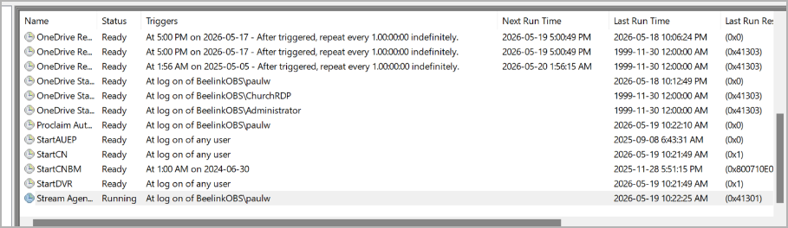
Figure 1 - Task Scheduler Library showing the Stream Agent task selected and running.

2. Why Task Scheduler Is Used
The BeelinkOBS computer is intended to behave like a church streaming appliance. When the normal church Windows user logs in, the control software should start automatically without relying on a volunteer to remember every step.
Stream Agent III provides the Web HUD, Director page, OBS control, MIDI cue handling from Proclaim, Axis camera steering, audio faders/meters, timer start support, logging, and troubleshooting information.
If Stream Agent III is not running, Proclaim MIDI cues and Web HUD controls will not operate even if OBS itself is open.

3. General Tab - Security and User Session
The task runs inside the normal BeelinkOBS desktop user session. This is intentional because Stream Agent III interacts with desktop-session applications such as OBS, Proclaim, browser-based Web HUD access, and local troubleshooting tools.
- Use the normal church operator account: BeelinkOBS\paulw.
- Use Run only when user is logged on. This keeps the app inside the visible Windows session.
- Do not require highest privileges unless a future change specifically needs administrator rights.
- Do not run the app as SYSTEM. Running as SYSTEM can break access to user-session programs and expected folders.
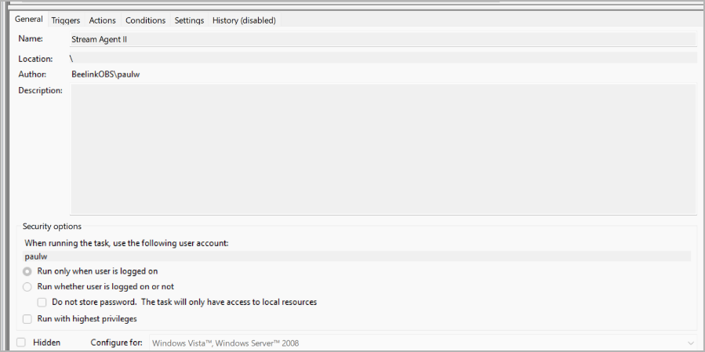
Figure 2 - General tab: the task runs under the normal BeelinkOBS user session.

4. Triggers Tab - When It Starts
The Stream Agent III task should start when the normal BeelinkOBS user logs into Windows:
At log on of BeelinkOBS\paulw
This is appropriate for the church environment because the app should be ready before a service without requiring the operator to open it manually. The trigger should remain enabled.
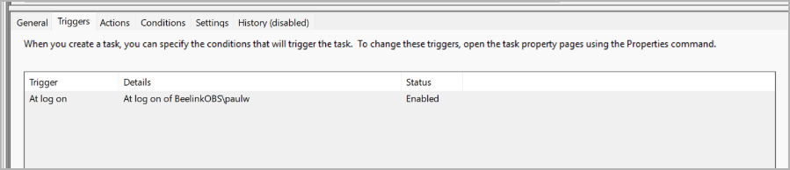
Figure 3 - Triggers tab: Stream Agent starts at logon for BeelinkOBS\paulw.

5. Actions Tab - How the Task Starts the App
The task starts Python in windowless mode using pythonw.exe. This avoids leaving a black console window open on the desktop.
Program/script: C:\Users\paulw\AppData\Local\Python\pythoncore-3.14-64\pythonw.exe
Arguments: "C:\ChurchAutomation\stream_agent_III\<current Stream Agent III app file>.py"
When updating to a newer app version, edit the Arguments field so it points to the current Stream Agent III Python file. Keep the interpreter path pointing to pythonw.exe unless the installed Python path changes.
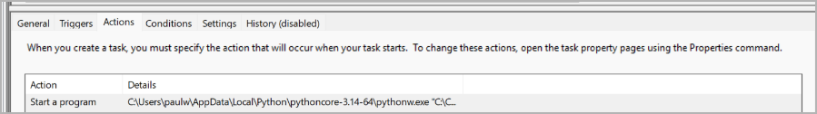
Figure 4 - Actions tab: the task starts the Python app using pythonw.exe.

6. Conditions Tab - When Windows Is Allowed to Start It
The task should not depend on idle time or a specific network condition. The church app should start whenever the operator account logs in.
- AC power condition enabled is acceptable for the BeelinkOBS mini PC because it should normally run from wall power or UPS power.
- Idle conditions should remain disabled. We do not want Windows waiting for the computer to become idle before launching Stream Agent.
- Wake/network conditions are not required for this task. Wake-on-LAN and remote access are handled elsewhere in the AV tech system.
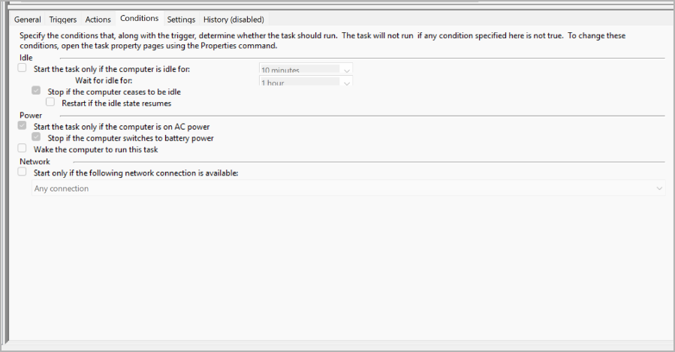
Figure 5 - Conditions tab: the task is not tied to idle or network availability.

7. Settings Tab - Reliability and Duplicate Protection
The Settings tab controls retry behavior, long-running task behavior, and duplicate-task protection. The most important setting is duplicate protection: only one copy of Stream Agent III should run.
Setting | Reason
Allow task to be run on demand | Allows manual testing from Task Scheduler.
Run task as soon as possible after a scheduled start is missed | Not required for a logon-start task; can remain off.
Restart on failure | Not currently used. Stream Agent has its own logging and restart decisions should be deliberate.
Stop the task if it runs longer than 3 days | Reasonable safety limit. The app normally runs for a service, not continuously for days.
Force stop if it does not end when requested | Allows Windows to clean up the task during shutdown or manual stop.
If already running: Do not start a new instance | Critical. Prevents two copies from fighting over OBS, MIDI, web ports, and logs.
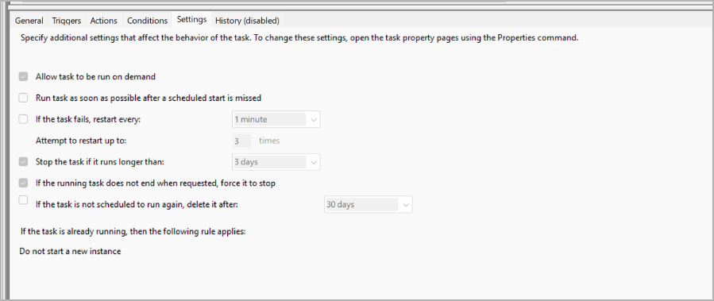
Figure 6 - Settings tab: allow manual run, keep duplicate protection enabled.

8. History Tab and Task Status
Task History is currently disabled. That is normal unless Windows Task Scheduler history has been enabled globally. For this system, Stream Agent logs are usually more useful than Task Scheduler history.
Common Task Scheduler status/result values:
Status / result | Meaning
Running | The task is currently active. For Stream Agent III, this normally means the app has launched.
Ready | The task is configured and waiting for its trigger or manual run.
0x0 | Last run completed successfully.
0x41301 | The task is already running. This is expected when Stream Agent remains open.
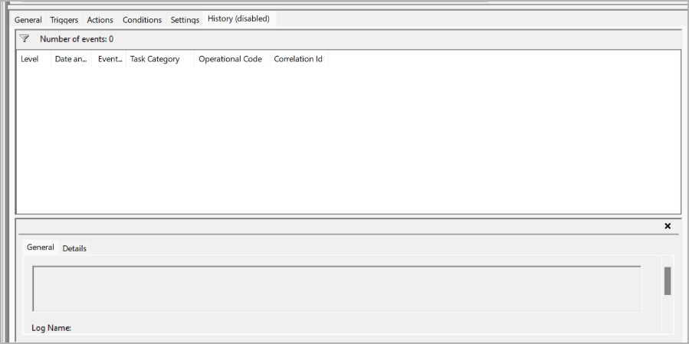
Figure 7 - History tab: history is disabled; use Stream Agent logs for normal troubleshooting.

9. How to Test the Auto-Launch Task
- Open Task Scheduler and select Task Scheduler Library.
- Select the stream_agent_III task.
- Click Run in the right-side Actions panel.
- Confirm the task status changes to Running.
- Open the Stream Agent Web HUD locally on BeelinkOBS, normally http://127.0.0.1:8765.
- From another LAN device, test the Web HUD using the BeelinkOBS LAN address, normally http://192.168.88.102:8765.
- Check Stream Agent logs if the Web HUD does not appear.

10. Troubleshooting Quick Reference
Problem | Likely fix
Task does not start at login | Confirm trigger is enabled and assigned to BeelinkOBS\paulw.
Task runs but Web HUD is not available | Check that the app path points to the current Python file and that the app did not crash on startup.
A black console window appears | Confirm the Program/script field uses pythonw.exe, not python.exe.
Two copies of Stream Agent open | Confirm Settings -> If the task is already running is set to Do not start a new instance.
App cannot control OBS | Confirm OBS is running, obs-websocket is enabled, and the OBS port/password match Stream Agent config.
MIDI cues do not work | Confirm loopMIDI/Proclaim MIDI routing is started and that Stream Agent sees the expected MIDI input port.

11. Related Auto-Launch Tasks in the AV System
The complete AV tech startup design may include separate startup tasks or startup entries for these components:
- OBS Studio
- loopMIDI
- Proclaim
- Master Fader
- Stream Agent III
Each required program should start reliably, but only one copy should run. Later documentation sections should use this Stream Agent III task as a model when documenting the other auto-launch components.

12. Future Documentation Notes
This document is intended to become one module of the larger AV Tech System manual. Future modules should describe OBS startup, Proclaim startup, loopMIDI routing, Master Fader startup, Wake-on-LAN remote access, and the Sunday service startup/shutdown checklist.

