**Field Sampling Methods for CCE 2024**

***Measurements taken at site establishment:***

**Site Measurements:**

Latitude

Longitude

Elevation

Slope

Aspect

Moisture

Site naming: start at 1 and proceed in order of establishment within the firescar. Each firescar should have 6 sites. Abbreviate firescar names either by using the first two letters of each word in a multi-word firescar, or the first four letter of the word in single-word firescars. Ex – Hess Creek – HECR, Shovel Creek – SHCR, Haystack – HAYS.

We are giving old sites new numbers! We need to record the old site number in the site notes.

Locate random location – orient 30m transect S to N when the terrain is flat or cross slope on slope, and record orientation. Choose a homogenous area that is representative. Sites should be a minimum of 100m apart, though 200-300m is best.

Each site will consist of a 30 m x 2 m belt transect with three distinct 10 m x 2 m plots. The 30 m transect is divided into three 10 m intervals (0-10 m, 10-20 m, 20-30 m) which are labeled as plot A, B, and C. Each plot will have a total of three quadrats located at 3 m, 6 m, and 9 m.

At each site a suite of environmental characteristics will be determined. We will record latitude, longitude, and elevation with a GPS receiver, and slope and aspect with a clinometer and compass. In the field, each plot will be assigned a soil drainage class on a six point scale, ranging from xeric to sub-hygric, based on topography‐controlled drainage and adjusted for soil texture and presence of permafrost (Johnstone *et al.* 2008; Walker *et al.* 2018b).

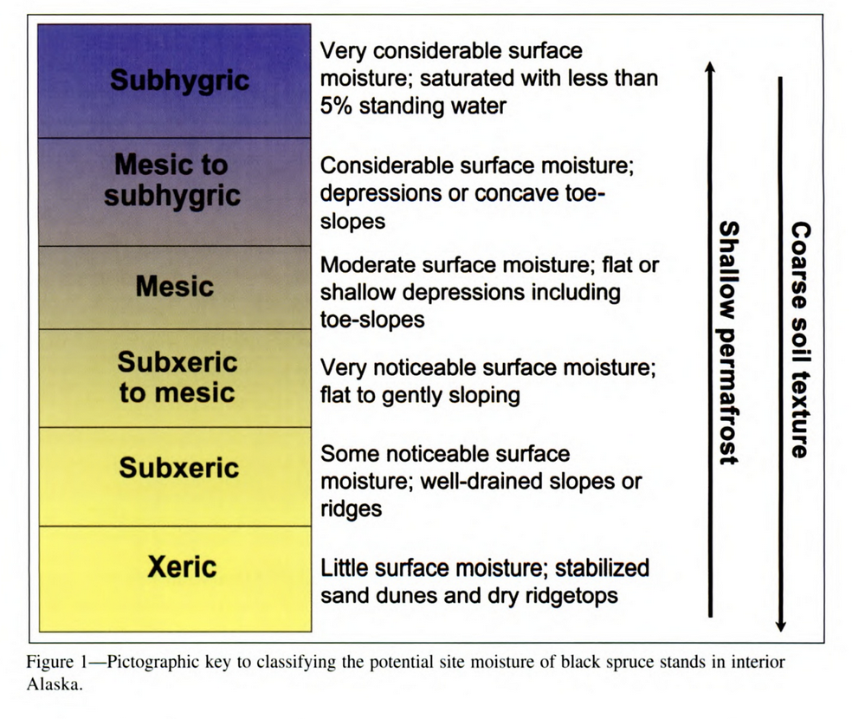

Pre-fire vegetation – just notes on density/species – ONLY want black spruce dominated sites.

Notes

Site photos – permanent! White board with dry erase marker: site, placement, direction, date. Take one photo at start and one photo at end.

Permanently mark plot with large wooden stakes. One at the beginning of each plot and one at the very end. Four stakes per site.

DNBR severity class – so that we are getting an equal distribution of severity classes across the fire scar.

**CCE Soils:**

At the time of plot establishment, collect one intact soil monolith (5 cm x 10 cm x variable depth) of the entire depth of the residual SOL and collect a 10 cm depth mineral soil core at the 3 m quadrat. Label with site number and plot. Unique ID = HECR1A-3O, HECR1B-3M, HECR1C-3O

To estimate burn depth, measure the distance from the highest adventitious root to the top of the residual SOL on one to three adventitious roots (AR height1, AR height2, AR height3) on each tree closest to the quadrats (three trees per plot – one at 3, one at 6, one at 9). Measure the SOL depth (AR SOL depth) directly beside the tree where you record ARs. Remember, only spruce have ARs!

**CCE Tree Disks - Stand age:**

At the time of site establishment, collect one basal tree disk from the closest mature representative trees to the plot center (meter 5 in each plot) to estimate stand age. Collect a disk from a tree that is 5 meters away (perpendicularly) from the transect in order to avoid influencing CWD, etc. Three disks per site, one per plot. Collect as close to the root collar as possible. Record species, height, and diameter. Unique ID: HECR1A, HECR1B, HECR1C.

If tree is too large to cut down or disk cannot be taken for some reason, taking a core is acceptable. Pith must be hit, and two cores must be taken from each tree.

**CCE Pre-fire tree Inventory and Combustion:**

At the time of site establishment, in each 2 x 10 m belt transects, measure the diameter at breast height (DBH; 1.37 m from the base) for all trees ≥ 1.37 m in height and the basal diameter of all trees < 1.37 m tall that were killed by fire. Must be originally rooted in 2m belt transect.

Record standing (y/n). Snag pre-fire (y/n).

For each tree, assess combustion by ranking cones, foliage, fine branches, coarse branches, and stems a 0, 25, 50, 75, or 100%. Usually, stems are 0% for trees but have a value for pre-fire snags. Pre-fire snags can be NA for the other categories.

Count – use this only if you have a big group of trees that are all the same, so that you only have to record things once. Then you would multiply by the count in data processing.

*Shrub combustion removed from protocol.*

***During site establishment and each subsequent sites visit:***

**CCE Soils:**

At each quadrat, measure green moss depth, residual SOL depth and thaw depth. Record what SOL hits. If the thaw probe doesn’t hit, enter 101 cm and record the thaw hit as >100cm.

**CCE Plant cover and seedlings and shrubs:**

At each quadrat, record the percent cover of understory vegetation and ground cover classes.

Ground cover needs to add to 100. If less than 1%, indicate trace with a 0.1.

Plant cover sum does not matter. Anything below 1.37 m and rooted within the plot is counted. If less than 1%, indicate trace with a 0.1.

Count species-specific regenerating seedlings and shrubs and measure three representative basal areas for each seedling and shrub species. If no seedlings are present in quadrats within a plot but you see them at the plot – put another quadrat down randomly (at meter 0, 1, 2, 4, 5, 7, 8) along the transect in that plot until you record one seedling. In the seedling notes for any quadrat sampled other than 3, 6, and 9, you must indicate how many quadrats were sampled until a seedling was counted. For example, if there were no seedlings in quadrats set at 3, 6, 9, and 4 meters, but there was a seedling in quadrat 8, in the notes you would say 5 m2 sampled for seedlings. We will not do this at sites one year after and will only begin in year 3 post-fire.

Take a photo of the quadrat from directly above.

**CCE Understory Species Present:**

Additional species list per SITE. Things found but not in quadrats. This should be relatively quick. Do not get bogged down with young forbs, grasses, or sedges that are not flowering or will be hard to identify. This should be used to characterize the area and for compositional change over time.

**CCE CWD combustion:**

Measure coarse woody debris (CWD) in each plot. Take the diameter of any piece of wood that is ≥ 5 cm diameter and < 45° angle from the ground that intersects the transect line. Where it intersects, measure the diameter, record the species, the percent combustion (0%, 25%, 50%, 75%), and hardness classification (hard, crumbly, or soft).

**CCE Brown’s Transect:**

In each plot, measure fine and coarse woody debris. The wood must be < 45° angle from the ground and intersect the transect line. Only a count is needed.

Counts of each:

* 1. meter: 1 hour fuels (<1/4 inch)
  2. meter: 10 hour fuels (1/4 to 1 inch)

0-5 meter: 100 hour fuels (1 inch to 3 inch)

0-10 meter: 1000 hour fuels (>3 inch)

Figure 1. Diagram of transect line for each site.

**Packing list:**

* Trowel (x1)
* Bread knife (x2)
* Parrot clippers (x2)
* Thaw probe (x1)
* Tinfoil (x3)
* Duct tape (x5)
* Notebook (x3)
* Write-in-the-rain paper (1 packet)
* Pencil (x5)
* Cutting board (x2)
* Plastic bags (x240)
* Ethanol wipes (x3)
* iPads (x2)
* Cable
* Battery pack
* 30m Transects (x2)
* 1m quadrat (x4)
* Tree calipers
* Seedlings calipers x3
* Clinometer
* Compass (x2)
* Saw (x1) + replacement blades
* Sharpies (x5)
* Paper bags (x20)
* Meter stick (x1)
* Plant book
* DBH tape (x1)
* Clicky clack (x2)
* Access to freezer (key)
* Bear spray (x3)
* Personal first aid kits (x3)
* List of emergency contact info
* Inreach (x1)
* Mineral soil corer (x1)
* Go – no go (x2)
* White board (x1)
* Dry erase markers (x3)
* Tree corer (x1)
* WD40 (x1)
* Rag (x1)
* Paper straws (x30)