<http://6285588.com/app/Ctrl/View/User/login.html>

[http://6285588.com/app/Ctrl/View/](http://6285588.com/app/Ctrl/View/Index/index.html#)[Index/index.html#](http://6285588.com/app/Ctrl/View/Index/index.html#)

<http://6285588.com/app/Ctrl/View/Index/main_desk.html>

<http://6285588.com/AllenMVC/AllenMVC.php>

Tp3.2.3

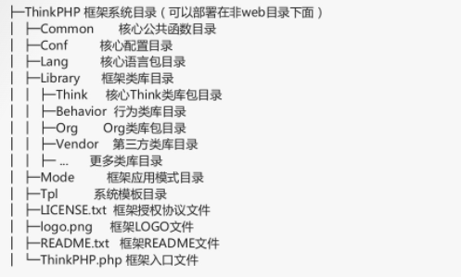

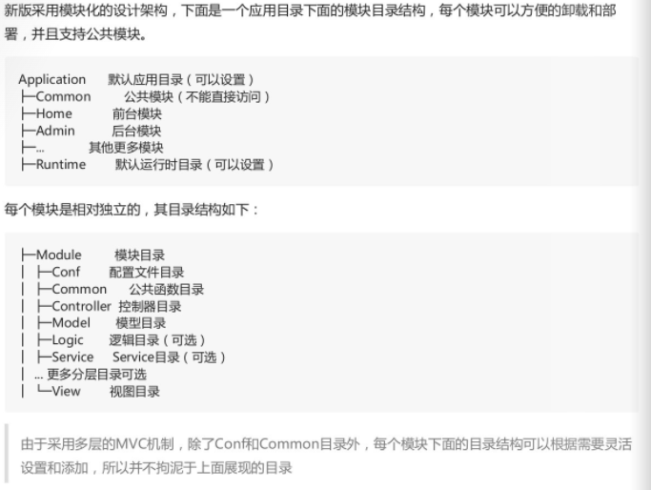

HIFaJ6mazfK3kE6lVLuTp2sEPgM65R 数据库密码

[1, admin, e8ug072j0988prt2dasldbl485, 432a5980296bf7112a849d18271abc57, 1, 2024-02-27 16:43:46, 172.71.218.229, null]

后台账号密码

<http://6285588.com/index.php?m=Ctrl&c=User&a=login> 后台

D:/wwwroot/dcgjc/zdjy_new/web/app/Qnmlgb6666666______6666666/Cache/Ctrl/

D:/wwwroot/dcgjc/zdjy_new/web/app/Ctrl/View/Index/index.html 后台路径

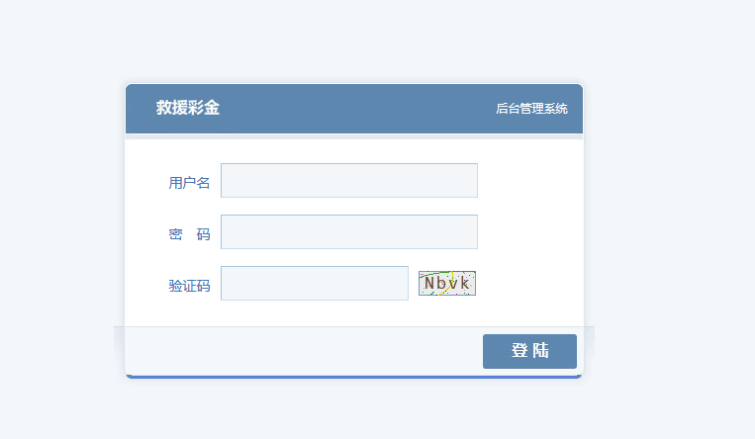

<http://6285588.com/index.php?a=lists&_=1709115765084> 信息泄漏

