Using the InkSecureSignature Sample

January, 2006
Applies to:
- Microsoft.TabletPC.Samples.InkSecureSignature.dll

System Requirements
Source code:
- Microsoft Visual Studio® .NET 2003 or 2005 with Visual Basic
Executable:
- .NET Framework version 1.1
- Microsoft Windows® XP Tablet PC Edition 2005

Installation
There are no configuration requirements to run the sample executable. Simply copy these files to a folder on your Tablet PC:
- InkSecureSignatureSample.exe
- InkSecureSignatureSample.exe.manifest
- Microsoft.TabletPC.Samples.InkSecureSignature.dll

Application Considerations:
- To prevent displaying anomalies when opening a Windows form control, after opening your solution in Visual Studio and before developing, rebuild your solution. On the Build menu, click Rebuild Solution. Also, rebuild immediately after converting this solution to Visual Studio 2005.
For more information about the cause of display anomalies and how to fix the issue, see FIX: User controls on a Windows form reposition to the top of the screen in the Visual C# Form Designer.

Signature Use Cases
The following example demonstrates the InkSecureSignature functionality with the sample application as shown in Figure 1.
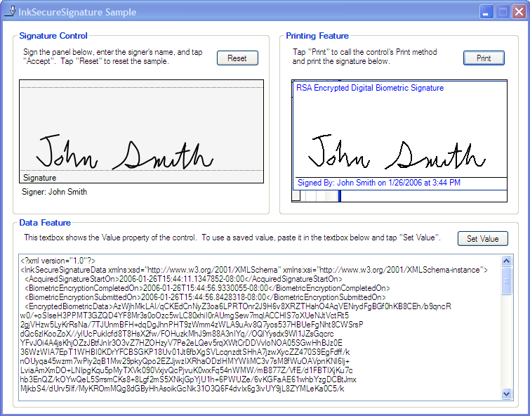

Exercise 1: Creating a Secure Signature.

Task 1: Enter a signature and encrypt it
- Start the InkSecureSignature.exe on a Tablet PC.
- Sign your name in the Signature box on the Signature Control area. Note that the signature ink is blue while the control collects the signature.
- Tap the Signer box, and then type your full name.
- Tap Accept. The following takes place:
- The control encrypts the e-signature.
- The control replaces the full-fidelity e-signature with an e-signature consisting only of black points (pixels), without additional metadata. This is called a washed signature.
- The control locks the signature to protect against user modifications and to protect the ink from the Clipboard.
- The control displays the XML data stream for the signature in the Data Feature box.
Note: The XML includes various elements describing the e-signature, including:
- <EncryptedBiometricData> The serialized and encrypted e-signature.
- <HardwareInfo> Includes the workstation name.
- <InkWashedSignature> Includes the display-safe version of the e-signature.
This XML can be stored in a file or database field for future retrieval.

Task 2: Reload XML into a Data Stream
This task demonstrates that an XML data stream can be reloaded back into the InkSecureSignature control (as if returning from a database record).
- Carefully edit the text in the <SignersName> element in the Data Feature box to change the signer’s name, then tap Set Value to send the XML stream to the InkSecureSignature control. Note that the control updates the Signer name string to reflect your edits.
- Tap the Print button to see a graphical (bitmap) version of the e-signature that can be printed or saved; this bitmap uses a low-fidelity display format that has reduced value to identity thieves.

Summary
You performed the following tasks.

Entered and encrypted an e-signature using your pen.
Reloaded an XML data stream by editing the <SignersName> element.

