**Pitchboard:**

My idea for this project is to create a portfolio for myself because it can be used outside of class to show employers what I am all about and my skills. I want the page to include a picture of myself, a description of myself and my hobbies, include pictures of my photoshop works (albeit limited because of my computer deleting my old portfolio) on a separate page, and a contact information section.

The people viewing my site would be possible future employers, friends, and family. I need my design to be a simple aesthetic that looks professional but also captures my lighthearted nature. The first persona would be a hiring staff member at a job I am applying for, the second would be a friend that wants to learn more about me, and the final persona would be a family member that wants to know what I am up to.

Comparative sites would be other people’s portfolios and personal sites.

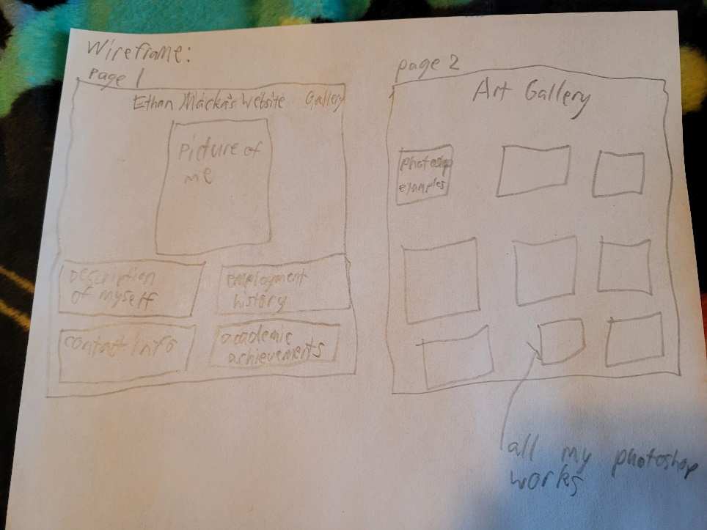**Wireframes:**

**Comps:**