Mackenzie O’Brien

Lab 9

4/5/2017

1. Functional Dependencies
   1. People
      1. PID🡪FirstName, LastName, Address, phoneNumber
   2. Players
      1. PID🡪Age, EmergencyContact, EmergencyPhone
   3. Coach
      1. PID🡪NumYears
   4. AsstCoach
      1. ACID,🡪NumYears
   5. AgeGroup
      1. AID🡪BeginAge, EndAge

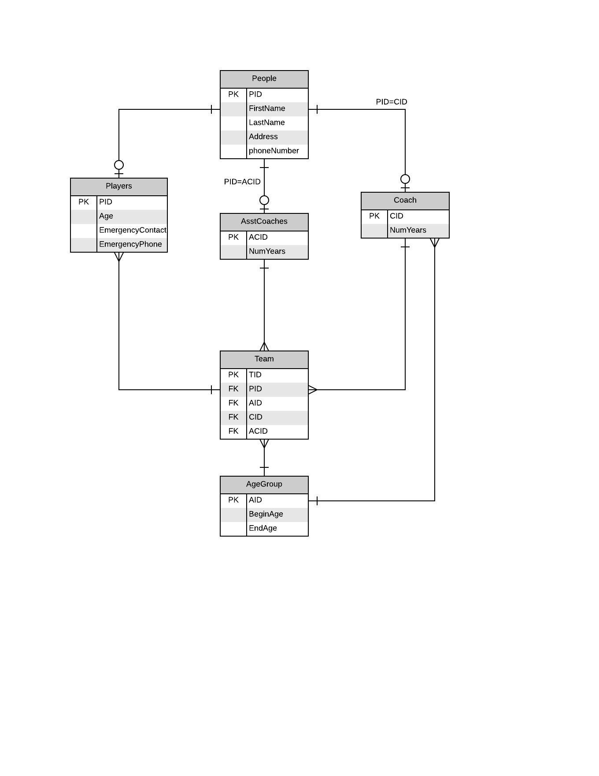

1. In order for a database to be in 3NF, it first must be in 2NF. In order to be in 2NF, it must first be in 1NF. In our database, all attributes are atomic and only has a single value, meaning that it is 1NF. It is then in 2NF since it is already in 1NF and everything is functionally dependent on its primary key. Since it is in 2NF and every attribute is dependent on only the key and nothing but the whole key.