Figure 1: Home Prices and Nitrate Contamination Notices in California, 2000–2024
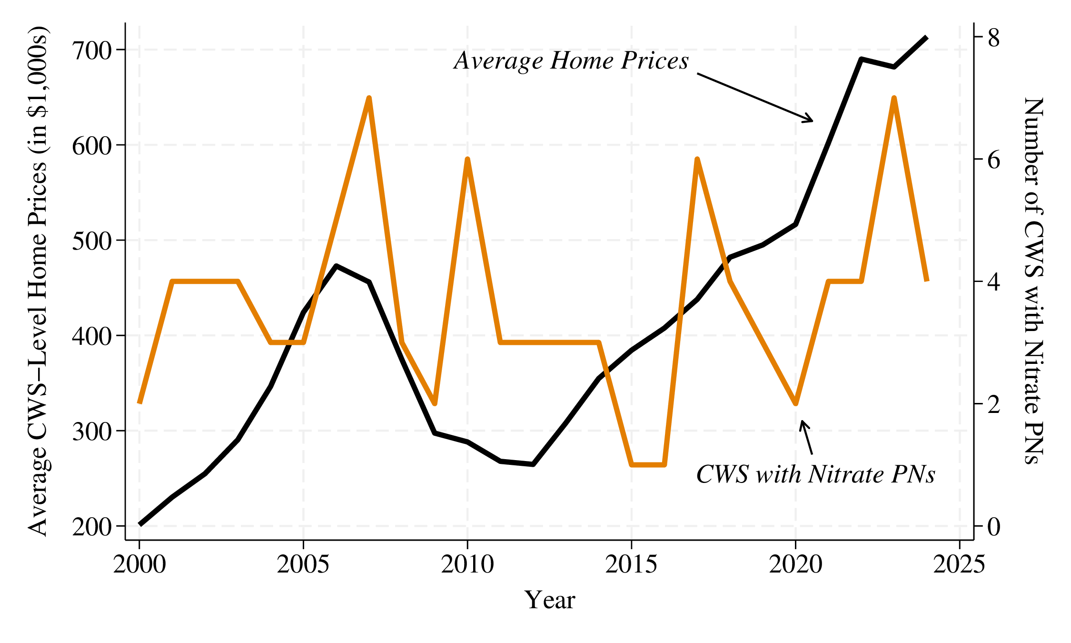
NOTES: Average annual home prices across community water systems (CWS) are plotted in black (left axis, in $1,000s). The number of CWS issuing a public notification (PN) for nitrate contamination in each year is plotted in orange (right axis). Home prices are measured using the Zillow Home Value Index (ZHVI), aggregated from ZIP codes to CWS service areas.
Source: Zillow Research (ZHVI); California State Water Resources Control Board; EPA Safe Drinking Water Information System (SDWIS).

Table 1: Summary Statistics for California Community Water Systems, 2000–2024
Variable | Mean | 10th Pct. | 90th Pct.
Home Value ($) | 392,001 | 126,371 | 725,803
Nitrate Notification Issued in Year (0/1) | 0.03 | 0.00 | 0.00
System Ever Issued a Nitrate Notification (0/1) | 0.44 | 0.00 | 1.00
Year of First Nitrate Notification | 2010 | 2001 | 2021
Service Population | 81,747 | 694 | 108,599
Number of Observations | 2,925
NOTES: Each observation is a community water system (CWS) in a given year. The sample includes CWS in California counties that experienced at least one nitrate public notification between 2000 and 2024. Home values are the typical home value from the Zillow Home Value Index, averaged across the ZIP codes served by each CWS. Year of First Nitrate Notification is calculated only for systems that ever issued one.

Table 2: Effect of Nitrate Contamination Notices on Home Prices
Outcome: Log Home Value | (1) | (2)
Nitrate Public Notification | -0.058*** | -0.069***
 | (0.022) | (0.024)
Water System and Year Fixed Effects | Yes | Yes
Estimator | Imputation | Two-Stage
Number of Observations | 2,875 | 2,875
NOTES: Each observation is a community water system (CWS) in a given year, 2000 to 2024. The explanatory variable equals 1 in the year a CWS issues its first nitrate public notification and every year after. Both columns include CWS and year fixed effects. Column 1 uses the Borusyak, Jaravel, and Spiess (2024) imputation estimator; Column 2 uses the Gardner et al. two-stage difference-in-differences estimator. Standard errors are clustered at the CWS level.
* p<0.1; ** p<0.05; *** p<0.01

Table 3: Effect of Nitrate Contamination Notices on Home Prices, by Water System Size
Outcome: Log Home Value | (1)
Nitrate Public Notification | -0.047***
 | (0.017)
Small Water System | -0.184***
 | (0.052)
Nitrate Public Notification × Small Water System | -0.031
 | (0.028)
County and Year Fixed Effects | Yes
Number of Observations | 2,875
NOTES: Each observation is a community water system (CWS) in a given year, 2000 to 2024. Small Water System equals 1 for CWS serving 3,300 or fewer residents. The model is estimated using OLS and includes county and year fixed effects. Standard errors are clustered at the CWS level. Results are fictitious and only for demonstration purposes.
* p<0.1; ** p<0.05; *** p<0.01

