**Desktop Sharer**

1. **Brief Introduction**

1.1 This software is meant to be used in the environment of an e-classroom or e-meeting room. One server runs on only one terminal as “Control Center”; all the other peer terminals have the client “Peer” installed on them. The Control Center can manage the peers by dividing them into groups, and by creating a broadcast session to share to one desktop to or to all others in the same session. The Control Center terminal can also monitor any peer desktop terminal at any time but not vice versa.

1. **Operating Environment**

2.1 OS environment

Desktop Edition: Windows 7 or later

Server Edition: Windows Server 2008 or later

(On both situation, VC11 Runtime Library must be installed.)

2.2 Network Environment

Local area network

Microsoft’s remote desktop (One OS with different terminals logging on remotely with different accounts )

1. **Detailed Operations**

3.1 Server-side software

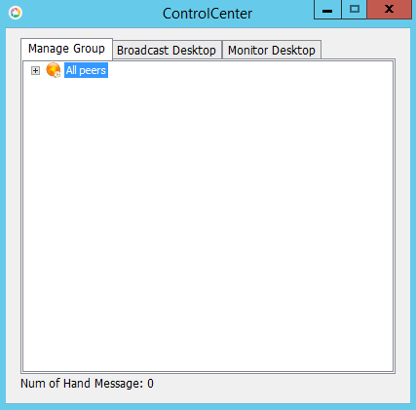

The server-side software in the “Control Center” is responsible for managing peers and sessions. The main interface is made up of three visible tabs “Manage Group”, “Broadcast Desktop”, “Monitor Desktop” and a hidden “Handup Message” window. The former three can be reached by clicking the corresponding tab title. The “Handup Message” window can be accessed by clicking the text “Num of Hand Message : ” . There is also a “Allow peers to exit” menu item in the system menu of “Control Center” (by right clicking the title bar), once the client-side software “Peer” is connected to the “Control Center”, the peer’s menu item “Exit program” is disabled to prevent it from exiting. If you want to enable the menu item and allow peers to exit, click this menu item “Allow peers to exit” inside the system menu of Control Center.

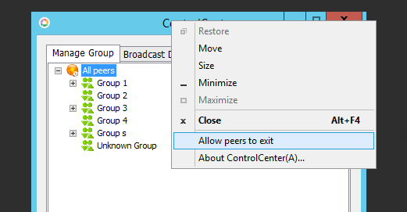

The main interaction with the UI is through right -click menu. The following are details:

3.1.1 Manage Group

This module is responsible for managing peers and groups. The interface is a tree structure representing peers in groups. The first level of the tree nodes is the “All peers”. The second level stands for groups, and the third level stand for peers. Icon of peers are of two types: online and offline and there is an icon for each node。 When someone logs on, the icon turns to green; when someone logs off, the icon turns to gray. Therefore the tree is dynamic. There is a group named “Unknown Group” but it is not an actual group. It only means the peers in it are not divided into any other existing groups. Peers with no group will show up here.

Operations are of two types:

Right click the peer and perform peer management, and right click the group and perform group management.

3.1.1.1 Peer Management

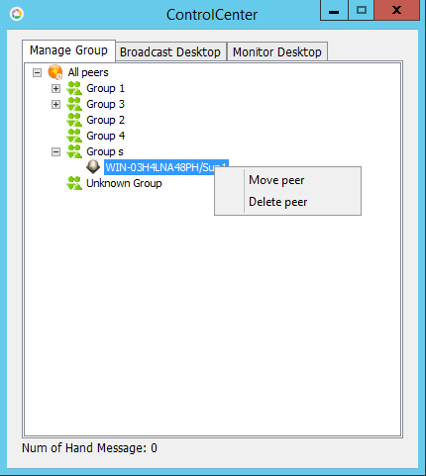

Move peer: move one peer from a group to another.

Delete peer: delete peer. Note that the deletion of an online peer and an offline peer is different as the online peer is moved into the “Unknown Group” while the offline peer is deleted directly.

3.1.1.2 Group Management

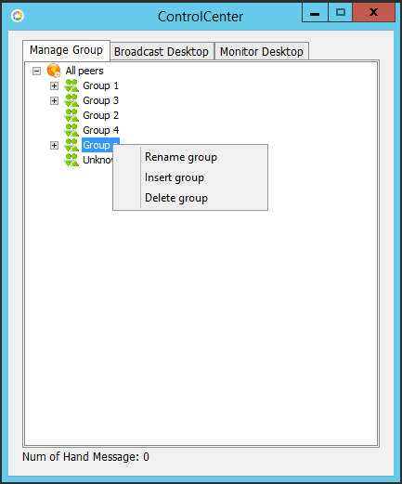

Rename group: New group or renamed groups cannot have the same as any other existing group’s name. The “Unknown Group” can’t be renamed.

Insert group: insert a new group after a current group by right-clicking the name of the current group and selecting “Insert group.” Group name will be specified by typing it into an input text dialog box. Note that the “Unknown Group” is usually the last group until you insert a group after it. But once the Control Center is restarted, the “Unknown Group” will be the last one again. The order of the rest groups might also change.

Delete group: Delete current group. Note that the peers of this group will be moved into “Unknown Group” if the group has peers inside. The “Unknown Group” cannot be deleted.

3.1.2 Broadcast Desktop

“Desktop broadcast session” means a desktop sharing session where one peer shares his desktop with the all the other peers in the same session. This kind of session may also be called “desktop share session”, “desktop broadcast share session”, or shorted as “broadcast session” or “share session”. Note that there are must be one peer sharing his or her screen with 0 or more viewers in the session.

Operations are of two kinds: right click in a white area of the “Control Center” window, right click on session item.

3.1.2.1 Right click on white area

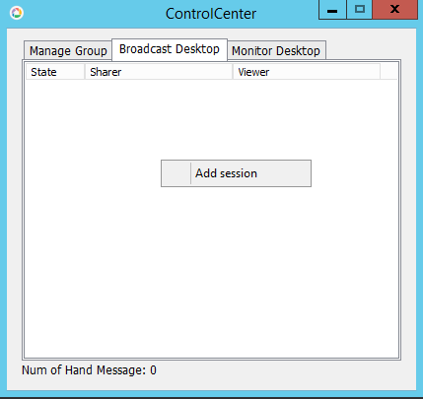

Add session: create a new broadcast session. Note that the situation of a peer of an existing session attending a new session concurrently is not allowed.

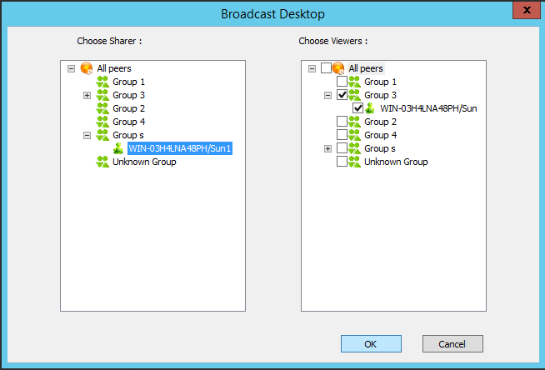

3.1.2.2 Right click on session item

After you create sessions by “Add session”, session items will show up in the list.

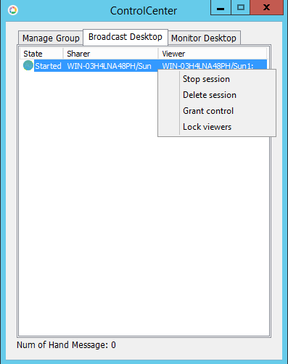

Stop session: stop the current broadcast session, after which it will become Start session to restart the session.

Delete session: delete a stopped session.

Grant control: in the pop-up control dialog you can choose a viewer to let him or her control the desktop of another sharer. Make sure none of the viewers is selected then click OK to revoke the privilege. Note that there can be at most one viewer having the control privilege in the broadcast session.

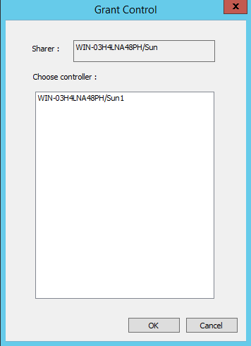

Lock viewers: locks the systems of all the viewers so that they cannot use keyboards and mice. They can only view the desktop being shared.

3.1.3 Monitor Desktop

“Monitor session” means share the desktop of the peer being monitored to the Control Center screen. Operation are of two types: right click in blank area; right click on a session item.

3.1.3.1 Right click in a white area of the “Control Center” window

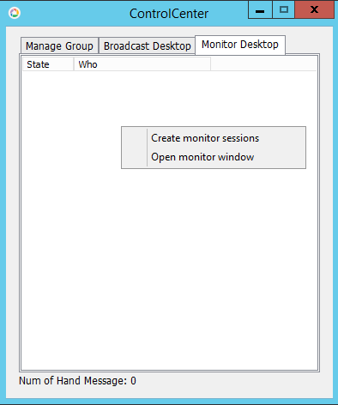

Create monitor: create new monitor sessions.

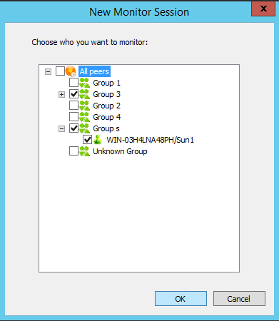

Open monitor window: open a window of all the monitored desktops.

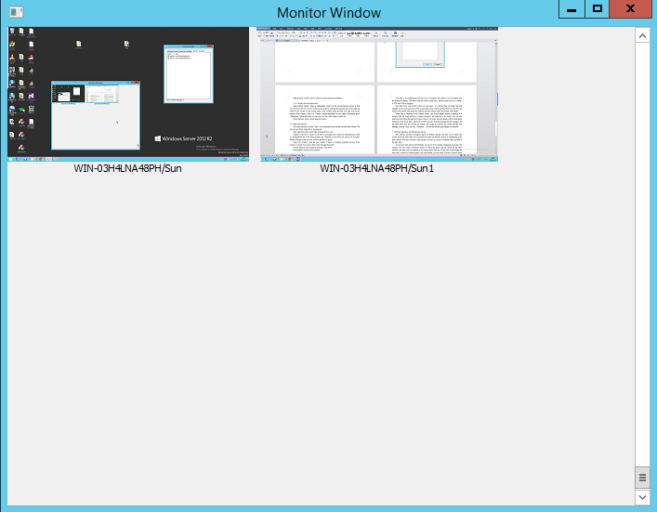

3.1.3.2 Right click on session item

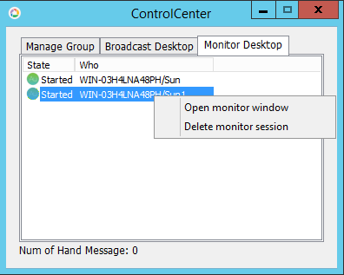

Open monitor window: Open an independent window for the current monitor session, so that you can resize the view or view in full screen mode by clicking the maximize box at the right-top corner of the window. In the system menu of the window (pops up when you right click on the caption of the window), there is a “Control” button indicating you can control the desktop and a “Thumbnail” button indicating you can also view the whole image in small size.

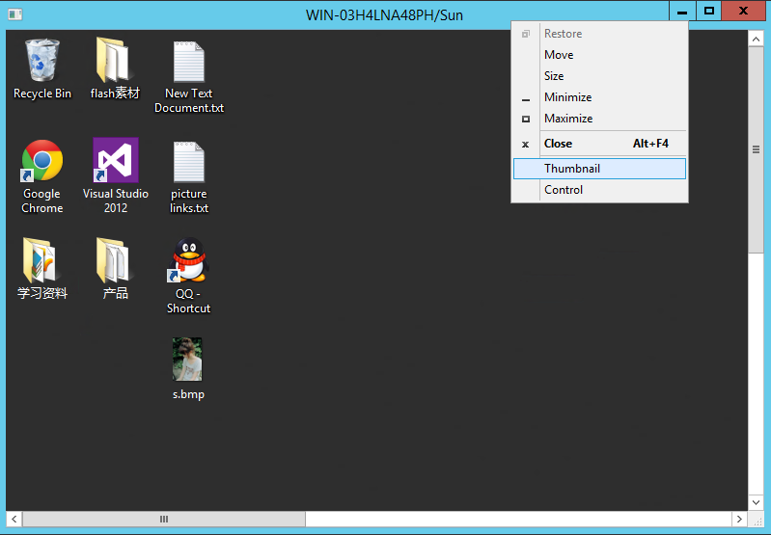

Delete monitor: delete current monitor session.

3.1.4 Hand-up Message

Hand-up Message Dialog shows up when you click the text on the left-bottom corner of the Control Center or when a Hand-up Message comes.

3.1.4.1 Right click in the white area

Clear Records: clear all the messages.

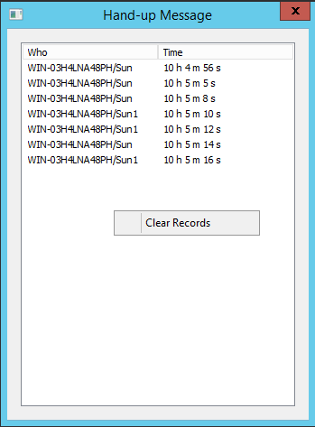

3.2 Client-side software

The client software is called “Peer”; it is minimized to the system tray area once started. The tray icon are either connected() or unconnected().

Main operations show up by right clicking the tray icon.

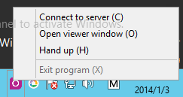

Connect to the server: connect to the server according to the connection information provided by configuration file. If the client already has connected to the server, no action will be taken. Double-clicking on the tray icon provides the same functionality as this menu item.

Open view window: open the view window if there is a desktop broadcast session. If the window is closed, you can also find it back through this menu item.

Hand up: send a hand-up message to the server.

Exit program: exit the client software. Note that this menu item is disable once connected to the Control Center, and it can be enabled by the clicking menu item “Allow peers to exit” on Control Center.

View window:

There is a “Thumbnail” button in the system menu of this window, watch thumbnail image using this button. Click the maximize box to enter full screen mode. Once you enter into full screen mode, on top edge of the screen, 1/4 length of the width of the screen to the left edge, there is an auto-hide “Exit full screen” button. Move you cursor to this area, let it stay there to let the button show up and you can click it and exit full screen mode. Note: if the peer is locked by Control Center, nothing shows up.



1. **Software Configuration and Advise**

Both the server side and the client side have a configuration file named “Config.ini” in their respective main directories. In the Config.ini of the Control Center, there is a “Connection” section and a “port” key under it, which corresponds to the TCP port number the Control Center is going to listen to on its start. In the “Config.ini” of the client end “Peer”, there is also a “Connection” section, but an “address” key is added to indicate the IP address “Peer” wants to connect to. The “port” key here indicates the TCP port number “Peer” will try to access on the server side. In order to connect successfully, the consistency between the two ports and between the value of “address” key and the IP address of the Control Center is running must the same. If the software is used in a multiple remote desktop environment, the value of “address” in the Peer’s Config.ini file can be local address or “localhost” or “127.0.0.1”. In order to take the new values of any changes, the modifications must happen before the Control Center starts on the server side , before connecting to the Control Center on the client side.

Note that if the configuration files are lost or corrupted, the software will use default port and default IP address. The server side will listen to port 5000, and the client will try to connect to TCP port 5000 on localhost.

Note that if you want stricter control over the peers, it is advised that you disable the task manager on the client and set the Peer as auto-start on the system starting. However, the Peer can connect successfully only under the condition that the Control Center has already been started.

When Peer is connected to the Control Center, the “Exit Program” button is disabled. It is assumed that the client software is neither necessary nor expected to be exited (You can also enable the Exit button through the Control Center if you want, for more details refer to the detailed operation of the server side). However, the Peer can still be killed through the task manager. On the other hand, after the viewers are locked, they might still operate the system through task manager by press “Ctrl+Alt+Del”. Therefore, it is advised that the task manager be disabled.

1. **Software Operation and Performance Advise**

This software provides the highest degree of desktop sharing. Any peer can be sharer and viewer and at the same time can be monitored because the monitor session is independent of the share session. The only collision is that one peer cannot be viewers of different share sessions at the same time.

As you have been given such flexibility, you can try every sharing method you like. For instance, you can create a broadcast session in which the sharer and the viewer are the same machine, and then view the desktop in full screen mode. You can do this, but do not expect good result. In order to let many people view one desktop, you can create a session with one sharer and many viewers as the rest. Another way is that you create many sessions, letting B view A’s desktop, C views B’s desktop, and D views C’s desktop......such a long chain. However, you cannot expect good performance at the tail the chain. You can also make the chain into a ring.

Something funny and worth mentioning is that to let many people view one desktop, the simplest way is to create a broadcast session specifying one peer as the sharer and the rest as viewers. But I am not sure it’s the best structure because it may cause a decrease in performance because of the heavy load of the single sharer. You can try a tree structure to distribute the load to many peers rather than only one, which means you need to create more than one broadcast session.

One peer can be the sharer of one share session, and in the meanwhile can be the sharer of another share session. This is enforced by organizing the viewers of the second session into the first session’s viewer group.

You can create monitor session. In fact, monitor session is the same as the broadcast session, the only difference being that the sharer of a monitor session is the peer being monitored, the only one viewer is the one in the Control Center. If you sometimes encounter problems that maybe not because of the problem of the software or a manufacturing defect but a logic error.