Mackenzie Miller – ECEN 404-903

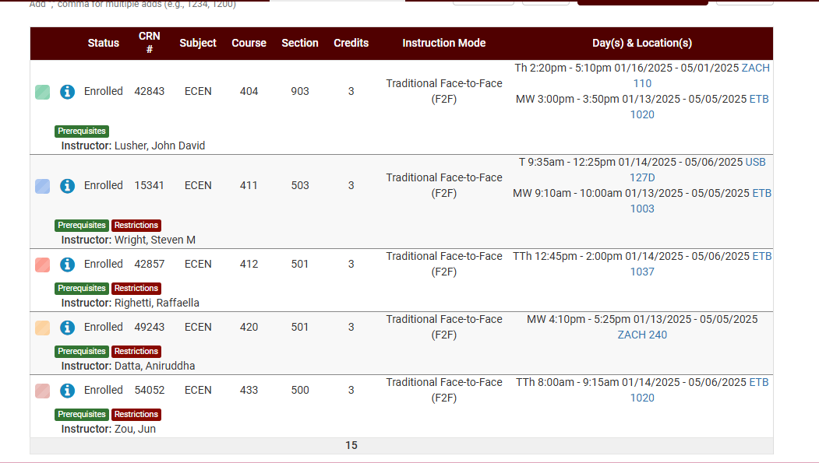

Andrew Nguyen – ECEN 404-903

Aidan Rader – ECEN 404-903

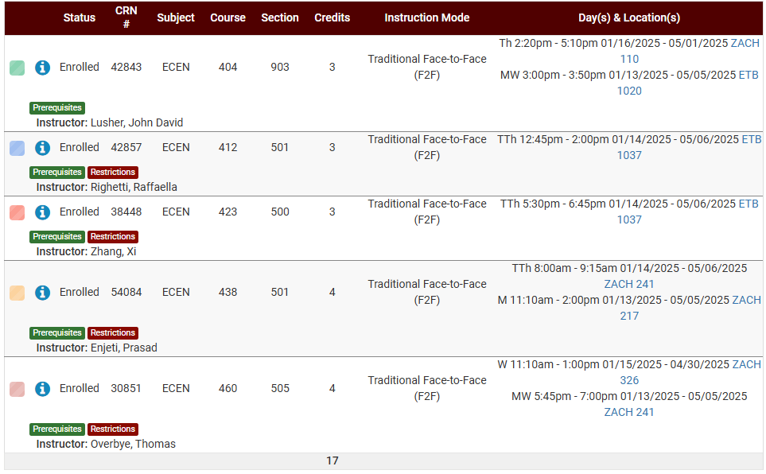

Ryan Regan – ECEN 404-903