VFD Motor Control Mackenzie Miller Andrew Nguyen Aidan Rader Ryan Regan

# Concept of Operations

##### REVISION – 0

15 September 2024

Concept of Operations for

VFD Motor Controller

Team VFD Motor Control

Approved by:

Project Leader Date

Prof. Kalafatis Date

T/A Date

**Change Record**

|  |  |  |  |  |
| --- | --- | --- | --- | --- |
| **Rev.** | **Date** | **Originator** | **Approvals** | **Description** |
| **0** | 9/15/2024 | VFD Motor Control Team |  | Draft Release |

### Table of Contents

###### Table of Contents III

###### List of Figures IV

###### Executive Summary 1

###### Introduction 2

* 1. Background 2
  2. Overview 2
  3. Referenced Documents and Standards 2

###### Operating Concept 3

* 1. Scope 3
  2. Operational Description and Constraints 3
  3. System Description 4
  4. Modes of Operations 5
  5. Users 5
  6. Support 5

###### Scenario(s) 6

* 1. HVAC 6
  2. Conveyor Belt 6
  3. VFD Pump 6

###### Analysis 7

* 1. Summary of Proposed Improvements 7
  2. Disadvantages and Limitations 7
  3. Alternatives 7
  4. Impact 7

**List of Figures**

Figure 1: VFD Motor Control Block Diagram 2

## Executive Summary

The sponsor for this project is in need of a VFD motor controller for an AC induction motor. The VFD will control the speed and torque of the AC motor. This project will help to increase energy efficiency by ensuring that the motor isn’t running at a higher speed than necessary. It also makes the system more reliable and sustainable by decreasing mechanical stress.

A Variable Frequency Drive (VFD) is a device that controls the speed of an electric motor by varying the frequency of the delivered voltage. VFDs are useful because they improve the energy efficiency, reliability, safety, stability, and controllability of a motor. The goal of this project is to make a VFD motor controller that will efficiently control the seed and torque of an electric motor.

## Introduction

#### *Background*

VFD motor controllers have several beneficial functionalities that can improve the quality of a system. A VFD motor controller regulates the speed and torque of electric motors by controlling the frequency and voltage supplied. The speed is controlled by varying the frequency of the supply of electricity. It also allows for more efficient systems. By running at certain speeds, the VFD can reduce the power consumed, allowing for energy to be saved. It also reduces stress on the motor by allowing for soft starting and stopping. The VFD also has a functionality allowing it to shut off the motor if something is shorted, overheating, or overloaded. The VFD will replace a fixed speed motor in a mechanical system.

#### *Overview*

While fixed speed motor controllers are still useful in some applications, more often than not a VFD motor controller is a better alternative. It offers all the functionality of a fixed speed motor controller while also being able to vary the speed and torque of the motor if needed. In this project, our team will work to create a Variable Frequency Drive to control motor speed. In addition, we will consider several different factors such as user interface for the drive, and implementation of the drive in a closed and open loop. This upgrade will improve the energy efficiency, reliability, safety, stability, and controllability of the motor.

#### *Referenced Documents and Standards*

“The Advantages of Frequency Drive Operation in Submersible Pumps.” *Grundfos*, [www.grundfos.com/us/learn/ecademy/all-courses/the-sp-submersible-pump/the-](http://www.grundfos.com/us/learn/ecademy/all-courses/the-sp-submersible-pump/the-) advantages-of-frequency-drive-operation-in-submersible-pumps. Accessed 15 Sept. 2024.

By, and Dosupply. “What Do VFDS DO in HVAC Systems?: Do Supply Tech Support.” *Do Supply Tech Support | Information and Troubleshooting on Allen-Bradley, Eaton, GE Fanuc, and More*, 11 Aug. 2022, [www.dosupply.com/tech/2022/08/11/what-do-vfds-do-](http://www.dosupply.com/tech/2022/08/11/what-do-vfds-do-) in-hvac-systems/.

Hoffman, Theresa. “What Are the Benefits of a Variable Frequency Drive?” Wolf Automation,[www.wolfautomation.com/blog/what-are-the-benefits-of-a-variable-](http://www.wolfautomation.com/blog/what-are-the-benefits-of-a-variable-) frequency-drive/. Accessed 15 Sept. 2024.

“Variable Frequency Drive for Conveyor and Material Handling.” *Variable Frequency Drive for Conveyor and Material Handling-Darwin Motion*, darwinmotion.com/blogs/variable- frequency-drive-for-conveyor-and-material- handling#:~:text=The%20use%20of%20a%20Variable,belt%20speed%2C%20reducin g%20energy%20consumption. Accessed 15 Sept. 2024.

IEEE 519-2014 Standard for Harmonics

## Operating Concept

#### *Scope*

The VFD motor controller is intended to control the speed and torque of an AC motor by varying the frequency and voltage supplied. This project will use three phase power as the input that will be converted to DC and then transmitted to a microcontroller via optoelectronics and used to power a motor. The microcontroller also will send signals to the DC link, again using optoelectronics, that contain the desired frequency specified by the user on the user interface. This VFD shall be implemented to increase efficiency and save energy.

#### *Operational Description and Constraints*

The VFD motor controller is designed to vary the frequency and voltage supplied to an AC motor to control its speed and torque. It converts a three-phase AC input into DC using a rectifier and transmitting the power using a microcontroller.

* + - Microcontroller Function
      * The microcontroller is responsible for generating pulse-width modulation (PWM) signals which are used to adjust the frequency and voltage supplied to the motor.
      * The user can set the desired motor speeds via the user interface or the code itself. The microcontroller then ensures that the motor is running according to its specifications.
    - Optoelectronics
      * LED lights are used to communicate between the high-voltage power components and the low-voltage microcontroller. This ensures that the signals are safely transmitted.
    - User Interface
      * The system contains a graphical user interface (GUI) that is programmed to allow the user to manually set parameters such as motor speed and start/stop commands as well as monitor real-time data like voltage, current, and motor speed.
    - Constraints:
      * Sustainability
        + Humidity, dust, and temperatures outside of the specified range can cause the VFD to malfunction.
      * Noise levels
        + The VFD is noise sensitive and is susceptible to external electrical noise, which could decrease the reliability of the system.
      * Power
        + The VFD requires stable three-phase AC power. Spikes or fluctuations could damage some of the system’s components.
      * Mechanical wear and maintenance
        + All parts of the VFD are subject to general mechanical wear and tear over time, especially if operated under high loads or in challenging environments.
      * Cost and installation
        + The VFD system can be expensive to produce, especially when considering large-scale applications. Consideration must be given to the specific needs of the project

#### *System Description*

The VFD motor controller is comprised of a DC link (includes a rectifier and DC bus), power controller, microcontroller, and optoelectronics. The DC link converts AC input into DC and minimizes the noise of the DC signal. The power controller controls the voltage. The microcontroller is used to produce PWM signals that will drive the motor.

Optoelectronics allows for communication between the high voltage side and the low voltage microcontroller.

This is a four-person project, and the roles are be split into:

* Firmware:
  + Write code in C that allows the rest of the VFD circuit to plug into the microcontroller and function according to desired specifications (how fast does the user want the motor to run).
  + Improve code to potentially include closed loop function (PID loop including VFD, controller, motor, and tachometer to detect motor speed) that would allow for automatic functionality with a given speed setpoint entered into the code
  + Design and program a user-interface that gives the user access to controlling different features such as the setpoint and start/stop as well as visualize information such as current motor speed, controller output to the VFD, and VFD voltage and current provided to the motor
* Sensors:
  + The first part of the sensors portion includes two optoelectronic circuits. One of those takes digital signals in and directly converts them to analog. The second, being more complicated, takes analog input, then, using an opto-isolator, the circuit converts the input to digital signals to be sent to the microcontroller. The analog side of the project works with very high voltage, while the digital side works with low voltage. Because of this, the two sides cannot be connected or the microcontroller will be overpowered and break, so the optoelectronics send signals and data across using light.
  + The second part of the sensors portion is a constant current and voltage measurement. This will be done using a current sensing resistor, which has a very small resistance, and a simple voltage divider circuit. These measurements will then be sent back to the firmware.
  + Finally, there will be a tachometer that measures the RPMs of the motor that is also sent to the firmware.
* Microcontroller:
  + The MCU is supplied by the 15 VDC from the AC power supply fed by the main power. The voltage will then be stepped down to a usable 3.3V. It receives feedback through low-voltage analog signals that represent voltage and current. The MCU will then send out PWM signals to the H bridge and power control system which are used to control the inverter stage of the VF which helps to adjust the output voltage and frequency supplied to the motor.
* Rectifier and DC Link:
  + The rectifier takes in three-phase AC power and converts it into DC power. For each phase, there are parallel diodes acting as a one-way bridge for the current allowing it to flow in only one direction. To maintain the correct current polarity the diode opens and closes in sequence as the AC waveform alternates. The DC output is then filtered by capacitors within the DC link to provide a stable DC voltage for the microprocessor.

#### *Modes of Operations*

There are three primary modes of operation for the variable frequency drive:

Constant Torque Mode: This mode maintains a constant torque across a diverse range of speeds by adjusting the voltage and frequency.

Variable Torque Mode: This mode varies torque and speed according to the load requirements.

Constant Power Mode: This mode maintains a constant power output and is usually used when the motor operates at higher speeds.

#### *Users*

The potential user for our VFD would be a plant operator or manager. The goal is to have it set up to ensure a seamless installation and programming process for use in a closed or open loop process. It is assumed that a plant operator would know and understand what both a VFD and PID loop are and what they do. There will be several simple controls that the user can change to make the VFD do what they want it to do.

#### *Support*

The current plan for user interface will be a GUI that the user can open on a computer that has several buttons and displays to allow the user to monitor and program the loop. We plan to create a manual describing what the VFD does and how to use it.

## Scenario(s)

#### *HVAC*

VFDs can be extremely useful in a Heating, Ventilation, and Air Conditioning (HVAC) system. VFDs can act as speed controllers for HVAC motors because they actively adjust the speed rate of those motors based on the building load demands. Without a VFD, an HVAC system will run at full power regardless of whether the system requires full power at that time. By running only as powerful as needed, energy and money are saved. Additionally, a VFD allows an HVAC motor to slowly get up to the full speed which is called a “soft start”. This lessens wear and tear on these HVAC motors, which helps them to last longer and saves money. VFDs can help HVAC systems to control temperature and pressure, among other measurements in a building, they help to save energy and extend the life of HVAC motors.

#### *Conveyor Belt*

In conveyors for production lines, a VFD allows an operator to control the belt's speed to match the production line's needs. This ensures that the belt is not moving too slow to decrease efficiency or too fast to risk injuring employees and consume copious amounts of energy. Wear and tear is also decreased by being able to run the belt at the most appropriate speed as to not overwork the parts or run the belt for too long. The slow start that a VFD can offer helps to reduce wear and tear on the conveyor parts so they can gradually get up to speed. There is the ability to gradually slow down the belt when turning off, which also extends the life of equipment. The VFD increases energy efficiency and reduces maintenance which both save money.

#### *VFD Pump*

VFDs are sought after for submersible pumps for several applications. The main benefit of a VFD in a water pump is the ability to keep a certain parameter constant. VFDs are commonly used in construction sites to keep groundwater at a constant level to build. The VFD does this by adjusting the speed of the motor controlling the water pump. Additionally, VFDs are useful in maintaining constant pressure in a water tank. VFDs are crucial in the operation of water pumps across many different disciplines because their speed control allows for constant parameters in the specified system.

## Analysis

#### *Summary of Proposed Improvements*

Improvements:

* + - Extended life of parts: being able to vary frequency and torque help to reduce overloading equipment and, in turn, makes them last longer
    - Increased efficiency: instead of a system having to run at a constant speed, a VFD allows the system to run only as fast as needed, which reduces energy consumption, and saves money
    - Limits safety risks: having a system run at the proper speed and maintain a safe amount of torque helps decrease the risk of injury

#### *Disadvantages and Limitations*

Disadvantage:

* + - VFD can damage motor windings and bearings
    - Can ruin insulation
    - Creates harmonics (potentially interfering with communications and data processing)
    - Can be very expensive
    - Is prone to overheating if not in a properly ventilated area.
    - Can create voltage spikes which could ruin the motor.

#### *Alternatives*

Alternatives to a VFD:

* Eddy Current Drive: induces a magnetic field that is adjustable to control the speed of a motor
* Soft Starters: Soft starters gradually increase the voltage to an AC motor during startup to reduce damage. They provide a more economical choice for applications where torque and speed control are only required during motor startup and stop.
* Cycloconverters: Cycloconverters convert the frequency of AC power from one frequency to another without having to convert to DC and back to AC. They are typically used in applications that require low speeds and high torque. This is a good alternative for when direct frequency conversion is more suitable than VFDs.

#### *Impact*

One environmental impact of a VFD is the ability to lower greenhouse gas emissions. By increasing the motor's energy efficiency through frequency adjustments to match load requirements, VFDs decrease the emissions released during the energy generation process.

A second environmental impact of a VFD is the degradation caused by mining the raw materials. While mining procures the rare metals needed for electronics, it also causes deforestation from the removal of forests, soil erosion from the disruption of the soil structure, and air pollution from the diesel emissions and dust particles generated by the machinery.

Another environmental impact of a VFD is the end-of-life disposal of electronic waste. Disposal of electronics can be challenging and, if done improperly, can contaminate soil and water with toxic metals. Alternatively, VFDs reduce this risk by reducing equipment wear, extending replacement intervals, and reducing disposal frequency.

A social impact of a VFD is the change in employment opportunities. The automation of the VFD reduces the need for operators who manually control the motor speed. Conversely, VFDs generate new roles including engineers who design the systems, miners who extract the raw materials, factory workers who assemble the components, and technicians who handle the maintenance.

Another social impact of a VFD is the safety risks. The VFD's automation of motor control within safe torque limits reduces the risk of accidents or injuries. However, if the VFD is improperly insulated or maintained, high voltages can pose a risk of electrical shock, and insulation breakdowns can pose a risk of short circuits and fire.

One ethical concern of a VFD is supply chain transparency. The raw materials for VFDs are often sourced from mines in countries with varying labor laws. In these mines, workers may face safety risks, including interacting with hazardous chemicals and dangerous machinery. Additionally, these mines should also avoid exploitative practices, including unfair compensation and unreasonable working hours.

A second ethical concern of a VFD is testing sufficiency. Before bringing a VFD to market, it should meet safety standards and demonstrate reliable operation. The testing process should include quality construction to prevent defects, comprehensive testing to identify defects, and clear documentation to resolve defects.

VFD Motor Control Mackenzie Miller Andrew Nguyen Aidan Rader Ryan Regan

# Functional System Requirements

##### REVISION – 0

26 September 2024

Functional System Requirements for

VFD Motor Control

Prepared by:

Author Date

Approved by:

Project Leader Date

John Lusher, P.E. Date

T/A Date

**Change Record**

|  |  |  |  |  |
| --- | --- | --- | --- | --- |
| **Rev.** | **Date** | **Originator** | **Approvals** | **Description** |
| **0** | 9/26/2024 | VFD Motor Control Team |  | Draft Release |

**Table of Contents**

Table of Contents III

List of Tables IV

List of Figures V

1. Introduction 1
   1. Purpose and Scope 1
   2. Responsibility and Change Authority 1
2. Applicable and Reference Documents 3
   1. Applicable Documents 3
   2. Reference Documents 3
   3. Order of Precedence 3
3. Requirements 4
   1. System Definition 4
   2. Characteristics 5
      1. Functional / Performance Requirements 5
      2. Physical Characteristics 5
      3. Electrical Characteristics 6
         1. Inputs 6
         2. Input Voltage Level 6
         3. Input Noise and Ripple 6
         4. External Commands 6
         5. Visual Output 6
         6. Connectors 6
         7. Failure Propagation 6
         8. Built in Test (BIT) 7

Appendix A: Acronyms and Abbreviations 8

Appendix B: Definition of Terms 9

### List of Tables

***Table 1: Subsystem Designations*** **2**

***Table 2: Applicable Documents*** **3**

***Table 3: Reference Documents*** **3**

### List of Figures

***Figure 1: Project Conceptual Image*** **1**

***Figure 2: Block Diagram of System*** **5**

## Introduction

#### *Purpose and Scope*

The VFD motor controller is intended to control the speed and torque of an AC motor by varying the frequency and voltage supplied. This project will use three phase power as the input that will be converted to DC and then transmitted to a microcontroller via optoelectronics and used to power a motor. The microcontroller also will send signals to the DC link, again using optoelectronics, that contain the desired frequency. The VFD motor controller will come with a user interface that allows the user to input the frequency needed and start or stop the system as needed. This VFD shall be implemented to increase efficiency and save energy.

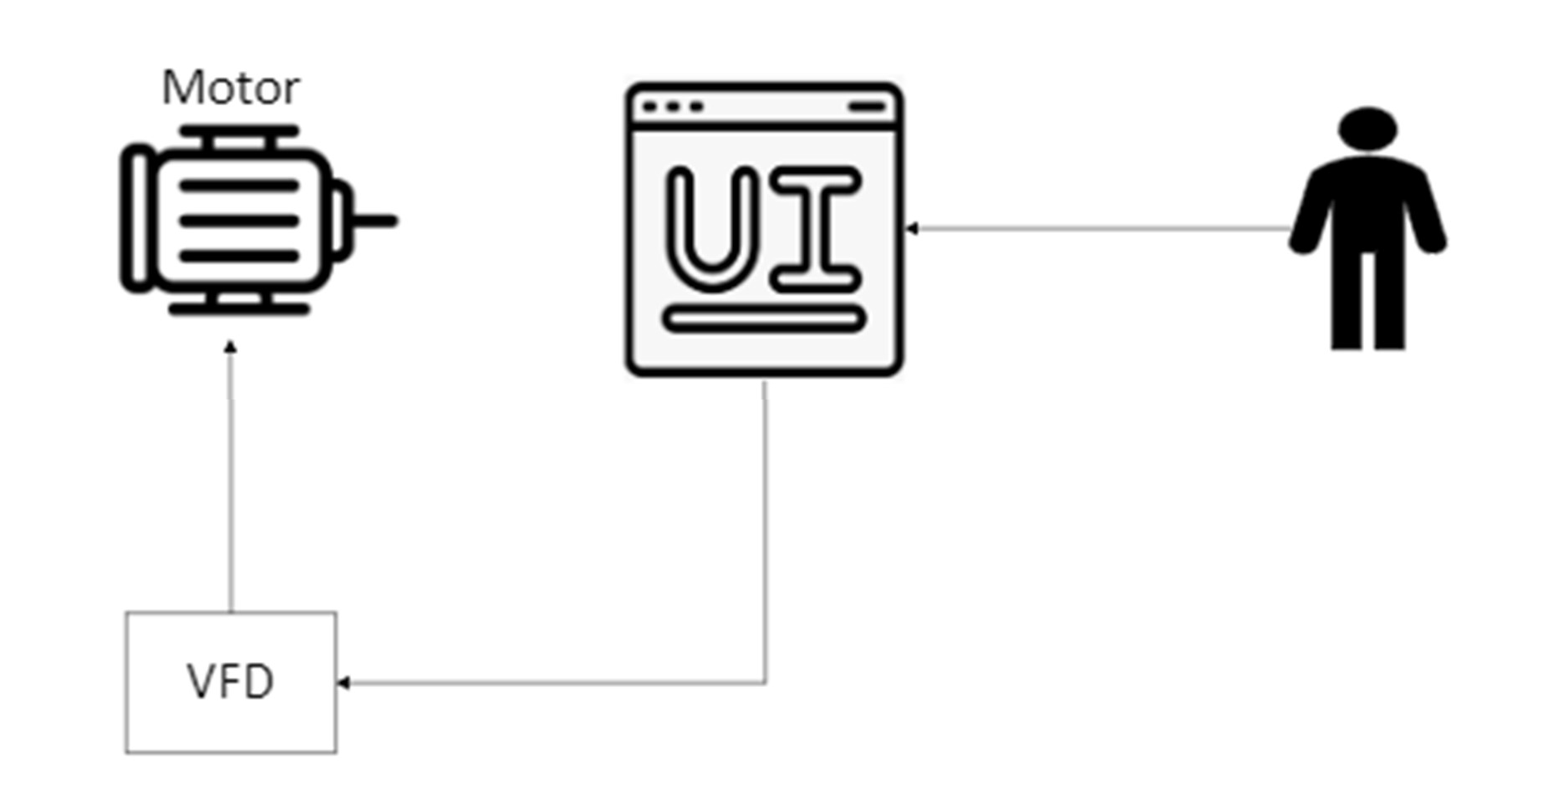

*Figure 1: Project Conceptual Image*

The following definitions differentiate between requirements and other statements. Shall: This is the only verb used for the binding requirements.

Should/May: These verbs are used for stating non-mandatory goals. Will: This verb is used for stating facts or declaration of purpose.

#### *Responsibility and Change Authority*

Briefly describe who has the responsibility for making sure the requirements are met (i.e., team leader) and who has the authority to make the changes (i.e., client and team leader).

**Team Member**

**Subsystem**

|  |  |
| --- | --- |
| Optoelectronics & Monitoring | Mackenzie Miller |
| Microcontroller | Andrew Nguyen |
| Rectifier & DC Link | Aidan Rader |
| Firmware | Ryan Regan |

*Table 1: Subsystem Designations*

## Applicable and Reference Documents

#### *Applicable Documents*

The following documents, of the exact issue and revision shown, form a part of this specification to the extent specified herein:

|  |  |  |
| --- | --- | --- |
| **Document Number** | **Revision/Release Date** | **Document Title** |
| IEEE 519-2014 | 3/27/2014 | Standard for Harmonics |
| NFPA 70 Artcile 430 | 08/8/2023 | Motors, Motor Circuits and Controllers |

*Table 2: Applicable Documents*

#### *Reference Documents*

The following documents are reference documents utilized in the development of this specification. These documents do not form a part of this specification and are not controlled by their reference herein.

|  |  |  |
| --- | --- | --- |
| **Document Number/**  **Publisher** | **Revision/Release Date** | **Document Title** |
| Microsemi | Revision 0/11-03-2005 | DM330030 Datasheet |
| Microchip Technology | Revision 11/06-2022 | dsPIC33CK256MP508 Family Data Sheet |
| Texas Instruments | Revision 3/05-2016 | LM2595 SIMPLE SWITCHER® Power Converter 150-  kHz 1-A Step-Down Voltage Regulator datasheet |
| Skyworks | Revision B/09-2023 | Si861x/2x Low-Power, Single- and Dual-Channel  Digital Isolator |
| Infineon | Revision 2019-10-16 | Control Integrated POwer System  (CIPOS™) IKCM30F60GD |
| IXYS | Revision 2021 | VUE75-06NO7 |

*Table 3: Reference Documents*

#### *Order of Precedence*

In the event of a conflict between the text of this specification and an applicable document cited herein, the text of this specification takes precedence without any exceptions.

All specifications, standards, exhibits, drawings or other documents that are invoked as “applicable” in this specification are incorporated as cited. All documents that are referred to within an applicable report are for guidance and information only, except ICDs that have their relevant documents considered to be incorporated as cited.

## Requirements

#### *System Definition*

The VFD motor controller is comprised of a DC link (includes a rectifier and DC bus), power controller, microcontroller, and optoelectronics. The DC link converts AC input into DC and minimizes the noise of the DC signal. The power controller controls the voltage. The microcontroller is used to produce PWM signals that will drive the motor. Optoelectronics allows for communication between the high voltage side and the low voltage microcontroller.

This is a four-person project split into these roles:

Firmware (Ryan Regan):

Write code in C that allows the rest of the VFD circuit to plug into the microcontroller and function according to desired specifications (how fast does the user want the motor to run). Improve code to potentially include closed loop function (PID loop including VFD, controller, motor, and tachometer to detect motor speed) that would allow for automatic functionality with a given speed setpoint entered into the code

Design and program a user-interface that gives the user access to controlling different features such as the setpoint and start/stop as well as visualize information such as current motor speed, controller output to the VFD, and VFD voltage and current provided to the motor

Sensors (Mackenzie Miller):

The first part of the sensors portion includes two optoelectronic circuits. One of those takes digital signals in and directly converts them to analog. The second, being more complicated, takes analog input, then, using an opto-isolator, the circuit converts the input to digital signals to be sent to the microcontroller. The analog side of the project works with very high voltage, while the digital side works with low voltage. Because of this, the two sides cannot be connected or the microcontroller will be overpowered and break, so the optoelectronics send signals and data across using light. The second part of the sensors portion is a constant current and voltage measurement. This will be done using a current sensing resistor, which has a very small resistance, and a simple voltage divider circuit. These measurements will then be sent back to the firmware. Finally, there will be a tachometer that measures the RPMs of the motor that is also sent to the firmware.

Microcontroller (Andrew Nguyen):

The MCU is supplied by the 15 VDC from the AC power supply fed by the main power. The voltage will then be stepped down to a usable 3.3V. It receives feedback through low-voltage analog signals that represent voltage and current. The MCU will then send out PWM signals to the H bridge and power control system which are used to control the inverter stage of the VFD which helps to adjust the output voltage and frequency supplied to the motor.

Rectifier and DC Link (Aidan Rader):

The rectifier takes in three-phase AC power and converts it into DC power. For each phase, there are parallel diodes acting as a one-way bridge for the current allowing it to flow in only one direction. To maintain the correct current polarity the diode opens and closes in sequence as the AC waveform alternates. The DC output is then filtered by capacitors within the DC link to provide a stable DC voltage for the microprocessor.

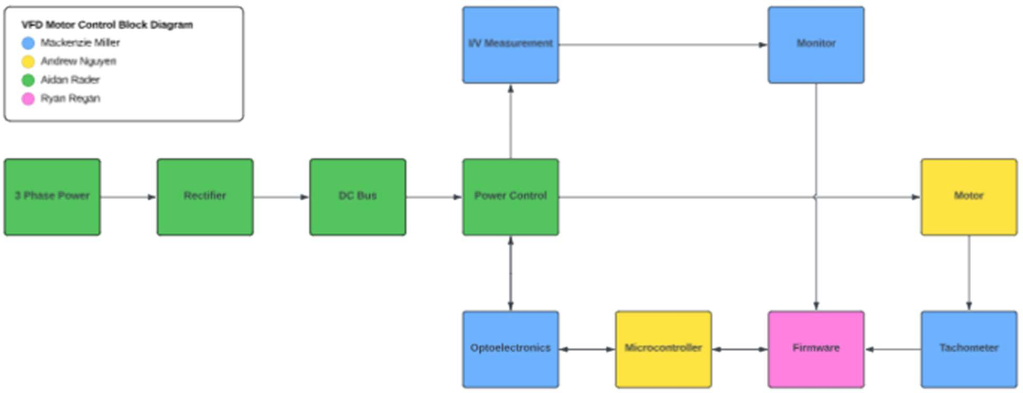

*Figure 2: Block Diagram of System*

#### *Characteristics*

###### Functional / Performance Requirements

* + - 1. **Speed and Torque Requirement**

The 0.25HP VFD motor shall run up to 1800RPM. The torque requirement for this is 73lb-ft of torque.

###### Frequency Requirement

The VFD motor controller shall be able to handle frequencies from 5Hz to 60Hz.

*Rationale: American standard frequency for alternating current*

###### Temperature Requirement

The VFD motor controller shall be able to operate at temperatures ranging from 0°C to 70°C.

*Rationale: Commercial temperature rating standards*

###### Physical Characteristics

* + - 1. **TBD**

###### Electrical Characteristics

###### Inputs

The presence or absence of any combination of the input signals in accordance with ICD specifications applied in any sequence shall not damage the VFD motor controller, reduce its life expectancy, or cause any malfunction, either when the unit is powered or when it is not.

No sequence of command shall damage the VFD, reduce its life expectancy, or cause any malfunction.

*Rationale: By design, should limit the chance of damage or malfunction by user/technician error.*

###### Input Voltage Level

The input voltage level for the VFD shall be three phase 208 VAC.

*Rationale: VFD specification, Sponsor*

###### Input Noise and Ripple

The maximum ripple allowed on the dsPIC33CK is 165mV peak to peak.

*Rationale: The specifications from the dsPIC33CK datasheet at 3.3V*

###### External Commands

The VFD Motor Control Team shall document all external commands in the appropriate ICD.

*Rationale: The ICD will capture all interface details from the low level electrical to the high- level packet format.*

###### Visual Output

The VFD shall include a Graphical User Interface that displays output measurements.

*Rationale: Provides the ability to see the outputs when VFD is running*

###### Connectors

The VFD shall use terminal blocks for all power and signal connections to ensure secure and vibration-resistant connections.

*Rationale: Noise must be limited to maintain signal integrity*

###### Failure Propagation

* + - * 1. **Overtemperature Shutdown**

The VFD shall have a sensor that automatically shuts the system down if the temperature rises above 70 degrees Celsius.

###### TBD

###### Built in Test (BIT)

The VFD shall have an internal subsystem that will generate test signals and evaluate the VFD responses and determine if there is a failure.

## Appendix A: Acronyms and Abbreviations

BIT Built-In Test

CCA Circuit Card Assembly

EMC Electromagnetic Compatibility

EMI Electromagnetic Interference

EO/IR Electro-optical Infrared

FOR Field of Regard

FOV Field of View

GPS Global Positioning System

GUI Graphical User Interface

Hz Hertz

ICD Interface Control Document

kHz Kilohertz (1,000 Hz)

LCD Liquid Crystal Display

LED Light-emitting Diode

mA Milliamp

MHz Megahertz (1,000,000 Hz) MTBF Mean Time Between Failure MTTR Mean Time To Repair

mW Milliwatt

PCB Printed Circuit Board

RMS Root Mean Square

TBD To Be Determined

TTL Transistor-Transistor Logic

USB Universal Serial Bus

VFD Variable Frequency Drive

VME VERSA-Module Europe

## Appendix B: Definition of Terms

VFD Motor Control Mackenzie Miller Andrew Nguyen Aidan Rader Ryan Regan

# Interface Control Document

##### REVISION – 0

26 September 2024

Interface Control Document for

VFD Motor Control

Prepared by:

Author Date

Approved by:

Project Leader Date

John Lusher II, P.E. Date

T/A Date

**Change Record**

|  |  |  |  |  |
| --- | --- | --- | --- | --- |
| **Rev.** | **Date** | **Originator** | **Approvals** | **Description** |
| **0** | 9/26/2024 | VFD Motor Control Team |  | Draft Release |

**Table of Contents**

###### Table of Contents III

###### List of Tables IV

###### List of Figures V

###### No table of figures entries found V

###### Overview 1

###### References and Definitions 2

* 1. Definitions 2

###### Physical Interface 3

* 1. Weight 3
  2. Dimensions 3
     1. Dimension of Optoelectronics and Feedback 3
     2. Dimensions of MCU 3
     3. Dimensions of Rectifier & DC Link 3

###### Thermal Interface 4

* 1. Temperature Sensing 4

###### Electrical Interface 5

* 1. Primary Input Power 5
  2. Voltage and Current Levels 5
  3. Signal Interfaces 5
  4. User Control Interface 5

###### Communications / Device Interface Protocols 6

* 1. Optoelectronic Communications 6
  2. Firmware and MCU Communications 6
  3. Device Peripheral Interface 6
  4. Host Device 6

**List of Tables**

***Table 1: Optoelectronics and Feedback Dimensions*** **3**

***Table 2: MCU Dimensions*** **3**

***Table 3: Rectifier & DC Link Dimensions*** **3**

***Table 4: Maximum Voltage and Current Values*** **5**

### List of Figures

No table of figures entries found.

## Overview

This Interface Control Document (ICD) for the VFD Motor Controller provides an overview of the requirements and specifications for a Variable Frequency Drive that will be used to control a motor and it’s speed. Created by Ryan Regan, Andew Nguyen, Mackenzie Miller, and Aiden Rader, this document describes the physical, electrical, thermal, and communication interfaces for the system.

###### Key Sections:

* Physical Interface: This section depicts the physical aspects of the VFD including weight, dimensions, and physical/spatial requirements.
* Thermal Interface: The VFD includes a thermal monitoring system using the VFO pin and ITRIP pins that will shut the system down if the temperature levels are too high
* Electrical Interface: The electrical specifications include motor power, DC supply voltage, and the microcontroller’s stepped-down voltage supply. The DC voltage will be regulated by an H-bridge, and optoelectronic circuits will be used to isolate the microcontroller from the high voltage section of the system.
* User Interface: The VFD’s firmware includes a Graphical User Interface (GUI) that will allow the user to start/stop the system, change the VFD’s setpoint, and monitor the voltage and current being input to the motor as well as the motor’s speed.
* Communication Protocols: Optoelectronics will be used for communication between the high-voltage power control and the low-voltage microcontroller. Additionally, the system will use UART for serial communication and will have USB connectivity for programming and debugging.

## References and Definitions

#### *Definitions*

AC Alternating Current

DC Direct Current

GUI Graphical User Interface

ICD Interface Control Document

MHz Megahertz (1,000,000 Hz)

MCU Micro Controller Unit

mA Milliamp

mW Milliwatt

N/A Not Applicable

TBD To Be Determined

VFD Variable Frequency Drive

## Physical Interface

#### *Weight*

The VFD motor controller may weigh up to 6lbs. The motor itself may weigh up to 13lbs.

#### *Dimensions*

###### Dimension of Optoelectronics and Feedback

|  |  |  |  |  |
| --- | --- | --- | --- | --- |
| **Component** | **Diameter** | **Length** | **Width** | **Height** |
| Digital Isolator | N/A | 0.406” | 0.406” | 0.104” |
| Analog to Digital Optoisolator | N/A | 0.442” | 0.354” | 0.158” |
| Operational Amplifier | N/A | TBD | TBD | TBD |
| Tachometer Disk | TBD | TBD | TBD | TBD |

*Table 1: Optoelectronics and Feedback Dimensions*

###### Dimensions of MCU

|  |  |  |  |  |
| --- | --- | --- | --- | --- |
| **Component** | **Diameter** | **Length** | **Width** | **Height** |
| dsPIC33CK | N/A | 0.394” | 0.394” | 0.039” |
| LM2595s-3.3 Buck Converter | N/A | 0.400” | 0.180” | 0.450” |
| Operational Amplifier(s) | N/A | TBD | TBD | TBD |

*Table 2: MCU Dimensions*

The physical dimensions of the subsystem will be relative to the size of the user’s laptop and the size of the motor, both should not exceed the size of a standard tabletop.

###### Dimensions of Rectifier & DC Link

|  |  |  |  |  |
| --- | --- | --- | --- | --- |
| **Component** | **Diameter** | **Length** | **Width** | **Height** |
| VUE75-06NO7 | N/A | 1.850” | 1.193” | 0.799” |
| IKCM30F60GD | N/A | 1.417” | 0.827” | 0.201” |
| Capacitor(s) | N/A | TBD | TBD | TBD |
| Inductor(s) | N/A | TBD | TBD | TBD |

*Table 3: Rectifier & DC Link Dimensions*

## Thermal Interface

### Temperature Sensing

The power control shall monitor the temperature via the VFO pin, and if the VFD temperature rises above a safe value, the ITRIP pin will automatically shut the project down to avoid damaging parts.

## Electrical Interface

#### *Primary Input Power*

The motor being used is 0.25HP producing 186.425W of power. The voltage supplied to the system is 295VDC which is then taken in by the H-bridge to generate a line-to-line voltage of 208V. 15VDC power is supplied to the MCU from the AC/DC power supply fed by the main power. This voltage will be stepped down to 3.3V for the MCU to use.

#### *Voltage and Current Levels*

|  |  |  |
| --- | --- | --- |
| **Component** | **Voltage (V)** | **Current (mA)** |
| dsPIC33CK | 3.3V | 50mA |
| IKCM30F60GD | 600V | 60A |

*Table 4: Maximum Voltage and Current Values*

#### *Signal Interfaces*

Pulse Width Modules will be sent from the microcontroller to the power control of the VFD project using optoelectronic circuitry to ensure the microcontroller does not come into contact with the high voltage in the power control.

Three phase voltage values will be sent to the microprocessor from the power control using optoelectronic circuitry to ensure that the microprocessor does not come into contact with the high voltage in the power control.

#### *User Control Interface*

One feature of the VFD’s firmware will be a Graphical User Interface containing 5 different buttons, sliders, and displays. There will be a button that allows the user to start/stop the VFD’s functioning, a slider that allows the user to change the duty cycle percentage (effectively speeding up and slowing down the motor), and three displays that show voltage and current input as well as the detected motor speed from the tachometer. The GUI will open as soon as the C code is ran on the user’s laptop given they have an X server installed.

## Communications / Device Interface Protocols

#### *Optoelectronic Communications*

The high voltage power control of the VFD will communicate to the low voltage or MCU via optoelectronics, or light to ensure that the MCU is not overpowered by the 208 VAC in the analog power control side.

#### *Firmware and MCU Communications*

The UI is programmed with C code and will be used in tandem with the microcontroller to control the on/off and duty cycle functions of the VFD’s input to the motor.

#### *Device Peripheral Interface*

The MCU will use UART interface for serial communication between external devices. This is what will allow a laptop to communicate with the microcontroller without USB connection. The GUI will be able to control and monitor the system without being directly connected to it. On top of this, it will also implement a USB receptacle for programming and debugging purposes.

#### *Host Device*

The C code containing the GUI will be run and used on Ryan Regan’s dell laptop but can be copied onto a flash drive or shared on Google Drive to be used on any computer as long as they have the proper compiling software and an X server installed.

VFD Motor Control Mackenzie Miller Andrew Nguyen Aidan Rader Ryan Regan

# Execution and Validation Plan

##### REVISION – 0

26 September 2024

Execution and Validation Plan Revision - 0

VFD Motor Control

## Execution Plan

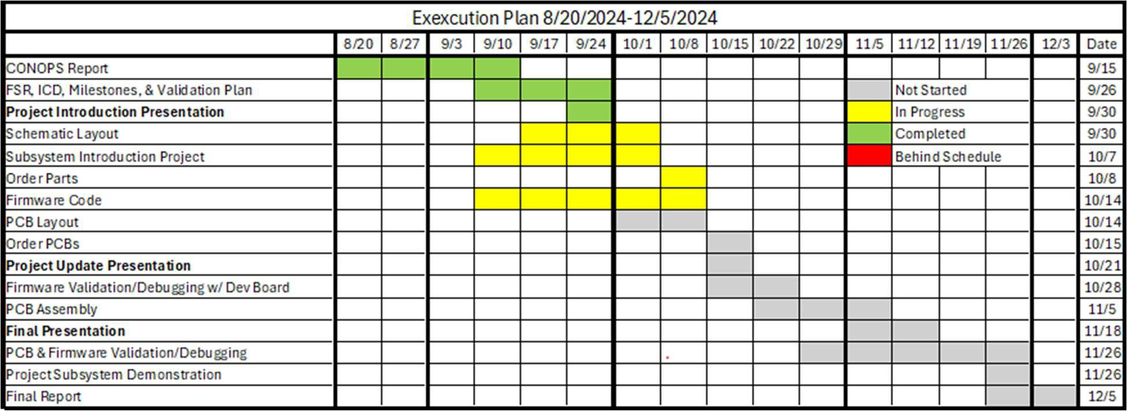

*Figure 1: Execution Plan*

**Validation Plan**

|  |  |  |  |  |  |
| --- | --- | --- | --- | --- | --- |
| Paragraph # | Test Name | Success Criteria | Methodology | Status | Responsible Engineer(s) |
|  | Electrical testing | The parameters are within the expected range. | Confirm that all electrical parameters (voltage, current, power) remain within safe and expected ranges under  varying conditions. | Untested | Aidan/ Mackenzie |
|  | Communication Testing | Firmware is successfully uploaded, and system can  communicate to PC. | Verify that data transfer between the VFD controller and the PC is reliable and supports functions like setting parameters and uploading firmware. | Untested | Andrew/Ryan |
|  | Controller Performance | Motor spins according to user defined parameters. | Validate that the system operates efficiently and delivers accurate motor  control across the expected range of operating conditions. | Untested | All |
| 3 | Thermal Shutdown | System shuts down when experiencing temperatures outside  the specified range. | Run the system at elevated ambient temperatures to ensure components do not overheat and that performance remains stable. | Untested | All |
|  | MCU voltage Step Down | MCU converts the voltage it is given to  3.3V. | Measure the voltage of the signals being sent to the MCU and measure that the MCU converts it to 3.3V. | Untested | Mackenzie/ Andrew |