2024-08-23 Meeting:

-When2meet: <https://www.when2meet.com/?26063770-ozUEt>, 3:30pm-4pm lab meeting, 2:30pm-5pm no lab meeting

-Mackenzie: out of town Fri evening, Sat, and Sun for away football games, no physical meeting

-Microsoft vs google ecosystem: set up Microsoft teams and file system

2024-08-27 Lab:

-Ryan: emailing john for description, and microcontroller dsp33 model number

-Subsystem creation:

-Aidan; Dc link: power -> rectifier -> Dc bus

-Mackenize; Feedback electronics: voltage and current monitoring; optoelectronics

-Drew; Microcontroller: mcu signals; microcontroller

-Ryan; Firmware:

-email John for Altium access

-Shima Hasanpour check-in:

-report weekly progress at the beginning of lab

-John Lusher notes:

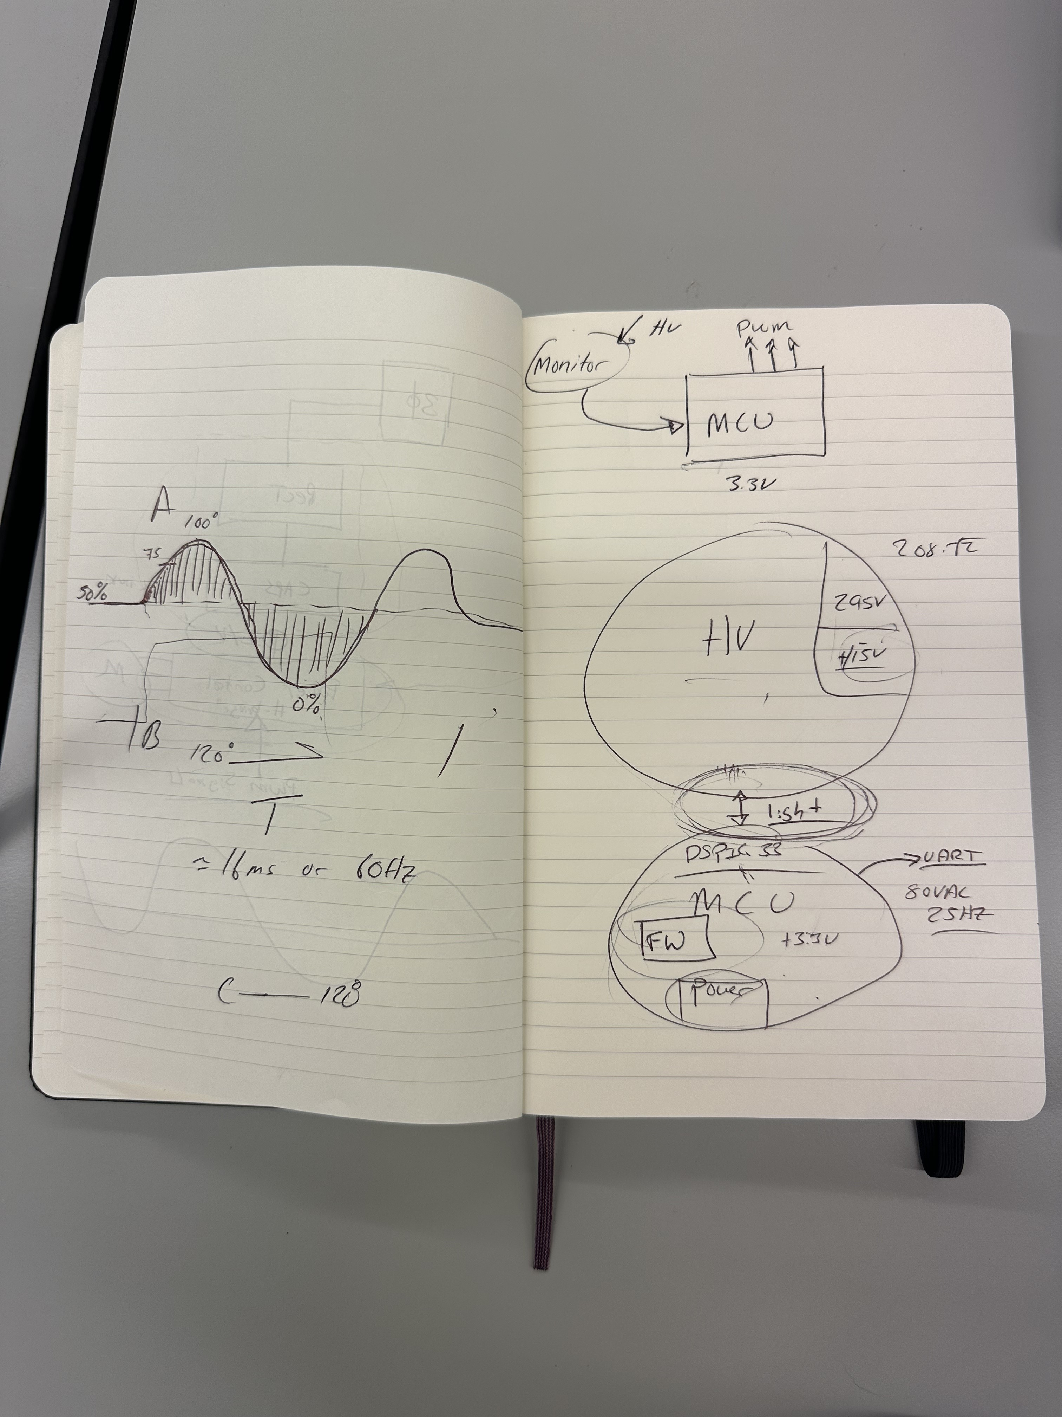

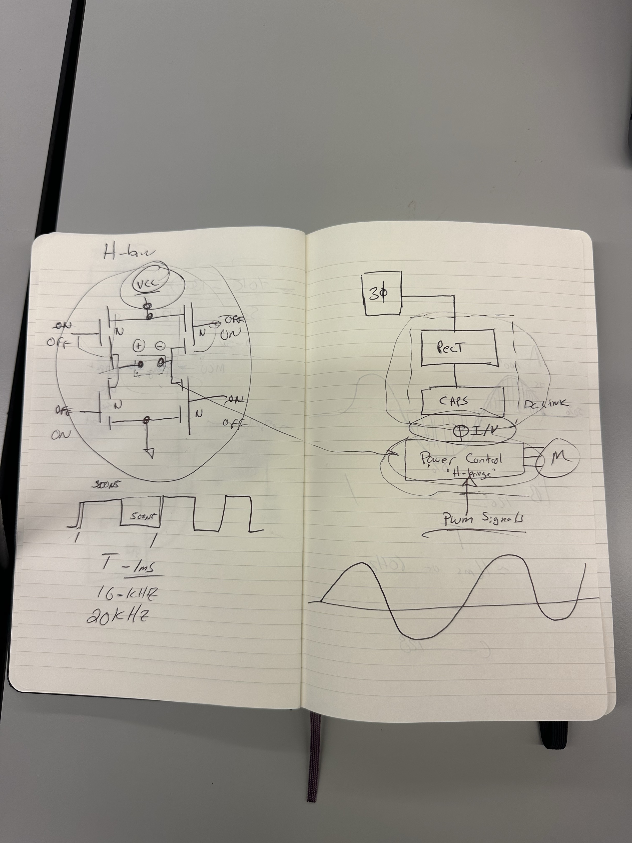

9/3:

-Shima Hasanpour check-in:

-what have you done

-what will you work on this next week

Ryan:

What did I do this week:

- Downloaded VSCode

- Studied the proposed microcontroller that we want to use

- Asked ChatGPT for a skeleton code

What will I do before next week:  
 - Document skeleton code/find out what it does to walk the TA through it

9/10:

-Shima Hasanpour check-in:

Ryan:

What did I do this week:

- Documented code, began work on graphic user interface

- Began debugging compiler issues

What will I do before next week:

- Fix compiler issues

- get the interface code to display something/anything

Aidan:

What did I do this week:

-determined rectifier type

-designed rectifier in altium

-calculated diode values

-designed dc link in altium

-started parts list

-conops

What will I do before next week:

-conops

-calculate capacitor values

-increase technical merit by changing from controlled to uncontrolled design

-full schematic layout

9/15 Meeting

-Aidan, Drew, Mackenzie

-Working on ConOps Report

-all subsystems descriptions moved from executive summary to system description

9/17:

-Shima Hasanpour check-in:

Ryan:

What did I do this week:

- Fixed compiler issues (reinstalled/updated Ubuntu to use for compiling and running)

- Got interface code to display a window with a singular button

- Added several displays such as the start/stop button, a text input for setpoint, and voltage, current, and motor speed displays

What will I do before next week:

- Add labels to the start/stop button and text box

- Fix the text box to add more debugging tools and make it more user-friendly

Aidan:

What did I do this week:

-conops

-calculated rectifier scr values

-calculated dc link capacitor value

-calculated dc link inductor value

What will I do before next week:

-full schematic layout with rectifier part, dc link circuits, and inverter part

-start presentation

-subsystem project

-quiz

9/24:

-Lusher:

-fsr/icd questions about what examples from the template we need and don’t need

-Shima Hasanpour check-in:

Aidan:

What did I do this week:

-full schematic layout: rectifier schematic component, power control schematic component, rd full schematic

-subsystem project: schematic component, pcb component

-FSR, ICD, validation/execution plan

What will I do before next week:

-full schematic layout: fd dc link schematic, fd full schematic

-pcb layout: rectifier pcb component, inverter pcb component

-presentation

-subsystem project: full schematic, full pcb layout, etc.