VFD Motor Controller

Mackenzie Miller

Andrew Nguyen

Aidan Rader

Ryan Regan

**Execution and Validation Plan**

REVISION – 1

28 April 2025

**Execution Plan**

*Figure 1: Execution Plan Fall 2024*

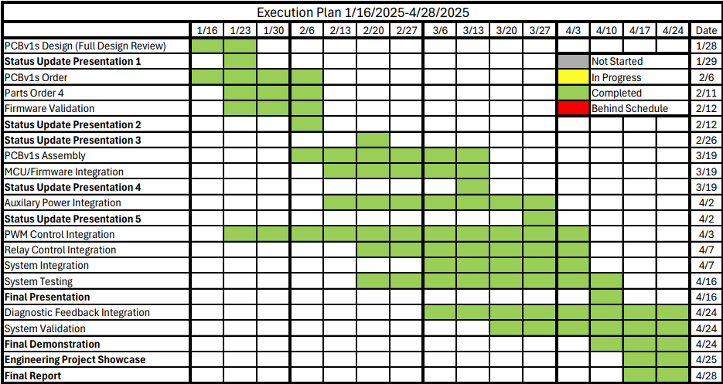

*Figure 2: Execution Plan Spring 2025*

**Validation Plan**

|  |  |  |  |  |  |
| --- | --- | --- | --- | --- | --- |
| Paragraph # | Test Name | Success Criteria | Methodology | Status | Responsible Engineer(s) |
| 3.2.3.11 | 15 VDC to Isolated 15 VDC Conversion | Power converters shall convert 15 VDC to isolated 15 VDC. | Apply 15 VDC input using a DC power supply. Verify 15 VDC output using an oscilloscope. | Tested | Aidan |
| 3.2.3.12 | 15 VDC to 3.3 VDC Conversion | Power converters shall convert 15 VDC to 3.3 VDC. | Apply 15 VDC input using a DC power supply. Verify 3.3 VDC output using an oscilloscope. | Tested | Drew |
| 3.2.3.13 | 3.3 VDC to Isolated 5 VDC Conversion | Power converters shall convert 3.3 VDC to isolated 5 VDC. | Apply 3.3 VDC input using a DC power supply. Verify 5 VDC output using an oscilloscope. | Tested | Aidan |
| 3.2.3.14 | Low Voltage Auxiliary Power | System shall convert 15 VDC to isolated 15 VDC , 3.3 VDC, and isolated 5 VDC. | Apply 15 VDC input using a DC power supply. Verify 15 VDC , 3.3 VDC, and 5 VDC outputs using an oscilloscope. | Tested | Mackenzie, Drew, Aidan |
| 3.2.3.15 | 120 VAC to 15 VDC Conversion | Power converters shall convert 120 VAC to isolated 15 VDC. | Apply 120 VAC input using a 120 VAC outlet. Verify 15 VDC output using an oscilloscope. | Tested | Drew |
| 3.2.3.16 | 120 VAC Auxiliary Power | System shall convert 120 VAC to 15 VDC, isolated 15 VDC , 3.3 VDC, and isolated 5 VDC. | Apply 120 VAC input using a 120 VAC outlet. Verify 15 VDC, 15 VDC , 3.3 VDC, and 5 VDC outputs using an oscilloscope. | Tested | Mackenzie, Drew, Aidan |
| 3.2.3.17 | Relay | Relay shall toggle the motor with the relay signal. | Apply 15 VDC coil voltage, 10 VDC contact voltage, and 5 VDC relay signal using a DC power supply. Verify 10 VDC output using an oscilloscope. | Tested | Aidan |
| 3.2.3.18 | Relay Signal Isolation | Digital to power shall convert the relay signal from 3.3 VDC to 5 VDC. | Apply 5 VDC supply voltage, 3.3 VDC supply voltage, and 3.3 VDC relay signal using a DC power supply. Verify 5 VDC output using an oscilloscope. | Tested | Mackenzie |
| 3.2.3.19 | Relay Signal Generation | MCU shall toggle the relay signal to 3.3 VDC with the button signal. | Apply 3.3 VDC supply voltage and 3.3 VDC button signal using a DC power supply. Verify 3.3 VDC output using an oscilloscope. | Tested | Drew, Ryan |
| 3.2.3.20 | Firmware Relay Signal Generation | Dev board shall toggle the relay signal to 3.3 VDC with the button signal. | (On the dev board) Apply 3.3 VDC supply voltage and 3.3 VDC button signal using a DC power supply. Verify 3.3 VDC output using an oscilloscope. | Tested | Ryan |
| 3.2.3.21 | Button Signal Generation | Button shall toggle the button signal to 3.3 VDC with a button press. | Apply 3.3 VDC supply voltage using a DC power supply and initiate a button press. Verify 3.3 VDC output using an oscilloscope. | Tested | Drew |
| 3.2.3.22 | On/Off Button | System shall toggle the motor between on and off state with a button press. | Apply 15 VDC coil voltage, 10 VDC contact voltage, 5 VDC supply voltage, and 3.3 VDC supply voltage using a DC power supply. Initiate one button press and later a second button press. Verify the motor rotates after the first button press and stops after the second button press using a video. | Tested | All |
| 3.2.3.23 | 10 VAC to 12 VDC Rectification | Rectifier shall convert 120 VAC to 112 VDC. | Apply 120 VAC input using a 120 VAC outlet. Verify 112 VDC output using an oscilloscope. | Tested | Aidan |
| 3.2.3.24 | 120 VAC to 112 VDC Rectification | Rectifier shall convert 120 VAC to 112 VDC. | Apply 120 VAC input using a 120 VAC outlet. Verify 112 VDC output using an oscilloscope. | Tested | Aidan |
| 3.2.3.25 | Power Control | Power control shall invert three high and three low 5 VDC PWM signals into three modified sine waves. | Apply 40 VDC bus voltage and 15 VDC supply voltage using a DC power supply. Apply three high and three low 5 VDC PWM signals at 120˚ phase shifts using a function generator. Verify three modified sine waves at 120˚ phase shifts using an oscilloscope. | Tested | Aidan |
| 3.2.3.26 | PWM Signal Isolation | Digital to power shall convert three high and three low PWM signals from 3.3 VDC to 5 VDC. | Apply isolated 5 VDC supply voltage and 3.3 VDC supply voltage using a DC power supply. Apply three high and three low 3.3 VDC PWM signals at 120˚ phase shifts using a function generator. Verify three high and three low 5 VDC PWM signals at 120˚ phase shifts using an oscilloscope. | Tested | Mackenzie |
| 3.2.3.27 | PWM Signal Generation | MCU shall generate three high and three low 3.3 VDC PWM signals with the knob signal. | Apply 3.3 VDC supply voltage and 3.3 VDC speed knob signal using a DC power supply. Verify three high and three low 3.3 VDC PWM signals at 120˚ phase shifts using an oscilloscope. | Tested | Drew, Ryan |
| 3.2.3.28 | Knob Signal Generation | Rotating potentiometer changes frequency to speed up and slow down motor. | Oscilloscope each signal output, spin knob and ensure the motor speed varies as expected. | Tested | Drew, Ryan |
| 3.2.3.29 | Firmware PWM Signal Generation | Dev board shall generate three high and three low 3.3 VDC PWM signals with the knob signal. | (On dev board) Apply 3.3 VDC supply voltage and 3.3 VDC speed knob signal using a DC power supply. Verify three high and three low 3.3 VDC PWM signals at 120˚ phase shifts using an oscilloscope. | Tested | Ryan |
| 3.2.3.30 | Firmware Knob Signal Generation | Rotating dev board potentiometer changes frequency to speed up and slow down motor. | (On dev board) Oscilloscope each signal output, spin knob and ensure the motor speed varies as expected. | Tested | Ryan |
| 3.2.3.31 | Low Voltage PWM Control | System shall change the motor speed with the knob signal. | Apply 40 VDC bus voltage, 15 VDC supply voltage, isolated 5 VDC supply voltage and 3.3 VDC supply voltage using a DC power supply. Verify the motor rotates at a different speed after a knob turn using a video. | Tested | All |
| 3.2.3.32 | 112 VDC PWM Control | System shall change the motor speed with the knob signal. | Apply 112 VDC bus voltage, 15 VDC supply voltage, isolated 5 VDC supply voltage and 3.3 VDC supply voltage using a DC power supply. Verify the motor rotates at a different speed after a knob turn using a video. | Untested | All |
| 3.2.3.33 | Motor On/Off Signal Generation | MCU shall toggle the motor on/off LED signal to 3.3 VDC with the button signal. | Directly inject 15V to MCU and use multimeter at the motor LED via. | Tested | Drew, Ryan |
| 3.2.3.34 | Motor On/Off LED | System shall toggle the motor on/off LED between on and off states with the motor on/off signal. | Directly inject 15V to MCU, then press relay toggle button and ensure the motor LED toggles. | Tested | Drew, Ryan |
| 3.2.3.35 | System On/Off Signal Generation | MCU shall toggle the circuit on/off LED signal to 3.3 VDC when the board receives power. | Directly inject 15V to MCU and use multimeter at the system LED via. | Tested | Drew, Ryan |
| 3.2.3.36 | System On/Off LED | System shall toggle the circuit on/off LED when the board is connected to power with the circuit on/off signal | Directly inject 15V to MCU and ensure the system LED turns on. | Tested | Drew, Ryan |
| 3.2.3.37 | Firmware Motor On/Off LED Signal Generation | Firmware shall toggle the dev board's on/off LED signal to 3.3 VDC with the button signal. | Directly inject 15V to dev board and use multimeter at the motor LED via. | Tested | Ryan |
| 3.2.3.38 | Firmware Motor On/Off LED | Firmware shall toggle the dev board's on/off LED between on and off states with the motor on/off signal. | Directly inject 15V to dev board, then press relay toggle button and ensure the motor LED toggles. | Tested | Ryan |
| 3.2.3.39 | Firmware System LED Signal Generation | Firmware shall toggle the dev board's on/off LED signal to 3.3 VDC when the board receives power. | Directly inject 15V to dev board and use multimeter at the system LED via. | Tested | Ryan |
| 3.2.3.40 | Firmware System LED | Firmware shall toggle the dev board's on/off LED when the board is connected to power with the circuit on/off signal | Directly inject 15V to dev board and ensure the system LED turns on. | Tested | Ryan |
| 3.2.3.41 | Computer Display | MCU will display diagnostic feedback information to the UART console on a computer running MPLAB X IDE. | Connect system to MPLAB X IDE using a laptop and USB-UART cable. Verify diagnostic print statements are being output to UART console. | Untested | Drew, Ryan |
| 3.2.3.42 | Diagnostic Feedback Signal Isolation | Diagnostic feedback circuit shall transport the voltage, current, and temperature signals from across the isolation barrier to the MCU. | Apply 15 VDC supply voltage, isolated 15 VDC supply voltage, and three 15 VDC feedback signals using a DC power supply. Verify three 15 VDC outputs using an oscilloscope. | Untested | Mackenzie |
| 3.2.3.43 | Diagnostic Feedback Signal Generation | Power Control shall generate 60 VDC voltage, current, and temperature feedback signals. | Apply 40 VDC bus voltage and 15 VDC supply voltage using a DC power supply. Apply three high and three low 5 VDC PWM signals at 120˚ phase shifts using a function generator. Verify three 60 VDC outputs using an oscilloscope. | Untested | Aidan |
| 3.2.3.44 | Diagnostic Feedback | System shall send the voltage, current, and temperature signals to the computer display. | Each feedback signal will be verified through the UART console output. | Untested | All |