Northern Pikeminnow Abundance in Deadwater Slough, Salmon River, Idaho, and Potential Impacts to Local Chinook Salmon Populations

Michael W. Ackerman1,2,✉, Nicholas J. Porter2, Kevin E. See2,3, Tara E. Blackman4, Michael S. Hall2, and Richard A. Carmichael2

07 April, 2022

1 Mount Hood Environmental, PO Box 4282, McCall, Idaho, 83638, USA  
2 Biomark, Inc., 705 South 8th Street, Boise, Idaho, 83702, USA  
3 Washington Department of Fish and Wildlife, Fish Program, Science Division, 1111 Washington Street NE, Olympia, Washington, 98501, USA  
4 Mount Hood Environmental, 39085 Pioneer Boulevard #100 Mezzanine, Sandy, Oregon, 97055, USA

✉ Correspondence: [Michael W. Ackerman <[mike.ackerman@mthoodenvironmental.com](mailto:mike.ackerman@mthoodenvironmental.com)>](mailto:mike.ackerman@mthoodenvironmental.com)

Keywords: Northern Pikeminnow; Chinook Salmon; predation; mark-recapture; bioenergetics

## Abstract

Predation on emigrating juvenile salmonids by piscivorous fishes is a widely-studied source of mortality within reservoirs and dam tailraces in the Columbia River basin. Native Northern Pikeminnow have been estimated to consume ~8% of the approximately 200 million juvenile salmonids emigrating through the lower Snake and Columbia rivers, annually. Less is known about the interaction between upstream, river-dwelling Northern Pikeminnow and their impacts on salmonid recovery above the reservoir systems. In this study, we examine the abundance of Northern Pikeminnow in a slow-water reach of the Salmon River, Idaho, known as Deadwater Slough, and consider their potential impacts on local Chinook Salmon populations. The Deadwater Slough is within a migration corridor for several Chinook Salmon populations as well as other Endangered Species Act-listings including steelhead and Sockeye Salmon. We estimated the abundance of Northern Pikeminnow in Deadwater Slough, an approximately 1.9 kilometer reach of the Salmon River, to be 19,499 in the fall and 10,352 in the spring, corresponding with the peak emigration windows of juvenile Chinook Salmon. Using these abundance values, we estimated Northern Pikeminnow consumption of juvenile Chinook Salmon. Assuming 60% of the Northern Pikeminnow diet is fish, of which 50% is juvenile Chinook Salmon, we estimated the Northern Pikeminnow population can consume 61,409 juvenile Chinook Salmon, annually. After performing a sensitivity analysis, we estimated Northern Pikeminnow predation on juvenile Chinook Salmon was equivalent to 377 (95% CI: 161 - 935) returning adults. Given the relatively small size of the Salmon River, the large densities and potential consumption rates of Northern Pikeminnow in Deadwater Slough suggest predation likely has a consequential impact on Chinook Salmon recovery in the Upper Salmon River.

# Introduction

The Snake and Columbia rivers drain a network of inland tributaries that provide essential spawning and rearing habitat for anadromous Pacific salmon *Oncorhynchus* spp. and steelhead *O. mykiss*. These fishes were historically abundant throughout the basin and consequently have tremendous ecological, cultural, and economic value (Lewis et al. 2019; Atlas et al. 2021). Over the last century, salmonid stocks throughout the Snake and Columbia rivers have undergone significant declines related to habitat modification in the freshwater environment (e.g., removal of beavers, river channel simplification, water withdrawals, hydrosystem development) and poor marine conditions, affecting their survival and recruitment at multiple life stages (Justice et al. 2017; Clark et al. 2020; Crozier et al. 2020). Consequently, action agencies have made considerable investments in the rehabilitation of tributary ecosystems and evaluation of factors attributed to the species decline (Roni et al. 2018; White et al. 2021).

Predation on emigrating juveniles by piscivorous fishes is another important, and potentially under-estimated, source of salmonid mortality. In the lower mainstem Snake and Columbia rivers it is estimated that predation on out-migrating salmonids during peak emigration has a significant negative impact on the overall population and success of recovery efforts (Tabor et al. 1993; Beamesderfer et al. 1996; Friesen and Ward 1999). Dams and reservoirs in the Columbia River are the primary locations associated with high rates of piscine predation on salmonids (Petersen 1994; Ward et al. 1995). There are generally two mechanisms that explain these high predation zones. First, migration (movement) rates of juvenile salmon are reduced during reservoir passage (Venditti et al. 2000), thereby increasing the time migrating smolts are vulnerable to predation. Second, reservoirs and downstream tailraces associated with dams on the Snake and Columbia rivers create favorable slow-water habitat for predatory fishes known to consume juvenile salmonids, such as the Northern Pikeminnow *Ptychocheilus oregonsis*. Northern Pikeminnow tolerate and thrive in relatively warm, slow-water habitats (Wydoski and Whitney 2003) and thus have benefited from dams on the Columbia River, becoming abundant predators of salmonid outmigrants (Knutsen and Ward 1999). Northern Pikeminnow are estimated to consume ~8% (16.4 million) of the approximately 200 million juvenile salmonids emigrating through the lower Snake and Columbia Rivers, annually (Beamesderfer et al. 1996).

Most predation studies have focused on reservoirs (Murphy et al. 2021) and mainstem reaches (Tabor et al. 1993; Ward et al. 1995; Shively et al. 1996; Zimmerman and Ward 1999) of the Columbia River basin whereas considerably less is known about the interaction between upstream, river-dwelling piscivorous fishes and their impacts on salmonid recovery above the reservoir systems (Rubenson et al. 2020). Upstream habitats containing slower water velocities and other attributes that support piscivorous predators may overlap with essential habitat for some salmonid species and life stages. One such example is Deadwater Slough, an approximately 1.9 km long reach of unnaturally slow and deep water in the Salmon River, Idaho. The Deadwater Slough is within a section of the Salmon River containing historically important overwinter rearing habitat for juvenile Chinook Salmon *O. tshawytscha* and is part of the migratory pathway for upstream Chinook Salmon, the endangered Snake River Sockeye Salmon *O. nerka* population (Axel et al. 2015) and several populations of threatened Snake River steelhead. The slough is also inhabited by piscivorous predators, Northern Pikeminnow and Smallmouth Bass *Micropterus dolomieu*, that are potential sources of mortality for rearing and migrating salmonids.

The Salmon River was historically the most productive tributary for Chinook Salmon in the Columbia River basin (Nemeth and Kiefer 1999), but those populations have become depleted in recent decades. Therefore, quantifying the mortality of spring/summer-run Chinook Salmon (hereafter Chinook Salmon) in the Upper Salmon River associated with piscine predation is of particular interest. Importantly, the Salmon River supports eight extant populations of Chinook Salmon upstream of Deadwater Slough (National Oceanic and Atmospheric Administration 2017). This includes the Lemhi River, which was historically the largest population, and is a prioritized candidate for restoration of natural processes to increase production of juvenile Chinook Salmon (Zimmerman et al. 2012).

Chinook Salmon in the Upper Salmon River are stream-type and exhibit two distinct migration tactics; downstream rearing (DSR) and natal reach rearing (NRR) (Copeland et al. 2014). The DSR migrants leave their natal area as subyearlings between June and November and typically overwinter in downstream, mainstem habitats until the following spring when they emigrate to the ocean as smolts. Alternatively, NRR migrants remain in their natal areas for approximately one year after emergence until emigration to the ocean as smolts. Diversity of migration tactics provides a mechanism for coping with adverse conditions in freshwater rearing and migration environments and buffers against catastrophic events, thereby increasing population resiliency (Dodson et al. 2013). Deadwater Slough represents an important habitat for Chinook Salmon in the Upper Salmon River as it supports rearing and migration of juveniles from all upstream populations including fall DSR and spring NRR migrants.

Recent studies have examined the downstream movement, distribution, and apparent survival (hereafter ‘survival’) of juvenile salmonid emigrants through the Salmon River, including the Deadwater Slough reach. Sockeye Salmon migrating through the mainstem Salmon River during spring were estimated to have 32% lower survival in the Deadwater Slough reach compared to directly adjacent reaches (Axel et al. 2015). Similarly, emigrating DSR Chinook Salmon had an approximate 10% reduction in transition probability through the Deadwater Slough compared to surrounding reaches during fall and early winter months (Ackerman et al. 2018; Porter et al. 2019). Low survival was attributed to lack of fish cover and low-velocity water delaying movement rates, thereby increasing predation risk.

In this study, we estimated the abundance of Northern Pikeminnow in the Deadwater Slough and evaluated potential impacts to juvenile salmon emigrants, focusing on DSR and NRR Chinook Salmon. We hypothesized that high densities of piscivorous predators in the Deadwater Slough might explain the reduced survival observed for juvenile Chinook Salmon. To test this, our objectives were four-fold:

1. Estimate the abundance of Northern Pikeminnow in the Deadwater Slough during the peaks of fall DSR and spring NRR juvenile emigrations;
2. Document predation on juvenile Chinook Salmon during the DSR and NRR emigration periods using gastric lavage;
3. Use an established bioenergetics approach to estimate consumption potential (grams) of the Northern Pikeminnow population on DSR and NRR Chinook Salmon emigrants at Deadwater Slough;
4. Estimate how consumption of juvenile Chinook Salmon emigrants at Deadwater Slough by Northern Pikeminnow may impact adult returns to the Upper Salmon River.

# Methods

## Study Site

The Deadwater Slough is an approximately 1.9 km section of the mainstem Salmon River located roughly 6 river kilometers (rkm) downstream from the town of North Fork, Idaho (Figure 1). The downstream end of the slough is located at the confluence of Dump Creek and the Salmon River. A large alluvial fan at the mouth of Dump Creek has, at least partially, created a hydraulic control in the Salmon River resulting in the formation of Deadwater Slough. Although the origin and timing of the alluvial fan and Deadwater Slough is somewhat ambiguous (Reichmuth et al. 1985; USACE 1986), some believe they coincided with the failure of a small mining reservoir in the Dump Creek drainage around 1897 that deposited substantial amounts of sediment at its confluence with the Salmon River (Emerson 1973). The slough is currently a slow, deep section in the river, spanning approximately 12 hectares, averaging 68 m wide, and has characteristics resembling a small reservoir.

## Northern Pikeminnow Demographics

We estimated the population size of piscine predators in the Deadwater Slough using a mark-recapture survey design and a catch per unit effort (CPUE) approach. Predators were sampled near the peaks of the fall DSR and spring NRR emigrations. During our initial survey in 2019, Northern Pikeminnow were the most prevalent piscine predator in Deadwater Slough and consequently became our focal taxa. Our intent was to survey during the emigration of the 2018 Chinook Salmon brood year that occurred fall 2019 and spring 2020, however logistical constraints during the onset of the Covid-19 pandemic delayed the spring 2020 survey until 2021. Over this period, an additional fall survey occurred during the 2020 DSR emigration. Fall surveys were constrained to two weeks to minimize Northern Pikeminnow immigration and emigration.

Multiple capture methods were employed during the fall 2019 survey to reduce selectivity and bias for species and size classes. Methods included raft electrofishing, fyke netting, snorkeling, and angling. After evaluating all methods, angling was the most effective method for capturing Northern Pikeminnow while also minimizing potential impacts to ESA-listed adult steelhead that were present during our surveys. Less effective methods were abandoned in subsequent years and the following analyses will focus on fish captured by angling, unless otherwise noted.

Our study relied heavily on volunteer anglers who were permitted to fish anywhere within Deadwater Slough. Each survey day, anglers boated or hiked their catch (periodically or upon filling a livewell) to a processing station at the boat ramp, approximately 500 m downstream from the top of the slough. For each fish, we recorded the date of capture, species, total length (TL; mm), and whether the fish was previously marked. Unmarked fish were given a physical mark (e.g., hole punch of lower caudal, upper caudal, left pelvic, right pelvic) unique to each day and then were released. Fish release sites were distributed throughout Deadwater Slough to facilitate mixing back into the population. Fish that died prior to release were included in that day’s total capture (or recapture) count, but not included in the number of marked fish available for recapture after that date. Finally, we recorded the angling start and end time for each crew (person or combinations of persons) to calculate CPUE as the number of Northern Pikeminnow caught per angler hour.

Two types of mark-recapture estimators were used to explore variation in abundance estimates: a single census and a multiple census estimator. For the single census estimator, we treated the first week of the survey as the mark event and the following week as the recapture event, pooling data within each week. Alternatively, the multiple census estimator treated each day as a sampling event and used information about the total number of marked fish from all previous events to calculate the total abundance. For the single census estimator, we used the Chapman-modified Lincoln-Peterson estimator:

$$\hat{N}=\frac{\left(M+1\right)\left(n+1\right)}{\left(m+1\right)}-1$$

where $M$ is the total number of fish marked and returned to the population during the first event (week), $n$ is the total number of fish caught in the second event (week), and $m$ is the number of marked fish caught during the second week. For a multiple census estimator, we used the Chapman-modified Schnabel estimator:

$$\hat{N}=\frac{\sum_{i=1}^{k}{n_{i}}M_{i}}{\left(\sum_{i=1}^{k}{m_{i}}\right)+1}$$

where $M$, $n$, and $m$ are indexed by each survey (day), $i$. The 95% confidence intervals of the Schnabel estimator were calculated using a Poisson approximation (Krebs 1999).

Because fish capture was dependent on volunteer anglers, there was concern that sampling effort was biased to locations preferred by anglers. If release sites for marked fish were not proximal to preferred angling locales, recently released fish may have been less susceptible to immediate capture than unmarked fish. To account for this potential bias, we included an adjusted “delayed-mixing” Schnabel estimator that assumed fish marked and released on a given survey day were not available for recapture for 48 hours. The delayed-mixing Schnabel estimator is given by:

$$\hat{N}=\frac{\sum_{i=1}^{k}{n_{i}}M_{i-1}}{\left(\sum_{i=1}^{k}{m_{i}}\right)+1}$$

All mark-recapture abundance estimators include a Chapman correction for small sample sizes (Chapman 1951) and assumed: (1) the population is closed (no immigration, emigration, births or deaths during the survey period), (2) all fish have equal chance of being caught in subsequent survey days, (3) marking a fish does not affect its chances of recapture, (4) no loss of marks, and (5) marks are not missed or misidentified.

Surveys conducted in spring 2021 did not follow a mark-recapture study design so Northern Pikeminnow abundance was estimated as the ratio of mean total CPUE in the fall surveys to the total CPUE in the spring survey, then multiplied that ratio by the mean abundance from fall surveys.

$${\hat{N}}_{spring}={\overline{N}}_{fall}*\frac{CPUE_{spring}}{CPUE_{fall}}$$

This approach assumes equal capture probabilities for fall and spring surveys. Fall and spring population estimates were converted into linear and areal densities by dividing by the length and area of Deadwater Slough, respectively. Length and area were measured in QGIS software (QGIS Development Team 2022) and using drone-generated orthoimagery.

Anglers reported that Northern Pikeminnow in Deadwater Slough were large-bodied. To describe the population size structure, we calculated the proportional stock density (PSD) for Northern Pikeminnow in Deadwater Slough. PSD is the percentage of all fish that meet criteria for “quality-length” (larger) individuals and “stock-length” individuals:

$$PSD=100*\frac{FQ}{FS}$$

where $FQ$ is the number of fish $≥$ quality-length, and $FS$ is the number of fish $≥$ stock-length. For Northern Pikeminnow in Deadwater Slough, we used 380 mm TL for quality-length and 250 mm TL for stock-length (Winther et al. 2020).

## Stomach Contents

Gastric lavage (Foster 1977) was used to examine the stomach contents of Northern Pikeminnow for the presence of juvenile Chinook Salmon and other fishes occupying Deadwater Slough. Immediately following lavage, stomach contents of individuals were preserved with 99% isopropyl alcohol in whirl-paks to be analyzed in a controlled environment. For each stomach sample, total wet weight (grams) was recorded for all stomach contents, including all fish and non-fish items (e.g., macroinvertebrates, organic matter). Fish and fish remnants were identified to the lowest taxonomic unit using diagnostic bones (Hansel et al. 1988; Frost 2000) or were categorized as unknown. Approximately 5% of Northern Pikeminnow were euthanized for dissection (n = 75) after gastric lavage to validate the efficacy of the methodology.

## Fish Consumption Potential

To estimate the total consumption potential of Northern Pikeminnow in Deadwater Slough during the peaks of fall DSR and spring NRR emigrations, we used the Fish Bioenergetics v4.0 application developed by Deslauriers et al. (2017) applied in R statistical software (R Core Team 2021). The daily rate of consumption in grams for an individual Northern Pikeminnow was estimated based on predator and prey energy densities, predator start and end weights, and water temperatures. Separate models were run for the fall period (September 15 - November 30) and the spring period (March 1 - May 31) to coincide with peak emigrations of DSR and NRR juveniles from the Lemhi River, the largest Chinook Salmon population in the Upper Salmon River.

Predator energy density for Northern Pikeminnow was fixed at 6,703 Joules (J)/g (Deslauriers et al. 2017). Prey energy densities were fixed at 3,000 J/g for invertebrates and 21,500 J/g for juvenile Chinook Salmon (Moss et al. 2016). Because we were unable to differentiate juvenile Chinook Salmon from other fish prey, we assume all fish prey have the same energy densities as juvenile Chinook Salmon. The average TL of Northern Pikeminnow caught in Deadwater Slough during our study was converted to fork length (FL) and then to weight (grams) using a weight-length formula from Parker et al. (1995).

$$log_{10}W_{s}=-4.886+2.986\left[log_{10}\left(FL\right)\right]$$

This resulted in average fall DSR and spring NRR starting weights of 598.7 and 430.7 g for Northern Pikeminnow with average TLs of 394.1 and 352.9 mm, respectively. We assumed no growth in individual Northern Pikeminnow, resulting in equal start and end weights. Mean daily water temperatures were summarized from 15-minute interval temperature readings between March 3, 2013 and June 14, 2021 from USGS gage station 13307000, approximately 22 rkm downstream of Deadwater Slough.

The proportion of fish in the Northern Pikeminnow’s diet relative to non-fish prey items is unknown in Deadwater Slough. Therefore, we conducted a series of model runs with varying proportions of fish in the diet ranging from 30 - 90%, in 10% increments. These values were supported by observations elsewhere in the Columbia River basin (54-86%: Shively et al. (1996); 48-86%: Zimmerman and Ward (1999); 37%: Gray and Dauble (2001)) that suggest fish are the majority of Northern Pikeminnow prey by volume. A model run was conducted for each combination of diet scenario and season, resulting in fourteen estimates of the total grams of fish consumed by an individual Northern Pikeminnow. To estimate the total biomass of fish consumed by Northern Pikeminnow in Deadwater Slough, we multiplied the grams of fish consumed by an individual Northern Pikeminnow by the estimated Northern Pikeminnow population sizes during fall and spring.

## Impacts to Chinook Salmon Populations

The proportion of Chinook Salmon prey relative to other fish prey in the Northern Pikeminnow diet is also unknown. However, there is some evidence that juvenile salmonids are by far the most consumed fish prey (Shively et al. 1996; Zimmerman and Ward 1999). Moreover, it is estimated that Chinook Salmon make up 64.2%, 29.3%, and 49.3% of the fish prey consumed by Northern Pikeminnow in the Columbia River below Bonneville Dam, in Columbia River reservoirs, and in the lower Snake River, respectively (Zimmerman and Ward 1999). Because the bioenergetics model does not differentiate juvenile Chinook Salmon from other fish prey items, we performed a sensitivity analysis to assess potential impacts of Northern Pikeminnow predation on local Chinook Salmon populations. Using values similar to Zimmerman and Ward (1999), we modeled three diet scenarios where Chinook Salmon comprised 30%, 50%, and 65% of the fish prey, by weight, in the Northern Pikeminnow diet during the fall DSR and spring NRR emigration periods. In this analysis, we assume 60% of the Northern Pikeminnow’s total diet is comprised of fish, representing the median scenario in our range of modeled diets.

We obtained an estimate of the number of juvenile Chinook Salmon consumed by dividing total biomass consumed by the average weight of DSR (10.3 g) and NRR (10.9 g) emigrants in the Upper Salmon River. The average weights of DSR and NRR emigrants were calculated from fish captured at seven rotary screw traps upstream of Deadwater Slough during the fall and spring periods. Although the primary impact to Chinook Salmon in Deadwater Slough by Northern Pikeminnow is juvenile predation, the common metric to evaluate salmon recovery is adult returns. We quantified the potential impact of Northern Pikeminnow predation on adult returns by estimating the number of equivalent adults expected to return to Lower Granite Dam if predation by Pikeminnow was eliminated in the Deadwater Slough. To accomplish this, we multiplied the estimated total juvenile Chinook Salmon consumed by the median Granite-to-Granite smolt-to-adult return rate (SAR) of 0.00614 (SD = 0.00051) from McCann et al. (2019) for Chinook Salmon in the Upper Salmon River.

All data and code for the analyses presented here can be found in a GitHub repository at ***zenodo DOI***.

# Results

## Northern Pikeminnow Demographics

Using hook-and-line angling, we caught a total of 1,663 Northern Pikeminnow over the course of the study including 14 recaptures; the overall CPUE was 1.32 Northern Pikeminnow per angler hour (Table 1). Mark-recapture abundance estimates of Northern Pikeminnow in Deadwater Slough ranged from 12,480 to 18,732 in fall 2019 and from 24,381 to 37,016 in fall 2020 (Table 3). We estimated larger populations of Northern Pikeminnow using the unadjusted multiple-census estimator compared to the single census and adjusted delayed-mixing multiple census estimators (Figure 2). Our sampling design most closely matched a multiple-census estimator; therefore, the Schnabel estimates were considered most appropriate. Accordingly, the mean Northern Pikeminnow abundance for the two fall sampling events was 27,874 (95% CI: 14,244 - 59,388) using the unadjusted Schabel estimator. Using the delayed-mixing Schnabel estimator the mean fall abundance estimate was 19,499 (95% CI: 9,952 - 41,597). All subsequent analyses use results from the adjusted delayed-mixing Schnabel estimator. For spring 2021, we estimated 10,352 (95% CI: 5,284 - 22,084) Northern Pikeminnow in Deadwater Slough. Those estimates translate to linear densities of 10,422 and 5,533 Northern Pikeminnow per rkm and areal densities (fish/100 m $​^{2}$) of 16.3 and 8.7 for fall and spring, respectively.

The lengths of Northern Pikeminnow ranged from 176 to 639 mm TL with an average of 389 mm (Figure 3). The PSD for Northern Pikeminnow in Deadwater Slough across all three surveys was 50%.

## Stomach Contents

We found that gastric lavage successfully removed food items in all dissected individuals, indicating the method was effective. Of the 1,558 Northern Pikeminnow sampled using gastric lavage, we found contents in 350 (22.5%) stomachs and confirmed fish or fish parts in 44 of those. Northern Pikeminnow captured during spring 2021 had a higher proportion of fish content in their diet compared to individuals captured in the fall surveys (Table 4). The mean wet weight of total contents for an individual was 0.98 g (median = 0.25 g; SD = 2.16 g). Overall, fish or fish remnants made up 11.7% of all stomach contents examined.

## Fish Consumption Potential

During the fall DSR emigration, we estimated an average-size Northern Pikeminnow (394.1 TL mm) to consume 43.55 g of fish to maintain their body size, assuming 60% of their diet consisted of fish prey (Figure 4). Fall consumption ranged from 35.74 g for a diet of 30% fish to 46.91 g for a diet of 90% fish. During the spring NRR emigration, we estimated an average-size Northern Pikeminnow (352.9 TL mm) to consume 42.51 g of fish, assuming 60% of their diet was fish prey (Figure 4). Spring consumption ranged from 34.01 for a diet of 30% fish to 44.33 for a diet of 90% fish. Daily consumption rates were higher early in the fall and late in the spring and corresponded with water temperatures above 8 degrees Celsius (Figure 4). Given estimated mean Northern Pikeminnow population sizes of 19,499 in the fall and 10,352 in the spring 2021, and a diet consisting of 60% fish, the Northern Pikeminnow population was estimated to consume 0.8 metric tons of fish during the fall DSR emigration and 0.4 metric tons during the spring NRR emigration in Deadwater Slough.

## Impacts to Chinook Salmon Populations

Given yearly fish consumption estimates during the fall DSR and spring NRR periods, we produced a sensitivity analysis to calculate the consumption of juvenile Chinook Salmon where 30%, 50%, and 65% of total fish prey consumed were juvenile Chinook Salmon (Figure 5). At the median value of 50%, we estimated that 61,409 (95% CI: 31,342 - 131,004) juvenile Chinook Salmon would be consumed. Using the median Granite-to-Granite SAR for Chinook Salmon in the Upper Salmon River, we estimated the “adult equivalents” of juveniles consumed to be 377 (95% CI: 161 - 935) adults (Figure 6).

# Discussion

All mark-recapture abundance estimators suggest a large population of Northern Pikeminnow occupies Deadwater Slough. The mean population size of Northern Pikeminnow was estimated to be 19,499 during the fall DSR emigration and 10,352 during the spring NRR emigration even after accounting for the potential of delayed mixing of marked fish. Those estimates translate to linear densities (fish/rkm) that are 15 and 8 times greater than densities reported by Beamesderfer and Rieman (1991) for the John Day Reservoir and approximately 4 and 2 times greater than projections for the lower Columbia River (Beamesderfer et al. 1996). Beamesderfer and Rieman (1991) acknowledged that their methods were unsuitable for sampling offshore, noting that water velocity, depth, and irregular bottom contours, and barge traffic made sampling offshore ineffective; therefore it is possible that their estimates may have been low. Conversely, the maximum depth at Deadwater Slough was approximately 6 m with a relatively homogenous bottom contour, making angling an effective method throughout the entire reach. Our estimated densities of Northern Pikeminnow suggest that slow-water reaches outside of the reservoir complexes on the Snake and Columbia rivers may support exceptionally high predator densities, consistent with findings of Harnish et al. (2014), Gray and Dauble (2001), and Zimmerman and Ward (1999). Given the dearth of current data available throughout the Columbia River basin, it is unclear how Northern Pikeminnow abundance estimates in this study compare to elsewhere in the basin; additional information on contemporary piscine predator abundances may be needed (Widener et al. 2021).

Several assumptions in our estimators may have influenced the magnitude of our abundance results. First, all models assumed a closed population; however, it is possible that immigration and emigration occurred. Nevertheless, our estimators still provide unbiased estimates of abundance assuming the immigration and emigration rates were equal between marked and unmarked fish. Emigration of marked individuals could reduce the marking fraction in the population leading to an upward bias in abundance estimates, but emigration rates would have needed to be substantial. The multiple census estimators, which we report, are more robust to this assumption because the marking fraction was estimated daily. We additionally have little reason to believe that emigration occurs during the two-week survey window owing to favorable habitat for Northern Pikeminnow in Deadwater Slough relative to adjacent reaches. Given the size of the sampling area and the short duration of our surveys, the closed population assumption was likely met. This assumption could likewise have affected results if mortality occurred for some marked fish released back to the population. During field processing, no mortalities or injuries post release were observed and fish injured prior to release were retained. Nevertheless, the potential for mortality amongst marked and released fish cannot be discounted.

Next, our abundance estimates assumed that capture and recapture events are random samples of the population. Angling methods often have a size selection bias, thereby limiting abundance estimates to a size range susceptible to angling, resulting in a conservative estimate of the total population. We also question the validity of our assumption of equal catchability of individual fish between sampling events. Two individual fish were recaptured during multiple days within a survey, indicating that marked fish were continually susceptible to angling. It is also possible that marked and released fish may not have immediately mixed thoroughly back into the population. Although we attempted to release marked fish evenly throughout Deadwater Slough, we anecdotally observed anglers congregating in particular areas of the slough to socialize or exploit “good” fishing locales. Violations of the assumption of equal catchability between marked and unmarked fish may have led to an overestimate of abundance of Northern Pikeminnow in our study if marked fish have lower catchability. This bias will be proportional to the difference in catchability of marked and unmarked fish. As an example, if marked fish were only 70% as likely to be caught as unmarked fish, the true abundance is closer to 70% of our abundance estimate. This would additionally account for marked and released fish being “hook shy” for a period of time. The adjusted delayed-mixing Schnabel estimator may account for these biases; however, the magnitude of bias is unknown.

The spring abundance estimate was smaller than fall abundance estimates due to the spring CPUE being approximately half of the mean fall CPUE (Table 1). Although our approach assumed equal capture probabilities between the fall and spring surveys, we believe that higher spring flows may result in lower capture probabilities of Northern Pikeminnow. Therefore, we believe our spring abundance estimate to be conservative.

In addition to the large population abundance, the observed (50%) PSD in this study was greater than observations of 41% below Bonneville Dam and 18% in Bonneville Reservoir (Winther et al. 2020). This suggests that a larger fraction of Northern Pikeminnow in Deadwater Slough are of a quality size relative to populations reported elsewhere in the Columbia River. Notably, the Idaho state catch-and-release record Northern Pikeminnow, measuring 639 mm TL, was caught in Deadwater Slough during the fall 2020 survey.

We performed gastric lavage on nearly all Northern Pikeminnow collected during this study. Observed prey species included juvenile Chinook Salmon as well as Redside Shiner *Richardsonius balteatus*, Largescale Sucker *Catostomus macrocheilus*, sculpin *Cottus* spp., and Mountain Whitefish *Prosopium williamsoni*, though decomposition from digestion rendered most fish contents unidentifiable. Although our approach provided useful information on prey species, the use of angling and gastric lavage to quantify diet composition in Northern Pikeminnow can be problematic. First, diets of angled fish can differ from those collected by other methods such as electrofishing (Hodgson and Cochran 1988). For instance, angled fish are more likely to have empty stomachs (Jurajda et al. 2016); possibly because they are captured while actively searching for food, suggesting they are hungry. Second, unlike other predators such as Smallmouth Bass and Walleye, that are commonly sampled using gastric lavage (Kamler and Pope 2001), Northern Pikeminnow are cyprinids and therefore lack a true stomach. Consequently, performing gastric lavage on cyprinid species can be ineffective for accurately quantifying diet composition (Hartleb and Moring 1995), or alternately, requires a modification in methodology to flush food items out the vent of the fish (Wasowicz and Valdez 1994). Therefore, we consider our diet composition estimates from gastric lavage to be conservative.

Our bioenergetics approach assumed that all available prey consumed by Northern Pikeminnow have energy densities equal to juvenile Chinook Salmon. Generalizing energy densities using a single species is a common approach (Petersen and Ward 1999). Other salmonids including juvenile steelhead and Sockeye Salmon are likely also available prey in Deadwater Slough, especially during the spring migration, and so generalizing energy densities among salmonids may not be problematic. Additionally, hatchery smolt releases (Chinook Salmon, steelhead, and Sockeye Salmon) are also prevalent in the mainstem Salmon River during the spring migration. To address the prevalence of other fish in the Northern Pikeminnow’s diet, we considered scenarios where DSR and NRR Chinook Salmon represent only 30%, 50%, and 65% of total fish prey consumed. These values may be considered conservative during the peak emigration periods when Chinook Salmon are abundant and the Northern Pikeminnow diet shifts almost entirely to piscivory, presumably on juvenile Chinook Salmon (Poe et al. 1991; Shively et al. 1996). This is likely the case during fall months when DSR Chinook Salmon are the dominant prey species available within the Salmon River and Deadwater Slough as 1) few to no hatchery releases are present in the river and 2) fall emigrations of steelhead and Sockeye Salmon are less prominent than Chinook Salmon. During spring when natural-origin steelhead and Sockeye Salmon are also actively emigrating from the Upper Salmon River and hatchery-origin releases of all three species (Chinook Salmon, steelhead, Sockeye Salmon) are present in the river, less than 50% Chinook Salmon in the Northern Pikeminnow’s diet may be more likely. Future work to quantify and identify juvenile salmonids in Deadwater Slough during their seasonal migration would be useful to validate the diet composition assumptions used in our model and to understand impacts to local populations.

Chinook Salmon populations above Deadwater Slough are within the Upper Salmon major population group (MPG) which supports eight independent, extant populations including Salmon River (above Redfish Lake Creek), Valley Creek, Yankee Fork Salmon River, East Fork Salmon River, Salmon River (mainstem below Redfish Lake Creek), Pahsimeroi River, Lemhi River, and North Fork Salmon River (National Oceanic and Atmospheric Administration 2017). Recovery of the MPG is desired to support local fisheries and economies. At least five of the eight populations must meet criteria set forth by McElhany et al. (2000) and the Interior Columbia Technical Recovery Team (2007) for the MPG to be considered viable and for recovery of the Snake River Evolutionary Significant Unit. We estimated that 61,409 juvenile Chinook Salmon may be consumed by Northern Pikeminnow assuming that 60% of their diet is fish and 50% of fish prey are Chinook Salmon. For context, this is approximately 1.35 times the average annual combined DSR and NRR emigration estimates for brood years 2011 - 2018 at a rotary screw trap located in the lower Lemhi River (Poole et al. 2019; Feeken et al. 2020; McClure et al. 2021), the largest population in the Upper Salmon MPG. Even under the most conservative scenario where 30% of the Northern Pikeminnow diet is fish and 30% of fish prey are Chinook Salmon, we estimate that 29,988 juvenile Chinook Salmon may be consumed which is 66% of the total DSR and NRR emigration for brood years 2011 - 2018. Considering that diet scenarios used in our study are likely conservative assumptions, especially during the fall DSR emigration, the estimated number of Chinook Salmon consumed is substantial.

Spawner abundance is perhaps the most important metric considered in determining a population’s viability and productivity. We estimated that consumption of juvenile Chinook Salmon by Northern Pikeminnow in the Deadwater Slough is equivalent to 377 adults, annually, which is 68% of the total mean spawner escapement for the Upper Salmon MPG in 2017 – 2019 (Kinzer et al. 2020). In the most conservative scenario, we estimated juvenile consumption equivalent to 184 adults, which is 33% of recent natural-origin adult Chinook Salmon returns. In the least conservative scenarios, adult equivalents approached recent escapements for the entire Upper Salmon MPG. The sensitivity analysis used some simplifying assumptions; for example, it assumed no juvenile mortality between Deadwater Slough and Lower Granite Dam which is an unrealistic assumption. Nevertheless, we found converting juveniles consumed to “adult equivalents” a useful exercise to place results in context with a metric commonly used for recovery.

In addition to juvenile Chinook Salmon, juvenile steelhead and Sockeye Salmon, including both natural-origin juveniles and hatchery releases, are also likely prey items for Northern Pikeminnow in Deadwater Slough. Accordingly, we surmise that juvenile emigration and adult returns of steelhead and Sockeye Salmon are also affected by predation, including hatchery populations, which provide for recreational fishing opportunities in the Upper Salmon River. Consequently, reducing predation mortality in Deadwater Slough could potentially benefit multiple upriver natural and hatchery populations, including other ESA-listed species. Because Deadwater Slough is part of the migratory pathway for multiple species and populations of emigrating salmonids, the positive impact could be greater than individual tributary rehabilitation actions which typically benefit a single population. Predation on juveniles from any of the ESA-listed salmonid species is likely detrimental to their recovery.

Deadwater Slough is a favorable candidate for management or restoration actions to benefit local Chinook Salmon populations. Three potential management actions could reduce predation at Deadwater Slough: 1) removing or reducing the Dump Creek alluvial fan, 2) a local Northern Pikeminnow bounty program to encourage harvest in Deadwater Slough aimed at reducing the predator population size, and 3) adding structure or cover within Deadwater Slough to provide refuge for juvenile salmonids to reduce predation rates. Reducing or removing the Dump Creek alluvial fan has the benefit of restoring natural fluvial processes in the Salmon River that likely existed in the reach prior to the formation or increase in size of the alluvial fan. Restoring natural processes could reduce Northern Pikeminnow densities to levels similar to upstream and downstream reaches where higher survival and transition probabilities for juvenile salmon have been observed relative to Deadwater Slough (Axel et al. 2015; Ackerman et al. 2018; Porter et al. 2019). Managers ought also to consider the feasibility and net benefit of restoring fluvial processes relative to potential losses for recreational fishing and bird watching opportunities (<https://www.audubon.org/important-bird-areas/deadwater-slough>).

Northern Pikeminnow bounty programs have proven successful at reducing population sizes and impacts on emigrating salmonids in the Columbia River (Winther et al. 2020). A local Northern Pikeminnow bounty program could provide monetary incentive for sportfisherman, in addition to boosting the local economy from lost revenues. Bounty programs could be conducted year-round or seasonally to coincide with peak juvenile outmigration(s). Each approach would require continual/annual effort and harvest to suppress the population size and as such, appropriate funding would be needed to support the program. Lastly, a more passive approach could be to improve cover or structure within Deadwater Slough that provides refugia for juvenile salmonids during their emigration. Cover should be appropriately sized to provide concealment to juvenile fishes while reducing access by larger fishes like Northern Pikeminnow. Adding cover could be a cost-effective approach; however, its potential effectiveness is unclear.

Although the origins of Deadwater Slough are somewhat ambiguous (Reichmuth et al. 1985; USACE 1986), it is likely that human activities in Dump Creek appear to have either exacerbated or contributed to its formation, and in turn, created favorable conditions for Northern Pikeminnow. Among the three surveys, our lowest population abundance estimate was greater than 10,000 Northern Pikeminnow occupying Deadwater Slough, suggesting a remarkably high density given the size of the area. The slow water velocity and lack of cover for fish also create conditions where juvenile salmonids that are rearing in or emigrating through Deadwater Slough, including Chinook Salmon, are susceptible to predation. We estimate that, at a minimum, Northern Pikeminnow in Deadwater Slough consume greater than 15,000 juvenile Chinook Salmon (the lower endpoint of the confidence interval for the most conservative scenario); however, it is likely that this value is closer to 61,000, annually. The magnitude of predation by Northern Pikeminnow is equivalent to 33% and 94% of recent adult escapements. Deadwater Slough predates the ESA-listing of Chinook Salmon populations in the Upper Salmon MPG in the 1990s and is therefore unlikely to be the primary cause for the population’s decline. However, predation by Northern Pikeminnow in Deadwater Slough and elsewhere should be considered among limiting factors hindering recovery efforts of ESA-listed Chinook Salmon populations in the Upper Salmon MPG.

# Acknowledgements

The authors extend much appreciation to the many volunteers that assisted with field efforts including collaborators from the Bureau of Reclamation, Idaho Governor’s Office of Species Conservation, Idaho Department of Fish and Game, and the Lemhi Regional Land Trust, among others. Special thanks to Braden Lott, Jared Barker, Brian Hamilton, Tulley Mackey, and Chelsea Welke for their help in the field. We further appreciate the administrative support and guidance from staff at Inter-Fluve. This manuscript benefited from reviews by Sean Gibbs, Mark Roes, and Ian Courter. Funding for this study was provided by the Bureau of Reclamation, Pacific Northwest Regional Office (contract No. 140R1021F0018) with assistance from the Idaho Governor’s Office of Species Conservation.

# Literature Cited

Ackerman, M. W., G. A. Axel, R. A. Carmichael, and K. See. 2018. Movement and distribution of sp/sum Chinook Salmon presmolts in the mainstem Salmon River, pilot study. Technical report prepared for Idaho Governor’s Office of Species Conservation.

Atlas, W. I., N. C. Ban, J. W. Moore, A. M. Tuohy, S. Greening, A. J. Reid, N. Morven, E. White, W. G. Housty, J. A. Housty, C. N. Service, L. Greba, S. Harrison, C. Sharpe, K. I. R. Butts, W. M. Shepert, E. Sweeney-Bergen, D. Macintyre, M. R. Sloat, and K. Connors. 2021. Indigenous systems of management for culturally and ecologically resilient Pacific salmon (*Oncorhynchus* spp.) fisheries. BioScience 71(2):186–204.

Axel, G. A., M. Peterson, C. C. Kozfkay, B. P. Sandford, M. G. Nesbit, B. J. Burke, K. E. Frick, and J. J. Lamb. 2015. Characterizing migration and survival between the upper Salmon River basin and Lower Granite Dam for juvenile Snake River sockeye salmon, 2014. Report of research by Fish Ecology Division, Northwest Fisheries Science Center, National Marine Fisheries Service, National Oceanic and Atmospheric Administration and Idaho Department of Fish and Game. Prepared for Division of Fish and Wildlife, Bonneville Power Administration. 36 pp.

Beamesderfer, C. P., D. L. Ward, and A. A. Nigro. 1996. Evaluation of the biological basis for a predator control program on Northern Pikeminnow (*Ptychocheilus* *Oregonensis*) in the Columbia and Snake rivers. Canadian Journal of Fisheries and Aquatic Sciences 53(12):2898–2908.

Beamesderfer, R. C., and B. E. Rieman. 1991. Abundance and distribution of Northern Squawfish, Walleyes, and Smallmouth Bass in John Day Reservoir, Columbia River. Transactions of the American Fisheries Society 120:439–447.

Chapman, D. G. 1951. Some Properties of the Hypergeometric Distribution with Applications to Zoological Sample Censuses. University of California Publications Statistics 1:131–160.

Clark, C., P. Roni, J. Keeton, and G. Pess. 2020. Evaluation of the removal of impassable barriers on anadromous salmon and steelhead in the Columbia River Basin. Fisheries Management and Ecology 27(1):102–110.

Copeland, T., M. W. Ackerman, M. P. Corsi, P. Kennedy, K. K. Wright, M. R. Campbell, and W. C. Schrader. 2014. Wild Juvenile Steelhead and Chinook Salmon Abundance and Composition at Lower Granite Dam, Migratory Years 2010 and 2011. Idaho Department of Fish and Game.

Crozier, L. G., J. E. Siegel, L. E. Wiesebron, E. M. Trujillo, B. J. Burke, B. P. Sandford, and D. L. Widener. 2020. Snake River Sockeye and Chinook Salmon in a changing climate: Implications for upstream migration survival during recent extreme and future climates. PLOS ONE 15(9):e0238886.

Deslauriers, D., S. R. Chipps, J. E. Breck, J. A. Rice, and C. P. Madenjian. 2017. Fish Bioenergetics 4.0: An R-based modeling application. Fisheries 42(11):586–596.

Dodson, J. J., N. Aubin-Horth, V. Thériault, and D. J. Páez. 2013. The evolutionary ecology of alternative migratory tactics in salmonid fishes: Alternative migratory tactics as threshold traits. Biological Reviews 88(3):602–625.

eBird. 2021. eBird: An online database of bird distribution and abundance [web application]. eBird, Cornell Lab of Ornithology, Ithaca, New York. Available: http://www.ebird.org. Accessed: November 10, 2021.

Emerson, J. L. 1973. A history of the Salmon National Forest. United States Forest Service. 194 pp.

Evans, A. F., N. J. Hostetter, D. D. Roby, K. Collis, D. E. Lyons, B. P. Sandford, R. D. Ledgerwood, and S. Sebring. 2012. Systemwide evaluation of avian predation on juvenile salmonids from the Columbia River based on recoveries of passive integrated transponder tags. Transactions of the American Fisheries Society 141(4):975–989.

Evans, A. F., Q. Payton, A. Turecek, B. Cramer, K. Collis, D. D. Roby, P. J. Loschl, L. Sullivan, J. Skalski, M. Weiland, and C. Dotson. 2016. Avian predation on juvenile salmonids: Spatial and temporal analysis based on acoustic and passive integrated transponder tags. Transactions of the American Fisheries Society 145(4):860–877.

Feeken, S. F., B. Barnett, E. Felts, E. J. Stark, M. Davison, J. R. Poole, C. McClure, B. A. Knoth, and M. E. Dobos. 2020. Idaho Anadromous Emigrant Monitoring, 2019 Annual Report. IDFG Report Number 20-09:67.

Foster, J. R. 1977. Pulsed gastric lavage: An efficient method of removing the stomach contents of live fish. The Progressive Fish-Culturist 39(4):166–169.

Friesen, T. A., and D. L. Ward. 1999. Management of Northern Pikeminnow and implications for juvenile salmonid survival in the lower Columbia and Snake rivers. North American Journal of Fisheries Management 19(2):406–420.

Frost, C. N. 2000. A key for identifying preyfish in the Columbia River based on diagnostic bones. U.S. Geological Survey, Western Fisheries Research Center, Columbia River Research Laboratory.

Gray, R. H., and D. D. Dauble. 2001. Some Life History Characteristics of Cyprinids in the Hanford Reach, Mid-Columbia River. Northwest Science 75(2):122–136.

Hansel, H. C., S. D. Duke, P. T. Lofy, and G. A. Gray. 1988. Use of diagnostic bones to identify and estimate original lengths of ingested prey fishes. Transactions of the American Fisheries Society 117(1):55–62.

Harnish, R. A., E. D. Green, K. A. Deters, K. D. Ham, Z. Deng, H. Li, B. Rayamajhi, K. W. Jung, and G. A. McMichael. 2014. Survival of wild Hanford Reach and Priest Rapids Hatchery fall Chinook Salmon juveniles in the Columbia River: Predation implications. Pacific Northwest National Laboratory.

Hartleb, C. F., and J. R. Moring. 1995. An improved gastric lavage device for removing stomach contents from live fish. Fisheries Research 24(3):261–265.

Hodgson, J. R., and P. A. Cochran. 1988. The effect of sampling methodology on diet analysis in largemouth bass (*Micropterus* *Salmoides*). SIL Proceedings, 1922-2010 23(3):1670–1675.

Interior Columbia Technical Recovery Team. 2007. Viability criteria for application to interior Columbia basin salmonid ESUs. National Marine Fisheries Service, Northwest Fisheries Science Center, National Oceanographic and Atmospheric Administration.

Jurajda, P., K. Roche, I. Sedlacek, and L. Vsetickova. 2016. Assemblage characteristics and diet of fish in the shallow coastal waters of James Ross Island, Antarctica. Polar Biology 39(12):2299–2309.

Justice, C., S. M. White, D. A. McCullough, D. S. Graves, and M. R. Blanchard. 2017. Can stream and riparian restoration offset climate change impacts to salmon populations? Journal of Environmental Management 188(2017):212–227.

Kamler, J. F., and K. L. Pope. 2001. Nonlethal methods of examining fish stomach contents. Reviews in Fisheries Science 9(1):1–11.

Kinzer, R., R. Orme, M. Campbell, J. Hargrove, and K. See. 2020. Report to NOAA Fisheries for 5-Year ESA Status Review: Snake River Basin Steelhead and Chinook Salmon population abundance, life History, and diversity metrics calculated from in-stream PIT-tag observations (SY2010-SY2019). IPTDSW (In-stream PIT-tag detection systems workgroup). 118 pp.

Knutsen, C. J., and D. L. Ward. 1999. Biological characteristics of Northern Pikeminnow in the lower Columbia and Snake rivers before and after sustained exploitation. Transactions of the American Fisheries Society 128(6):1008–1019.

Krebs, C. J. 1999. Ecological methodology. Addison Welsey Educational Publishers, Inc., Menlo Park, CA.

Lewis, D. J., S. J. Dundas, D. M. Kling, D. K. Lew, and S. D. Hacker. 2019. The non-market benefits of early and partial gains in managing threatened salmon. PLOS ONE 14(8):e0220260.

McCann, J., B. Chockley, E. Cooper, B. Hsu, G. Scheer, S. Haeseker, R. Lessard, T. Copeland, E. Tinus, A. Storch, D. Rawding, and M. DeHart. 2019. Comparative survival study of PIT-tagged spring/summer/fall Chinook, summer steelhead, and Sockeye. Draft 2019 annual report. BPA Project #19960200. Available at: https://www.fpc.org/documents/CSS/2019CSS_FullDRAFT.pdf.

McClure, C., B. Barnett, E. A. Felts, M. Davison, N. Smith, B. A. Knoth, J. R. Poole, and S. F. Feeken. 2021. Idaho Anadromous Emigrant Monitoring, 2020 Annual Report. IDFG Report Number 21-11:65.

McElhany, P., M. H. Ruckelshaus, M. J. Ford, T. C. Wainwright, and E. P. Bjorkstedt. 2000. Viable salmonid populations and the recovery of evolutionarily significant units. U.S. Department of Commerce, National Oceanic and Atmospheric Administration, Technical Memo. NMFS-NWFSC-42.:156 pp.

Moss, J., J. Murphy, E. Fergusson, and R. Heintz. 2016. Allometric relationships between body size and energy density of juvenile Chinook (*Oncorhynchus* *Tshawytscha*) and Chum (*O. Keta*) Salmon across a latitudinal gradient. North Pacific Anadromous Fish Commission Bulletin 6(1):161–168.

Murphy, C. A., J. D. Romer, K. Stertz, I. Arismendi, R. Emig, F. Monzyk, and S. L. Johnson. 2021. Damming salmon fry: Evidence for predation by non-native warmwater fishes in reservoirs. Ecosphere 12(9):e03757.

National Oceanic and Atmospheric Administration. 2017. ESA recovery plan for Snake River spring/summer Chinook Salmon (*Oncorhynchus* *Tshawytscha*) and Snake River basin steelhead (*Oncorhynchus* *Mykiss*).

Nemeth, D. J., and R. B. Kiefer. 1999. Snake River spring and summer Chinook Salmon choice for recovery. Fisheries 24(10):16–23.

Parker, R. M., M. P. Zimmerman, and D. L. Ward. 1995. Variability in biological characteristics of Northern Squawfish in the lower Columbia and Snake rivers 124:335–346.

Petersen, J. H. 1994. Importance of spatial pattern in estimating predation on juvenile salmonids in the Columbia River. Transactions of the American Fisheries Society 123(6):924–930.

Petersen, J. H., and D. L. Ward. 1999. Development and corroboration of a bioenergetics model for Northern Pikeminnow feeding on juvenile salmonids in the Columbia River. Transactions of the American Fisheries Society 128(5):784–801.

Poe, T. E., H. C. Hansel, S. Vigg, D. E. Palmer, and L. A. Prendergast. 1991. Feeding of predaceous fishes on out-migrating juvenile salmonids in John Day Reservoir, Columbia River. Transactions of the American Fisheries Society 120(4):405–420.

Poole, J. R., E. Felts, M. Dobos, B. Barnett, M. Davison, C. J. Roth, B. A. Knoth, and E. J. Stark. 2019. Idaho Anadromous Emigrant Monitoring, 2018 Annual Report. IDFG Report Number 19-11:71.

Porter, N. J., M. W. Ackerman, T. Mackey, G. A. Axel, and K. E. See. 2019. Movement and distribution of Chinook Salmon presmolts in the mainstem Salmon River, 2018/2019 annual report. Prepared by Biomark, Inc. - Applied Biological Services and Fish Ecology Division, Northwest Fisheries Science Center, National Marine Fisheries Service, National Oceanic and Atmospheric Administration. 47 pp.

QGIS Development Team. 2022. QGIS Geographic Information System. Open Source Geospatial Foundation.

R Core Team. 2021. R: A language and environment for statistical computing. R Foundation for Statistical Computing, Vienna, Austria.

Reichmuth, D., A. Potter, M. Knops, and M. Leaverton. 1985. Reducing Ice Jams Along the Salmon River Deadwater Reach: Problems, Proposals and Prospects. A Prelminary Review, Evaluation and Proposal. Page 69. Geomax, Prepared for {{Idaho Department}} of {{Fish}} and {{Game}}.

Roni, P., P. J. Anders, T. J. Beechie, and D. J. Kaplowe. 2018. Review of tools for identifying, planning, and implementing habitat restoration for Pacific salmon and steelhead. North American Journal of Fisheries Management 38(2):355–376.

Rubenson, E. S., D. J. Lawrence, and J. D. Olden. 2020. Threats to rearing juvenile Chinook Salmon from nonnative Smallmouth Bass inferred from stable isotope and fatty acid biomarkers. Transactions of the American Fisheries Society 149(3):350–363.

Shively, R. S., T. P. Poe, M. B. Sheer, and R. Peters. 1996. Criteria for reducing predation by Northern Squawfish near juvenile salmonid bypass outfalls at Columbia River dams. Regulated Rivers: Research & Management 12(4-5):493–500.

Tabor, R. A., R. S. Shively, and T. P. Poe. 1993. Predation of juvenile salmonids by Smallmouth Bass and Northern Pikeminnow in the Columbia River near Richland, Washington. North American Journal of Fisheries Management 13(4):831–838.

USACE. 1986. Salmon River Flood Damage Reduction. Lemhi County, Idaho. Detailed Project Report and Environmental Impact Statement. Page 705. US Army Corps of Engineers.

Venditti, D. A., D. W. Rondorf, and J. M. Kraut. 2000. Migratory behavior and forebay delay of radio-tagged juvenile fall Chinook Salmon in a lower Snake River impoundment. North American Journal of Fisheries Management 20(1):41–52.

Ward, D. L., J. H. Petersen, and J. J. Loch. 1995. Index of predation on juvenile salmonids by Northern Squawfish in the lower and middle Columbia River and in the lower Snake River. Transactions of the American Fisheries Society 124:321–334.

Wasowicz, A., and R. A. Valdez. 1994. A nonlethal technique to recover gut contents of Roundtail Chub. North American Journal of Fisheries Management 14(3):656–658.

White, S. M., S. Brandy, C. Justice, K. A. Morinaga, L. Naylor, J. Ruzycki, E. R. Sedell, J. Steele, A. Towne, J. G. Webster, and I. Wilson. 2021. Progress towards a comprehensive approach for habitat restoration in the Columbia Basin: Case study in the Grande Ronde River. Fisheries 46(5):229–243.

Widener, D. L., J. R. Faulkner, S. G. Smith, T. M. Marsh, and R. W. Zabel. 2021. Survival estimates for the passage of spring-migrating juvenile salmonids through Snake and Columbia River dams and reservoirs, 2020. U.S. Department of Commerce, NOAA Contract Report NMFS-NWFSC-CR-2021-05.

Winther, E., C. M. Barr, C. Miller, and C. Wheaton. 2020. Report on the predation index, predator control fisheries, and program evaluation for the Columbia River Basin Northern Pikeminnow Sport Reward Program, 2020 annual report. Pages 155 pp. Pacific States Marine Fisheries Commission, Washington Dept. of Fish and Wildlife, Oregon Dept. of Fish and Wildlife.

Wydoski, R. S., and R. R. Whitney. 2003. Inland fishes of Washington: Second edition, revised and expanded. University of Washington Press.

Zimmerman, M. P., and D. L. Ward. 1999. Index of predation on juvenile salmonids by Northern Pikeminnow in the lower Columbia River basin from 1994-96. Transactions of the American Fisheries Society 128(6):995–1007.

Zimmerman, M., K. Krueger, P. Roni, B. Bilby, J. Walters, and T. Quinn. 2012. Intensively Monitored Watersheds Program: An updated plan to monitor fish and habitat responses to restoration actions in the lower Columbia watersheds:41.

# Tables

Table 1: Summary of Northern Pikeminnow angling survey data. Fall surveys included mark and recapture weeks for the single census estimate. Spring surveys included only a single capture week to estimate catch-per-unit-effort.

|  |  |  |  |  |  |  |
| --- | --- | --- | --- | --- | --- | --- |
| Survey | Survey Week | Date | Fish Caught | Recaptures | Marked Fish Returned | CPUE |
| Fall 2019 | 1 | Nov 12 | 29 | 0 | 28 | 1.83 |
| Nov 13 | 146 | 0 | 146 |
| Nov 14 | 93 | 1 | 93 |
| 2 | Nov 19 | 149 | 2 | 132 |
| Nov 20 | 104 | 1 | 77 |
| Nov 21 | 143 | 4 | 118 |
| Fall 2020 | 1 | Oct 20 | 173 | 0 | 170 | 1.23 |
| Oct 21 | 188 | 1 | 187 |
| Oct 22 | 104 | 0 | 102 |
| Oct 23 | 41 | 0 | 41 |
| 2 | Oct 27 | 42 | 0 | 41 |
| Oct 28 | 47 | 1 | 46 |
| Oct 29 | 157 | 4 | 156 |
| Oct 30 | 45 | 0 | 45 |
| Spring 2021 | 1 | May 18 | 85 | - | - | 0.81 |
| May 19 | 64 | - | - |
| May 20 | 41 | - | - |
| May 21 | 12 | - | - |

Table 2: Bioenergetics model runs to estimate the grams of fish consumed during the fall DSR and spring NRR Chinook Salmon emigrations. The date ranges for each model run, the assumed proportion of fish in the diet, and the total grams of fish consumed by an individual Northern Pikeminnow to maintain its body weight for a given season are shown. Northern Pikeminnow start and end weights were 598.7 and 430.7 g for the fall and spring seasons, respectively.

| **Season** | **Date Range** | **% Fish in Diet** | **g Consumed** |
| --- | --- | --- | --- |
| Fall | Sep 15 – Nov 30 | 30 | 35.74 |
| 40 | 39.37 |
| 50 | 41.75 |
| 60 | 43.55 |
| 70 | 44.88 |
| 80 | 45.98 |
| 90 | 46.91 |
| Spring | Mar 1 – May 31 | 30 | 34.01 |
| 40 | 39.54 |
| 50 | 39.54 |
| 60 | 42.51 |
| 70 | 42.51 |
| 80 | 43.52 |
| 90 | 44.33 |

Table 3: Point estimates, standard errors, and 95% confidence intervals for each of the mark-recapture estimators and for the fall sampling efforts. Standard errors are not available for the multiple-census estimators.

| **Survey** | **Estimator** | $$\hat{N}$$ | **SE** | **95% CI** |
| --- | --- | --- | --- | --- |
| Fall 2019 | Chapman | 13,298 | 4,322 | 6,898 - 27,893 |
| Fall 2019 | Schnabel | 18,732 | NA | 10,057 - 37,851 |
| Fall 2019 | Schnabel - Delayed Mixing | 12,480 | NA | 6,701 - 25,219 |
| Fall 2020 | Chapman | 24,381 | 9,066 | 11,547 - 55,761 |
| Fall 2020 | Schnabel | 37,016 | NA | 18,430 - 80,924 |
| Fall 2020 | Schnabel - Delayed Mixing | 26,518 | NA | 13,203 - 57,975 |

Table 4: Counts of the total number of Northern Pikeminnow captured, gastric lavaged, individuals with stomach contents, and individuals with fish prey contents.

| **Survey** | **Captured** | **Lavaged** | **Stomach Contents** | **Fish Contents** |
| --- | --- | --- | --- | --- |
| Fall 2019 | 664 | 660 | 57 | 12 |
| Fall 2020 | 797 | 793 | 188 | 25 |
| Spring 2021 | 202 | 105 | 105 | 7 |
| Total | 1,663 | 1,558 | 350 | 44 |

# Figures

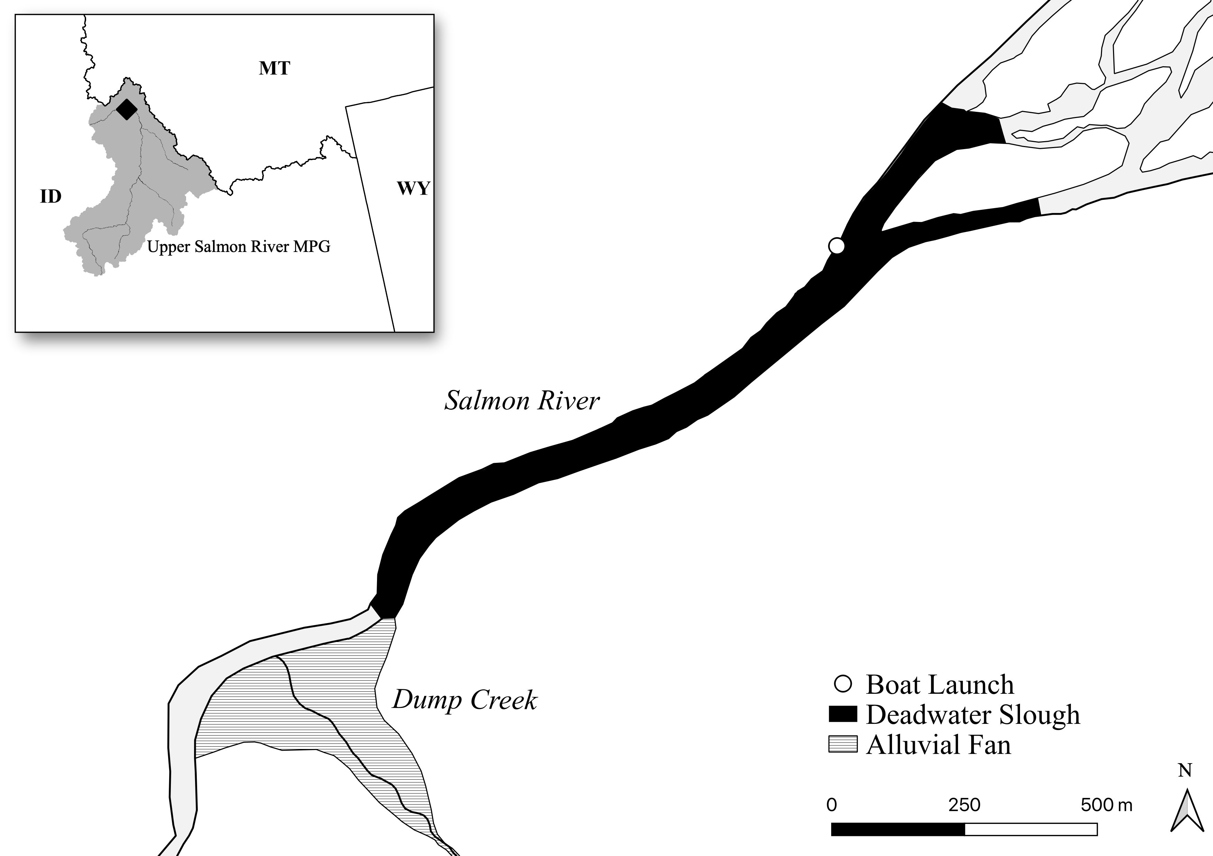

Figure 1: Map of the Deadwater Slough study area within the Upper Salmon River MPG. The Dump Creek alluvial fan is loacted at the downstream end of the study reach.

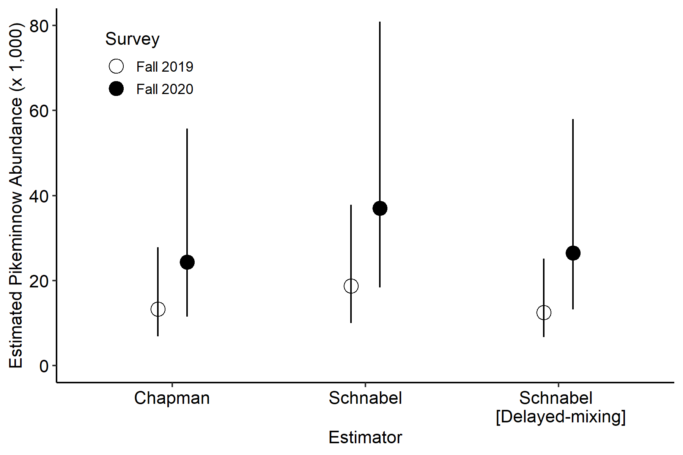

Figure 2: Estimated abundance of Northern Pikeminnow in Deadwater Slough from three mark-recapture estimators for the fall surveys. Error bars indicate 95% confidence intervals.

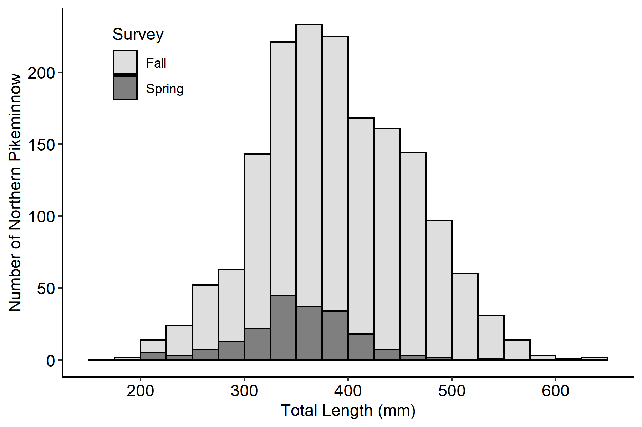

Figure 3: Length frequency histogram of Northern Pikeminnow caught using hook-and-line angling during the study.

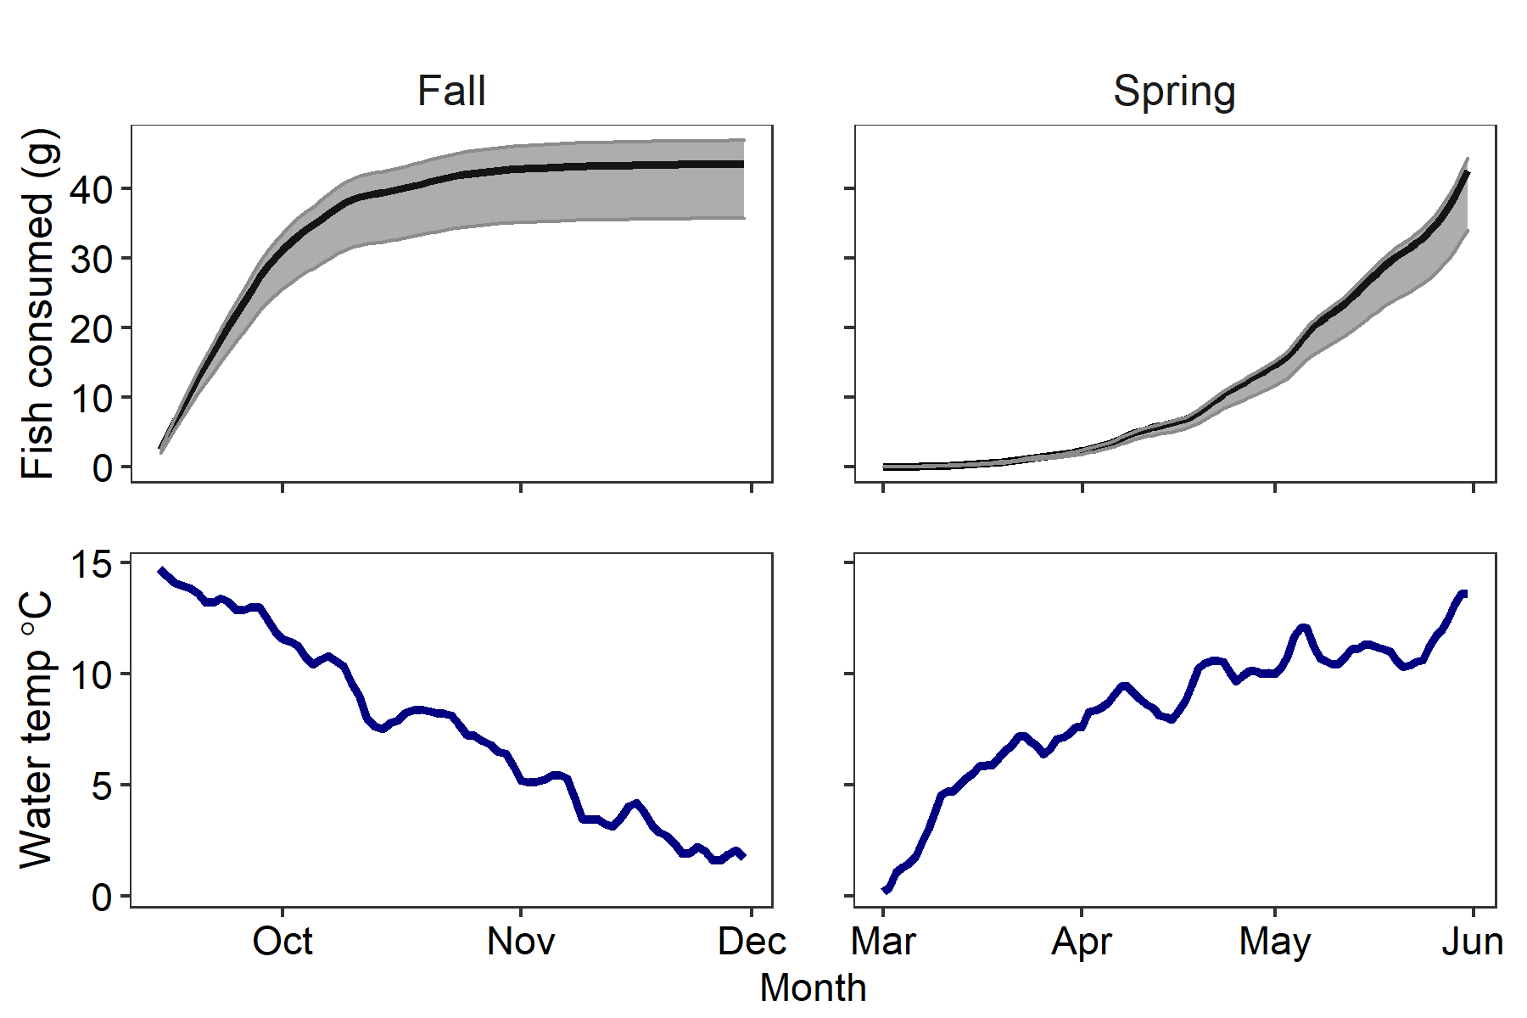

Figure 4: The cumulative fish prey consumed (g) by an individual Northern Pikeminnow during the peak Chinook Salmon emigrations for fall DSR (top left) and spring NRR (top right) and corresponding daily mean water temperatures (bottom panels). The black line is the median Northern Pikeminnow diet scenario, consisting of 60% fish and the gray area shows the range between diet scenarios of 30% and 90% fish prey. Daily mean water temperatures were summarized from six years of data available from the Shoup gage station.

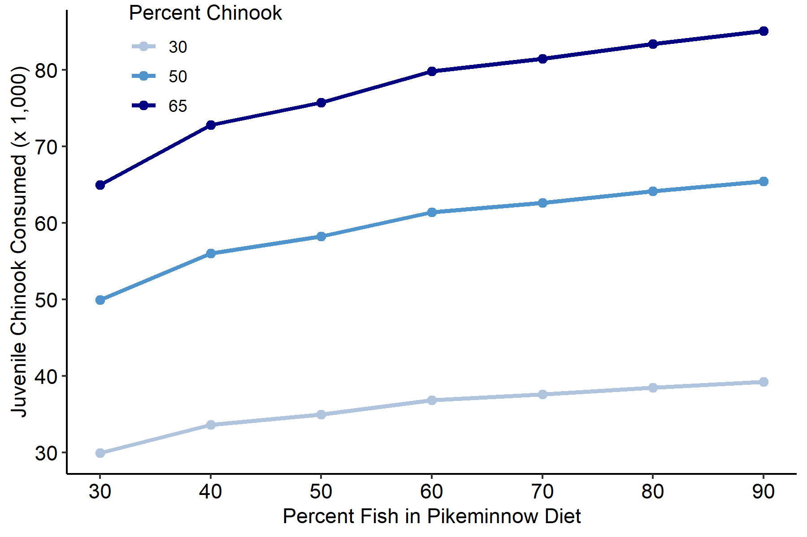

Figure 5: Estimated number of juvenile Chinook Salmon consumed by Northern Pikeminnow from a sensitivity analysis of diet scenarios made up of variable percentages of fish. The proportion of Chinook Salmon in the total fish prey consumed by Northern Pikminnow were evaluated for 30%, 50%, and 65% scenarios, similar to those reported by Zimmerman and Ward 1999

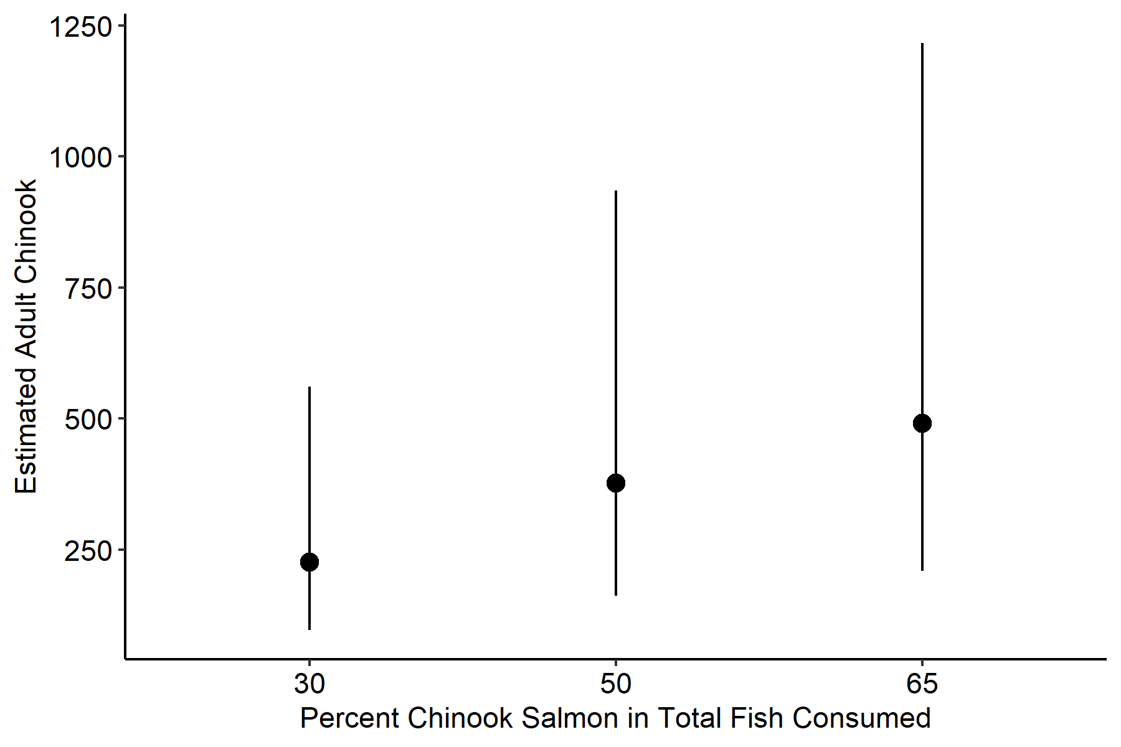

Figure 6: Estimated reduction in the annual number of returning adult Chinook Salmon as a result of Northern Pikeminnow predation. Error bars indicate 95% confidence intervals.

### Colophon

This report was generated on 2022-04-07 07:08:25 using the following computational environment and dependencies:

#> - Session info ---------------------------------------------------------------  
#> setting value  
#> version R version 4.1.1 (2021-08-10)  
#> os Windows 10 x64 (build 22000)  
#> system x86_64, mingw32  
#> ui RTerm  
#> language (EN)  
#> collate English_United States.1252  
#> ctype English_United States.1252  
#> tz America/Denver  
#> date 2022-04-07  
#> pandoc 2.14.0.3 @ C:/Program Files/RStudio/bin/pandoc/ (via rmarkdown)  
#>   
#> - Packages -------------------------------------------------------------------  
#> package * version date (UTC) lib source  
#> assertthat 0.2.1 2019-03-21 [1] CRAN (R 4.1.1)  
#> backports 1.4.1 2021-12-13 [1] CRAN (R 4.1.2)  
#> bit 4.0.4 2020-08-04 [1] CRAN (R 4.1.1)  
#> bit64 4.0.5 2020-08-30 [1] CRAN (R 4.1.1)  
#> bookdown 0.24 2021-09-02 [1] CRAN (R 4.1.1)  
#> broom 0.7.11 2022-01-03 [1] CRAN (R 4.1.2)  
#> cachem 1.0.6 2021-08-19 [1] CRAN (R 4.1.1)  
#> callr 3.7.0 2021-04-20 [1] CRAN (R 4.1.1)  
#> cellranger 1.1.0 2016-07-27 [1] CRAN (R 4.1.1)  
#> cli 3.1.1 2022-01-20 [1] CRAN (R 4.1.2)  
#> colorspace 2.0-2 2021-06-24 [1] CRAN (R 4.1.2)  
#> crayon 1.5.0 2022-02-14 [1] CRAN (R 4.1.2)  
#> data.table 1.14.2 2021-09-27 [1] CRAN (R 4.1.1)  
#> DBI 1.1.2 2021-12-20 [1] CRAN (R 4.1.2)  
#> dbplyr 2.1.1 2021-04-06 [1] CRAN (R 4.1.1)  
#> desc 1.4.0 2021-09-28 [1] CRAN (R 4.1.1)  
#> devtools 2.4.2 2021-06-07 [1] CRAN (R 4.1.1)  
#> digest 0.6.28 2021-09-23 [1] CRAN (R 4.1.1)  
#> dplyr * 1.0.7 2021-06-18 [1] CRAN (R 4.1.1)  
#> ellipsis 0.3.2 2021-04-29 [1] CRAN (R 4.1.1)  
#> english * 1.2-6 2021-08-21 [1] CRAN (R 4.1.2)  
#> evaluate 0.14 2019-05-28 [1] CRAN (R 4.1.1)  
#> fansi 1.0.2 2022-01-14 [1] CRAN (R 4.1.2)  
#> farver 2.1.0 2021-02-28 [1] CRAN (R 4.1.1)  
#> fastmap 1.1.0 2021-01-25 [1] CRAN (R 4.1.1)  
#> forcats * 0.5.1 2021-01-27 [1] CRAN (R 4.1.1)  
#> fs 1.5.0 2020-07-31 [1] CRAN (R 4.1.1)  
#> FSA * 0.9.1 2021-07-17 [1] CRAN (R 4.1.2)  
#> generics 0.1.2 2022-01-31 [1] CRAN (R 4.1.2)  
#> ggplot2 * 3.3.5 2021-06-25 [1] CRAN (R 4.1.1)  
#> glue 1.6.1 2022-01-22 [1] CRAN (R 4.1.2)  
#> gridExtra * 2.3 2017-09-09 [1] CRAN (R 4.1.2)  
#> gtable 0.3.0 2019-03-25 [1] CRAN (R 4.1.1)  
#> haven 2.4.3 2021-08-04 [1] CRAN (R 4.1.1)  
#> here * 1.0.1 2020-12-13 [1] CRAN (R 4.1.1)  
#> highr 0.9 2021-04-16 [1] CRAN (R 4.1.1)  
#> hms 1.1.1 2021-09-26 [1] CRAN (R 4.1.1)  
#> htmltools 0.5.2 2021-08-25 [1] CRAN (R 4.1.1)  
#> httr 1.4.2 2020-07-20 [1] CRAN (R 4.1.1)  
#> janitor * 2.1.0 2021-01-05 [1] CRAN (R 4.1.1)  
#> jsonlite 1.7.3 2022-01-17 [1] CRAN (R 4.1.2)  
#> kableExtra * 1.3.4 2021-02-20 [1] CRAN (R 4.1.1)  
#> knitr 1.37 2021-12-16 [1] CRAN (R 4.1.2)  
#> labeling 0.4.2 2020-10-20 [1] CRAN (R 4.1.1)  
#> lattice 0.20-44 2021-05-02 [2] CRAN (R 4.1.1)  
#> lemon * 0.4.5 2020-06-08 [1] CRAN (R 4.1.2)  
#> lifecycle 1.0.1 2021-09-24 [1] CRAN (R 4.1.1)  
#> lubridate * 1.8.0 2021-10-07 [1] CRAN (R 4.1.1)  
#> magrittr * 2.0.1 2020-11-17 [1] CRAN (R 4.1.1)  
#> memoise 2.0.1 2021-11-26 [1] CRAN (R 4.1.2)  
#> modelr 0.1.8 2020-05-19 [1] CRAN (R 4.1.1)  
#> munsell 0.5.0 2018-06-12 [1] CRAN (R 4.1.1)  
#> pillar 1.7.0 2022-02-01 [1] CRAN (R 4.1.2)  
#> pkgbuild 1.3.1 2021-12-20 [1] CRAN (R 4.1.2)  
#> pkgconfig 2.0.3 2019-09-22 [1] CRAN (R 4.1.1)  
#> pkgload 1.2.4 2021-11-30 [1] CRAN (R 4.1.2)  
#> plyr 1.8.6 2020-03-03 [1] CRAN (R 4.1.1)  
#> prettyunits 1.1.1 2020-01-24 [1] CRAN (R 4.1.1)  
#> processx 3.5.2 2021-04-30 [1] CRAN (R 4.1.1)  
#> ps 1.6.0 2021-02-28 [1] CRAN (R 4.1.1)  
#> purrr * 0.3.4 2020-04-17 [1] CRAN (R 4.1.1)  
#> R6 2.5.1 2021-08-19 [1] CRAN (R 4.1.1)  
#> Rcpp 1.0.7 2021-07-07 [1] CRAN (R 4.1.1)  
#> readr * 2.1.2 2022-01-30 [1] CRAN (R 4.1.2)  
#> readxl 1.3.1 2019-03-13 [1] CRAN (R 4.1.1)  
#> remotes 2.4.2 2021-11-30 [1] CRAN (R 4.1.2)  
#> reprex 2.0.1 2021-08-05 [1] CRAN (R 4.1.1)  
#> rlang 0.4.12 2021-10-18 [1] CRAN (R 4.1.1)  
#> rmarkdown 2.11 2021-09-14 [1] CRAN (R 4.1.1)  
#> rprojroot 2.0.2 2020-11-15 [1] CRAN (R 4.1.1)  
#> rstudioapi 0.13 2020-11-12 [1] CRAN (R 4.1.1)  
#> rvest 1.0.2 2021-10-16 [1] CRAN (R 4.1.1)  
#> scales 1.1.1 2020-05-11 [1] CRAN (R 4.1.1)  
#> sessioninfo 1.2.2 2021-12-06 [1] CRAN (R 4.1.2)  
#> snakecase 0.11.0 2019-05-25 [1] CRAN (R 4.1.1)  
#> stringi 1.7.6 2021-11-29 [1] CRAN (R 4.1.2)  
#> stringr * 1.4.0 2019-02-10 [1] CRAN (R 4.1.1)  
#> svglite 2.0.0 2021-02-20 [1] CRAN (R 4.1.1)  
#> systemfonts 1.0.3 2021-10-13 [1] CRAN (R 4.1.1)  
#> testthat 3.1.0 2021-10-04 [1] CRAN (R 4.1.1)  
#> tibble * 3.1.6 2021-11-07 [1] CRAN (R 4.1.2)  
#> tidyr * 1.2.0 2022-02-01 [1] CRAN (R 4.1.2)  
#> tidyselect 1.1.1 2021-04-30 [1] CRAN (R 4.1.2)  
#> tidytable * 0.6.5 2021-09-03 [1] CRAN (R 4.1.1)  
#> tidyverse * 1.3.1 2021-04-15 [1] CRAN (R 4.1.1)  
#> tzdb 0.2.0 2021-10-27 [1] CRAN (R 4.1.1)  
#> usethis 2.1.3 2021-10-27 [1] CRAN (R 4.1.1)  
#> utf8 1.2.2 2021-07-24 [1] CRAN (R 4.1.1)  
#> vctrs 0.3.8 2021-04-29 [1] CRAN (R 4.1.1)  
#> viridisLite 0.4.0 2021-04-13 [1] CRAN (R 4.1.1)  
#> vroom 1.5.7 2021-11-30 [1] CRAN (R 4.1.2)  
#> webshot 0.5.2 2019-11-22 [1] CRAN (R 4.1.1)  
#> withr 2.4.3 2021-11-30 [1] CRAN (R 4.1.2)  
#> xfun 0.27 2021-10-18 [1] CRAN (R 4.1.1)  
#> xml2 1.3.3 2021-11-30 [1] CRAN (R 4.1.2)  
#> yaml 2.2.1 2020-02-01 [1] CRAN (R 4.1.1)  
#>   
#> [1] C:/Users/mikea/Documents/R/win-library/4.1  
#> [2] C:/Program Files/R/R-4.1.1/library  
#>   
#> ------------------------------------------------------------------------------

The current Git commit details are:

#> Local: main C:/Git/DeadwaterPaper  
#> Remote: main @ origin (https://github.com/mackerman44/DeadwaterPaper.git)  
#> Head: [489ffcd] 2022-04-07: updated author order

# Supplementary Materials

Although not formally assessed in this study, avian predators are another potential source of mortality for juvenile Chinook Salmon and other ESA-listed salmonids in the Deadwater Slough. The Deadwater Slough is recognized as an important bird watching and nesting area due to the associated upstream braided channels and riparian and backwater habitats [(Deadwater Slough - Audubon Important Bird Areas)](https://www.audubon.org/important-bird-areas/deadwater-slough). Several piscivorous bird species have been documented using Deadwater Slough including the Common *Mergus merganser* and Hooded *Lophodytes cucullatus* mergansers, the Great Blue Heron *Ardea herodias*, the Double-crested Cormorant *Phalacrocorax auritus*, and the Belted Kingfisher *Megaceryle alcyon* (eBird 2021). During the initial sampling effort in fall 2019, a two-person crew walked the entire reach including surrounding and upstream areas scanning for passive integrated transponder (PIT) tags that are implanted into thousands of natural- and hatchery-origin salmonids in the Upper Salmon River, annually. During that informal survey, 10 PIT tags were recovered near active bird nests and in an upstream anastomizing reach where herons and eagles are prevalent, suggesting that mortality may have been a result of avian predation. The PIT tag histories in [PTAGIS](https://www.ptagis.org/) indicate these tags were implanted into a combination of juvenile Chinook Salmon (3), Sockeye Salmon (4), and steelhead (3). Two of the Chinook Salmon and one steelhead were natural-origin, the remaining were of hatchery-origin. Avian predation contributes a major component of the total mortality for yearling Chinook Salmon in some locations in the lower Snake and Columbia rivers, particularly at hydroelectric dams and within reservoirs (Evans et al. 2012; 2016); however, we did not observe large colonies of piscivorous birds within the study area. Although we did observe Belted Kingfishers, mergansers, and Great Blue Herons at Deadwater Slough; Great Blue Herons were especially prevalent in the anastomizing reach immediately upriver of the slack water reach. Additionally, there is documentation of individual Double-crested Cormorants (eBird 2021) at the Deadwater Slough; however, the site is not within their breeding range, rather, it is part of a migration corridor. Given the current avian species known to occupy Deadwater Slough, it is unlikely that avian predation on juvenile salmonids is comparable to elsewhere in the Columbia River basin with large piscivorous bird colonies. Nevertheless, we hypothesize that the reservoir-like conditions and associated habitat features at the Deadwater Slough may increase the probability of avian predation on juvenile Chinook Salmon and other ESA-listed salmonids from the many piscivorous birds known to use the site. Future studies of predation would benefit from estimates from piscivorous avian predators.