Mining high density juvenile fish and redd sites in the ISEMP/CHaMP dataset; do particular habitat characteristics stick out in areas with lots of fish/redds?

Mike Ackerman, Kevin See, and Richie Carmichael

March 30, 2020

Table of Contents

1 Biomark, Inc.

# Introduction

The Bureau of Reclamation (BOR), Idaho Governor’s Office of Species Conservation (OSC), and an interdisciplinary team of partners have assembled an Upper Salmon Assessment Team to complete biologic and geomorphic analysis in support of future project identification, prioritization and design in the Upper Salmon Subbasin, Idaho. The goal is stream and riparian habitat rehabilitation to support recovery of imperiled Chinook salmon and steelhead populations. The biologic and geomorphic analyses are being lead by Biomark, Inc. (Biomark) and Rio Applied Science and Engineering (Rio ASE), respectively. Previous efforts from the team identified the “problem” within the target watersheds (IRA; Idaho OSC Team 2019). The second phase, termed the Multiple REach Assessments (MRA), includes identifying appropriate and focused “solutions” to the identified capacity problems. To achieve this goal, the team will collaboratively summarize existing and targeted physical habitat conditions relative to documented habitat needs for specific species and life stages, including discussion of high-quality habitat, its creation, and its maintenance to inform future rehabilitation actions.

One of the primary goals of the MRA is to identify target or preferred conditions from a fish’s perspective to later translate those into appropriate, target geomorphic conditions. Here, we mine an existing paired fish-habitat dataset from the Columbia River Basin available for 2011-2017 in an effort to describe target conditions for Chinook salmon and steelhead. This is a dataset that is similarly used in Quantile Random Forest (QRF) models to estimate available habitat capacity. We want to explore sites within the dataset that have particularly high juvenile or redd densities and examine distributions of habitat covariates for those sites to see if particular habitat characteristics are related to high densities i.e., do distributions of particular habitat characteristics in high density sites differ from all other sites?

All of the data, scripts, etc. described in the document are available in the [champ_Q4s](https://github.com/mackerman44/champ_Q4s) repo available on www.github.com.

## Objectives

Explore sites within the 2011-2017 paired fish-habitat dataset from ISEMP/CHaMP and determine whether the mean or median values for habitat characteristics in sites with high juvenile fish or redd densities are different than values from all other sites with lower densities. We define high density sites as those in the highest quartile of densities for a given species by life stage scenario. Species and life stage combinations include:

* Species: Chinook salmon, steelhead
* Life Stages: Summer parr, Winter presmolts, Redds

For each scenario, we attempt to identify habitat covariates that are unique to those high density sites i.e., their distribution in the highest quartile sites is different than all sites with lower juvenile fish/redd densities.

# Methods

## Data

The data sources used and described here are described in further detail in Appendix B of the IRA (Idaho OSC Team 2019).

### Study Site

The fish and habitat data span the years 2011-2017 and are from a total of 11 watersheds within the interior Columbia River Basin: Asotin, Entiat, Grande Ronde (upper), John Day, Lemhi, Methow, Minam (tributary of Grande Ronde), Secesh, Tucannon, Wenatchee, and Yankee Fork. Habitat data were collected by the Columbia Habitat Monitoring Program (CHaMP) and juvenile fish and redd data collected at CHaMP surveys sites were provided by several collaborators and projects and included the Integrated Status and Effectiveness Monitoring Program (ISEMP; ISEMP/CHaMP 2017).

### Habitat Data

The habitat data were collected by CHaMP and downloaded from the [CHaMP website](https://www.champmonitoring.org/). CHaMP sites are 200- to 500-meter reaches within wadeable streams across select watersheds within the interior Columbia River Basin and were selected based on a spatially balanced Generalized Tesselation (GRTS) sample selection algorithm (Stevens and Olsen 1999, 2004). Habitat data within CHaMP sites are collected using the CHaMP protocol (CHaMP 2016), which calls for field data collection during the low-flow periods, typically from June through October. CHaMP habitat data include, but are not limited to, measurements describing channel complexity, channel units, disturbance, fish cover, large woody debris, riparian cover, size (depth, width, discharge), substrate, temperature, and water quality.

### Juvenile Fish Data

Juvenile fish surveys were conducted for Chinook salmon and steelhead during the summer and winter low-flow seasons at many of the same sites that were surveyed for habitat using the CHaMP protocol. Fish survey methods to estimate juvenle abundance included mark-recapture, three-pass removal, two-pass removal, and single-pass electrofishing, as well as snorkeling. See et al. (2018) provide further detail on methods used to generate juvenile abundance estimates. Summer sampling and data collection were conducted at the site-scale, whereas winter sampling was conducted at the channel unit scale, and primarily using snorkel surveys.

Juvenile abundance estimates were translated into linear (parr/m) and areal (parr/m $​^{2}$) densities; although here we only use the linear densities for juvenile fish.

### Redd Data

Chinook salmon and steelhead redd data were graciously provided by the Idaho Department of Fish and Game, Nez Perce Tribe Department of Fisheries Resources, Oregon Department of Fish and Wildlife, U.S. Fish and Wildlife Service, and the Washington Department of Fish and Wildlife and span the years 1995 to 2016. Redd data were available for the following CHaMP watersheds: Asotin, Entiat, John Day, Lemhi, Methow, Minam, Secesh, Tucannon, upper Grande Ronde, Wenatchee, and Yankee Fork. The latitude and longitude of each CHaMP site and each redd were snapped to a route in ArcGIS and the number of redds that occurred within 500 meters upstream or downstream of each CHaMP site for each year in which redds were observed were counted and transformed into linear densities (redds/km).

## Analysis

All of the scripts and data used are available in the [champ_Q4s](https://github.com/mackerman44/champ_Q4s) Git repo. We provide detailed methods for a single species x life stage combination, and in this case, focus on Chinook salmon and summer parr rearing. Similar methods are then applied to both species and all three life stages and we attempt to note differences in methods where appropriate:

* Read in the appropriate dataset, according to life stage, using the load_data() function in *R/1_load_data.R*. Each dataset contains the following number of records: Summer parr (1137), winter presmolt (1462), and adult spawning (565). Each observation/record includes estimates of juvenile fish/redd abundance and density for a site paired with all of the habitat measurements collected for that site at the same spatial scale. For the summer parr and adult spawning life stages, the data are at the CHaMP site scale. For the winter presmolt life stage, data are at the channel unit scale.
* Use the clean_data() function in *R/2_clean_data.R* to filter, reduce, and prepare the above dataset according to species and life-stage. The clean_data() function performs the following steps:
  + Filter the dataset to only include records for the given species, Chinook salmon or steelhead.
  + Reduce columns in the dataset to include:
    - Fish abundance and linear density estimates; either fish/m for the juvenile rearing life stages or redds/km for the adult spawning life stage.
    - Information that can be used to parse the dataset either by watershed or channel classification (channel type or Tier 1 classification).
    - Relevant habitat measurements/covariates that we are interested in that may be correlated with observed fish/redd densities or useful for habitat rehabilitation.
  + Reduce the dataset to only include records where fish or redds were observed. For records where abundance or density equals 0, sometimes it is unclear whether that was due to the site not being sampled or the site being sampled, but no fish or redds observed.
* Parse the data using the parse_data() function in *R/parse_data.R*. The function splits the above dataset by watershed and channel classification. For the summer parr and adult spawning datasets, that channel classification is done according to the **Channel_Type** column and for the winter presmolts dataset using the **Tier1** column. Those columns contain the following unique values:
  + **Watershed:** Asotin, Lemhi, Wenatchee, Entiat, John Day, South Fork Salmon, Upper Grande Ronde, Minam, Methow, Yankee Fork, Tucannon
  + **Channel_Type:** Plane-bed, Island_braided, Straight, Pool-riffle, Meandering, Step-pool, Confined, Cascade
  + **Tier1:** Riffle, Pool, SSC, Run
* We eliminate any parsed data set with too few observations. In our case, we used a minimum sample size of 20.
* After parsing the data by watershed or channel classification, calculate the quartiles of the observed aerial juvenile fish or redd densities. All surveys/sites in the uppermost quartile are assigned to a **Q4** category containing highest densities; all other surveys/sites are assigned to a **Rest** category containing lower densities.
* Finally, after filter/reducing the dataset by species and life stage and then parsing by watershed and channel classification, we compare the means of the habitat measurements between the **Q4** sites and the **Rest** sites using a Wilcoxon rank sum test. This is then repeated across all habitat covariates for each parsed dataset. As an example, for Chinook salmon summer parr, we have datasets for 7 watersheds and 9 channel types and after removing those datasets that are too small we calculate the mean for each covariate for the **Q4** and **Rest** sites and then compare the means and grab the p-value from the Wilcoxon rank sum test performed within each dataset.
* The results then allow us to examine the number of datasets (and which datasets) there was a difference in means for a habitat covariate between high and low density sites. We can also, for example, calculate the mean or median p-value for each habitat covariate.

# Results

## Chinook salmon

### Summer parr

For Chinook, summer parr, there were 50 habitat covariates that had a significant p-value of less than 0.1 in at least 1 of the 9 datasets evaluated including 2 covariates that were significant in $≥\frac{1}{2}$ of the datasets (Figure 1). Those covariates include: Q, Cond.

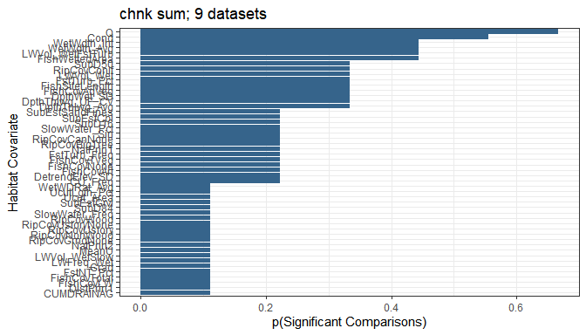

Figure 1: The number of comparisons, among data frames evaluated, where the mean of a habitat covariate was significantly different between those CHaMP sites with juvenile Chinook salmon estimated densities in the upper quartile versus all other sites where juveniles were observed. Comparisons were made using a Wilcoxon rank sum test.

We further summarized the mean and median p-value among the Wilcoxon rank sum tests performed in each 9 datasets and for each habitat covariate (Figure 2). There were 2 habitat covariate(s) that had a median p-value $≤$ our $α=$ 0.1 which include: Q, Cond.

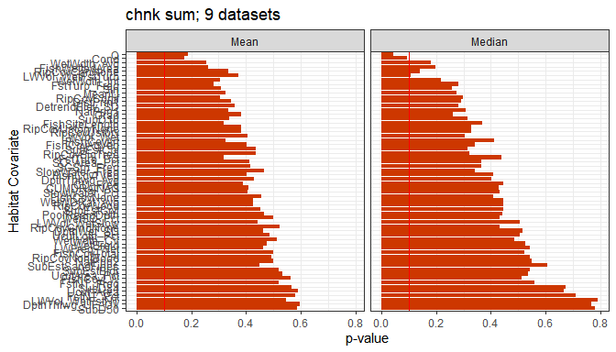

Figure 2: The median (md_p) and mean (mn_p) p-values from Wilcoxon rank sum tests for each covariate when comparisons were made for all sites with juvenile Chinook salmon densities in the upper quartile versus all other sites with fish oservations.

The above results give us some idea of those habitat covariates that seem to vary between sites with high observed densities for Chinook salmon, summer parr and all other sites with lower densities. Let’s examine some of the habitat covariates that were significant in a high proportion of cases, had a low median p-value, or some combination of both and might be informative for habitat rehabilitation. Here, we’ll examine the following a little further: Q, Cond, LWVol_WetFstTurb. Figure 3 shows the distributions of those habitat covariates comparing sites with high densities (Q4) with lower densities (Rest) for each case where the means were found to be significantly different ( $α=$ 0.1). These plots could be used to infer target conditions for Chinook salmon, summer parr for those habitat covariates. Additionally, Table 1 provides the quartiles, including medians, for those distributions.

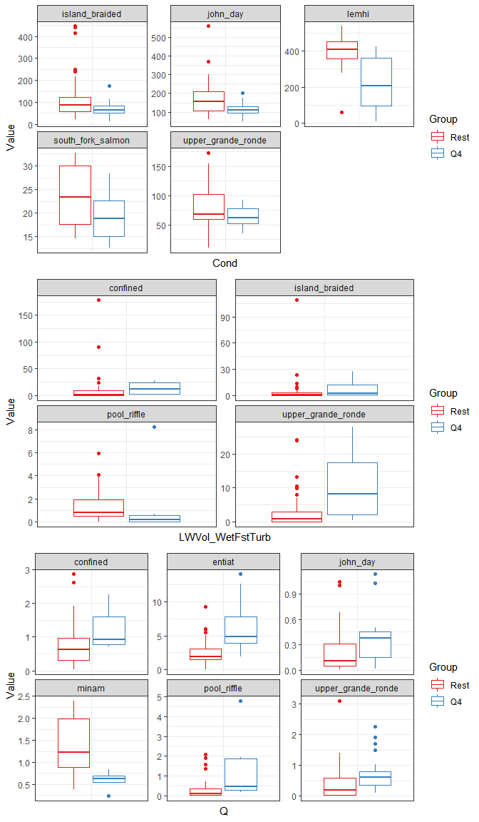

Figure 3: Boxplots comparing the distribution of our habitat covariates of interest for Chinook salmon, summer parr for each dataset where comparisons of the means were significant using the Wilcoxon rank sum test. The Q4 group includes those sites with observed densities in the upper quartile whereas the Rest group includes all other sites with lower densities. The box shows the median and the first and third quartiles (i.e. the 25th and 75th percentiles.).

Table 1: Quartiles, including medians (50%), for our habitat covariates of interest for this species x life stage scenario.

|  |  |  |  |  |
| --- | --- | --- | --- | --- |
| Habitat Covariate | Group | 25% | 50% | 75% |
| Cond | Rest | 57.500000 | 84.60000 | 134.80000 |
| Cond | Q4 | 50.750000 | 68.20000 | 93.10000 |
| LWVol_WetFstTurb | Rest | 0.040200 | 0.70990 | 3.32380 |
| LWVol_WetFstTurb | Q4 | 0.834625 | 3.14540 | 13.81232 |
| Q | Rest | 0.064275 | 0.37795 | 1.16495 |
| Q | Q4 | 0.378375 | 0.70960 | 1.91070 |

### Winter presmolt

For Chinook, winter presmolts, there were 24 habitat covariates that had a significant p-value of less than 0.1 in at least 1 of the 8 datasets evaluated including 7 covariates that were significant in $≥\frac{1}{2}$ of the datasets (Figure 4). Those covariates include: CU_Freq, FishCovLW, Discharge, FishCovAll, FishCovNone, Dpth_Max, Temp.

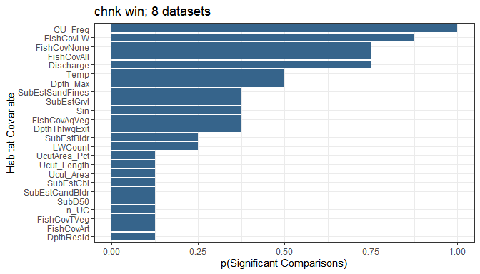

Figure 4: The number of comparisons, among data frames evaluated, where the mean of a habitat covariate was significantly different between those CHaMP sites with juvenile Chinook salmon estimated densities in the upper quartile versus all other sites where juveniles were observed. Comparisons were made using a Wilcoxon rank sum test.

We further summarized the mean and median p-value among the Wilcoxon rank sum tests performed in each 8 datasets and for each habitat covariate (Figure 5). There were 5 habitat covariate(s) that had a median p-value $≤$ our $α=$ 0.1 which include: Discharge, CU_Freq, FishCovLW, FishCovAll, FishCovNone.

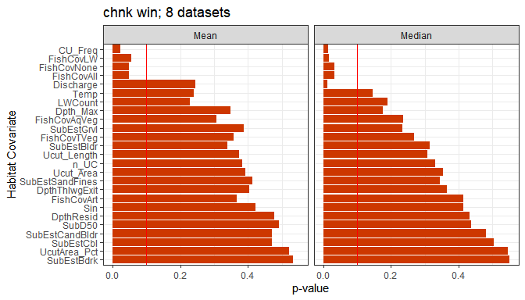

Figure 5: The median (md_p) and mean (mn_p) p-values from Wilcoxon rank sum tests for each covariate when comparisons were made for all sites with juvenile Chinook salmon densities in the upper quartile versus all other sites with fish oservations.

The above results give us some idea of those habitat covariates that seem to vary between sites with high observed densities for Chinook salmon, winter presmolt and all other sites with lower densities. Let’s examine some of the habitat covariates that were significant in a high proportion of cases, had a low median p-value, or some combination of both and might be informative for habitat rehabilitation. Here, we’ll examine the following a little further: CU_Freq, FishCovLW, FishCovAll, Discharge, Dpth_Max. Figure 3 shows the distributions of those habitat covariates comparing sites with high densities (Q4) with lower densities (Rest) for each case where the means were found to be significantly different ( $α=$ 0.1). These plots could be used to infer target conditions for Chinook salmon, winter presmolt for those habitat covariates. Additionally, Table 1 provides the quartiles, including medians, for those distributions.

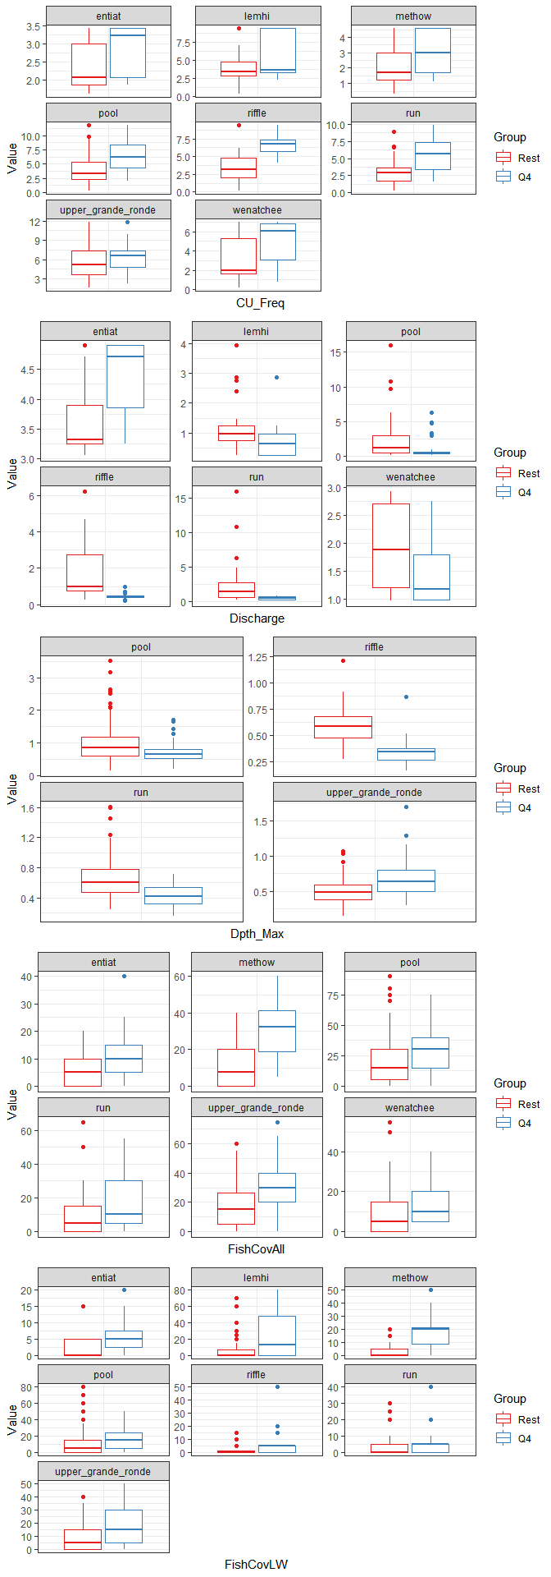

Figure 6: Boxplots comparing the distribution of our habitat covariates of interest for Chinook salmon, winter presmolts for each dataset where comparisons of the means were significant using the Wilcoxon rank sum test. The Q4 group includes those sites with observed densities in the upper quartile whereas the Rest group includes all other sites with lower densities. The box shows the median and the first and third quartiles (i.e. the 25th and 75th percentiles.).

Table 2: Quartiles, including medians (50%), for our habitat covariates of interest for this species x life stage scenario.

|  |  |  |  |  |
| --- | --- | --- | --- | --- |
| Habitat Covariate | Group | 25% | 50% | 75% |
| CU_Freq | Rest | 1.946256 | 3.344535 | 5.046178 |
| CU_Freq | Q4 | 3.429064 | 5.710931 | 7.325717 |
| Discharge | Rest | 0.729300 | 1.250700 | 2.904000 |
| Discharge | Q4 | 0.401900 | 0.477500 | 0.969900 |
| Dpth_Max | Rest | 0.475100 | 0.618400 | 0.888925 |
| Dpth_Max | Q4 | 0.419100 | 0.554600 | 0.779200 |
| FishCovAll | Rest | 5.000000 | 10.000000 | 25.000000 |
| FishCovAll | Q4 | 10.000000 | 25.000000 | 40.000000 |
| FishCovLW | Rest | 0.000000 | 0.000000 | 10.000000 |
| FishCovLW | Q4 | 1.250000 | 10.000000 | 20.000000 |

### Redds

For Chinook, adult spawning, there were 59 habitat covariates that had a significant p-value of less than 0.1 in at least 1 of the 11 datasets evaluated including 1 covariates that were significant in $≥\frac{1}{2}$ of the datasets (Figure 7). Those covariates include: SubD84.

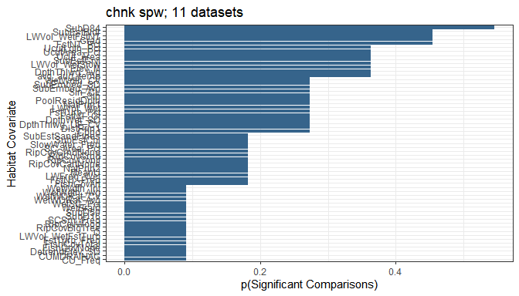

Figure 7: The number of comparisons, among data frames evaluated, where the mean of a habitat covariate was significantly different between those CHaMP sites with Chinook salmon estimated redd densities in the upper quartile versus all other sites where redds were observed. Comparisons were made using a Wilcoxon rank sum test.

We further summarized the mean and median p-value among the Wilcoxon rank sum tests performed in each 11 datasets and for each habitat covariate (Figure 8). There were 1 habitat covariate(s) that had a median p-value $≤$ our $α=$ 0.1 which include: SubD84.

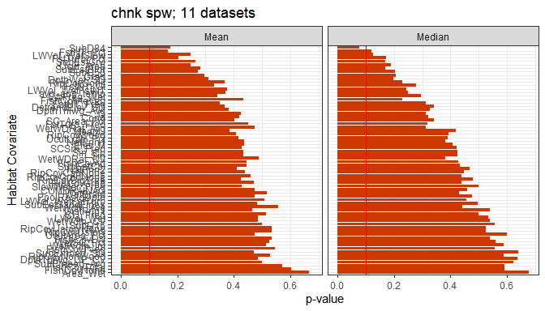

Figure 8: The median (md_p) and mean (mn_p) p-values from Wilcoxon rank sum tests for each covariate when comparisons were made for all sites with Chinook salmon redd densities in the upper quartile versus all other sites with redd observations.

The above results give us some idea of those habitat covariates that seem to vary between sites with high observed densities for Chinook salmon, adult spawning and all other sites with lower densities. Let’s examine some of the habitat covariates that were significant in a high proportion of cases, had a low median p-value, or some combination of both and might be informative for habitat rehabilitation. Here, we’ll examine the following a little further: SubD84, FstNT_Pct, LWVol_WetSlow, SubEstGrvl. Figure 3 shows the distributions of those habitat covariates comparing sites with high densities (Q4) with lower densities (Rest) for each case where the means were found to be significantly different ( $α=$ 0.1). These plots could be used to infer target conditions for Chinook salmon, adult spawning for those habitat covariates. Additionally, Table 1 provides the quartiles, including medians, for those distributions.

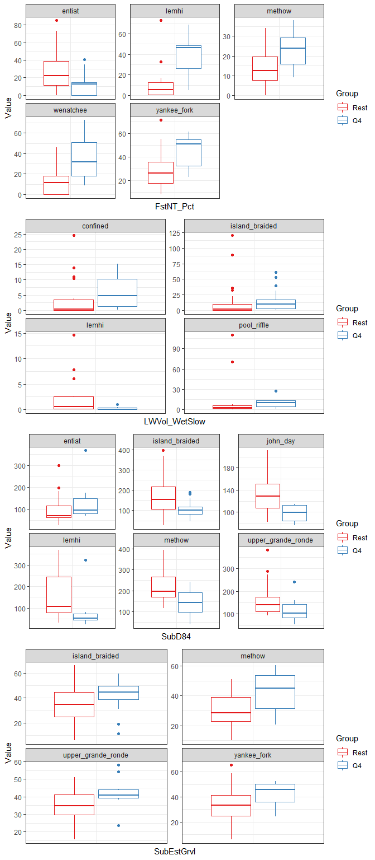

Figure 9: Boxplots comparing the distribution of our habitat covariates of interest for Chinook salmon, adult spawning for each dataset where comparisons of the means were significant using the Wilcoxon rank sum test. The Q4 group includes those sites with observed densities in the upper quartile whereas the Rest group includes all other sites with lower densities. The box shows the median and the first and third quartiles (i.e. the 25th and 75th percentiles.).

Table 3: Quartiles, including medians (50%), for our habitat covariates of interest for this species x life stage scenario.

|  |  |  |  |  |
| --- | --- | --- | --- | --- |
| Habitat Covariate | Group | 25% | 50% | 75% |
| FstNT_Pct | Rest | 6.252700 | 16.574200 | 29.767400 |
| FstNT_Pct | Q4 | 13.297100 | 30.120250 | 46.947800 |
| LWVol_WetSlow | Rest | 0.113575 | 1.927850 | 6.877838 |
| LWVol_WetSlow | Q4 | 1.061550 | 6.520125 | 13.510450 |
| SubD84 | Rest | 100.000000 | 142.000000 | 198.250000 |
| SubD84 | Q4 | 79.625000 | 98.000000 | 130.250000 |
| SubEstGrvl | Rest | 24.822700 | 34.288600 | 43.351500 |
| SubEstGrvl | Q4 | 38.118200 | 44.095000 | 50.082200 |

## Steelhead

### Summer parr

For steelhead, summer parr, there were 57 habitat covariates that had a significant p-value of less than 0.1 in at least 1 of the 12 datasets evaluated including 1 covariates that were significant in $≥\frac{1}{2}$ of the datasets (Figure 10). Those covariates include: RipCovGrndNone.

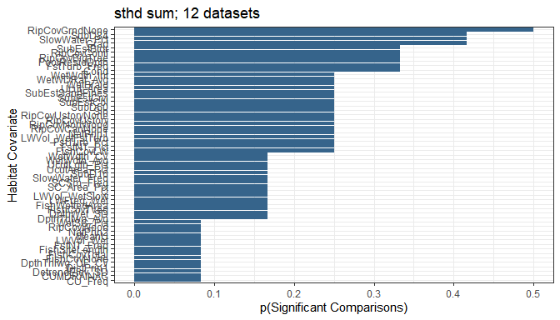

Figure 10: The number of comparisons, among data frames evaluated, where the mean of a habitat covariate was significantly different between those CHaMP sites with juvenile steelhead estimated densities in the upper quartile versus all other sites where juveniles were observed. Comparisons were made using a Wilcoxon rank sum test.

We further summarized the mean and median p-value among the Wilcoxon rank sum tests performed in each 12 datasets and for each habitat covariate (Figure 11). There were 0 habitat covariate(s) that had a median p-value $≤$ our $α=$ 0.1 which include: .

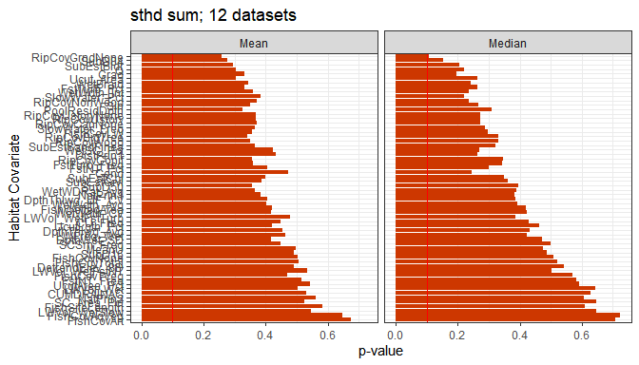

Figure 11: The median (md_p) and mean (mn_p) p-values from Wilcoxon rank sum tests for each covariate when comparisons were made for all sites with juvenile steelhead densities in the upper quartile versus all other sites with fish observations.

The above results give us some idea of those habitat covariates that seem to vary between sites with high observed densities for steelhead, summer parr and all other sites with lower densities. Let’s examine some of the habitat covariates that were significant in a high proportion of cases, had a low median p-value, or some combination of both and might be informative for habitat rehabilitation. Here, we’ll examine the following a little further: RipCovGrndNone, SubD84, SlowWater_Pct, Grad. Figure 3 shows the distributions of those habitat covariates comparing sites with high densities (Q4) with lower densities (Rest) for each case where the means were found to be significantly different ( $α=$ 0.1). These plots could be used to infer target conditions for steelhead, summer parr for those habitat covariates. Additionally, Table 1 provides the quartiles, including medians, for those distributions.

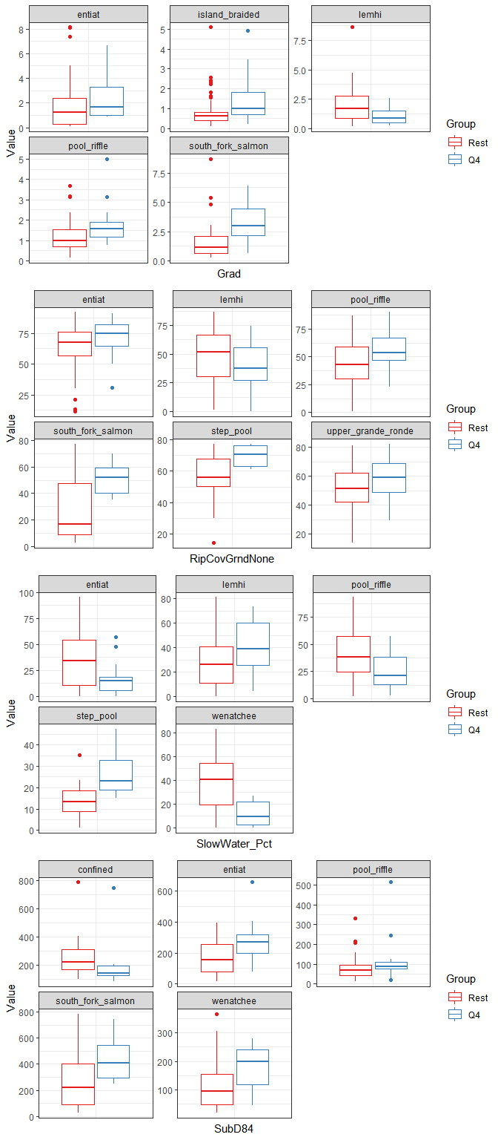

Figure 12: Boxplots comparing the distribution of our habitat covariates of interest for steelhead, summer parr for each dataset where comparisons of the means were significant using the Wilcoxon rank sum test. The Q4 group includes those sites with observed densities in the upper quartile whereas the Rest group includes all other sites with lower densities. The box shows the median and the first and third quartiles (i.e. the 25th and 75th percentiles.).

Table 4: Quartiles, including medians (50%), for our habitat covariates of interest for this species x life stage scenario.

|  |  |  |  |  |
| --- | --- | --- | --- | --- |
| Habitat Covariate | Group | 25% | 50% | 75% |
| Grad | Rest | 0.50985 | 0.9641 | 2.02525 |
| Grad | Q4 | 0.86130 | 1.3010 | 2.25600 |
| RipCovGrndNone | Rest | 37.50000 | 53.8500 | 66.50000 |
| RipCovGrndNone | Q4 | 45.70000 | 59.5000 | 70.00000 |
| SlowWater_Pct | Rest | 13.96960 | 32.8101 | 48.23400 |
| SlowWater_Pct | Q4 | 12.04870 | 18.7698 | 37.40830 |
| SubD84 | Rest | 65.00000 | 100.0000 | 217.00000 |
| SubD84 | Q4 | 100.00000 | 186.0000 | 280.00000 |

### Winter presmolt

For steelhead, winter presmolts, there were 24 habitat covariates that had a significant p-value of less than 0.1 in at least 1 of the 9 datasets evaluated including 6 covariates that were significant in $≥\frac{1}{2}$ of the datasets (Figure 13). Those covariates include: FishCovLW, CU_Freq, FishCovAll, FishCovNone, Discharge, Dpth_Max.

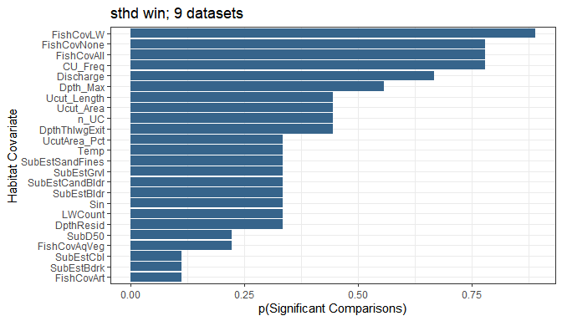

Figure 13: The number of comparisons, among data frames evaluated, where the mean of a habitat covariate was significantly different between those CHaMP sites with juvenile steelhead estimated densities in the upper quartile versus all other sites where juveniles were observed. Comparisons were made using a Wilcoxon rank sum test.

We further summarized the mean and median p-value among the Wilcoxon rank sum tests performed in each 9 datasets and for each habitat covariate (Figure 14). There were 6 habitat covariate(s) that had a median p-value $≤$ our $α=$ 0.1 which include: CU_Freq, Discharge, FishCovLW, FishCovAll, FishCovNone, Dpth_Max.

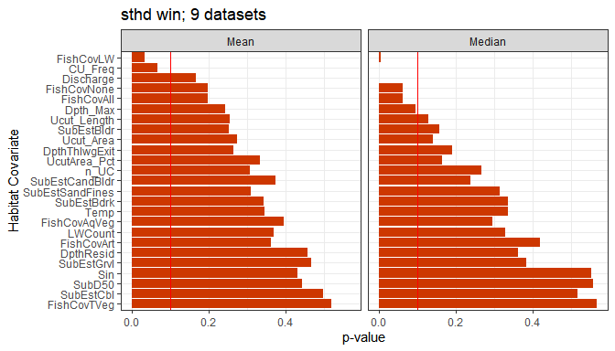

Figure 14: The median (md_p) and mean (mn_p) p-values from Wilcoxon rank sum tests for each covariate when comparisons were made for all sites with juvenile steelhead densities in the upper quartile versus all other sites with fish observations.

The above results give us some idea of those habitat covariates that seem to vary between sites with high observed densities for steelhead, winter presmolt and all other sites with lower densities. Let’s examine some of the habitat covariates that were significant in a high proportion of cases, had a low median p-value, or some combination of both and might be informative for habitat rehabilitation. Here, we’ll examine the following a little further: FishCovLW, CU_Freq, FishCovAll, Discharge, Dpth_Max. Figure 3 shows the distributions of those habitat covariates comparing sites with high densities (Q4) with lower densities (Rest) for each case where the means were found to be significantly different ( $α=$ 0.1). These plots could be used to infer target conditions for steelhead, winter presmolt for those habitat covariates. Additionally, Table 1 provides the quartiles, including medians, for those distributions.

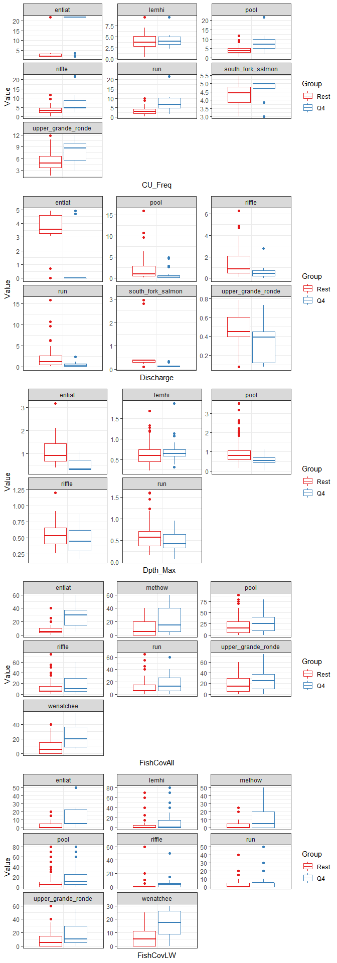

Figure 15: Boxplots comparing the distribution of our habitat covariates of interest for steelhead, winter presmolts for each dataset where comparisons of the means were significant using the Wilcoxon rank sum test. The Q4 group includes those sites with observed densities in the upper quartile whereas the Rest group includes all other sites with lower densities. The box shows the median and the first and third quartiles (i.e. the 25th and 75th percentiles.).

Table 5: Quartiles, including medians (50%), for our habitat covariates of interest for this species x life stage scenario.

|  |  |  |  |  |
| --- | --- | --- | --- | --- |
| Habitat Covariate | Group | 25% | 50% | 75% |
| CU_Freq | Rest | 2.358369 | 3.601851 | 5.198673 |
| CU_Freq | Q4 | 4.651767 | 6.609413 | 9.861212 |
| Discharge | Rest | 0.437100 | 0.729300 | 2.750800 |
| Discharge | Q4 | 0.109700 | 0.379700 | 0.549300 |
| Dpth_Max | Rest | 0.499300 | 0.665400 | 0.923925 |
| Dpth_Max | Q4 | 0.377800 | 0.552700 | 0.687000 |
| FishCovAll | Rest | 5.000000 | 10.000000 | 25.000000 |
| FishCovAll | Q4 | 10.000000 | 20.000000 | 35.000000 |
| FishCovLW | Rest | 0.000000 | 0.000000 | 5.000000 |
| FishCovLW | Q4 | 0.000000 | 5.000000 | 20.000000 |

### Redds

For steelhead, adult spawning, there were 50 habitat covariates that had a significant p-value of less than 0.1 in at least 1 of the 7 datasets evaluated including 1 covariates that were significant in $≥\frac{1}{2}$ of the datasets (Figure 16). Those covariates include: Elev_M.

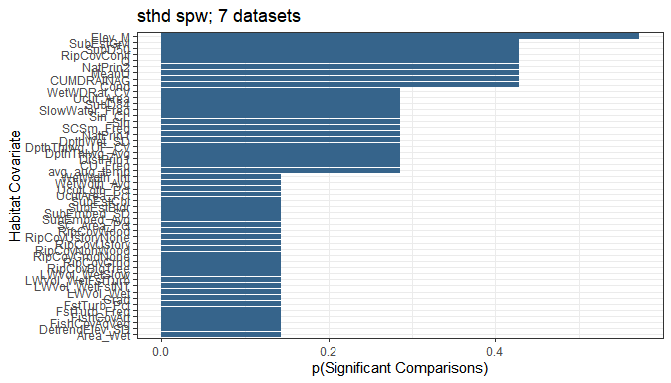

Figure 16: The number of comparisons, among data frames evaluated, where the mean of a habitat covariate was significantly different between those CHaMP sites with steelhead estimated redd densities in the upper quartile versus all other sites where redds were observed. Comparisons were made using a Wilcoxon rank sum test.

We further summarized the mean and median p-value among the Wilcoxon rank sum tests performed in each 7 datasets and for each habitat covariate (Figure 17). There were 1 habitat covariate(s) that had a median p-value $≤$ our $α=$ 0.1 which include: Elev_M.

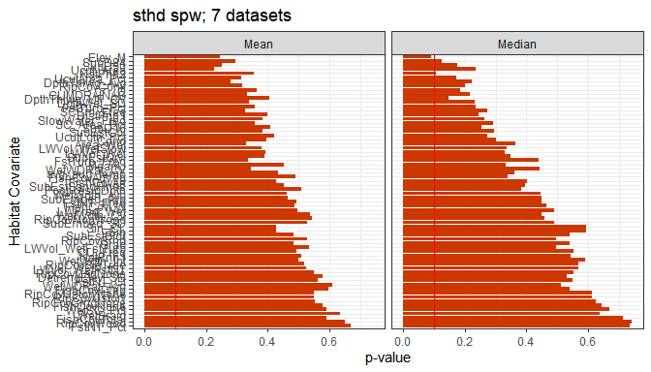

Figure 17: The median (md_p) and mean (mn_p) p-values from Wilcoxon rank sum tests for each covariate when comparisons were made for all sites with steelhead redd densities in the upper quartile versus all other sites with redd observations.

The above results give us some idea of those habitat covariates that seem to vary between sites with high observed densities for steelhead, adult spawning and all other sites with lower densities. Let’s examine some of the habitat covariates that were significant in a high proportion of cases, had a low median p-value, or some combination of both and might be informative for habitat rehabilitation. Here, we’ll examine the following a little further: Elev_M, SubEstGrvl, SubD50, NatPrin2. Figure 3 shows the distributions of those habitat covariates comparing sites with high densities (Q4) with lower densities (Rest) for each case where the means were found to be significantly different ( $α=$ 0.1). These plots could be used to infer target conditions for steelhead, adult spawning for those habitat covariates. Additionally, Table 1 provides the quartiles, including medians, for those distributions.

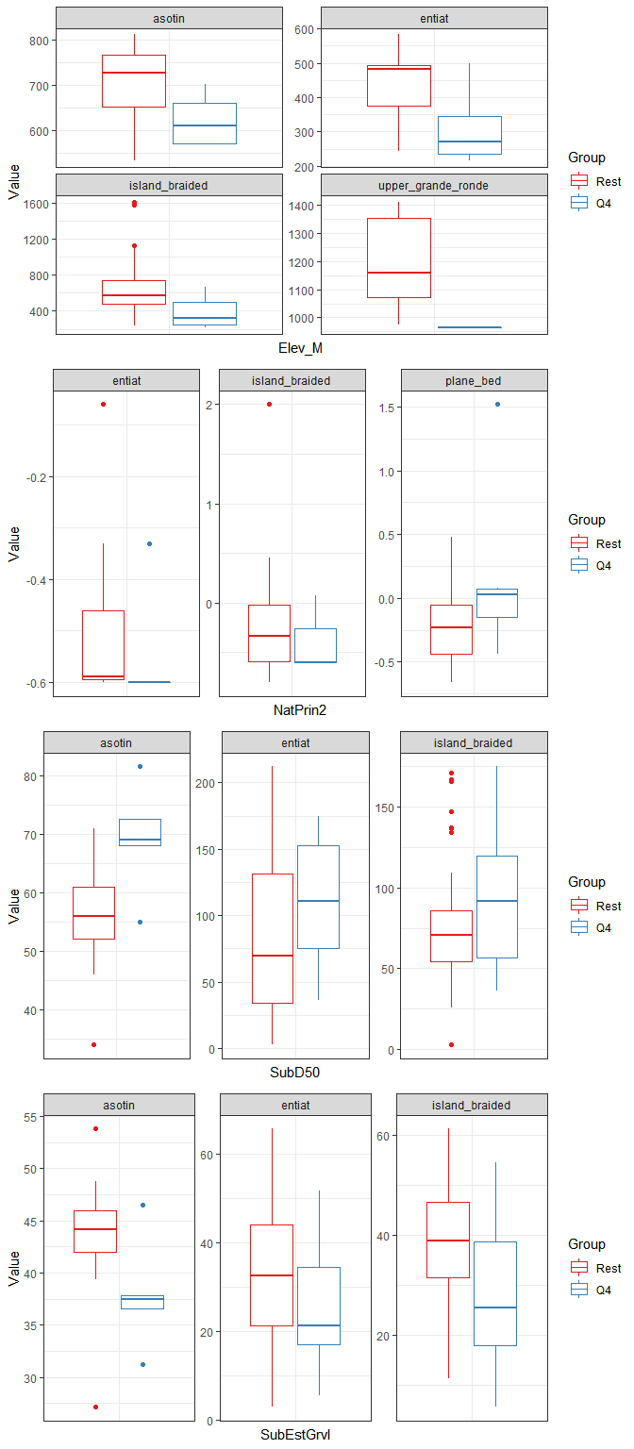

Figure 18: Boxplots comparing the distribution of our habitat covariates of interest for steelhead, adult spawning for each dataset where comparisons of the means were significant using the Wilcoxon rank sum test. The Q4 group includes those sites with observed densities in the upper quartile whereas the Rest group includes all other sites with lower densities. The box shows the median and the first and third quartiles (i.e. the 25th and 75th percentiles.).

Table 6: Quartiles, including medians (50%), for our habitat covariates of interest for this species x life stage scenario.

|  |  |  |  |  |
| --- | --- | --- | --- | --- |
| Habitat Covariate | Group | 25% | 50% | 75% |
| Elev_M | Rest | 483.0000 | 589.4450 | 847.36250 |
| Elev_M | Q4 | 251.5000 | 316.0000 | 499.00000 |
| NatPrin2 | Rest | -0.5900 | -0.4400 | -0.15000 |
| NatPrin2 | Q4 | -0.6000 | -0.6000 | -0.25750 |
| SubD50 | Rest | 43.5000 | 68.2500 | 86.75000 |
| SubD50 | Q4 | 58.0000 | 94.0000 | 124.00000 |
| SubEstGrvl | Rest | 27.0156 | 38.9273 | 46.32815 |
| SubEstGrvl | Q4 | 18.0000 | 26.6605 | 37.81955 |

# Discussion

## Chinook salmon

### Summer parr

Both Q (Discharge; $\frac{m^{3}}{sec}$) and Cond (Conductivity; $\frac{μS}{sec}$) were found to have differing means between the “Q4” sites and “Rest” sites in greater than half of datasets evaluated, and further, had a median p-value less than our $α=$ 0.1. Conductivity tended to be lesser in the “Q4” sites while discharge tended to be higher (with the exception of the Minam River dataset; Figure 3). However, neither Q or Cond can necessarily be modified by restoration actions.

Of interest, though, is that LWVol_WetFstTurb or the total volume ($m^{3}$) of large wood pieces within the wetted channel and fast water turbulent channel units also had a very low median p-value and was higher in 3 of 4 datasets where the p-value was significant (Figure 3).

### Winter presmolt

For Chinook salmon, winter presmolts, five habitat covariates had significantly different means in greater than half of datasets evaluated and a median p-value of less than $α=$ 0.1. These included: CU_Freq, FishCovLW, FishCovNone, FishCovAll, and Discharge.

* **CU_Freq**: Channel unit frequency measured as the count of channel units per 100 meters. The means of CU_Freq between “Q4” and “Rest” sites were different in all datasets (Figure 4) and CU_Freq for the “Q4” sites were higher in all cases (Figure 6). For the sites with high observed densities the median CU_Freq was 5.7 channel units per 100 meters whereas the median value for all other sites was 3.3. Channel unit frequency is a good indicator of channel complexity and a higher CU_Freq appears to support higher densities of juvenile Chinook salmon during winter months.
* **FishCovLW, FishCovNone, FishCovAll**: As FishCovNone (% of channel unit with no fish cover) and FishCovAll (% of setted area with the following types of cover: aquatic vegetation, artificial, woody debris, and terrestrial vegetation) are essentially the inverse of each other, we focus on FishCovAll here as it tends to be more intuitive. FishCovAll and FishCovLW (% of wetted area that has woody debris as fish cover) means were significantly higher in sites with high juvenile fish densities in a large proportion of cases (Figure 6). It is not surprising that sites with increased fish cover tended to have higher observed densities for juvenile Chinook salmon during winter months. Increasing fish cover, in all channel unit types, should be considered when attempting to increase habitat capacity for juvenile Chinook salmon in winter months.
* **Discharge**: Discharge was also found to be significant in a high proportion of cases and tended to be lower in “Q4” sites (Figure 6), with the exception of the Entiat River dataset. However, discharge is another metric that cannot necessarily be modified by restoration activities.

In addition, Dpth_Max was significant in half of the datasets evaluated and so was examined further. The Dpth_Max was significantly lower for the “Q4” sites in three (pool, riffle, run) channel unit type datasets, but was higher in the Upper Grande Ronde dataset (Figure 6). Dpth_Max is the maximum depth of the wetted channel unit in meters.

### Adult spawning

Here, we examined 4 habitat covariates further:

* **FstNT_Pct**: Or fast non-turbulent % is the percentage of the wetted area identified as fast water non-turbulent channel units. FstNT_Pct was higher in most cases with higher observed redd densities with the exception of the Entiat River dataset (Figure 9).
* **LWVol_WetSlow**: Large wood volume in wetted, slow water measured as the total volume of large wood pieces within the wetted channel and slower water/pool channel units. LWVol_WetSlow tended to be higher in “Q4” sites with higher observed redd densities (Figure 9). Intuitively, this makes sense as redds are typically constructed in pool-riffle sequences and large, woody cover in those pools would support better cover during adult holding.
* **SubD84**: The diameter of the 84th percentile particle derived from pebble counts. SubD84 tended to be smaller in the “Q4” sites with higher redd densities (Figure 9).
* **SubEstGrvl**: The percent of coarse and fine gravel (2-64 mm) within the wetted site area. Opposite of SubD84, SubEstGrvl was higher in the “Q4” sites for all cases where the means were different between sites (Figure 9).

## Steelhead

### Summer parr

### Winter presmolt

### Adult spawning

## Conclusions

# Literature Cited

Idaho OSC Team (Idaho Governor’s Office of Species Conservation and partners). 2019. Upper Salmon Subbasin Habitat Integrated Rehabilitation Assessment. Assessment prepared for and with the U.S. Department of the Interior, Bureau of Reclamation. June 2019. 625 pp.

ISEMP/CHaMP. 2017. Integrated Status and Effectiveness Monitoring Program (ISEMP) and Columbia Habitat Monitoring Program (CHaMP) Annual Combined Technical Report, January - December 2016. BPA Projects 2003-017-00 and 2011-006-00, 93 Electronic Pages.