Radio Tag-Only CJS Models
Kevin See^{1,✉}, Mike Ackerman¹, and Nick Porter¹
June 02, 2020
¹ Biomark, Inc. 705 South 8th St., Boise, Idaho, 83702, USA
✉ Correspondence: Kevin See <kevin.see@merck.com>

Introduction
We are interested primarily in estimating survival of fish from release (e.g. at the Lower Lemhi screw trap) between each RT site using radio tag detections only, with a Cormack Jolly-Seber (CJS) model.

Methods

Data
The data is radio tag (RT) detections, which were downloaded from various fixed sites over the last three years. We compressed these detections and summarised capture histories, eliminating any detections that indicated upstream movement.
In 2017-18 and 2018-19, we focused on tags that were released from the lower Lemhi rotary screw trap (code LLRTP). In 2019-20, we also included tags released from the upper Lemhi rotary screw trap (code LEMTRP). We did remove any tags released at the lower Lemhi trap that were detected upstream in the Lemhi River. There were 16 tags with a detection history like this.

Model
We used a Cormack Jolly-Seber model to estimate survival between reaches and detection probability at each detection point. The detection probability at the last site and the survival to that site are confounded in the model, and cannot be estimated separately, and so results from the final reach each year are excluded.

Results
We can extract summary statistics from the posteriors, and construct plots of detection probablities, survival probabilities and cummulative survival probabilities.
Table 1: Estimates of survival between detection points.
season | Reach | mean | se | cv | lwrCI | uprCI
17_18 | LLRTP to LH | 0.819 | 0.053 | 0.065 | 0.712 | 0.919
17_18 | LH to MB | 0.858 | 0.059 | 0.068 | 0.733 | 0.961
17_18 | MB to TR | 0.916 | 0.049 | 0.054 | 0.804 | 0.994
17_18 | TR to RR | 0.842 | 0.055 | 0.066 | 0.729 | 0.939
17_18 | RR to BG | 0.958 | 0.034 | 0.035 | 0.876 | 0.999
17_18 | BG to NF | 0.890 | 0.054 | 0.061 | 0.776 | 0.983
17_18 | NF to DW | 0.807 | 0.070 | 0.087 | 0.656 | 0.928
17_18 | DW to LR | 0.910 | 0.062 | 0.068 | 0.767 | 0.995
17_18 | LR to SR | 0.713 | 0.100 | 0.140 | 0.516 | 0.915
17_18 | SR to CC | 0.798 | 0.132 | 0.166 | 0.535 | 0.991
18_19 | LLRTP to LH | 0.837 | 0.044 | 0.053 | 0.748 | 0.923
18_19 | LH to CA | 0.817 | 0.045 | 0.056 | 0.723 | 0.900
18_19 | CA to TR | 0.941 | 0.030 | 0.032 | 0.873 | 0.989
18_19 | TR to RR | 0.929 | 0.029 | 0.031 | 0.864 | 0.977
18_19 | RR to NF | 0.922 | 0.035 | 0.038 | 0.844 | 0.980
18_19 | NF to DW | 0.797 | 0.047 | 0.058 | 0.701 | 0.884
18_19 | DW to LR | 0.793 | 0.061 | 0.077 | 0.673 | 0.911
18_19 | LR to SR | 0.655 | 0.074 | 0.114 | 0.510 | 0.794
18_19 | SR to CC | 0.677 | 0.090 | 0.133 | 0.504 | 0.861
18_19 | CC to YP | 0.486 | 0.121 | 0.248 | 0.286 | 0.779
18_19 | YP to VC | 0.296 | 0.108 | 0.364 | 0.114 | 0.533
18_19 | VC to SB | 0.839 | 0.135 | 0.160 | 0.498 | 0.994
19_20 | LEMTRP to BC | 0.918 | 0.060 | 0.065 | 0.782 | 0.996
19_20 | BC to TC | 0.719 | 0.096 | 0.134 | 0.544 | 0.930
19_20 | TC to EC | 0.922 | 0.066 | 0.071 | 0.751 | 0.997
19_20 | EC to SS | 0.841 | 0.095 | 0.113 | 0.648 | 0.990
19_20 | SS to EU | 0.863 | 0.100 | 0.116 | 0.634 | 0.994
19_20 | EU to LF | 0.574 | 0.146 | 0.253 | 0.339 | 0.907
19_20 | LF to LLRTP | 0.685 | 0.142 | 0.208 | 0.404 | 0.939
19_20 | LLRTP to DD | 0.961 | 0.033 | 0.034 | 0.882 | 0.999
19_20 | DD to LH | 0.844 | 0.057 | 0.068 | 0.733 | 0.956
19_20 | LH to MB | 0.886 | 0.057 | 0.065 | 0.760 | 0.985
19_20 | MB to TR | 0.792 | 0.060 | 0.075 | 0.667 | 0.901
19_20 | TR to NF | 0.871 | 0.054 | 0.062 | 0.751 | 0.962
19_20 | NF to DW | 0.901 | 0.052 | 0.058 | 0.778 | 0.984
19_20 | DW to LR | 0.859 | 0.073 | 0.085 | 0.701 | 0.982
19_20 | LR to SR | 0.687 | 0.105 | 0.152 | 0.485 | 0.902
19_20 | SR to CC | 0.716 | 0.143 | 0.200 | 0.440 | 0.978
Table 2: Estimates of detection probability.
season | site | mean | se | cv | lwrCI | uprCI
17_18 | LH | 0.658 | 0.059 | 0.090 | 0.536 | 0.768
17_18 | MB | 0.632 | 0.062 | 0.099 | 0.507 | 0.750
17_18 | TR | 0.746 | 0.058 | 0.078 | 0.628 | 0.846
17_18 | RR | 0.713 | 0.064 | 0.090 | 0.580 | 0.830
17_18 | BG | 0.869 | 0.048 | 0.056 | 0.761 | 0.946
17_18 | NF | 0.782 | 0.068 | 0.086 | 0.635 | 0.902
17_18 | DW | 0.788 | 0.070 | 0.089 | 0.642 | 0.908
17_18 | LR | 0.841 | 0.068 | 0.081 | 0.690 | 0.952
17_18 | SR | 0.798 | 0.100 | 0.125 | 0.577 | 0.954
17_18 | CC | 0.556 | 0.131 | 0.236 | 0.310 | 0.826
18_19 | LH | 0.652 | 0.051 | 0.078 | 0.547 | 0.745
18_19 | CA | 0.689 | 0.047 | 0.068 | 0.593 | 0.775
18_19 | TR | 0.878 | 0.034 | 0.039 | 0.802 | 0.936
18_19 | RR | 0.866 | 0.036 | 0.042 | 0.789 | 0.929
18_19 | NF | 0.877 | 0.038 | 0.044 | 0.794 | 0.942
18_19 | DW | 0.928 | 0.033 | 0.036 | 0.851 | 0.978
18_19 | LR | 0.818 | 0.061 | 0.075 | 0.687 | 0.919
18_19 | SR | 0.857 | 0.065 | 0.076 | 0.709 | 0.959
18_19 | CC | 0.866 | 0.085 | 0.098 | 0.667 | 0.984
18_19 | YP | 0.849 | 0.133 | 0.157 | 0.507 | 0.996
18_19 | VC | 0.827 | 0.143 | 0.173 | 0.474 | 0.995
18_19 | SB | 0.848 | 0.131 | 0.155 | 0.509 | 0.996
19_20 | BC | 0.373 | 0.054 | 0.145 | 0.270 | 0.481
19_20 | TC | 0.264 | 0.058 | 0.221 | 0.160 | 0.388
19_20 | EC | 0.077 | 0.029 | 0.375 | 0.031 | 0.145
19_20 | SS | 0.452 | 0.068 | 0.150 | 0.326 | 0.588
19_20 | EU | 0.282 | 0.065 | 0.230 | 0.166 | 0.419
19_20 | LF | 0.243 | 0.078 | 0.322 | 0.111 | 0.417
19_20 | LLRTP | 0.584 | 0.096 | 0.165 | 0.388 | 0.767
19_20 | DD | 0.302 | 0.052 | 0.171 | 0.206 | 0.407
19_20 | LH | 0.607 | 0.062 | 0.103 | 0.484 | 0.726
19_20 | MB | 0.786 | 0.056 | 0.072 | 0.665 | 0.883
19_20 | TR | 0.801 | 0.061 | 0.076 | 0.666 | 0.904
19_20 | NF | 0.878 | 0.051 | 0.058 | 0.764 | 0.959
19_20 | DW | 0.884 | 0.054 | 0.061 | 0.767 | 0.966
19_20 | LR | 0.794 | 0.078 | 0.099 | 0.623 | 0.924
19_20 | SR | 0.757 | 0.103 | 0.136 | 0.532 | 0.922
19_20 | CC | 0.813 | 0.132 | 0.162 | 0.522 | 0.992
Table 3: Estimates of cummulative survival up to detection points.
season | site | mean | se | cv | lwrCI | uprCI
17_18 | LLRTP | 1.000 | 0.000 | 0.000 | 1.000 | 1.000
17_18 | LH | 0.819 | 0.053 | 0.065 | 0.712 | 0.919
17_18 | MB | 0.701 | 0.053 | 0.076 | 0.596 | 0.804
17_18 | TR | 0.642 | 0.054 | 0.085 | 0.538 | 0.743
17_18 | RR | 0.540 | 0.054 | 0.101 | 0.432 | 0.646
17_18 | BG | 0.517 | 0.054 | 0.104 | 0.412 | 0.623
17_18 | NF | 0.461 | 0.055 | 0.120 | 0.356 | 0.575
17_18 | DW | 0.371 | 0.053 | 0.142 | 0.275 | 0.481
17_18 | LR | 0.338 | 0.051 | 0.150 | 0.246 | 0.443
17_18 | SR | 0.241 | 0.048 | 0.201 | 0.155 | 0.344
17_18 | CC | 0.191 | 0.048 | 0.253 | 0.107 | 0.304
18_19 | LLRTP | 1.000 | 0.000 | 0.000 | 1.000 | 1.000
18_19 | LH | 0.837 | 0.044 | 0.053 | 0.748 | 0.923
18_19 | CA | 0.683 | 0.041 | 0.060 | 0.597 | 0.758
18_19 | TR | 0.642 | 0.041 | 0.063 | 0.561 | 0.717
18_19 | RR | 0.597 | 0.041 | 0.069 | 0.512 | 0.674
18_19 | NF | 0.550 | 0.042 | 0.077 | 0.464 | 0.630
18_19 | DW | 0.439 | 0.040 | 0.091 | 0.363 | 0.516
18_19 | LR | 0.348 | 0.041 | 0.117 | 0.270 | 0.432
18_19 | SR | 0.227 | 0.034 | 0.149 | 0.164 | 0.293
18_19 | CC | 0.154 | 0.029 | 0.192 | 0.101 | 0.217
18_19 | YP | 0.074 | 0.022 | 0.301 | 0.039 | 0.126
18_19 | VC | 0.022 | 0.009 | 0.438 | 0.007 | 0.044
18_19 | SB | 0.018 | 0.008 | 0.452 | 0.006 | 0.037
19_20 | LEMTRP | 1.000 | 0.000 | 0.000 | 1.000 | 1.000
19_20 | BC | 0.918 | 0.060 | 0.065 | 0.782 | 0.996
19_20 | TC | 0.658 | 0.084 | 0.127 | 0.509 | 0.839
19_20 | EC | 0.605 | 0.077 | 0.127 | 0.462 | 0.763
19_20 | SS | 0.506 | 0.068 | 0.134 | 0.383 | 0.644
19_20 | EU | 0.436 | 0.071 | 0.163 | 0.301 | 0.582
19_20 | LF | 0.247 | 0.064 | 0.258 | 0.149 | 0.400
19_20 | LLRTP | 0.163 | 0.032 | 0.196 | 0.105 | 0.231
19_20 | DD | 0.157 | 0.031 | 0.198 | 0.101 | 0.223
19_20 | LH | 0.132 | 0.027 | 0.202 | 0.085 | 0.189
19_20 | MB | 0.117 | 0.024 | 0.207 | 0.074 | 0.168
19_20 | TR | 0.092 | 0.020 | 0.216 | 0.058 | 0.137
19_20 | NF | 0.080 | 0.018 | 0.222 | 0.049 | 0.120
19_20 | DW | 0.072 | 0.017 | 0.228 | 0.044 | 0.108
19_20 | LR | 0.062 | 0.015 | 0.243 | 0.037 | 0.096
19_20 | SR | 0.043 | 0.012 | 0.277 | 0.023 | 0.070
19_20 | CC | 0.030 | 0.010 | 0.326 | 0.015 | 0.052
We also present these results in Figures 1, 2, 3 and 4.
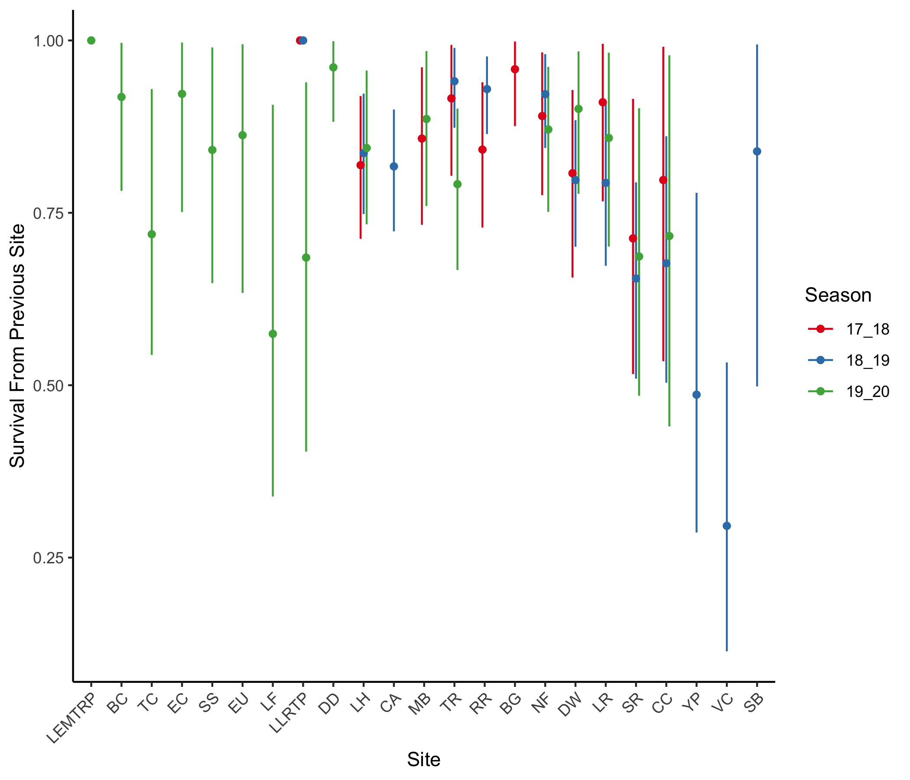
Figure 1: Estimates, with 95% confidence intervals, of survival between detection points
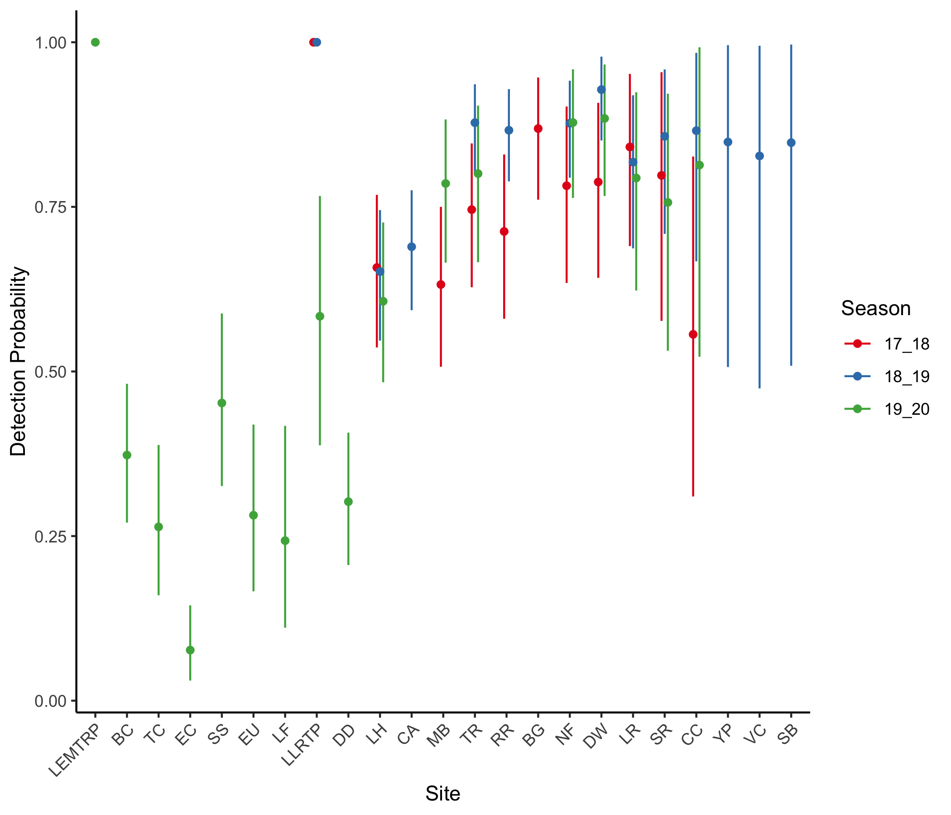
Figure 2: Estimates, with 95% confidence intervals, of detection probabilities.
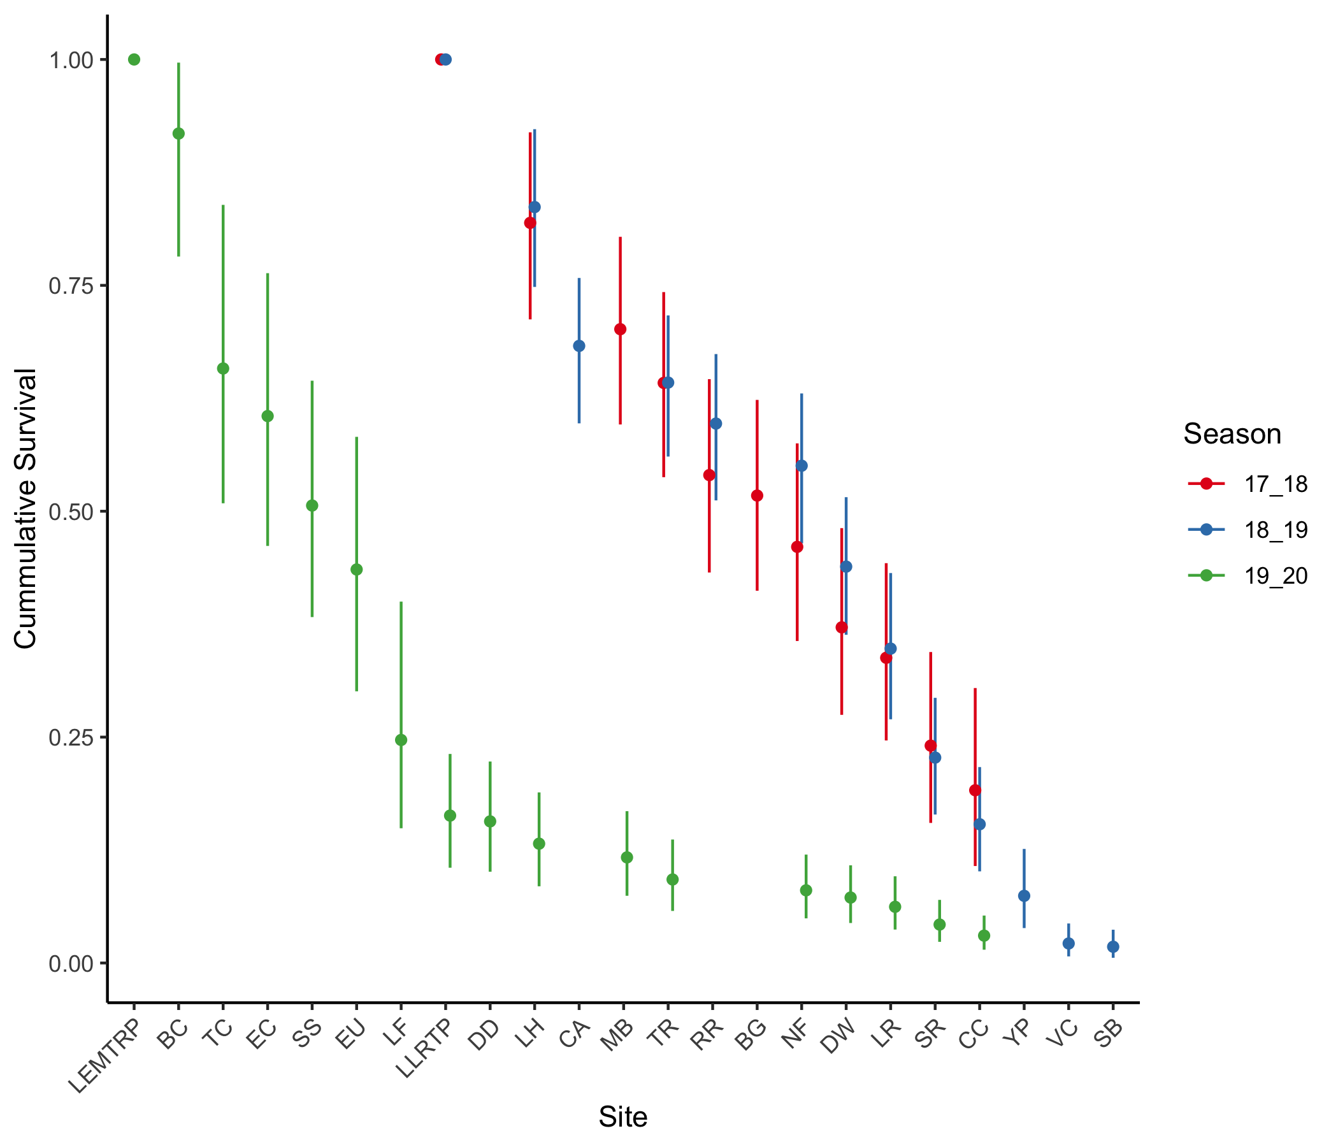
Figure 3: Estimates, with 95% confidence intervals, of cummulative survival across reaches.
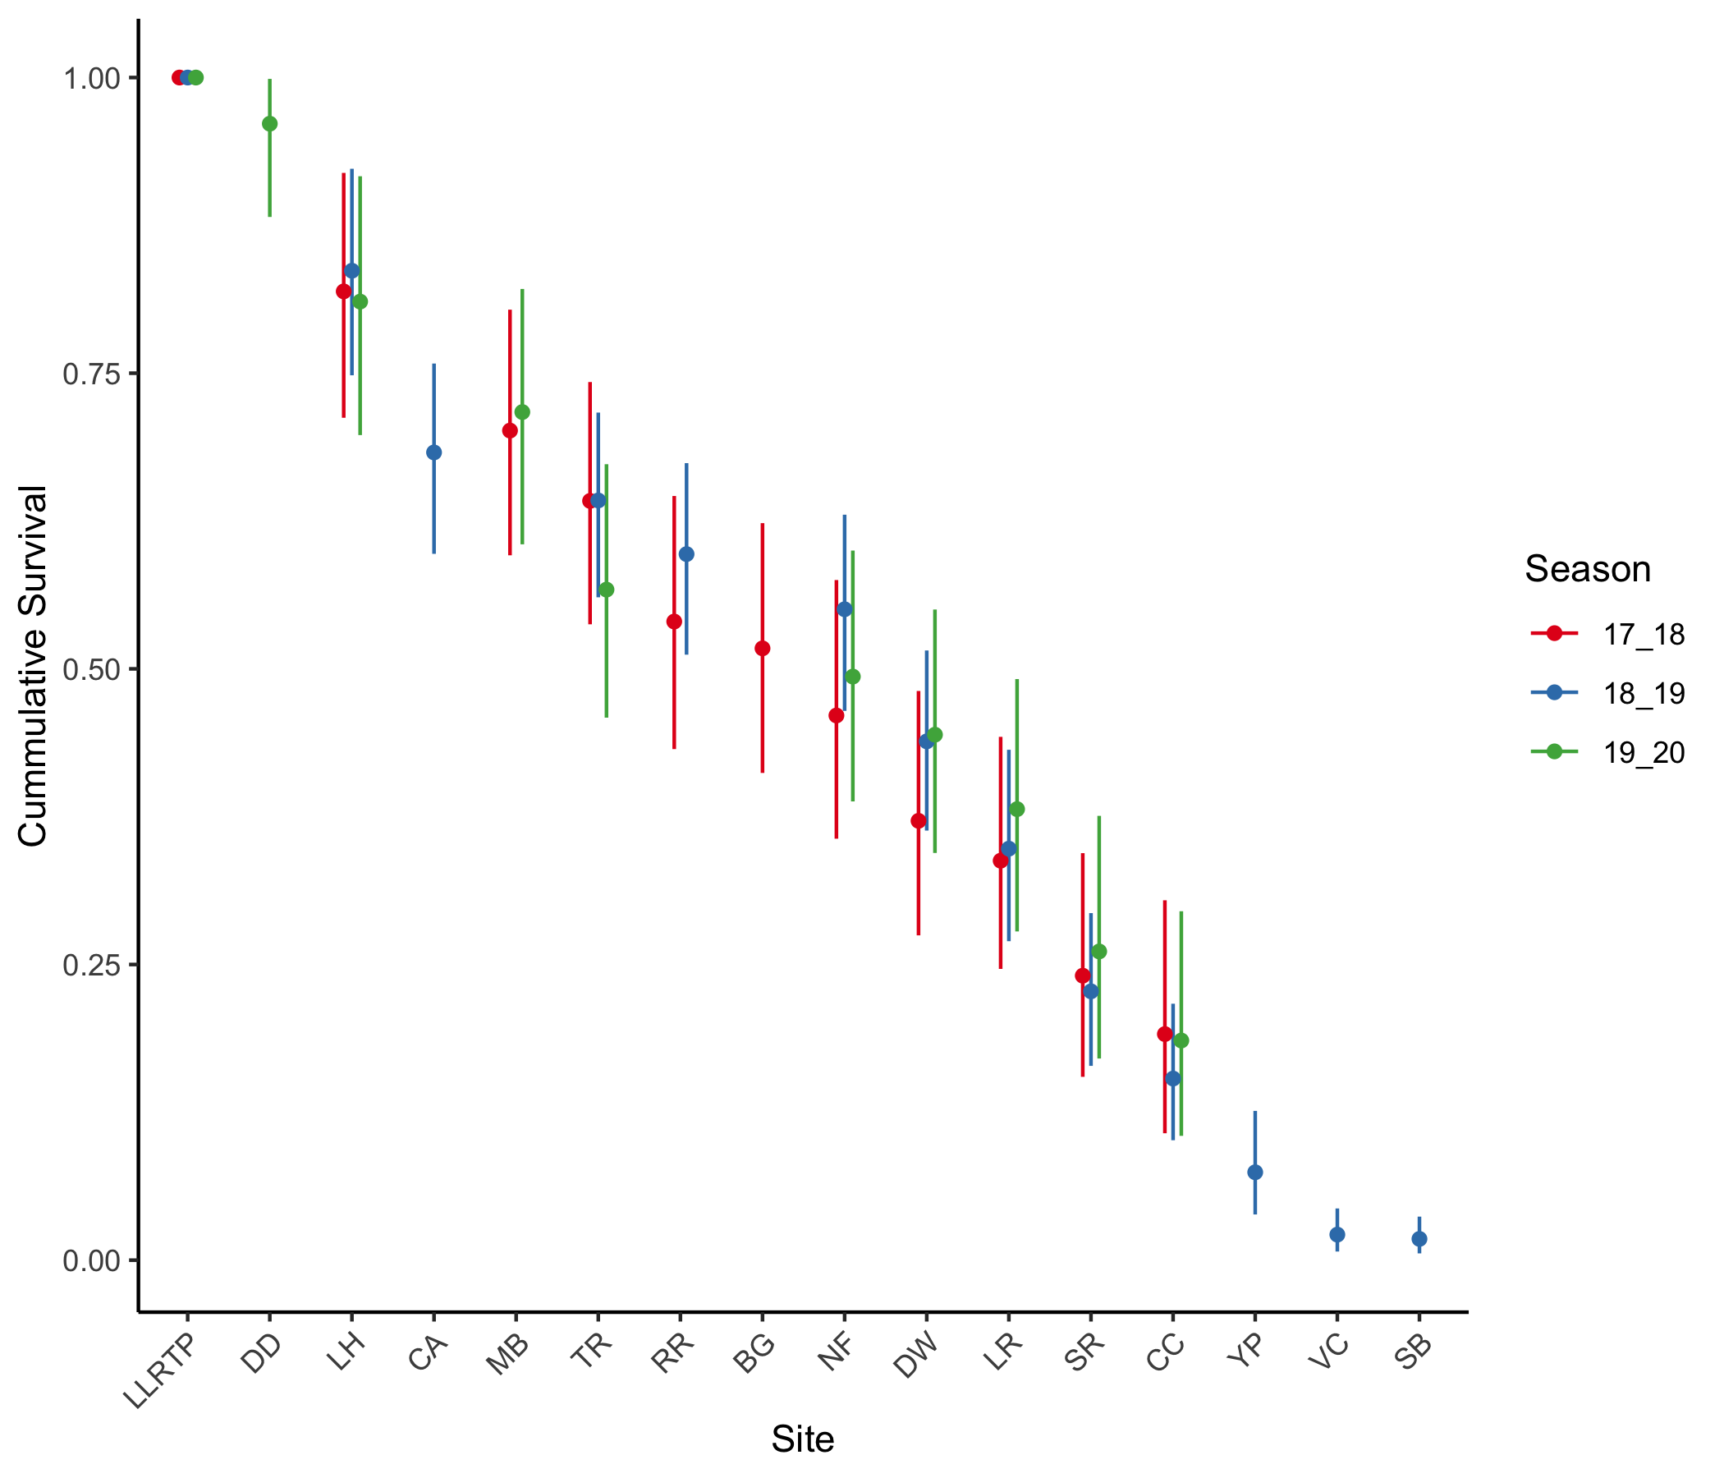
Figure 4: Estimates, with 95% confidence intervals, of cummulative survival across reaches, resetting survival in 2019-20 to start at Lower Lemhi screw trap.

Discussion
Some of the caveats to keep in mind with CJS models include:
- Estimates of $ϕ$ are really estimates of apparent survival, or transistion probability (i.e. the chance that a fish survives AND moves past the next detection point). $1−ϕ_{i}$ represents the chances that an animal either died in reach $i−1$, or left the population (became unavailable for detection). The latter is analogous to a fish that hunkers down in a reach to ride out the winter. It may be surviving very well within that reach, or it may have died there, there is no way to tell from only the radio tag observations.

