

SILESIAN UNIVERSITY OF TECHNOLOGY
FACULTY OF AUTOMATIC CONTROL, ELECTRONICS AND
COMPUTER SCIENCE

Master Thesis

One-shot-learning Gesture Recognition Using a Kinect Camera.

Author: Łukasz Macura
Supervisor: Ph.D. Michał Kawulok
Table of Content
Table of Content 2
1. Introduction 5
1.1 Presentation of topic 5
1.2 Motivations 7
1.3 Input & output files 7
1.4 Research Point 9
1.5 Thesis guideline 10
2. Project Analysis 11
2.1 The Kinect camera 11
2.2 Body Tracking – Image Processing versus Depth Processing 12
2.3 Depth Processing - Body Tracking 13
2.3.1 Machine Learning Body Part Separation 21
2.3.2 Segmentation method based on the analysis of extremes 28
2.4 First Shoot Learning 32
2.4.1 Analysis of problem 32
2.4.2 Hands Gesture Recognition 33
2.4.2.1 ‘$1 Recognizer’ 34
2.4.2.2 Protractor: A Fast and Accurate Gesture Recognizer 36

- Introduction

1.1 Presentation of topic
Human – Computer Interaction (HCI) was design in 1960s to achieved simply goals as typing at a keyboards, moving and pointing with mouse, selecting from menus or drop icons on the desktop. These interfaces are far from ideal this is the reason why engineering’s tried to improve or even create a brand new HCI’s devices. The first attempted on that field as connection a keyboards with mouse to create better interface for gamers. These devices were strictly inspired by the real human objects and should imitate theirs basic functionality in that way a computer steering wheel was designed. In current virtual environments (VEs) keyboards, mouse’s and pads are still the most popular device nevertheless they are inconvenient and unnatural in 3D VE’s. The evolution of HCI headed toward for the gesture detection in that way Human Computer Intelligent Interaction (HCII) was born. The human movements, body tracking, gesture recognition has become the most important part of HCII in recent years. Many techniques developed in HCII are based on the computer vision and they can be extended to other areas of science such a robot control.
Gestures, Gesture Computer and gesture recognition are the pillars of human-computer interaction. The history was started from a video-based system called Gesture Computer which is the first contact-less man-machine devices. The main goal of the system was detect human body parts and analyzing gesture in real-time manner. The idea is presented on the Fig 1.

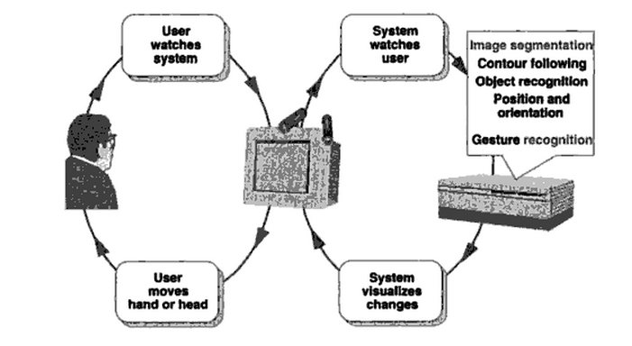
Fig1. GestureComputer overview

The idea of Gesture Computer evolved a bit however the basics remained still the same. The System is tracking user (Kinect device) and recognize gesture (Xbox or computer) then visualize changes on the screen. The Fig2. presents modern version of pseudo-Gesture Computer.

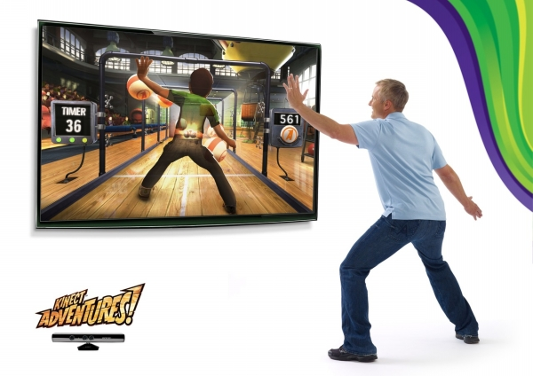
Fig2. Pseudo-GestureComputer

The system complexity is very large, despite the fact of the scheme is simply. The flow chart of the system consists of four main steps:

- Tracking user
- Gestures recognition
- Displaying changes
- User interaction

The implementation of these steps ensures that the system can handle the interaction with people and meet current requirements of HCII.

1.2 Motivations

The main goal of the project is designed system for gesture recognition which allows replaced the traditional remote controls. This goal is consistent with Kinect commercial slogan, "You are the controller" and fits well with the idea of ​​my work. The gesture and sign language recognition is being preceded using Kinect device which records both an RGB image and depth image (using an infrared sensor). The system should learn gestures using One-Shot-Learning method which is similar to human learning methods and then recognize that pattern from the sets which consists from many different patterns. The result of my work will be a system (HCII) that can recognize basic gestures of the user and on the basis of data supplied to it.

1.3 Input & output files

The input data are organized in batches. Each batch includes 100 recorded gesture grouped in sequences of 1 to 5 gestures performed by the same user. The appropriate number of gestures can be called a “lexicon”. Lexicons could be divided into categories which are presented on Fig3.

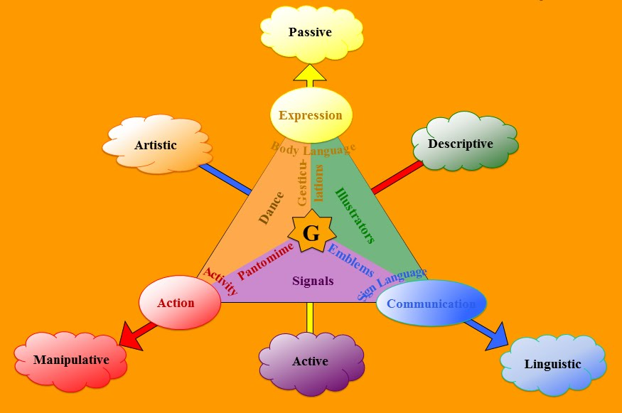
Fig3. Lexicons categories

Each record taken from Kinect device consists of RGB and depth Image stored in two separately video files. The video is formatted in lossy-compressed AVI format. Additionally given batch need a z-depth coefficient which informs about position of Kinect device in relation to the user. See Fig 4.

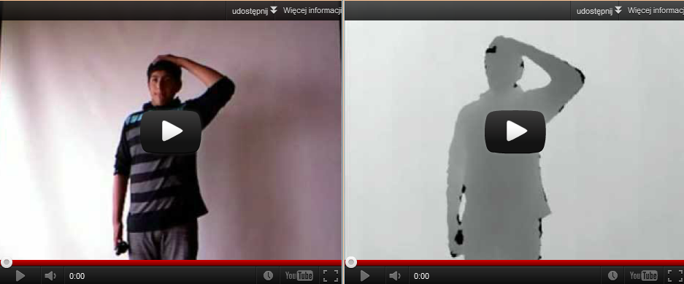
Fig4. Kinect record (On the left RGB image, on the right Depth image)

The Kinect depth images were produced after normalization:

To get appropriate data from *avi files:

- Calculate the average RGB values to get v.
- Perform

minD – Minimum distance to the camera
maxD – Maximum distance to the camera
acc – Accuracy which the depth is known
(0) Medicore
(1) Good.
(2) Very Good

The normalization table describes parameters for given batch (see examples).

set num mini maxi acc miss
devel 1 801 1964 2 0
devel 2 801 1968 1 0
devel 3 801 1506 1 0
devel 4 801 1869 1 0
devel 5 824 1964 2 0

The output file checking correctness of the results it is in the given form:

[ file_name ] [ , ] [sequence of gestures ] (see examples)

devel01_11, 9 4 4 9
devel01_12, 6 9 6
devel01_13, 4 8

1.4 Research Point

The research part of my work is very significant and includes creation of Tracking Body and One Shot Learning systems.

Tracking Body module is responsible for obtaining human body to get appropriate data to further analysis. The main problem in that step is to create flexibility system which can deal with many different possess of different people. In that point we should taking into account many other factories which influenced on the whole data analysis. The records can differ in quality, relation position of human body from Kinect device, objects in background and other objects which can influenced on the human body. This is the reason why create Tracking Body system need to be robust and flexible.

First Shot Learning module is responsible for analyzing data obtained by the Tracking Body modules. The main idea is creating a specialized gestures vocabulary from input data. The system should be capable of learning and recognize new gesture from a single video clip. In that way gesture could be stored in gestures vocabulary and used in everyday life. Create a rich vocabulary of gestures is crucial for HCII because it allows applications replace mouse or keyboard by more intuitive way of communication with hardware. What are the most important factories influenced on the gesture-hardware communication? First and foremost the system has to deal with many different gestures which differ in time execution, quality and can be presented in sequence with unknown time interval between single gestures. The next very important factor would be accuracy of Body Tracking module if this accuracy would be too low the different between similar gestures cannot be captured by the learning system. In the classic ways of machine learning this problem could be easy solved by increasing of learning data but in the First Shot Learning methodology excludes such option.

In conclusion, the fact is that human are capable of recognizing patterns like hand gestures after seeing just one example. My work should answer on the question if the machines can do that too?

1.5 Thesis guideline

At this point, the main aim of the work and thesis to prove is known. In the next few chapters I will present the technologies, algorithms, ideas and problems which I had to overcome during implementation.

Firstly, next chapter ‘Project Analysis’ touches on widely issue of body tracking, machine learning and methods of gestures recognition. In this chapter the behavior of Kinect camera would be described as well. What is more the different between classical gesture recognition would be confronted with a brand new approach based on Kinect depth.

Secondly, chapters “Internal Specification” and “External Specification” focus on technical design and implementation from point of view source code. The chapter presents the whole application and modules which are responsible for data processing, learning and storing appropriate serialize data on the hardware.

The last part of my work is description of final result evaluation, possibilities of improvements, problems and trying to get an answer on previously stated thesis. Result evaluation is based on the testing of output data when specified input data are supplied to the system. The procedure helps to get a final answer if machine could recognize gestures pattern as human can do. Additional in the chapter could be find possibilities improvement of the system which leads to getting better results.

- Project Analysis

2.1 The Kinect camera

A Kinect camera (also called a Kinect sensor or Kinect) is a physical device that contains RGB and infrared cameras, a microphone and tilt mechanism. It was officially designed on the Xbox platform, however the PC industry is quickly liked the idea of ​​the Kinect and began to grow rapidly. The physical device is presented on the Fig5.

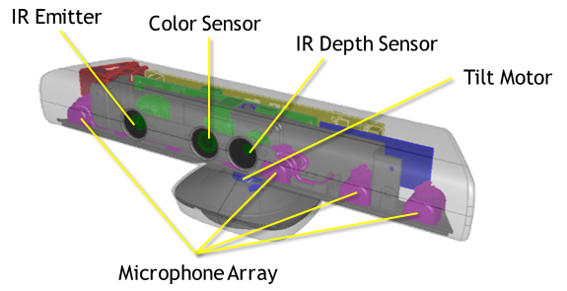
Fig5. Kinect Physical device with description

A Kinect specification according to Microsoft Corporation.

Kinect | Array Specifications
Viewing angle | 43° vertical by 57° horizontal field of view
Vertical tilt range | ±27°
Frame rate (depth and color stream) | 30 frames per second (FPS)
Audio format | 16-kHz, 24-bit mono pulse code modulation (PCM)
Audio input characteristics | A four-microphone array with 24-bit analog-to-digital converter (ADC) and Kinect-resident signal processing including acoustic echo cancellation and noise suppression

Kinect examplary images from RGB and infrared cameras are presented on the Fig4.

Why Kinect is so extraordinary?

Kinect can product of three- dimensional data using infrared camera which allows process not a classical image processing but depth image processing which can detect in easier why even no–human objects. Kinect’s normal depth vision ranges from 3 to 12 feet and is it recommended using Kinect in that distance because the reliability of the depth values degrades at the edges of the field of view.

2.2 Body Tracking – Image Processing versus Depth Processing

Identifying the presence of human body in video stream is very complex task using classical image processing methodology. On the image influences brightness, contrast level, backgrounds and great number of different possess which could be presented by different people in different clothes and body parameters. There exist many different methods to accomplish that task. This methods work quite good in face detection because human face differ from other object and it is relatively easy extract facial features from an image. The situation looks worse in the case when algorithms need extract full body in real- time. In this point we need something better, faster and more flexible then classic image Processing. The weakness of traditional image processing is overcomes by depth processing. Using depth processing the algorithms do not operate on classical pixels but on the 3D points which build a whole scene in 3D space (see Fig6).

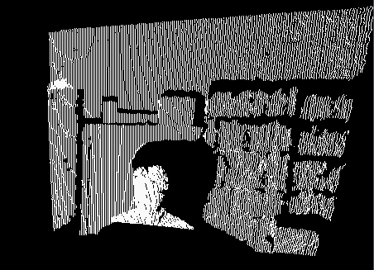
Fig6. 3D scene generated by Kinect

Each point in the image besides the traditional X and Y axis also contains the z-depth, which corresponds to the distance of the point from the Kinect. Coordinates depth facilitates image analysis and allows completely new algorithms, which give wondrous effects.

Thanks to that approach extracts body from the image is relatively simple task and what is more important it is many times faster than getting body from traditional image. More information about depth processing could be found in the next chapter – “Depth Processing – Body Tracking.

  - Depth Processing - Body Tracking

Depth processing analysis is used in the body tracking and it is the really first step during working on the input data. The purpose of that step is to obtaining the representation of body parts which could further analyze by gesture recognize algorithms. The process of obtaining the full body human and body parts is presented in the steps above.

- Extract human body from depth image (see Fig7).

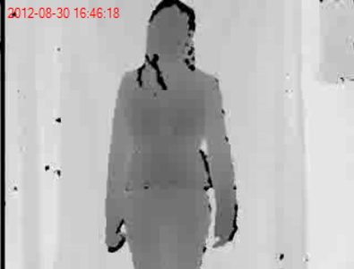
Fig7. Depth image to analyze in step 1

Initial image from infrared Kinect camera has too much information which is not required in further analysis. In the first step of that point the proper human body should be separated from background. The idea how to manage the first assumption is presented on the Fig8. On the z-axis background, distortion objects and human body was pointed. The z-axis informs about the distance from Kinect camera in that way position and depth of body could be found and separated from background.

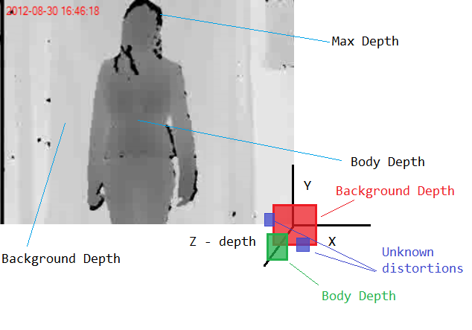
Fig8. Depth image analyzing description

Separation of background and body could be done in many different ways.

- Analyzing different in the depth value in given region. If the different is too high current proceeding region is the boundary region between background and body. Taking into account different between background and body depth on the boundary region algorithm can separate proper body (see Fig9). However distortion still reminded after this step separation.

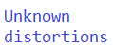
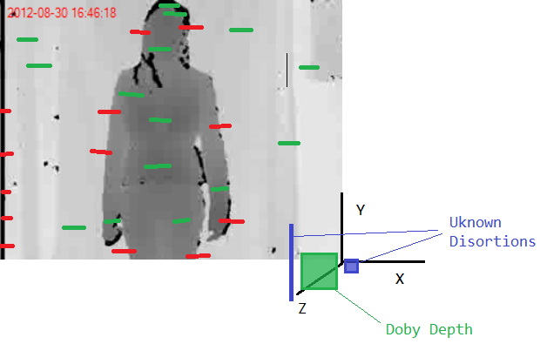
Fig9. Depth image removing background method (a)

- Get average depth from the interval between minimum and average depth values and cut off the rest. In that way body would be obtained together with distortions (see Fig10).

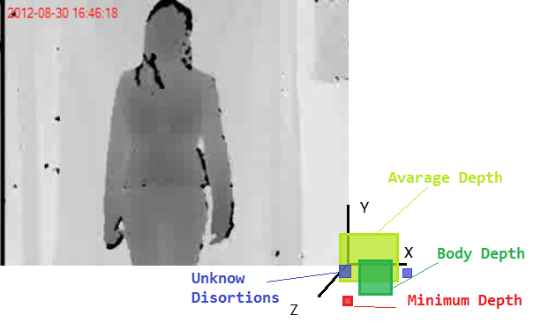
Fig10. Depth image removing background method (b)

Applying one of those two methods leads to satisfied result. The obtained body is separated from background in efficient way (see results Fig11). Unfortunately unknown distortions could appear on the final image after segmentation. This problem is solved in the next few steps.

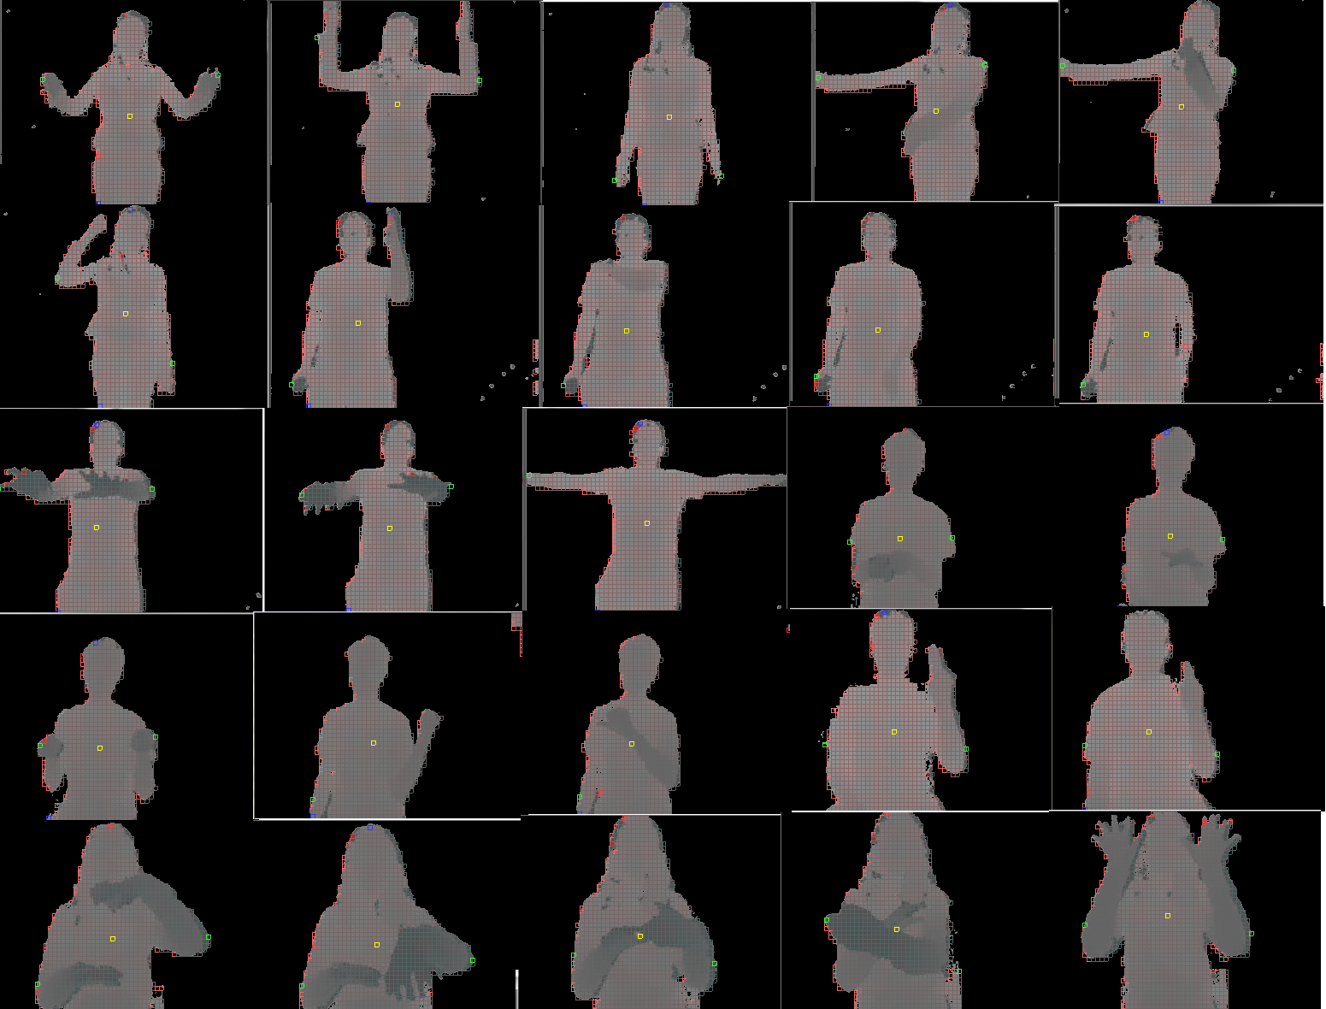
Fig11. Depth image segmentation – results

- Remove unknown distortions from the extracted body

Segmentation of image it is just a beginning of human body analyzing. The next step is to prepare the obtained image in the first step to further analysis. Method which helps achieve that goal is based on the converting depth segmented image into ‘depth squares’ with determined size and appropriate depth (Fig12).

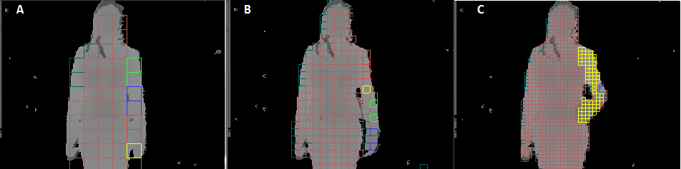
Fig12. Depth squares image. A – size 20, B – size 10, C – size 5

On the Fig12 ‘Depth squares’ method is presented with three different variation size (square size is equal to 5, 10 and 20 pixels). The size of the squares influences on the accuracy of further analysis. The optimal size of the square should balance the accuracy and efficiency of calculation. On the Fig13 execution of ten loops for different square is presented.

Fig13. Ten loops execution operating on one frame

The conclusion is very interesting. If body tracking algorithms can operate on the square size equals to 5 pixels the execution of body segmentation would be almost 30 times more efficient then operating on native values – 1 x 1. The lost in accuracy between those squares size (ex. 1 and 5) could be omitted during body part segmentation. Pure segmentation results are presented in the Fig14.

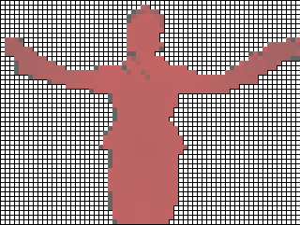
Fig14. Squares segmentation result
Fig14 is good enough to precede next body tracking calculation on it. The resulting image did not lost information about depth values and overcame problems with distortions. Why distortions of full body are so important to further analysis? Analysis of that issue is presented on the Fig15.

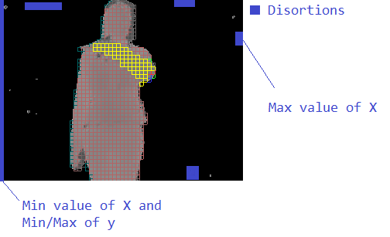
Fig15. Distortions problems

Distortions on the Fig15 make impossible extremes analysis which is crucial for extracting body parts from depth image. This is the main reason why distortions have to be removed before body parts analysis. Distortions removing process could be done suing a variety of methods.

- Nearest Neighbor Search – method is used for removing single regions of distortions which size is relatively small. It is based on the searching neighbor in the nearest regions firstly according to x-axis then y-axis. The boundary limits should be set in that way that width and height of the distortions are relatively small and provide that during of execution no parts of hands or legs would be cut off. Fig16 presents exactly which kind of distortions would be removed.
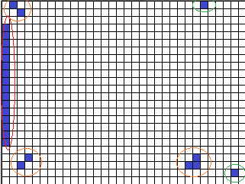
Fig16. Nearest neighbor search methods of removing distortions

The squares marked as green are for sure some kind of distortions, orange ones need additional calculation because it may happen that one of them could be a part of body. In fact even if the distortions removing algorithm removes too many squares (small part of body) this calculation error could be omitted. From point of view further analysis it is better to remove more then leave some small distortions on the image.

- Junction Search – method is based on the assumption that whole body is one common object. In other words, from any point on the human body can achieve a different point not leaving his area. First step of the algorithm is to find the inner point and then remove the entire region which could not be directly linked with that point. The visualization of the method is presented on the Fig17.

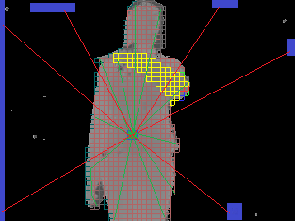
Fig17. Visualizations of junction search

The result of this method is better than the previous one and it is more natural from point of view structure of the human body.

- Separating parts of the human body

The last and the most complex part of body tracking is separation of body parts to get head, hands, torso and legs. Those are the primitive body parts from which more detailed regions as elbows or wrists can be obtained later.

At the outset, let's focus on getting basic part of the human body:
- Head
- Tors
- Hands
- Legs

At the Fig18 basic part of human with proportions are marked. The assumptions of constant body proportions simplify calculation of body regions. Based on that knowledge segmentation of elbows and wrist is easy task and no more complex mathematical calculations are needed. The nature laws can be used in body tracking algorithms.

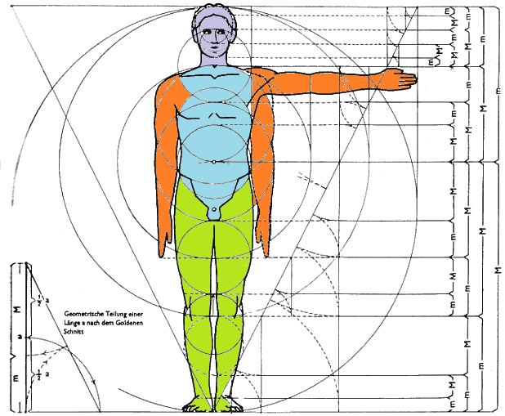
Fig18. Human body visualization

Tracking body algorithms have to resolve many different body segmentation problems. The common class problems are presented below. (Fig 19 – 21)

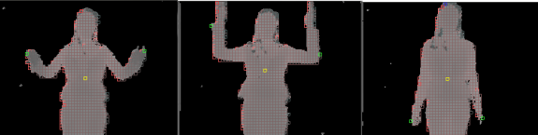
Fig19. Class I – Large number of different poses

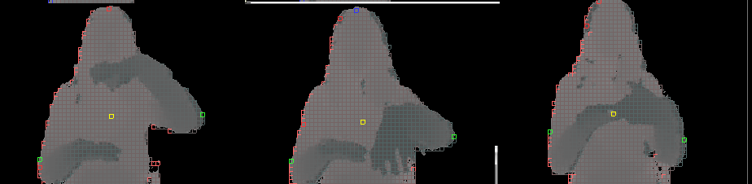
Fig20. Class II – Override parts of the body

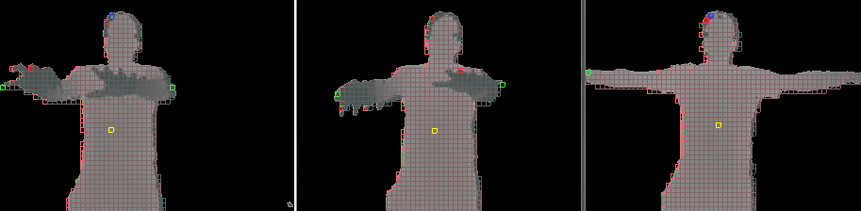
Fig21. Class III – Different users and perspective

These three classes of problems are the greatest challenge which body tracking algorithms have to overcome. In that point many methods could be considered to resolve this task in most efficient and reliable way. Methods which are described in the next paragraph are different but both give a good result. The first method is based on the machine learning processing which need some additional time to train a system. Another method is working on maxima analysis.

    - Machine Learning Body Part Separation

The basic idea is to supply set of training data which provide the system possibility to recognize patterns on the image. How the system is supplied with the data? The data need to be prepared manually using application functionality (see Fig 22).

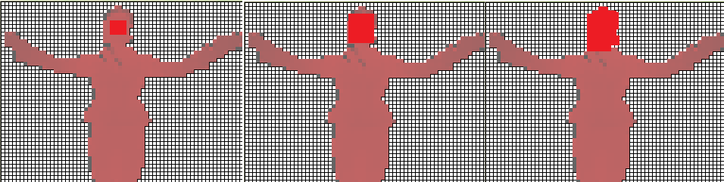
Fig22. Supplying data to learning system – marked head
On the Fig22 the process of marking head is presented. The next step is save the results in external xml file and then use that file during recognition step again. Whole process of extracts body parts from image consists of two main steps:
- Get Input Data – Learning Process
- Operate on Input Data - Recognize Process

- Learning Process – the idea is presented on the Fig22. User need supply input data in the form of separation body parts (one body part in that same time) and save the result. When the image is stored in xml file all the necessary information about body part, size of the body etc. are saved. Getting input data is relatively fast and easy step because more complex analysis of occurs in Recognizing Process.

- Recognize Process – the processing is based on the ‘chain rule’. The main ‘chain rule’ assumption is to treat a whole body as sequence of regions which all together create a full object. The execution of recognize algorithm is running in the correct order:

- Head

The first step is getting the region of head. Finding head part is relatively simply because head has almost constant position relative to the torso. Size and shape are well defined so analysis does not need taking into account changes associated with a variety of pos.
However even in head analysis some special situation should be considered (see Fig23).

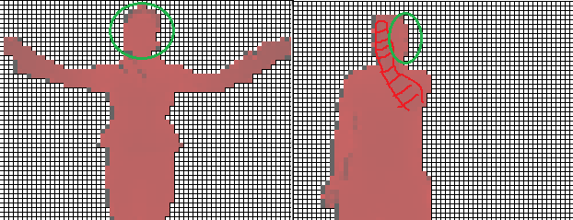
Fig23. Head problem analysis
Theoretically a hand position is not crucial for the head analysis however according to ‘chain rule’ in which all elements depends for each other a hand position has to be taken into account. In another way veiled part of the head would be treated as a casual case what is not true. The steps of the algorithm are as follows. (See fig24)

  - Remove regions below whole body centroid (red).
  - Remove regions on the sides of the body and upper part of torso (orange, green).
  - Remove special cases presented on the fig23 (blue). In that case algorithm need to analyze differs in z – depth values. The most of the z – depth values are in the narrow limits of torso values or even from average body depth. However in the most pessimistic case when depth of the hands is almost identical with head z – depth, algorithm could omit that difference and marked only head. Solving that problem during head analyzing it is not a good decision it seems more appropriate to overcome that in time of hands recognizing process.

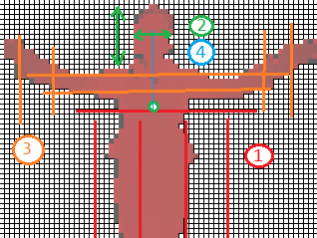
Fig23. Extract head region from image

The final result of head segmentation is presented on the fig24. In the process of segmentation, satisfactory results were obtained for different poses, people, and obscured part of the head.

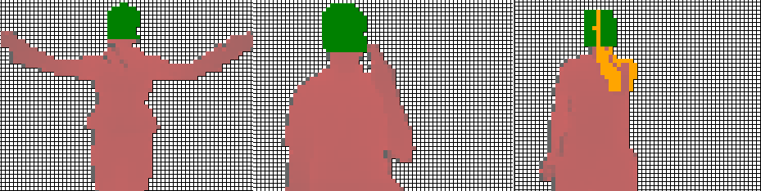

Fig24. Results of head segmentation (green)

- Torso

The torso analysis is based on the same method as head recognition was done. Depth of that part of body is very consistent and is almost constant position relative to the head. The special case during this analysis is similar to head as well – position of the head can cover torso region. The steps of the algorithm are as follows (See Fig25).

  - Remove previously found head region (red).
  - Remove bottom of torso based height and width of the torso calculated from the centroid point. (orange, blue)
  - Remove regions on the sides ex. Hands (violet)
  - Depth analysis to cut off from the torso region hands if it necessary. In the most pessimistic case if z-depth values between body and hands are not enough to perform proper analysis the RGB image could be used. In that processing classical approach may help get hands position. However in almost every case the hand recognition should give a good result and handle with cases approximated to the most pessimistic one.

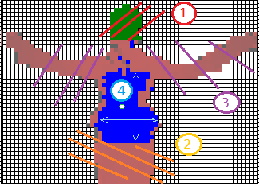
Fig25. Extract torso region from image
The final result of torso segmentation is presented on the fig26. In the process of segmentation, satisfactory results were obtained for different poses, people, and obscured part of the head.

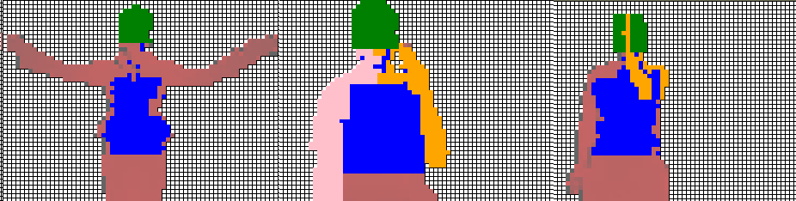
Fig26. Results of torso segmentation (blue)

- Lower Torso (Legs)

Lower Torso segmentation is not a key issue. The reason for this is the selection of the input files, which mainly focus on the upper part of torso and hands gestures. The method used for getting this region of the body is the simplest one and based on the previous steps (see results on Fig27).

  - Head Segmentation
  - Torso Segmentation
  - Get the area directly below the upper torso
  - Remove all residues

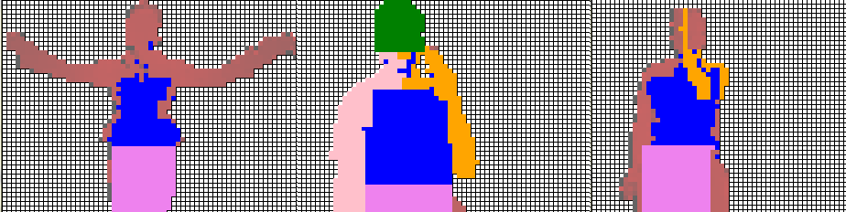
Fig27. Results of lower torso segmentation (dark pink)

The final results (Fig27) are not accurate as head or torso segmentation process because there is no need for that.

- Hands

The hands segmentation is the most important part of the body tracking algorithms and the most complicated as well.

The most important one because many of gestures based only on the hands position and configuration. The input files correspond to different classes of gestures but each of them is connected with signs, signals and gesticulations of hands. This is the reason why hand segmentation has to very accurate and effective.

The most complicated one because hands have got almost unlimited positions and configurations. Many different way of movements, speed and occlusion of other parts of body is the main difficult which the tracking algorithm has to overcome in this case.

The first step of analysis of hands segmentation is to realize a set of problems (Fig28). Squares describe a class of the pose. The class of the image is the mapping complexity of given image to analysis.

- Green – Easy
- Orange – Medium
- Red - Complex

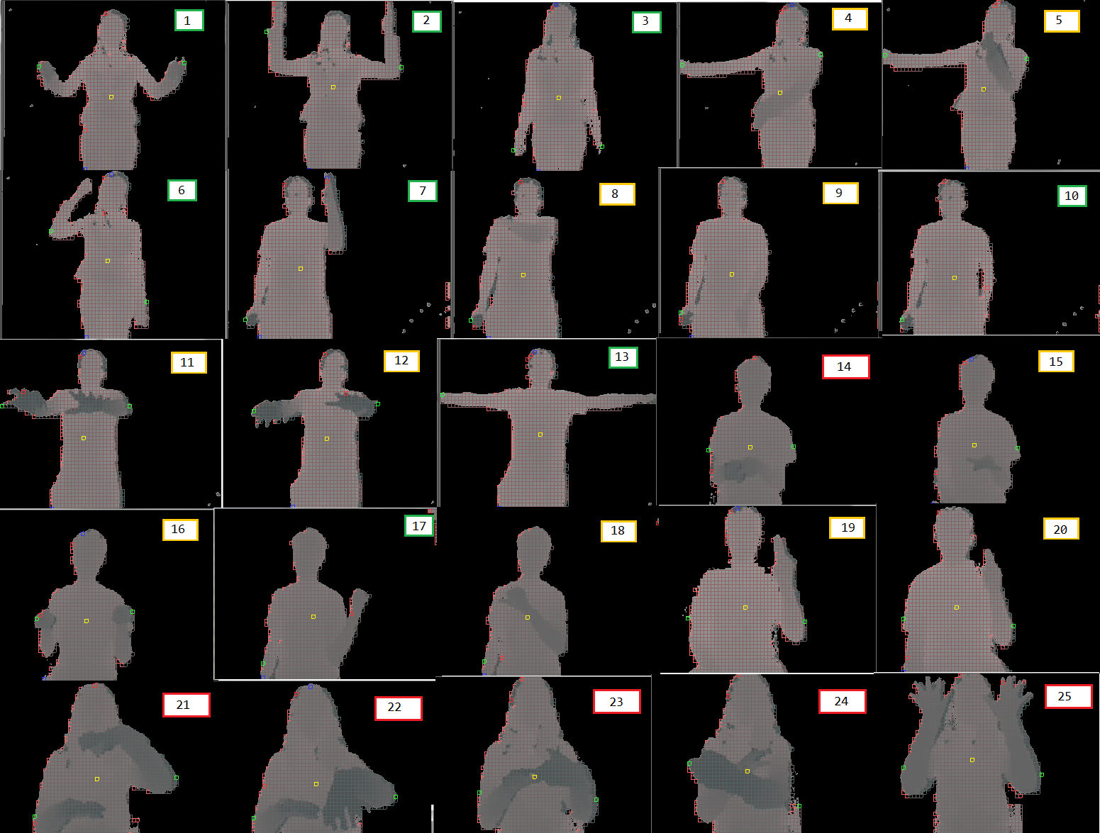

Fig28. Image classes during hands segmentation

What is the most significant difference between classes for analysis?

The ‘green’ cases during the segmentation process do not need z-depth consideration. That kind is a trivial one and analysis use only 2D space to get successful results. The ‘orange’ cases are more complex and without classic 2D analysis need a z-depth consideration as well. The ‘red’ cases not only need accurate z-depth analysis but also recognition of single metacarpus placement. In those cases hands could be located in ‘tricky ways’ what could be very hard to analyze. The steps of the algorithm are as follows (See Fig29):

  - Get below body parts:
    - Head
    - Torso
    - Lower Torso
  - Remove regions of the body on the left or on the right according to the hand which is actually analyzing.
  - Analyze obtained body parts in the step 1 to identity of the non-trivial cases.
  - Extract hand from the image in 2D space.
  - If step 4 is not successes start 3D space analysis (z – depth analysis).

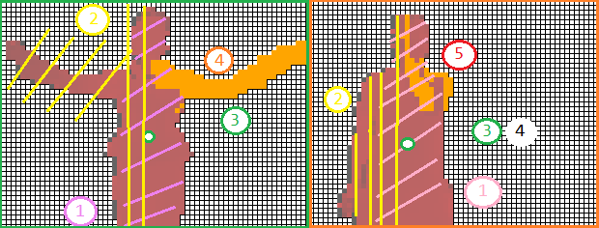
Fig29. Left hand segmentation for two classes of image (green – easy, orange – medium)

The algorithm results for three classes of images are presented on the Fig30. Blue and red circles denote respectively the success or failure of the method.
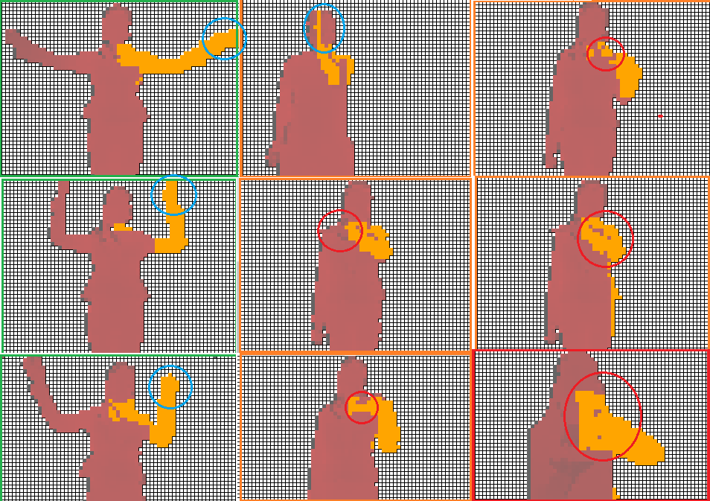

Fig30. Results of left hand segmentation

The results testify that the algorithm copes well with only the trivial cases. The cases highlighted in orange are processed with too little accuracy, and the hardest, most demanding (red class) is segmented in an invalid way. What is more the algorithm requires pre-segmentation initial conditions. Another drawback is the amount of hand segmented information which cannot sufficiently described the key position of the hand region.

The above analysis leads to the conclusion that hands segmentation is the process too complicated to carry out in a standard way. In contrast to the more static parts of the body such as the head and torso hands have too much range of motion to analyze in static based on the proportions of the body. Machine learning method is not able to do it sufficient way this is the reason to use another method to analysis of human body.

The recognize algorithm is generally based on the recalculation of the body proportion, position and recombination of the whole body parts. This method needs a set of input data and gives good result for static part (head, torso) of human body because theirs size, orientation and position are almost constant. Separation based on the z-depth improves algorithm but event then analyzing hands tracking is not possible for more complicated cases.

The core of human learning tracking algorithm is in the form (see Fig31):

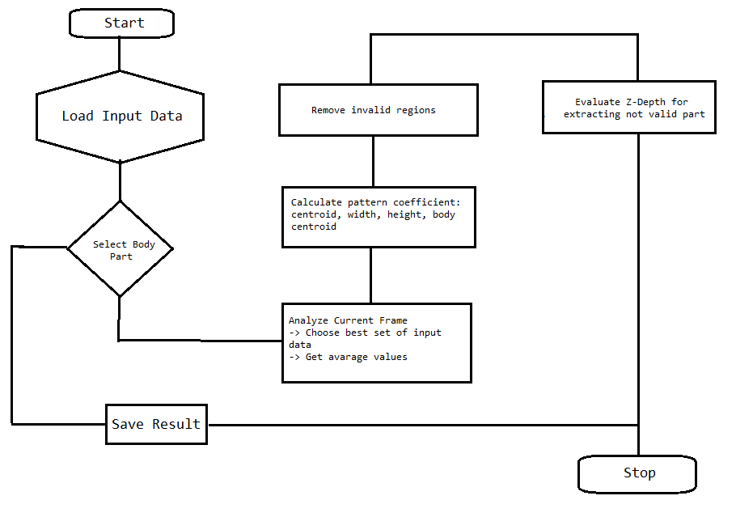
Fig31. Extracting body part algorithm

    - Segmentation method based on the analysis of extremes

The next method is used to overcome problem of hands segmentation which occurred in the previous algorithm. The algorithm steps are presented in the Fig32.

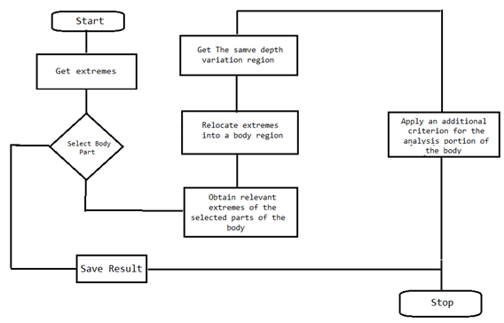
Fig32. Extremes analysis algorithm

The steps of the algorithm from Fig23 are described below:

- Get Extremes – the extremes values describe the most significant points of the human body (see Fig33).

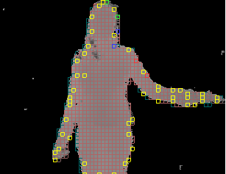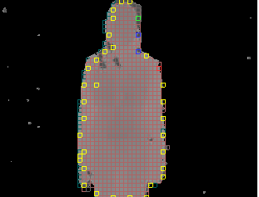
Fig32. Getting extremes values

On the Fig 32 all the extreme values of human body are marked. You can see that the key parts of the body such as hands and head centered on the largest number of points. Based on this assumption we can build the next steps of the algorithm. However, if this assumption is sufficient and clear in the context of all classes known Fig28 a picture?

Analysis of classes depending on the degree of complexity (see Fig33). On the blue marked region of the hand that need to be analyzed by the algorithm, but does not contain a sufficient amount of extremes. Green color corresponds to the part of the hand that has the appropriate number of extreme points for further analysis.

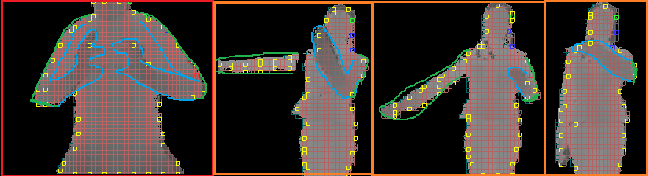
Fig32. Different image classes analysis
The results obtained in the picture Fig32 testify that the method of extremes analysis can handle partly with more complex image classes.

- Select body part and obtained relevant extremes

The next step of the algorithm is getting appropriate extremes for further analysis valid for selected body part (ex. Left hand). In the case of hands extreme values for head could be cut off. When the left hand is selected the region on the right side of the body could be removed. The result of those steps is presented on the Fig33.

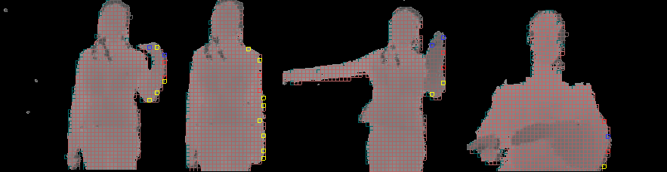
Fig33. Extremes for selected body part(left hand)

- Relocate extremes into a body regions

In that step the extremes are relocate to the region with the lower z-depth value. Thanks relocation the algorithm shortens the interval of z-depth to further analysis. Illustrated on the Fig34. Squares of white background present an initial state before relocation, arrows indicate squares after relocation.

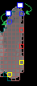
Fig34. Extremes relocation

- Getting similar z-depth variation level

The idea of that step is presented on the Fig35. On the grey-red marked all the regions which are in the given range (depth variation) on whole image. On the red marked region which size id determined and depth variation as well. The core of that analysis could be used in hand segmentation to getting z-depth region of hand.

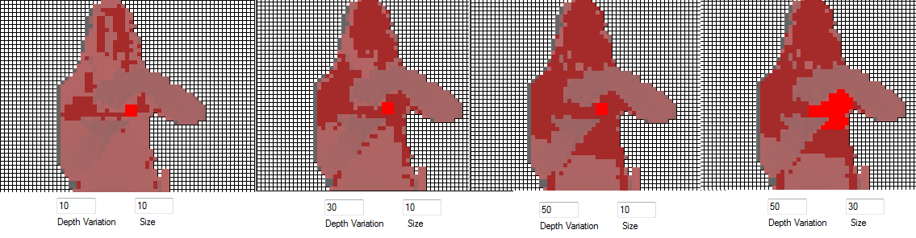
Fig35. Getting z-depth similarity from image

Analyzing z-depth variation is an approach that works well for hand segmentation. The algorithm should be carried out step by step, starting from the extreme point, which belongs to the hand. Then, in each subsequent step, we analyze the parts of the hand before stepping fixed size. This analysis provides us with a hand region to obtain in a very simple way, and what is more important gives good results in qualitative and performance as well. Steps algorithms have been presented on the Fig36.

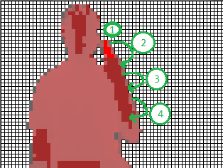
Fig36. Z-depth analyzing of the hand region

The result of the algorithm is presented on the Fig37.

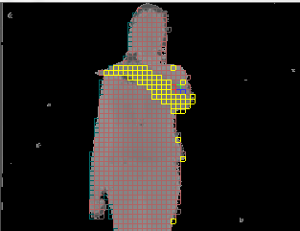
Fig36. Z-depth analyzing of the hand region

Confirmation of the correctness of the result of the algorithm is a good starting step for further analysis. Initial algorithm solves the problem posed by static image analysis which cannot overcome the problem of hands segmentation.

  - First Shoot Learning
The first shoot is a kind of learning, learning algorithms, which were formed in opposition to the classical methods. The main foundation of classical learning algorithms is to provide to the system large amounts of data upon which the system is able to recognize a pattern. First shoot learning directs in a different direction, and assumes that the system should solve the problem with the minimum amount of data, in the ideal case of one sample. This type of learning in some areas is close to the human way of acquiring of knowledge.

    - Analysis of problem
The main problem in the analysis of gestures is their diversity. Variety is not only kinds of gestures, but also differences in the performance of the same gesture by the man. Large amount of input data could offset these differences, however broke the basic assumption of first shooting learning algorithm. If we cannot take advantage of the large amounts of data the best solution would be to create them. The only way to increase the amount of data is more accurate image analysis. The figure below shows typical examples, which will have to deal with the algorithm.
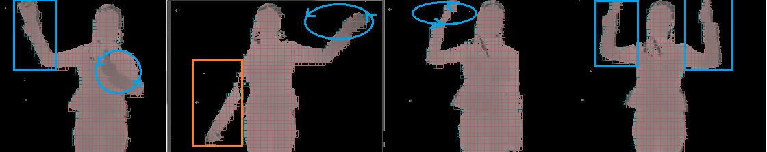
Fig37. Gesture classes.

In blue part of the body that are involved in creating gesture. Orange highlights part of the body, which may be relevant for gesture but not necessarily.
Gestures can be divided into two main classes:
- hands gestures
- palms gestures
Each of these classes must be analyzed separately because it poses other challenges to the algorithm. Movement of the hand gestures are treated with $1 Recognizer and Protractor: A Fast and Accurate Gesture Recognizer. However, the analysis will be carried out hand gestures using histograms.

    - Hands Gesture Recognition
Hands gesture recognizer is based on the two method of gesture recognize - $1 Recognizer and Protractor: A Fast and Accurate Gesture Recognizer. The main assumption of hand gesture recognizer is to look for similarities to the recognition by the human gestures. The human being is able to recognize hand gestures based mainly on 2D space. Abundance of z (z-depth) although very useful for image analysis is ignored in standard cases by humans. This assumption could be used in practice to simplify the algorithm which can operate on a 2D plane. However, this approach has a drawback, namely the analysis excludes gestures that take place in accordance with the z-plane. In this case, replacing of the plane is needed and new leading planes should be chosen. The idea is presented on the Fig38.

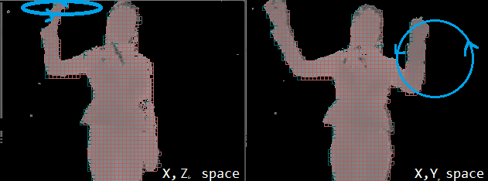
Fig38. Gestures in two different spaces.

Swapping planes in Fig38 leads to two independent gestures, which can easily recognize by the algorithm. Another requirement that must be met in the analysis of gestures is monitor entire region of the body, for this purpose you can use histograms, which greatly facilitate the analysis. The next few chapters present an algorithm to recognize gestures in more details. The last chapter in this section ‘First Shoot Learning – final evaluation’ describes the whole method of gestures segmentation.

      - ‘$1 Recognizer’
The ‘$1 recognizer’ algorithm is easy and efficient way to get almost 97% accuracy with only 1 loaded template loaded – basic assumption of first shoot learning. The basic features of the recognizer are:
- resistance on different speed and sensing in sampling
- support rotation, scale and position invariance
- no advanced mathematical techniques are required – fast enough
- return N-best result list with sensible from 0 to 1
- need only one sample to ‘teach’ a brand new pattern
The algorithm consists of four main steps, which prepare the appropriate input data, and then compares them with the mark of the patterns. A more detailed description underneath.

- Resample the point path
The step makes the gesture path comparable at different movement speed of sampling. The gesture path consists of points and interval between them when the speed of movement is greater than intervals grow. Speed ​​of movement affects the number of received samples, so the value should be clarified, as the interval to select a number from 31 < N < 257. Resampling process is presented in the Fig39.

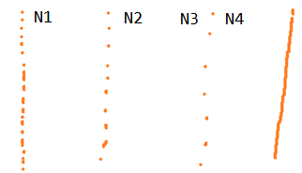
Fig39. Resamples line for N1 > N2 >N3 < N4
Each of lines from Fig39 is the same line but sampled in different way. The resample process needs some mathematical operation and linear interpolation to getting point path. At the end of this step algorithm has exactly N point to analysis.

- Rotate gesture

This step searches over the space for the best alignment between two point-paths. The first step is getting ‘indicative angle’ which is formed between the centroid of the gesture and the gestures first point. The next step is to rotate whole gesture in a way that this angle is at 0 degree.

- Translate and scale

In this step the reference squares is obtained from rotated gesture. Thanks to scaling this square in non-uniformly way we are able to rotate the candidate about its centroid and check the changes between current pattern and pattern library according to ration, not to ration aspect. To simplify calculation the point (0, 0) is chosen as centroid point of the gesture.

- Find the best score

The last step of the algorithm is recognize phase. In this point the input pattern is resampled, scaled, rotated and translated and ready for comparing with library patterns. Firstly algorithm is looking for average distance d between corresponding points according to below equation.

Distance is the path-distance between input pattern and templates pattern. This minimum path-distance is converted to a [0-1] score.

score =

size – the length of a side of the reference square

The algorithm return the list of the scores for every comparison the best score with the highest value is the searching solution.

Limitation of the $1 Recognizer

The $1 Recognizer in the pure form has some limitations. The core of the algorithm is a geometric template matcher which means that $1 is rotation, scale and position invariant. The algorithm cannot distinguish gestures whose identities depend on specific orientation, aspects ration or locations. The next problem is that $1 does not use time so gesture cannot be differentiated on the basis of speed. This is the reason why $1 Recognizer should be modified and adapted to the current needs.

      - Protractor: A Fast and Accurate Gesture Recognizer

Protractor is based on a nearest neighbor approach. The algorithm searches for similar gesture by calculating an optimal angular distance between input pattern and library patterns. The gestures are preprocesses into an equal length vectors in similar way to the $1 Recognizer, but with key differences in handling orientation sensitive and scaling. Protractor uses a closed-form solution to calculate best solution which improves accuracy and speed of calculations. In another way Protractor is a modified and better version of $1 Recognizer. Main steps of the algorithms are presented below.

1. Resample and translate points (The same as in the $1 Recognizer)

2. Reduce noise in gesture orientation

The orientation information of a gesture could be useful or irrelevant that type of information depends on the application. The algorithm gives possibility to analyze gesture with or without orientation irrelevant. In case when this option is orientation irrelevant Protractor rotates a resamples gesture around the centroid point to get zero orientation in indicative angle similar to $1 Recognizer.

Protractors analyze gesture in terms of one of the eight basic directions and select the smallest rotation that requires. As a result, Protractor can specify a maximum of eight gestures, which differ in orientation.

Protractor uses N = 16, which allows enough resolution for later classification. Note that Protractor does not rescale resampled points to fit a square as the $1 recognizer does which preserves the aspect ratio of a gesture and also makes it possible to recognize narrow (or 1-dimensional) gestures such as horizontal or vertical lines. Rescaling these narrow gestures to a square will seriously distort them and amplify the noise in trajectories.

3. Classification

Perform classification Protractor starts from calculation of the inverse cosine distance between vectors vt and vg:

As a result the equation gets the distance between two vectors in a space which makes the algorithm scale invariant. The cosine distance is represented by the multiplication of the magnitude:

Protractor acquires the vector representation of a gesture by aligning indicative orientation but it cannot completely remove the noise in gesture orientation. To solve that issue Protractor rotates a template to get better similarities to unknown gesture. Then Protractor uses a closed-form solution to find a rotation that lead to the minimum angular distance.

Calculation of the maximum similarity tends to the solution:

Where a is the dot product of vt and vg,

The final score becomes the top choice in the N-best candidate list. That kind of calculation is much more efficient than $1 algorithm. Protractor can search through stored template over 70 times faster than above mentioned algorithm.

  - Results of processing Protractor algorithm

Selected algorithm for further analysis is Protractor is improved, expanded version of $1 recognizer. The analysis is performed on the gesture from Fig38. The gesture may be presented in the following way see Fig40.

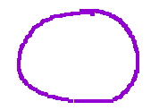

Fig40. Interpretation of gesture from Fig38

The gesture is almost circle and this pattern should be recognizing with good accuracy by Protractor algorithm. The results are presented on the Fig41.

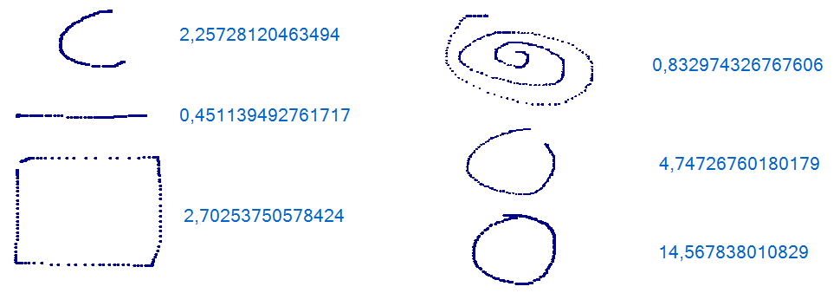
Fig41. Recognizing of pattern with scores

The results in Figure 41 confirmed the correctness of the algorithm with only one sample input data. The analysis confirmed that the assumptions Shoot First Learning are possible to fulfill in the process of pattern recognition. The increase in the number of samples leads to better quality results however; this increase may be omitted due to the nature of analysis, which assumes patterns of building based on just one sample.

  - First Shoot Learning – final evaluation

Analysis of gestures as a whole is a very complex process, which consists of pattern recognition, gesture directions and taking into consideration the 3D space. Apart from that also plays a big role performance of algorithm, which must analyze gesture in online mode. The method presented below is one way to recognize hand gestures:

- Hand Tracking
- Save hands position regards to other body elements
- Use Protractor learning method for saving/recognize sample
- Analyze the sequence of gesture creating

Those four steps are core of gesture recognition algorithms. Algorithm analysis will be carried out on the basis of Fig38.

Roberto Cipolla and Alex Pentland, Computer Vision for Human-Machine Interaction, Cambridge University Press 1998
Kinect Adventures / press release
http://gesture.chalearn.org/data
See http://gesture.chalearn.org
See http://www.kaggle.com/c/GestureChallenge
MSDN / Microsoft release
Official Kinect Specification taken from MSDN / Microsoft release
Method is not connected with original „Nearest neighbor search”
http://www.marcus-frings.de/text-nnj.htm

