**Sub-lethal and Lethal Effects of Exposure to Extreme Cold in the Invasive Anomuran *Petrolisthes armatus***

Kevin Mack

April 2016

EVSS 695

Applied Quantitative Methods

Dan McGlinn

Major Advisors: Dara Wilber and Robert Podolsky

Advisory Committee: Amy Fowler and Virginia Shervette

**Abstract**

The green porcelain crab, Petrolisthes armatus, is an intertidal anomuran crab with a native range extending from the Indian River, FL south to Brazil. In the mid-1990s, the species invaded northward and established populations on intertidal oyster reefs along the South Atlantic Bight, first appearing in Charleston, SC and later expanding as far north as Wilmington, NC. Petrolisthes armatus appears limited in its poleward expansion by its intolerance of extreme cold winter temperatures, although the mechanism is not well understood. Crabs collected from five locations within the species' northernmost invaded range from Savannah, GA to Wilmington, NC were used in incubation trials to determine whether cold temperatures experienced by adults induce different sublethal (loss of righting response) or lethal effects among locations, between crab size, or between sexes. Following an acclimation period, crabs were exposed to a chronic cold temperature trial informed by the January 2014 cold snap in Charleston Harbor, SC. Crabs from more northerly locations survived significantly longer as temperatures decreased. Regardless of location, females survived and maintained the righting response longer than males. These results suggest differences in cold tolerance between sexes, and indicate that thermal tolerance may vary along a latitudinal gradient in P. armatus.

**Research Objective**

In order to determine if *Petrolisthes armatus* populations differ in their tolerance of extreme cold within their invaded range, I will conduct laboratory trials to compare the cold temperature thresholds that induce sub-lethal and lethal effects in *P. armatus* and examine differences among populations at five locations along a latitudinal gradient. It is anticipated that northern *P. armatus* populations will exhibit greater cold tolerance than southern populations, maintaining a righting response and surviving for longer incubation durations. Additionally, it is predicted that male crabs, because they are larger and more abundant, will exhibit greater cold tolerance than females.

**Methods**

Collection:

*Petrolisthes armatus* were collected from five locations (Fig. 1) across a latitudinal gradient from Savannah, GA (Skidaway Island; 31°59’25.3”N, 81°01’165”W) where the species is well-established, to Wilmington, NC (34°10’45.3”N, 77°50’35.5”W), near the northern range limit of the species. Intermediate sites in the range being sampled in South Carolina include Baruch (Winyah Bay; 33°20’28.7”N, 79°10’44.9”W), Charleston (32°45’09.0”N, 79°53’51.2”W), and Bluffton (Harbor River; 32°17’20.4”N, 80°48’33.7”W). At each location, two sites were established based on availability and access to intertidal oyster reef. Collections were conducted using plastic trays (30.5 cm W x 45 cm L x 10.5 cm H), lined with 2 mm mesh screen, filled with dead oyster shell oriented to maximize crab recruitment, and secured with hooked rebar and plastic fencing. One tray at each site contained a HOBO temperature datalogger (Onset UA-001-64) to record temperature fluctuations experienced by the crabs. Five trays were deployed in June 2015 at spring low tide within the intertidal oyster reef matrix at each site and retrieved after three months in September 2015.

Upon retrieval, trays were placed in large plastic garbage bags and sealed before being removed from the site. Four of the five trays from each site were rinsed through a 0.5 mm mesh sieve to separate macrofauna from sediment and oyster shell hash. Species, sex, and carapace width were recorded for all crabs, both native brachyurans and the invasive *P. armatus*. Crabs from the one remaining tray at each site were transported to the laboratory for use in cold temperature tolerance experiments. Both male and female P. armatus were used in the cold tolerance trial, although only adult crabs (carapace width > 3 mm) and non-ovigerous females were used. Unfortunately, low sample sizes at both Wilmington sites prevented crabs from that location from being used in cold tolerance experimentation.

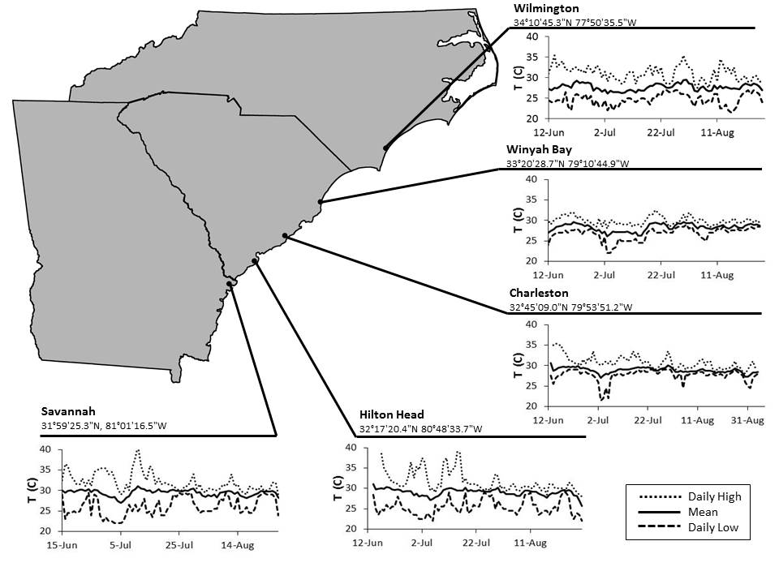

**Figure 1.** Five study locations within the northernmost invaded range of *P. armatus* and thermal history of each site; daily high, mean, and low water temperatures [T(C); °C], June-September 2015. Temperatures recorded via temperature loggers within trays at each location.

Acclimation:

Following collection from each field site, live crabs experienced two consecutive thermal acclimation periods. In the first, ambient water temperature was held at 20 oC for 2 weeks. During this acclimation period, crabs were held by site in the Grice Marine Lab wet lab in separate open-topped holding tanks equipped with aerators. Holding tanks contained oyster shells to simulate natural conditions and provide refuge. Tanks were filled with filtered sea water pumped from Charleston Harbor by the Grice Marine Lab seawater system at room temperature and unaltered salinities. Crabs were fed (Hikari Tropical Crab Cuisine pellets) every 48 hours and water changes were conducted every 72 hours.

During the second acclimation period, subsamples of crabs from each site experienced a gradual reduction in temperature from 20 oC to 12 oC over the course of 2 weeks within an incubator. Crabs were held by site in plastic bins, each bin contained oyster shell substrate and an aerator, were fed every 48 hours, and water changes were conducted every 72 hours. Other studies have shown that marine crab temperature tolerances vary seasonally, with animals collected in winter better able to tolerate extreme cold (Cuculescu et al., 1998). Essentially, an animal collected in summer is not physiologically prepared for winter temperatures. This acclimation period is intended to allow *P. armatus* collected during summer months to be gradually introduced to winter temperatures typical of the Mid Atlantic Bight, without causing undue stress. Acclimation periods as brief as eight hours have been shown to enhance the cold tolerance of a congener, *Petrolisthes cinctipes* (Ronges et al., 2012).

Cold Tolerance Trial:

Following the acclimation periods, crabs were assigned to cells within individual holding arrays (plastic jewelry trays), using site and sex (non-gravid females) as factors. Holding arrays contained 30 individual cells (4.35 cm x 5.45 cm) and a lid which was securely closed. Each cell contained 30 mL filtered sea water, cooled to the initial incubation temperature. One cell in each array contained an iButton temperature logger (Maxim DS1921G-F5#) in place of a crab. Three arrays were placed on each shelf in the incubator. A randomized block method was used to assign crabs to individual holding array cells, using the three incubator shelves as blocks. Each block consisted of three individual holding arrays, each of which has 30 available cells. Each block contained five males and five females from each site, a total of 80 animals, and seven empty wells (blanks). Crabs and blanks were assigned randomly across the block.

Temperatures used in chronic cold trials were informed by water temperatures recorded during the January 2014 cold snap in Charleston Harbor, SC, where water temperatures reached a minimum of 3 °C (USGS, 2014). Trials begin at 12 °C, and dropped by 1 °C per day until the temperature of 2 °C was reached or mortality reached 100%, whichever came first. Crabs were checked for sub-lethal and lethal effects twice a day (morning and evening). Sub-lethal effects are measured via a righting response, a normal behavior of crustaceans that is lost following exposure to extreme temperatures when the animal enters a “cold coma” state (Rebach, 1974; Castañeda et al., 2004), but is recovered when returned to normal temperatures (Lagerspetz and Vainio, 2006). Using a rubber tipped dissection probe, each crab was gently flipped onto its back, and the amount of time taken to successfully right itself was recorded up to one minute. Any non-mortal change in response, such as a slowed righting time is considered a sub-lethal effect. Crabs unable to right themselves after one minute had failed the righting response test and were considered to be exhibiting a sub-lethal effect.

A number of crabs collected at Grice were assigned to cells in jewelry trays in the same manner and are used as a control group because of their relative ease of collection, and to maximize the number of crabs from other sites that could be used in the temperature trials. Control crabs received the same treatment during both acclimation periods, but did not undergo a temperature trial, instead they were held at 2. °C in a second incubator during the duration of the experiment to control for the effect of confinement. These crabs were checked for sub-lethal and lethal effects on the same morning/evening schedule. The cold temperature thresholds that induced sub-lethal and lethal effects in *P. armatus* will likely be influenced by the crab’s thermal history (Cuculescu, et al., 1998; Teapolt and Somero, 2014), therefore, measures taken in the laboratory may be non-conservative estimates of cold tolerance and sub-lethal effects.

Analysis:

Differences in temperature tolerance for both sub-lethal and lethal effects were examined among sites, sexes, and sizes. Main effects were tested with a Log-Rank test of generated Kaplan Meyer Survival Curves. A Cox Proportional Hazards model was used to determine differences in righting response loss or survival probability for each of the main effects. All analyses were conducted in R using the survival package (Therneau and Grambsch, 2000).

**Results**

Sub-lethal Effects:

No difference in *Petrolisthes armatus* righting response loss was found between sites (*X*2 = 20.4, p = 0.617; Fig. 2). However, crabs from Northern sites tended to maintain their righting response longer than crabs from southern sites (*X*2 = 10.4, p = 0.064; Fig. 3), with a Cox Proportional Hazards model predicting a 12.5% higher risk of righting response loss in crabs from Southern sites (p < 0.05). Crabs from both Northern and Southern sites experienced 50% righting response loss at 105 hours duration, corresponding to a water temperature between 8 °C and 7 °C. All crabs had lost their righting response and were in a state of cold coma by 129 hours duration, corresponding to a water temperature of 6 °C.

Female *P. armatus* maintained their righting response significantly longer than males (*X*2 = 15.9, p < 0.01; Fig. 4). A Cox Proportional hazards Model predicted a nearly 14% higher risk of righting response loss in male crabs (p < 0.05). No interaction with site or region was detected. While females maintained their righting response longer than males, both sexes experienced 50% righting response loss at 105 hours duration, corresponding to a water temperature between 8 °C and 7 °C. Regardless of sex, all crabs had lost their righting response and were in a state of cold coma by 129 hours duration, corresponding to a water temperature of 6 °C. In both males and females righting response loss appears to be inversely related to carapace width (Fig. 5).

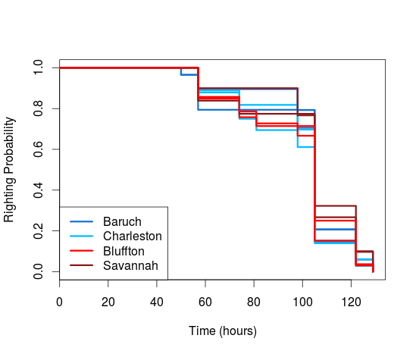

**Figure 2.** Kaplan Meier curve of righting probability in *P. armatus* from both study sites at each location; from North to South, Baruch, Charleston, Bluffton (SC) and Savannah (GA) during cold temperature trial. Log-Rank test: *X*2 = 20.4, p = 0.617.

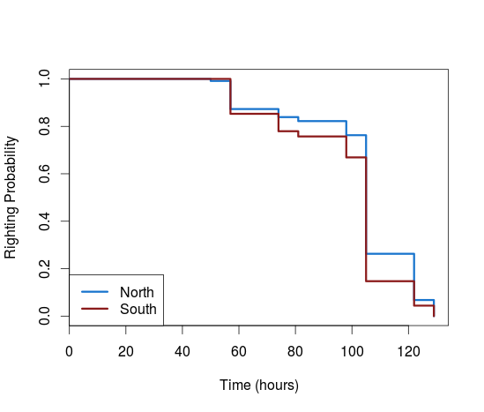

**Figure 3.** Kaplan Meier curve of righting probability in *P. armatus* from Northern and Southern sites during cold temperature trial. Log-Rank test: *X*2 = 10.4, p = 0.064.

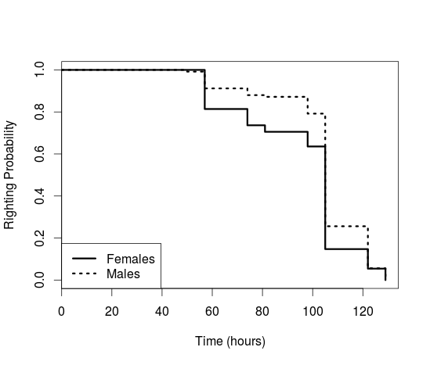

**Figure 4.** Kaplan Meier curve of righting probability in *P. armatus* females and males during cold temperature trial. Log-Rank test: *X*2 = 15.9, p < 0.01.

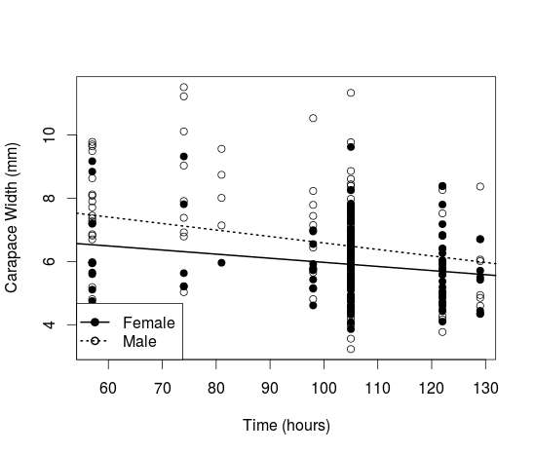

**Figure 5.** Carapace width (mm) of *P. armatus* plotted by time of righting response loss for females (R2 = 0.036, p <0.05) and males (R2 = 0.062, p < 0.01 ) during cold temperature trial.

Lethal Effects:

Differences in *Petrolisthes armatus* survival were found to exist between sites (*X*2 = 55.6, p < 0.001; Fig. 6). Crabs from Northern sites survived significantly longer than southern sites (*X*2 = 31.5, p < 0.001; Fig. 7). A Cox Proportional Hazards model found a 14% higher mortality risk in crabs from Southern sites (p < 0.05). In crabs from Northern sites, 50% mortality occurred at 266 hours duration, corresponding to water temperatures increasing from 2 °C to 3 °C. In Southern sites, 50% mortality occurred 24h sooner, at 242 hours, corresponding to water temperatures decreasing from 3 °C to 2 °C. Crabs from Southern sites were more likely to die as a result of exposure to cold water temperatures than crabs from Northern sites.

Females survived significantly longer than males (*X*2 = 54.9, p < 0.001; Fig. 8), with a Cox Proportional Hazards model predicting a 30% higher mortality risk in male crabs than female crabs (p < 0.001). Females experienced 50% mortality at 273 hours after crabs had experienced the most extreme cold and corresponding to temperatures increasing from 3 °C to 4 °C. A number of females died while attempting to molt with rising water temperatures, but were not included in the survivorship analysis. Males reached 50% mortality 31 hours sooner at 242h, corresponding to water temperatures decreasing from 3 °C to 2 °C. Regardless of region, male crabs were more likely to die as a result of exposure to cold water temperatures than female crabs. No interaction was found between sex and region. Survival was found to be inversely related to carapace width in males only (Fig. 9).

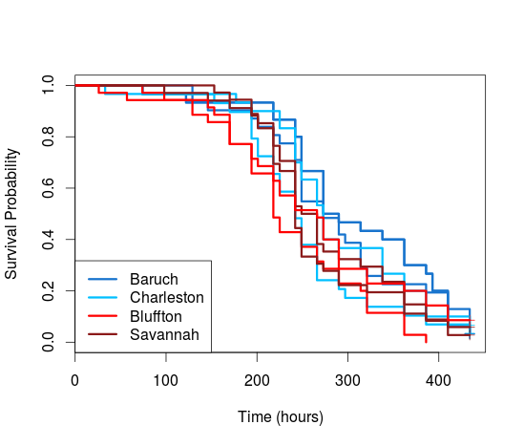

**Figure 6.** Kaplan Meier curve of survival probability in *P. armatus* from both study sites at each location; from North to South, Baruch, Charleston, Bluffton (SC) and Savannah (GA) during cold temperature trial. Log-Rank test: *X*2 = 55.6, p < 0.001.

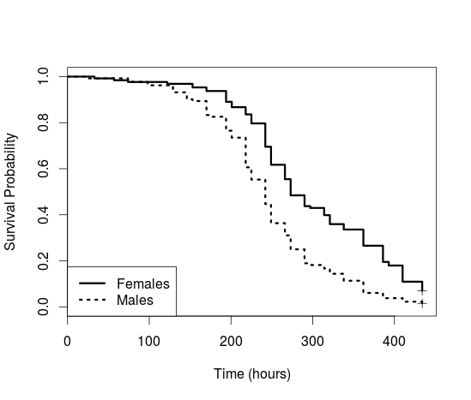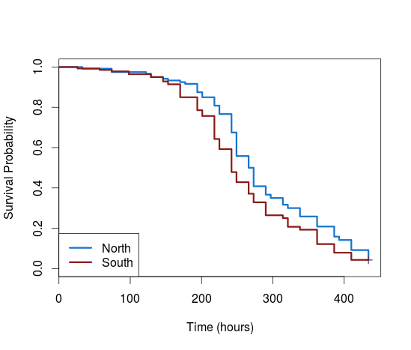

**Figure 8.** Kaplan Meier curve of survival probability in *P. armatus* females and males during cold temperature trial. Log-Rank test: *X*2 = 54.9, p < 0.001.

**Figure 7.** Kaplan Meier curve of survival probability in *P. armatus* from Northern and Southern sites during cold temperature trial. Log-Rank test: *X*2 = 31.5, p < 0.001.

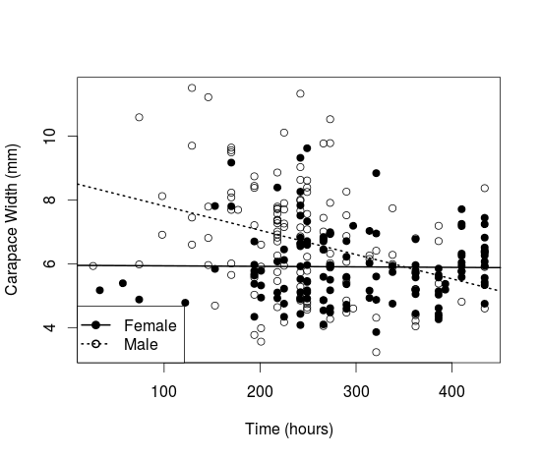

**Figure 9.** Carapace width (mm) of *P. armatus* plotted by time of righting response loss for females (R2 = 0.00, p = 0.88) and males (R2 = 0.10, p < 0.001) during cold temperature trial.

**Discussion**

Sub-lethal vs Lethal Effects:

In this trial, *Petrolisthes armatus* experienced sub-lethal effects, quantified as a loss of righting response and induction of a cold coma state, initiated when water temperatures dropped below 8 °C. By 6 °C all crabs tested had entered a cold coma state. While no significant difference in righting response loss was detected between sites, the higher risk hazard in crabs from Southern sites indicates the potential for locally adapted populations. Mortality was induced in *P. armatus* only at extremely cold water temperatures, which would be infrequently experienced outside of cold snap events. Crabs were unable to survive extreme cold water temperatures below 3 °C; however, observed mortalities as water temperature increased indicate that duration of cold events may play a role in *P. armatus* survival. Additionally, the differences in survival between crabs collected from northern and southern sites, and the higher risk hazard in crabs from southern sites further supports the potential for locally adapted populations in this species. Following a cold snap in 2010, Canning-Clode et al. (2011) found that *P. armatus* experienced a loss of mobility and was unable to survive extreme cold temperatures below 4°C. However, their study did not address potential differences in cold tolerance by crab size or sex, and did not examine latitudinal differences between populations. The present study found similar results, suggesting differences in cold tolerance exist between sexes, and indicating that thermal tolerance may vary along a latitudinal gradient in P. armatus.

Latitudinal Differences:

Latitudinal variations appear to exist in *P. armatus*, detected here as differences in the cold temperature thresholds which result in sub-lethal and lethal effects among populations. This finding is consistent with previous work that showed differences in sub-lethal cold tolerance were influenced by latitude in the native range of a congener species *Petrolisthes aiolaceus* (Gaitán-Espitia et al., 2014). Additionally, Castañeda et al. (2004) found that sub-lethal righting responses varied across a latitudinal gradient in a species of terrestrial isopod that also exhibits a cold coma response, with slower times exhibited by warm-adapted (lower latitude) populations following exposure to cold. The cold tolerance differences detected in this study may also provide evidence for locally adapted populations and is consistent with the climactic variability hypothesis discussed by Gaitán-Espitia et al. (2014) which predicts a higher degree of thermal tolerance in populations that experience more thermal variation (higher latitude) compared to those with less thermal variation (low latitudes).

The mechanism behind the latitudinal variations detected in the most poleward invaded range of *P. armatus* is still unclear. Explanations for a similar latitudinal gradient in thermal tolerances found in both the native and invasive range of the intertidal crab *Carcinus maenas*, include adaptive genetic differences between populations, some level of developmental plasticity following recruitment and metamorphosis, and acclimatization plasticity (Teapolt and Somero, 2014). Previous work has found *P. armatus* populations to be genetically homogeneous within their invaded range (Hartman, 2003), and the relatively short time scale associated with the species’ poleward range expansion render adaptive genetic differences an unlikely explanation. Developmental plasticity is a possibility as the species’ larvae are largely retained within the natal estuary (Tilburg et al., 2010), however little is known about larval dispersal range or supply within the species’ invaded range. Acclimatization plasticity is another possibility as the thermal tolerances of crustaceans has been repeatedly shown to vary depending on acclimation conditions (Cuculescu, et al., 1998; Stillman, 2004; Teapolt and Somero, 2014). However, it is not likely that adult individuals acclimatized to a certain thermal regime are moving between populations and needing to re-acclimate. The present study did not attempt to test the mechanism behind any potential population differences, whether the result of acclimation to local climes or adaptation of populations, but it is hoped that additional trials with crabs collected during different seasons, and from the poleward most field site, Wilmington NC, will provide more information on the latitudinal differences observed.

Sex Differences:

It was surprising that females maintained their righting response longer than males. Males are generally more abundant and larger than females within the species’ invaded range (Hartman, 2003; Hadley et al., 2010), indicating a higher fitness level, or differences in resource allocation. While only non-ovigerous female crabs were used in this trial it is possible that differences in the male and female reproductive cycles lead to the observed differences in righting response loss. It is also possible that female crabs allocated resources or energy stores which would have otherwise been used in reproduction to better tolerate cold water temperatures, in a type of bet hedging. Unfortunately, little work has been done on differences in thermal tolerance between sexes in crustaceans. Future trials using crabs collected during different seasons are anticipated to be very informative in this regard. The observed inverse relationship between carapace width and righting response loss was very weak, and may be the result of the larger, less hardy, males entering a cold coma state before females. Because sex and size are so closely related in this species it is difficult to further elucidate this relationship, and future trials will be very useful in this regard.

Implications:

Given the continued trend of warming ocean waters and observed cold tolerance in northern *P. armatus* populations there is potential that this species will continue its poleward range expansion. Because impacts of *P. armatus* on oysters and their associated fauna is unclear (Hollebone and Hay, 2008; Hadley et al., 2010; Byers et al., 2014), determining how the species responds to cold events, and how those events may alter community structure is important. Additionally, this work has implications for range shifts and invasions consistent with trends in warming ocean waters.

**Literature Cited**

Byers, J.E., Smith, R.E., Weiskel, H.W., and C.Y. Robertson. 2014. A non-native prey mediates the effects of a shared predator on an ecosystem service. PLoS ONE. 9:1-8.

Canning-Clode, J., Fowler, A.E., Byers, J.E., Carlton, J.T., and G.M. Ruiz. 2011. Caribbean creep chills out: climate change and marine invasive species. PLoS ONE. 6:1-5.

Castañeda, L.E., Lardies, M.A., and F. Bozinovich. 2004. Adaptive latitudinal shifts in the thermal physiology of a terrestrial isopod. Evolutionary Ecology Research. 6:579-593.

Cuculescu, M., Hyde, D., and K. Bowler. 1998. Thermal tolerance of two species of marine crab, *Cancer pagurus* and *Carcinus maenas*. Journal of Thermal Biology. 2:107-110.

Gaitán-Espitia, J.D., Bacigalupe, L.D., Opitz, T., Lagos, N.A., Timmermann, T., and M.A. Lardies. 2014. Geographic variation in thermal physiological performance of the intertidal crab *Petrolisthes violaceus* along a latitudinal gradient. Journal of Experimental Biology 217:4379-4386.

Hadley, N.H., Hodges, M., Wilber, D.H., and L.D. Coen. 2010. Evaluating intertidal oyster reef development in South Carolina using associated faunal indicators. Restoration Ecology. 5:691-701.

Hartman, M.J. 2003. Population dynamics and trophic interactions of *Petrolisthes armatus*, an invasive decapod crustacean. Dissertation, University of South Carolina, Columbia, SC. 143 pp.

Hollebone, A.L. and M.E. Hay. 2008. An invasive crab alters interaction webs in a marine community. Biological Invasions. 10:347-358.

Lagerspetz, K.Y.H. and L.A. Vainio. 2006. Thermal behavior of crustaceans. Biological Review. 81:237-258.

Rebach, S. 1974. Burying behavior in relation to substrate and temperature in the hermit crab, *Pagurus longicarpus*. Ecology. 55:195-198.

Ronges, D., Walsh, J.P., Sinclair, B.J., and J.H. Stillman. 2012. Changes in extreme cold tolerance, membrane composition and cardiac transcriptome during the first day of thermal acclimation in the porcelain crab *Petrolisthes cinctipes*. Journal of Experimental Biology. 215:1824-1836.

Tepolt, C.K. and G.N. Somero. 2014. Master of all trades: thermal acclimation and adaptation of cardiac function in a broadly distributed marine invasive species the European green crab, *Carcinus maenas*. Journal of Experimental Biology 217:1129-1138.

Tilburg, C.E., Seay, J.E., Bishop, T.D., Miller III, H.L. and C. Meile. 2010. Distribution and retention of *Petrolisthes armatus* in a coastal plain estuary: The role of vertical movement in larval transport. Estuarine, Coastal, and Shelf Science 88:260-266.

U.S. Geological Survey, 2014, National Water Information System data available on the World

Wide Web (Water Data for the Nation), accessed April 4 2014, at URL http://waterdata.usgs.gov/sc/nwis/uv?site_no=021720710.

Therneau, T.M. and P.M. Grambsch. 2000. Modeling Survival Data: Extending the Cox Model. Springer, New York.