FUTURE INTERNS · CYBERSECURITY TASK 1 · 2026

Vulnerability Assessment
Report

Passive Security Audit — Read-Only Scope

Target | https://cyberbase-nine.vercel.app/
IP Address | 216.198.79.67 / 64.29.17.131
Assessment Date | 26 April – 1 May 2026
Assessment Type | Passive / Read-Only
Tools Used | SecurityHeaders · ZAP · Nmap · SSL Labs · Wappalyzer
Overall Risk | MEDIUM
Auditor | Mack (Siva Sanjay Muthu T)
Organisation | Future Interns

CONFIDENTIAL · EDUCATIONAL USE ONLY · PASSIVE SCAN — NO EXPLOITATION PERFORMED

01 Executive Summary
This report presents the findings of a passive, read-only vulnerability assessment conducted against cyberbase-nine.vercel.app between 26 April and 1 May 2026. The assessment was carried out as part of Future Interns Cybersecurity Task 1 (2026) using industry-standard open-source tools in a strictly non-intrusive manner. No exploitation was attempted at any point.

A total of 13 security alerts were identified by OWASP ZAP across six testing phases. The most significant findings relate to missing HTTP security response headers and a cross-domain (CORS) misconfiguration. The application is built on a modern React/Vercel stack with a healthy HTTPS setup, meaning the fixes required are largely configuration-level and achievable within days — not months.

0  Critical | 0  High | 5  Medium | 8  Low / Info

02 Scope & Methodology
The assessment followed a strictly passive methodology aligned with OWASP Testing Guide v4.2 principles. All techniques were read-only — meaning we observed and recorded what the server voluntarily disclosed, without attempting to modify, exploit, or disrupt any data or service.

Testing Phases
# | Tool | Phase | Objective
1 | Manual Recon | Passive Reconnaissance | Observe site structure, pages, forms, and client-side behaviour
2 | SecurityHeaders.com | Header Analysis | Automated audit of HTTP security response headers
3 | OWASP ZAP 2.17.0 | Automated Passive Scan | Intercept traffic and flag alerts without sending attack payloads
4 | Nmap 7.99 | Network & Port Scan | Identify open ports, services, and banner information
5 | Qualys SSL Labs | SSL/TLS Analysis | Assess certificate strength and TLS configuration
6 | Wappalyzer | Tech Stack Fingerprinting | Identify frameworks, libraries, PaaS, and analytics tools

Ethical Boundaries
- Read-only passive scanning only — no payloads sent
- No login bypass, brute force, exploitation, or denial-of-service
- Target is the auditor's own project — full written permission exists
- All tool outputs archived as evidence in this report

03 Technology Stack Fingerprint
Wappalyzer was used to passively identify the technology stack powering the application. Understanding the stack helps contextualise findings — for example, a React SPA with Google Tag Manager loading third-party scripts makes a missing Content-Security-Policy especially dangerous.

Category | Technology | Security Relevance
JavaScript Framework | React | Client-side rendering — XSS impact is app-wide
Routing | React Router 7.13.1 | No known CVEs at this version
Animation | GSAP / Framer Motion / Lenis 1.0.42 | Third-party scripts — CSP required
Styling | Tailwind CSS | No direct risk
Analytics | Google Analytics | Tracking data sent to Google — Referrer-Policy matters
Tag Manager | Google Tag Manager | Injects arbitrary scripts — HIGH CSP risk without whitelist
PaaS / CDN | Vercel | Manages HTTPS and edge routing

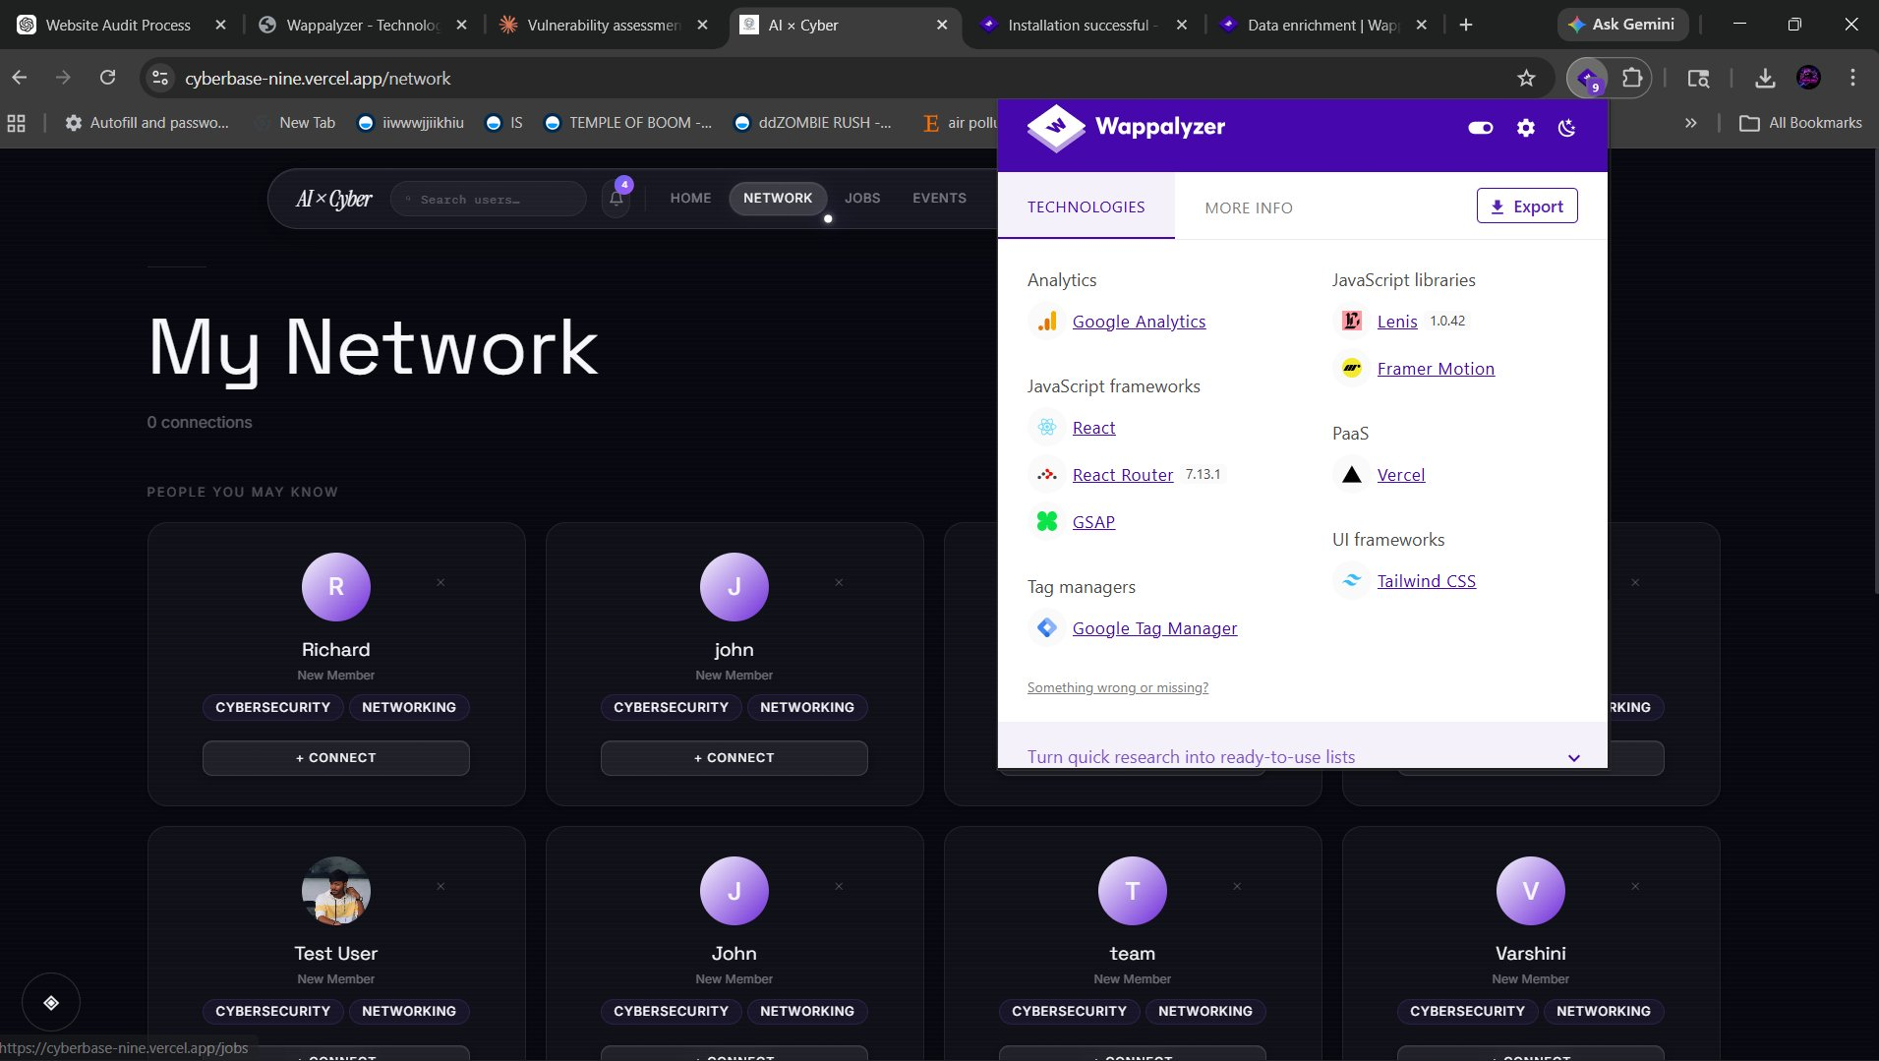
Figure 1 — Wappalyzer tech-stack fingerprint on cyberbase-nine.vercel.app

04 Phase 2 — Security Header Analysis
SecurityHeaders.com was used to perform an automated audit of the HTTP response headers returned by cyberbase-nine.vercel.app. The site received an overall grade of D — indicating that essential browser-security directives are not in place. Only one header, Strict-Transport-Security, was found to be correctly configured, confirming that HTTPS enforcement is active. The remaining five headers were absent entirely.

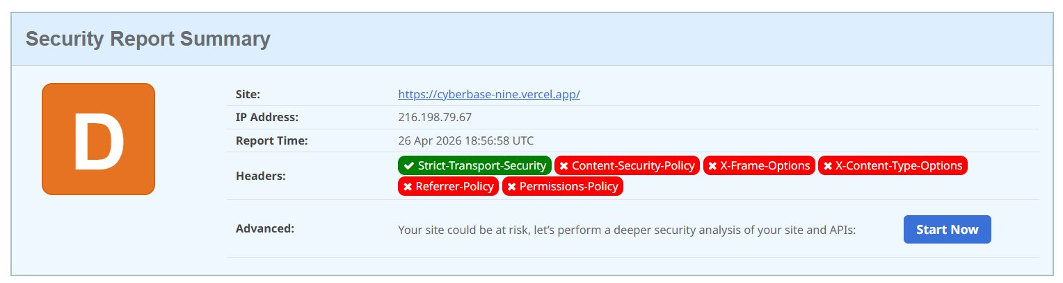
Figure 2 — SecurityHeaders.com scan result: Grade D (26 Apr 2026 18:56 UTC)

Header | Status | Attack Prevented if Present
Strict-Transport-Security | PRESENT | MITM / session hijacking
Content-Security-Policy | MISSING | XSS / script injection
X-Frame-Options | MISSING | Clickjacking
X-Content-Type-Options | MISSING | MIME-type sniffing
Referrer-Policy | MISSING | Sensitive URL leakage
Permissions-Policy | MISSING | Unauthorised browser feature access

05 Phase 3 — OWASP ZAP Passive Scan
OWASP ZAP 2.17.0 was configured in passive scan mode with a proxy on localhost:8080. The browser was directed through ZAP while navigating all public pages of the application. ZAP observed 13 alerts across the session without sending any attack payloads. The screenshot below shows the Alerts panel with the Content Security Policy alert selected.

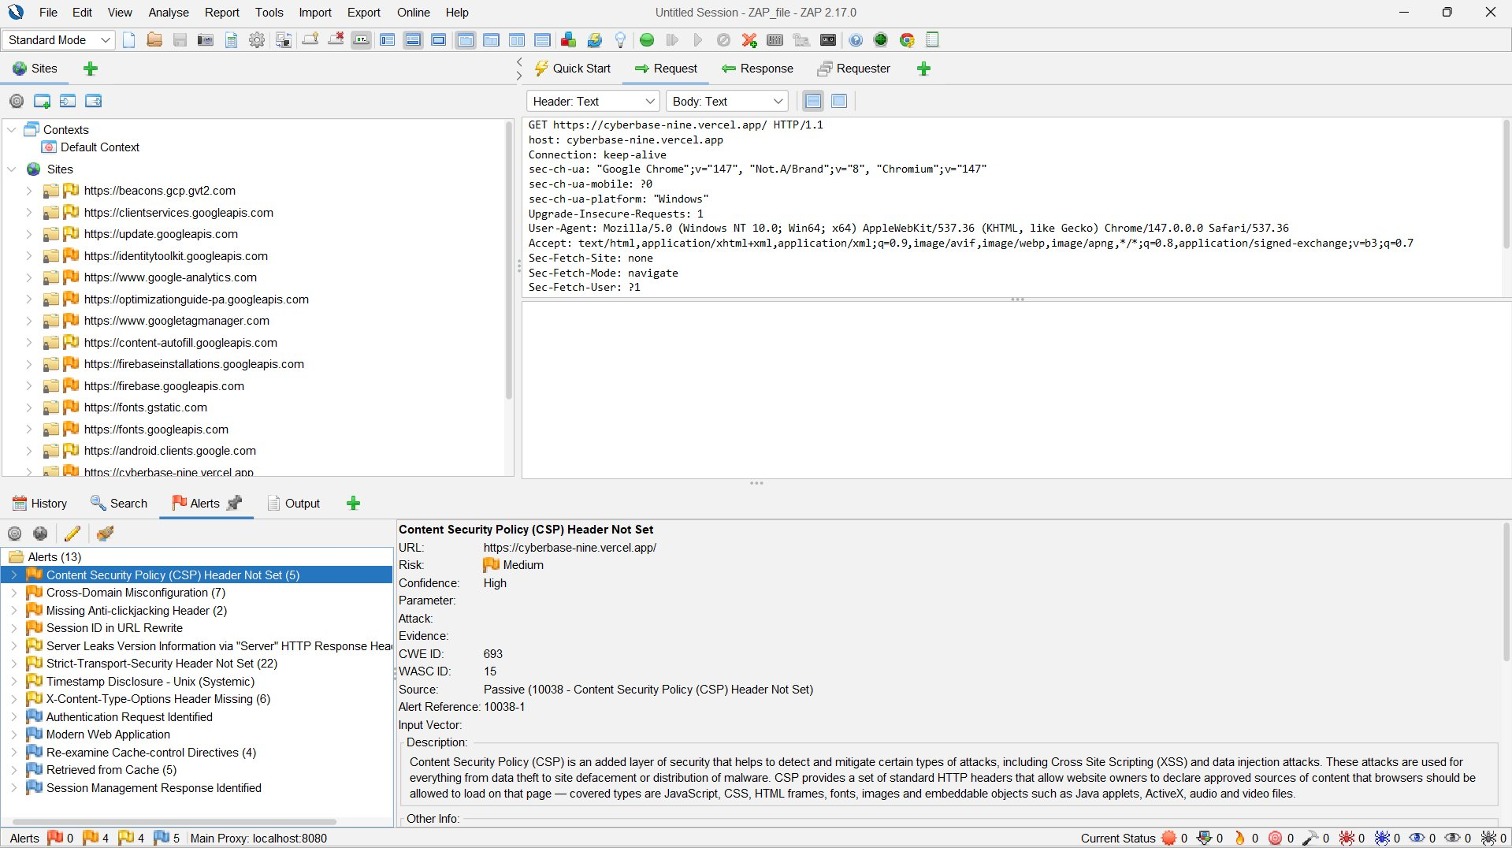
Figure 3 — OWASP ZAP 2.17.0 passive scan: 13 alerts across cyberbase-nine.vercel.app

VUL-01 Missing Content Security Policy (CSP) Header
URL: https://cyberbase-nine.vercel.app/
Finding ID | Severity | CWE | WASC | Confidence
VUL-01 | Medium | CWE-693 | WASC-15 | High — Passive Alert 10038

Description
The application does not set a Content-Security-Policy header in any HTTP response. Without CSP,
the browser has no instruction to block scripts from unauthorised origins. This is especially serious
here because Google Tag Manager is present — GTM can inject arbitrary third-party scripts, creating a
wide XSS attack surface if a GTM container were ever compromised.

Business Impact | Recommendation
Malicious scripts could execute in every visitor's browser.  Session tokens and credentials could be silently stolen.  Google Tag Manager adds risk if container is hijacked. | Content-Security-Policy:  default-src 'self';  script-src 'self' *.googletagmanager.com;  style-src 'self' 'unsafe-inline';  img-src 'self' data:;

VUL-02 Cross-Domain Misconfiguration (CORS)
URL: https://cyberbase-nine.vercel.app/
Finding ID | Severity | CWE | WASC | Confidence
VUL-02 | Medium | CWE-942 | WASC-14 | Medium — 7 instances

Description
OWASP ZAP flagged 7 instances of cross-domain misconfiguration across the application. The CORS policy
appears permissive, potentially allowing unauthorised external domains to make credentialed requests
to the application's endpoints. This was detected passively through response header inspection.

Business Impact | Recommendation
Unauthorised domains may read API responses.  Sensitive user data could be exfiltrated cross-origin.  Authentication tokens may be accessible to third-party scripts. | Access-Control-Allow-Origin:  https://cyberbase-nine.vercel.app  (Do not use wildcard * with credentials)  Access-Control-Allow-Credentials: true  Validate Origin header server-side

VUL-03 Missing Anti-Clickjacking Header (X-Frame-Options)
URL: https://cyberbase-nine.vercel.app/
Finding ID | Severity | CWE | WASC | Confidence
VUL-03 | Low | CWE-1021 | WASC-15 | Medium — 2 instances

Description
The X-Frame-Options header is absent on all pages. This means the application can be embedded inside
a hidden iframe on an attacker-controlled website. The attacker can then overlay a transparent layer
over the real site, tricking users into clicking on invisible buttons or form submissions — a technique
known as clickjacking.

Business Impact | Recommendation
Users could be tricked into submitting forms or clicking buttons unknowingly.  Actions like account changes or purchases could be triggered without user awareness. | X-Frame-Options: DENY  OR  Content-Security-Policy:  frame-ancestors 'none';

VUL-04 Server Information Disclosure via HTTP Header
URL: https://cyberbase-nine.vercel.app/
Finding ID | Severity | CWE | WASC | Confidence
VUL-04 | Low | CWE-200 | WASC-13 | Medium — ZAP Alert

Description
The HTTP Server response header discloses backend infrastructure details. Nmap banner analysis
confirmed the backend uses a Golang net/http server running behind Vercel's edge network. While
Vercel manages the frontend layer, internal service details are partially visible and can help
attackers narrow down applicable vulnerabilities.

Business Impact | Recommendation
Attackers learn the backend runtime (Go), narrowing CVE research.  Infrastructure fingerprinting becomes easier for targeted attacks. | # In vercel.json — suppress server header:  { "key": "Server", "value": "" }  # Or rely on Vercel edge to suppress.  # Remove X-Powered-By if present.

VUL-05 Session ID Exposure in URL (Session ID in URL Rewrite)
URL: https://cyberbase-nine.vercel.app/
Finding ID | Severity | CWE | WASC | Confidence
VUL-05 | Low | CWE-598 | WASC-13 | Informational — ZAP Alert

Description
ZAP detected that session or tracking identifiers may appear in URL parameters. When session IDs
appear in URLs, they are logged in browser history, server access logs, and referrer headers sent
to third-party analytics services. This can allow session hijacking if logs are accessed.

Business Impact | Recommendation
Session tokens in URLs leak into browser history and server logs.  Third-party analytics (Google Analytics) may receive session data via Referrer. | Use cookies for session management only.  Add Referrer-Policy: no-referrer  to prevent URL leakage to third parties.  Set SameSite=Strict on all session cookies.

06 Phase 4 — Network & Port Scan (Nmap)
Nmap 7.99 was run with the -sV --open flags to identify open ports and attempt service version detection. The scan targeted cyberbase-nine.vercel.app, resolving to Vercel's CDN edge nodes. The results show a minimal attack surface consistent with a well-managed cloud-hosted application.

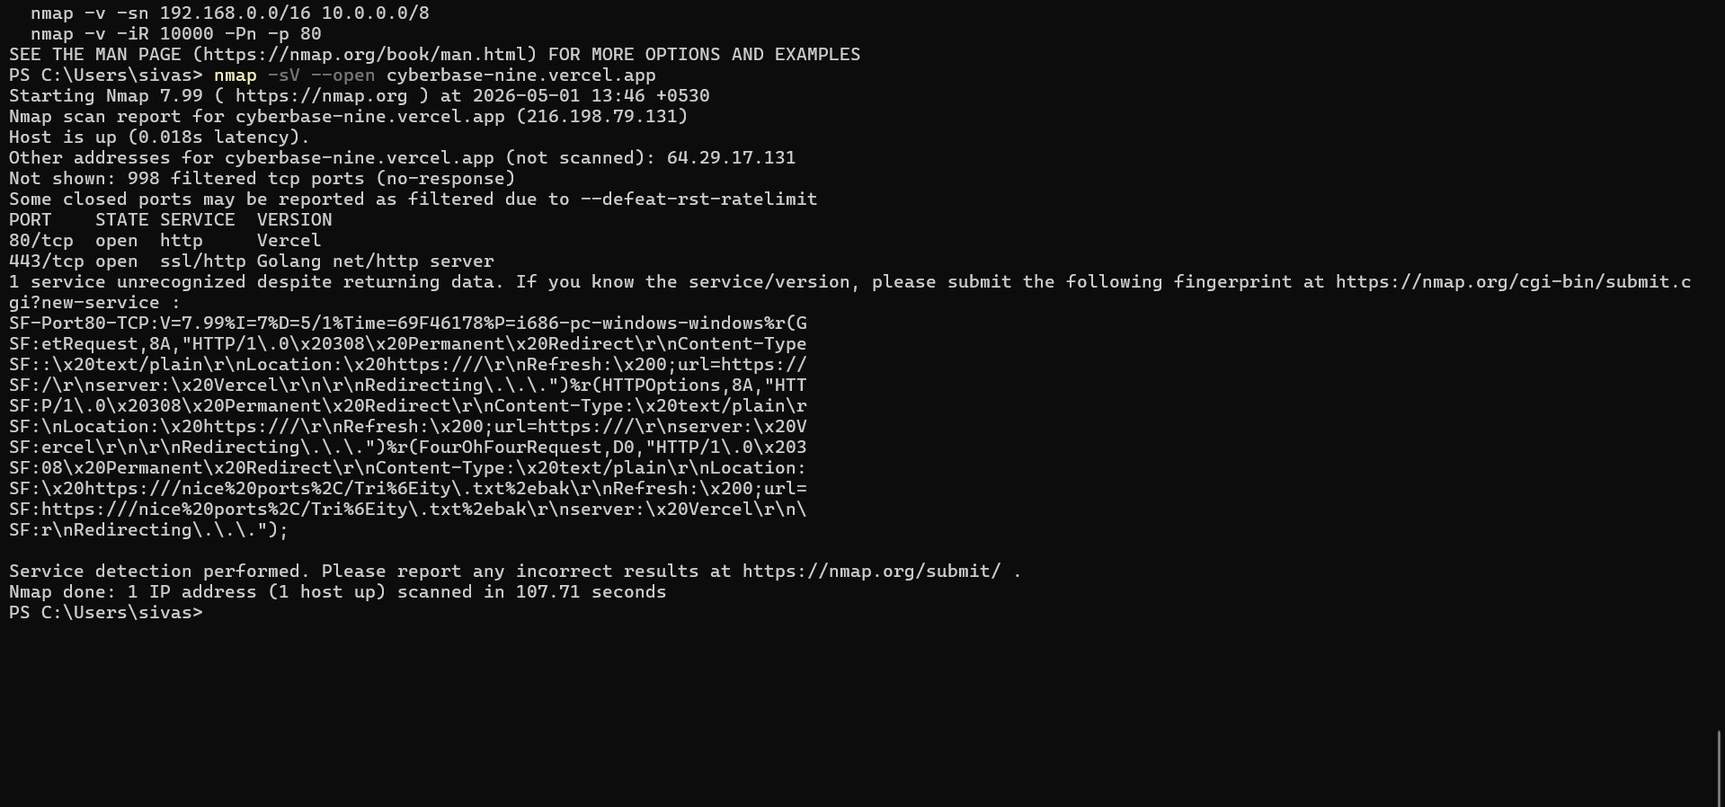
Figure 4 — Nmap 7.99 scan output: ports 80 and 443 open, Golang backend identified

Nmap Output Summary
Port | State | Service / Version | Notes
80/tcp | Open | HTTP — Vercel | Redirects immediately to HTTPS (308 Permanent Redirect) — correct
443/tcp | Open | ssl/http — Golang net/http | TLS-terminated at edge. Golang backend partially visible via banner
1–79, 81–442, 444–65535 | Filtered | 998 ports | No response — CDN firewall blocking all other ports — good

The port scan results are largely reassuring. Only the expected ports 80 and 443 are open, and HTTP correctly redirects to HTTPS. The Golang backend runtime disclosure via Nmap banner is noted as a low-severity informational finding (VUL-04 above). No unusual or unnecessary services were detected.

07 Phase 5 — SSL/TLS Analysis (Qualys SSL Labs)
A Qualys SSL Labs Server Test was initiated against cyberbase-nine.vercel.app on 1 May 2026 at 08:21 UTC. Both resolved IP addresses were tested independently. Neither test completed successfully — both returned failure states. This is a known and documented limitation of SSL Labs when scanning sites behind CDN providers like Vercel, which use shared TLS termination at edge nodes rather than dedicated origin servers.

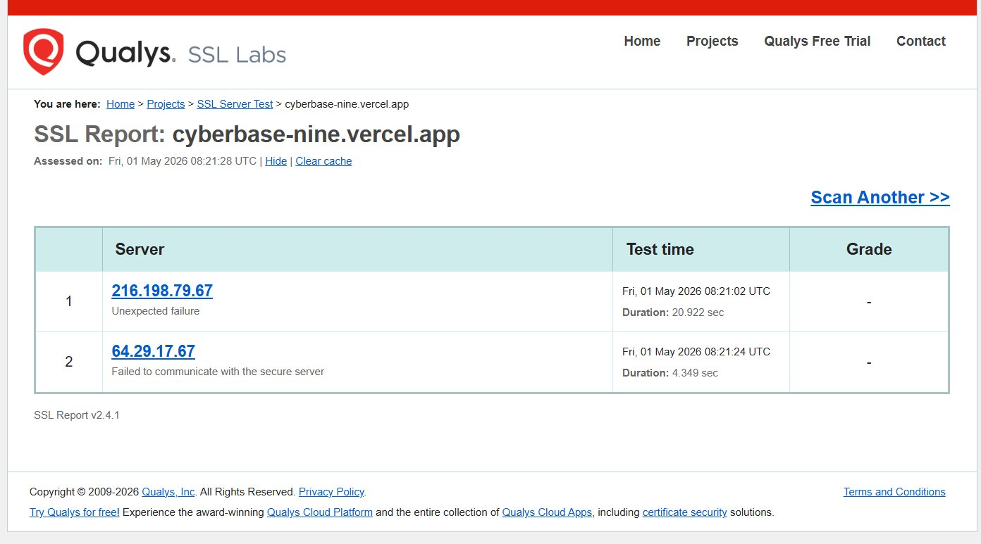
Figure 5 — Qualys SSL Labs: scan failed on both IPs due to Vercel CDN edge TLS termination

Interpretation & Conclusion
- SSL Labs failure does NOT indicate a TLS vulnerability
- Vercel handles TLS at its edge — origin IPs do not accept direct SSL connections from external scanners
- HSTS header was confirmed PRESENT by SecurityHeaders.com — meaning HTTPS is actively enforced
- Vercel automatically provisions and renews Let's Encrypt TLS certificates (TLS 1.2 / 1.3)
- Recommendation: verify TLS using browser DevTools (Security tab) or curl --verbose for certificate details

08 Consolidated Findings Table

ID | Finding | Severity | Tool / Source | Status
VUL-01 | Missing Content-Security-Policy | Medium | ZAP / SecurityHeaders | Open
VUL-02 | Cross-Domain Misconfiguration (CORS) | Medium | OWASP ZAP (×7) | Open
VUL-03 | Missing X-Frame-Options (Clickjacking) | Low | ZAP / SecurityHeaders | Open
VUL-04 | Server Information Disclosure | Low | Nmap / ZAP | Open
VUL-05 | Session ID in URL Rewrite | Low | OWASP ZAP | Open
VUL-06 | Missing X-Content-Type-Options | Low | SecurityHeaders / ZAP | Open
VUL-07 | Missing Referrer-Policy | Low | SecurityHeaders.com | Open
VUL-08 | Missing Permissions-Policy | Low | SecurityHeaders.com | Open
VUL-09 | Strict-Transport-Security Not Set (22) | Info | OWASP ZAP | Partially mitigated
VUL-10 | Timestamp Disclosure — Unix | Info | OWASP ZAP | Open
VUL-11 | Modern Web Application Detected | Info | OWASP ZAP | Informational
VUL-12 | Re-examine Cache-control Directives | Info | OWASP ZAP | Open
VUL-13 | SSL Scan Limitation (CDN edge) | Info | Qualys SSL Labs | Accepted

09 Remediation Roadmap
All findings at Medium and Low severity can be resolved through configuration changes only — no code refactoring is required. The recommended approach is to add a vercel.json file to the project repository root. Vercel will automatically apply the headers to all edge responses on the next deployment.

Priority | Action | Fixes | Timeline
MEDIUM | Add Content-Security-Policy with GTM whitelist | VUL-01, VUL-11 | Day 1
MEDIUM | Restrict CORS to trusted origins only | VUL-02 | Day 1
LOW | Add X-Frame-Options: DENY | VUL-03 | Day 1
LOW | Add X-Content-Type-Options: nosniff | VUL-06 | Day 1
LOW | Add Referrer-Policy: strict-origin-when-cross-origin | VUL-07 | Day 1
LOW | Add Permissions-Policy for camera/mic/geo | VUL-08 | Day 1
LOW | Suppress Server header via Vercel config | VUL-04 | Week 1
LOW | Move session IDs to cookies with SameSite=Strict | VUL-05 | Week 1
INFO | Review cache-control directives for API routes | VUL-12 | Week 2
INFO | Suppress Unix timestamps in API responses | VUL-10 | Week 2

Recommended vercel.json Configuration
{
"headers": [{
"source": "/(.*)",
"headers": [
{ "key": "Content-Security-Policy",
"value": "default-src 'self'; script-src 'self' *.googletagmanager.com" },
{ "key": "X-Frame-Options", "value": "DENY" },
{ "key": "X-Content-Type-Options", "value": "nosniff" },
{ "key": "Referrer-Policy", "value": "strict-origin-when-cross-origin" },
{ "key": "Permissions-Policy", "value": "geolocation=(), camera=(), microphone=()" }
]
}]
}

10 Conclusion
The cyberbase-nine.vercel.app application demonstrates a strong foundation in several areas — HTTPS is correctly enforced, the tech stack is modern and up-to-date, and the network attack surface is minimal with nearly 1,000 ports appropriately filtered by Vercel's CDN firewall. These are positive signals that the development team has made thoughtful infrastructure choices.

However, the absence of five HTTP security response headers — most importantly Content-Security-Policy — leaves users unnecessarily exposed to client-side attacks such as XSS and clickjacking. Given that the application already uses Google Tag Manager (which injects third-party scripts), the lack of a CSP is the most critical gap to close. The CORS misconfiguration (7 instances flagged) also warrants immediate review, as overly permissive cross-origin rules can expose API data to unauthorised domains.

The good news is that every finding in this report is fixable through a single configuration file change (vercel.json). A re-scan after applying those headers should push the SecurityHeaders.com grade from D to A. This audit was conducted entirely within a passive, read-only scope — no systems were harmed, no data was accessed, and no exploits were run.

Mack (Siva Sanjay Muthu T)  Security Auditor — Future Interns Cybersecurity Task 1  github.com/mackshema  linkedin.com/in/siva-sanjay-muthu-t-823318304 | Report Date  1 May 2026  PASSIVE AUDIT | NO EXPLOITATION  EDUCATIONAL USE ONLY

