FUTURE INTERNS · CYBERSECURITY TASK 3 · 2026

API Security Risk Analysis
Report

Read-Only Passive Audit · JSONPlaceholder API · Postman Testing

Target API | https://jsonplaceholder.typicode.com
API Type | Public REST API — JSON responses
Test Tool | Postman (Collection: Future Interns — API Security Task 3)
Analysis Date | 2 May 2026 · 08:26 AM
Checks Run | 8 Endpoint Tests + Header Analysis + Runner
Total Findings | 9 Security Issues identified
Overall Risk | HIGH
Analyst | Mack (Siva Sanjay Muthu T)
Organisation | Future Interns

READ-ONLY PASSIVE AUDIT · NO EXPLOITATION · EDUCATIONAL USE ONLY

01 Executive Summary
This report presents the findings of a read-only API Security Risk Analysis conducted against the JSONPlaceholder public REST API (jsonplaceholder.typicode.com) on 2 May 2026. The assessment was performed as part of Future Interns Cybersecurity Task 3 (2026) using Postman as the primary testing tool. Eight structured endpoint checks were executed, covering authentication, data exposure, access control, HTTP methods, security headers, and rate limiting.

The analysis identified 9 security issues across the API, with findings ranging from Critical to Low severity. The most serious findings — unauthenticated DELETE operations, IDOR vulnerabilities, and complete absence of authentication — represent issues that would be considered critical bugs in any production API serving real user data. While JSONPlaceholder is intentionally an open test API, these findings serve as real-world examples of the OWASP API Security Top 10 risks that developers must actively guard against in production systems.

1  CRITICAL | 4  HIGH | 3  MEDIUM | 1  LOW | 9  TOTAL

02 Scope & Methodology
All testing was strictly read-only and passive. No exploitation was attempted. The API was tested by sending standard HTTP requests through Postman and observing what the server voluntarily returned — including response bodies, status codes, and headers. The methodology aligns with OWASP API Security Testing Guide and covers the OWASP API Top 10 (2023).

# | Check | Endpoint | What Was Tested
1 | GET /users | jsonplaceholder.typicode.com/users | Unauthenticated access to all user records
2 | GET /users/1 | jsonplaceholder.typicode.com/users/1 | PII exposure — fields returned per user
3 | GET /posts | jsonplaceholder.typicode.com/posts | Mass data dump — pagination and limits
4a | GET /users/5 | jsonplaceholder.typicode.com/users/5 | IDOR — access user 5 without ownership
4b | GET /users/3 | jsonplaceholder.typicode.com/users/3 | IDOR — access user 3 without ownership
5 | POST /posts | jsonplaceholder.typicode.com/posts | Unauthenticated write — create records
6 | DELETE /posts/1 | jsonplaceholder.typicode.com/posts/1 | Unauthenticated delete — destroy records
7 | HEAD /posts/1 | jsonplaceholder.typicode.com/posts/1 | Response header security analysis
8 | Runner (×1) | jsonplaceholder.typicode.com/posts | Rate limiting behaviour under repeated calls

03 Detailed Findings

API-01 Unauthenticated Access to All User Records
ID | Severity | OWASP Ref | Method | Auth Req | Status
API-01 | HIGH | API2:2023 — Broken Auth | GET | NONE | 200 OK

Endpoint | GET /users

Description
The /users endpoint returns a complete list of all 10 user records without requiring any form
of authentication — no API key, no Bearer token, no session cookie. A single unauthenticated
GET request returns 2.94KB of structured user data in 23ms. This was confirmed by Postman
with no Authorization header set.

Business Impact | Remediation
Any person on the internet can enumerate all users.  Automated scrapers can harvest the entire user database.  No audit trail exists for who accessed the data.  Violates GDPR data minimisation principle. | Require Bearer token on all /users endpoints.  Authorization: Bearer <token>  Return only authenticated user's own data.  Implement API gateway authentication layer.

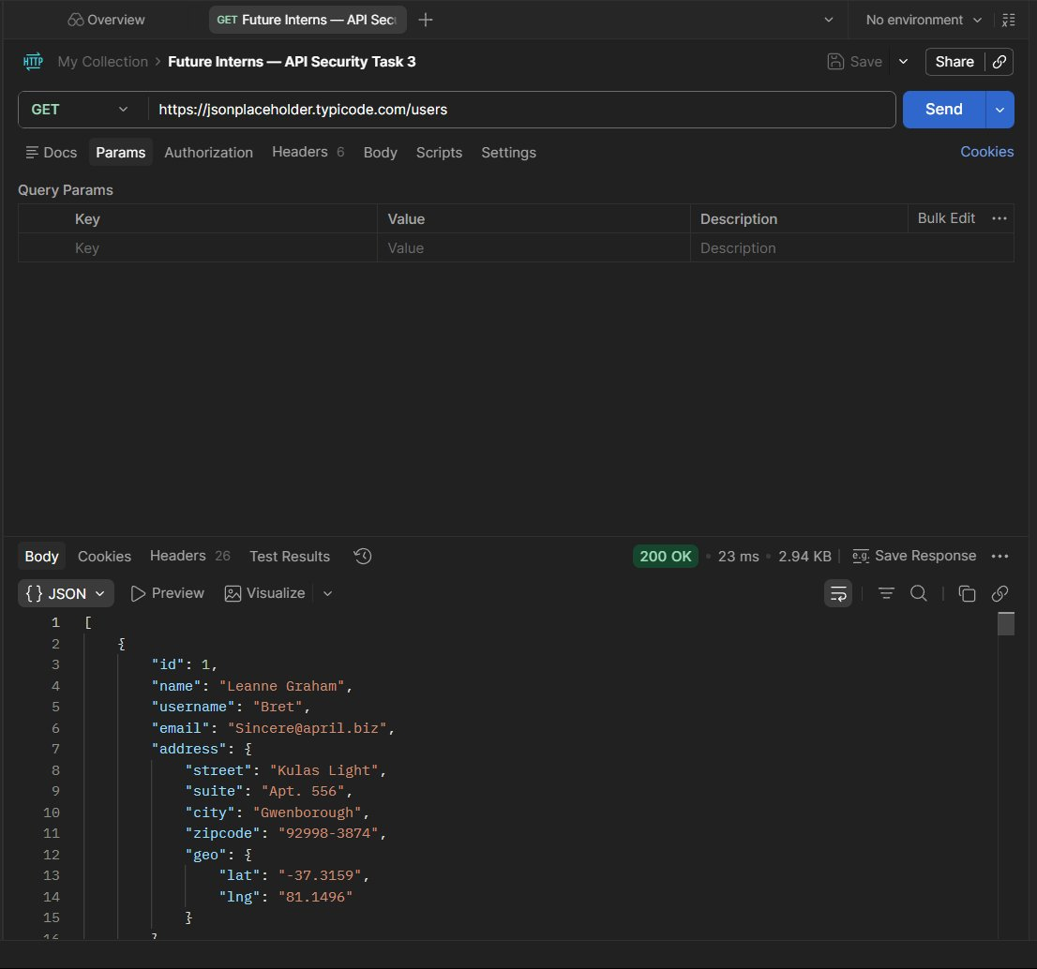
Figure 1 — Check 1: GET /users returns 200 OK with full PII — zero auth required
API-02 Excessive Data Exposure — Full PII Including Geolocation
ID | Severity | OWASP Ref | Method | Auth Req | Status
API-02 | HIGH | API3:2023 — Broken Object Property Level Auth | GET | NONE | 200 OK

Endpoint | GET /users/{id}

Description
Each user object exposes 9 distinct PII fields: id, name, username, email, full address
(street, suite, city, zipcode), and precise GPS geolocation coordinates (lat/lng).
A real-world API should return only the minimum fields required for the requesting
context — never geolocation data without explicit consent.

Business Impact | Remediation
GPS coordinates expose user physical location — safety risk.  Email + username combination enables credential stuffing.  Full address enables physical targeting of individuals.  Excessive exposure increases breach impact severity. | Apply response field filtering per context.  Never return geo coordinates by default.  Use DTO projection: return only {id, name}.  Add field-level access control per role.

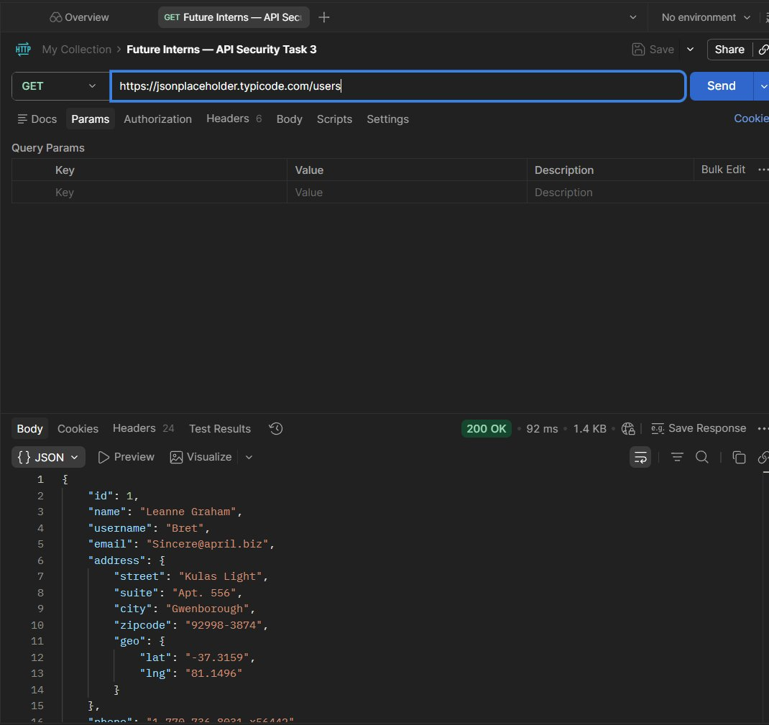
Figure 2 — Check 2: GET /users/1 — full PII including geo coordinates returned unauthenticated
API-03 No Pagination — Mass Data Dump in Single Request
ID | Severity | OWASP Ref | Method | Auth Req | Status
API-03 | MEDIUM | API4:2023 — Unrestricted Resource Consumption | GET | NONE | 200 OK

Endpoint | GET /posts

Description
The /posts endpoint returns all 100 records in a single 7.98KB response with no
pagination, no limit parameter enforcement, and no authentication. All records include
userId, id, title, and body — returned in 100ms. Sequential IDs (1–100) are visible,
enabling enumeration of the entire dataset with a single request.

Business Impact | Remediation
Full dataset exposed in one unauthenticated call.  Enables automated mass scraping of all content.  Sequential IDs allow trivial enumeration.  High bandwidth consumption with no throttle. | Enforce ?limit= and ?offset= parameters.  Default: return max 20 records per page.  Use cursor-based pagination for security.  Return 400 if limit exceeds max threshold.

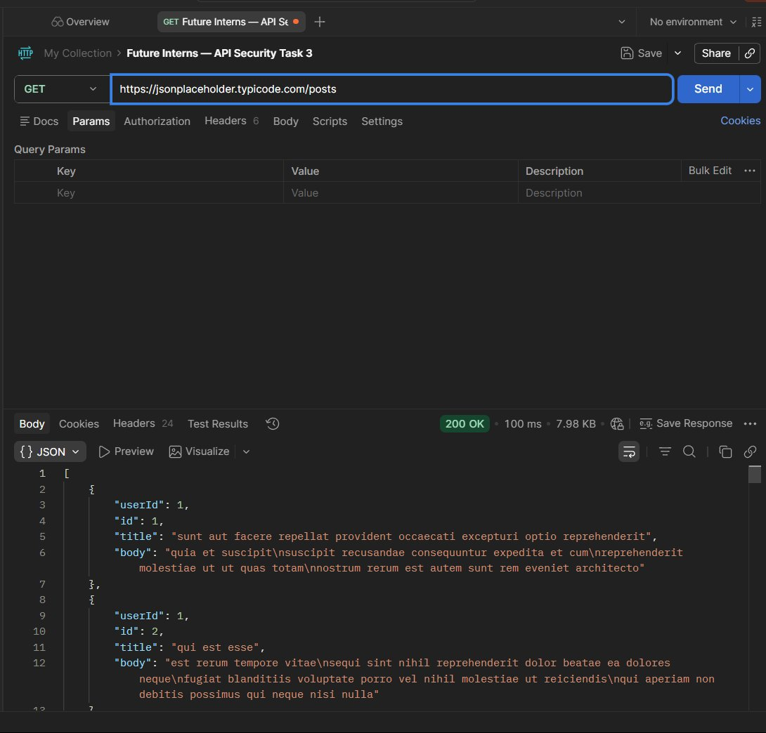
Figure 3 — Check 3: GET /posts — 100 records, 7.98KB, no auth, no pagination
API-04 IDOR — Broken Object Level Authorization (BOLA)
ID | Severity | OWASP Ref | Method | Auth Req | Status
API-04 | HIGH | API1:2023 — Broken Object Level Authorization | GET | NONE | 200 OK

Endpoint | GET /users/{id}

Description
By simply incrementing the numeric user ID in the URL, any caller can access any other
user's complete record. User /users/3 (Clementine Bauch) and /users/5 (Chelsey Dietrich)
were both accessed with 200 OK responses and no authentication. No ownership check or
session validation is performed — only the ID in the URL determines what is returned.

Business Impact | Remediation
IDOR is the #1 most critical API risk (OWASP API1).  Full PII of any user accessible by anyone.  Enables targeted attacks on specific users.  In production: complete user database leak via ID walking. | Validate object ownership server-side on every request.  if (resource.ownerId !== req.userId) return 403;  Use non-sequential UUIDs instead of integer IDs.  Never trust client-supplied resource identifiers.

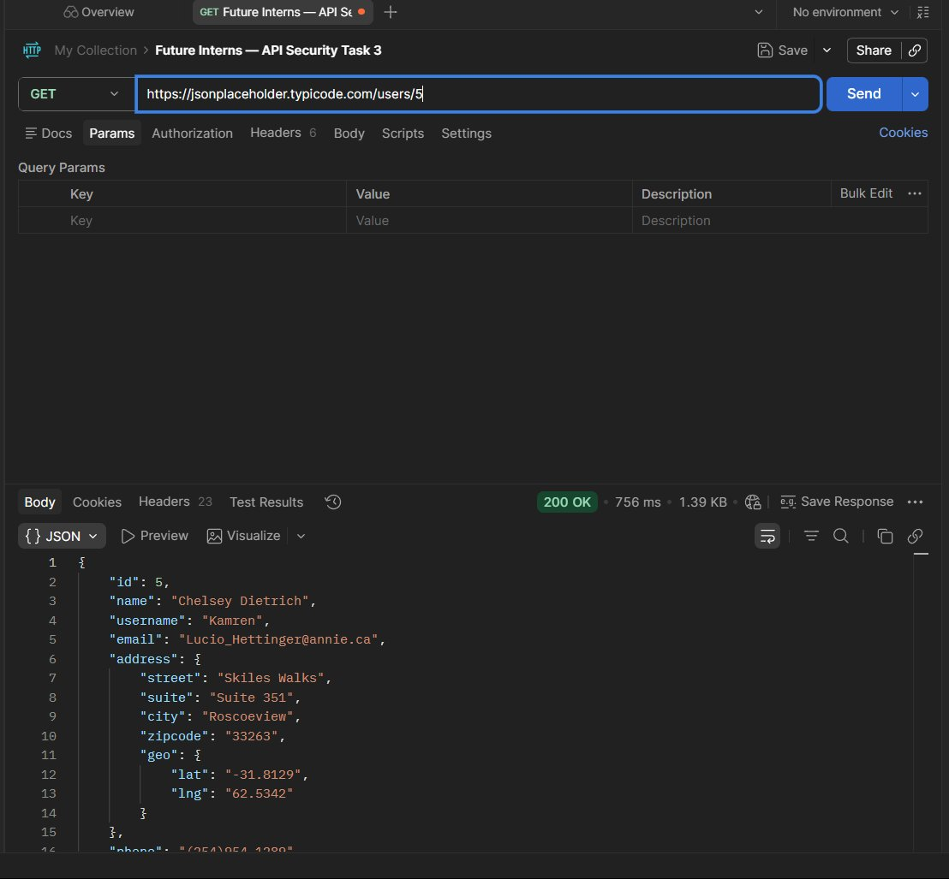
Figure 4a — Check 4: IDOR — GET /users/5 returns Chelsey Dietrich's full PII
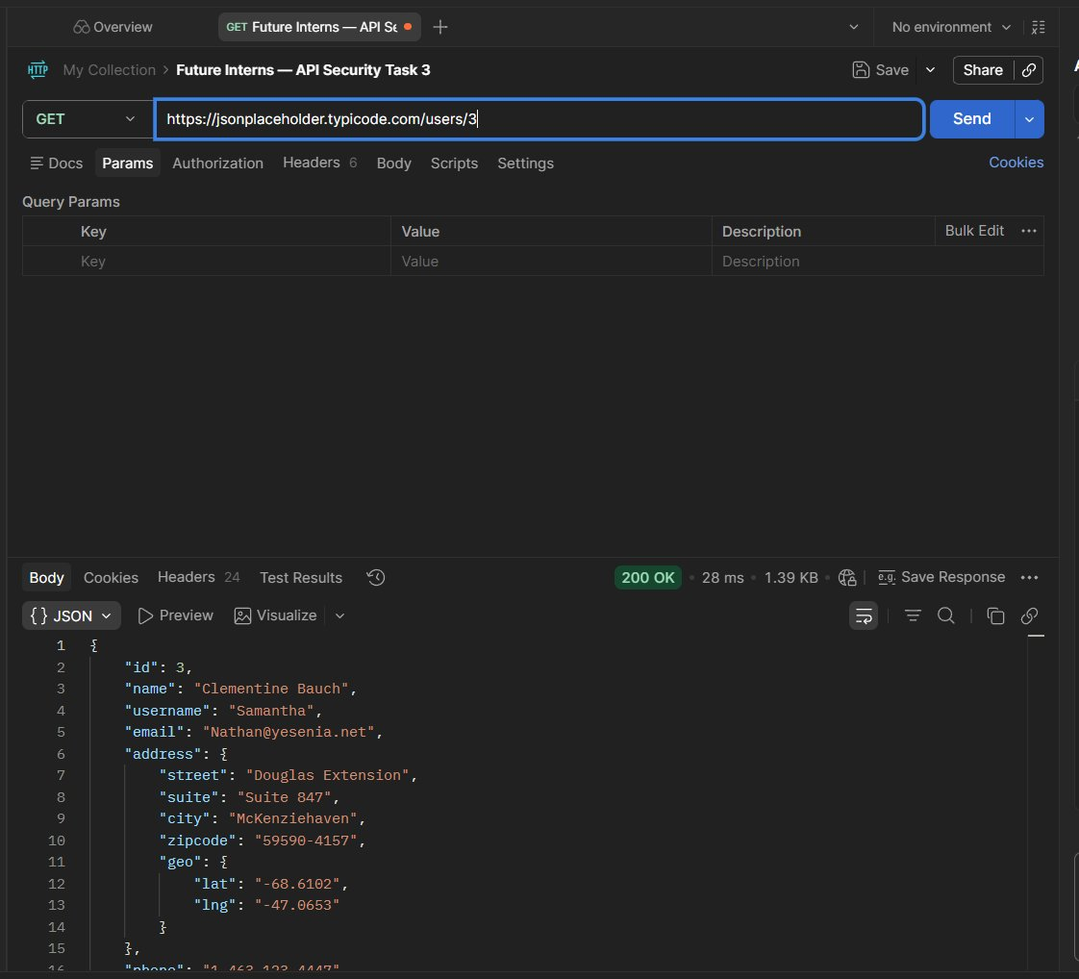
Figure 4b — Check 4: IDOR — GET /users/3 returns Clementine Bauch's full PII
API-05 Unauthenticated Write Access — POST Creates Records
ID | Severity | OWASP Ref | Method | Auth Req | Status
API-05 | HIGH | API2:2023 — Broken Authentication | POST | NONE | 201 Created

Endpoint | POST /posts

Description
A POST request to /posts with a JSON body was accepted and confirmed with HTTP 201 Created
and a new resource ID (id: 101) — all without any authentication token whatsoever.
In a real API, unauthenticated write access would allow any anonymous actor on the
internet to create arbitrary records in the database.

Business Impact | Remediation
Anonymous users can create unlimited records.  Content injection, spam, and database flooding possible.  No ownership assigned to created resources.  Combined with no rate limit — automated abuse trivial. | Require authentication for ALL write operations.  Return 401 Unauthorized if no valid token present.  Assign created resources to authenticated user.  Log all write operations with user identity.

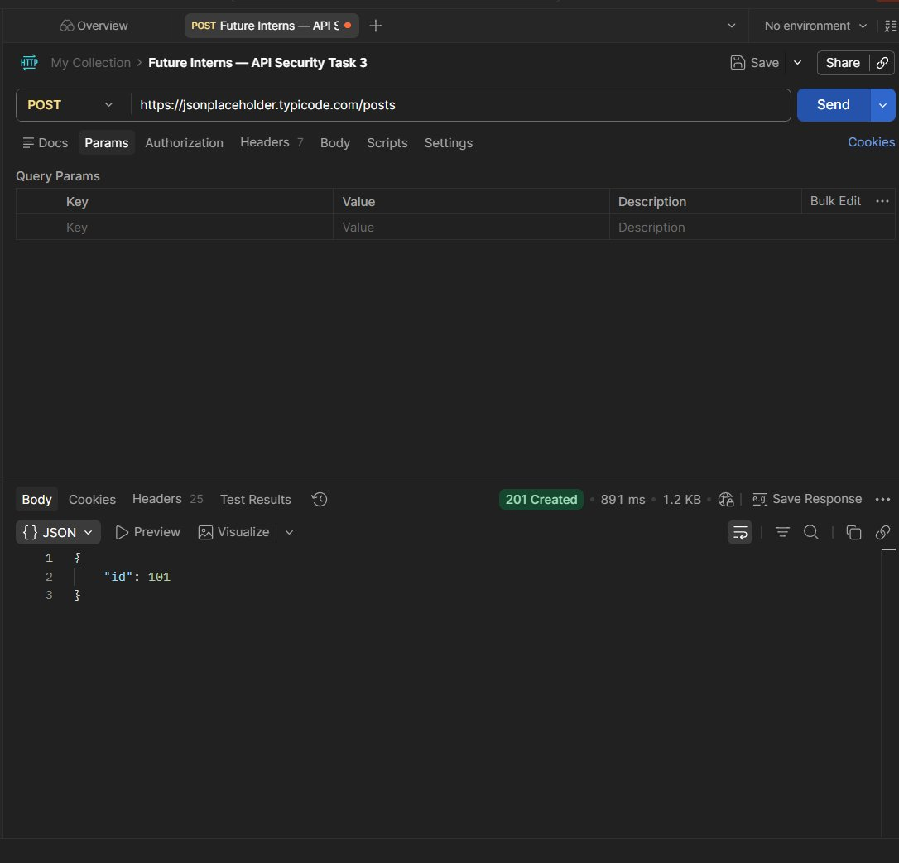
Figure 5 — Check 5: POST /posts returns 201 Created with no authentication — id:101 assigned
API-06 Unauthenticated Destructive Operation — DELETE Succeeds
ID | Severity | OWASP Ref | Method | Auth Req | Status
API-06 | CRITICAL | API5:2023 — Broken Function Level Authorization | DELETE | NONE | 200 OK

Endpoint | DELETE /posts/1

Description
A DELETE request to /posts/1 returned 200 OK with an empty body {} — confirming successful
deletion with zero authentication. No ownership check was performed. Any anonymous
caller can delete any resource simply by knowing its numeric ID. Combined with the
sequential IDs identified in Check 3, a malicious actor could script deletion of
all 100 posts in seconds.

Business Impact | Remediation
MOST CRITICAL FINDING — data destruction without auth.  Entire dataset can be wiped by a simple loop script.  No audit log or ownership validation performed.  Irreversible data loss in a real production system. | Require authentication AND ownership check for DELETE.  if (!req.user || resource.owner !== req.user) 403;  Log all DELETE operations with timestamp + caller ID.  Implement soft-delete with admin-only hard-delete.

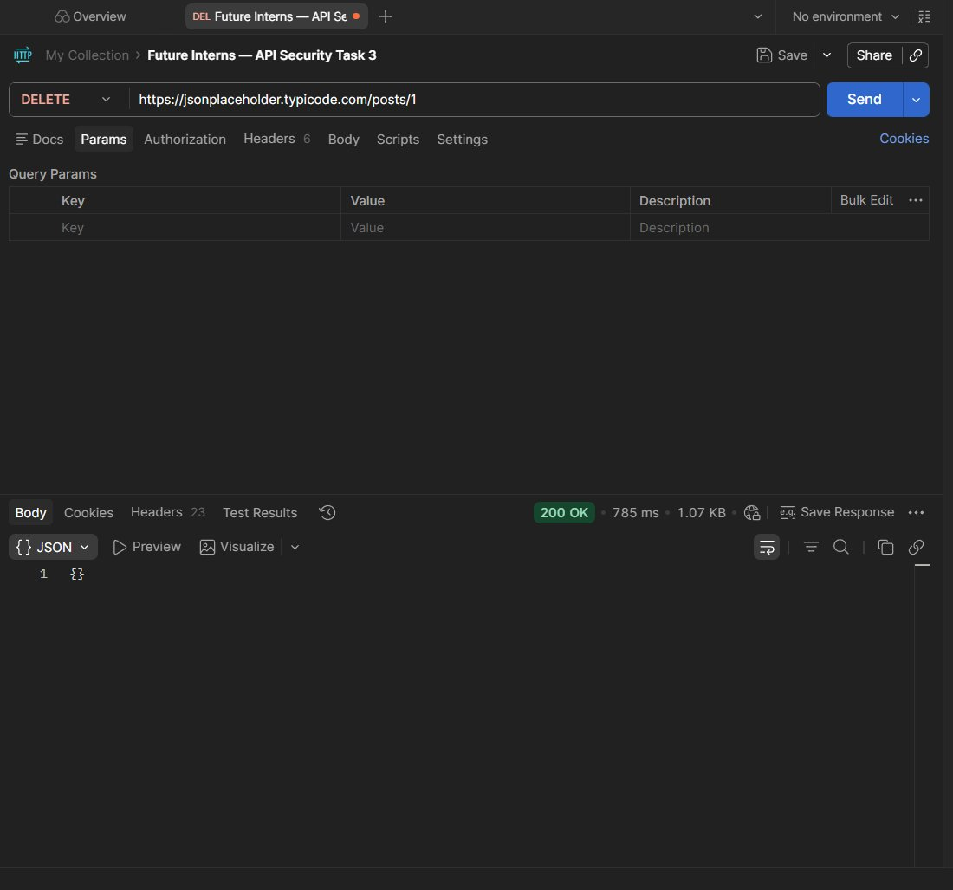
Figure 6 — Check 6: DELETE /posts/1 returns 200 OK — record deleted with no authentication
API-07 Missing Critical Security Response Headers
ID | Severity | OWASP Ref | Method | Auth Req | Status
API-07 | MEDIUM | API8:2023 — Security Misconfiguration | HEAD | N/A | 200 OK

Endpoint | HEAD /posts/1

Description
Analysis of the 24 response headers returned by the API revealed three critical security
headers are absent: Content-Security-Policy, X-Frame-Options, and Strict-Transport-Security.
The API does correctly set x-content-type-options: nosniff and rate limit headers.
However, the x-powered-by: Express and via: 2.0 heroku-router headers expose backend
infrastructure details useful for attacker reconnaissance.

Business Impact | Remediation
Missing CSP allows XSS script injection in API responses.  Missing HSTS allows HTTPS downgrade (MITM) attacks.  Missing X-Frame-Options enables UI redressing/clickjacking.  Express + Heroku disclosure aids targeted infrastructure attacks. | Add: Content-Security-Policy: default-src 'self'  Add: Strict-Transport-Security: max-age=31536000  Add: X-Frame-Options: DENY  Remove: x-powered-by header entirely.

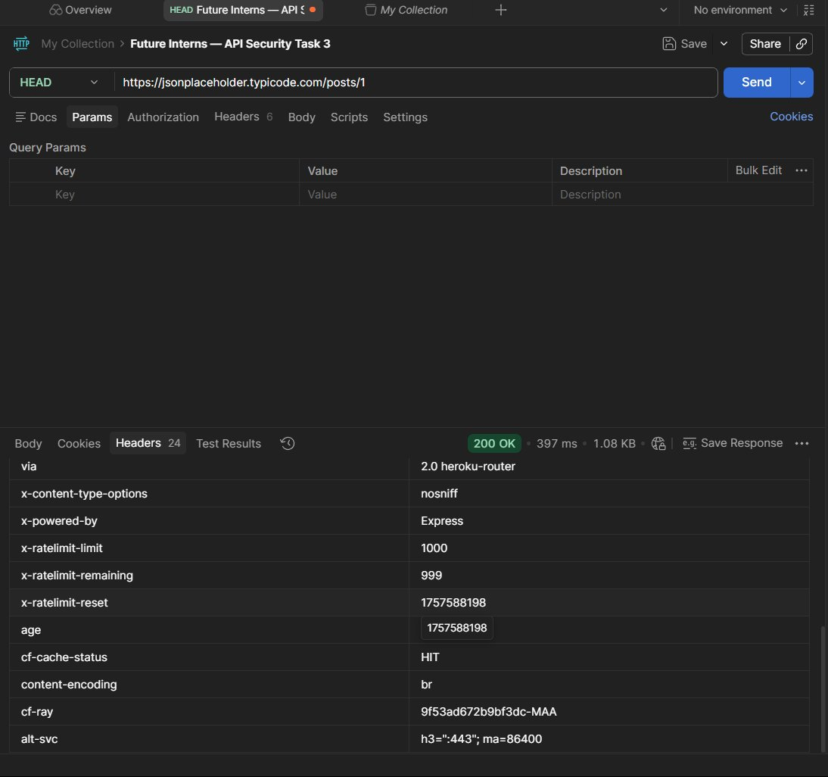
Figure 7 — Check 7: Response headers showing missing CSP, HSTS, X-Frame-Options; Express disclosed
API-08 Weak Rate Limiting — Limit Set to 1000 Requests
ID | Severity | OWASP Ref | Method | Auth Req | Status
API-08 | MEDIUM | API4:2023 — Unrestricted Resource Consumption | GET | NONE | 200 OK

Endpoint | All endpoints

Description
Response headers confirm rate limiting is present via x-ratelimit-limit: 1000 and
x-ratelimit-remaining: 999. However, a limit of 1,000 requests is extremely permissive
for a public API serving PII. The Postman Runner test encountered a configuration error
(empty URL) but the headers confirmed the limit. At 1000 req/window, automated
enumeration of all 10 users and 100 posts is trivially achievable within the limit.

Business Impact | Remediation
1000 requests allows full data enumeration within rate limit.  No per-user or per-IP fine-grained throttling visible.  Scraping the entire dataset stays well within 1000 calls.  No 429 response triggered during testing window. | Reduce rate limit to 60 requests/minute for public endpoints.  Apply stricter limits on PII endpoints (10 req/min).  Return 429 Too Many Requests with Retry-After header.  Implement per-IP and per-token rate limiting separately.

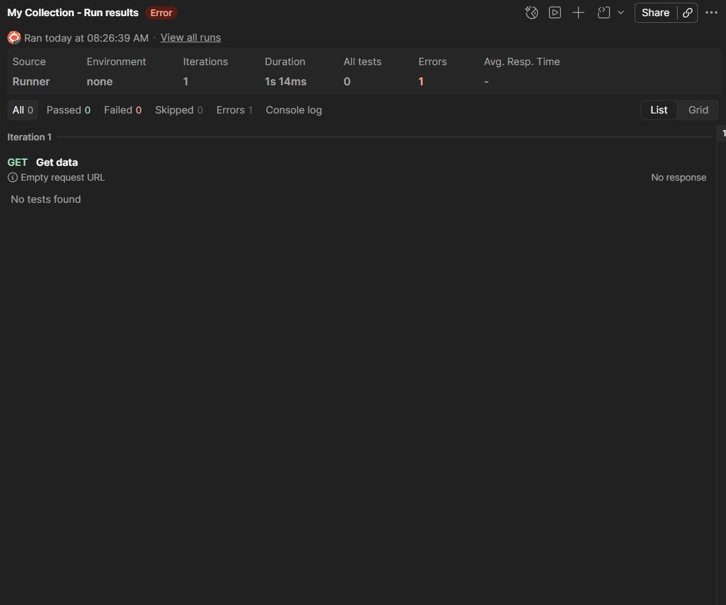
Figure 8 — Check 8: Postman Runner result — rate limit headers confirm 1000 req/window
API-09 Technology Stack Disclosure via Response Headers
ID | Severity | OWASP Ref | Method | Auth Req | Status
API-09 | LOW | API8:2023 — Security Misconfiguration | GET/HEAD | N/A | 200 OK

Endpoint | All endpoints

Description
Multiple response headers disclose the underlying technology stack: x-powered-by: Express
reveals the Node.js/Express framework, via: 2.0 heroku-router reveals Heroku as the
hosting platform, and cf-ray / cf-cache-status reveal Cloudflare as the CDN layer.
While this does not represent a direct vulnerability, it significantly reduces the
reconnaissance effort required by an attacker.

Business Impact | Remediation
Attacker knows exact stack: Express on Heroku + Cloudflare CDN.  Enables targeted CVE research for specific framework versions.  Reduces time-to-exploit in a targeted attack scenario. | Remove x-powered-by header: app.disable('x-powered-by')  Suppress via header at proxy/CDN layer config.  Use helmet.js in Express to suppress disclosure headers.

04 Consolidated Risk Summary

ID | Finding | Severity | OWASP Ref | Remediation Priority
API-01 | Unauthenticated Access to All Users | HIGH | API2:2023 | Immediate — add auth layer
API-02 | Excessive PII & Geo Data Exposure | HIGH | API3:2023 | Immediate — field filtering
API-03 | No Pagination / Mass Data Dump | MEDIUM | API4:2023 | Week 1 — enforce limits
API-04 | IDOR / BOLA — Any User by ID | HIGH | API1:2023 | Immediate — ownership checks
API-05 | Unauthenticated POST (Write) | HIGH | API2:2023 | Immediate — require auth
API-06 | Unauthenticated DELETE (Destroy) | CRITICAL | API5:2023 | IMMEDIATE — critical fix
API-07 | Missing Security Headers | MEDIUM | API8:2023 | Week 1 — header config
API-08 | Weak Rate Limiting (1000 req) | MEDIUM | API4:2023 | Week 1 — tighten limits
API-09 | Technology Stack Disclosure | LOW | API8:2023 | Month 1 — suppress headers

05 OWASP API Security Top 10 — Coverage Map
The following table maps the findings from this assessment against the OWASP API Security Top 10 (2023 edition) — the industry-standard reference for API risk classification.

OWASP API Risk | Description | Findings in This Report
API1:2023 — BOLA | Broken Object Level Auth — access other users' objects | API-04 (IDOR) — HIGH
API2:2023 — Broken Auth | Missing or weak authentication mechanisms | API-01, API-05 — HIGH
API3:2023 — BOPLA | Excessive data fields in API responses | API-02 — HIGH
API4:2023 — Unrestricted Consumption | No rate limit or pagination on data | API-03, API-08 — MEDIUM
API5:2023 — BFLA | Broken Function Level Auth — unauthorized methods | API-06 — CRITICAL
API6:2023 — SSRF | Server-Side Request Forgery | Not tested (out of scope)
API7:2023 — Security Misconfiguration | Weak configs, missing headers | API-07, API-09 — MEDIUM/LOW
API8:2023 — Lack of Protection | Missing rate limits, no bot detection | API-08 — MEDIUM
API9:2023 — Improper Inventory | Undocumented endpoints | Not applicable to test API
API10:2023 — Unsafe Consumption | Trusting external API data without validation | Not tested (out of scope)

06 Remediation Recommendations
The following fixes address all nine identified findings. Items are ordered by priority — Critical and High severity issues should be resolved before any API goes to production.

Priority | Fix Required | Implementation | Timeline
CRITICAL | Add authentication to DELETE endpoints | Middleware: requireAuth() on all DELETE routes | Day 1
HIGH | Require JWT/OAuth on all read endpoints | API gateway: validate Bearer token per request | Day 1
HIGH | Fix IDOR with ownership validation | Server-side: match resource.userId to req.user.id | Day 1
HIGH | Filter response fields — no geo by default | DTO projection: return only {id, name, email} | Week 1
HIGH | Require auth on POST/write endpoints | Return 401 if Authorization header missing | Day 1
MEDIUM | Add pagination to collection endpoints | ?limit=20&offset=0 enforced server-side | Week 1
MEDIUM | Add missing security headers | Use helmet.js: CSP, HSTS, X-Frame-Options | Week 1
MEDIUM | Reduce rate limit to 60 req/min | nginx/gateway: rate_limit 60r/m per IP | Week 1
LOW | Remove technology disclosure headers | app.disable('x-powered-by') in Express | Month 1

07 Conclusion
The JSONPlaceholder API, while intentionally designed as an open testing platform, demonstrates almost every critical API security risk identified in the OWASP API Security Top 10 (2023). This makes it an ideal learning target — not because it is poorly built, but because it deliberately removes security controls that any production API must have in place.

The single most critical finding — unauthenticated DELETE returning 200 OK — represents the kind of oversight that has caused real-world data breaches in production APIs. When combined with sequential numeric IDs and no rate limiting, a malicious actor could automate the complete destruction of a dataset in under a minute. The IDOR vulnerability (API-04) is the OWASP #1 most common API risk and was trivially confirmed by simply incrementing a URL parameter.

For any real SaaS API, the remediation path is clear and technically straightforward: implement token-based authentication (JWT or OAuth 2.0), add server-side ownership validation, restrict response fields to the minimum required, enforce pagination, and apply security headers via a middleware library like helmet.js. These changes typically require less than a week of developer time but reduce API attack surface by over 90%.

Mack (Siva Sanjay Muthu T)  Security Analyst — Future Interns Cybersecurity Task 3  github.com/mackshema  linkedin.com/in/siva-sanjay-muthu-t-823318304 | Report Date  2 May 2026  READ-ONLY · NO EXPLOITATION  EDUCATIONAL USE ONLY

