March 11, 2021

DATA TRANSMITTAL/SPECIFICATION

Product Type | Taxnet.pro (Tax SMG)
Data Description | OECD—Economic Surveys  Bundle OECD-172-ES  Canada 2021
Editorial Contact | Alicia Bertrand x 9581  cc: Hellen Kerr, Charlane Vitez
Transmittal to Analysis | March 11, 2021
Size | 130 pp
Electronic Files | Y:\IMP-Conversion\public\Outsourcing-SGML\Data Analysis-Conversion\TAX\OECD\OECD-172-ES\
Comment | SUPPLIER:  - Use CARSWELL.DTD  - Copyright: name of the country is not required, please see provided file: copyright-template-new.sgm  NOTES FOR HEADINGS:  - DO NOT ADD <BOLD> tag within <COMMENT><TI>  - Use <P><BOLD> for flush-left bold heading.  - Use <P><EM> for flush-left italicized heading.  - Use <P><BOLD><EM> for flush-left italicized bold headings  no <BLOCK2>, <BLOCK3>, etc.  NOTES FOR GRAPHIC:  - Only one set of graphics is required (in colour OR black & white); see revised instructions highlighted in yellow under Graphics Inventory  - Graphic file name style has been changed, add “TAX” to the next available graphic file name  e.g.  next available graphic file name is OC003203.BMP (existing/old graphic file name style)  new file name style as:  TAXOC003203.BMP  - Corresponding *.TIF files are also required.  - New graphic file name style for the ongoing bundles only. Do not change existing graphics to new file naming convention.  - Do not rename existing graphic name OC....BMP to TAXOC...BMP  NOTE FOR ANALYSIS:  - Never re-name the PDF source file that is submitted by the editor. The filename is added to the SGML file for linking to PDF online and should therefore remain as is.
From | Carol Wong
Transmittal to Supplier | March 11, 2021
Graphics | SUPPLIER
Date Required | RUSH—On or before March 16, 2021
Routing | SUPPLIER

KEYING SPECIFICATIONS
SUPPLIER:

- Only e-file provided

- <COMMENT>

Use <COMMENT> as the container tag for each document.
Comment <TI> and <N> will be provided in the Data Inventory under “Data” and “COMMENT <N>” accordingly.

e.g. <N>2015/1</N><TI>OECD Economic Surveys Mexico, January 2015</TI>

Example (from the Data Inventory):
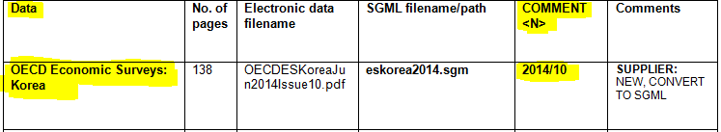
- <DATE>
Use <DATE> tag for the date which usually appears on the first page of the PDF (source file).
Lower and uppercase letters should be used to capture the date.
e.g. <DATE>March 2014</DATE>
- Use <FREEFORM> tagging within <COMMENT>.
- Add a <P><GRAPHIC> link at the beginning of the file directly after opening <FREEFORM> tag:
a) The <GRAPHIC> filename will be the same as the source PDF filename.
b) <COMMENT><TI> has to be used as the <LINKTEXT> content.
Example:
<P><GRAPHIC FILENAME="OECDESEuropeanUnion2014Issue6.pdf">
<LINKTEXT>OECD Economic Surveys European Union, March 2014</LINKTEXT>
</GRAPHIC></P>
- HEADINGS
- Use <BLOCK1><TI> for centered headings, e.g. “Executive summary”, “Chapter ...”, etc.
- Use <BLOCK0><TI> before <BLOCK1><TI> if it is necessary to capture two sets of centered headings.
- Capture all headings exactly the way they appear in the source file (e.g. all uppercase, lower and uppercase, bold and italic, etc.).
e.g.:
<TI>Basic statistics of the Netherlands, 2012</TI>
<TI>Executive summary</TI>

  - Use <P><BOLD> for flush-left bold heading.
  - Use <P><EM> for flush-left italicized heading.
  - Use <P><BOLD><EM> for flush-left italicized bold headings.
NOTE: use <P> for flush left bold or bold/italic heading, no <BLOCK2>, <BLOCK3>, etc.

- INLINE TEXT
- Use <BOLD> for inline bold face text.
Use <BOLD><EM> for inline bold and italic text.
- Use <STRIKE> for strike out text.
- Place <EM> tags around any legislative section reference numbers that appear italic. If the numbers are not italicized, leave them as is.
- If open and close quotation marks surround quoted material, use the &ldquo; and &rdquo; entities to surround the text.
e.g.:
<QUOTE><P>&ldquo; .....&rdquo;</P></QUOTE>
- Use <ITEM><N> for indented, numbered paragraphs or indented paragraphs with dash (“—“).
Example 1:
From the source file:
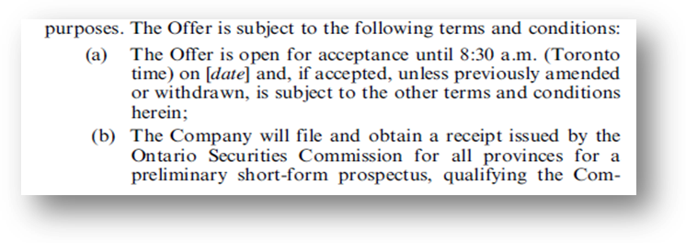
SGML tagging:

<P>…purposes. The Offer is subject to the following terms and conditions:
<ITEM><N>(a)</N><P>The Offer is open…</P></ITEM>
<ITEM><N>(b)</N><P>The Company will file…</P></ITEM>

Example 2:
From the source file:

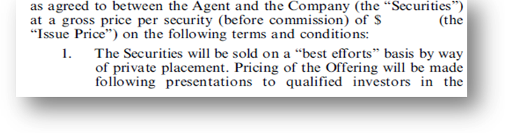

SGML tagging:

<P>… on the following terms and conditions:
<ITEM><N>1.</N><P>The Securities will be sold…</P></ITEM>

Example 3:

From the source file:

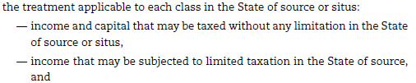

SGML tagging:

<P>… the treatment applicable to each class in the State of source or situs:
<ITEM><N>&mdash;</N><P> income and capital that may be taxed without any limitation in the State
of source or situs,</P></ITEM>
<ITEM><N>&mdash;</N><P>income that may be subjected to limited taxation in the State of source,
and</P></ITEM>

- Do NOT use <APPENDIX> tag for this project. If an Appendix/Annex appears at the end of a file:

- Use <BLOCK1> for the appendix title if the title is centered.

- Use <GRAPHIC> tag to capture graphics, tables or content which appears within boxes.
Examples:
<P><GRAPHIC FILENAME="TAXOE000078.BMP"><LINKTEXT>Figure 5. Evolution of price competitiveness</LINKTEXT></GRAPHIC></P>
<P><GRAPHIC FILENAME="TAXOE000137.BMP" SIZE="pagewidth,150">
<LINKTEXT>Main recommendation to promote trade</LINKTEXT></GRAPHIC></P>
- A. DO NOT include the inline flush-right “StatLink ...” line within a graphic.
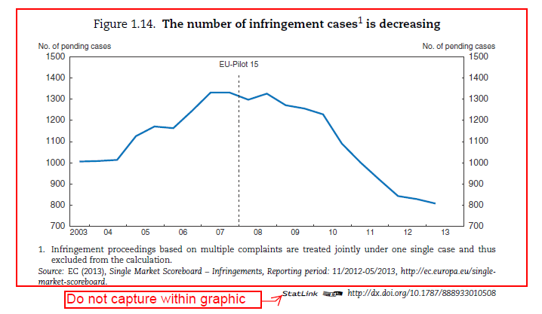
- Place the StatLink (change StatLink to Statlink) within a <P> tags.
  - Use <LINK> tag with HREF attribute to capture the http link within a <BOLD> tag, even the link is not in bold in the source file.
  - Please see standard tagging below:

Example:
<P>Statlink <BOLD><LINK HREF="http://dx.doi.org/10.1787/888933007126">
http://dx.doi.org/10.1787/888933007126</LINK></BOLD></P>
Note: Statlink instead of StatLink—regardless of the source file

B. Statlink within graphic image in between two paragaphies:

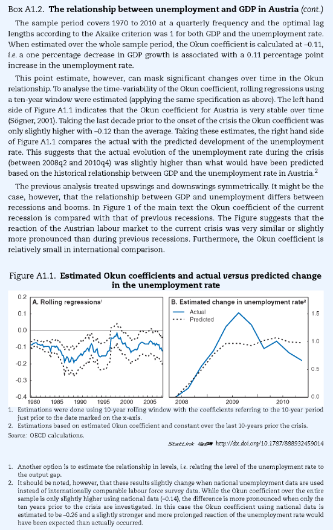
“Statlink” within graphic image in between paragraphs, repeat the “Statlink” after the closing </GRAPHIC></P>, please see sample below.

Sample:

...</GRAPHIC></P>
<P>Statlink <BOLD><LINK HREF="http:......"> http://.....</LINK></BOLD></P>

- For “SPECIAL FEATURE” text (usually two columns that appear at the end of a source document right before the copyright information), processing instructions have to be added:
  - add processing instruction <?columns2> before two column text
  - add processing instruction <?columns1> after two column text right before the copyright information
Example:

From the source file:

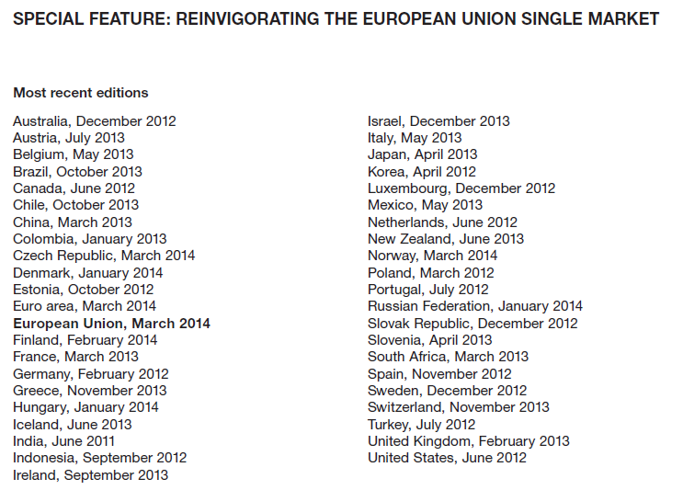

SGML tagging:
<P><BOLD>SPECIAL FEATURE: REINVIGORATING THE EUROPEAN UNION SINGLE
MARKET</BOLD></P>
<P><BOLD>Most recent editions</BOLD></P><?columns 2>
<P><LINE>Australia, December 2012</LINE>
<LINE>Austria, July 2013</LINE>
…
<LINE>United States, June 2012</LINE></P>
<?columns 1>

12. Copyright information is required at the end of every <COMMENT>:
- Copy the SGML TABLE from the provided copyright-template-new.sgm file and place the copyright information (see below) at the very end of <COMMENT>.

© OECD

OECD copyrighted material - you can copy, download or print content for your own use, and you can include excerpts from OECD publications, databases and multimedia products in your own documents, presentations, blogs, websites and teaching materials, provided that suitable acknowledgment of OECD as source and copyright owner is given. You should cite the Title of the material, © OECD, publication year (if available) and page number or URL (uniform resource locator) as applicable.

All requests for public or commercial use and translation rights should be submitted to rights@oecd.org
OECD Publications
2 rue André-Pascal
75775 PARIS Cedex 16
France

IGNORE:
  - all footers and headers
  - Table of Contents
  - picture on p. 1
  - OECD logo
  - OECD Publication page
  - ISBN page

GRAPHICS INVENTORY

SUPPLIER:

- The original inventory which was used for the legacy data will be used for the ongoing data. An additional column titled zip file name needs to be added by Innodata
- Graphic filenames should be assigned in a sequential order starting with the next available number, i.e. TAXOC.....BMP
- Corresponding TIF images are also required.
- Graphics inventory is to be returned to Carswell with each new graphic added
- An EXCEL spreadsheet *.xls is to be maintained by Innodata and returned to Carswell with each converted bundle.
- The EXCEL spreadsheet must be cumulative. The work sheet is to list all .BMP images created. Please sort each sheet by Bundle Number.
- The image should mimic the original. If the original image is in colour, then the *.BMP will be in colour. If the original image is in black and white, then the *.BMP will be in black and white.
- Upon return to Carswell all graphics pertaining to a particular bundle should be placed into zip file as follows:
Bundle-ES-2018-XX.zip
- Graphics to be scanned at 300 dpi.
- Do not use the same (duplicated) .BMP filename for different graphics/images.
- The graphic filenames must be in all uppercase letters.
- In the SGML file:
  - A <GRAPHIC> tag is added to the appropriate .sgm file.
  - The .BMP filename is used as the graphic attribute.
  - Surround each <GRAPHIC> tag with <P>.
  - Within the <GRAPHIC></GRAPHIC> tags, a description of the scanned image is to be included within <LINKTEXT> tags.
  - The <LINKTEXT> tag content is a brief description of the scanned image.
- The <LINKTEXT> content is a brief description of the scanned image.
- Often there will be either a heading or title content that could be used, e.g. Basic Statistics of Czech Republic, 2012; Figure 1. Convergence in GDP per capita; Table 1. Short-term macroeconomic indicators, etc.
- If more than one image with different Figure or Table’s number in the same page, they should be captured in separate graphic file name

Examples:
<P><GRAPHIC FILENAME="TAXOC000074.BMP" SIZE="pagewidth,200">
<LINKTEXT>Figure 1. EuroBarometer</LINKTEXT></GRAPHIC></P>

<P><GRAPHIC FILENAME="TAXOC000080.BMP" SIZE="pagewidth,300">
<LINKTEXT>Table 1. Macroeconomic indicators and projections</LINKTEXT>
</GRAPHIC></P>

GRAPHICS INVENTORY

BUNDLE NO | .key Filename | PDF/  DOC page number | BMP Filename | <LINKTEXT> | COLOUR | Date Created | Zip file name
 |  |  |  |  |  |  | Bundle-ES-2018-XX.zip

Graphic size attribute required for smaller images:

- A. 3 images in a page: set size attribute to: SIZE="pagewidth,150"
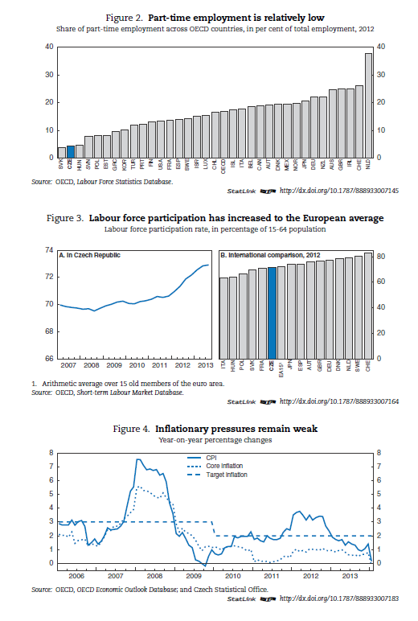
DO NOT capture any “StatLink” within graphic, use <P>:
e.g. <P>Statlink <BOLD>
<LINK
HREF="http://dx.doi.org/10.1787/888933007126">http://dx.doi.org/10.1787/8889330\
07126</LINK></BOLD></P>
A.1 or just one small image in a page
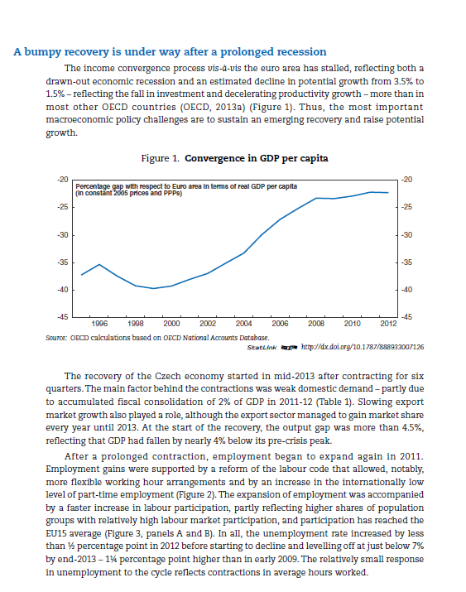
- B. 2 images in a page: SIZE="pagewidth,200"
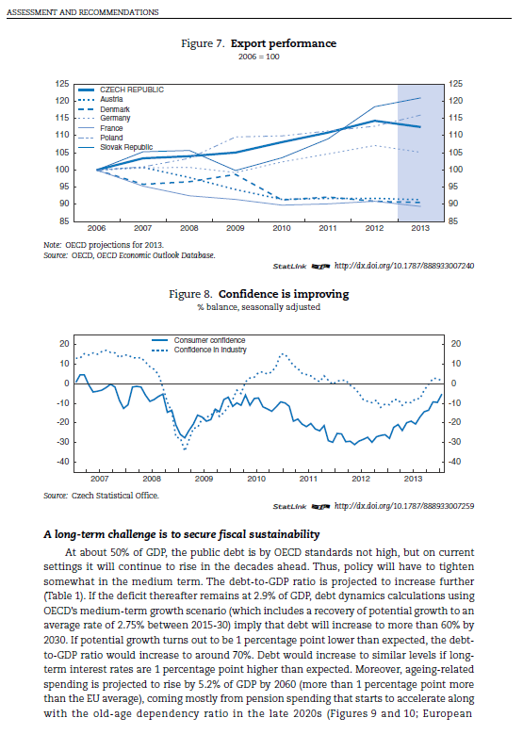

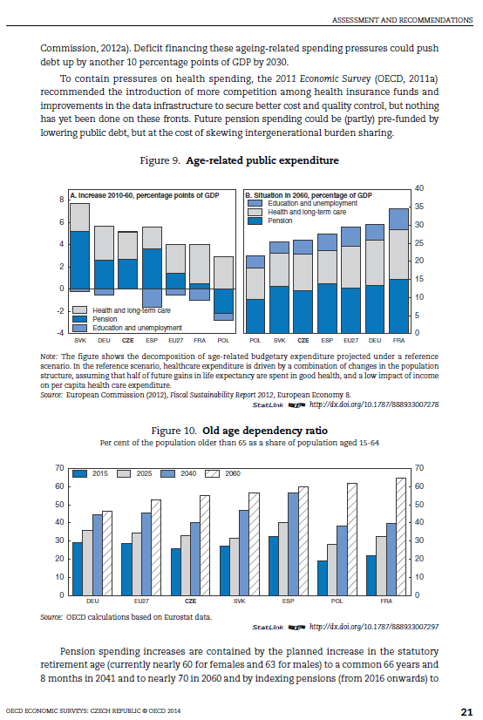

- C. half page image in a page: SIZE="pagewidth,300"
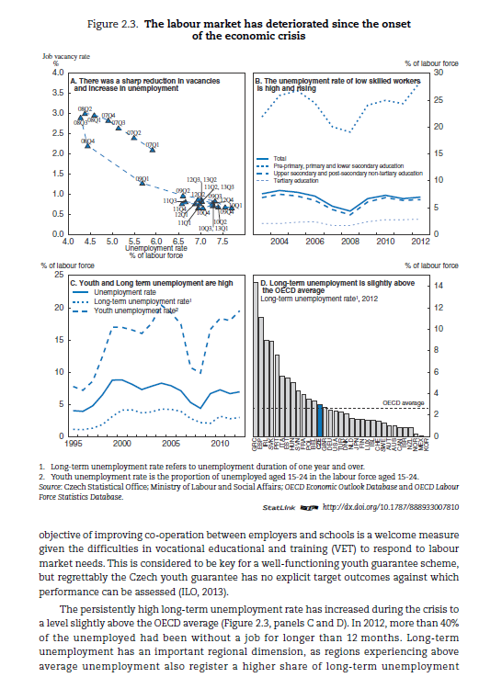

- D. full page image in a page: no need to set size attribute

GENERAL SPECS:

Please see GENERAL INSTRUCTIONS in LEGKEY2SPECS.doc.

