July 8, 2021

DATA TRANSMITTAL / SPECIFICATIONS

Product | Securities Partner Plus/SecuritiesSource  (Legal SMG)
Product Title/Release Number | Bundle Poli-872  Policy Documents (MX, TSX)
Editorial Contacts | Marie Nigro  cc: Maet Clemente
Transmittal to Analysis | July 8, 2021
Size | 18 pages
Electronic Files | Y:\IMP-Conversion\public\Outsourcing-SGML\Data Analysis-Conversion\SECURITIES\POLI-872\  *.pdf (8 files)
Comment | SUPPLIER:  - Add new documents  - Use <STRIKE> and <EM> tags for struck through and underlined text (if any)  - Capture tabular or columnar text using <TABLE> tagging  - See Keying Specs on:  - non-capture of DM #s  - changes in capturing footnote text  - instruction on how to capture text above title  - use of &bull; instead of &rarr; on arrow-bulleted lists  - use of <BOLD> tag for text appearing as bold  - <POLIDOC> attribute CLIPDATE is required when updating existing files  IN-HOUSE:  - Make sure CLIPDATE is the same as MODDATE before turning over the bundle.
From | Carol Wong
Transmittal to Supplier | July 8, 2021
Date Required | July 14, 2021
For | SUPPLIER

KEYING SPECIFICATIONS

SUPPLIER:

- Some documents have DM# or docs# lines appearing at the end. Do NOT capture them.
E.g., appear as DM# 790099, docs# 78198

- Until further notice, follow these changes in capturing footnote text for Poli-bundles:
- Footnote text should be captured in a single <P> tag only
- Do not use any other tags between footnote <P> and </P> tags
- For bulleted and numbered lists, flow the text in one continuous paragraph without using any <P1>, <P2>, <ITEM> tags
- Use &bull; for “” bullets

Example: Do not use <P1>, etc.
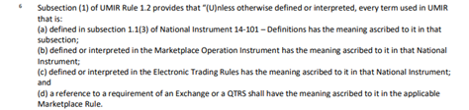

Should be tagged as:
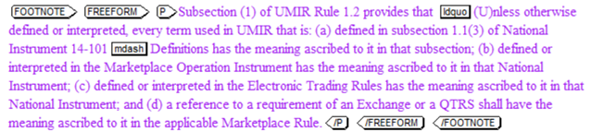

Example: This is WRONG tagging. Do not use <ITEM>

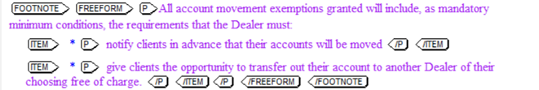

Should be tagged as:
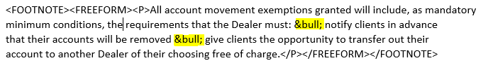

- Some documents have text above the title. Capture the text as the first <P> within <FREEFORM>.

Example:
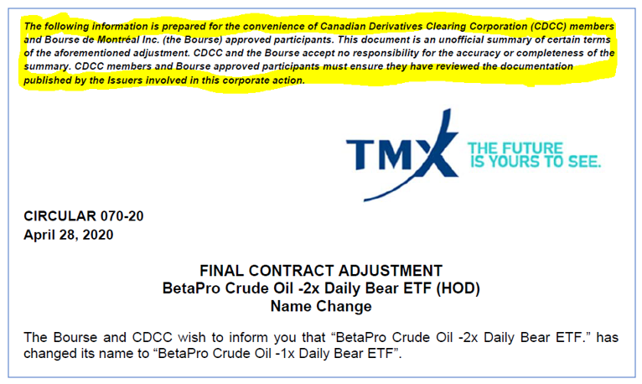

Should be tagged as:
<POLIDOC LABEL="Circular”>
<POLIDENT>
<N>070-2020</N>
<TI>Final Contract Adjustment&mdash;BetaPro Crude Oil -2x Daily Bear ETF (HOD)&mdash;Name Change</TI>
<DATE>April 28, 2020</DATE>
</POLIDENT>
<FREEFORM>
<P><BOLD><EM>The following information is prepared … in this corporate action.</EM></BOLD></P>
<P>The Bourse and CDCC wish to inform …</P>

- Use <EM> tag for in-line text appearing as italic.
- Use <BOLD> tag for in-line text appearing as bold.
- Do not use the &rarr; entity.
- Use &bull; in place of right arrowhead bullets.

Example:
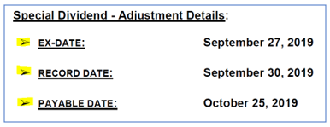

Should be tagged as:
<TABLE>
…
<TBLROW>
<TBLCELL COLSTART="1">&bull;</TBLCELL>
<TBLCELL COLSTART="2"><BOLD><EM>EX-DATE:</EM></BOLD></TBLCELL>
<TBLCELL COLSTART="3"><BOLD>September 27, 2019</BOLD></TBLCELL>
</TBLROW>
…
<TBLROW>
<TBLCELL COLSTART="1">&bull;</TBLCELL>
<TBLCELL COLSTART="2"><BOLD><EM>RECORD DATE:</EM></BOLD></TBLCELL>
<TBLCELL COLSTART="3"><BOLD>September 30, 2019</BOLD></TBLCELL>
</TBLROW>
…
<TBLROW>
<TBLCELL COLSTART="1">&bull;</TBLCELL>
<TBLCELL COLSTART="2"><BOLD><EM>PAYABLE DATE:</EM></BOLD></TBLCELL>
<TBLCELL COLSTART="3"><BOLD>October 25, 2019</BOLD></TBLCELL>
</TBLROW>
…
</TABLE>

- <POLIDOC> TAGGING:
New <POLIDOC> sgm file:
- For new <POLIDOC> SGM file, DO NOT add attribute CLIPDATE on <POLIDOC> tags. CLIPDATE will be added IN-HOUSE (see “NOTES for In-House only” below)

Updated <POLIDOC> sgm file:
- For adding new <POLIDOC> and updates to existing SGM files:
- Attribute CLIPDATE is required on <POLIDOC> tags
- CLIPDATE value is date in YYYYMMDD format:
  - Example: March 22, 2017: <POLIDOC CLIPDATE="20170322">
  - If <POLIDOC> is updated to include new or changed information from the government:
    - SET CLIPDATE value to the day that SGML file is wip-check into RCS
    - If no CLIPDATE is present, add CLIPDATE and set value to the day that SGML file is checked into RCS

NOTES for In-House only: After QA but before final-check-in/load into production:
- New SGM file: add attribute CLIPDATE to the day that SGML file is initial-loaded/final check into production
- Existing SGM file: change the CLIPDATE value to the day that SGML file is final-check into production

  - If <POLIDOC> is updated for editorial or minor corrections only:
    - Do not change CLIPDATE value
    - Do not add CLIPDATE if no CLIPDATE is present

- Example of a <POLIDOC> with CLIPDATE attribute:

<POLIDOC LABEL="National Instrument" CLIPDATE="20160829">
<POLIDENT>
<N>41-101</N>
<TI>General Prospectus Requirements</TI>
<DATE LABEL="Effective">March 17, 2008</DATE>

General Instructions:

- Use the CARSWSELL.DTD to convert this material.
- Use all of the entities listed in the CARSWELL.ENT where appropriate.
- Key <TI> contents in upper and lower case.
- Do not key periods at the end of </TI>.
- Do not key spaces around &mdash; or &ndash; entities.
- Use <ITEM><p> (within <FREEFORM>) for lists with bullets or m-dashes. Do not key bullets or m-dashes as a bullet is generated.
- Use entities to represent underscore lines (an &ellip10; entity for short lines, an &ellip35; entity for long lines and two &ellip35; entities together for extra long lines). Do not place more than two &ellip35; entities together.
- Tag text that appears immediately below a line following the &ellip10; or &ellip35; entity that represents the line (e.g. <P>&ellip35; Signature of Applicant</P>).
- Do not key <EM> within <EDITNOTE>.
- Use <NP> only if every paragraph in the document is numbered.
- Use the <STRIKE> tag to surround in-line material that has been marked in the electronic file as struck out. The strike out indicates a change in text. This material commonly appears as text struck out, followed by underlined replacement text.
- If the <N> of the Form, Companion Policy, Multilateral Instrument, National Instrument or National Policy appears to be struck out, capture the number with <STRIKE> tag. If the number appears to be struck out, and is immediately followed by another number which is not struck out, capture both of the struck out number and the new number.
- Use the Table Specifications for All Data to convert all Table material.

INVESTMENT INDUSTRY REGULATORY ASSOCIATION OF CANADA

Generally:
- Each Document is to be tagged as <POLIDOC LABEL=”IIROC Notice”> or as shown on inventory.
- Do not reproduce the graphics “IIROC” or “OCRCVM” which appear on the top of the notice.
- <N> content can be found in the tagging samples
- Do not capture the lines “Please distribute... etc.” appearing on the right side of document.
- Once the <FREEFORM> element has been opened, use <BLOCK1><TI> for high-level centered titles. Use <BLOCK2><TI> for left-aligned high-level titles or to capture nested titles within <BLOCK1>, etc.
- Please do not convert table of contents if they appear within the notices.
- Capture the attachments as appendices to the main notices – after closing the </FREEFORM>.

Sample: (generally)

<POLIDOC LABEL="IIROC Notice" CLIPDATE=”20180118”>
<POLIDENT><N>17-0006</N>
<TI>Rules Notice …Custodial Agreements</TI>
<DATE>January 4, 2018</DATE>
</POLIDENT>
<FREEFORM>
<P><EM>Contact:</EM>
<LINE>Dennis Dirksen</LINE>
...<LINE>ddirksen@iiroc.ca</LINE>
</P>
<P>Attached is a listing of Custodial Agreements …</P>
…
</FREEFORM>
<APPENDIX>
<TI>Custodial Agreements (31-12-17)<TI>
<FREEFORM>
<BLOCK2><TI>Bare Trustee Agreements</TI>
…
</APPENDIX>
</POLIDOC>

MONTREAL EXCHANGE CIRCULARS

- Capture the Circulars within <POLIDOC LABEL=”Circular”>.
- Use the Circular No. assigned as the <POLIDOC><N> e.g., <N>001-2017</N>. Generally they are found at the upper right of the header and/or bottom left of the last page. Do not capture them elsewhere.
- Ignore the TMX graphic and tabled text which appears on top of each document, the text “CIRCULAR”, and the address at the bottom of the page.
- All tabled text must be captured within <TABLE> tags.
- Capture the first centered heading as the <TITLE> of the <POLIDOC>
- Any boxed text which appears after the main heading can be captured within <P> in capital letters.
- If any date appears amended, capture them within <DATE LABEL="Amended"></DATE> tags.
- If any Circular has another amended number, place the Amended number within the first <P> tags.

Sample: (generally)

<POLIDOC LABEL="Circular" CLIPDATE=”20190118”>
<POLIDENT>
<N>001-2019</N>
<TI>Final Contract Adjustment&mdash;Industrial Alliance. (IAG/FIA) &mdash;Plan of Arrangement</TI>
<DATE>January 3, 2019</DATE></POLIDENT>
<FREEFORM>
<P><BOLD>THE FOLLOWING INFORMATION IS PREPARED FOR THE CONVENIENCE … </BOLD</P>
...
<P>
<LINE>Gladys Karam</LINE>
…</P>
</FREEFORM>
</POLIDOC>

MUTUAL FUND DEALERS ASSOCIATION OF CANADA

- Each Notice is to be tagged as <POLIDOC LABEL=“Bulletin”> as shown on the inventory.
- It is not necessary to reproduce the French text if it appears on the first page.
- <DATE> content can be found on the top right-hand side. It is usually the month and year.
- If any date appears amended, capture them within <DATE LABEL="Amended"></DATE> tags.
- <N> content is the Bulletin # right after the date (on the inventory) or right above the date (on the upper right of the first page of the document).
- Do not key boxes that appear around some text.
- Use <TABLE> sparingly but as needed to capture table text.
- Always close </FREEFORM> before opening an <APPENDIX>.

Special Instructions for Bulletins:

- Use <POLIDOC LABEL=”Bulletin”> for each document.
- Place the number which appears on the top right for e.g. “0456-M” within the <POLIDENT><N> tags.
  - Do not capture the word “Bulletin” or symbol “#” which appears before the number.
  - Do capture the alphabet which appears hyphenated after the number.
  - Please query if there is no number.
- Ignore the MFDA logo which appears on top of page and the address which appears at the bottom of the page.
- Ignore the heading “MFDA Bulletin” and the text “For Distribution to Relevant Parties within your Firm” which appears before the main title.
- Place the titles which appear on inventory as the <POLIDOC><TI>. Do not include the date amendment or issuing information if placed with the headings on the inventory. Capture them within the <DATE> tags.
- Use <FREEFORM> tagging to capture the contents of each document.
- Some of the notices might contain Contact name and address; please capture them as the first <P> after opening the <FREEFORM>.

Sample: (generally)

<POLIDOC LABEL="Bulletin" CLIPDATE=”20180118”>
<POLIDENT>
<N>0738-P</N>
<TI>Policy&mdash;Approval of Housekeeping … (Performance Reporting)</TI>
<DATE>January 4, 2018</DATE>
</POLIDENT>
<FREEFORM>
<P>Contact:
<LINE>Paige Ward </LINE>
<LINE>...</LINE> …</P>
<P>On July 27, 2017, the CSA published, in final form, certain amendments to …</P>
...
</FREEFORM>
</POLIDOC>

TORONTO STOCK EXCHANGE
Generally:
- Each Notice is to be tagged as <POLIDOC LABEL=“”>, unless otherwise specified. See LABEL column on the Data Inventory.
- Unless otherwise specified, use “Member Notice” as the value of <POLIDOC> LABEL for new documents under “Member Notices”.
- <DATE> content can be found on the upper left-hand side.
- <N> content is located on upper left-hand side, and may be preceded by “Ops Notice.” Capture only the number, usually, starting with the year, dash, and the 3-digit number.
- Colons indicate nesting.
- Key bold, underlined, or italicized text as <EM>, but do not surround <TI> content with <EM>.
- Do not key boxes that appear around some text.
- Use <TABLE> for tabular material (two-column text or more).
- Always close <FREEFORM> before opening as <APPENDIX>

Sample: (TSX –generally)
<POLIDOC LABEL="Member Notice” CLIPDATE=”20180115”>
<POLIDENT>
<N>2017-001</N>
<TI>IIROC and Bank of Canada Issue Paper on Impact of Alpha Speedbump</TI>
<DATE>January 10, 2018</DATE>
</POLIDENT>
<FREEFORM>
<P> IIROC and Bank of Canada have published the results of their joint study titled ...</P>
...
</FREEFORM>
</POLIDOC>

