March 3, 2021

DATA TRANSMITTAL / SPECIFICATIONS

Product Type | CED 4th (Legal SMG)
Product Title/Release Number | Supplement to Real Property (Ontario)  Bundle CED-616  April 2021
Editorial Contact | Susan Gomes
Transmittal to Analysis | March 3, 2021
Size | 2 files; 14 pages
Electronic Files | Y:\IMP-Conversion\public\Outsourcing-SGML\Data Analysis-Conversion\CED\CED-616\
Comment | SUPPLIER:  - Note change to placement of <SUP> tagging when <SUP> tag encounters punctuation.  - New supplement (highlighted in green, March 3, 2021) tagging instructions added, please see “KEYING SPECIFICATIONS” for details (Notes ***, ****, etc.)  - Please note on the instruction on <QUOTE>, (highlighted in yellow below)  ANALYSIS:  - Note for replacement files only: Once the existing  file has been replaced with new material, please  WIP-CHECK-IN. Never final-check-in.  Note to EDITOR:  No longer need the caret codes in front of case cites,  still need the caret codes for the footnotes but not the one in front of the case cites  (Caret coding added to <CITE> tags within <CASEREF> as requested for workflow. This assumes that crup (which adds CCDB numbers) is not run on the data but that CCDB numbers are cut into the –text file by editorial.)  - <PATCH REASON=“PROBLEM”> surrounds data that falls out of the expected structure. See “KEYING SPECIFICATION” for details.
From | Carol Wong
Transmittal to Supplier | March 3, 2021
Date Required | HIGH—1 to 5 days
For | SUPPLIER CONVERSION

KEYING SPECIFICATIONS
Specific Instructions:

- For this data, please do not key any page number processing instructions.
- When keying Internet addresses, please use the &lt; and &gt; entities to represent single angle brackets that may surround the address. For example &lt;http://www.cira.ca&gt;. Angle brackets from the keyboard are SGML sensitive and cause problems when processing the data.

<PATCH REASON="PROBLEM"> surrounds data that falls out of the expected structure. The editor will check and fix the <PATCH>.

Example:
- incompleted cite:
… 2006 MBQ … ➔ …<CITE><PATCH REASON=”PROBLEM”>2006 MBQ</PATCH></CITE>…

CarswellOnt 8004 ➔ <CITE><PATCH REASON=”PROBLEM”>CarswellOnt 8004</PATCH></CITE>

9 R.F.L. (2d) at 327 ➔ <CITE><PATCH REASON=”PROBLEM”>9 R.F.L. (2d) at 327</PATCH></CITE>

- extra courtjur:
217 O.A.C. 38 (Ont.S.C.J.) (Div.Ct.) ➔ … <CITE>217 O.A.C. 38</CITE><COURTJUR><PATCH REASON=”PROBLEM”>(Ont.S.C.J.) (Div.Ct.)</PATCH></COURTJUR>

Endnote not specified in the content:
- capture the endnote (<SUP>) at the end of the paragraph

e.g.
§240.1 In Alberta, a party in a proceeding under the Family Law Act may appeal a decision of the court in accordance with the regulations.

- Family Law Act, S.A. 2003, c. F-4.5, s. 89.

capture as:
<docp><n>&sect;240.1</n><p>In Alberta, a party in a proceeding under the <em>Family Law Act</em> may appeal a decision of the court in accordance with the regulations.<sup>^CEDSInfant:&sect;240.1 1</sup></p>

<endnote><n>1</n><p><em>Family Law Act</em>, S.A. 2003, c. F-4.5, s. 89.</p></endnote></p></docp>

A separate <QUOTE><P> tag is NO LONGER required for capturing all URLs that appear within the <ENDNOTE> tag.
Please DO NOT use <QUOTE> tag in this instance going forward.

Before:

E.g.
<ENDNOTE>
<N>1</N>
<P><EM>See</EM> Statistics Canada study at
<QUOTE>
<P>http://www.statcan.ca/english/research/11-621-MIE/11-621-MIE2005024.pdf
</P></QUOTE>, and the analysis published by the Canadian Centre for Policy Alternatives at
<QUOTE>
<P>http://policyalternatives.ca/News/2005/10/TaxesPaidByRichRls/.
</P></QUOTE>
</P>
</ENDNOTE>

New requirements:

E.g.
<ENDNOTE>
<N>1</N>
<P><EM>See</EM> Statistics Canada study at http://www.statcan.ca/english/research/11-621-MIE/11-621-MIE2005024.pdf, and the analysis published by the Canadian Centre for Policy Alternatives at
http://policyalternatives.ca/News/2005/10/TaxesPaidByRichRls/.
</P>
</ENDNOTE>

New instructions (March 3, 2021):

SPECIFICATIONS FOR SUPPTEXT.SGM AND SUPPTEXT2.SGM FILES

Do not use <PATCH> tags when there are multiple <SUP> within one <DOCP>:

Correct tagging:

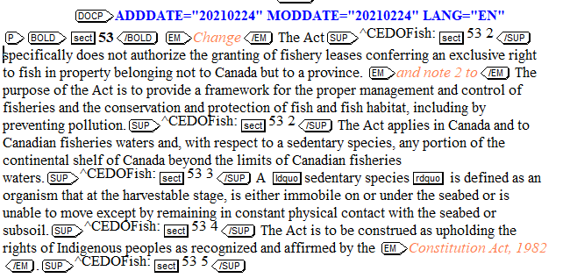

Incorrect tagging:
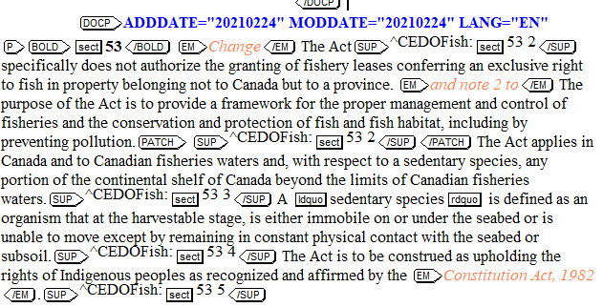

***
Tagging for all <SUP> should include the caret code and section number (these are not specified in the Word document, but should be included).

Correct tagging:

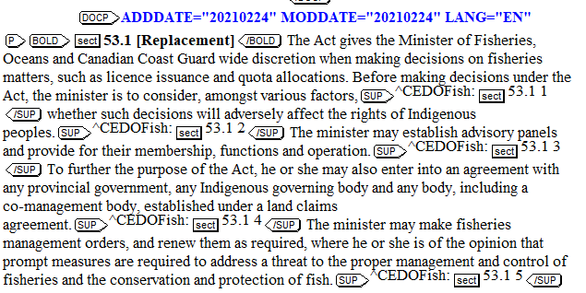

Incorrect tagging:

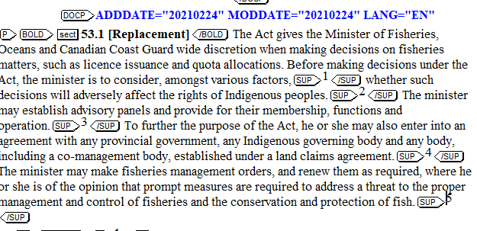

***
Tagging for Abridgment mapping should appear within their own <DOCP> tags. There is a lot of variety in how these are tagged. Some are in <QUOTE> or <PATCH> tags. They should all appear as follows:

Correct tagging:

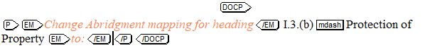
***

The size for headings that are being added or changed is always 12 and they appear in new <BLOCK> and <TI> tags:

Correct tagging:

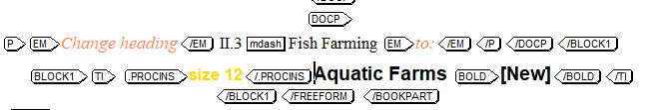

***
Do not put all references to “see” in bold tags. Only use bold tags around “see” if it is indicated in the Word document.

Correct tagging:

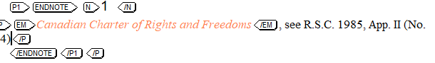

Incorrect tagging:

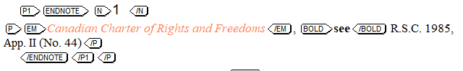

General Instructions

Title Material
- Convert <TI> contents upper and lower case.
- Please follow bolding as provided word files
DO NOT list within <TI>:
- Do not surround the entire contents of <TI> with <EM> tags.
- Do not use <EM> tags to surround Act, Regulation and Rule titles in <TI>.
- Do not key periods at the end of </TI> tags.
- Do not use <CASEREF> within <TI> tags as this causes problems for WLEC TOC building.
- Do not <BOLD> “see now” references

Use of <EM> tags:
- Capture the text “supra, infra, bona fide, inter alia and prima facie”, in <EM> even when it does not appear in italics in the source file
- Capture the Act, Regulation and Rule titles in <EM> even when it does not appear in italics in the source file—with the exception of <TI>, see “Title Material” above.

Use of <BOLD> tags:
- Use <BOLD> tag for all “see also”, “See also”, “but see”
- Use <BOLD> tag for “See” or “see”, UNLESS the “See” or “see” is followed immediately by “Canadian Abridgment…”— <EM> tag is required
e.g.
<EM>See</EM>:

See Canadian Abridgment: <LINK….
tag as:
<EM>See</EM> Canadian Abridgment: <LINK….

<BOLD>See</BOLD>:
<P>See &sect;51.</P>
tag as:
<P><BOLD>See</BOLD> &sect;51.</P>

Infra and Supra Text
- The italic text "supra" and "infra" often follow an abbreviated style of cause reference that also appears in italic. The italic text "supra" and "infra" should be tagged within their own <EM> tags when they follow other italic text. For example <EM>Smith</EM>, <EM>infra</EM> rather than <EM>Smith, infra</EM>.

Entitites (&mdash; and &ndash;)
- Do not key spaces around the &mdash; or &ndash; entities.
- Use the &ndash; entity for all types of ranges whether the range includes numbers or letters.

French Data — Appropriate Entities
- When converting French material key the entity &nbsp; (non-breaking space) before colons, before the "%" sign and before the "$".
- Use the following entities within French text in place of the <SUP> tag:

TO GENERATE | CONVERT AS
nº | n&ordm;
Superscript e | &sup-e;
Superscript er | &sup-er;
Superscript ere | &sup-ere;
Superscript ère | &sup-egre;
Superscript ers | &sup-ers;
Superscript rs | &sup-rs;
Superscript re | &sup-re;
Superscript res | &sup-res;
Superscript lle | &sup-lle;
Superscript me | &sup-me;
Superscript os | &sup-os;

- NEVER place any of the above entities within the <SUP> tag. These entities are to be used in place of <SUP>. If the superscript content does not appear in the above chart, use <SUP> to capture the superscripted text. For example, 1^{ier} would be captured as 1<SUP>ier</SUP> and NOT as 1<SUP>i&sup-er;</SUP>.

SUPPLEMENT:

Notes:
*******
1. Add <FORMAT> before each first level bookpart <N>, numbering scheme I, II, III, etc.

e.g.

<ROOT>
<BOOKPART>
<FORMAT>
<RUNNING PLACE="FootStartOdd1RC">June 2011</RUNNING> ⬅ *
<RUNNING PLACE="FootStartOddRC">June 2011</RUNNING> ⬅ *
<RUNNING PLACE="FootOtherEvenLC">CED (4th)</RUNNING> ⬅ *
<RUNNING PLACE="FootStartOdd1C"><?Folio></RUNNING>
<RUNNING PLACE="FootStartOddC"><?Folio></RUNNING>
<RUNNING PLACE="FootOtherEvenC"><?Folio></RUNNING>
<RUNNING PLACE="TopOtherEvenLC"><?vear><?HR 0.0p><?HR 0.5p></RUNNING>
<RUNNING PLACE="TopOtherEvenA">SUPPLEMENT TO SENTENCING</RUNNING> ⬅ **
<RUNNING PLACE="TopOtherOddRC"><?rear><?HR 0.0p><?HR 0.5p></RUNNING>
<RUNNING PLACE="TopOtherOddA">SENTENCING</RUNNING> ⬅ ***
</FORMAT>

Note:
* Check Transmittal cover page “Product” for release month
** Check Inventory “Data” for supplement title content
*** Check Inventory “Data” for title content (without the word “Supplement to”)

2. Change the first two <RUNNING PLACE …> lines content according to the release month,
check cover page “PRODUCT” for release month

Note: Use “Month 2011” if release month not provided
e.g.

<FORMAT>
<RUNNING PLACE="FootStartOdd1RC">June 2011</RUNNING> ⬅ 1st line, release month
<RUNNING PLACE="FootStartOddRC">June 2011</RUNNING> ⬅ 2nd line, release month
<RUNNING PLACE="FootOtherEvenLC">CED (Ont. 4th)</RUNNING>
<RUNNING PLACE="FootStartOdd1C"><?Folio></RUNNING>
<RUNNING PLACE="FootStartOddC"><?Folio></RUNNING>
<RUNNING PLACE="FootOtherEvenC"><?Folio></RUNNING>
<RUNNING PLACE="TopOtherEvenLC"><?vear><?HR 0.0p><?HR 0.5p></RUNNING>
<RUNNING PLACE="TopOtherEvenA">SUPPLEMENT TO ACTIONS</RUNNING>
<RUNNING PLACE="TopOtherOddRC"><?rear><?HR 0.0p><?HR 0.5p></RUNNING>
<RUNNING PLACE="TopOtherOddA">ACTIONS</RUNNING>
</FORMAT>

3. Change the third <RUNNING PLACE…> line content according to the CED jurisdiction:
CED Shared: CED (4th)
CED West: CED (West. 4th)
CED Ont.: CED (Ont. 4th)

e.g. CED Ontario

<FORMAT>
<RUNNING PLACE="FootStartOdd1RC">June 2011</RUNNING>
<RUNNING PLACE="FootStartOddRC">June 2011</RUNNING>
<RUNNING PLACE="FootOtherEvenLC">CED (Ont. 4th)</RUNNING> ⬅ 3rd line, CED Ontario
jurisdiction
<RUNNING PLACE="FootStartOdd1C"><?Folio></RUNNING>
<RUNNING PLACE="FootStartOddC"><?Folio></RUNNING>
<RUNNING PLACE="FootOtherEvenC"><?Folio></RUNNING>
<RUNNING PLACE="TopOtherEvenLC"><?vear><?HR 0.0p><?HR 0.5p></RUNNING>
<RUNNING PLACE="TopOtherEvenA">SUPPLEMENT TO ACTIONS</RUNNING>
<RUNNING PLACE="TopOtherOddRC"><?rear><?HR 0.0p><?HR 0.5p></RUNNING>
<RUNNING PLACE="TopOtherOddA"> ACTIONS</RUNNING>
</FORMAT>

4. Change the 8th <RUNNING PLACE…> line content according to the CED title (all upper case
required), see data inventory under “DATA” for CED title:

<FORMAT>
<RUNNING PLACE="FootStartOdd1RC">June 2011</RUNNING>
<RUNNING PLACE="FootStartOddRC">June 2011</RUNNING>
<RUNNING PLACE="FootOtherEvenLC">CED (Ont. 4th)</RUNNING>
<RUNNING PLACE="FootStartOdd1C"><?Folio></RUNNING>
<RUNNING PLACE="FootStartOddC"><?Folio></RUNNING>
<RUNNING PLACE="FootOtherEvenC"><?Folio></RUNNING>
<RUNNING PLACE="TopOtherEvenLC"><?vear><?HR 0.0p><?HR 0.5p></RUNNING>
<RUNNING PLACE="TopOtherEvenA">SUPPLEMENT TO ACTIONS</RUNNING> ⬅ 8th line,
CED title
<RUNNING PLACE="TopOtherOddRC"><?rear><?HR 0.0p><?HR 0.5p></RUNNING>
<RUNNING PLACE="TopOtherOddA">ACTIONS</RUNNING>
</FORMAT>

Copy the whole <FORMAT> and add to each of the first level <BOOKPART> before the <N> tag and continue the step 5

5. Change last <RUNNING PLACE …> line content, PART number (if any) plus the first <bookpart> title (all upper case required), numbering scheme, I, II, III, etc.:

e.g.

<FORMAT>
<RUNNING PLACE="FootStartOdd1RC">June 2011</RUNNING>
<RUNNING PLACE="FootStartOddRC">June 2011</RUNNING>
<RUNNING PLACE="FootOtherEvenLC">CED (Ont. 4th)</RUNNING>
<RUNNING PLACE="FootStartOdd1C"><?Folio></RUNNING>
<RUNNING PLACE="FootStartOddC"><?Folio></RUNNING>
<RUNNING PLACE="FootOtherEvenC"><?Folio></RUNNING>
<RUNNING PLACE="TopOtherEvenLC"><?vear><?HR 0.0p><?HR 0.5p></RUNNING>
<RUNNING PLACE="TopOtherEvenA">SUPPLEMENT TO ACTIONS</RUNNING>
<RUNNING PLACE="TopOtherOddRC"><?rear><?HR 0.0p><?HR 0.5p></RUNNING>
<RUNNING PLACE="TopOtherOddA">ACTIONS</RUNNING>
</FORMAT>

***
Format of <BOOKPART><TI>:
- For Ontario:
e.g.
Ontario Title 3 ➔ <TI>Title 3</TI>

Title 3 ➔ <TI>Title 3</TI>
- For Western:
e.g.
Western Title 3 ➔ <TI>Title 3</TI>
Title 3 ➔ <TI>Title 3</TI>
- For Shared:
Ontario Title 3
Western Title 5

➔ <TI>Ontario Title 3&newline;Western Title 5</TI>

Use of <SUP>:
- Use <SUP> for any endnote numbers in square bracket within the main supplement:
e.g.
…projects or signatory to agreements.[1] …

tag as:
… projects or signatory to agreements.<SUP>^xxxxx&sect;xx 1</SUP> …

- Caret code required for all endnote within <SUP>, please see inventory under “Code” for caret code content
- Caret code/endnote style within <SUP>: ^caret code: + section number (where the supplement refer to) + endnote number, e.g. <SUP>^CEDOAct:&sect;27 1</SUP>
- Where <SUP></SUP> tags encounter punctuation (periods and commas), place the <SUP></SUP> tags immediately after the period or comma. For example:
CORRECT:
The panel may cancel the certificates.<SUP>^CEDSentS:&sect;12 1</SUP>
INCORRECT:
The panel may cancel the certificates <SUP>^CEDSentS:&sect;12 1</SUP>.

Format of <ENDNOTE>:
- Capture all <ENDNOTE>s within a <P1>, DO NOT use separate <P1> for different <ENDNOTE>
- The corresponding numbered note and text is tagged as <ENDNOTE><N></N><P> within a <P1>.
e.g.
<P1>
<ENDNOTE>
<N>1</N>
<P>Canada …
… </ENDNOTE>
<ENDNOTE>
<N>2</N>
<P>Securities …
</ENDNOTE>
</P1>
…

Use of <CASEREF>:
- Use <CASEREF> within <ENDNOTE> for any case references. Do not key a period within the <N></N> tags.
- For all case references use <CASEREF> tagging within the open <P> tag.
- DO NOT USE THE <SUP> TAG WITHIN <CITE>:
For example D.L.R. cites:
1 D.L.R. 4th 2 should be converted as:

<CITE>1 D.L.R. (4th) 2</CITE> ⬅ correct
<CITE>1 D.L.R. (4<SUP>th</SUP>) 2</CITE> ⬅ incorrect

- Case references may appear as:
- two parties separated by "v." or "c." ;
- one party followed by ", Re" ;
- one or more parties beginning "In the Matter of" or "In Re" .
- Within <CASEREF>:
- Place style of cause within <SOC>.
- For an unreported case place the judgment date within <JUDGDATE>. Do not key parenthesis.
- For an unreported case place the docket number within <DOCKET>.
- For a reported case place the round bracketed year within <YEAR>. Do not key parenthesis that may surround the year.
- Place the main cite, or first cite listed, within <CITE>.
- Never use <SUP> or <SUB> tags within <CITE>.
- Use the <PAGENUM> tag for any "at" references that follow <CITE> data (i.e. 12 C.B.R. 14 at 15).
- Use the <PARANUM> tag for any paragraph references in among data tagged as <CITE>, <DOCKET>, <JUDGDATE> etc. Do not capture the &para; symbol within the <PARANUM> tag as the <PARANUM> tag will generate the ¶ symbol. For example <CITE>[1998] 1 S.C.R. 770</CITE><PARANUM>63</PARANUM> is proper tagging.
- Place any further cites within <CORRELAT> tags. The <CORRELAT> tag contains optional <SOC> and required <CITE>.
- Place the name of the judge or "decider" within <DECIDER> tags.
- Place the court/jurisdiction data within <COURTJUR>. Do not key parenthesis that may surround the court/jurisdiction.
- Place a different "level" of the case (i.e. higher or lower court information) within <CASEHIST>. The <CASEHIST> tag contains optional <CASEDISP> (for treatment of the higher or lower court level such as "reversed by" or "reversing" etc.) and required <CASEREF>. Do not key <TEXT> within <CASEDISP>.
- Do not key punctuation that would fall between tags.

- Note: do not add <ENDNOTE> in <CASEREF> tag, if <ENDNOTE> belongs to <CASEREF> material, please add it after the closing </CASEREF>:

…</CASEREF><ENDNOTE>…</ENDNOTE>
(endnote in <CASEREF> results in broken links on wlec and problems with the Novus conversions)

- Do not use <CASEREF> within <TI> tags as this causes problems for WLEC TOC building.
- The strings "see also", "See also", "but see" and "But see" should always be surrounded with <EM></EM> tags. Casing of the first letter of the strings should reflect whether a new sentence begins or not. Where "see" or "but" follows a semi-colon the "s" or "b" should be lower case. Where "See" or "But" begins a new paragraph the "S" or "B" should be upper case.
- References to other CED titles will appear within the text in all upper case and should be keyed in upper and lower case.

Tagging Samples:

Supplement:

<ROOT>
<BOOKPART>
<FORMAT>
<RUNNING PLACE="FootStartOdd1RC">June 2011</RUNNING>
<RUNNING PLACE="FootStartOddRC">June 2011</RUNNING>
<RUNNING PLACE="FootOtherEvenLC">CED (Ont. 4th)</RUNNING>
<RUNNING PLACE="FootStartOdd1C"><?Folio></RUNNING>
<RUNNING PLACE="FootStartOddC"><?Folio></RUNNING>
<RUNNING PLACE="FootOtherEvenC"><?Folio></RUNNING>
<RUNNING PLACE="TopOtherEvenLC"><?vear><?HR 0.0p><?HR 0.5p></RUNNING>
<RUNNING PLACE="TopOtherEvenA">SUPPLEMENT TO ACTIONS</RUNNING>
<RUNNING PLACE="TopOtherOddRC"><?rear><?HR 0.0p><?HR 0.5p></RUNNING>
<RUNNING PLACE="TopOtherOddA">ACTIONS</RUNNING>
</FORMAT>
<TI>Ontario Title 3</TI>
<FREEFORM>
<BLOCK1><TI><?size 14>ACTIONS</TI></BLOCK1>
<BLOCK1><TI><?size 14>Part II&mdash;Forms and Classes of Action</TI>
<DOCP><P><?size 10>&sect;14 note 2 <-- Place the processing instruction <?size 10> after the first
<DOCP><P> of the text paragraph following the <BLOCK1>
<P1>Federal Courts ...</P1></P>
...

<DOCP> sample tagging:

§27.5 [New] Contempt of court is a remedy provided under the various court rules and is not a cause of action.[1] | <DOCP>  <P><BOLD>&sect;27.5 [New] </BOLD> Contempt of court is a remedy provided under the various court rules and is not a cause of action.<SUP>^CEDSentS:&sect;27.5 1</SUP>  <P1><ENDNOTE>  <N>1</N>  <P><CASEREF>...</CASEREF>.</P>  </ENDNOTE></P1>  </P></DOCP>
Change Abridgment mapping for heading I.3.d.iii — Sharing Gross Returns to:  See Canadian Abridgment: BUS.I.2.b Business associations — Nature of business associations — Nature of partnership — Contrasted with other relationships | <DOCP><P><EM>Change Abridgment mapping for heading</EM> I.3.d.iii&mdash;Sharing Gross Returns <EM>to</EM>:  <P1><EM>See</EM> Canadian Abridgment: BUS.I.2.b Business associations&mdash;Nature of business associations&mdash;Nature of partnership &mdash;Contrasted with other relationships</P1></P></DOCP>
126 note 1  Ross v. Chandler: (1911), 19 O.L.R. 584 should read (1909), 1909 CarswellOnt 599. | <DOCP><P>126 note 1  <P1><CASEREF><SOC>Ross v. Chandler</SOC></CASEREF><EM>:</EM> <CASEREF><YEAR>1911</YEAR><CITE>19 O.L.R. 584</CITE> <EM>should read</EM> <CASEREF><YEAR>1909</YEAR><CITE>1909 CarswellOnt 599</CITE></CASEREF>.

Use <BOLD> tags for text which appears in bold

HIGHLIGHTS: (if any)

- Capture the whole document within a <BOOKPART>
- Place the centred title and number within <BOOKPART><TI>
- Add PI <?szie 14> before “Title” within <TI>, e.g. <BOOKPART><TI><?size 14>Title 115</TI>
- Use <FREEFORM> tagging within <BOOKPART>
- <COMMENT> note required
- Use <BLOCK1> for centred, all upper case heading, add PI <?size 14> before the title within <TI>, e.g. <BLOCK1><TI><?size 14>PARTNERSHIP</TI>
- Use <BOLD> for bold face text
- Add a &newline; entities in a <P> or <P1> to create a space between paragraph

Highlights sample taging:

<BOOKPART>
<TI><?size 14>Title 115</TI>
<FREEFORM>
<BLOCK1>
<TI><?size 14>PARTNERSHIP</TI>
<P>&newline;</P> ⬅ &newline; entities
<P><?size 10><BOLD>HIGHLIGHTS:</BOLD>
This supplement incorporates ...</P>
<P>&newline;</P> ⬅ &newline; entities
<P><BOLD>Cases:</BOLD>
<P1>&newline;</P1> ⬅ &newline; entities
<P1><BOLD>British Columbia:</BOLD></P1>
<P1><CASEREF>...
...

PLEASE NOTE: This data is a working manuscript subject to in-house editorial review and renumbering upon return to Carswell. Please use <PATCH REASON="PROBLEM"></PATCH> to surround data that "falls out" of the paragraph structure. Use <P> tagging within <PATCH>. Use <FOOTNOTE> tagging and all other appropriate tagging within the <PATCH> where appropriate.

PLEASE NOTE: no longer need the caret codes in front of case cites—October 6, 2005

