Simulation

Ecoflex 3mm thick

pressure area 24 [mm2]

pressure center at (15, 5.2) [mm] which is at taxel number 7 only

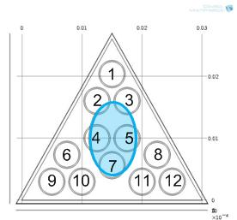

1. gentle touch 10kPa: C7 = 1.79452e-13F

result fig are 10kpa1.fig and 10kpa2.fig

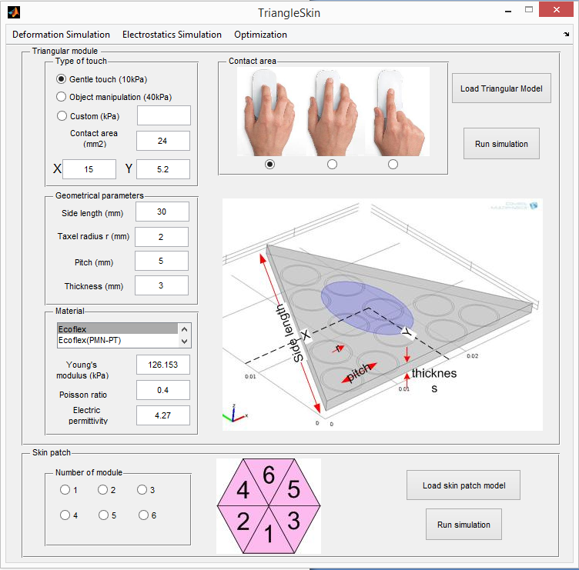

2. Object manipulation 40kPa: C7 = 1.93168e-13F

result fig are 40kpa1.fig and 40kpa2.fig

