C Programming
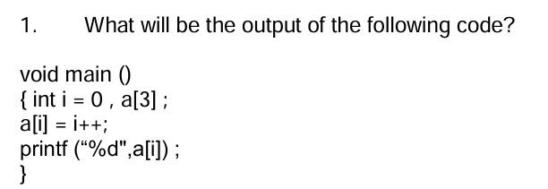

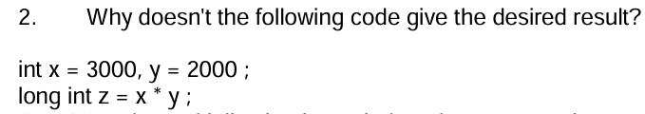

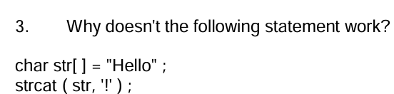

C++ Programming
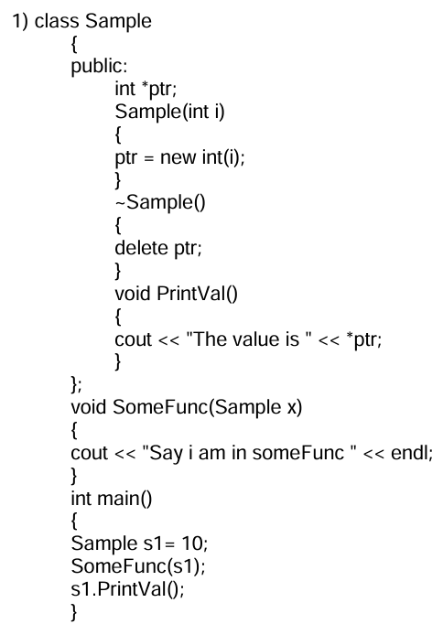
What is the output and explain the same?

Technical Questions
Data structures

A data structure is a specialized way of organizing, managing, and storing data in a computer so it can be accessed and modified efficiently.

Operating Systems: Used in process scheduling (queues) and memory management (linked lists).
Databases: B-trees and hash tables optimize indexing and queries.
Networking: Graphs are used for packet routing and network topology representation.
AI and ML: Trees and graphs model decision-making and search algorithms.

Unix
In Unix, devices are represented as special files located in the /dev directory. These files allow the operating system and applications to interact with hardware devices as if they were regular files. There are two main types of device files: block devices and character devices.

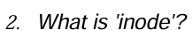
An inode (short for index node) is a data structure used in Unix-like file systems to store metadata about a file or directory. Every file and directory has an associated inode that holds information about it, except for its name or actual data.

DBMS

A database is an organized collection of data that can be easily accessed, managed, and updated. Databases are used to store information efficiently and securely, allowing users and applications to retrieve and manipulate data as needed. They are managed using a Database Management System (DBMS), such as MySQL, Oracle, or MongoDB.

A key is a field or set of fields in a table that uniquely identifies a record. Keys are used to establish and enforce relationships between tables. types: primary,foreign,candidate,super, alternate key,unique.

Operating system
Reentrancy is a property of a function or code that allows it to be interrupted in the middle of execution and safely called again ("re-entered") before the previous executions are complete.

Belady's Anomaly is a phenomenon in which increasing the number of page frames in a paging system causes more page faults instead of reducing them.

SQL
Data Definition Language (DDL).
create,alter,drop,truncate,rename.
Like

Computer Networks
guided and unguided

