Api Chosen
My Api was to do with the biodiversity of Global Species . It had a lot of opportunities for creating different features in the Blazor application .
It was an open authenticated key so it was easy to incorporated a CORS header. There was problems with the YAML. The relative file had to repeated. Dotnet was installed and the testing stage made sure that it aimed for testing the csproj as it was only one singular file .

Pipelines
The app was connected with a Yaml file on the dev branch in order
It is coded to trigger status checks on push and pull of all branches
Then the code is tested in many forms
- Static Analysis
- Code Coverage
- Unit Tests
Static Code Analysis was run using dotnet. It was configured to make sure that it examines and finds fault in only real errors not irrelevant syntax like lack of comment. This was put on to ensure that the build success percentage is higher. It was also coded so that dotnet does not change the errors only checks for them.

Branch Protection:
A branch rule was created on the main repository to only allow collaboration if the status checks have passed
This was useful for continuous delivery as no code would be pushed into the main repository if it didn’t work – the azure pipeline was connected to the GitHub repository so it both frameworks worked together in order to make sure the code worked.

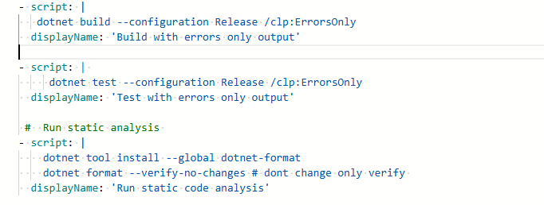

Features
Global Api Call
The api needed to be accessible and sourced globally so each can access the information easily .
In order to do this i created a service file in the root directory where the api is called .
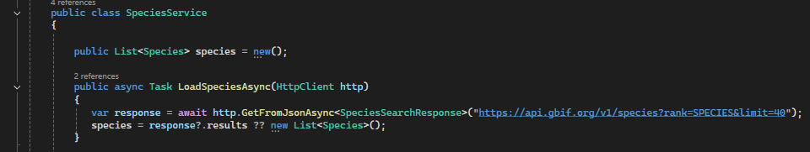
This this Task is called in other pages to populate the list field with the species data.

SpeciesList
The species list populated with the GBIF api and the Wikipedia API ( for images and text ) had two main obstacles.
- GBIF API did not contain images and if they had images it would have been tough to attain through and not consistent through all species.
- The two services files - APIS did not recognize eachother as my aim was to create a null check between for images – if so don’t display
Solutions
- (Wikipedia Service where a url is constructed with the direct link to the species relevant page provided a stable way to get images for biological classification levels and species themselves. This service is described later in the document

- The species model needed to be added with two nullable fields mirroring the species api retrieved data. A async task was made in the species service where the Wikipedia service populates the two fields .It was then called in relevant pages. The aim is so species without images don’t display.
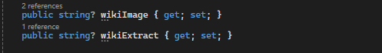
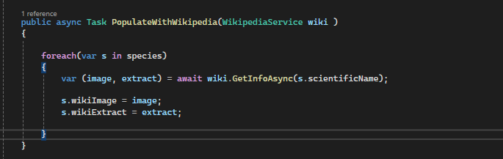
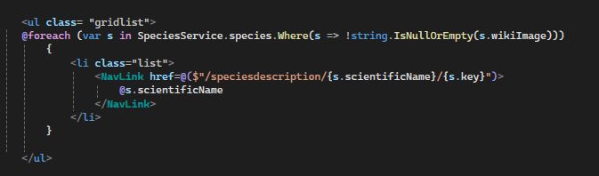

In conclusion since some species did not have pictures in the api I made sure they were not accessible for the time being for UI Purposes .
Species Description
A navigation link passes the name of the species as a variable onto the next page.
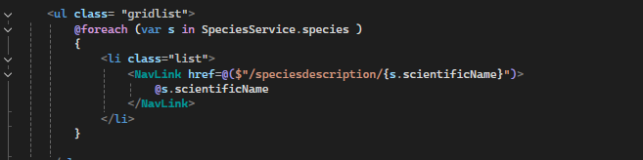
This is then used to reference an object of SpeciesList to find a match as the latin name of an animal can be assumed as unique .Onprameter runs when the url has changed . The services list is then ran to find the first matching variable in the object with the passed parameter to the page.
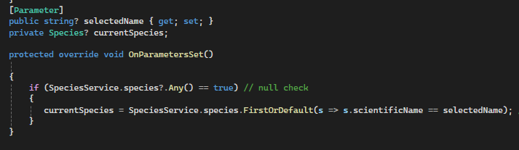
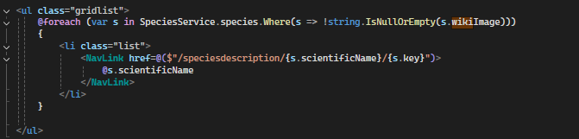
Since the api is a sample of a very large database I decided to filter out entries that cant get a picture for them . As this just helps with the UI for now .This can be undone easily, as it may be seen as inaccurate .

Further Description Phylum Classification

Conditional case for If the number of descendants from the API is not null means there are many families under the main KINGDOM? .This null check helps with find API endpoints that contain data for further description .

Null checks were implemented ordering species by phylum if they had no column name :
With “ ?? ” I created a fallback as to if it was null

Wikipedia Service

How a url is formed is with different parameters joined with an &
Example of panthers
https://en.wikipedia.org/w/api.php?format=json&action=query&prop=pageimages|extracts&exintro=1&explaintext=1&piprop=thumbnail&pithumbsize=600&titles=Panthera%20leo
returns
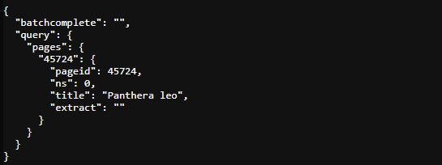

The model class for the Wikipedia service is designed with a dictionary(key value pairing eg., “name”:”Joe”) containing the page id and the actual page -> the title , first paragraph and the image
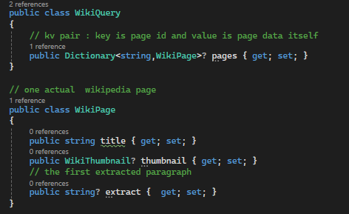

Json needs to be serialized so key value pairs turn into an object
Eg., “name”:”Joe” -> var person = JsonSerializer.Deserialize<Person>(json);
So its accessible through person.name

In the relevant page I made a constructor where I asynchronous constructed the relevant object of the class by matching it with the identified species through uri parameter passing.
Url passing
Local api connection through taxon key
Shallow copy of object of retrieved match from service array
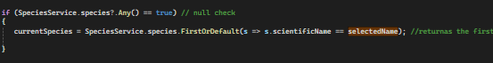

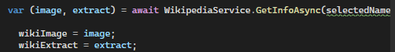

Pagination

Since the gbif is not an encylopedia but a backbone record of all species the api data is not a flat list but organized in a tree form . Using keys to go down the tree to display
Since the api limits a response of around 1000 entries in any given time and the problem that theyre is such a vast explanse of species entries this is done by design to not crash the site. It causes a problem for me to list all the records. Pagination is a great help with this problem .
But a problem comes up with pagination itself – the api does not have a direct url for lists of lower ranks like family as its not an encyclopedia . To create such needed specific filtering on the client side to extract
The api comes with a value called offset with can be used to display entries starting from the value you entered .This came in handy and I could set the variables dynamically for the offset and limit in a separate method where it increments each time it is called.
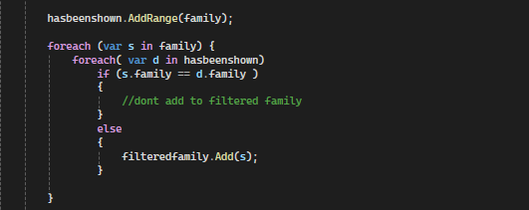
The problem was this can create duplicates and it was a list . Hashsets are an easier form to look up

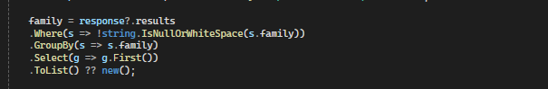

Since FirstOrdefault was so useful I decided to research how to manipulate lists with full control of what goes in .

