Windows Struct Implementation
Some structs are the easy type [StructLayout(LayoutKind.Sequential)] meaning the fields are stored im memory in the same order they are declare in the struct .

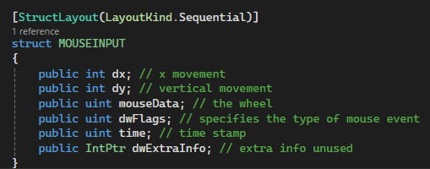
Since any event with the mouse gives defined information this struct is given by windows to implement in a method to emulate mouse input. If you moved the mouse at any point windows is given this information about the event .

Here we can see
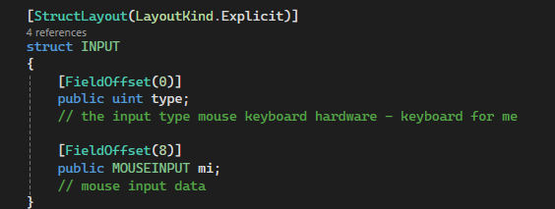
With the explicity type of struct you must specific the exact byte offset of every field eg.,
MOUSEINPUT , KEYBDINPUT and HARDWAREINPUT all exist in the same space at bit 8 – you must define which one you are using . It’s a false union in C#.
Bits 0-3 contain the type
Bits 4-7 contain the padding
And you correctly define the next chosen field at offset 8
The padding exists due to the architecture of the 64 bit system .

https://rajapet.com/2008/10/17/strange-64-bit-error-with/
https://www.jacksondunstan.com/articles/3325

Keyboard Event Hook Struct
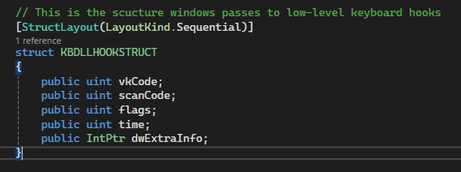
This is a struct given by windows to describe a single lowlevel event delivered a hook of WH_KEYBOARD_LL (low level keyboard event)
vkCode is the Windows Virtual Keycode for key – eg., 25 is K 28 is J – dictionary by number simply.
scanCode is the physical keys position according to the keyboard layout – not needed for this feature.
Flags can encode several Boolean properties
For example bit 4 tells us that this keystroke was synthesised from a real keyboard
Bit 7 is an important one as it can show transition state – 0 for key down or 1 for keyup . This means release is able to coded for.
Timestamp is the time it was set at .
https://learn.microsoft.com/en-us/windows/win32/api/winuser/ns-winuser-kbdllhookstruct

Installing Keyboard Hook
The aim here is to make sure any keyboard event gets recognized by my application before it runs through the windows .
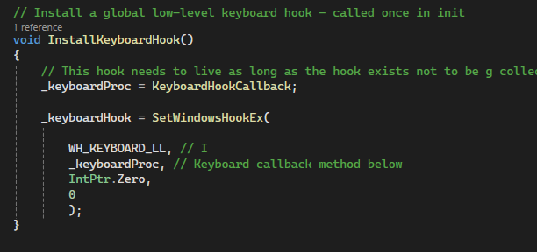
We can see here that The keyboard hook callback is created to a delegate pointing to the callback . This stores it in a field so the garbage collector does not reclaim it . Without this windows would still call the invalid function pointer .
The 4 variables in the method I want tell the system this in order :
“ I want to see the keyboard input before it gets turned into a windows input”
“ I want to run the method stated”
‘ This hook lives in my exe not a dll “ ( its called by IPC )
“ Its thread( 0 all keyboard events from every system .) “

KeyboardHookCallback Method
Here we want to basically take a sneak peak at every keyboard event before it gets passed onto apps just like SubclassProc in Quick Command Register Hotkey
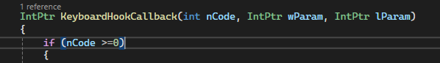

nCode is the parameter you use if you want it filter out events so other events don’t use the same method / hook and get processed incorrectly.
Wparam means word param – typically holds a set of possible info based on the event -> WM_KEYDOWN or SYSKEYDOWN (these have codes ) This digusishes between key press release and system key events eg., those involving alt .
lParam stands for long param – this in my case holds the info of what I want that I am going to pass into the struct given by windows – where the system naturally fills each event perfectly with this struct .
Since lParam (long parameter ) is an intptr which is a raw pointer to a block of memory, we are aiming to focus in on lParam as this parameter contains the information about a keyboard event .
KBLLHOOKSTRUCT is the windows struct that defines the layout of the memory block we just casted into it . It contains fields like vkCode ( virtual key code ) which is what we want
So we are saying take this pointer and interpret the bytes it points to as a keyboard struct .
wParam is the param from the hook that indicated the type of keyboard event.
It casts the const as an intptr so it can be compared to the wParam .Its an if statement both types need to be the same type . This is a keypress down event not a key release event

https://learn.microsoft.com/en-us/windows/win32/winmsg/about-hooks
https://learn.microsoft.com/en-us/windows/win32/api/winuser/nf-winuser-setwindowshookexw
https://learn.microsoft.com/en-us/dotnet/api/system.runtime.interopservices.marshal.ptrtostructure?view=net-10.0

