The one characterizing the parental care stages

Principal Investigators - Rebecca Calisi, Matt MacManes, John Wingfield

Postdocs - Suzanne Austin, Rayna Harris, Jesse Krause,

Grad students - Victoria Farrar, April Booth, Andrew Lang

Undergrads - Tanner Feustel, Candice Lee, Annie Bond?

Others - Fred?, Rechelle Viernes

## Introduction

## Methods

### Fig 1: Graphical abstract of methods

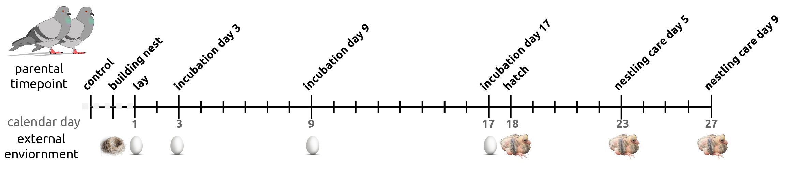

## Results

## Fig 2: Prolactin fluctuates the most and peaks near hatch in males and females

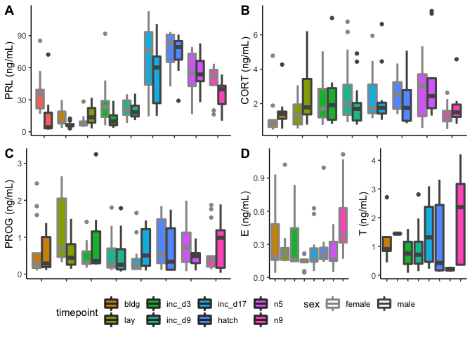

## Figure 3: General RNAseq pattern, tissue > sex > parental stage

*Needs to be replaced with a better PCA plot showing all samples as points*

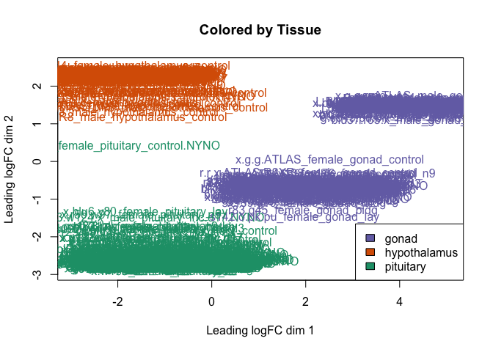

## Figure 4: model showing ability to predict non-parental, egg care, and nestling care

*redo color scheme, fix titles*

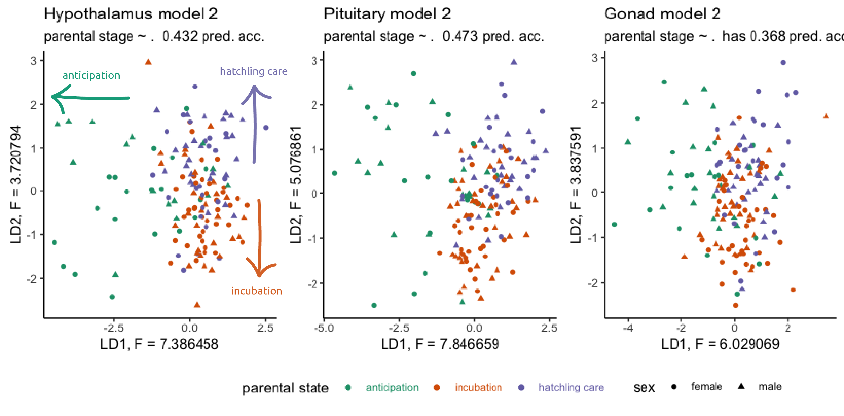

## Figure 5: PRL gene expression in the pituitary in prolactin mirrors PRL in blood

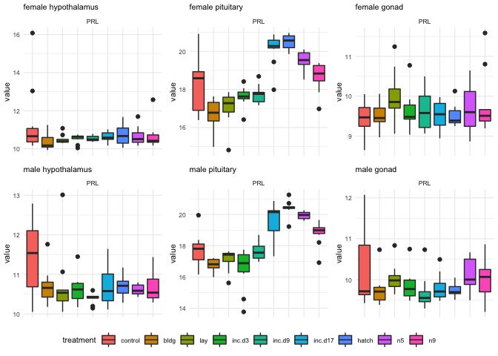

## Figure 6: Many genes mirror the PRL expression pattern

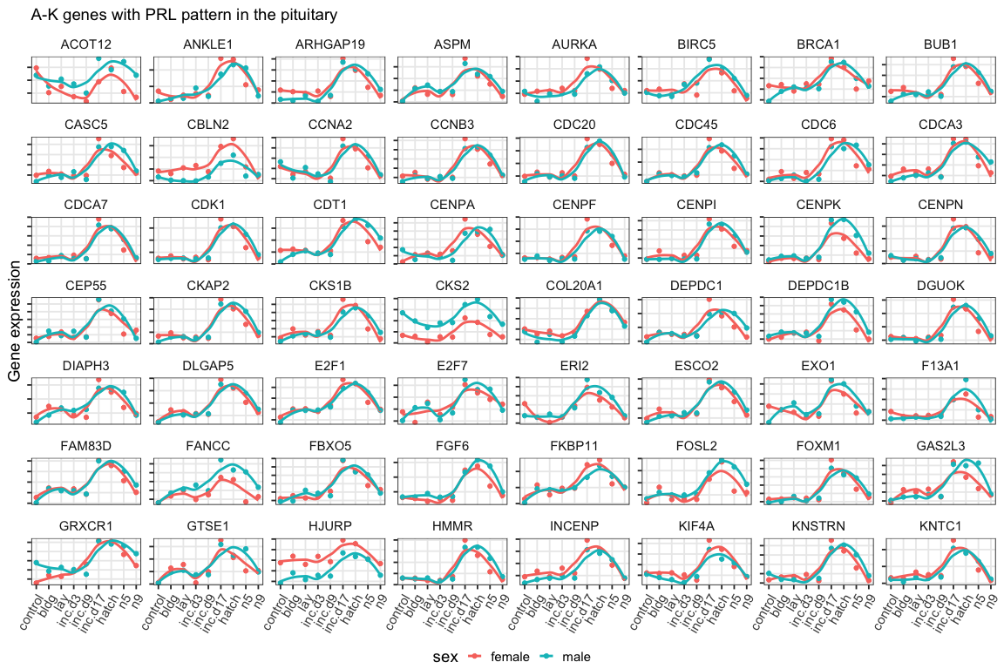

## Discussion

* What genes differ in expression between timepoints?
* What stages are most different, stressful, responsive?
* How do genes in the HPG affect genes in other regions?
* How do male and females differ?
* How do tissues differ?
* What is the relationship between genes and hormones across timepoints?

## Conclusion

## Acknowledgements

## Data availability