The one where we remove their offspring

Principal Investigators - Rebecca Calisi, Matt MacManes, John Wingfield

Postdocs - Suzanne Austin, Rayna Harris, Jesse Krause,

Grad students - Victoria Farrar, April Booth, Andrew Lang

Undergrads - Tanner Feustel, Candice Lee, Annie Bond?

Others - Fred?, Rechelle Viernes

## Introduction

## Methods

## Results

### Fig x: Prolactin drops when offspring removed around hatch

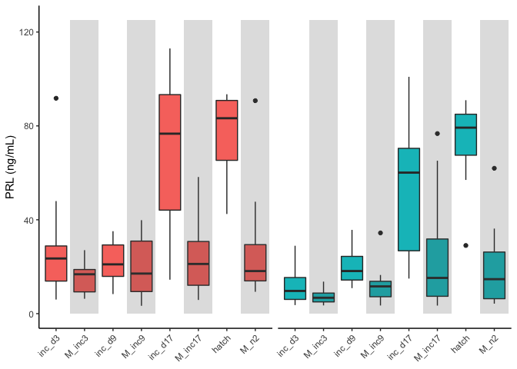

## Discussion

## Conclusion

## Acknowledgements

## Data availabilty