**What is the problem?**

Resource interference makes it difficult to fully utilize WSCs while mixing latency critical and noncritical tasks. How can we extend and optimize existing architectural features to allow safe (and optimal) co-location of critical and noncritical tasks?

**3.0 DESIGN SPECIFICATIONS**

We wish to take an existing computer architecture simulation and improve the functionality to see clear performance gains by handling the execution of latency critical and noncritical tasks such that the deadline for latency critical tasks is met and we do not have abundant amounts of idling within the pipeline. We will use an existing simulation to meet the senior design deadline. Thus, we can focus on improving qualities of chosen architecture. We want to look at inner-pipeline resource allocation that includes cache and memory managing, buffer space, and power allocation. Since we will be working purely with software, we will be able to control these aspects much easier than in actual hardware.

**Our requirements section describes the specific criteria our final design must meet. Here, we outline and elaborate on what constitutes satisfactory project completion. There are multiple paths we could pursue for realizing and evaluating a design. We have decided the most straightforward way is to enhance an open-source academic simulator. The input to such a system consists of a mix of publicly available *workloads* with previously known performance characteristics. The output of the system is the intangible evaluation of the *simulation performance* executing such workloads. As for the operating environment, it’s important to standardize the execution environment in which the simulation performance is evaluated as to ensure fair comparison between existing solutions and our experimental solutions. Finally, we need to characterize and analyze the system’s performance by a set of testable performance parameters that can be measured reasonably consistently.**

Our design specifications describe the requirements for designing a temperature adaptive heating system for integration into wetsuit fabrics. There are three criteria for inputs that our design must adhere to. Firstly, our input sensors must read water temperature and user temperature accurately. Secondly, the input power supply must fall within a range that enables effective heating. Lastly, our system must properly respond when a user updates the on/off state. There are also two criteria for outputs our design must adhere to. Firstly, our system must heat the user to a safe temperature. Secondly, status information on the user interface must be accurate. Our user interface must display water/user temperature, potential error messages, and system on/off. Furthermore, the system must be durable enough to handle the high pressure, high salinity, and low temperature of the environments it will operate in. We will test our device to ensure it functions under specific operating temperature, pressure and battery life.

**3.1 Input/Output Specifications**

Our system will take four different inputs and produce two outputs. The inputs will come from two temperature sensors, a power supply, and an on/off switch . The temperature sensors will collect water and user temperatures, and the user will turn the system on and off. Our system will also require an input power supply. The outputs of our system consist of heat and updates to a user interface. A diagram showing the inputs, process, and outputs of our system is described in Figure 2.

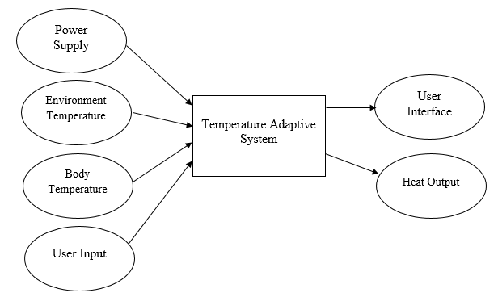

**Figure 2: Input / Output Diagram**

**3.1.1 Input Specifications**

Inputs to our system come from a power supply, sensor readings, and user inputs. The power supply provides our system with the electrical energy required to operate. The sensors provide two readings, body temperature and environmental temperature, which allow our system to update accordingly. The user input allows a client to turn the system on and off.  The specifications for these inputs are in Table 1.

**Table 1. Inputs**

|  |  |  |
| --- | --- | --- |
| Specification Name | Specification | Justification |
| Main Power Supply | | |
| Power Rating | 500 W - 1200 W | 500 W minimum to output enough heat to warm user according to calculations in Appendix E |
| Voltage Rating | 7V - 12V | Standard voltage range used in heating element applications |
| Size | < 12” x 12” x 2” | Less than space remaining after Dive Equipment |
| Auxiliary Power Supply | | |
| Charge Rating | 205mAh - 420mAh | Chosen so that user interface can be powered for 24+ hours |
| Voltage Rating | 3.3 V - 5 V | Standard microcontroller input voltage |
| Input Sensors | | |
| Body Temperature Accuracy | To 0.1°C | A drop of 0.1°C below 35.0°C can cause hypothermia |
| Environmental Temperature Accuracy | To 1°C | To report temperature to user |
| User Inputs | | |
| On/Off | Boolean True / False | Simplest representation for the system |

**3.1.2 Heat Output Specifications**

Our system outputs heat to warm the user. The specifications for our system heat output are in Table 2.

**Table 2. Heat Output**

|  |  |  |
| --- | --- | --- |
| Specification Name | Specification | Justification |
| Heat Output Accuracy | Within .1°C | Inaccuracy could cause the user to drop below 35.0°C |
| Heat Output Current Rating | 20-100mA | Sufficient for heating but within safe levels |

We have outlined a specific set of operating criteria that our system must meet. The performance specifications outlined in Table 5 provide ranges for system temperature output and input, environmental pressure, environmental salinity, and size. Additionally, Appendix C outlines standard tests that ensure electrical textiles meet metrics of breaking force, bursting force, dimensional change and flammability. Appendix D lists tests that our system must undergo to ensure it does not experience dielectric breakdown.

**Table 5: Testing Criteria [18][9]**

|  |  |  |
| --- | --- | --- |
| Test Criteria | Value | Justification |
| Minimum operating temperature | -3º C | The lowest temperature that salt water can reach while continuing to be a fluid |
| Maximum operating temperature | 40º C | The highest recorded ocean temperature |
| Maximum operating pressure | 15750 psi | Deepest recorded dive [7] |
| Operating life | 24 hours | Each scuba dive on a scuba diving expedition can last up to an hour, and most expeditions involve multiple dives[9]. |