**Ronald Macmaster**

**EID: rpm953**

**Software Testing HW 1**

**Sections 1.1, 1.2, and 1.3:**

1.1, 1.2 and 1.3 are implemented in the .java files.

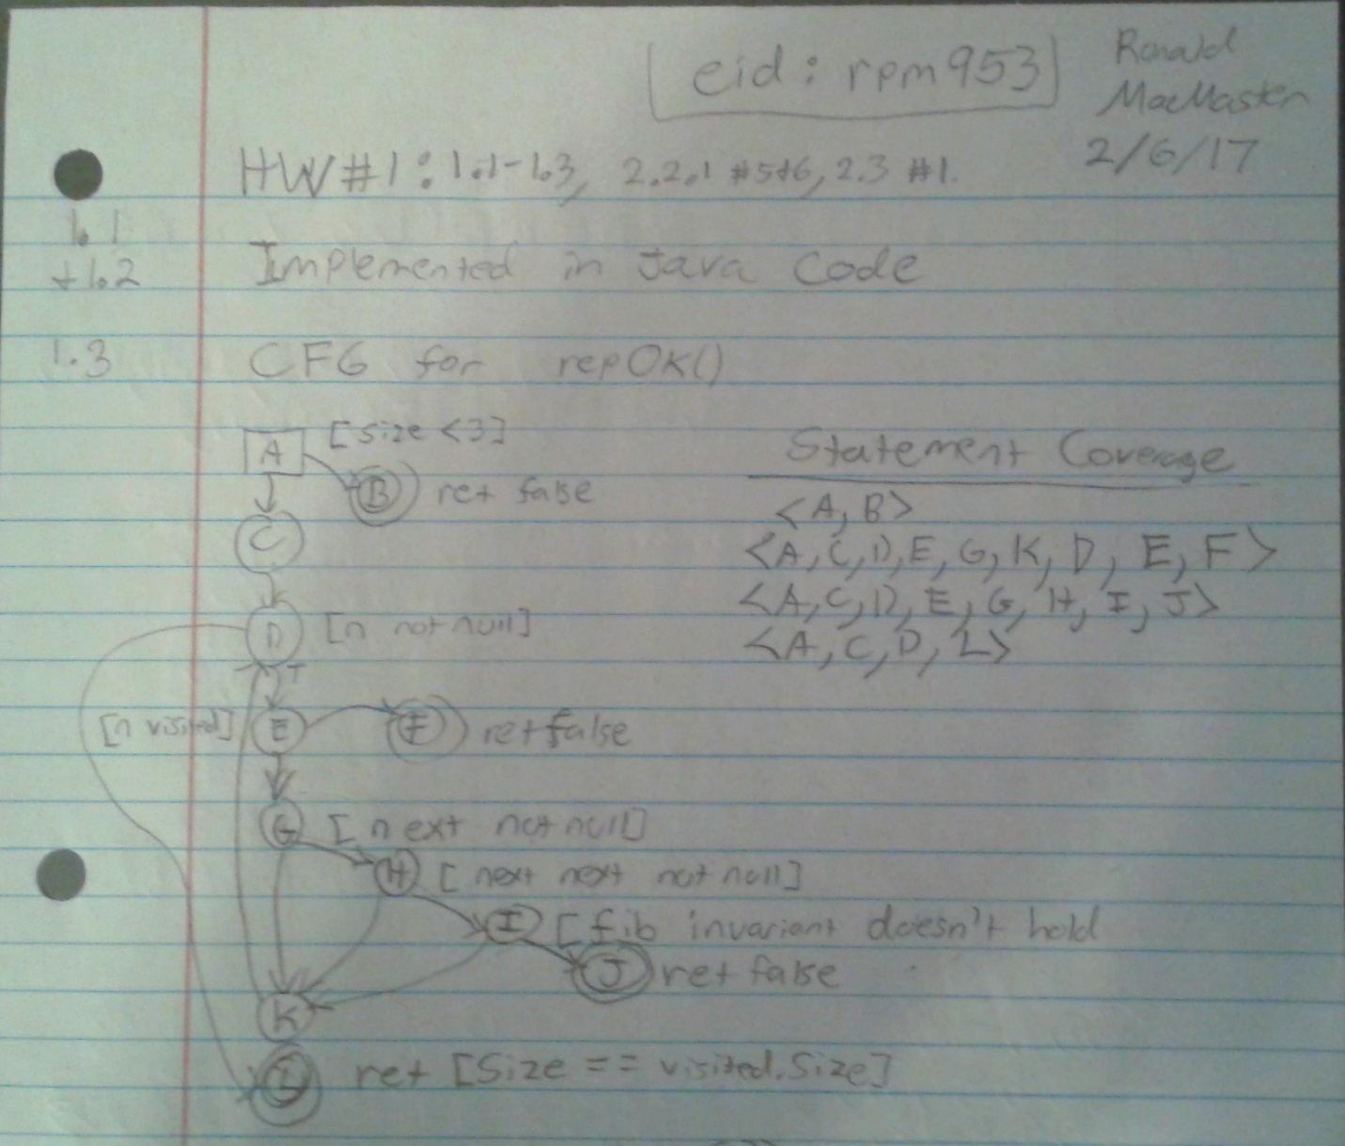

**Section 2.2.1**

**Question #5:** a-e on this page. f & g on next page.

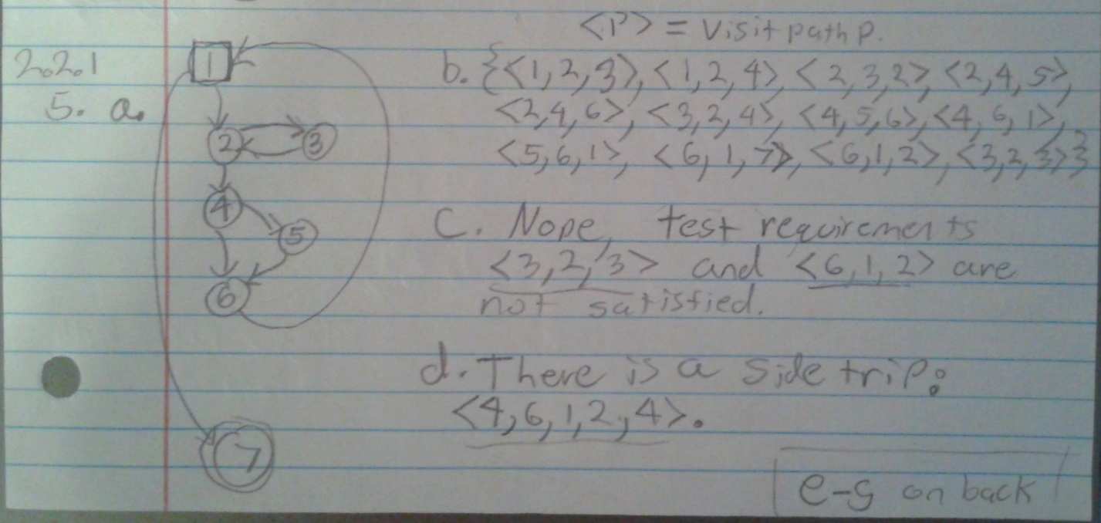

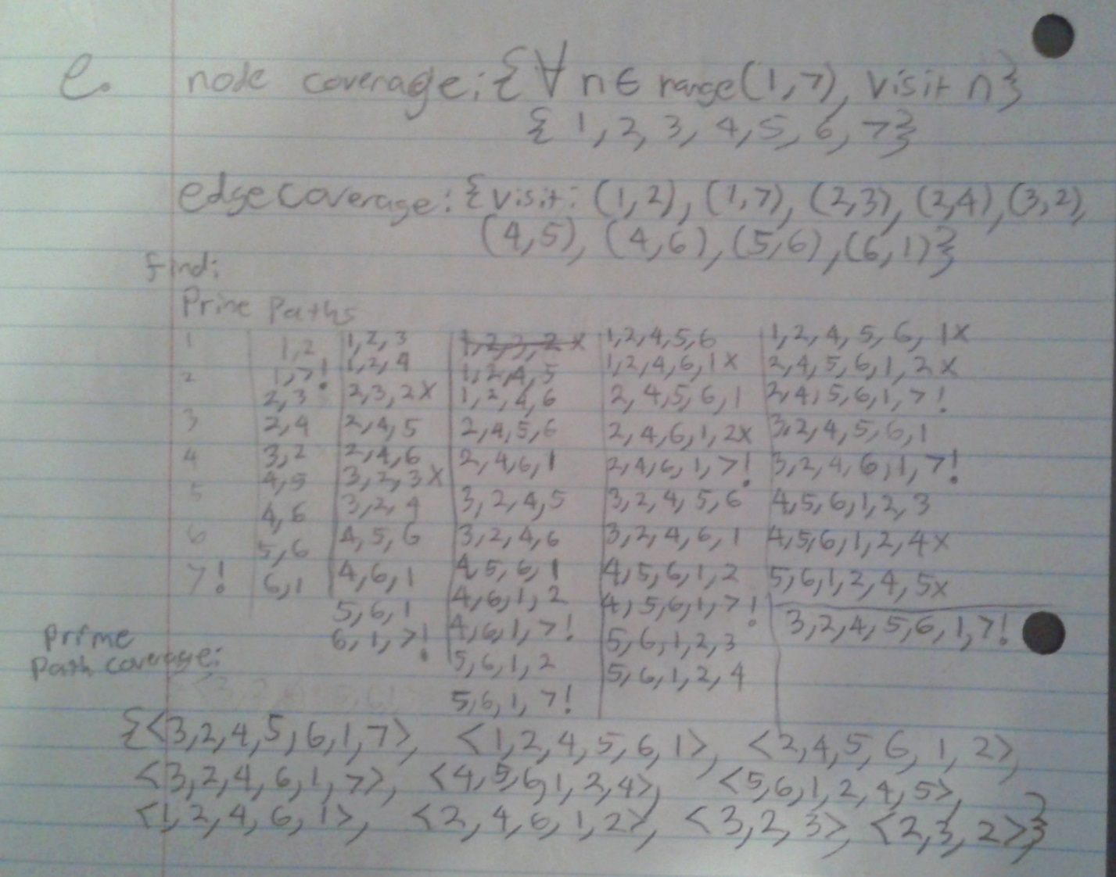

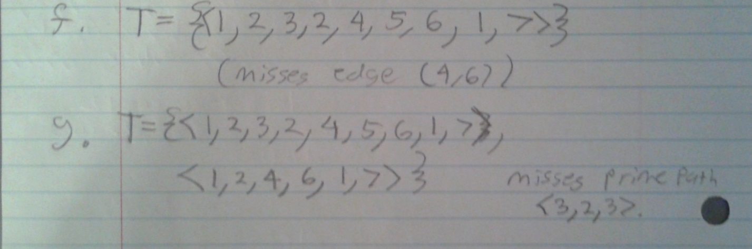

**Question #6:**

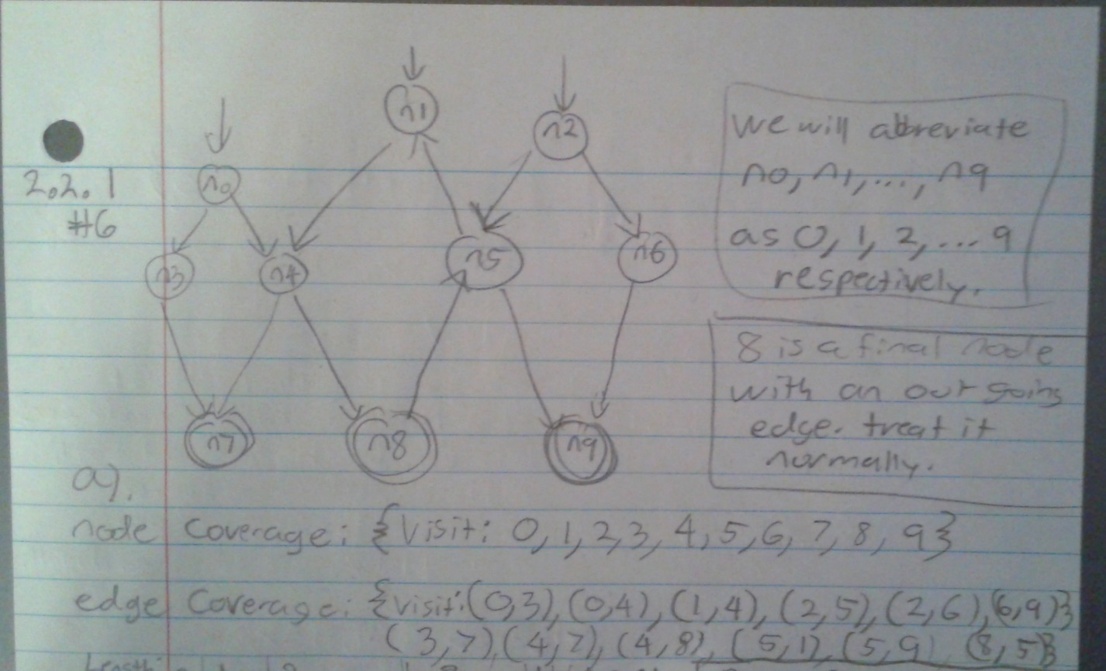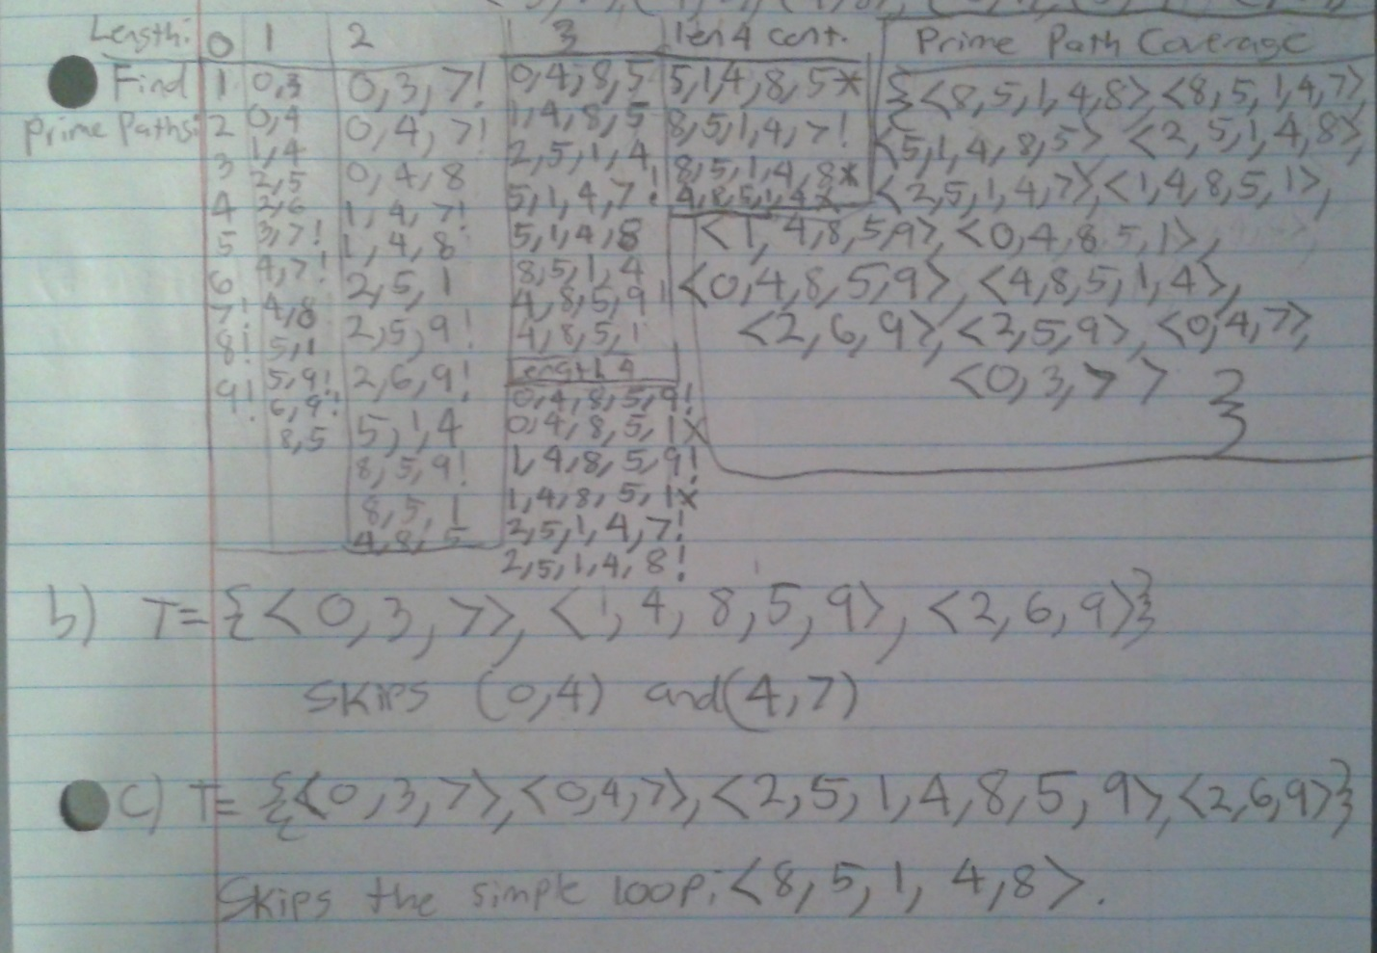

**Section 2.3**

**Question #1:**

