**Name: Ronald Macmaster**

**EID: rpm953**

**Software Testing (EE 360T) HW 2**

**1. [7 points] Exercises - Section 3.3 Question 3 - answer this question with respect to CACC instead of GACC (Pages 130-131)**

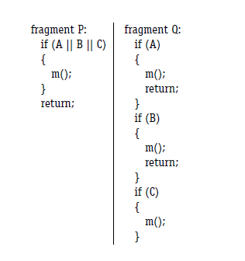

1. ***Give a CACC test set for fragment P. (Note that GACC, CACC, and RACC yield identical test sets for this example.)***

P = {(A || B || C)} // only one predicate. Cp = {A, B, C} p = (A || B || C)

Truth Table:

|  |  |  |  |
| --- | --- | --- | --- |
| **A** | **B** | **C** | **A || B || C** |
| T | T | T | T |
| T | T | F | T |
| T | F | T | T |
| T | F | F | T |
| F | T | T | T |
| F | T | F | T |
| F | F | T | T |
| F | F | F | F |

For c = A: Choose B and C such that P(A = true) != P(A = false).

Set B and C false. A determines p, and the condition holds.

For c = B and c = C, set the other two clauses false, and the condition holds.

**CACC Tests:**

**T = {(F, F, F), (T, F, F), (F, T, F), (F, F, T)}. // t = (A, B, C).**

The predicate is in Disjunctive Normal Form (DNF), so this makes sense.

1. ***Does the CACC test for fragment P satisfy edge coverage on fragment Q?***   
   Yes, the CACC test for fragment P satisfies edge coverage on fragment Q.
2. ***Write down an edge coverage test set for fragment Q. Make your test set include as few tests from the CACC test set as possible.***  
   The CACC test set already is a minimal test suite for edge coverage.   
   **T = {(F, F, F), (T, F, F), (F, T, F), (F, F, T)}. // t = (A, B, C).**

**2. [6 points] Exercises - Section 4.1 Question 2 (Page 159) - answer this question with respect to only the method Push using exactly two characteristics where each characteristic has two blocks in its partition**

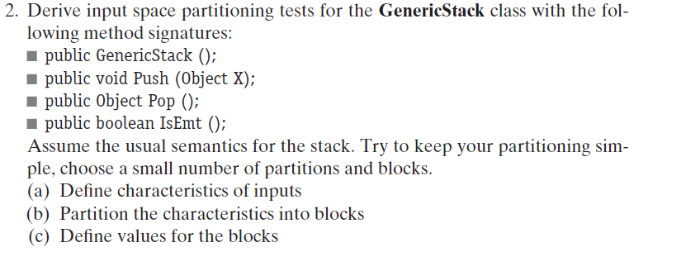

1. ***Define characteristics of inputs.***

Characteristic 1: Input X is null.  
Characteristic 2: Class of input X is Object.

1. ***Partition the characteristics into blocks.***Characteristic 1: Input X is null.

{Input X is null, Input X is NOT null};  
Characteristic 2: Class of input X is Object.

{Class of input X is Object, Class of input X is NOT Object};

1. ***Define values for the blocks.***

Characteristic 1: Input X is null.

{(null), (new Object())};

Characteristic 2: Class of input X is Object.

{(new Object()), (new Integer())};

**3. [7 points] Exercises - Section 4.2 Question 4 (Pages 163-164)**

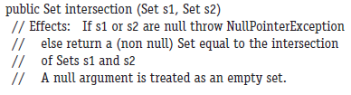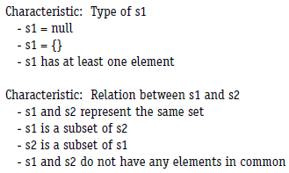

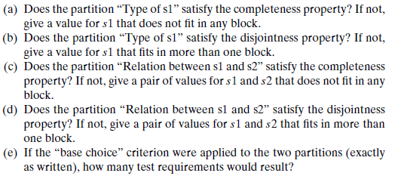

1. **Yes, it does satisfy the completeness property. No set s1 can be formed that does not fit in any of those three blocks.**
2. **Yes, it does satisfy the disjointness property. No set s1 can be formed that satisfies more than one of the block properties.**
3. **No, it does NOT satisfy the completeness property.   
   Consider the set pair (s1, s2) = ({3, 4, 5}, {3, 4, 6}). The two sets have some elements in common, but they are not the same set. Also, neither set is a subset of the other!**
4. **No, it does NOT satisfy the disjointness property. Consider the pair where s1 and s2 are the same set, s1 is a subset of s2 and s2 is also a subset of s1! Ex.: (s1, s2) = ({6}, {6}). {6} and {6} are the same set.   
   Also, {6} is a subset of {6}.**
5. **The number of tests that result from using the “base choice” criterion can be expressed as:  
   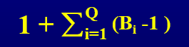**

**For this example, the total would be ( 1 + ( 3 – 1 ) + ( 4 – 1 ) ) = 6 tests.**